DevOps CS316
Assignment #4
CI/CD Pipeline with Git and GitHub Actions

Member 1 | Muhammad Hashir | Reg# 2023429
Member 2 | Zain ul Abdeen | Reg# 2023773
Course Code | CS316
Instructor | Muhammad Sajid Ali
Total Marks | 100
Date | May 2026

A. Project Introduction
This assignment focuses on implementing a complete CI/CD pipeline using Git, GitHub, GitHub Actions, and AWS EC2. The objective is to automate the software delivery process from development through testing to staging, mirroring real-world DevOps practices.

Selected Project: Task Manager Application
We selected a Task Manager web application built with the MERN stack (MongoDB, Express.js, React, Node.js). The application provides full CRUD operations for task management and demonstrates interaction between all three tiers of a modern web application.

Technology Stack
- Frontend: React.js (Create React App) running on port 3000
- Backend: Node.js with Express.js REST API running on port 5000
- Database: MongoDB (containerized via Docker)
- Containerization: Docker and Docker Compose
- CI/CD: GitHub Actions
- Cloud: AWS EC2 (Ubuntu 24.04 LTS)
- Testing: Jest and Supertest

Assignment Objective
The primary objective is to automate the complete software delivery lifecycle across four environments:
- Development: Local developer machines with Docker Compose
- Testing: AWS EC2 instance (devops-testing) triggered on pull requests
- Staging: AWS EC2 instance (devops-staging) triggered on merge to main branch
- Production: Represented conceptually by the staging environment in this assignment

B. Challenges Faced

1. SSH Key Permissions on Windows
When attempting to SSH into the EC2 instance using the downloaded .pem key file, Windows threw a 'Bad permissions' error because the key file was accessible to multiple user groups. This required using PowerShell ACL (Access Control List) commands to strip all inherited permissions and grant access only to the current user.

2. NODE_ENV Syntax on Windows
The standard Unix syntax for setting environment variables (NODE_ENV=test jest) is not supported on Windows PowerShell. The package.json test script had to be updated to use Windows-compatible syntax: 'set NODE_ENV=test && jest --forceExit'.

3. MongoDB Dependency in Unit Tests
The initial unit test for the GET /api/tasks route timed out because it required a live MongoDB connection which was not available in the test environment. The test was refactored to remove the database dependency, replacing it with a pure logic test for task completion toggling.

4. Hardcoded API URL in Frontend
The React frontend had the API URL hardcoded as localhost:5000, which caused 'Failed to fetch' errors when deployed on EC2 since the browser was pointing to the user's local machine instead of the EC2 server. This was resolved by using the REACT_APP_API_URL environment variable injected via Docker Compose.

5. Branch Protection Blocking CI/CD Workflow Commits
After enabling branch protection rules on the main branch requiring pull requests, direct pushes (including workflow file commits) were blocked. This was resolved by temporarily disabling the ruleset enforcement status for infrastructure commits, then re-enabling it afterward.

6. Docker .gitignore Conflict with create-react-app
The create-react-app scaffolding automatically initialized a Git repository inside the frontend folder, which conflicted with the root-level repository. The nested .git folder was removed using Remove-Item -Recurse -Force .git while retaining the .gitignore file.

C. Complete Flow Diagram

The following describes the complete CI/CD flow implemented in this assignment:

DEVELOPER WORKFLOW
1. Developer creates feature/fix branch from main
2. Developer makes changes and commits to feature branch
3. Developer pushes branch to GitHub
4. Developer creates Pull Request to merge into main
TESTING WORKFLOW (Triggered on Pull Request)
5. GitHub Actions: Checkout code
6. GitHub Actions: Install backend dependencies (npm install)
7. GitHub Actions: Run unit tests (Jest)
8. GitHub Actions: Run linting (ESLint)
9. GitHub Actions: Install frontend dependencies
10. GitHub Actions: Build frontend (npm run build)
11. SSH into Testing EC2 (16.16.184.217) and deploy via Docker Compose
12a. SUCCESS: Email sent to QA/Instructor with access link http://16.16.184.217:3000
12b. FAILURE: Email sent to Instructor + PR author with workflow logs link
QA VALIDATION
13. QA accesses http://16.16.184.217:3000 and validates the changes
14. QA approves and merges Pull Request into main branch
STAGING WORKFLOW (Triggered on Push to Main)
15. GitHub Actions: Same build, test, lint steps repeated
16. SSH into Staging EC2 (13.60.242.2) and deploy via Docker Compose
17a. SUCCESS: Email sent to team with access link http://13.60.242.2:3000
17b. FAILURE: Email sent to Instructor + commit author with logs link

D. Screenshots

Note: Screenshots are to be inserted under each relevant task heading below. Each screenshot should be accompanied by an appropriate caption describing the context and outcome.

Task 1: Application Selection and Local Deployment

1.1 Project Structure
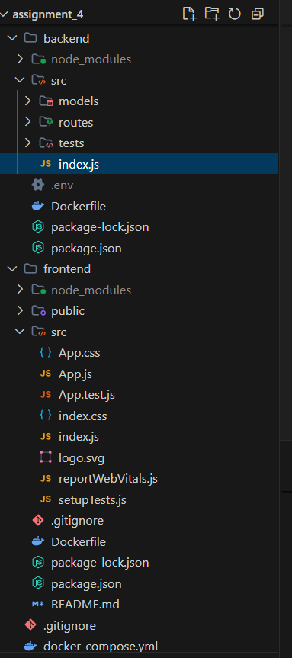

1.2 Application Running on Localhost
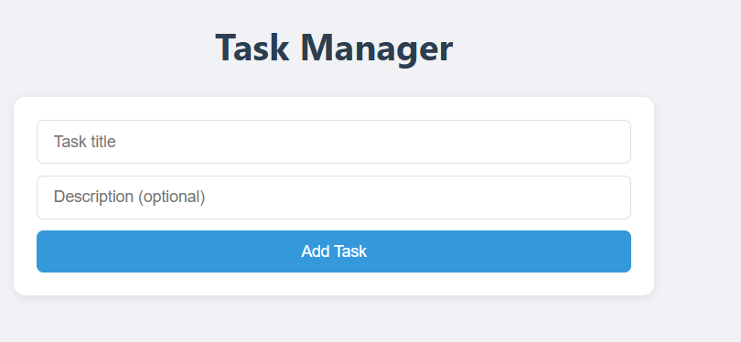

1.3 GitHub Repository
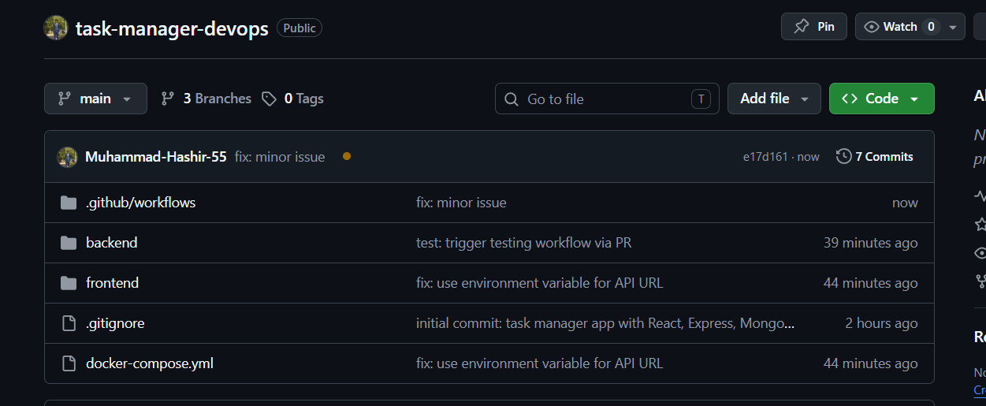

1.5 Collaborators Added
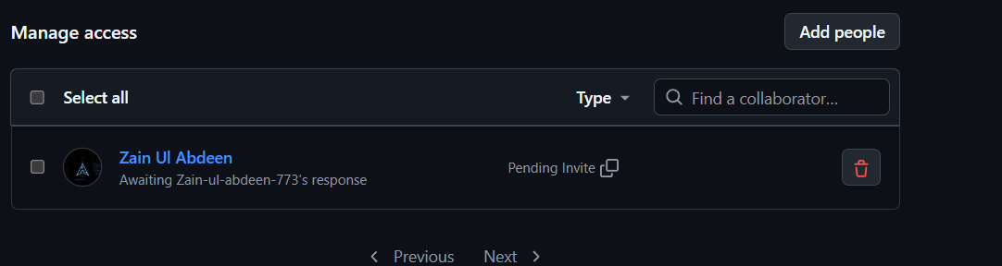

1.6 Branch Protection Rule
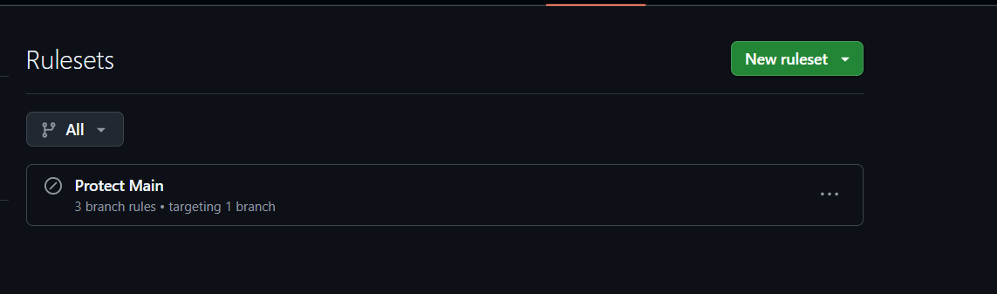

1.7 Unit Tests Passing
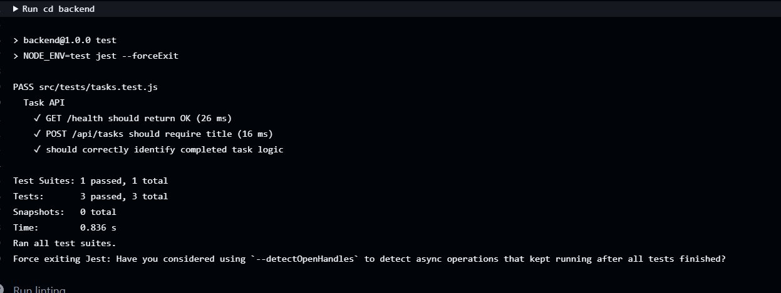

Task 2: AWS EC2 Instances

2.1 Security Group Created
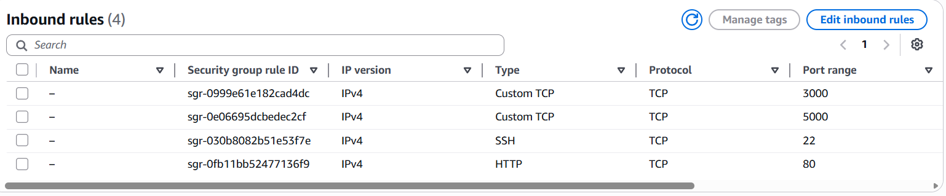

Security Group Inbound Rules:

Type | Protocol | Port | Source
SSH | TCP | 22 | 0.0.0.0/0
Custom TCP | TCP | 3000 | 0.0.0.0/0
Custom TCP | TCP | 5000 | 0.0.0.0/0
HTTP | TCP | 80 | 0.0.0.0/0

2.2 Testing EC2 Instance
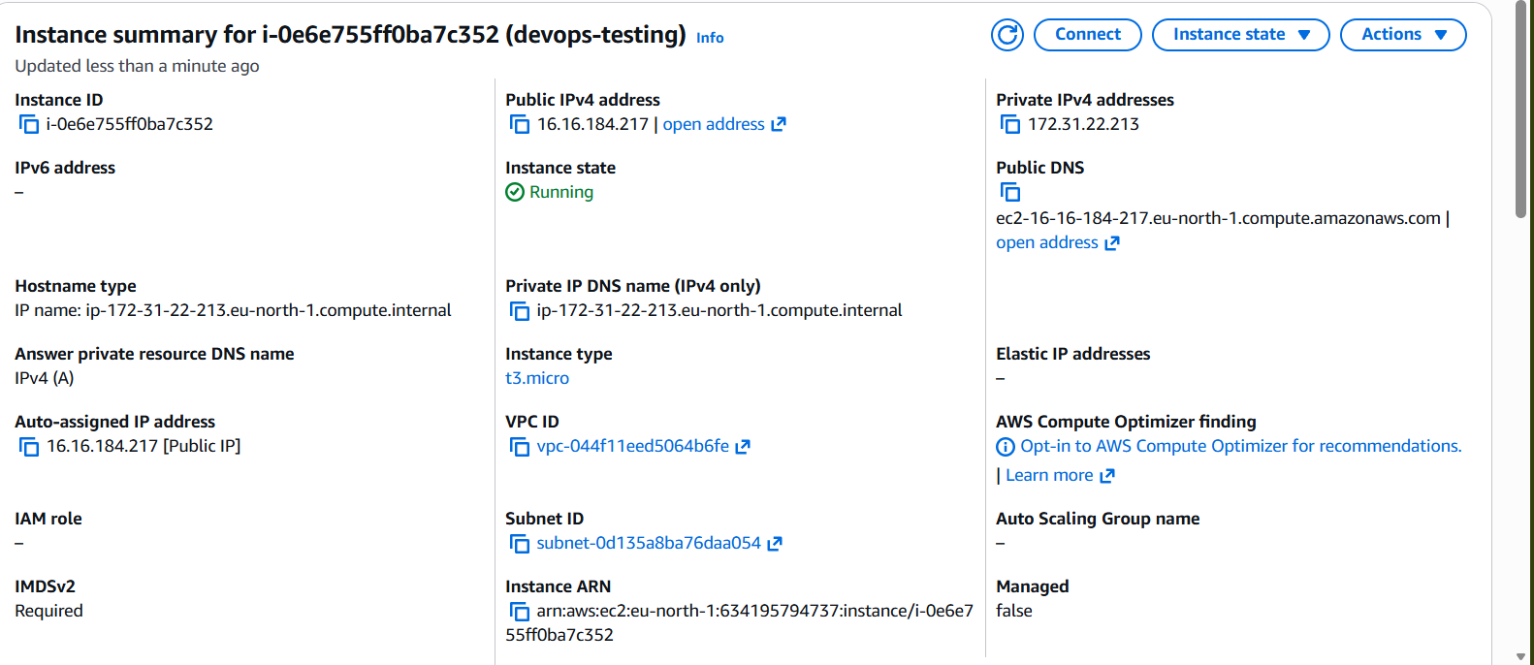

2.3 Staging EC2 Instance
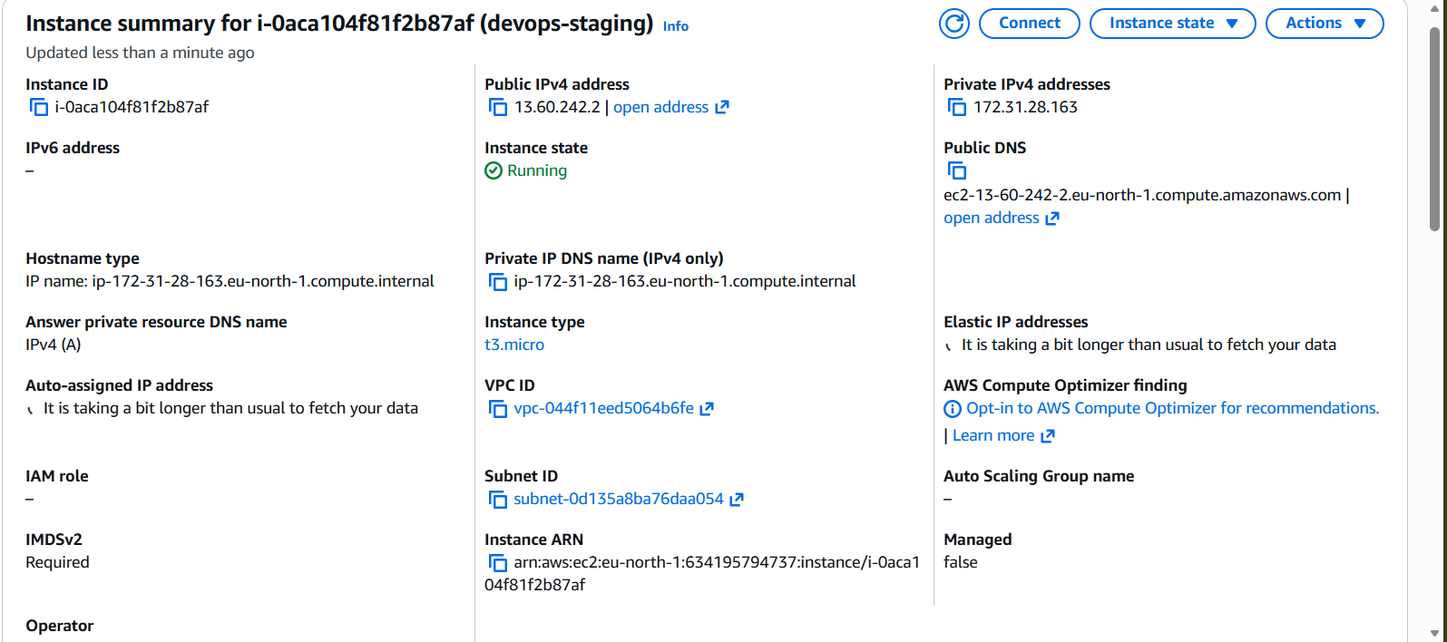

2.4 Dependencies Installed on Testing Server
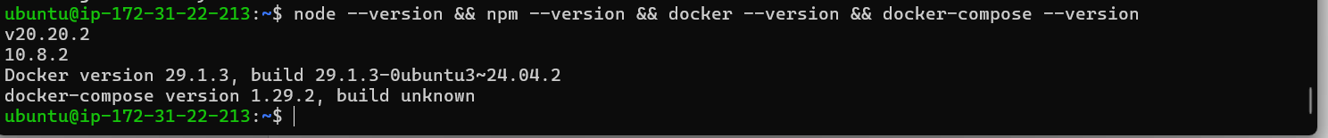

2.5 Dependencies Installed on Staging Server
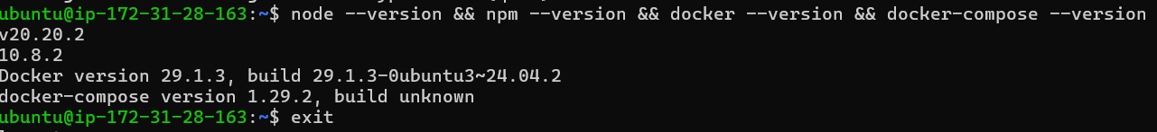

Task 3: GitHub Actions CI/CD Workflows

3.1 GitHub Secrets Configured
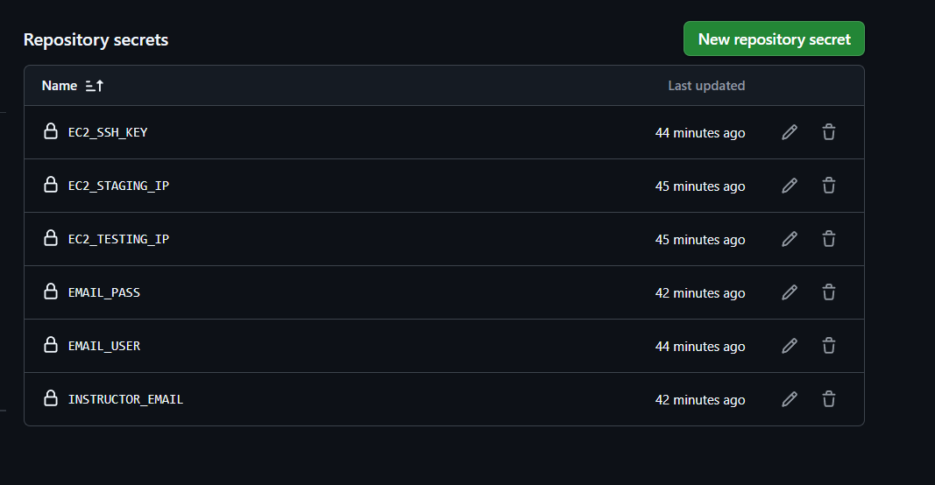

3.2 Workflow Files
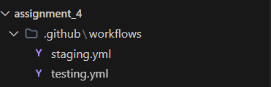

3.3 Pull Request Created
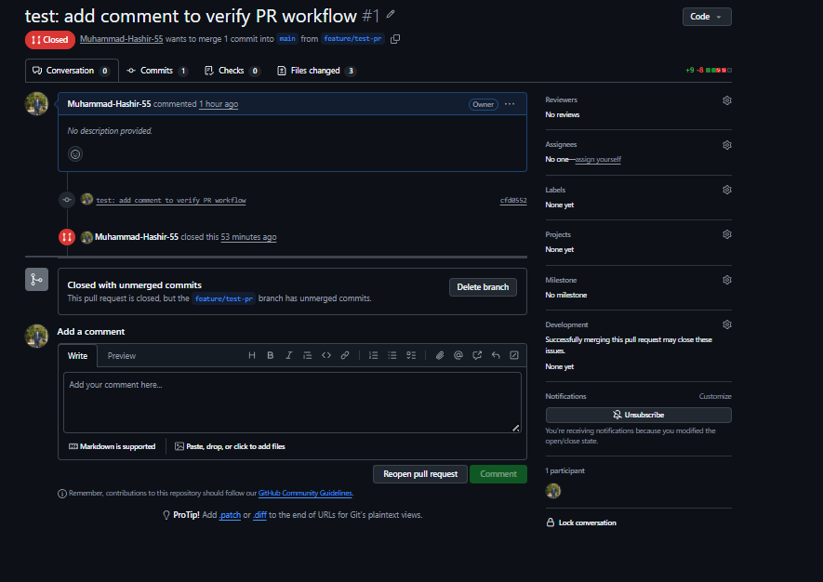

3.4 Testing Workflow Triggered on PR
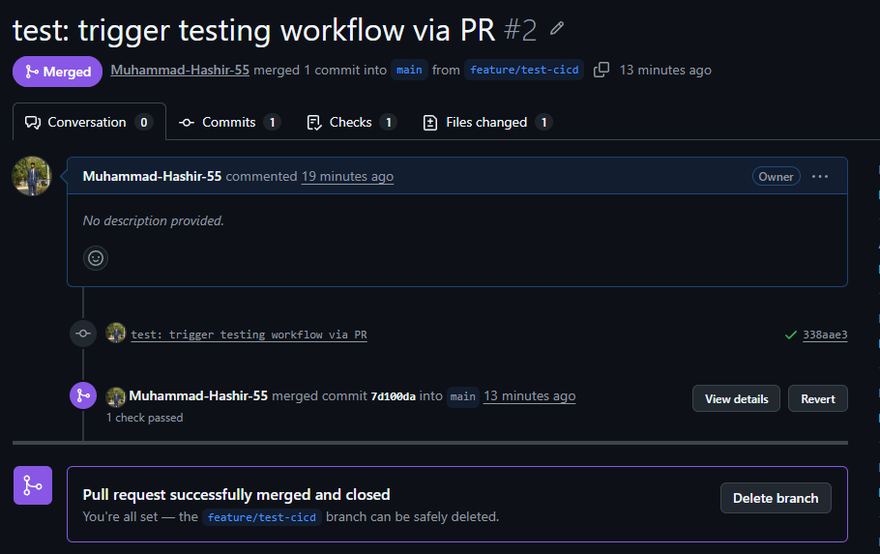

3.5 Testing Workflow Passed
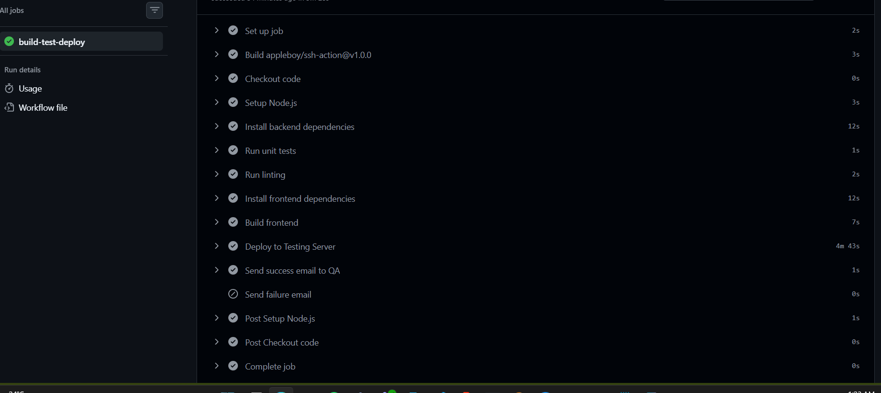

3.6 App Deployed on Testing Server
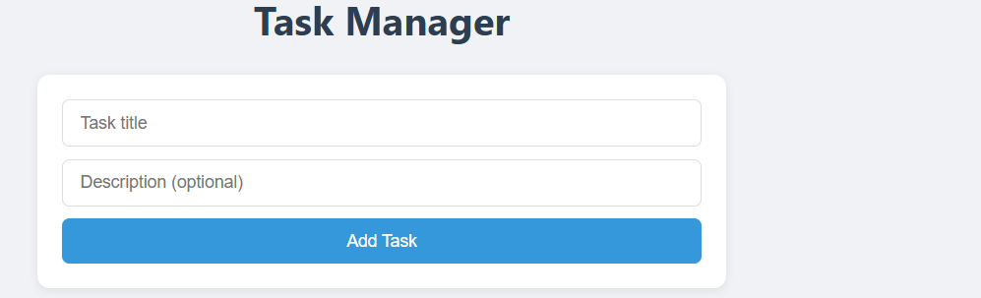

3.7 Success Email Received
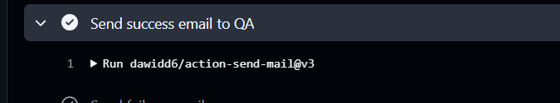

3.8 Staging Workflow Triggered on Merge to Main
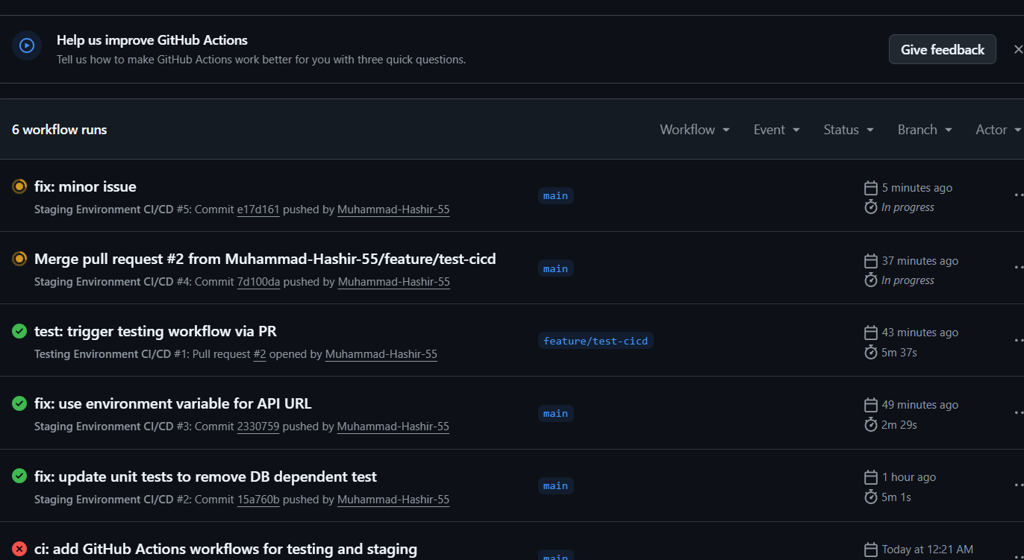

3.9 Manual Workflow Trigger (workflow_dispatch)
