Architecture & Construction Planning Document
ExpenseMate — Personal Expense Manager
Project Title | ExpenseMate — Personal Expense Manager
Document Type | Architecture Document (Phase 2 Deliverable)
Chosen Style | Layered Client-Server Architecture (local)
Technology Stack | Python + SQLite (alt: C# + SQL Server)
Course | Software Construction — Assignment 01
Deadline | 18 September 2026
Prepared By | Member A (Views), Member B (Standards, Tools & Timeline) — Both (Style Selection)

1. Introduction
This document is the Phase 2 deliverable of the ExpenseMate project. It builds on the requirements captured in the Phase 1 SRS and defines: (a) the chosen architectural style, (b) the system's Logical, Process, Physical, and Deployment views, (c) coding standards and tools, and (d) the project construction timeline (Gantt chart).

2. Architectural Style Selection
Three candidate styles were evaluated against ExpenseMate's requirements (single local user, modular budget/analytics logic, future cloud-backup extension):
Style | Advantages for ExpenseMate | Limitations / Notes
Layered | Clear separation of concerns (UI/Logic/Data); easy to test each layer in isolation; matches team split (backend vs frontend). | Strictly sequential calls between adjacent layers only; some overhead for simple operations.
Client-Server | Matches the assignment's stated architecture; supports a future networked/cloud-backup server without a redesign. | For a single-user local app, the 'server' is logical rather than physical in the current release.
Peer-to-Peer | Not applicable — no peer nodes exchange data in this system. | Rejected: adds unnecessary complexity; no multi-node data sharing requirement exists.
Decision: ExpenseMate adopts a Layered Client-Server architecture. The system is internally layered (Presentation, Business Logic, Data Access) so modules can be developed, tested, and maintained independently; it is client-server at the boundary so a future cloud-backup server (Phase 5 maintenance scope) can be introduced without restructuring the client.

3. Architectural Views

3.1 Logical View
The Logical View shows the system decomposed into three layers plus the persistent data store. The Presentation Layer handles all user interaction; the Business Logic Layer owns transaction rules, budget/alert logic, analytics, and CSV import/export; the Data Access Layer isolates all SQL/SQLite operations behind DAOs so the storage engine can be swapped with minimal impact on upper layers.
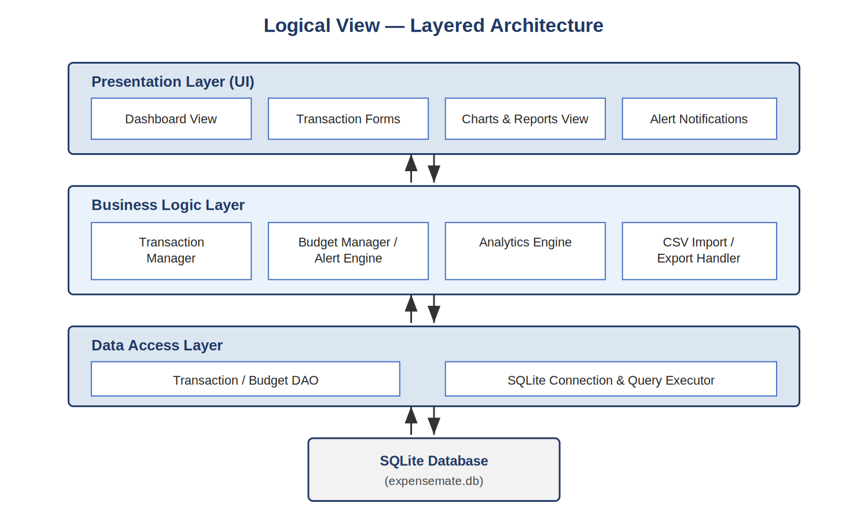
Figure 1: Logical View — Layered Architecture

3.2 Process View
The Process View shows two concurrent runtime flows: the main UI process handling user-initiated transactions synchronously through the Business Logic Service down to the database, and a concurrent Budget Alert Monitor that evaluates category spend against thresholds after every expense insert and pushes an alert event back to the UI when a threshold is crossed.
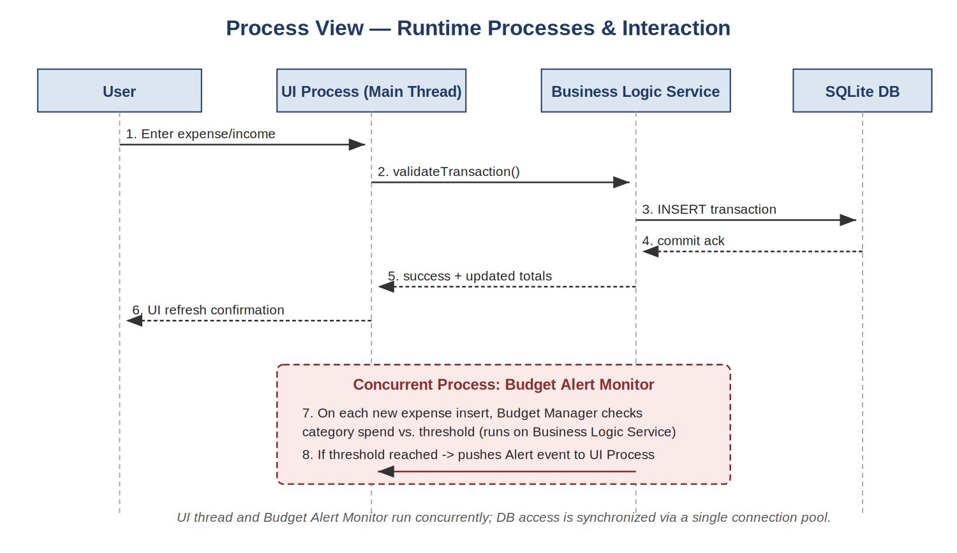
Figure 2: Process View — Runtime Interaction Sequence

3.3 Physical View
In the initial release, all software components run on a single physical node — the user's computer. The Python runtime hosts the application (UI + logic + data access) and the SQLite database file resides on local disk; CSV import/export interacts with the local file system.
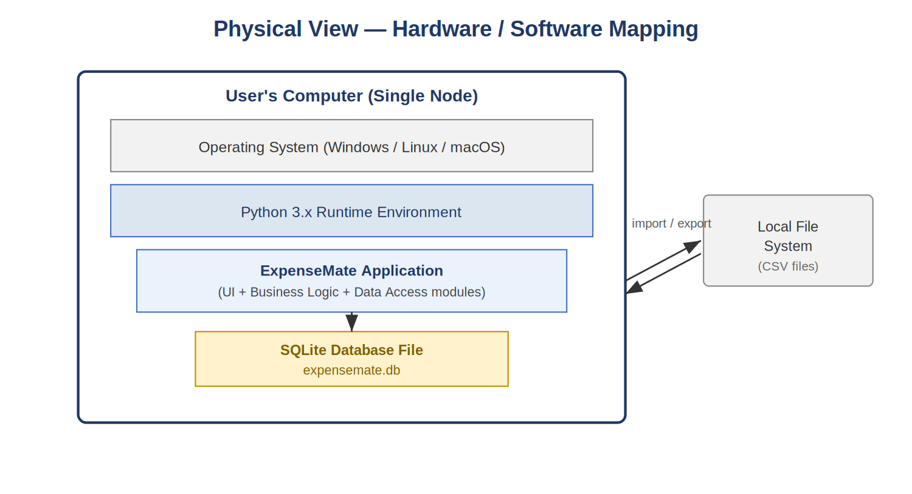
Figure 3: Physical View — Hardware / Software Mapping

3.4 Deployment View
The deployment diagram formalizes the physical view using UML notation: the Client PC node hosts the Python runtime and two artifacts (the application script and the SQLite database file). A Cloud Backup Server node is shown as a planned, out-of-scope extension for the Phase 5 maintenance stage, connected by a future network link.
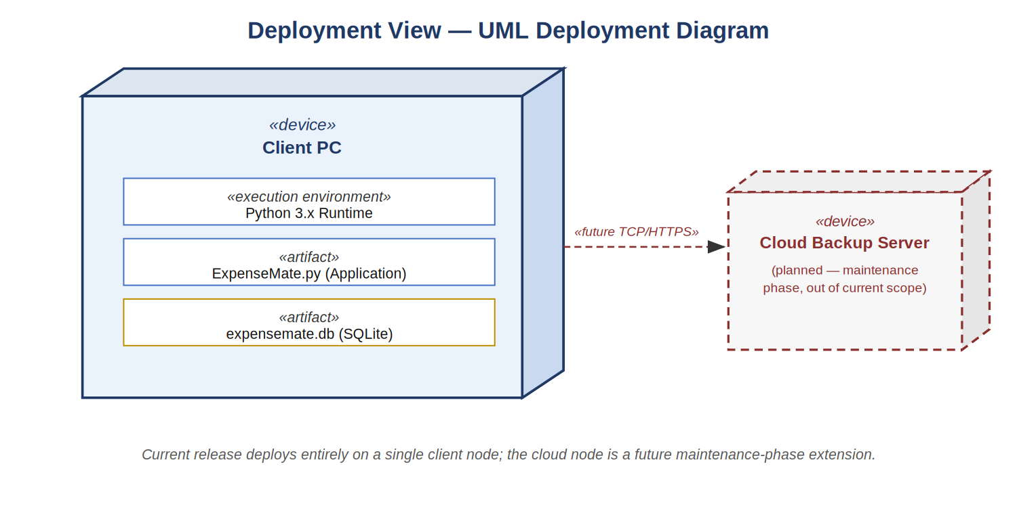
Figure 4: Deployment View — UML Deployment Diagram

4. Coding Standards, Tools & Process
The following standards and tools were agreed by both team members for Phase 3 (Coding & Unit Testing) onward, to keep contributions from both members consistent and mergeable.
Aspect | Standard / Tool
Language & Version | Python 3.11+ (single codebase for client-server local architecture).
Style Guide | PEP 8; enforced with the 'black' formatter and 'flake8' linter.
Naming Conventions | snake_case for functions/variables, PascalCase for classes, UPPER_CASE for constants; module names lowercase.
Documentation | Docstrings (Google style) on every public class/function; inline comments for non-obvious logic only.
Version Control | Git, hosted on GitHub. Feature-branch workflow: feature/<name> -> pull request -> review -> merge to main.
Commit Convention | Conventional Commits (feat:, fix:, test:, docs:, refactor:).
Testing | pytest for unit tests; target ≥70% coverage per module (tracked via coverage.py).
IDE / Tools | VS Code / PyCharm; DB Browser for SQLite; GitHub Projects (Kanban) for task tracking.
Code Review | Every pull request requires review/approval from the other team member before merge.

5. Project Timeline / Gantt Chart
The six assignment phases are scheduled across seven weeks, ending on the project deadline. Phase 3 (Coding & Unit Testing) is allotted the longest window given the split backend/frontend workload; Phase 6 concludes with the report and joint demo.
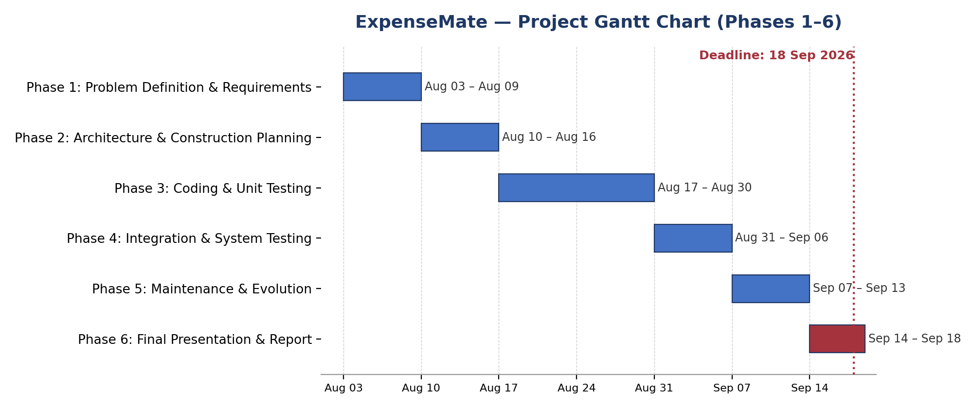
Figure 5: ExpenseMate Project Gantt Chart (Phases 1–6)
Phase | Start | End | Ownership
Phase 1: Problem Definition & Requirements | Aug 03 | Aug 09 | Both (A: SRS text, B: use case diagram)
Phase 2: Architecture & Construction Planning | Aug 10 | Aug 16 | Both (A: views, B: standards & timeline)
Phase 3: Coding & Unit Testing | Aug 17 | Aug 30 | A: Backend, B: Frontend; both write unit tests
Phase 4: Integration & System Testing | Aug 31 | Sep 06 | A: Integration + complexity, B: System testing + fault rates
Phase 5: Maintenance & Evolution | Sep 07 | Sep 13 | Both (feature); A: bug fixes; B: code quality
Phase 6: Final Presentation & Report | Sep 14 | Sep 18 | B: report; Both: demo

6. Summary
This architecture document, together with the Phase 1 SRS, forms the baseline for Phase 3 construction: modules will be implemented per the Logical View's layer boundaries, following the agreed coding standards, and tracked against the Gantt chart timeline above.

