Software Requirements Specification
ExpenseMate — Personal Expense Manager
Project Title | ExpenseMate — Personal Expense Manager
Document Type | Software Requirements Specification (SRS)
Architecture | Client-Server (Local)
Technology Stack | Python + SQLite (alt: C# + SQL Server)
Course | Software Construction — Assignment 01
Deadline | 18 September 2026
Prepared By | Member A (Requirements), Member B (Use Case Diagram)

1. Introduction

1.1 Purpose
This document specifies the functional and non-functional requirements for ExpenseMate, a personal expense management system. It is intended for the development team, course instructor, and evaluators as the baseline for design, construction, and testing in subsequent assignment phases.

1.2 Scope
ExpenseMate is a local client-server desktop application that enables a single user to record income and expenses, set monthly category-wise budgets, receive budget alerts, import/export transaction data as CSV, and view visual analytics (charts) of spending. The system will be implemented using Python with an SQLite database. Multi-currency support and cloud backup are out of scope for the initial release and are planned as adaptive maintenance features.

1.3 Definitions, Acronyms, and Abbreviations
- SRS — Software Requirements Specification
- FR — Functional Requirement
- NFR — Non-Functional Requirement
- CSV — Comma-Separated Values file format
- DB — Database (SQLite)
- UI — User Interface

1.4 References
Assignment 01 handout — Software Construction course; IEEE Std 830-1998 (SRS structure guideline).

1.5 Overview
Section 2 describes the product at a high level. Section 3 lists the specific functional and non-functional requirements and the use case diagram. Section 4 lists assumptions and constraints carried forward into the design phase.

2. Overall Description

2.1 Product Perspective
ExpenseMate is a new, standalone system with a local client-server architecture: a lightweight UI client communicates with a backend logic/data layer that persists records in an SQLite database on the same machine.

2.2 Product Functions (Summary)
- Record and categorize income and expense transactions
- Define and track monthly budgets per category
- Trigger budget alerts when spending thresholds are reached
- Import/export transactions via CSV
- Display category-wise analytics through visual charts
- Generate period summary reports

2.3 User Classes and Characteristics
Primary user: an individual managing personal finances, with basic computer literacy and no programming background. The system is designed for single-user, non-administrative use in this release.

2.4 Operating Environment
Desktop environment (Windows/Linux/macOS) with Python 3.x runtime and local SQLite database file; no external network dependency required for core functionality.

2.5 Design and Implementation Constraints
- Must use Python + SQLite (or equivalent C# + SQL stack) as specified by the assignment.
- Must follow a layered/client-server architecture separating UI, business logic, and data access.
- Development and delivery timeline is bound by the six assignment phases and the 18 Sep 2026 deadline.

2.6 Assumptions and Dependencies
- The user has the application installed locally; no multi-user concurrency is assumed.
- CSV files used for import follow a defined column format (date, amount, category, description).
- Charting relies on a Python charting library (e.g., Matplotlib) available in the runtime environment.

3. Specific Requirements

3.1 Functional Requirements
ID | Requirement Description | Priority
FR-1 | The system shall allow a user to register and log in with a username and password. | High
FR-2 | The system shall allow a user to record income transactions with amount, date, source, and category. | High
FR-3 | The system shall allow a user to record expense transactions with amount, date, category, and notes. | High
FR-4 | The system shall allow a user to define a monthly budget for each expense category. | High
FR-5 | The system shall generate a budget alert when spending in a category reaches or exceeds a configurable threshold (e.g., 80%/100%) of the budget. | High
FR-6 | The system shall allow a user to import transactions from a CSV file. | Medium
FR-7 | The system shall allow a user to export transactions and reports to a CSV file. | Medium
FR-8 | The system shall display category-wise spending analytics as visual charts (pie/bar/line). | High
FR-9 | The system shall allow a user to edit or delete a previously entered transaction. | Medium
FR-10 | The system shall persist all data locally in an SQLite database between sessions. | High
FR-11 | The system shall allow a user to generate a monthly/period summary report. | Medium
FR-12 | The system shall support multiple currencies for transaction entry (maintenance-phase feature). | Low

3.2 Non-Functional Requirements
ID | Category | Requirement Description
NFR-1 | Performance | The system shall load the dashboard and render charts for up to 5,000 transactions within 2 seconds.
NFR-2 | Usability | The UI shall allow a new user to record a transaction in no more than 3 clicks/steps.
NFR-3 | Reliability | The system shall not lose recorded data in the event of an application crash (transaction-safe DB writes).
NFR-4 | Portability | The client-server components shall run on Windows, Linux, and macOS without code changes.
NFR-5 | Security | User passwords shall be stored using a salted hash; the local database shall not store passwords in plain text.
NFR-6 | Maintainability | The codebase shall follow a layered structure (UI / Logic / Data) with unit test coverage ≥ 70% per module.
NFR-7 | Scalability | The database schema shall support extension to multi-currency and cloud backup without redesign.

3.3 Use Case Diagram
The primary actor is the User, who interacts directly with the core use cases (registration, transaction entry, budgeting) and indirectly triggers the Receive Budget Alert use case when a budget threshold is crossed. CSV import/export, analytics, and reporting are supporting use cases available once the user is authenticated.
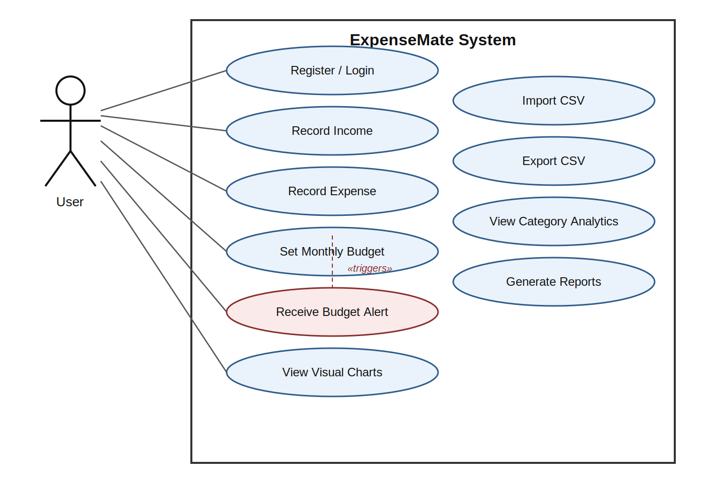
Figure 1: Use Case Diagram — ExpenseMate

4. Traceability & Sign-off
Functional requirements FR-1 to FR-11 map to the core release; FR-12 (multi-currency) and cloud backup map to Phase 5 (Maintenance & Evolution) as adaptive maintenance items, consistent with the assignment's maintenance scope.
Prepared for: Software Construction — Assignment 01 (ExpenseMate).

