SHIKRA: Specialized in Hunting Intelligent, Known Ransomware for Analysis



By:

Muhammad Hassan
31144

Junaid Zubair
37578

Muhammad Khubaib Qasim
35861

Supervised by:
Dr. Jawaid Iqbal Jadoon

Faculty of Computing
Riphah International University, Islamabad Spring/Fall 20xx

Submitted To

Faculty of Computing,
Riphah International University, Islamabad

As a Partial Fulfillment of the Requirement for the Award of the Degree of
Bachelors of Science in Cyber Security

Faculty of Computing
Riphah International University, Islamabad
Date: [date of final presentation]

Final Approval

This is to certify that we have read the report submitted by Muhammad Hassan (sap), Junaid Zubair (sap) and Khubaib Qasim (35861) for the partial fulfillment of the requirements for the degree of the Bachelor of Science in Cyber Security (BS CYS). It is our judgment that this report is of sufficient standard to warrant its acceptance by Riphah International University, Islamabad for the degree of Bachelor of Science in Cyber Security (BS CYS).

Committee:

1
Dr. Jawaid Iqbal (Supervisor)

2
Dr. Jawaid Iqbal
(In-charge Cyber Security)

3
Dr. Musharraf Ahmed (Head of Department)

Declaration

We hereby declare that this document “SHIKRA: Specialized in Hunting Intelligent, Known Ransomware for Analysis” neither as a whole nor as a part has been copied out from any source. It is further declared that we have done this project with the accompanied report entirely on the basis of our personal efforts, under the proficient guidance of our teachers especially our supervisor Dr. Jawaid Iqbal Jadoon. If any part of the system is proved to be copied out from any source or found to be reproduction of any project from anywhere else, we shall stand by the consequences.

Muhammad Hassan
31144

Junaid Zubair
37578

Muhammad Khubaib Qasim
35861

Dedication
We have dedicated this work to our families because the constant encouragement that we have received from them has inspired us immensely. Their support and belief in this work have enabled us to overcome multiple barriers and challenges that we could encounter in our day-to day travels.

Our special thanks also goes to our supervisor for affording us his knowledge, support, and belief throughout this project. His guidance has not only motivated us, but guided the direction of this project, making the development of this SHIKRA system possible. Only thanks to his vision and faith in ourselves it was possible to implement this endeavor.

Acknowledgement
First of all, we are obliged to Allah Almighty the Merciful, the Beneficent and the source of all Knowledge, for granting us the courage and knowledge to complete this Project.
We acknowledge our supervisor and our teachers and our class fellows who have provided guidance and motivation for this project.

Muhammad Hassan
31144

Junaid Zubair
37578

Muhammad Khubaib Qasim
35861

Abstract
Ransomware forensics is becoming a vital issue in today's cybersecurity landscape, as old technology cannot detect and analyze evasive malware behavior. SHIKRA is a research project to develop an automated ransomware forensic analysis tool that utilizes a QEMU- based Windows 10 victim virtual machine (VM) to provide realistic user environments and perform ransomware research in a reproducible, controlled environment. The focus is on automating the entire forensic process, from infection to analysis and report generation.

At its center is an automation framework based on Bash scripts run on an Ubuntu host platform that provisions a Windows 10 VM with randomly assigned hardware IDs and realistic resource configurations. The framework is aimed at defeating prevalent evasion tactics employed by contemporary ransomware, including anti-VM detection and time- based sleep. The process gathers copious forensic data, including file system, registry, network, and memory activity using tools like ProcMon, RegShot, Wireshark, INetSim, and Volatility. The tools are externally installed on the analyst's machine and remotely controlled to yield stealth and dependability.

The entire data captured is retrieved through secure channels and uploaded to a centralized cloud database via Firebase for real-time monitoring and collaboration. The dashboard runs on a React frontend and Flask backend, which offers visualization, filtering, and automatic report generation for the forensic logs. Simulated user activity scripts offer the functionality for the ransomware payloads to run as they would in a live configuration to further enhance forensic accuracy.

SHIKRA also features auto-VM snapshotting and rollback to provide a clean slate for every analysis iteration, allowing repeatable and rapid testing. There will be more log correlation, more in-depth malware behavior profiling, and more integration with other malware families in future work. The research demonstrates the feasibility of automating ransomware forensics with little human intervention, offering scalable repeatable solutions to modern threat analysis.

Table of Contents

Chapter 1 Introduction 1
  - Introduction 2
  - Opportunity & Stakeholders 2
    - Stakeholders 2
  - Motivations & Challenges 3
    - Motivation 3
    - Challenges 3
  - Significance of Study 3
  - Goals & Objectives 3
  - Scope of the Project 4
  - Chapter Summary 4
Chapter 2 Literature / Market Survey 6
  - Introduction 7
  - Literature Review / Technologies & Products Overview 7
    - Technologies and Products 7
      - Cuckoo Sandbox 7
      - FlareVM 8
      - Remnux 8
      - Hybrid Analysis 8
  - Comparative Analysis 8
  - Research Gaps 9
  - Problem Statement 9
  - Chapter Summary 9
Chapter 3 Requirements and System Design 10
  - Introduction 11
  - Architecture of the System 11
  - Functional Requirements 11
  - Non-Functional Requirements 12
  - Design Diagrams 12
    - Figure 3.5.1 System Architecture Diagram
    - Figure 3.5.2 Data Flow Diagram
    - Figure 3.5.3 Sequence Diagram
  - Hardware and Software Requirements 12
  - Threat Scenarios 13
  - Threat Resistance Model 13
  - Chapter Summary 13
Chapter 4 Proposed Solution 14
  - Introduction 15
  - The Suggested Model 15
  - Data Collection 15
  - Data Pre-Processing 16
  - Techniques and Tools 16
  - Measures of Evaluation 17
  - Chapter Summary 17

List of Figures
Figure 3.5.1 System Architecture Diagram 12
Figure 3.5.2 Data Flow Diagram 13
Figure 3.5.3 Sequence Diagram 14

List of Tables
Table 2.1 Comparative Analysis of Ransomware Forensic Frameworks 8

Chapter 1: Introduction

Chapter 1: Introduction

Introduction
SHIKRA is a ransomware forensic analysis environment that automates and executes on a representative Windows environment in an effort to achieve fast, deterministic malware activity insights. By coordinating QEMU-based Windows 10 victim VMs with random hardware IDs and user-simulated-like activity, SHIKRA bypasses typical anti-analysis and time-based evasion methods. SHIKRA automates the entire ransomware investigation process—provisioning, infection, data collection, and reporting—so security teams can concentrate on threat hunting and remediation and not environment manual setup and tear-down.

Opportunity & Stakeholders

The recent spate of high-profile ransomware campaigns has exposed vulnerabilities in traditional sandbox and manual analysis processes. Fewer entities can afford to set up and maintain standalone forensic labs, and generic malware sandboxes consistently yield incomplete or deceptive results against sophisticated threats. SHIKRA fills the gap by offering an end-to-end, open-source platform that scales from lone analysts to security operations centers (SOCs).

Stakeholders
      - Incident Response Teams: Gain a turnkey platform for capturing comprehensive file, registry, network, and memory artifacts without manual VM resets.
      - Malware Researchers: Leverage an extensible codebase to integrate new analysis tools or custom scripts.
      - Small-to-Medium Enterprises (SMEs): Access enterprise-grade forensic capabilities without large infrastructure investments.
      - Academic Institutions: Use SHIKRA as a teaching aid for hands-on malware analysis courses.

Motivations & Challenges

Motivation
      - Escalating Ransomware Impact: Ransomware incidents have grown by over 300 percent annually, inflicting severe financial and reputational losses.
      - Automation Gap: Existing tools require tedious manual configuration and frequent environment resets, slowing investigations.
      - Data Centralization: Forensic artifacts are often siloed locally, hindering collaboration and trend analysis.

Challenges
      - Anti-VM Detection: Crafting VM configurations that evade fingerprinting by modern ransomware.
      - Timing-Based Evasion: Simulating realistic uptime and interaction patterns to prevent dormancy or payload self-destruct.
      - Tool Integration: Automating installation and coordination of ProcMon, RegShot, Wireshark, INetSim, and Volatility across host and guest.
      - Secure Artifact Transfer: Ensuring integrity and confidentiality when moving logs and memory snapshots to the cloud.
      - Scalability: Balancing automation speed with resource constraints when running multiple concurrent VM instances.

Significance of Study

This project demonstrates end-to-end automated, reproducible ransomware forensics is achievable using open-source virtualization and orchestration technologies. SHIKRA revolutionizes malware analysis by integrating anti-evasion countermeasures, user simulation, and cloud-native data pipelines—providing future forensic frameworks with a template and facilitating community-driven innovations.

Goals & Objectives
- Automate Windows 10 VM provisioning with randomized hardware IDs via QEMU and libvirt.
- Implement snapshot and rollback workflows for clean, repeatable test environments.
- Script external installation of forensic tools (ProcMon, RegShot, Wireshark, INetSim, Volatility).
- Develop user-simulation scripts to bypass interaction-based evasion.
- Capture file system, registry, network, and memory artifacts and securely upload to Firebase.
- Build a React + Flask dashboard for real-time visualization, filtering, and automated reporting.
- Ensure framework extensibility for new tools, malware families, and analysis techniques.

Scope of the Project
- VM Automation: Bash scripts on Ubuntu to create, configure, snapshot, and rollback Windows 10 VMs.
- Forensic Tool Orchestration: External deployment and control of analysis utilities via scripted workflows.
- Evasion Countermeasures: Hardware ID randomization and simulated user actions.
- Data Pipeline: Secure log extraction (shared folders or serial redirection) and cloud upload (Firebase API).
- Dashboard: Centralized web UI for monitoring VM status, reviewing artifacts, and exporting forensic reports.

Chapter Summary
In this chapter, we define the objective and scope of SHIKRA, our ransomware forensic analysis automation platform. We began by highlighting the shortcoming of existing malware analysis platforms—i.e., not having turnkey reproducible environments that remove advanced anti-VM and time-based evasion attacks. SHIKRA addresses this shortcoming by integrating QEMU-based Windows 10 VMs with randomized hardware IDs, automated snapshot/rollback, and user-simulation scripts that mimic real-world use. We then outlined the key stakeholders/responders, malware analysts, SMEs, and schools—and described what each gains from SHIKRA's cloud-based, automated forensic pipeline. For responders and analysts, the most significant benefits are rapid environment setup and complete artifact collection; for SMEs, it's enterprise capability at low infrastructure cost; and for educators, it's an in-the-lab tool for instruction in contemporary malware forensics.

Our motivations were the dramatic increase in ransomware attacks (300 % year on year), the human overhead of legacy analysis configurations, and forensic data fragmentation. Corresponding challenges were outlined—anti-VM fingerprinting, time-based payload dormancy, tool orchestration between host and guest, safe transfer of logs, and scalable VM management.

We established SHIKRA as a proof-of-concept that open-source virtualization and scripting can be shown to have strong, reproducible forensic processes. By combining ProcMon, RegShot, Wireshark, INetSim, and Volatility, and streaming logs to a centralized Firebase backend, SHIKRA not only speeds up investigations but facilitates community-driven development.

Lastly, we broke down our objectives and goals—from automated provisioning of VMs and anti-evasion countermeasures to secure data channels and a React + Flask dashboard—and established the scope of the project, which ranges from VM automation to tool integration, artifact extraction, cloud upload, and real-time

visualization. Later chapters will detail the technical design, implementation details, and analysis of each SHIKRA component, and how they fit together to form an end- to-end ransomware forensics solution.

Chapter 2: Literature / Market Survey

Chapter 2: Literature / Market Survey

Introduction
The ransomware forensics market has expanded exponentially because organizations require reproducible, automated processes to inspect more sophisticated malware. Most of the existing frameworks, however, employ manual provisioning, lack end-to-end anti-evasion, or retain local storage artifacts, which complicates collaboration and historical trend analysis. This chapter gives an overview of leading ransomware analysis solutions, their strength and weakness, and introduces the research gaps that are being overcome by SHIKRA—full automation of VM provisioning, anti-VM and timing-evasion countermeasures, and cloud-based, centralized forensic data management.

Literature Review / Technologies & Products Overview
Two principal approaches dominate the ransomware analysis landscape:

- Sandbox-Based Static/Dynamic Analysis: Deploys preconfigured VMs or containers to execute malware samples and collects indicators (file hashes, string patterns).
- Live-VM Instrumentation & Monitoring: Uses enhanced virtualization techniques combined with host-side tools to capture registry, memory, network, and file system changes in real time.

While sandbox solutions simplify initial setup, they often lack realistic user- simulation and anti-evasion measures. Conversely, live-VM approaches provide richer data but typically require extensive manual configuration and teardown.

Technologies and Products

Cuckoo Sandbox
        - Type: Open-source dynamic malware analysis
        - Strengths: Pluggable instrumentation modules, network capture
        - Limitations: Generic VM profiles easily detected; manual snapshot management required

FlareVM
        - Type: Windows-based analysis distribution

        - Strengths: Preinstalled forensic utilities (ProcMon, RegShot, Wireshark)
        - Limitations: Manual VM reset; no centralized logging or anti-evasion scripts

Remnux
        - Type: Linux distribution for malware reverse-engineering
        - Strengths: Comprehensive tool suite; strong static analysis support
        - Limitations: Limited dynamic analysis orchestration; no VM fingerprint randomization

Hybrid Analysis
        - Type: Cloud-based sandbox service
        - Strengths: Scalability; built-in threat scoring and API access
        - Limitations: Black-box; limited custom tooling; retains data provider-side only

Comparative Analysis

Tool / Framework | Automation Level | Anti-Evasion Countermeasures | Artifact Coverage | Cloud Integration
Cuckoo Sandbox | Medium (scripts) | Low (static VM profiles) | File, network | Optional via plugins
FlareVM | Low (manual) | None | Registry, file, network | None
Remnux | Low (manual) | None | Static analysis | None
Hybrid Analysis | High (SaaS) | Low (controlled infra) | File, network, memory | Proprietary cloud only
SHIKRA  (Proposed) | High (end- to-end) | Strong (HW randomization, U/X simulation) | File, registry, network, memory | Open API to Firebase

Table 2: Comparative Analysis of Ransomware Forensic Frameworks

From Table 2, existing tools either automate only parts of the workflow or lack anti- evasion robustness and centralized data access. SHIKRA is designed to fill these gaps by delivering fully automated VM lifecycle management, realistic user-interaction simulation, comprehensive artifact capture, and cloud-native logging.

Research Gaps
- Evasion Resistance: Most frameworks use static VM configurations easily detected by modern ransomware.
- Workflow Automation: Manual snapshotting, teardown, and tool installation remain time-consuming tasks.
- Data Centralization: Forensic logs and memory dumps are typically stored locally, hindering collaborative analysis.
- Extensibility: Proprietary or black-box sandboxes offer little scope for integrating new tools or custom scripts.

Problem Statement
While there are a number of ransomware analysis tools, there is no end-to-end, anti-evasion hardened, fully automated pipeline that extracts file, registry, network, and memory artifacts and streams them in parallel to a cloud database for real-time visualization and reporting. SHIKRA addresses this gap using QEMU-based VM orchestration, user-simulation scripts, secure artifact extraction, and a React + Flask dashboard backed by Firebase.

Chapter Summary
This chapter discussed leading ransomware forensics solutions and compared their automation capabilities, anti-evasion capabilities, and data handling approaches. We determined essential shortfalls—i.e., VM fingerprint randomization, end-to-end analysis automation, and cloud-native data pipelines—to inform the design of SHIKRA. SHIKRA's component architecture and design are discussed in the following chapter, outlining how SHIKRA mitigates the shortfalls of current state-of-the-art frameworks.

Chapter 3: Requirements and System
Design

Introduction
The architecture of the system and the SHIKRA project's functional and non- functional needs are described in this chapter. A secure data acquisition and transfer system is implemented, using shared folder synchronization and optional SSH protocols. A dashboard is created for monitoring forensic artifacts such as network captures, registry changes, memory dumps, and file system alterations, classified based on the unique identifiers of the analyzed VM environments. It is also responsible for receiving forensic files which are sent from the virtualized endpoints. A bash automation script and QEMU-based VM infrastructure is used to simulate infection and extract artifacts. The host-based orchestration handles secure extraction and forwarding of the forensic artifacts which are then displayed on the dashboard.

Architecture of the System

The following essential elements form the basis of the system architecture:

- A Bash automation layer: Bash scripts handle the provisioning, infection, rollback, and artifact extraction phases. It is responsible for simulating realistic environments and launching forensic tooling across victim VMs.
- Data Transfer: Secure file transfer is achieved through shared folder mapping or encrypted SCP-based channels, ensuring isolation and confidentiality between the guest VM and host analyst system.
- Dashboard Interface: A dashboard built using the Flask framework. Its job is to receive forensic files (logs, memory, network data) from the VMs. The app.py Python script is responsible for receiving these files and displaying them on the dashboard. The dashboard also handles basic preprocessing of forensic outputs.
- QEMU Virtual Environment: QEMU is used to host Windows VMs which simulate user behavior and execute ransomware samples. It enables snapshot rollback and hardware obfuscation to defeat anti-VM techniques.

Functional Requirements

Sample Management
    - Accept malware samples via web upload
    - Store samples securely with hash identification
    - Support common file types (PE, scripts, documents)
    - Track analysis status (pending, running, completed)

Analysis Execution
    - Execute samples in isolated Windows VM
    - Configure analysis timeout (default 5 minutes)
    - Take VM snapshots before/after analysis
    - Reset VM to clean state after each analysis

Behavioral Monitoring
    - Monitor process creation/termination using ProcMon
    - Track file system changes (create, modify, delete)
    - Monitor registry modifications
    - Filter noise using predefined rules
    - Generate behavioral timeline.

Network Analysis
    - Capture network traffic during analysis
    - Provide fake internet services (INetSim)
    - Log DNS queries and HTTP requests
    - Extract contacted IPs and domains
    - Simulate network responses

Memory Analysis
    - Create memory dumps during execution
    - Extract running processes from memory
    - Identify injected code
    - Extract network connections

Reporting
    - Generate analysis reports in HTML format
    - Include behavioral timeline visualization
    - Show network activity graphs
    - Export IOCs (IPs, domains, file hashes)
    - Provide executive summary

Web Interface
    - Sample submission page
    - Analysis progress dashboard
    - Real-time monitoring view
    - Report viewing and download
    - Analysis history search

Cloud Integration
    - Upload analysis logs to Firebase
    - Store reports in cloud storage
    - Sync data between local and cloud
    - Configure cloud services

Configuration Management
    - Manage VM profiles (Windows versions)
    - Configure ProcMon filters
    - Set behavioral detection patterns
    - Configure network simulation

Non-Functional Requirements

Performance
    - Support 5 concurrent analyses
    - Web pages load within 5 seconds
    - Analysis completes within configured timeout
    - VM reset takes less than 2 minutes

Security
    - Isolate analysis VMs from host network
    - Encrypt malware samples at rest
    - Use HTTPS for web interface
    - Prevent VM escape
    - Secure file transfer to/from VMs

Reliability
    - Handle VM crashes gracefully
    - Recover from network failures
    - Preserve analysis data on system restart
    - Log all system errors

Usability
    - Simple file upload interface
    - Clear progress indicators
    - Intuitive report navigation
    - Real-time status updates

Maintainability
    - Modular Python codebase
    - Configuration via JSON files
    - Comprehensive logging
    - Shell scripts for setup/maintenance

Compatibility
    - Host: Ubuntu 20.04+ or CentOS 8+
    - Analysis VMs: Windows 7/10/11
    - Web browsers: Chrome, Firefox, Safari
    - Python 3.8+

Design Diagrams

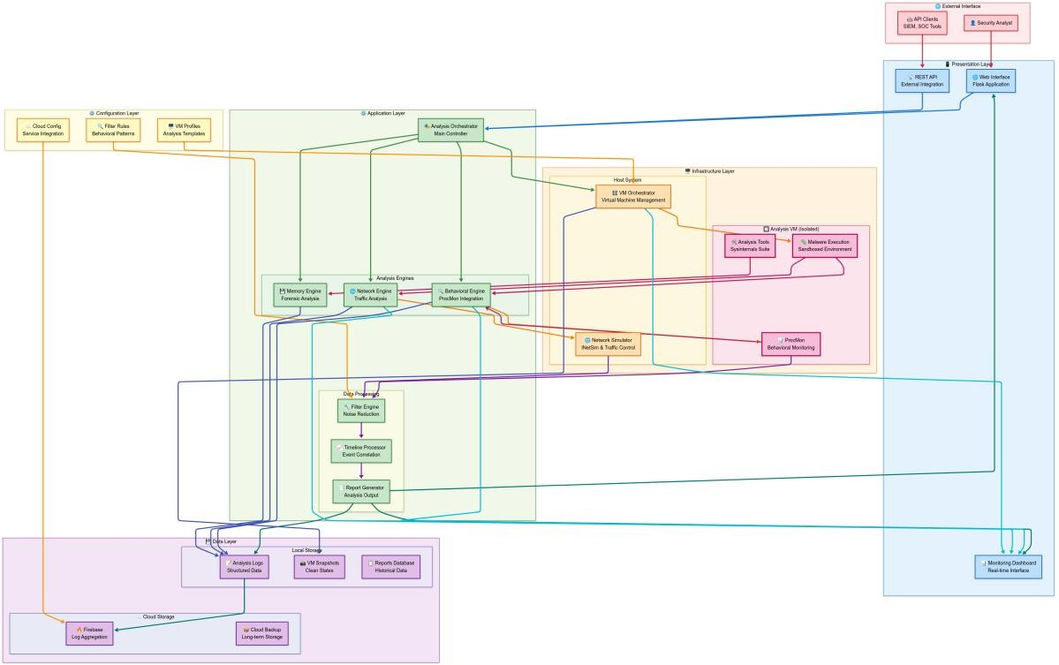
Figure 3.5.1 System Architecture Diagram

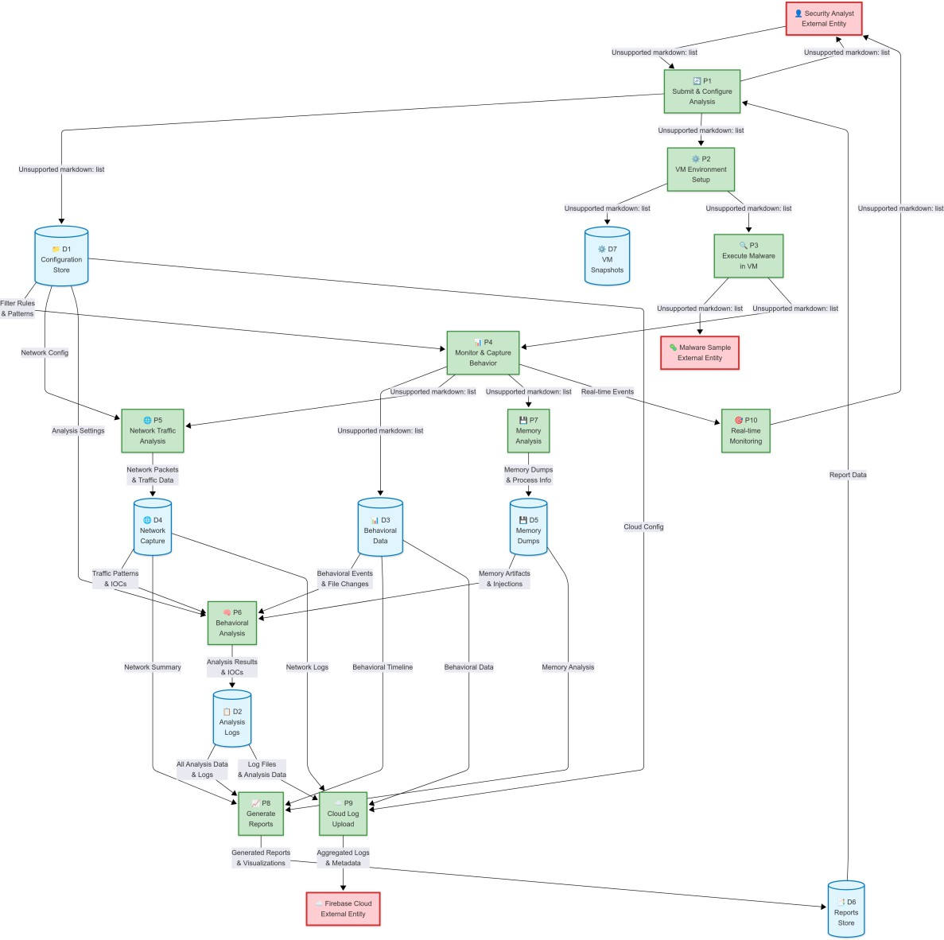

Figure 3.5.2 Data Flow Diagram

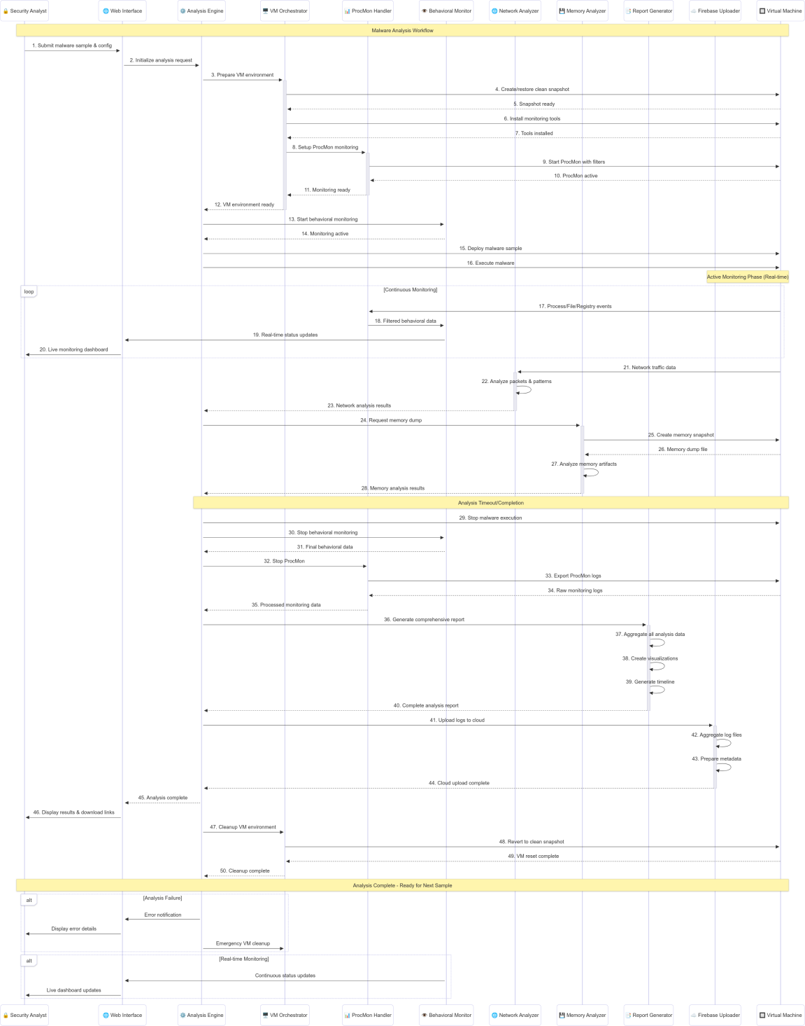

Figure 3.5.3 Sequence Diagram

Hardware and Software Requirements

Hardware:
  - Host system (analyst laptop or workstation) capable of running multiple QEMU virtual machines.
  - Virtual machines (Windows-based) for sample execution and forensic capture.

Software:
  - QEMU and libvirt for VM management, Flask framework for dashboard, bash for automation, Python for backend logic.

Threat Scenarios
The following threat scenarios will be addressed by the SHIKRA system:
- Crypto Ransomware Behavior: Identification of files that are encrypted or renamed post-infection, indicating a ransomware payload execution.
- Registry Tampering: Suspicious registry writes used for persistence or disabling of recovery services.
- Unusual Network Traffic: IPs or domains contacted by ransomware for C2 communication or data exfiltration.

Threat Resistance Model
The following will be part of the SHIKRA’s threat resistance plan:

- Automated Artifact Logging: All significant behavioral artifacts including registry writes and file encryption patterns are logged for threat attribution.
- Execution Monitoring and Alerts: Abnormal execution patterns trigger dashboard notifications, ensuring analysts are aware of the infection stage and indicators.

Chapter Summary
This chapter introduces the completed and the planned development work associated with the SHIKRA project in terms of architectural structure and functional specifications. In the next chapter, the proposed solution framework, data acquisition, processing, and assessment metrics is outlined.

Chapter 4: Proposed Solution

Chapter 4: Proposed Solution 4.1Introduction
This chapter explains SHIKRA's end-to-end ransomware forensic framework's architecture and workflow. SHIKRA integrates QEMU-based VM orchestration, host-side forensics tools, anti-evasion countermeasures, safe artifact extraction, and cloud-backed dashboard. The two primary components are:
- the Victim VM Automation layer, provisioned, configured, and snapped Windows 10 VMs with random hardware IDs and realistic user simulation;
- the Forensic Data Pipeline, which collects file, registry, network, and memory artifacts, securely transfers them to Firebase, and presents them through a React + Flask dashboard. This design supports end-to-end automation, repeatability, and low human intervention.

The Suggested Model

Our approach combines an experimental approach—applying baseline VM profiles and user-simulation scripts to detect anomalies in malware behavior— with a quantitative approach—quantifying artifact yield, analysis time, and coverage. Through having forensic output evaluated against known clean-state baselines and through having the execution times of tools recorded, SHIKRA identifies anomalies typical of ransomware activity and provides actionable intelligence to analysts.

Data Collection

SHIKRA’s primary data sources are:

    - File System Snapshots: Captured via Volatility host-side commands and RegShot comparisons.
    - Registry Changes: Logged through ProcMon with event filters for file and registry writes.
    - Network Traffic: Recorded by host-side Wireshark/Zeek via INetSim-generated service emulation.
    - Memory Dumps: Taken from the VM using QEMU’s --memory-backend
snapshot functionality.
    - Baseline VM Profiles: Clean snapshots of the victim VM with identical hardware randomization procedures but without malware.

Data Pre-Processing

Pre-processing is handled by our Flask-based backend (app.py):

    - Artifact Filtering: JSON-formatted ProcMon, RegShot, and network PCAP logs are parsed to extract events matching configurable indicators (e.g., file encryption patterns, registry key modifications).
    - Normalization: Timestamps across VM snapshots, host logs, and cloud uploads are synchronized to UTC.
    - Anomaly Scoring: Each artifact stream is scored against baseline profiles using simple statistical thresholds (e.g., sudden registry write spikes or unusual DNS request volume).
    - Prioritization & Alerts: High-score anomalies trigger immediate dashboard notifications and automated report generation.

Techniques and Tools

    - QEMU & libvirt: Automated VM provisioning, hardware-ID randomization, snapshot, and rollback.
    - Bash Automation Scripts: Host-side orchestration for each VM instance, including tool installation and user-simulation triggers.
    - User-Simulation Scripts: Python scripts using pyautogui to emulate mouse, keyboard, and application workflows, countering timing-based evasion.

Forensic Utilities:
      - ProcMon/RegShot (via Wine or native port) for file/registry monitoring
      - Wireshark/Zeek & INetSim for network capture and protocol emulation
      - Volatility for memory analysis
    - Secure Data Transfer: Shared-folder mapping or QEMU serial port redirection combined with SCP over SSH for encrypted uploads.
    - Cloud Backend: Firebase Realtime Database and Storage for centralized artifact ingestion.
    - Dashboard: React frontend with Flask REST API for real-time visualization, filtering, and automated PDF/HTML report export.

Measures of Evaluation
We will evaluate SHIKRA against the following criteria:

    - Automation Coverage: Percentage of workflow steps fully automated without manual intervention.
    - Artifact Yield: Number and completeness of captured indicators (files, registry entries, network sessions, memory structures) compared to manual baseline.

    - Evasion Resistance: Success rate of malware execution in VM (i.e., proportion of samples that execute payload without self-destructing).

Performance:
      - Provisioning Time: Time from script invocation to ready-state VM.
      - Analysis Latency: Time from malware execution to artifact availability in dashboard.
    - Scalability: Ability to run multiple concurrent VMs (e.g., 5, 10, 20) on a standard analyst workstation.
    - Usability: Qualitative feedback from pilot users on dashboard clarity, report usefulness, and overall ease of use.

Chapter Summary

In this chapter, we described SHIKRA's solution architecture along the lines of VM automation, forensic data acquisition, preprocessing pipelines, and cloud- driven visualization. We described our quantitative and experimental model of anomaly detection, the targeted data sources and preprocessing routines, and the collection of open-source tools and scripts behind the framework. We then established clear evaluation metrics—automation coverage, artifact yield, evasion resistance, performance, scalability, and usability—to confirm SHIKRA's value as a reproducible, scalable ransomware forensic platform. The next chapter will describe the implementation detail and prototype deployment results.

