Hardware Logbook

# Testing components:

Set Thonny for circuitpython and raspberry pi pico (<https://learn.adafruit.com/circuitpython-libraries-on-micropython-using-the-raspberry-pi-pico/thonny-setup>)

## SPI Camera x2 (Work!)

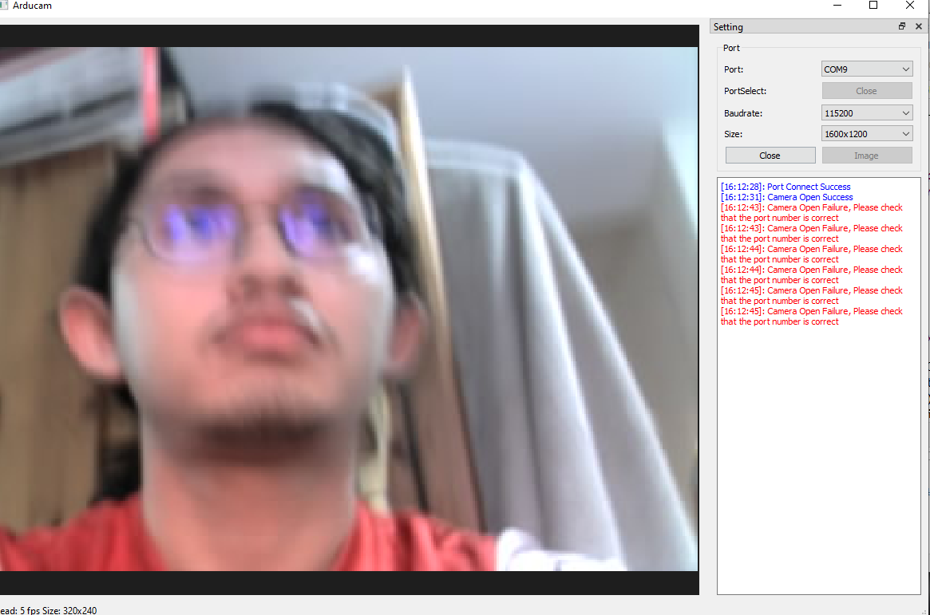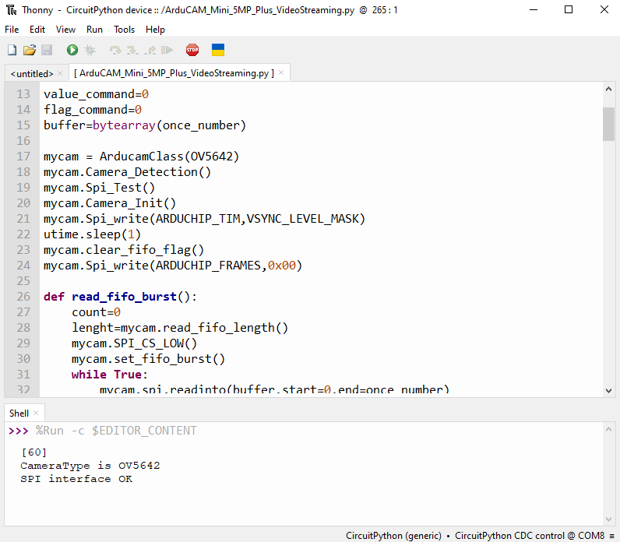Using examples provided, [SPI Camera for Raspberry Pi Pico - Arducam Wiki](https://docs.arducam.com/Arduino-SPI-camera/Legacy-SPI-camera/Pico/Camera-Module/SPI-Camera/) and [ArduCAM/PICO_SPI_CAM (github.com)](https://github.com/ArduCAM/PICO_SPI_CAM), after weeks of struggling and even shorting one of my Pico (don’t use multimeter carelessly while Pico is powered!), finally got it working. The problem was the provided jumper wires are probably old, and rusted inside thus not having stable connection (or at all) getting SPI error when using the HOSTAPP.exe or even worse not even able to initialize the app properly when running the program through Thonny (when my SDA and SCK wire are not working, tested using multimeter connection test). I opened it and exposed some inside wire to it to work better but still not stable, so will just opt to soldering direct connection when assembling prototype, or try using university jumper wire to see if it’s better.

Very unstable connection, also to note is that the focal length (focus) is fixed depending on how tight I turn the lens in, and the default is the best (I think). Also, the demo app kinda shite, as I am unable to go higher res (even when the option is there) so I have no idea full capability

I had tested both camera module and can confirm they are working! Now time to test other components.

## SDIO breakout board and sd card

Following this tutorial: <https://learn.adafruit.com/adafruit-microsd-spi-sdio/circuitpython>.

It works! 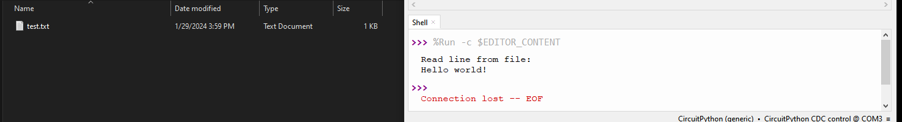 Used pins from <https://www.instructables.com/Raspberry-Pi-Pico-Micro-SD-Card-Interface/>.

## Mic testing

This one seems pretty difficult to implement as my mic is Analog electret mic (thus needs ADC and some memory management stuff), not the usual and simpler I2S which is easier to program and have more resources especially in circuit python. Might revisit and implement later instead after stereo camera works tbh.

Put in last priority for now as deemed more complicated than worth it compared to other features (stereo and video), problems encountered is that only hearing static noises, maybe bad sample rate etc or when converting binary to waveform, my hypothesis its harder to sample properly because lack of clock, so might need external clock trigger etc idk.

## MONO camera (SD CARD + CAMERA + BUTTON)

Following [ferrapons](https://gist.github.com/ferranpons/faf789e7f69b37997567903037bbcad2) code, it works with new wires (better connections) for still image, but still taking too long for high res, so might need solder wire directly or prototype on perfboard to further test full capabilities of pico. NEED TO FIGURE OUT HOW TO TAKE AND SAVE VIDEO NEXT!

Wiring is as in code, and pull up resistor is used for button, refer image:

ALSO NEED TO CREATE CIRCUIT DIAGRAM (especially important for perfboard to reduce pin error etc)

February 6, 2024 – Finished soldering one side for mono testing

February 7, 2024 – Tested it, got ltos of photos, buffer size need to be bigger for optimization, python is too slow

February 8, 2024 – Demonstrated to Tom (failed), after debugging in lab, it seems the culprit is due to incomplete initialization/library import?? Buffer not initialized??? Because after running the example app (the one with HostAPP.exe) on another PC then reflashing the main.py code, suddenly It works fine, now get some data regarding latency to take pictures and why change to C (python too slow, but need more concrete evidence)

* Todo from meeting:

1. Update Gantt chart (done)
2. Email second supervisor
3. Change to C library (and note the performance of Python library to justify)
4. Try implement stereo (optional)

Performance table of Python library with different config of resolution and buffer (using modified ferrapons code), ferrapons-with-latency.py:

Example, 1024x768 at 16384 buffer and 2592x1944 at 16384 buffer:

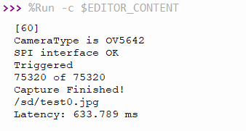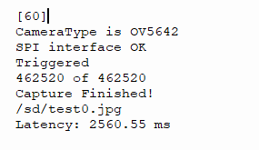

Orange are latency time in ms:

|  |  |  |  |
| --- | --- | --- | --- |
| Resolution/Buffer size | 1024 | 8192 | 16384 |
| 320x240 | 386.719 | 245.117 | 235.352 |
| 1280x960 | 1382.81 | 813.477 | 771.484 |
| 2592x1944 | 5664.06 | 2708.01 | 2560.55 |

As seen above, all of the latency even on best case (high buffer, low res) have 235ms latency which is not suitable for smooth video (atleast 30fps), as the video is just bunch of images frames taken continuously thus would result in around 4fps video… The main culprit for slow performance seems to stem from python slow interpreter execution as it is running on the pico itself. Thus the need to change to C is needed to optimize performance. Another consideration is to use raspberry pi pico dual core to multithread the process to take picture and save to sd card in parallel.

Tried flashing C compiled .uf2 files, no difference lol. Refer my new issue [Impossible to get video capture working at viable requirement, very low framerate (fps) and resolution · Issue #14 · ArduCAM/PICO_SPI_CAM (github.com)](https://github.com/ArduCAM/PICO_SPI_CAM/issues/14)

**VIDEO CAMERA NOT VIABLE WITH CURRENT HARDWARE WITHOUT ADVANCED TINKERING (STILL NOT GONNA REACH 60 FPS HD REGARDLESS) SO REDUCE SCOPE TO PICTURE ONLY UNFORTUNATELY**

**According to this github issue reply from official Arducam:** <https://github.com/ArduCAM/Arduino/issues/1#issuecomment-178943246>

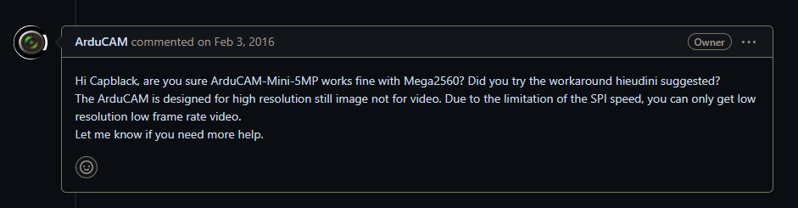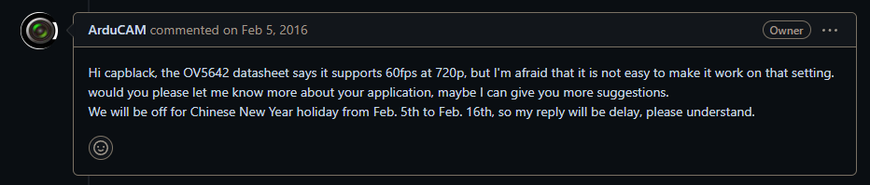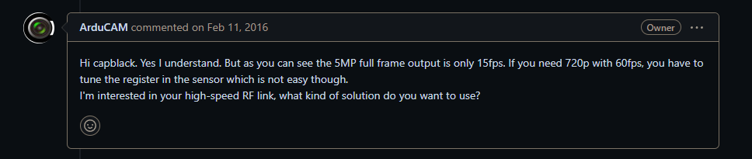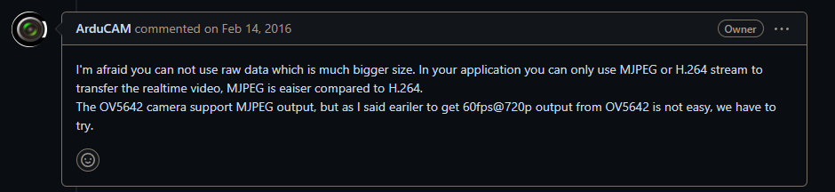

**There was no further engagement regarding that topic unfortunately. And further research regarding fps and long capture time suggest microcontroller choice is most important:** [https://github.com/ArduCAM/Arduino/issues/298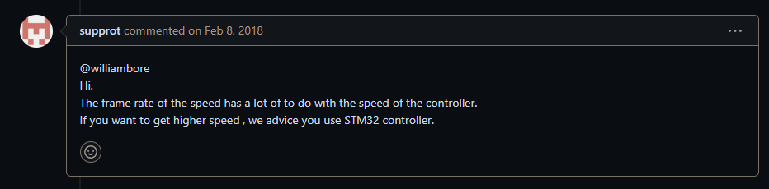](https://github.com/ArduCAM/Arduino/issues/298)

[How to increase FPS on ESP32-Cam 🚀 : esp32 (reddit.com)](https://www.reddit.com/r/esp32/comments/vndbh7/how_to_increase_fps_on_esp32cam/)  
Even assuming it works, 15 fps is not enough for good video especially stereo video for VR media consumption, and lowering resolution also not a good idea, thus both drawback induces motion sickness: [OV5642_camera_module_software_application_notes_1.1.pdf (uctronics.com)](https://www.uctronics.com/download/OV5642_camera_module_software_application_notes_1.1.pdf)

15fps 1080p must be a lie if most users cant even get 15fps on lowest resolution lol…

**There a more examples of such issues which imo shows its too complicated for the scope and timeframe of my project. The alternative is to drop the video functionality. For future revisions, it seems it is better to use higher speed hardware that is built specifically for video with proven examples etc instead of trusting manufacturers advertised specifications… For example, using a raspberry pi 4 or higher with 2 usb webcam camera such as** [Arducam 1080P Low Light Wide Angle USB Camera Module with Microphone for Computer, 2MP 1/2.8" CMOS IMX291 100 Degree Mini UVC USB2.0 Webcam (uctronics.com)](https://www.uctronics.com/arducam-1080p-low-light-wide-angle-usb-camera-module-with-microphone-for-computer-2mp-1-2-8-cmos-imx291-100-degree-mini-uvc-usb2-0-webcam-board-with-3-3ft-1m-cable-for-windows-linux-and-mac-os.html).  
  
In hindsight, should’ve followed a proven tutorial or project such as these which I found during research phase for this project: [Low cost stereo camera | Hackaday.io](https://hackaday.io/project/19533-low-cost-stereo-camera/), [Making A Low-Cost Stereo Camera Using OpenCV | LearnOpenCV #](https://learnopencv.com/making-a-low-cost-stereo-camera-using-opencv/), or even kits such as [StereoPi | StereoPi - DIY stereoscopic camera based on Raspberry Pi](https://stereopi.com/) (although this is impossible as most are out of project budget). Atleast this is good learning experience and good to know and document so future peeps don’t make same mistakes and assumptions as I did.

February 19, 2024 – Finally finished soldering and programmed basic interval + button functionality, the concern now that can be seen from main_19_Feb_images folder is that there is too much motion blur as the capture time is too slow, so the alternative is to either:

1. **Reduce resolution to lowest and observe if way better or not (320x240) and if it have enough data and comfortable for watching in VR or not**
2. **Just have more intervals, and use some image blur recognition and hope that most image is not blurry while discarding blurry ones.. This takes advantage of very big (32GB) size of SD CARD, still need calculation for confirmation tho. Ideally, the transfer process should only every week or few days, best case is months.**

**So now I’ll try change to lowest res and see if theres motion blur or not, as having motion blur on images will make stereoscopic effect to not work at all and just blurry mess especially if the images are not sync enough… This is hard and disappointing.. Should’ve bought USB WEBCAM CAMERAS AND USED RASPBERRY PI COMPUTERS :SOB: :SOB: 😭😭😭**

**Ok 320x240 is horrendously low res, even tho it average around 200-300ms, so I’ll opt to next one which is 640x480 that average around 500ms, still gives lots of blurry but still better than 1024x768 that averages latency around 600-800ms… Idk man.**

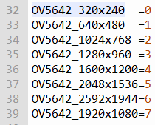

**…. Bad news… walking at normal speed and not caring about the time interval, all photos are blurry… as seen in the folder, the one that’s not blurry is when I stand still for a bit or press the trigger button…. This is depressing…**

**Tbh I think it’ll still be blurry at lowest res… 250ms is still a lot of latency…… The fix might be having accelerometer and only taking pics when its not moving?? To save storage and maximise timing efficiency :O, maybe I should look into this..**

**OK 320x240 tested and as expected… It is still blurry when I didn’t pay any mind to stand still around 5 sec or more.. Another observation is that lateral movement is less susceptible and have slightly better blur effect (vignette like) as moving forward/backward keep the middle thing in focus while rotational movement make the blur sooo bad. So ig I really need to look into accelerometer method if possible, though this effect might be less noticeable when mounter on my cap.. we’ll see…. F**

**Also as it’ll be blurry anyway, I think going for middle ground res for testing rn (640x480) is good choice.**

**For next, I should look into accelerometer and how to implement this, and try 3d print the cap mount ASAP so I can test for real faster to see if my idea of culling the blurry photos is even feasible or not..**

**Fin for tonight…**

**27 February 2024**

**Shits not working, too much problem, motion blur even when taking picture man, too much latency, SPI just wont work for moving picture etc so whatever, the idea to use accelerometer seems tooooo overkill and too much complexity for little gains that’s probably wont even be efficient. Thankfully the b16 lab have two identical spare webcam, phew! Working at 720p (HD) 30fps, tested both on my beefy pc and they seem very good! So benching all previous pico work DAMN! But whatever, note for report writing and viva Q&A: answer diplomatically and positively if asked reasons for why not start with rasp pi in first place, like trying to minimize form factor etc instead of too much ambitious, unforeseen complexities arise when developing instead saying manufacturer scam by misleading spec sheet (even tho they did and true), be positive but don’t lie etc.**

# **USB WEBCAM**

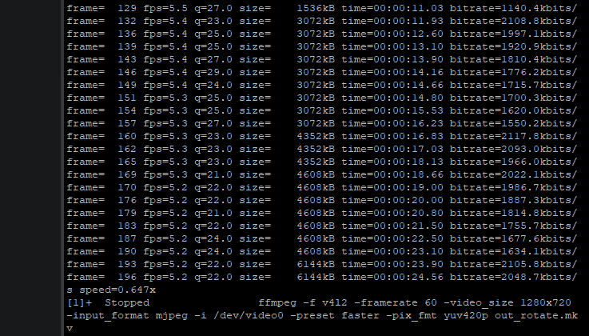Changed to 2x USB Webcam running headless Raspbian OS, any linux pc should work as well (rn using rasp pi 3b+ from uni but might change for better later as its too slow, I think). Here is the proof:

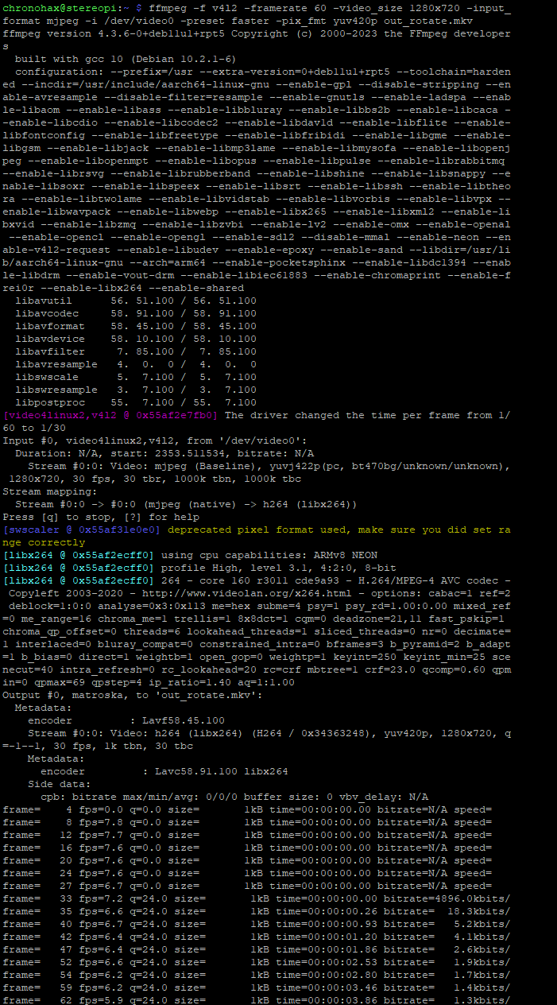Average fps around 5fps for 1 camera… so maybe only 2fps for stereo… too low for video but can work for image, but need immaculate sync and stuff, also note the bitrate is 2000kbits for one camera, so half that for stereo. Rpi 3b+ have 1.4GHz quad core and 1Gb ram, most likely culprit is RAM and maybe even sd card speed (will need test with faster card I have, drone video card), and also test active cooled Rpi from Irfan.

Overall I think would still work fine but I’ll research for personal buy mini pc/SBC/ rpi like pc soo can get best one and keep later for my project, and use it for extended ‘budget’ etc. idk man what Im yapping anymore, now lets try the rpi with fan and see if theres any difference.

Note: Used ffmpeg, ffplay for recording and streaming. Headless (no GUI) and SSH had been proven makes the video smoother and also much more enjoyable working experience cus less lag. Only problem is cant use Bluetooth keyboard so make sure have another kb (no need mouse for CLI) and video display still works even on CLI based OS with ffplay. Used v4l2-ctl –list-devices to check /dev/video0 etc.  
Recorded video with guidance from: [video capture - recording from webcam using ffmpeg at high framerate - Stack Overflow](https://stackoverflow.com/questions/47292785/recording-from-webcam-using-ffmpeg-at-high-framerate).

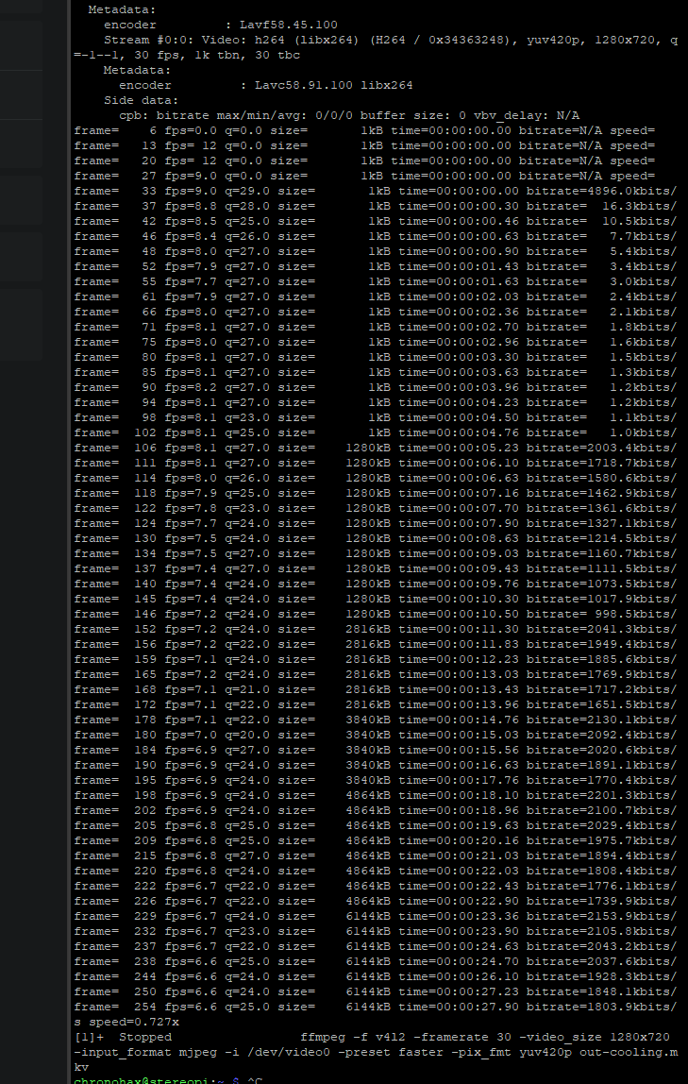Another problem regardless if I use powerful PC or not is power, my powerbank cant give out 5V/5A even using USB-C so maybe need to get a UPS option from thepihut etc.  
Fan cooled test using same command:

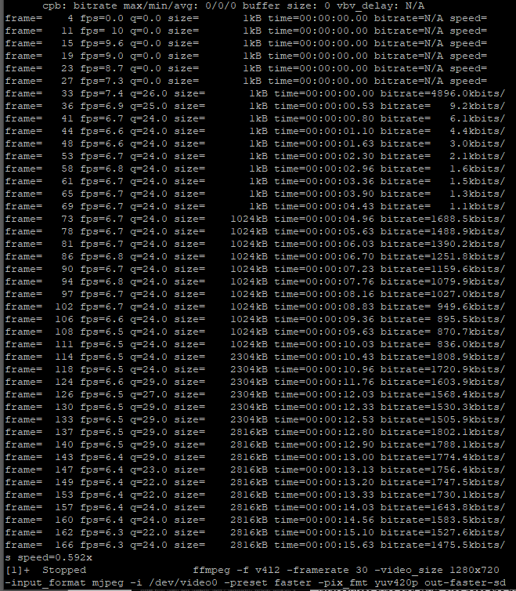Shows that active cooling does help, giving more fps, averaging around 6.6. That means more Hz will help and also not having enough power will cause performance degradation as expected from underclocked etc, next will format the faster SD and see if that helps as well including active cooling:

For some reason, im getting segmentation fault when running ffplay on the faster sd card, and there’ no fps difference anyway (might be cpu bottleneck then or not formatted with optimized setting), but surely not because of shutdown error as I’ve flashed it twice now on this faster 128gb sd card, ig could be because of size tho.. Now time to find stronger pc..   
After looking into specs and future proof of SBCs and mini pc, rasp pi 5 seems like a great choice (a bit low power but also best bang for buck, though im not sure if I want 4gb or 8gb cus the price difference is quite huge)