ELEC2217 - Team B - 2nd Review Report 24/2/2023
Abi Brett, Giulio Girelli, Thomas Short, Muhammad Yusri, Jerry Wang, Syazwan Zulkepli

Introduction
In this report, we present our smart-meter group project, which aims to design a system that maximizes power usage efficiency and supports renewable energy sources using algorithm decision making. We describe the box and PSU design, simulation results, and challenges of our project. We also discuss the implications, limitations, and future directions of our work. This report demonstrates our achievements and learning outcomes from this project so far.

Project Progress and Box
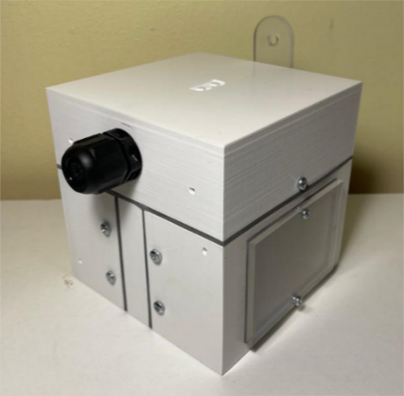
The contributions by the members are fairly balanced with everyone having their own major roles and contributions on each crucial part of the project. For the group deliveries we have managed to collaborate effectively with each other and carry out all the tasks as a performing team. For Housing, Giulio contributes the most as he had the most experience with CAD software. For PSU design and testing, the work is mostly collaborative between Jerry and Abi. Interface design and testing is spearheaded by Tom and assisted by Abi. Syazwan is responsible for the software part of the project, as he is the most skilled in terms of coding. Muhammad checks the quality of each part and make sure they are ready for integration. So far we have successfully followed our plans and met our deadlines. We have taken care of avoiding to rush through our work and leave it for the last-minute submission. Our smart-meter is taking shape step-by-step and in Figure 1 it is shown the front view of our box.
Figure 1: front view of box
Box design
We have made the box 105x105x105 mm to allow space for the head of the screws and meet the size requirement. To minimize the junctions that could cause internal water leakage, we have chosen to divide the box in 4 pieces: a top part and 3 parts at the bottom. The top part is mounted with a screw to the right and the left parts, as it can be seen in Figure 2. The latter are kept tight together by the middle piece, which shares 4 bolts with both, as shown in Figure 3. The box can be easily and quickly opened by unscrewing the two screws that keep the top attached to the bottom and splitting them apart. The walls of the box have been made 4mm wide, which allow a good strength and implementations of other features.
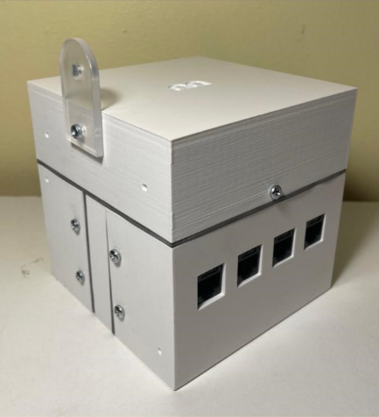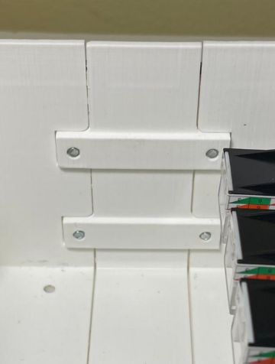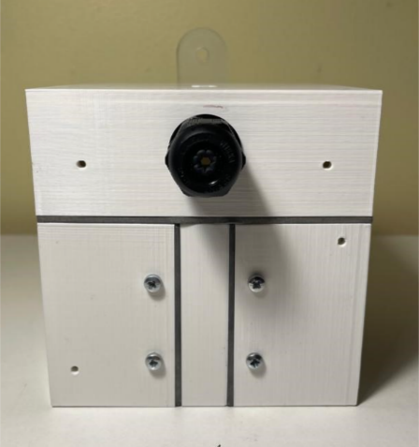
Figure 2: back view of box Figure 3: joint of parts Figure 4: front face of box
We have incorporated in-out mountings, which turned out to be a more effective compared to other solutions that we tested. M3 bolts are used for the IlMatto, the mounting lug and the mounts in between parts, as they need to withstand greater strain; the rest has been suited for M2.5 bolts. To enhance water resistance, we have sectioned the extremities of the parts, such that they can fit into each other and break the straight path into the box for water. We have also left some space on the external joint to place and compress rubber gasket, counteracting internal water leakage, and it shown in Figure 4.
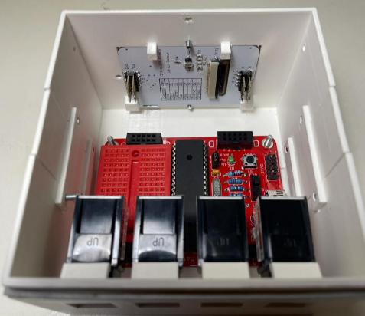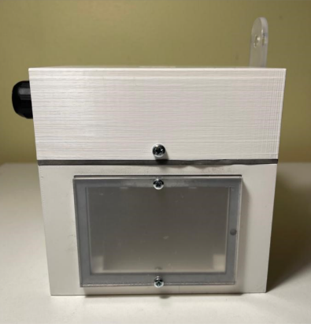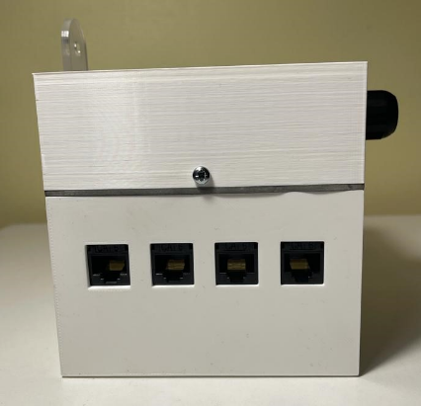
Figure 5: inside of box Figure 6: right face of box Figure 7: left face of box
The four RJ45 connectors have been placed on the left side, as Figure 7 shows. Our design includes clipping features on the internal wall, which can be seen in Figure 5, so that the connectors are well fixed in place. The display has been located on the right side like in Figure 6. It is fixed from the inside with 4 brackets, and it has been covered from the outside with an acrylic sheet. Next to the display, we have fitted the green LED. Figure 5 also depicts the bottom part, which is where the IlMatto has been screwed up. The top piece is where the PSU has been segregated and where the gland for the mains cable has been fitted, which can be seen in figure 4. A plastic floor has been used to divide the top section to the rest of the box. The mounting lug has been made of acrylic and externally fixed to the top part. The interface circuitry has taken the rest of the space left inside the box.

Power Supply Unit
Figure 12 shows our final PSU provides steady-state output voltages of 10.36V and 5.18V respectively. In this way, 5.18V can power the IlMatto while 10.36V can be used for the interface circuitry. The PSU consumes 1.8W (Figure 9) when in the testbed.
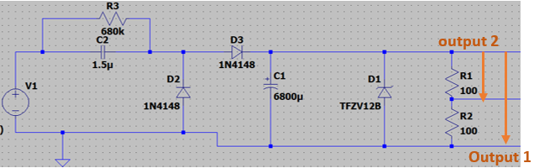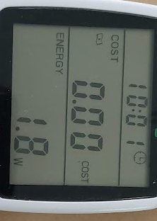
Figure 8: capacitor pump PSU full circuit diagram Figure 9: PSU input power
After the first test of the PSU with the testbed, we found out that LTSpice’s Simulation was quite inaccurate and differs significantly from the measured values, as Figure 11 and Figure 12 demonstrate. Therefore, we have now used the simulation only for reference and the testbed values as the actual values for the PSU. Our first design had a higher value X-rated capacitor which caused an inrush in current. This led us to change the design to a 1.5µF X-rated capacitor which reduces the max input current. The load resistor is 200 Ω because we require 10V and 50mA: 10V/50mA = 200 Ω (Figure 13).
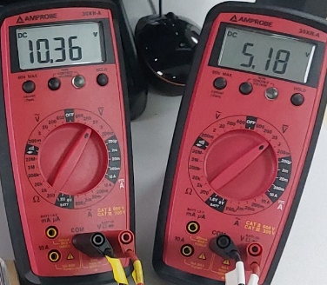
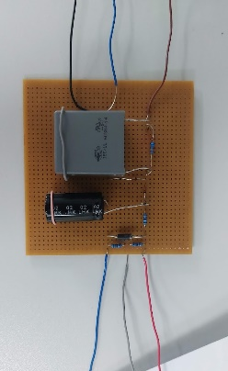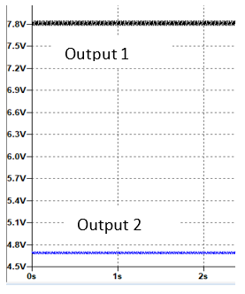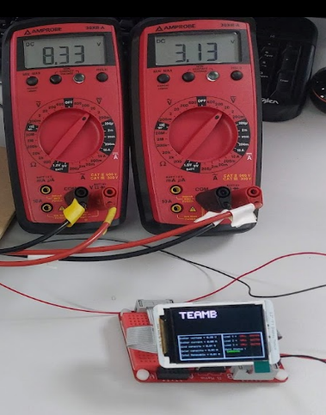
Figure 13: load resistor steady-state output values
Figure 10: built PSU Figure 11: LTSpice simulation Figure 12: testbed voltmeter vlaues with il Matto
From Figure 13, our voltage output is 10.36V and we approximated a total of 50mA current coming from the PSU. The interface circuitry is made of 4 circuits which we estimated to require 10mA. Our IlMatto when displaying our smart-meter information has an approximated 40mA current draw. To provide 2 steady-state values with the necessary values, we have used a 200 Ω load resistor for Output 1 and a 100 Ω resistor for Output 2. The 200 Ω resistor is made from Load 1 (i.e., 100 Ω resistor) and another 100 Ω resistor in series. Using this method, Load 1 and Load 2 act as a potential divider where both voltages are used and give out two correct and reliable steady-state outputs. The simulation of the output voltages can be seen in Figure 10.

From Figure 12 we can see that the IlMatto and its display are successfully powered by the PSU with 3.13V. The value of the first voltmeter is 8.33V instead of 10.3V due to the other half of the load resistor remained; this shouldn’t be a problem when it is removed and connected to the interface.

Software algorithm
The development of the software is making steady progress, with several key milestones achieved. The smart-meter is now able to measure the analogue inputs using ADC. Since the signal is scaled down so that readings in the IlMatto will not be saturated, the actual value of the analogue signals is calculated manually in the microcontroller. The busbar voltage and current, which is an AC signal, is scaled down by the circuit interface and the rms value is measured and calculated by the microcontroller as well. This allows for more reliable readings of the busbar voltage and current.
The smart-meter is also able to send PWM output, which is used to control how much power is needed to be supplied by the main to the loads. The amount of power needed to be requested is calculated based on how much current we are lacking. This feature has been applied together with the algorithm.
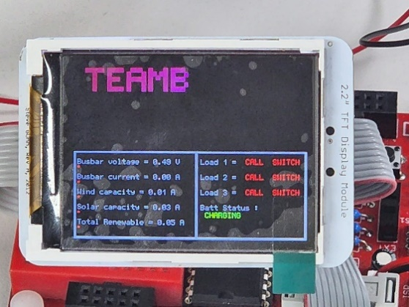
The algorithm to decide which load to turn on and off based on the load calls is close to completion. A few amendments are needed in order to decide which load is prioritized in the event where power is insufficient to drive all loads.
The display for the smart-meter has been designed, but it required some more fine-tuning to resolve frequent blinking issues. Now the display is able to responds to ADC and load and battery status, providing live reaction and a simple graphical representation of the data. Figure 13 shows an example of the display at operating conditions.
Figure 13: display in operating condition

Interface Circuitry
Progress regarding the Interface Circuitry has been efficient. Circuit designs for all the different forms of interface (digital to analogue, analogue to digital, 3.3v to 5v, and 5v to 3.3v) have been completed and simulated successfully using LTSpice.
The plan for 3.3v to 5v TTL is to connect these directly, but it still requires further testing and confirmation. However, should this fail, a backup circuit design has been developed and simulated. For the 5v to 3.3v a circuit that makes use of a single BC547B NPN transistor has already been successfully tested on breadboard.
Alongside the breadboard tests for the digital circuits, we also tested the RC filter that we plan to use alongside the IlMatto’s PWM output to create a Digital-to-Analogue-Converter substitute. However, we encountered issues relating to the cut-off frequency, which were not present in the LTSpice simulations, but with hindsight they should have been considered. We are planning to reassess the values of R and C and find a more effective solution.
The 50Hz AC analogue output interface circuitry makes use of a half wave rectifier circuit which also acts as an inverting amplifier with a gain off less than 1 to scale the signal appropriately. Since the signal is a sine wave and we are only obtaining a half wave anyway, the inversion of the signal will not matter. Attenuating the negative voltage component of the AC input is necessary as the ADC of the IlMatto can only read positive values between 0-Vcc (0-3.3v). Lastly, the DC analogue output interface circuitry uses two cascaded inverting amplifier circuits with gains of less than 1, scaling the signals to be within the acceptable range of the IlMatto’s ADC.

Conclusion
Over the course of the first 4 weeks, we have tried a number of solutions both for the PSU and the interface circuitry. The first solutions unfortunately were not as efficient as we expected, and we have spent a lot of time trying to improve it. By researching and running a lot of simulations we finally managed to produce a PSU and many parts of the interface that were functionally better. The box has also been improved several times since the start of the project. After the first review we realized that some of the features that we implemented were very risky and inefficient in terms of the requirements to be met, therefore we worked hard to adjust every small detail, by doing several test prints and make sure we did not miss on any tenth of millimeter. Concerning the software, there has been a steady progress week by week for both the control of the display and the control of the signals. We have already developed a sample algorithm based on the test scenarios, which we are going to adapt to the final one once is published.
In conclusion, we have managed to finalise the design and the assembly of the box, which meets all the requirements and is expected to perform well at the water-resistance test. The PSU has been designed, simulated, built and tested, and is ready for the safety test. The software has made significant progress and will be adapted to the final scenario once is published. We are also continuously improving the interface circuitry and we are planning to finalize it and finish all tests by the end of week 5.
Our plan for the following weeks is to complete all the missing components of our smart-meter and to start testing the device fully assembled as soon as possible, following the published final scenario. We are going to make sure that we will not miss on any deadline, and we are going to leave us enough time to produce a good group report for the last submission.

