ELEC2217 - Team B - 2nd Review Report 24/2/2023
Abi Brett, Giulio Girelli, Thomas Short, Muhammad Yusri, Jerry Wang, Syazwan Zulkepli

1. Introduction
In this report, we present our smart-meter group project, which aims to design a system that maximizes power usage efficiency and supports renewable energy sources using algorithm decision making. We describe the housing and PSU design, simulation results, interface and software development, and challenges of our project. We also discuss the implications, limitations, and future directions of our work. This report demonstrates our achievements and learning outcomes from this project.

2. Project Progress
The contributions by the members have been fairly balanced with everyone having their own major roles and contributions on each crucial part of the project. For the group deliveries we have managed to collaborate effectively with each other and carry out all the tasks as a performing team. For Housing, Giulio has contributed the most as he has the most experience with CAD software. For PSU design and testing, the work has been mostly collaborative between Jerry and Abi. Interface design and testing has been completed by Tom and Abi. Syazwan has been responsible for the software part of the project, as he is the most skilled in terms of coding. Muhammad has checked the quality and the integration of each part, and has taken over the LabView simulations of our device. Despite the challenging deliverables, we have successfully followed our plans and met our deadlines. We have taken care of avoiding to rush through our work and leave it for the last-minute submission. Figure 1 shows the front view of our device.
Figure 1: front view of box
3. Box design
We have made the box 105x105x105 mm to allow space for the head of the screws and meet the size requirement. To minimize the junctions that could cause internal water leakage, we have chosen to divide the box in 4 pieces: a top part and 3 parts at the bottom. The top part is mounted with a screw to the right and the left parts, as it can be seen in Figure 2. The latter are kept tight together by the middle piece, which shares 4 bolts with both, as shown in Figure 3. The box can be easily and quickly opened by unscrewing the two screws that keep the top attached to the bottom and splitting them apart. The walls of the box have been made 4mm wide, which allow a good strength and implementations of other features.
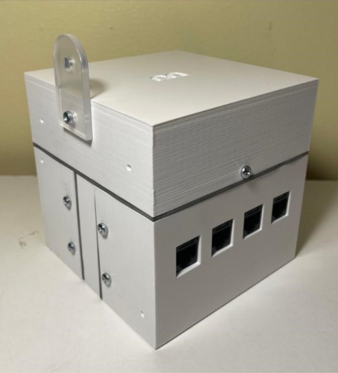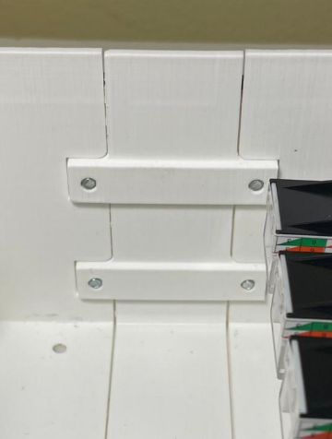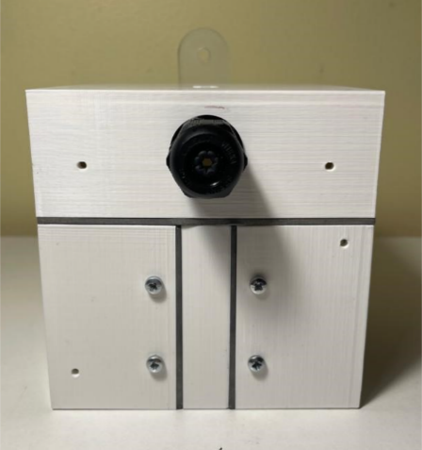
Figure 2: back view of box Figure 3: joint of parts Figure 4: front face of box
We have incorporated in-out mountings, which turned out to be a more effective in terms of compression of the parts together, compared to other solution that we tested, which had screws on the outside. The new solution is more resistant and has also allowed us to make the box a little bigger, creating more space inside the box. M3 bolts are used for the IlMatto, the mounting lug and the mounts in between parts, as they need to withstand greater strain; the rest has been suited for M2.5 bolts. To enhance water resistance, we have sectioned the extremities of the parts, such that they can fit into each other and break the straight path into the box for water. We have also left some space on the external joints to place and compress rubber gasket, counteracting internal water leakage, as shown in Figure 4. The middle piece has a thicker section on the inside where the in-out mountings are placed, as shown in Figure 3, to make the part stronger and avoid that it breaks.
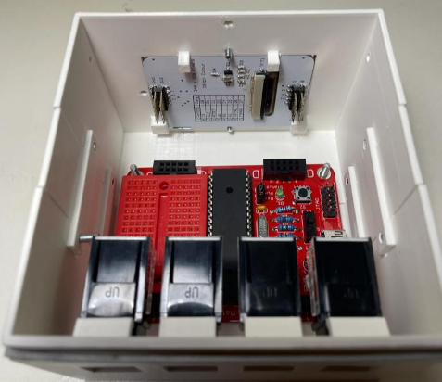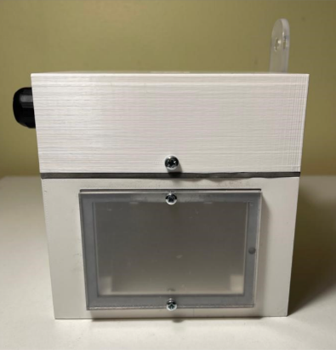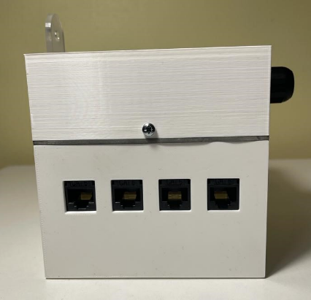
Figure 5: inside of box Figure 6: right face of box Figure 7: left face of box
The four RJ45 connectors have been placed on the left side, as Figure 7 shows. Our design includes clipping features on the internal wall, which can be seen in Figure 5, so that the connectors are well fixed in place. The display has been located on the right side like in Figure 6. It is fixed from the inside with 4 brackets, and it has been covered from the outside with an acrylic sheet. Next to the display, we have fitted the green LED. Figure 5 also depicts the bottom part, which is where the IlMatto has been screwed up. In this way, it could be easily wired to the other parts of the device. The top piece is where the PSU has been segregated and where the gland for the mains cable has been fitted, which can be seen in figure 4. A printed plastic floor has been used to divide the top section to the rest of the box. It is fixed by four screws from the outside of the top piece, Figure 4 shows two of them. The mounting lug has been made of acrylic and externally fixed to the top part. The interface circuitry has taken the rest of the space left inside the box. The housing was tested several times under the shower to assess its water-resistive capabilities. The results were very positive, as almost no water entered the box. These tests confirmed that our design was well suited for the requirements and ready for the water test.

4. Power Supply Unit
We have successfully built, tested, and integrated a capacitor pump PSU for the smart meter design. Figure 1 shows the final PSU design schematic on LTSpice. An additional 3.3V voltage regulator is used to power the Il-Matto.
At first, we used a half-wave rectifier design (Figure 1) which was relatively less efficient as the neutral wire was grounded. Consequently, the negative voltage was zeroed by the ground and half of the input power was lost. This resulted in the output being low and less desirable for the smart meter’s requirements. Hence, we have decided to implement the full-wave rectifier instead, to obtain higher output power and improve efficiency.
(Figure 1 – The first PSU design with half-wave rectifier)
The 1.5u capacitance capacitor and R3 act as the ‘pump’ and are responsible for charging and discharging voltage directly from the main power. Since C2 is connected directly with the main power supply, C2 has been chosen X2 rated for safety reasons. Figure 3 shows the voltage ‘pump’ action of the C2 capacitor. R3 acts as the bleeding resistor of the C2 capacitor to ensure safety., such that C2 is discharged to less than 2V after being disconnected from the main in less than two seconds.
The implementation of the full-wave rectifier consists of four 1N4148 diodes. The full-wave rectifier converts the alternating current into direct convergent, which is desirable for both interface circuitry and powering the Il-Matto. This converts the complete cycles of alternating current into pulsating DC. Figure 4 shows the waveform after the full-wave rectifier, as the alternating current became pulsating DC current all in the positive y-axis.
(Figure 2 – The final PSU design with full-wave rectifier)
(Figure 3 – The Voltage Waveform of C2 capacitor) (Figure 4 – Voltage after the rectifier )
In order to smooth out the pulsating DC voltage produced by the full-wave rectifier, we have used a 6800u smoothing capacitor to smooth out the output of the PSU. As the 6800u capacitor charges and discharges at high frequency, the sinusoidal wave becomes a smooth curve reaching steady-state around 4.5 seconds.
We have implemented a 12V zener diode to limit the voltage output of the PSU, since the interface circuit required at least 10V. A 1K ohm resistor R4 has been placed in series with the zener diode in order to prevent too much current going across it.
At the load we have used a potential divider where both resistors are used as outputs, such that maximum efficiency maintained. R1 is the output for the interface circuit, and when it is connected it gives out 12.41V to the interface op-amp. R2 connects to the il-Matto and outputs 3.3V to the voltage regulator. Output waveforms are shown in Figure 5.
(Figure 5 – PSU schematic output waveform before connects to the smart meter)
After testing and further research, we found out that resistor is not suitable for distributing voltage for microcontrollers, since the current draw of microcontroller changes constantly and the resistor cannot have a steady supply of voltage and current. Therefore, we have added an external voltage regulator outside the PSU. After careful consideration, we have decided to use the circuit for the LM3090 voltage regulator with an output of 3.3V. Figure 5 shows the circuit and Figure 6 shows the layout on the stripboard.
(Figure 5 – The voltage regulator circuit) (Figure 6 – The voltage regulator build)
The PSU successfully supplies 3.2V to the voltage regulator, which in turn successfully powers IlMatto with 3.1V. The output that connects to the interface circuitry produces 12.4V. The current draw of the Il-Matto and the interface circuitry is about 75mA, which results in a total power output of 1.15W. The power consumption is 1.5W when the smart meter is in operation, resulting in an efficiency of 0.9/1.5 = 60%. This value of efficiency is acceptable and has been expected by the capacitor power supply unit design.

5. Software algorithm
Our project’s software is designed as best as possible to assure a smooth running of our smartmeter device. The microcontroller uses an analogue-to-digital converter to measure the busbar voltage and current, wind capacity, and solar capacity (ADC). Based on the matching load calls, the microcontroller (il Matto) examines the measurements to decide which load switch should be turned on and off. The algorithm also assesses how much current is required from main if renewable energy is inadequate to fully charge the battery and power the load.
The software design is written in C, which was chosen for the design’s adaptability, portability, and embedded system effectiveness. Analogue to Digital conversion (ADC), Pulse Width Modulation (PWM), display, and algorithm are the system’s four core parts.
The busbar’s voltage and current, as well as the amounts of wind and solar energy, are all measured by the ADC feature of the Atmega644p microcontroller. To fit the ADC’s range, the signals are scaled down using and external circuit interface. To calculate and control power, the module converts the analogue signals to digital signals. Traditionally, the busbar voltage and current signals are stabilised using complex circuit interfaces before they can be fed into a microcontroller for further reading. However, in our smartmeter, we have implemented a unique approach where the il Matto is used to directly measure the scaled down AC signals without converting it to DC. This is done by measuring the ADC input and comparing the measured values in every instance to find the maximum value. This maximum value is used to find the root mean square of the AC signal. Many advantages of this approach include a more straightforward overall design and a circuit interface with less complexity.
The quantity of power requested from the main supply is decided by the PWM signal. It adjusts the voltage levels to the proper level required to charge the battery and power the load. Figure 1 shows the output of a working PWM at 30% duty cycle as observed from an oscilloscope.
Figure 1 : Working PWM output from the smartmeter.
The display module is responsible for providing the user with the real-time status of the system. This involves power consumption, battery status and percentage, and load status. A simple graphic depiction of the power produced by renewable sources is also included. Figure 2 shows the UI of our smartmeter.
Figure 2 : The latest display design
Based on the appropriate load calls, the algorithm module determines which load switches to turn on and off. If there is insufficient energy from renewable sources to charge the battery and power the load, it will decide how much power to request from main supply or if there is enough battery percentage to discharge. The algorithm is also designed to maximise the survival rate as much as possible, by deciding which is the best load to turn off in the event of insufficient renewable energy, main supply, and battery to power all loads in demand.

6. Interface Circuitry
Circuit designs for analogue input and output, digital input and output have all been considered and simulated using LTSpice.
The plan for the digital input was to connect directly to the il Matto and keep a backup circuit design if something failed. For the digital output, a circuit that makes use of a single BC547B NPN transistor was successfully tested and built on stripboard. However, once it came to integration, we have realised that the il Matto could take the signal without any interface, consuming less power.

For the analogue input, we have chosen to utilise the IlMatto’s PWM output to create a Digital-to-Analogue-Converter substitute. This involved an RC filter going into the input of the TS954IN opamp. However, we encountered issues relating to the cut-off frequency, which were not present in the simulations. These were causing a non-steady output voltage which would not vary linearly with the duty cycle. The TS954IN has been chosen over other opamps available as its 14V max supply voltage was high enough to allow for a range of 0-10V. As the supply current did not go above 1.1mA for 10V, we have achieved lower power consumption and produced the correct output for the circuit. After adjusting the values of R and C in the RC filter we were able to reduce the cut off frequency and subsequently achieve full circuit functionality. Further adjustment was required and in the final circuit variation of the duty cycle led the circuit to linearly output a DC voltage between 0v-10.3v. There was a maximum ripple of around 50mV at 50% duty cycle, this could have been reduced further with a smoothing capacitor but throughout testing it was determined that this would be unnecessary due to the way that we understood the test bed would be reading values.
The 50Hz AC analogue output interface circuitry started as a half wave rectifier circuit which also acts as an inverting amplifier with a gain off less than 1 to scale the signal appropriately. Since the signal is a sine wave and we are only obtaining a half wave anyway, the inversion of the signal did not matter. Attenuating the negative voltage component of the AC input is necessary as the ADC of the il Matto can only read positive values between 0-Vcc (0-3.3v). After testing, we found the circuit to be unreliable and the circuit was simplified to just feature a single opamp and no diodes. Whilst this did occasionally produce the desired output it was still quite inaccurate, so our circuit has been changed more fundamentally to use a full wave rectifier leading to a resistor and capacitor in parallel. A full wave rectifier has been used over a single diode, allowing for greater efficiency and the use of a smaller smoothing capacitor. The circuit also can respond faster to changes and has small enough ripple to prevent errors to the Vmax reading on the ADC. The new circuit for AC analogue output requires no opamp and has been made smaller and more compact than our previous attempt. This redesign has allowed for more separate circuits to be fitted in the box and has made integration much easier. If we had had more time, we would have changed the PWM quad opamp to a single opamp to reduce the space and minimise loss slightly more.
After reviewing the final scenario, the max value of the Analogue DC output was within the IlMatto’s reading range, hence it did not need any scaling and our circuitry was not required anymore. Prior to this information being revealed we had prepared circuits to scale these inputs, either by way of a voltage divider or two cascaded opamps.
Through testing and consideration of the final scenario we were able to cut the interface circuitry down to just the two circuits shown in the figures above. This saved both power and space. Whilst it was not part of the task it could also be argued that these decisions would both reduce manufacturing costs and increase manufacturing efficiency.

7. Integration
Our smart-meter has experienced a step-by-step integration, where simulating and testing have been very crucial to ensure the best quality. In the integrating stage of our device, we have made sure that our smart-meter is first of all safe and avoids any potential shock hazard. The internal sections have been kept as neat as possible by shorting wires and smart positioning. The wires connecting the PSU to IlMatto have been made much longer, to make sure that when the box is opened the connections do not break or come off. We used solder to ensure high-quality connections when needed and we have covered the joint with isolating tape to avoid shocking hazards. Our layout inside the box also ensures that none of the components can touch each other and cause some unintended short circuits that could affect the operation of the device.
8. Budget
From the £40 budget allowed, we spent £13.55 to buy components that were needed to integrate in our PSU. We bought 12V zener diodes, the 6800uF capacitor, and the 5.6uF X2-rated capacitor. Although the price of the 3 single components was actually much lower (£5.26), we had to order packages of multiple components and invest more budget.

9. Conclusion
Thanks to great effort from all members of the team, we managed to complete the project and submit our fully functional smart-meter. Teamwork played a key role in our design and allowed us to be on time for all the deadlines spread across the 7 weeks. Despite the challenges and the time constraints, each component of our smart-meter was thoroughly designed, simulated and tested. We were determined in ensuring the highest quality as possible, in order to perform at best during the final review.
Over the course of the project, we tried a number of solutions both for the PSU and the interface circuitry. The first solutions unfortunately were not as efficient as we expected, and we spent a lot of time trying to improve them, by looking on the internet and simulating new solutions. Although, the tests on stripboard were often far from the simulation expectations, we finally managed to produce circuits that were functionally better. When it came to the first review, our PSU managed to meet the requirements, but it consumed a bit too much power. In the end, the PSU was successfully powering the IlMatto and producing a sufficiently high reference voltage for the interface, while the interface was carrying out all the designed tasks.
The box was successfully designed and improved several times since the start of the project, by doing several test-prints and correcting small details. At the water-test during the second review, the box did not perform as good as expected, as 2ml of water leaked in. We identified that the acrylic sheet covering the display was the most sensitive part of the box, which may have caused those small water drafts into the box. We realized that we could have used four bolts instead of two to fix the acrylic sheet to the box, which could have made the component tighter to the wall and could have avoided water leakage.
The software experienced a steady progress week by week for both the control of the display and the control of the signals. The few issues on blinking and calculations were solved quite quickly. The algorithm was designed to prioritize Load 1 above the others and consider Load 3 as least important. The control flow was based on the renewables availability and on the battery level. Our design was aimed to save as many people as possible from the scenario and minimize mains usage.
In conclusion, we managed to finalise the design and the assembly of the device, which met all the requirements. At the final review we encountered some issues with the PSU and the LabView software, which did not allow us to test our device as much as we wanted. The final output produced a fairly good score, but we regret that we could not submit a better version of it. In our last submission, both our mains usage and our battery ratio usage were too high. These issues could have been caused by either the algorithm being designed not well enough or by the interface that produced some wrong signals. If more time were allowed for the project, we could have spent more time testing the device fully integrated and ensured a better performance.

