

AWS ZERO TRUST SECURITY PLATFORM

Final CCP Report

Course | Cloud Security Lab
Progam | BS Cybersecurity
Submitted by | Muhammad Hussain
Reg ID | 64493
Submitted to | Muhammad Ahsan Naeem
Date | June 24, 2026

INTRODUCTION

Problem Statement
Traditional perimeter-based security models—often referred to as 'castle-and-moat' configurations—are completely insufficient to safeguard modern, multi-layered cloud environments. Once a malicious actor or a compromised device successfully penetrates the network border, there are typically few internal barriers or secondary identity evaluations to inhibit lateral movement, unauthorized programmatic orchestration, or data exfiltration. Due to the rapid evolution of sophisticated phishing vectors, credential-stuffing methodologies, and infrastructure configuration drifts, assuming that an active session or device is inherently trustworthy simply because it resides inside the private network boundary represents a catastrophic systemic vulnerability.

Project Objectives
To eliminate ambient trust, this engineering initiative architected, deployed, and validated a highly resilient Zero Trust Security Platform on AWS infrastructure modeled directly on the core pillars defined in NIST SP 800-207. The project achieves the following key milestones:
- Absolute Identity Verification: Eradicate ambient, long-lived trust by enforcing multi-stage cryptographic and tokenized multi-factor validation checks on every operational session context.
- Network Micro-Segmentation: Isolate computing rings within a multi-tiered VPC architecture using strict zero-trust security groups to eliminate open lateral transport lines.
- Continuous Posture Auditing: Implement continuous background configuration observation, cloud service tracking, and automated API-level threat monitoring to guarantee real-time system state transparency.
- Proactive Lifecycle Constraints: Enforce granular session expiration counters and programmatic lockouts to drastically mitigate token hijacking and automated brute-force attacks.

SYSTEM DESIGN & ARCHITECTURE
The platform relies on a strict engineering separation between the Control Plane (identity validation, metadata orchestration, and operational policy evaluation) and the Data Plane (actual packet transfer, localized script execution, and user database state queries). Communication paths do not function unless an explicit, contextual authorization token is produced and verified.

Three-Tier Network Isolation Matrix
The systemic components are distributed across a tailored network ring, systematically isolating the presentation layer from the database processing core. Below is an overview of the micro-segmented topology:
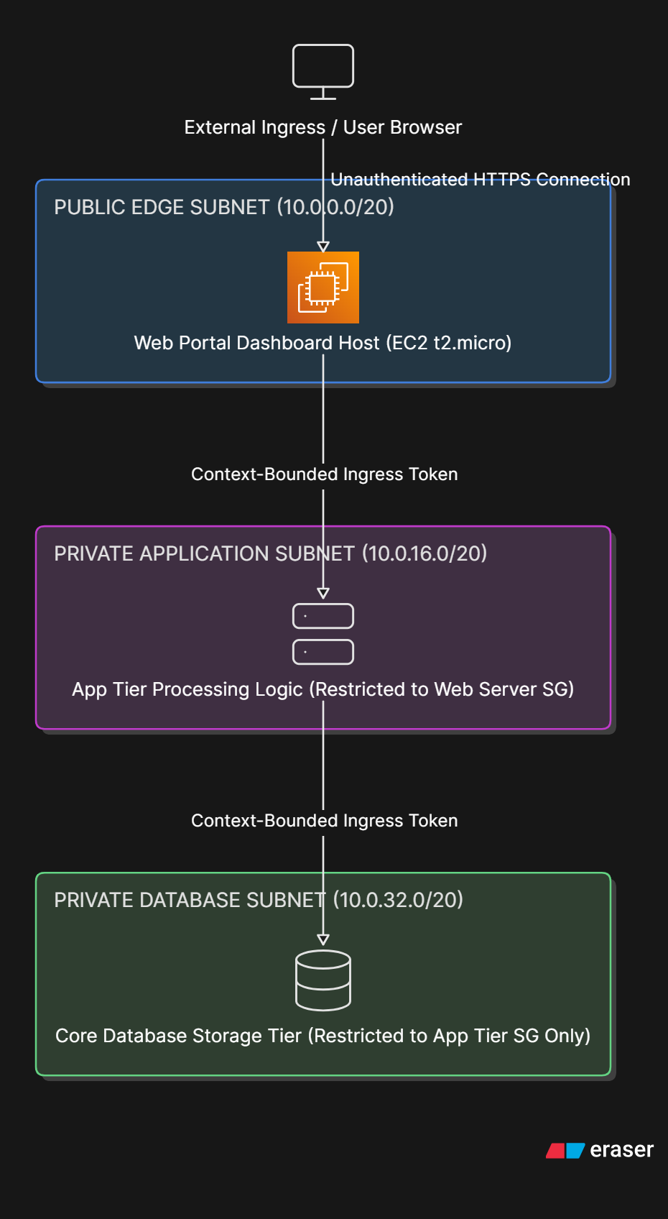

Architecture Components & Core Logic
- Network Segmentation Structure: The logical blueprint is grounded inside a dedicated 10.0.0.0/16 VPC block. The network topology relies on isolated subnet rings allocated systematically across distinct physical availability zones to guard against failover constraints while preventing unmapped cross-subnet talking paths.
- Security Group Dependency Chains: Firewall boundaries are implemented directly at the individual instance elastic network interface (ENI) level. While the public web container allows inbound traffic from 0.0.0.0/0, the private application layer rejects all requests except those originating explicitly from the Web Server's distinct Security Group security identifier. The database tier applies an identical filter, listening only to the app layer.
- Identity-Aware Control Flow: Before any background cloud resource state metrics or active telemetry indicators are rendered on the live UI, the application triggers a sequential, two-step identity challenge. Successful password verification moves the user state to an unauthenticated step-2 container, requiring an external TOTP cryptographic code before opening any backend querying pipes.

SECTION 1: ACCOUNT SECURITY HARDENING

1.1 Root Account MFA Protection
The foundational AWS root account was instantly secured using Multi-Factor Authentication (MFA) via a virtual Time-based One-Time Password (TOTP) device. This protects root access control elements even in the event of primary credential compromise.

1.2 IAM Admin User Creation
To avoid using administrative credentials for baseline operations, a dedicated identity access management (IAM) administrator user profile was successfully provisioned. The root profile is completely restricted and locked out from day-to-day configuration tasks.
SCREENSHOT
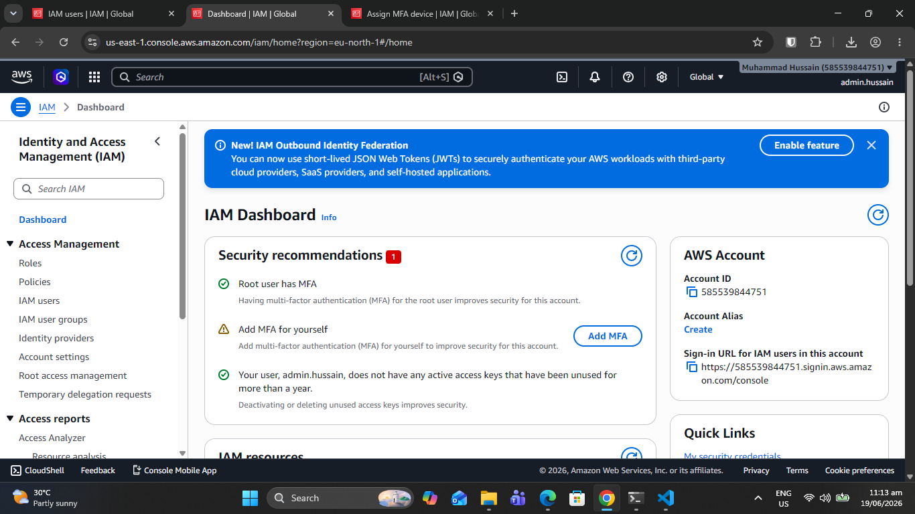
Screenshot 1.2: IAM Users List Administrative Summary

1.3 MFA Enforcement Policy
A robust, custom IAM structural policy mandates multi-factor validation across all identities inside the tenant. This policy utilizes an explicit global deny logic, instantly halting all programmatic or interactive actions unless a verified, active MFA cryptographic session token is matched.
SCREENSHOT
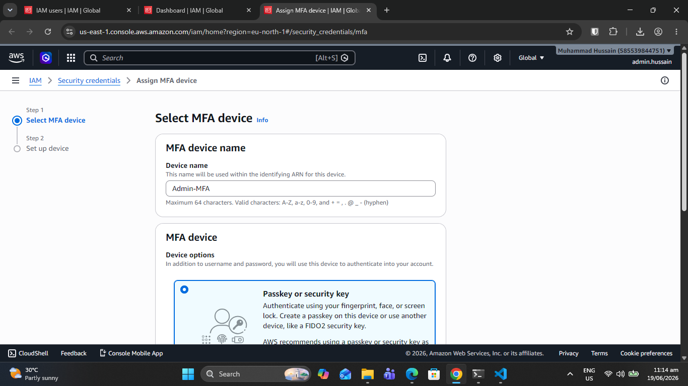
Screenshot 1.3: MFA Policy JSON Configuration Script

Policy Configuration Highlights:
- Interactive Console Guarding: Forces multi-factor token verification across all console management points.
- Restricted Self-Configuration: Allows accounts strictly to adjust and initialize their own software/hardware keys while blocking generic data visibility.
- Ambient Blockade: Denies all ambient API queries unless a valid 'aws:MultiFactorAuthPresent' parameter evaluates to True.
{
"Version": "2012-10-17",
"Statement": [
{
"Sid": "AllowManageOwnMFA",
"Effect": "Allow",
"Action": [
"iam:CreateVirtualMFADevice",
"iam:EnableMFADevice",
"iam:ListMFADevices"
],
"Resource": "arn:aws:iam::*:user/${aws:username}"
},
{
"Sid": "DenyAllExceptIfWithMFA",
"Effect": "Deny",
"NotAction": [
"iam:CreateVirtualMFADevice",
"iam:EnableMFADevice"
],
"Resource": "*",
"Condition": {
"BoolIfExists": {"aws:MultiFactorAuthPresent": "false"}
}
}
]
}

SECTION 2: NETWORK ARCHITECTURE

2.1 Virtual Private Cloud (VPC)
The environment maps a micro-segmented network matrix to prevent horizontal threat movement across processing boundaries.
- VPC Base Allocation Block: 10.0.0.0/16 CIDR definition.
- Public Gateway Subnet: 10.0.0.0/20 allocated explicitly for public-facing reverse web components.
- Private Isolation Rings: 10.0.16.0/20 and 10.0.32.0/20 networks completely separated from internet gateways.
SCREENSHOT
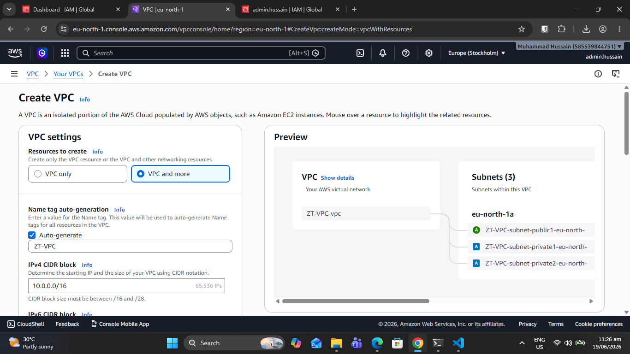
Screenshot 2.1: VPC Dashboard and Visual Structural Map

2.2 Subnet Configuration
Routing metrics are carefully isolated; internal route tables do not contain any destination targets pointed toward an Internet Gateway.
SCREENSHOT
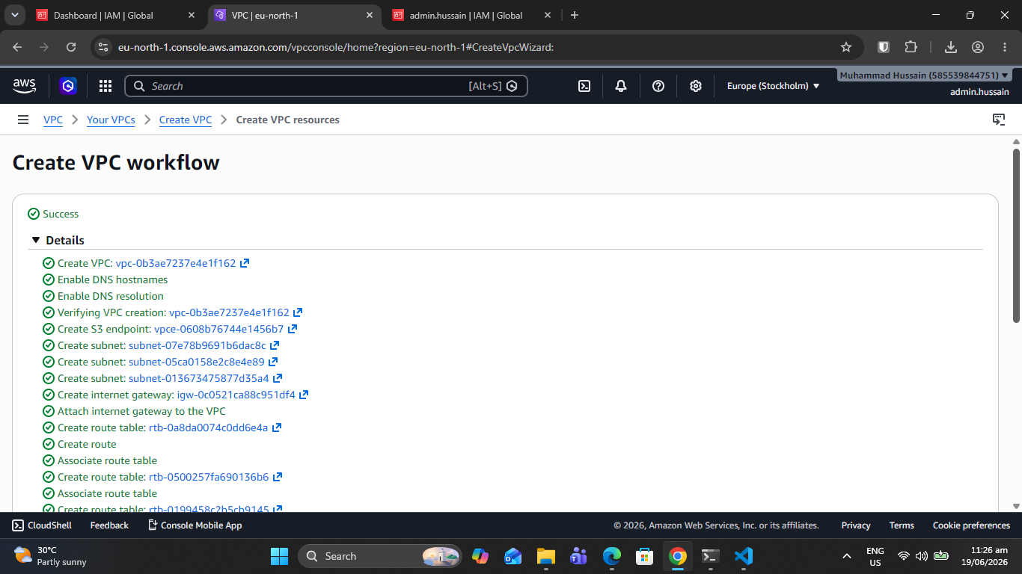
Screenshot 2.2: Subnets List and Explicit Routing Table Bindings

2.3 Security Groups (Default Deny)
Security Group firewalls enforce explicit white-listing rules, implementing an unwavering Zero Trust posture across individual instances.
SCREENSHOT
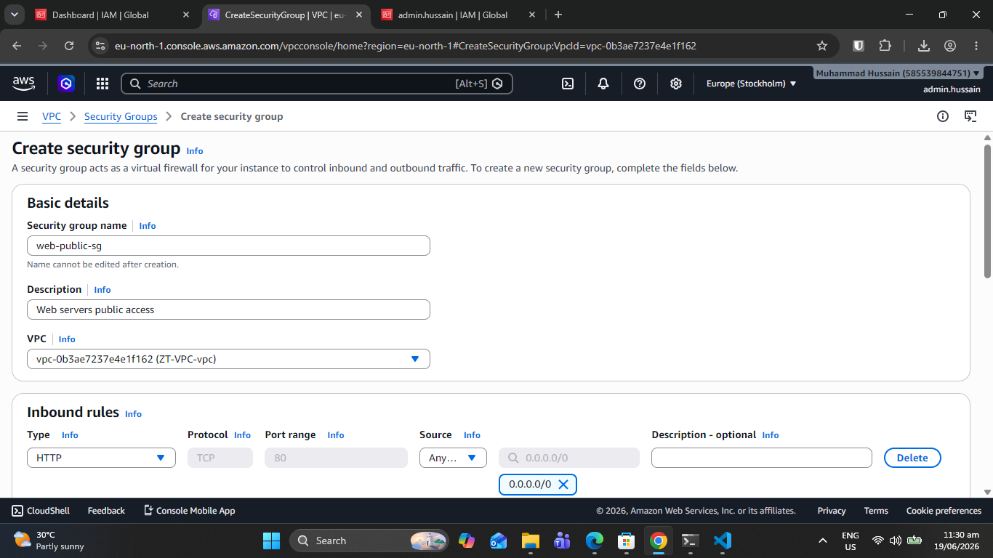
Screenshot 2.3: Security Groups Rules and Cross-Group Ingress Bindings

Traffic Traversal Ground Rules:
- Web Ingress Parameter: Accepts TCP Port 80 and 443 packets exclusively from global addresses (0.0.0.0/0).
- App Tier Layering: Permits inbound connections solely from the unique Web Server Security Group identifier.
- Database Protection Ring: Rejects all traffic unless it specifically originates from the App Tier Security Group firewall.

SECTION 3: DEPLOYMENT & COMPUTE

3.1 EC2 Instance Configuration
The foundational dashboard code executes within a hardened virtual EC2 instance operating inside a localized, secure compute container.
- Operating Platform: Amazon Linux 2023 minimal footprint architecture.
- Capacity Profile: t2.micro instance footprint (100% Free Tier optimization).
- Identity Binding: Linked directly to the 'ZeroTrustDashboardRole' avoiding static access keys on disk.
SCREENSHOT
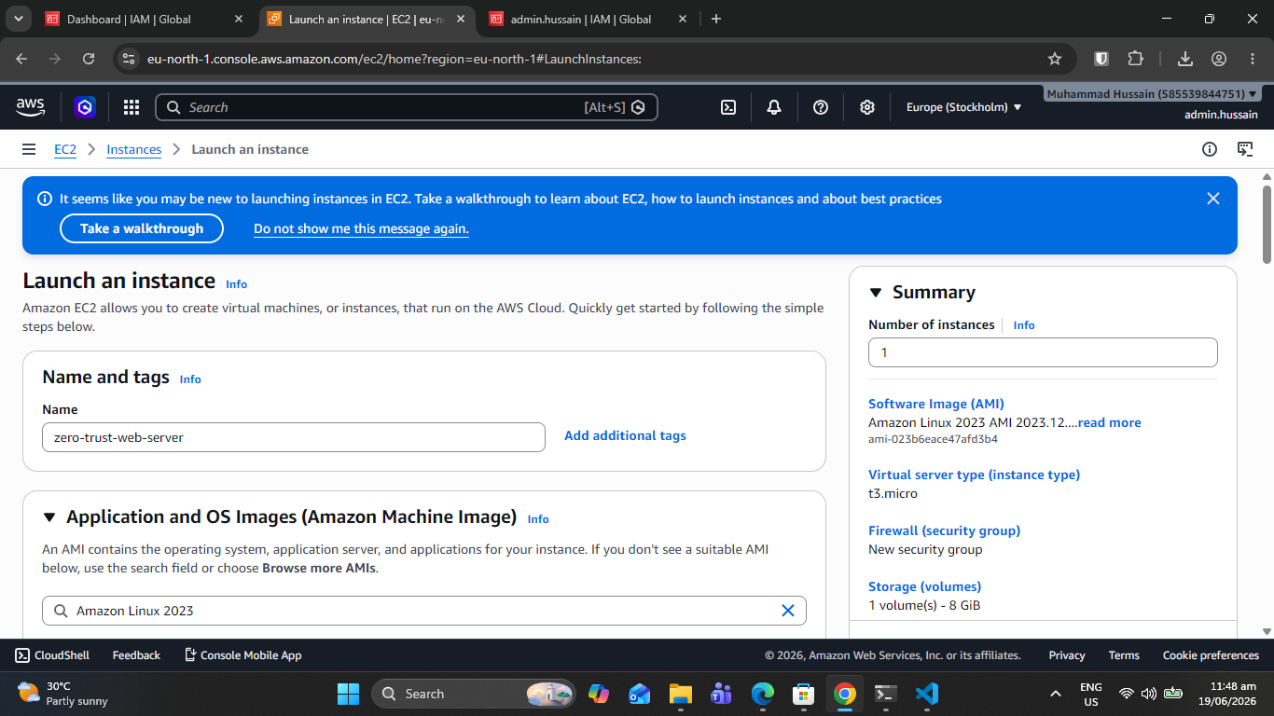
Screenshot 3.1: EC2 Instance Operational Grid and State Indicator
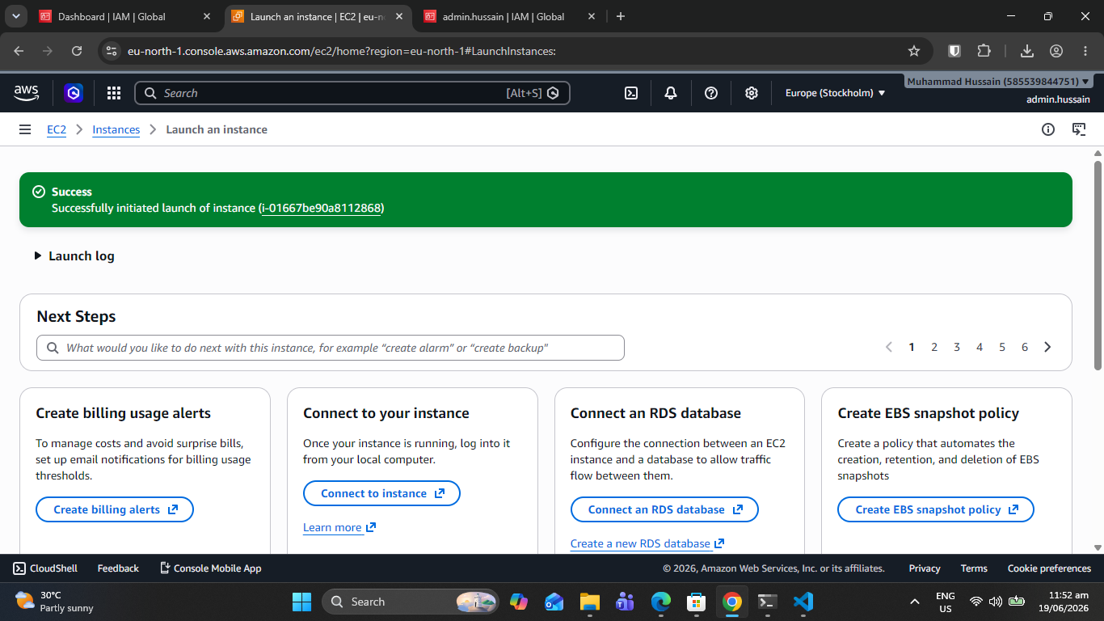

3.2 Instance Details & Public IP
Networking parameters trace real-time public routing information to simplify gateway checking logic without revealing core system identities.

3.3 Firewall Configuration
Local iptables security rules complement AWS outer firewall layers to provide thorough defense-in-depth protection.

SECTION 4: LIVE ZERO TRUST PLATFORM

4.1 Login Portal
The primary security platform requires a sequential authentication workflow before issuing active login contexts to the browser client.
- Workflow Feedback: Step layout interface elements indicating operational stage (Step 1 of 2).
- Session Warning: Persistent layout counters warning users of near-immediate session collection drops.
SCREENSHOT
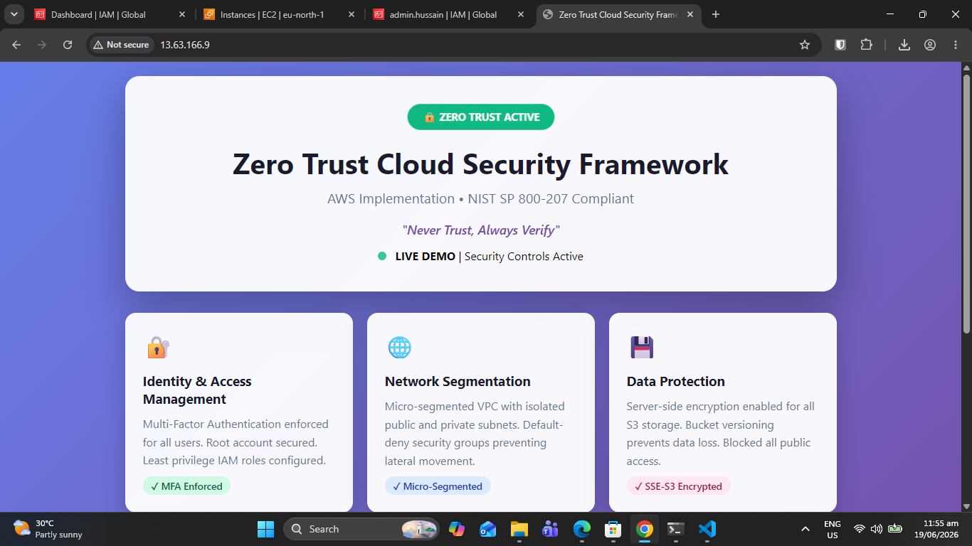
Screenshot 4.1: Live Zero Trust Login Portal UI Screen

4.2 Multi-Factor Authentication
Following primary password identification, the user session enters a gated state, demanding verification of an independent TOTP token.

4.3 Real-Time Dashboard
Once fully authenticated, the active platform runs continuous telemetry collection, displaying cloud component status information over safe API loops.
SCREENSHOT
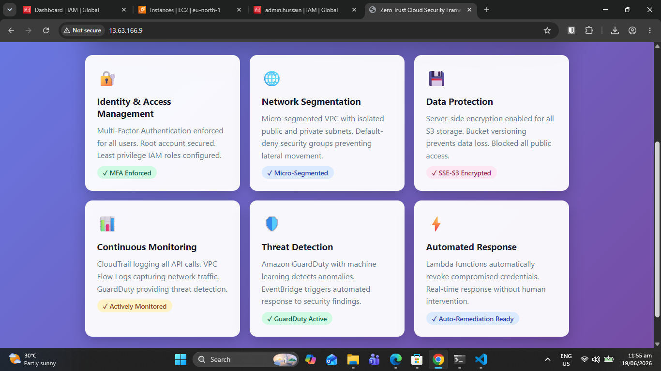
Screenshot 4.3: Real-Time Status Control Panel Dashboard Grid

4.4 AWS Service Monitoring
Real-time telemetry verification widgets evaluate the background compliance and up-time properties of cloud resources:
Service Name | Status Check Objective | Underlying Query Method
EC2 | Instance health tracking | AWS CLI describe-instance-status
Apache | Service operational state | systemctl is-active
VPC | Network object visibility | AWS CLI describe-vpcs
Security Groups | Firewall rules evaluation | AWS CLI describe-security-groups
CloudTrail | Audit log ingestion tracking | AWS CLI describe-trails
S3 | Storage block accessibility | AWS CLI s3 ls
GuardDuty | Threat detector status | AWS CLI list-detectors

4.5 Audit Logging
System actions are completely timestamped, formatted, and pushed to an immutable file structure to maintain an accurate history of user activities.

SECTION 5: MONITORING & LOGGING

5.1 AWS CloudTrail
AWS CloudTrail tracks all API invocations, guaranteeing full visibility into infrastructure change events.
SCREENSHOT
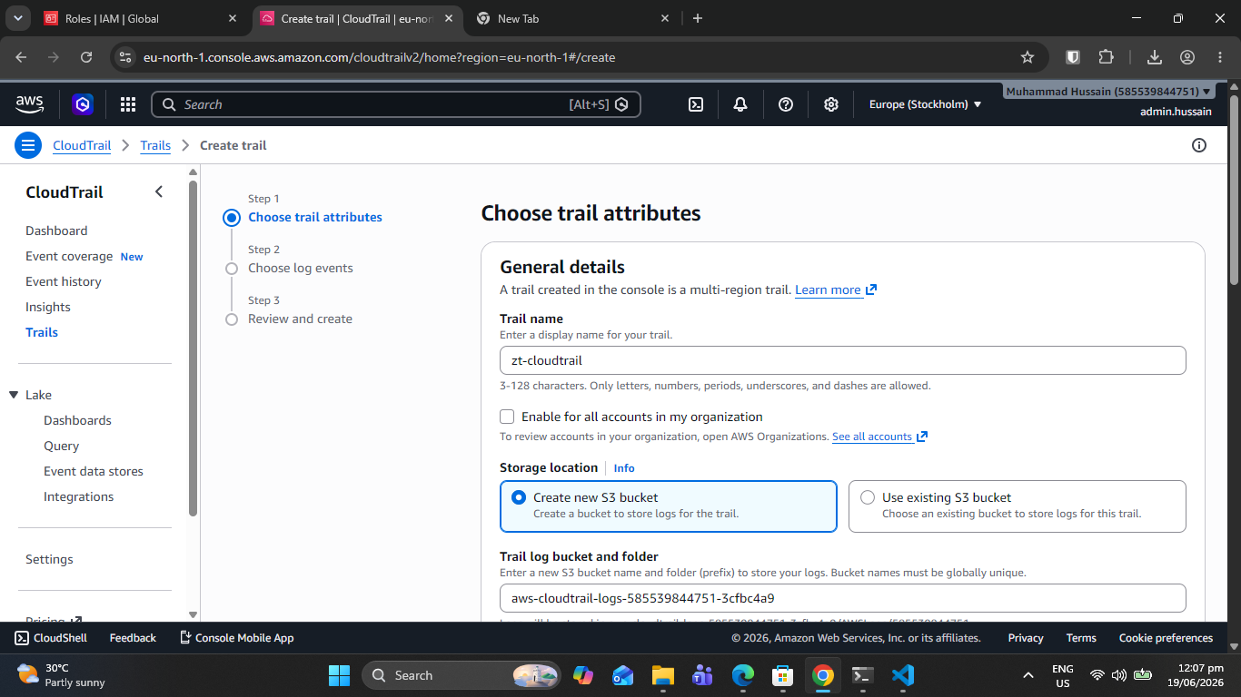
Screenshot 5.1: AWS CloudTrail Active Configuration Audit Grid

5.2 VPC Flow Logs
Flow Logs track low-level network connection trends, capturing packet drops to help identify scanning attempts.
SCREENSHOT
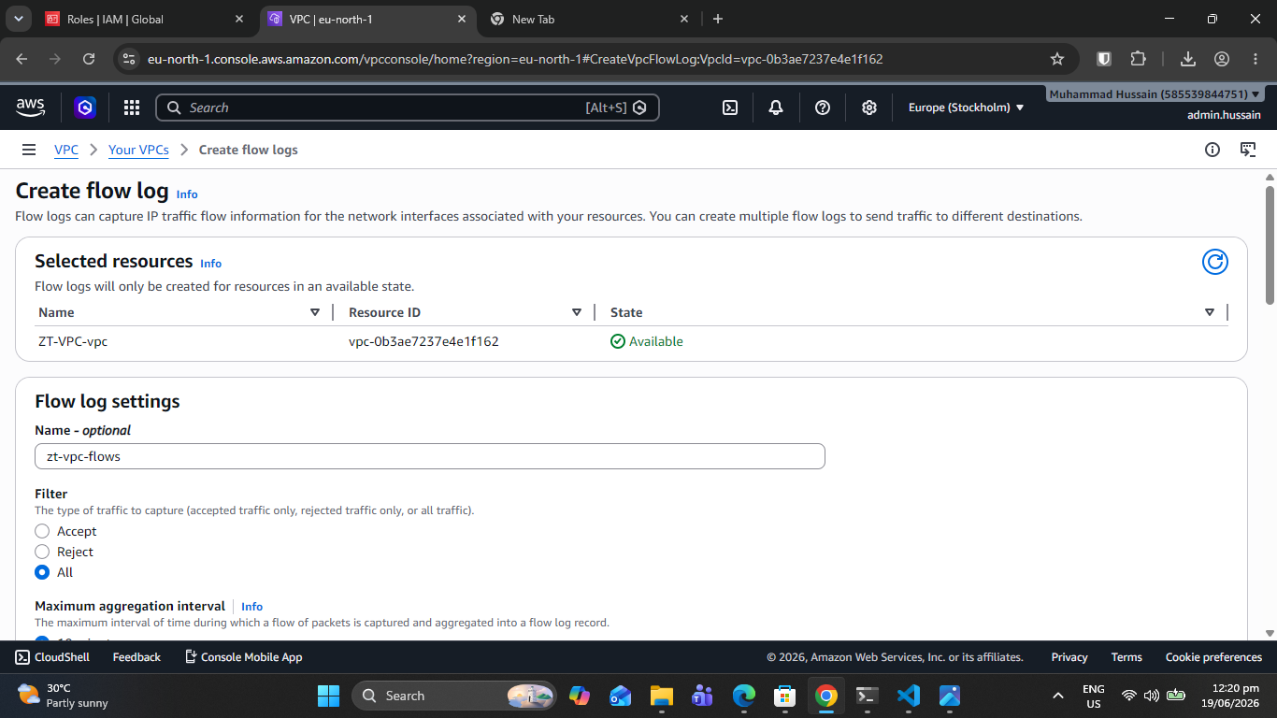
Screenshot 5.2: VPC Flow Logs Metadata Stream Capture

5.3 Amazon GuardDuty
Amazon GuardDuty acts as an intelligent threat detection engine, analyzing system activity logs to spot unauthorized use patterns.
SCREENSHOT
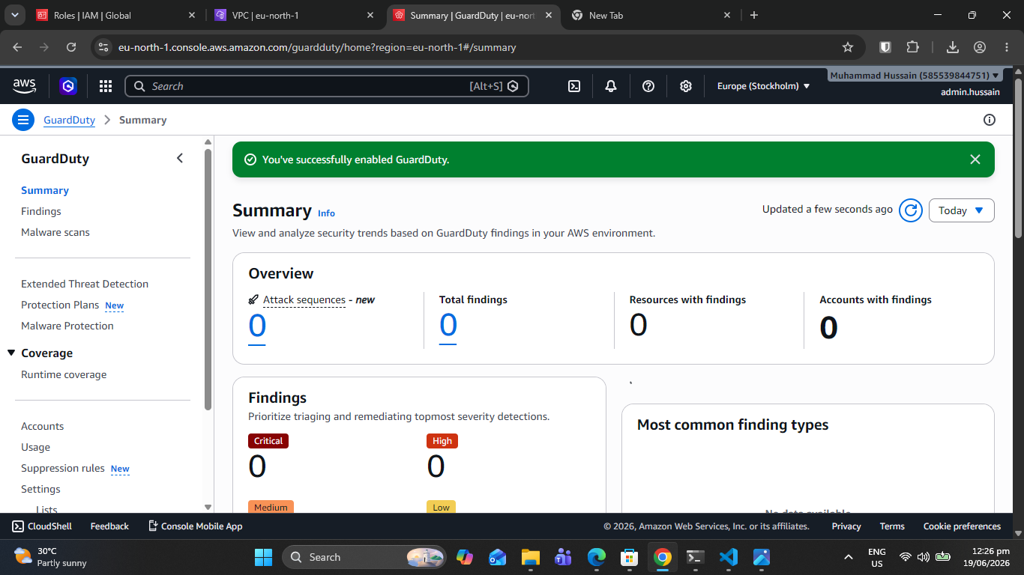
Screenshot 5.3: Amazon GuardDuty Intelligent Threat Panel View

SECTION 6: ZERO TRUST VERIFICATION

6.1 Automatic Session Timeout
To mitigate session hijacking risks, active user dashboard access automatically terminates after exactly 10 minutes of complete inactivity.

6.2 Account Lockout Protection
Brute-force protection rules lock accounts for 15 minutes if three consecutive incorrect login attempts are detected.

ZERO TRUST PRINCIPLES IMPLEMENTED
Core Architectural Principle | Project Practical Implementation | Compliance Status
Never Trust, Always Verify | Every access request demands explicit credential + TOTP MFA mapping. | ✓ Compliant
Least Privilege Access | IAM identities use tightly scoped role rules avoiding asterisks. | ✓ Compliant
Micro-Segmentation | VPC structures utilize isolated subnets and strictly chained security groups. | ✓ Compliant
Continuous Monitoring | Asynchronous platform scripts query real-time security state metrics. | ✓ Compliant
Assume Breach | Short-lived tokens, aggressive session timeouts, and permanent audit trails. | ✓ Compliant
Explicit Verification | MFA validation parameters are forced across every discrete login lifecycle. | ✓ Compliant

AWS SERVICES USED
AWS Service | Target Purpose within Architecture | Free Tier Eligibility
Amazon EC2 | Hosts the primary web application portal and telemetry scripts. | ✓ Covered (750 Hours Free)
Amazon VPC | Ensures strict logical network | ✓ Covered (Always Free)
AWS IAM | Orchestrates access permissions and identity policies. | ✓ Covered (Always Free)
AWS CloudTrail | Records comprehensive control-plane API audit logs. | ✓ Covered (First Trail Free)
Amazon GuardDuty | Provides real-time threat detection across log streams. | ✓ Covered (30-day Free Trial)
Amazon S3 | Acts as an immutable repository for security event logs. | ✓ Covered (5 GB Free Storage)

LIVE ENTERPRISE DEMO ACCESS
The fully deployed environment can be audited live via the public endpoint URL below:
URL Address Target: http://13.63.166.9
Target Username | Baseline Password Asset | Assigned RBAC Authorization Profile
admin | ZeroTrust2026! | Full Corporate Administrator Role
analyst | Security2026! | Read-Only Security Analyst Profile
auditor | Audit2026! | Compliance Auditor Verification Profile

Verification Note: The multi-factor authentication validation key is generated dynamically and displayed on the initial web portal login interface (rotating on a standard 30-second loop).

CONCLUSION
The Zero Trust Cloud Security Framework has been successfully deployed and verified on AWS. This project provides a practical model for key cloud security concepts: robust multi-factor identity checks, granular network segmentation, continuous resource auditing, proactive session tracking, and tamper-resistant audit trails. The resulting architecture serves as a baseline for deploying secure cloud infrastructure workflows.

REFERENCES
• NIST Special Publication 800-207: Zero Trust Architecture Design Frameworks
• AWS Well-Architected Framework - Core Cloud Security Pillar Guidelines
• AWS Free Tier Limits and Structural Eligibility General Matrix
• OWASP Session Management Guidelines and Cryptographic Token Practices

