⁷

FACULTY OF ENGINEERING SCIENCES AND TECHNOLOGY

Department of Computer Science

Program : BS Cyber Security

Lab Manual

CYE425L- Cloud Security Lab

Instructor’s Name: M. Ahsan Naeem
Student’s Name: Muhammad Hussain
Roll No. 64493
Batch: Spring 2023
Instructor | Muhammad Ahsan Naeem
Designation | Lecturer
Department | FEST
Semester | Spring 2026
Office Location | EDE – 101 (Cubical – 05)
Email | muhammmad.ahsan@iqra.edu.pk
Office Hours | 8.30 AM to 4.30 PM
Prerequisite(s) | Data Communication and Computer Network
Credit Hours | 1



FACULTY OF ENGINEERING SCIENCES AND TECHNOLOGY

CYE425L- Cloud Security Lab
Prepared By:
Muhammad Hussain

Reviewed / Approved By:
Muhammad Ahsan Naeem

Faculty of Engineering Sciences & Technology Iqra University



FACULTY OF ENGINEERING SCIENCES AND TECHNOLOGY

Course Objective(s)

The course aims to equip students with the practical skills needed to design and build a Virtualized Data Center and convert it in to a Private Cloud. Students will also get a chance to create a domain environment and apply security policies for the controlled access. Students will learn advance features of Virtualization and be able manage and troubleshoot server issues effectively

Course Contents

The lab sessions include installing and configuring Type 2 Hypervisors (Workstation an Oracle Box), Virtual machine Deployment, Installing OSes on virtual machines, ESXi deployment, vCenter Server, Installing Windows
Servers, Active Directory Domain Services, User accounts, Folder Permissions, Group Policy Objects (GPO)



FACULTY OF ENGINEERING SCIENCES AND TECHNOLOGY

TABLE OF CONTENT

Week No | Lab No | Lab Description | Credit hrs | CLO
1 | 1 | Download and install virtualization software (VMware Workstation or VirtualBox) | 3 | 1
2 | 2 | AWS Identity and Access Management (IAM): Users, Roles, and Policies | 3 | 3
3 | 3 | AWS Cloud Shell: Command-line access and resource management | 3 | 2
4 | 4 | AWS Lambda: Create and deploy serverless functions | 3 | 3
5A | 5A | Secure Docker Deployment in Cloud Environments | 3 | 2
5B | 5B | Docker Deployment and Installation on AWS EC2 Server | 3 | 2
6 | 6 | Cloud Lab: Monitoring AWS Lambda using CloudWatch Metrics & Logs | 3 | 3
7 | 7 | CCP Discussion | 3 | 3
8 | 8 | Mid Term
9 | 9 | Data Protection: Encryption and Key Management Systems | 3 | 3
10 | 10 | Designing and Configuring an AWS VPC | 3 | 3
11 | 11 | Auditing with AWS CloudTrail | 3 | 3
12 | 12 | Container Security Architecture: Managed Image Scanning | 3 | 3
13 | 13 | Infrastructure as Code (IaC): Secure Deployments using AWS CloudFormation | 3 | 3
14 | 14 | Implementing DevSecOps Pipelines: Automated Security Controls in AWS CodePipeline | 3 | 3
15 | 15 | CCP Submissions and Viva | 3 | 3
16 | 16 | Final Term



FACULTY OF ENGINEERING SCIENCES AND TECHNOLOGY

Course Learning Outcomes
CLOs |  | CLO Statement |  | BT  Level | Mapping |  |  |  | %  Weight
 |  |  |  |  | GAs |  | ACM KA | SGDs
CLO1 |  | Apply the concepts of Virtualization techniques to design, configure, and simulate private cloud |  | P1 | GA2 |  | #10  NC | 4 | NA
CLO2 |  | Practice problem-solving and network troubleshooting skills by configuring and testing servers and hypervisors |  | A2 | GA6 |  |  |  | NA
CLO3 |  | Design data center architecture for private cloud |  | C6 | GA4 |  |  |  | NA
Note: On successful completion of course GA 1 (Academic Education) will automatically attain.
Course Textbook / Reference Books and Supplementary Reading Material
S No | Book Title |  | Author(s) |  |  | Edition/publication year/publisher
1. | Cloud Computing and Virtualization |  | Dac-Nhuong Le |  |  | 1st Edition, 2018, Scrivener
2. | Cloud Computing Principles and  Paradigms. |  | Rajkumar Buyya |  |  | 1st Edition, 2010, WILEY
3. | Mastering Active Directory |  | Dishan Francis |  |  | 3rd Edition, 2021, Packet Publish
Course Learning Outcomes
CLOs |  | CLO Statement |  | BT  Level | Mapping |  |  |  | %  Weight
 |  |  |  |  | GAs |  | ACM KA | SGDs
CLO1 |  | Apply the concepts of Virtualization techniques to design, configure, and simulate private cloud |  | P1 | GA2 |  | #10  NC | 4 | NA
CLO2 |  | Practice problem-solving and network troubleshooting skills by configuring and testing servers and hypervisors |  | A2 | GA6 |  |  |  | NA
CLO3 |  | Design data center architecture for private cloud |  | C6 | GA4 |  |  |  | NA
Note: On successful completion of course GA 1 (Academic Education) will automatically attain.



FACULTY OF ENGINEERING SCIENCES AND TECHNOLOGY

Psychomotor Rubrics Assessment Hardware

Lab # | Score Allocation
 | Experimental  Setup Marks (3) | Procedure Marks (2) | Experimental  Results Marks (3) | Laboratory  Manual Marks (2) | Total Marks  (10)
1
2
3
4
5
6
7
8
9
10
11
12
13
14
Total Mark |  |  | 140 | Total Obtained Marks



FACULTY OF ENGINEERING SCIENCES AND TECHNOLOGY

Psychomotor Rubrics for Software based Lab

Course Name (Course Code):

Criteria | Exceeds Expectations  (>=90%) | Meets Expectations  (70%-89%) | Developing  (50% - 69%) | Unsatisfactory  (<50%)
Software Skills | Ability to use software with its standard and advanced features without assistance | Ability to use software with its standard and advanced features  with minimal assistance | Ability to use software with its standard features with assistance | Unable to use the software
Programming/ Simulation | Ability to program/ simulate the lab tasks with simplification | Ability to program/ simulate the lab tasks without errors | Ability to program/  simulate lab tasks with errors | Unable to program/simula te
Results | Ability to achieve all the desired results with alternate ways | Ability to achieve all the desired results | Ability to achieve most of the  desired results with errors | Unable to achieve the desired results
Laboratory Manual | All sections of the report are very well written and technically accurate. | All sections of the report are technically accurate. | Few sections of the report  contain technical errors. | All sections of the report  contain multiple technical errors.

Overall Score: out of 14

Examined by:

(Name and Signature of lab instructor)



FACULTY OF ENGINEERING SCIENCES AND TECHNOLOGY

Psychomotor Rubrics Assessment Software based Lab

Course Name (Course Code):

Lab # | Score Allocation
 | Software Skills  Marks (3) | Programming/  Simulation  Marks (2) | Experimental  Results Marks (3) | Laboratory Manual  Marks (2) | Total Marks  (10)
1
2
3
4
5
6
7
8
9
10
11
12
13
14
Total Marks |  | 140 |  | Total Obtained marks

Overall Score: out of 14

Examined by:

(Name and Signature of lab instructor)



FACULTY OF ENGINEERING SCIENCES AND TECHNOLOGY

Affective Domain Rubrics Assessment

Course Name (Course Code): Semester:
Overall Score: out of 14

Examined by:

(Name and Signature of lab instructor)



FACULTY OF ENGINEERING SCIENCES AND TECHNOLOGY

Open Ended Lab Assessment Rubrics

Course Name (Course Code):
Semester:

Criteria and Scales
Excelent (10-8) | Good (7-5) | Average (4-2) | Poor (1-0)
Criterion 1: Understanding the Problem: How well the problem statement is understood by the student
Understands the problem clearly and clearly identifies the underlying issues. | Adequately understands the problems and identifies the underlying issues. | Inadequately defines the  Problem and identifies the underlying issues. | Fails to define the problem adequately and does not identify the underlying gissues.
Criterion 2: Research: The amount of research that is used in solving the problem
Contains all the information needed for solving the problem | Good research, leading to a successful solution | Mediocre research which may or may not lead to an adequate solution | No apparent research
Criterion 3: Class Diagram: The completeness of the class diagram
Class diagram with complete notations | Class diagram with incomplete notations | Class diagram with improper naming convention and notations | No Class diagram
Criterion 4: Code: How complete and accurate the code is along with the assumptions
Complete Code according to the class diagram of the given case with clear assumptions | Incomplete Code according to the class diagram of the given case with clear assumptions | Incomplete Code according to the class diagram of the given case with unclear assumptions | Wrong code and naming conventions
Criterion 5: Report: How thorough and well organized is the solution
All the necessary information  Clearly organized for easy usse in solving the problem | Good information organized well that could lead to a good solution | Mediocre information which may or may not lead to a solution | No report provided



FACULTY OF ENGINEERING SCIENCES AND TECHNOLOGY

Open Ended Lab Assessment Rubrics

Course Name (Course Code):
Semester:

Criteria and Scales
Excellent (10-8) | Good (7-5) | Average (4-2) | Poor (1-0) | Total Marks 10
Criterion 1: Understanding the Problem: How well the problem statement is understood by the student
- 8) | (7-5) % | (4-2) % | (1-0) %
Criterion 2: Research: The amount of research that is used in solving the problem
(10-8) | (7-5) % | (4-2) % | (1-0) %
Criterion 3: Class Diagram: The completeness of the class diagram
(10-8) | (7-5) % | (4-2) % | (1-0) %
Criterion 4: Code: How complete and accurate the code is along with the assumptions
(10-8) | (7-5) % | (4-2) % | (1-0) %
Criterion 5: Report: How thorough and well organized is the solution
(10-8) | (7-5) % | (4-2) % | (1-0) %
Total |  |  |  | ( /5)

Total marks obtained:

Name and signature of lab instructor:



FACULTY OF ENGINEERING SCIENCES AND TECHNOLOGY

Criteria | Exceed Expectations (>=90%) | Meets Expectations  (70%-89%) | Developing (50%-69%) | Unsatisfactory %)
Project Presentation  +  Project Demonstration | Ability to demonstrate the project with achievement of required objectives having clear understanding of project limitations and future  enhancements. Hardware and/or Software modules are fully functional, If applicable. | Ability to demonstrate the project with  achievement of required objectives but  understanding of project limitations  a future enhancements are insufficient.  Hardware and/or Software modules are functional, if applicable. | Ability to demonstrate the project with achievement of at least 50% required objectives and insufficient  understanding of project  limitations and future enhancements. Hardware and/or Software modules are partially functional, if applicable. | Ability to demonstrate the project with achievement of less than 50% required objectives and lacks in understanding of project limitations and future enhancements. Hardware and/or Software modules are not functional, if applicable.
Project Report | All sections of the project report are very well-written and technically accurate. | All sections of the Project report are technically accurate. | Few sections of the Project report contain technical errors. | Project report has several  grammatical/spelling errors and sentence construction are poor.
Viva | Able to answer  the questions easily and correctly across the project. | Able to answer the Questions related to the project | Able to answer the questions but with mistakes | Unable to answer the questions



FACULTY OF ENGINEERING SCIENCES AND TECHNOLOGY

Rubrics for Lab Project / CCA

Course Name (Course Code):

Total marks:
Name and Signature of lab instructor:

Project # | Score Allocation
 | Project Presentation +  Project Demonstration Marks (5) | Project Report Marks (2) | Viva Marks (3) | Total Marks  (10)
1
2
Total Obtained Score



FACULTY OF ENGINEERING SCIENCES AND TECHNOLOGY

Project / CCA Rubric based Assessment

Course Name (Course Code): Semester:

Total marks obtained:

Name and Signature of lab instructor:



FACULTY OF ENGINEERING SCIENCES AND TECHNOLOGY

Mid Term Rubrics

Course Name (Course Code):
Semester:

Criteria | Exceeds Expectations (>=90%) | Meets Expectations (70%-89%) | Developing (50%-69%) | Unsatisfactory (<50%)
Performance | Able to present full knowledge of both problem and solution. | Able to present adequate knowledge of both problem and solution | Able to present sufficient knowledge of both problem and Solution | No or very less knowledge of both problems and solution
Viva | Able to answer the questions easily and correctly | Able to answer the questions | Able to answer the questions but with mistakes | Unable to answer the questions

Mid Term Rubrics based Assessment

Course Name (Course Code): Semester, Batch:

Examined by:

(Name and Signature of concerned lab instructor)



FACULTY OF ENGINEERING SCIENCES AND TECHNOLOGY

Final Term Rubrics

Course Name (Course Code):
Semester:

Criteria | Exceeds Expectations  (>=90%) | Meets Expectations (70%-89%) | Developing (50%-69%) | Unsatisfactory (<50%)
Performance | Able to present full knowledge of both problem and solution. | Able to present adequate knowledge of both problem and  solution | Able to present sufficient knowledge of both problem and  Solution | No or very less knowledge of both problems and solution
Viva | Able to answer the questions easily and correctly | Able to answer the questions | Able to answer the questions but with mistakes | Unable to answer the questions

Final Term Rubrics based Assessment

Course Name (Course Code):
Semester:
Batch:

Score Allocation
Performance | /45
Viva | /5
Total Obtained Score | / 50

Examined by:

(Name and Signature of concerned lab instructor)



FACULTY OF ENGINEERING SCIENCES AND TECHNOLOGY

Final Lab Assessment

Assessment Tool | CLO-1 (20) | CLO-2 (20) | CLO-3 (10)
Lab Manual
Subject Project/Viva
Lab Exam / Viva
Score Obtained
Total Score out of 50

Examined by:

(Name and Signature of concerned lab instructor)



FACULTY OF ENGINEERING SCIENCES AND TECHNOLOGY
Lab Session 01

Objective:

Download and install virtualization software (either VMware Workstation or Oracle VirtualBox).

Required Equipment:
- VMware Workstation or Oracle VirtualBox installer
- Windows/Linux machine

Introduction:
Virtualization software allows running multiple operating systems on a single physical machine. It is essential for cloud computing labs as it provides isolated environments for testing and deployment.

Procedure:
- Navigate to the official VMware or VirtualBox website.
- Download the installer for your operating system.
- Run the installer with administrative privileges.Accept the license agreement and follow installation steps.
- Launch the software and verify installation.

Task:
Install and configure virtualization software successfully.

Conclusion:
You will have a working virtualization environment ready for cloud labs.

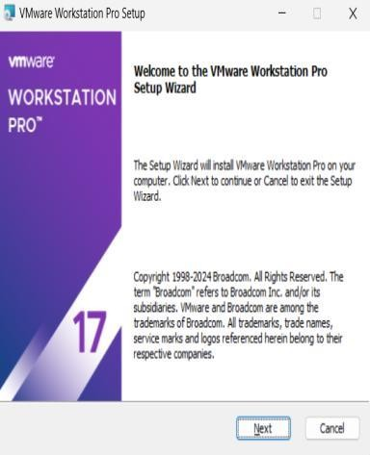
Task 1:
Installing and Configuring VMware Workstation on a Windows Machine.

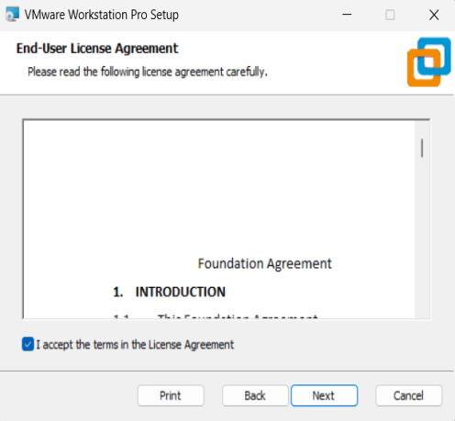

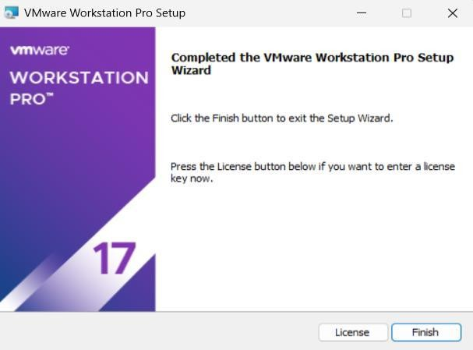
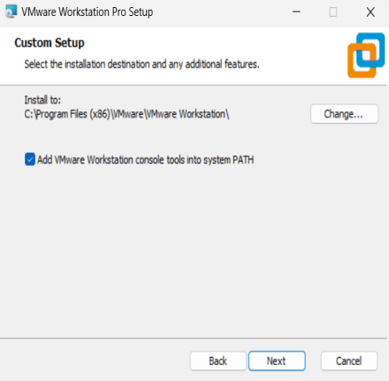
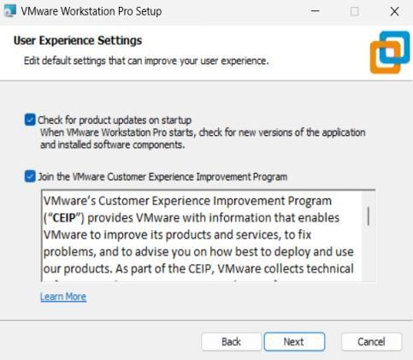
Workstation and gained hands-on experience with its key features. Documenting these steps ensures reproducibility and understanding

QUESTIONS

Question 1:

What are the differences between VMware Workstation and VirtualBox?

Question 2:

Why is virtualization important in cloud computing?

Question 3:
What are the key configuration steps after installing VMware Workstation.



FACULTY OF ENGINEERING SCIENCES AND TECHNOLOGY
Lab Session 02

Objective:

Understand AWS Identity and Access Management (IAM).

Required Equipment:
- AWS account
- Internet connection

Introduction:
IAM enables secure control of access to AWS services and resources. It allows creation of users, groups, and roles with specific permissions.

Procedure:
- Log in to AWS Management Console.
- Navigate to IAM service.
- Create a new user and assign permissions.
- Create groups and roles for access control.
- Apply policies to restrict or allow actions.

Task:
Create IAM users, groups, and roles with appropriate policies.

Conclusion:
You will understand how to manage access securely in AWS

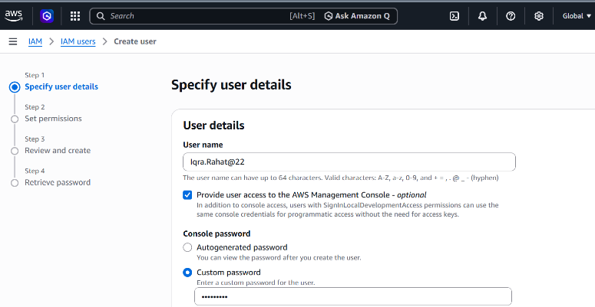

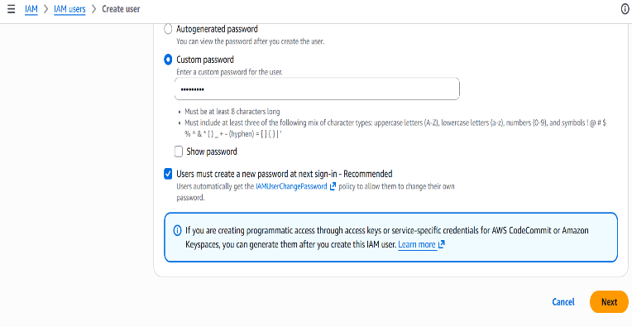

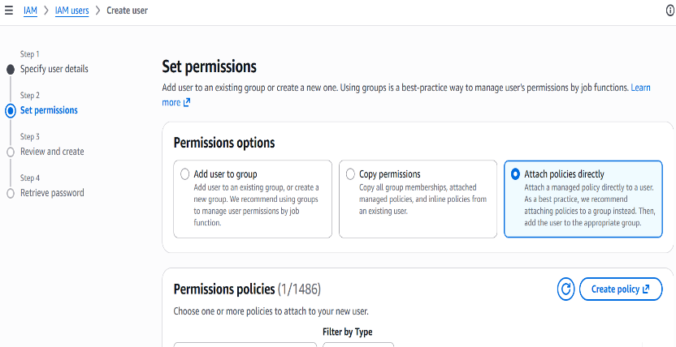

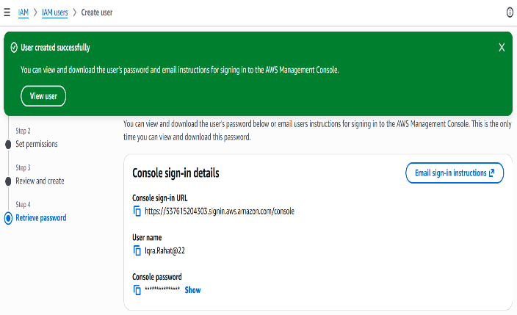

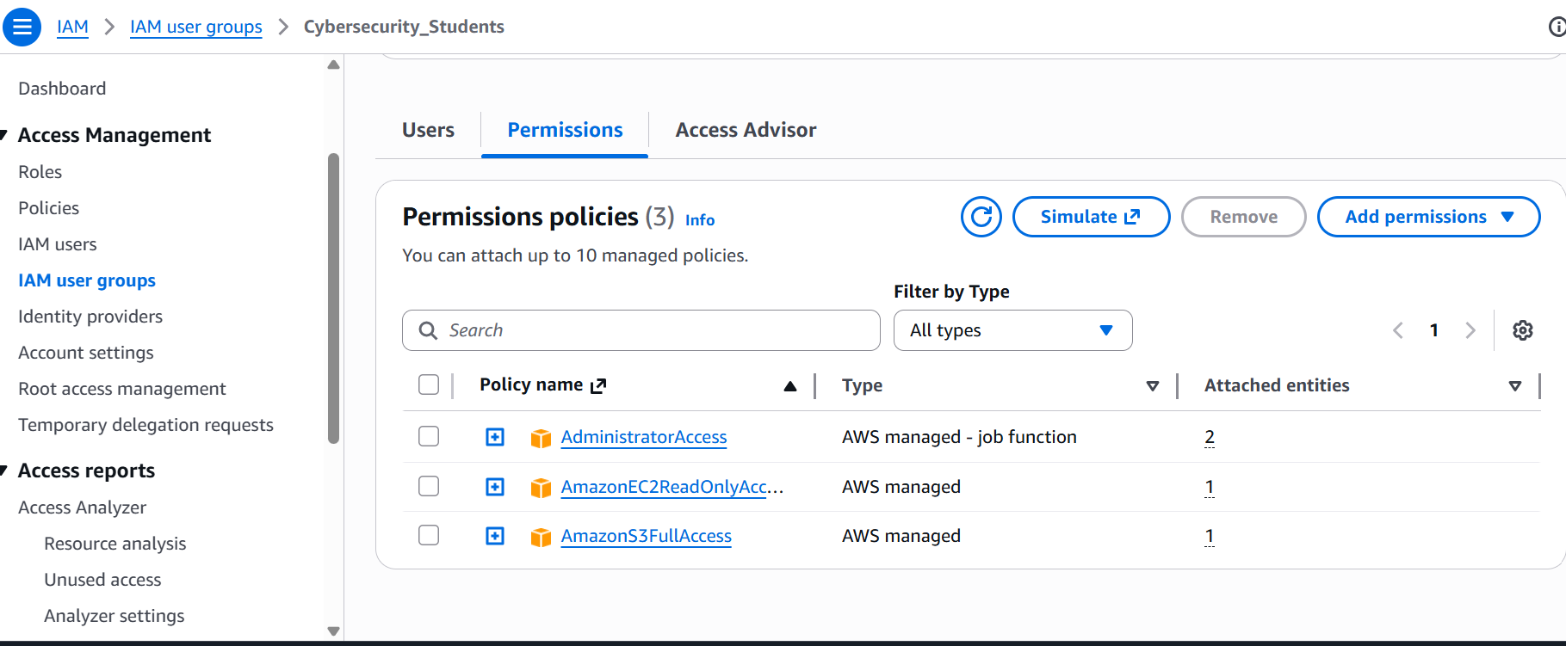

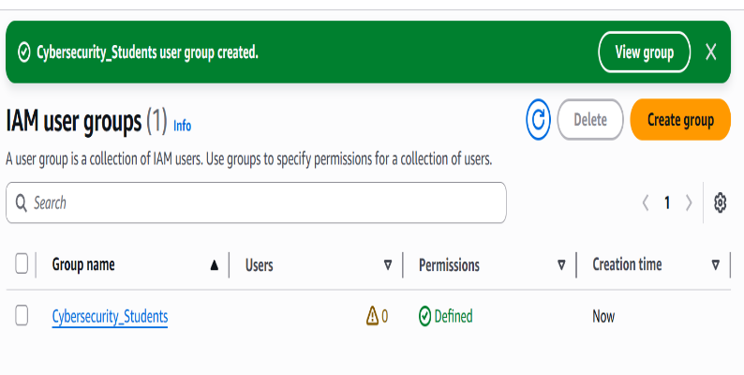

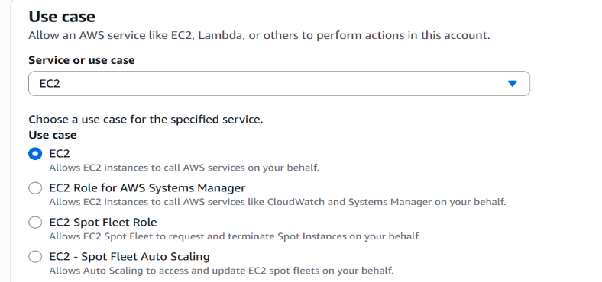

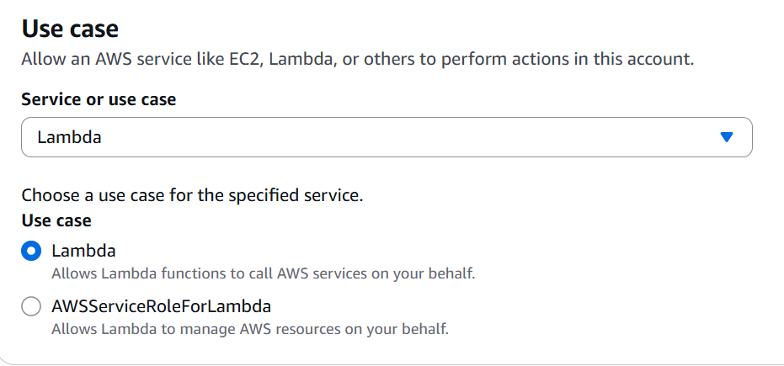

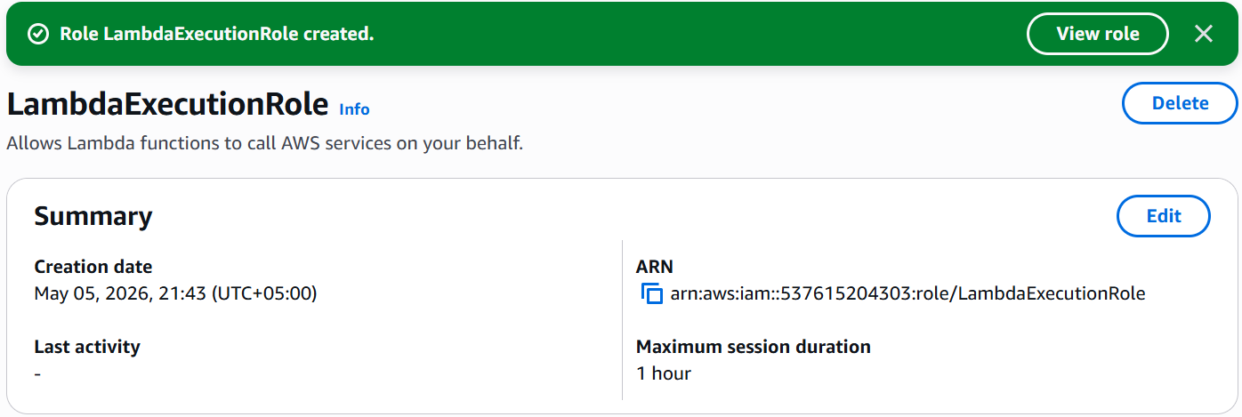

QUESTIONS:

Question 1:

What is the difference between IAM roles and IAM users?

Question 2:

Why are policies important in IAM?



FACULTY OF ENGINEERING SCIENCES AND TECHNOLOGY
Lab Session 03

Objective:

Understand AWS CloudShell for command-line access and resource management.

Required Equipment:
- AWS account
- Internet connection

Introduction:
AWS CloudShell is a browser-based command-line interface that allows users to interact with AWS services directly from the AWS Management Console. It comes with pre-installed tools like AWS CLI, enabling efficient resource management without additional setup.

Procedure:
- Log in to AWS Management Console.
- Open AWS CloudShell from the console.
- Explore the command-line interface.
- Run basic AWS CLI commands.
- Manage AWS resources using CloudShell.

Task:
Use AWS CloudShell to execute commands and manage AWS resources.

Conclusion:
You will understand how to use CloudShell for command-line operations and resource management in AWS.
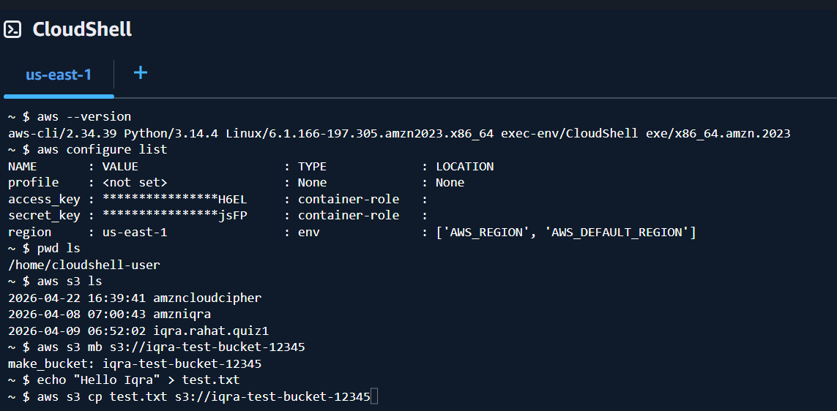

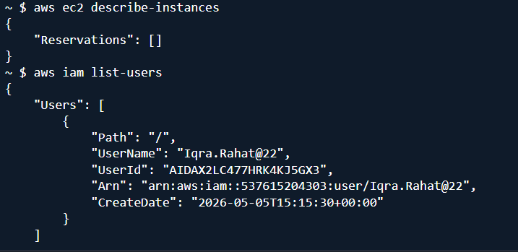

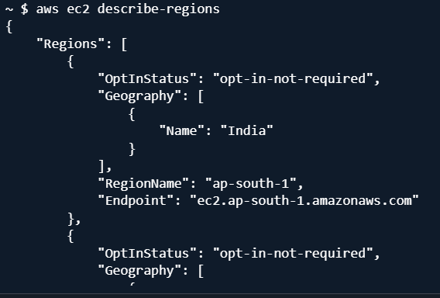

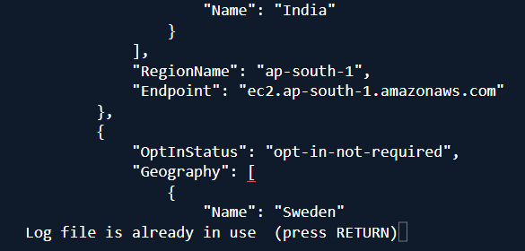

QUESTIONS:

Question 1:

What is AWS CloudShell and why is it useful?

Question 2:

How does AWS CLI help in resource management?



FACULTY OF ENGINEERING SCIENCES AND TECHNOLOGY
Lab Session 04

Objective:

Understand AWS Lambda and create server less functions.

Required Equipment:
- AWS account
- Internet connection

Introduction:
AWS Lambda is a server less computing service that allows users to run code without managing servers. It automatically handles scaling and executes code in response to events, making application development faster and more efficient.

Procedure:
- Log in to AWS Management Console.
- Navigate to AWS Lambda service.
- Create a new Lambda function.
- Write and deploy function code.
- Test the function and monitor execution.

Task:
Create and deploy a simple AWS Lambda function.

Conclusion:
You will understand how server less computing works and how to deploy functions using AWS Lambda.

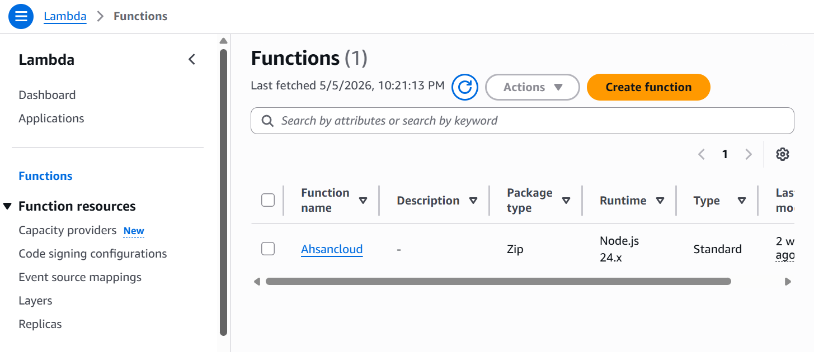

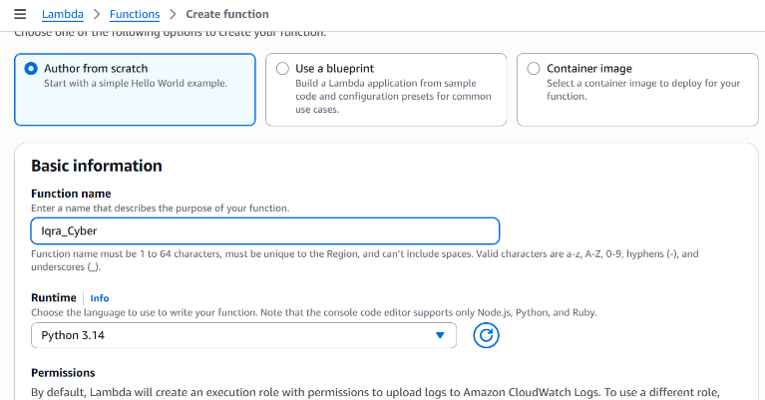

QUESTIONS:

Question 1:

What is AWS Lambda and how does it work?

Question 2:

What are the advantages of serverless computing?



FACULTY OF ENGINEERING SCIENCES AND TECHNOLOGY
Lab Session 05A

Objective:
Understand Docker and create, manage, and run containers using basic Docker commands.

Required Equipment:
- System with Docker installed
- Internet connection
- Terminal / Command Prompt

Introduction:

Docker is an open-source platform used to develop, ship, and run applications inside containers. Containers package an application with all its dependencies, ensuring consistency across different environments. Docker simplifies deployment and improves scalability similar to serverless concepts but with more control over runtime environments.

Procedure:

1. Check Docker Installation
Verify Docker is installed and running:
docker --version

2. Pull a Sample Image
Download a basic image from Docker Hub:
docker pull nginx

3. Run a Container on Port 8080
Start a container and map it to port 8080:
docker run -d -p 8080:80 --name mycontainer nginx

4. List Running Containers
docker ps

5. List All Containers (including stopped)
docker ps -a

6. Stop a Container
docker stop mycontainer

7. Start a Container
docker start mycontainer

8. View Container Details
docker inspect mycontainer

9. Access Application
Open browser and visit:

http://localhost:8080

Task:
- Install Docker (if not installed)
- Pull an image (e.g., nginx)
- Run a container on port 8080
- List running and stopped containers
- Start and stop the container

Conclusion:
You will understand how Docker containers work, how to deploy applications inside containers, and how to manage them using essential Docker commands. This lab builds a foundation for advanced topics like container orchestration and cloud deployment.

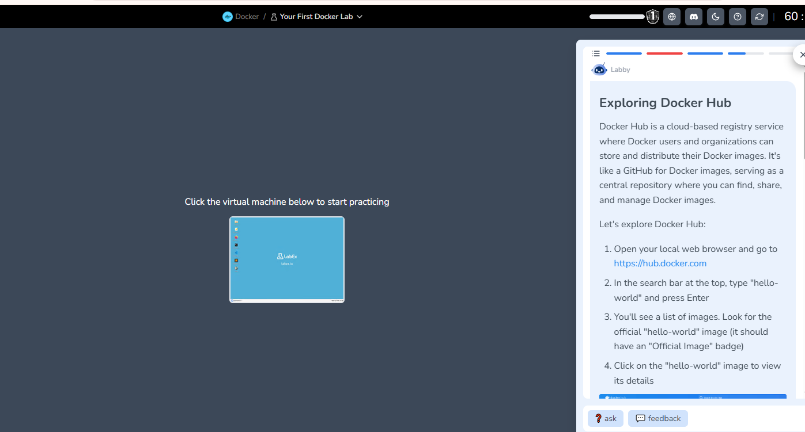

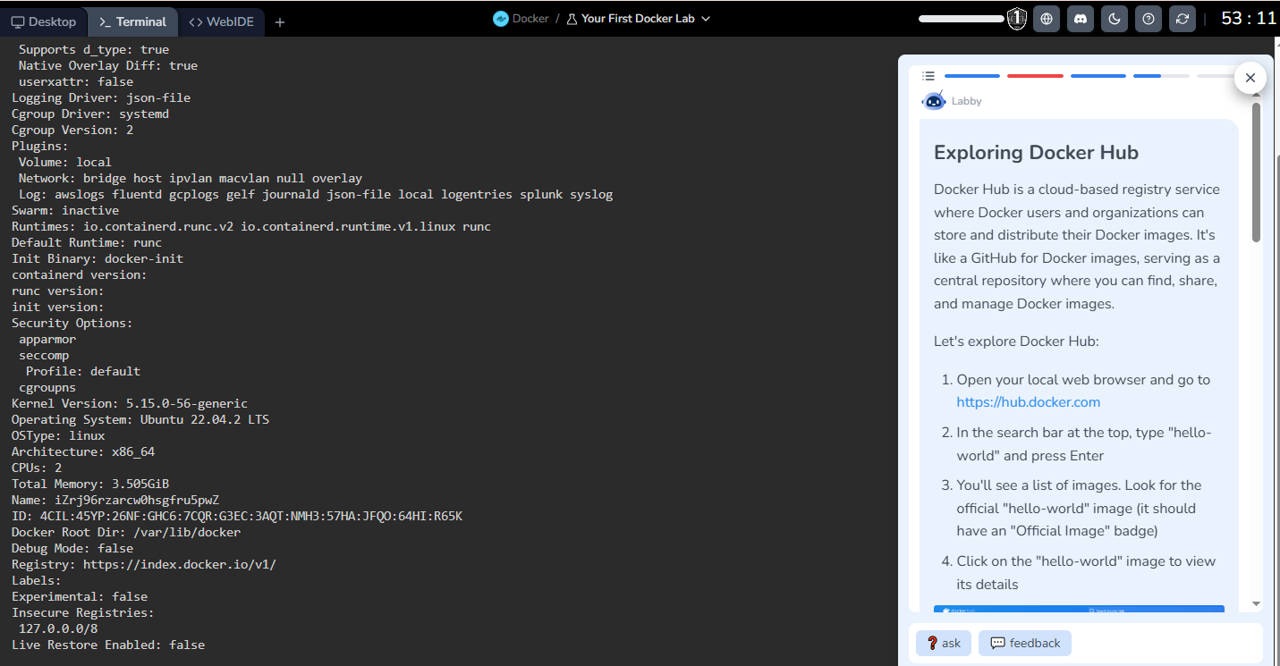

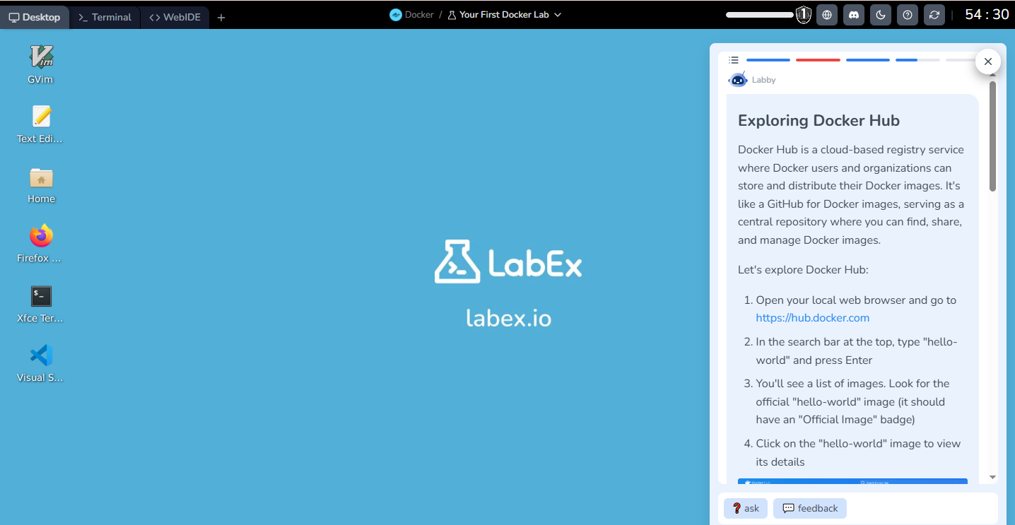

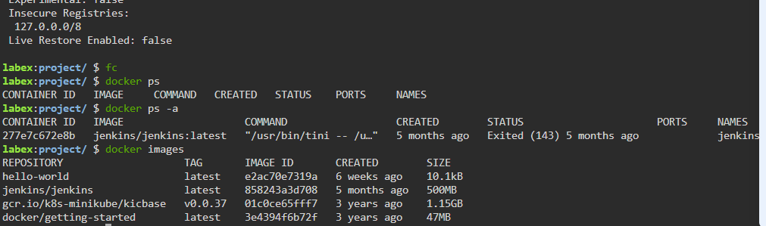



FACULTY OF ENGINEERING SCIENCES AND TECHNOLOGY
Lab Session 05B

Objective:

Docker Deployment and Installation on AWS EC2 Server
- AWS account

Requirements
- AWS Account
- EC2 Instance (Ubuntu Linux Recommended)
- Internet Connection
- SSH Client (PuTTY or Terminal)

Introduction
Docker is a containerization platform that allows developers to package applications and their dependencies into lightweight containers. AWS EC2 provides scalable virtual servers in the cloud where Docker can be installed and deployed for application hosting, testing, and cloud security practices.

Procedure / Steps

Step 1: Log in to AWS Management Console
- Open AWS Console.
- Sign in using your AWS account credentials.

Step 2: Launch an EC2 Instance
- Navigate to EC2 Dashboard.
- Click Launch Instance.
- Enter instance name (e.g., DockerLabServer).
- Select Ubuntu Server 22.04 LTS AMI.
- Choose instance type (t2.micro for free tier).
- Create or select an existing key pair.
- Allow:
  - SSH (Port 22)
  - HTTP (Port 80)
Click Launch Instance.

Step 3: Connect to EC2 Instance

Using Terminal:
ssh -i your-key.pem ubuntu@your-ec2-public-ip

Step 4: Update System Packages
sudo apt update && sudo apt upgrade -y

Step 5: Install Docker
sudo apt install docker.io -y

Step 6: Start and Enable Docker Service
sudo systemctl start docker
sudo systemctl enable docker

Step 7: Verify Docker Installation
docker --version

Step 8: Run Docker Test Container
sudo docker run hello-world

Step 9: Pull and Run Nginx Container
sudo docker pull nginx
sudo docker run -d -p 80:80 nginx

Step 10: Verify Deployment
- Copy EC2 Public IP.
- Open browser:
http://your-ec2-public-ip
- Nginx welcome page should appear.

Task
- Install Docker on AWS EC2 instance.
- Deploy an Nginx container using Docker.
- Access the application through the EC2 public IP.

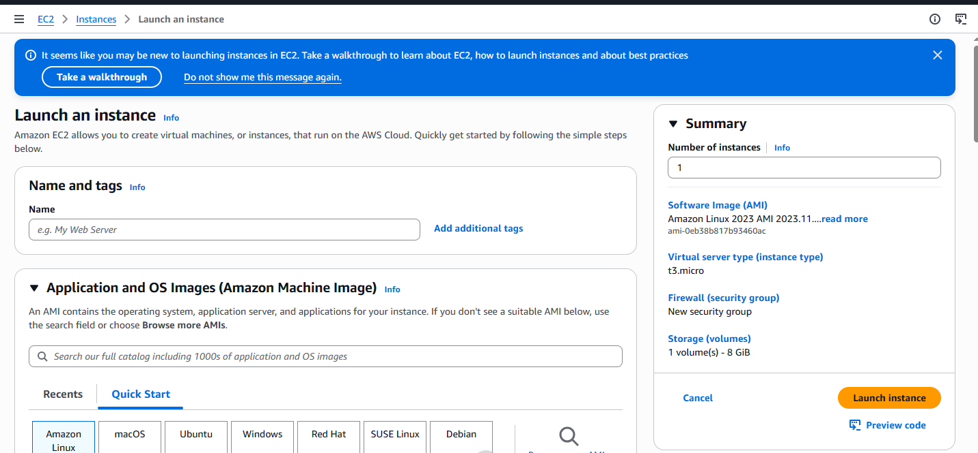

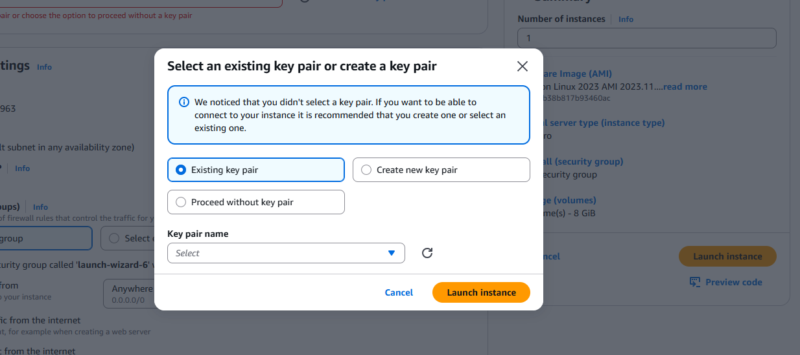

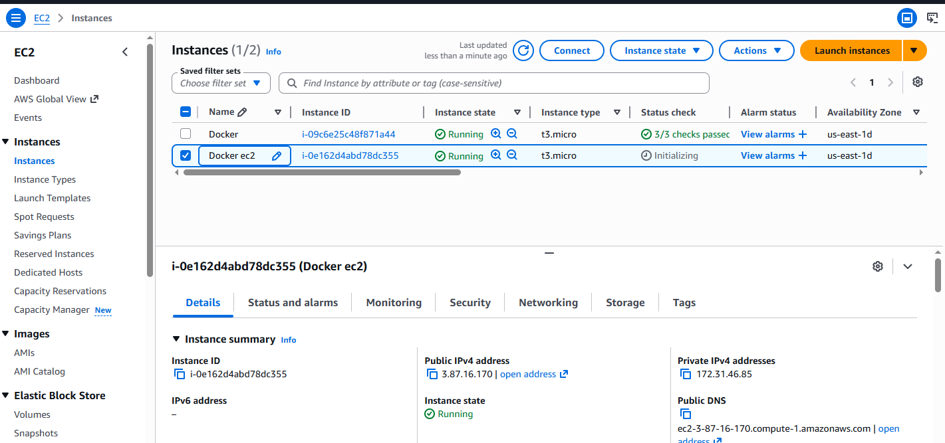

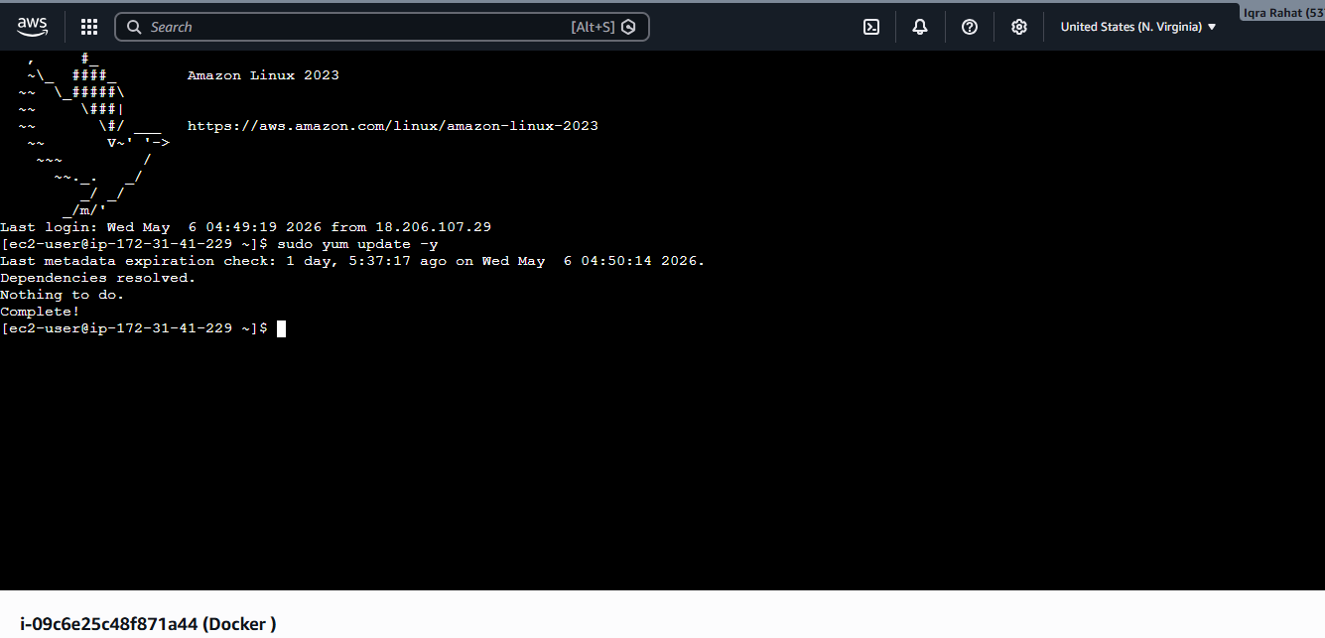



FACULTY OF ENGINEERING SCIENCES AND TECHNOLOGY
Lab Session 06

Cloud Lab: Monitoring AWS Lambda using CloudWatch Metrics & Logs

Objective:
Understand how to monitor serverless applications using Amazon CloudWatch by analyzing metrics and logs generated from AWS Lambda functions.

Required Equipment:
- AWS account
- Internet connection
- Basic Lambda function (pre-created or created during lab)

Introduction:
Amazon CloudWatch is a monitoring and observability service that provides data and insights for AWS resources. It collects metrics, logs, and events, enabling users to track performance, detect anomalies, and troubleshoot issues.
When integrated with AWS Lambda, CloudWatch automatically records execution logs and performance metrics such as duration, invocation count, and errors, helping developers monitor serverless applications effectively.

Procedure:

1. Log in to AWS Management Console
- Open AWS Console
- Navigate to AWS Lambda

2. Create or Select a Lambda Function
- Create a new function OR use an existing one
- Add simple code (e.g., return “Hello World”)

3. Deploy and Invoke Function
- Click Deploy
Use Test to execute the function multiple times

4. Navigate to CloudWatch Logs
- Open Amazon CloudWatch
- Go to Logs → Log groups
- Select your Lambda log group:
/aws/lambda/your-function-name

5. Analyze Logs
- Open latest log stream
- Observe:
  - Request ID
  - Execution time
  - Memory usage
  - Custom logs (if added using console.log() or print())

6. View Metrics
- In CloudWatch, go to Metrics → Lambda
- Analyze key metrics:
  - Invocations
  - Duration
  - Errors
  - Throttles

7. Create a CloudWatch Alarm
- Go to Alarms → Create Alarm
- Select metric (e.g., Errors > 1)
- Configure notification (email via SNS)

Task:
- Create or use a Lambda function
- Invoke it multiple times
- View logs in CloudWatch
- Analyze at least two metrics (e.g., duration, errors)
- Create an alarm for monitoring

Conclusion:
You will understand how to monitor serverless applications using CloudWatch, analyze logs, track performance metrics, and detect issues in AWS Lambda functions. This lab builds a strong foundation for cloud monitoring, debugging, and security observability.

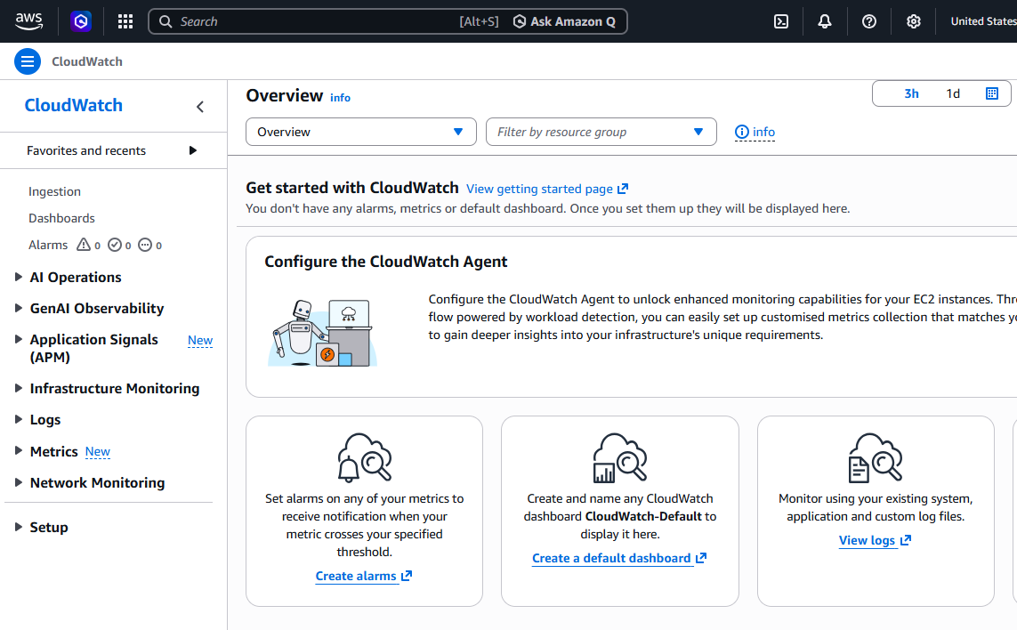

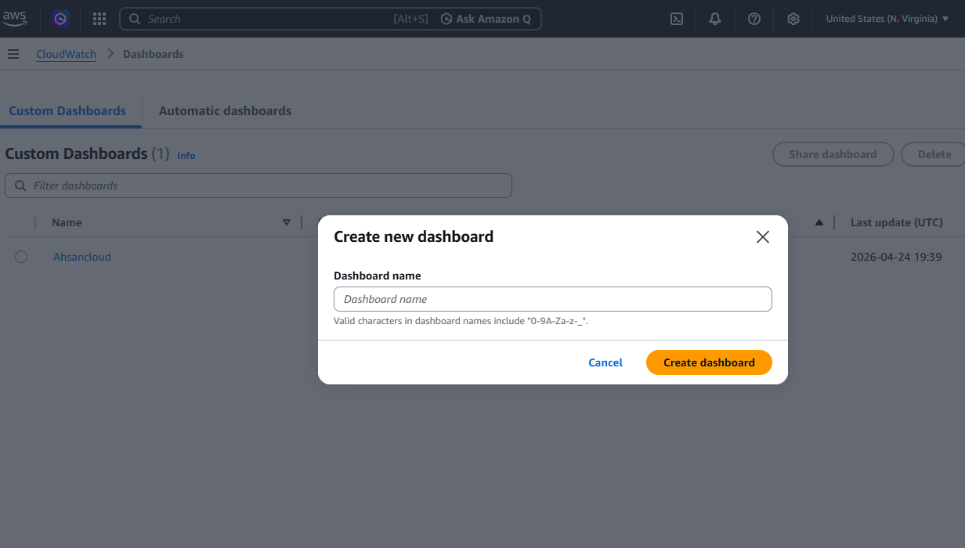

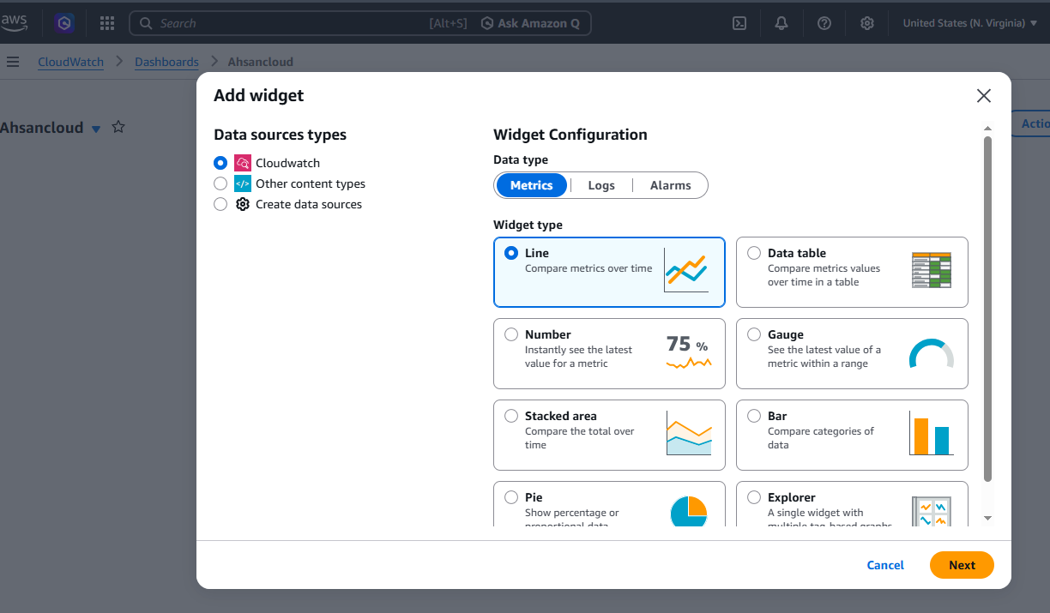

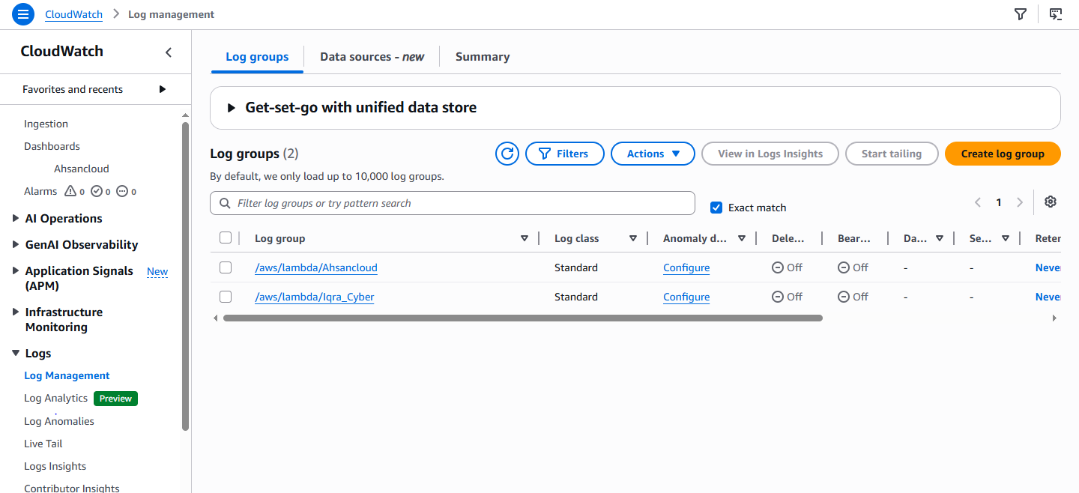



FACULTY OF ENGINEERING SCIENCES AND TECHNOLOGY
Lab Session 07

CCP Discussion



FACULTY OF ENGINEERING SCIENCES AND TECHNOLOGY
Lab Session 08

Mid Term Exam



FACULTY OF ENGINEERING SCIENCES AND TECHNOLOGY
Lab Session 09

Data Protection: Encryption and Key Management Systems
Objective
The primary objective of this cloud lab is to master data protection frameworks at rest inside cloud environments. Students will acquire hands-on experience using AWS Key Management Service (AWS KMS) to centralize cryptographic keys, design custom access control policies, enforce data encryption rules on Amazon Simple Storage Service (S3), and validate defense-in-depth isolation mechanisms under multi-user access scenarios.
Required Equipment
- AWS Cloud Infrastructure: An active AWS Account with permissions to provision Identity and Access Management (IAM) entities, Amazon S3 resources, and AWS KMS Customer Managed Keys.
- Client Workspace: A local computer with a modern web browser and a local plain-text editor (e.g., Visual Studio Code, Notepad++) for inspecting and editing JavaScript Object Notation (JSON) policy files.
- Network Access: Unrestricted outbound internet access to interface with the AWS Management Console over HTTPS.
Introduction & Theoretical Framework
Data protection is an essential pillar of cloud data governance, regulatory compliance (e.g., HIPAA, PCI-DSS, GDPR), and general risk management. Cloud architectures classify data security into two operational domains:
- Data in Transit: Data moving across networks, protected via network transport layer security protocols like TLS 1.2 or TLS 1.3.
- Data at Rest: Data committed to persistent storage volumes, object stores, or databases, protected using cryptographic block-ciphers.
The Role of AWS Key Management Service (KMS)
AWS KMS is a fully managed, highly available service that provides centralized creation, governance, and auditing of cryptographic keys. KMS integrates natively with over 100 AWS services to secure underlying application data. Behind the scenes, AWS KMS leverages physical Hardware Security Modules (HSMs) validated under standard government profiles (FIPS 140-3 Level 3) to safeguard root cryptographic secrets. At no point can any operator, administrator, or AWS service extract plaintext master keys from these operational hardware boundries.
Key Management Architecture and Taxonomy
- AWS Managed Keys: Created automatically by AWS services on your behalf when you choose default encryption (e.g., aws/s3, aws/lambda). These keys are managed entirely by AWS, incur no monthly baseline fee, but cannot be modified, shared across accounts, or customized with fine-grained access parameters.
- Customer Managed Keys (CMKs): Keys explicitly created, owned, and configured by the user. They provide absolute control over key operational lifecycles, lifecycle states, custom description tags, automated execution intervals, and conditional authorization logic.
- Symmetric vs. Asymmetric Keys: Symmetric keys utilize a single 256-bit Advanced Encryption Standard (AES-GCM) key to execute both encryption and decryption operations. Asymmetric keys utilize a mathematically linked public-private key pair (RSA or Elliptic Curve) to facilitate cross-boundary secure data exchange or digital signatures.
The Concept of Envelope Encryption
To optimize performance across high-volume cloud transactions, AWS utilizes an architectural pattern known as Envelope Encryption. Instead of passing massive files directly to the centralized KMS API for processing, KMS generates a unique Data Encryption Key (DEK) backed by the root master key. The storage service uses the plaintext DEK locally to execute rapid, high-speed AES-256 block encryption on the data payload. Once encryption concludes, the plaintext DEK is securely purged from system volatile memory, leaving behind only the encrypted data payload and an encrypted copy of the DEK bundled alongside it as metadata.
Architectural Note: Envelope Encryption Workflow
1. Storage Service calls KMS: 'GenerateDataKey' using the master KMS Key ID.
2. KMS generates a new Data Encryption Key (DEK) and returns two copies: one Plaintext DEK and one Encrypted DEK.
3. Service uses the Plaintext DEK to encrypt your raw file, then purges the Plaintext DEK from RAM.
4. Service stores the Encrypted DEK alongside your encrypted file data inside the physical storage block.
Understanding KMS Key Policies
Key Policies are the primary mechanism for controlling access to AWS KMS keys. Unlike other AWS resources where identity-based IAM policies are sufficient, a KMS key policy acts as a hard boundary gatekeeper. Identity-based IAM policies have zero effect unless the target Key Policy explicitly declares an open statement handing authority over to the account's root IAM framework. Key policies are structured in standard JSON syntax.
Step-by-Step Procedure
Step 1: Authenticate and Set Up Test Personas
1.1 Log into the AWS Management Console using your primary credentials.
1.2 Navigate to IAMby typing 'IAM' into the unified search bar.
1.3 Create an operational test usernamed 'unauthorized-security-tester'. Assign programmatic console access, but do not attach any permissions policies to this user. This entity represents an unprivileged insider threat or an out-of-scope operator.
Step 2: Provision a Customer Managed Symmetric Key
2.1 Navigate to AWS KMSby entering 'KMS' or 'Key Management Service' in the search bar.
2.2 Click Customer managed keysin the left-hand navigation pane, then select Create key.
2.3 Configure Key settings:Select Symmetric as the key type and Encrypt and decrypt as the key usage. Leave the key material origin as KMS. Click Next.
2.4 Define Metadata:Set the Alias field to 'lab-data-protection-key'. Enter a descriptive summary in the Description text block (e.g., 'Master CMK for Lab 09 Data Protection compliance testing'). Click Next.
Step 3: Define Administrative and Usage Bindings
3.1 Assign Key Administrators:Select your primary active administrator user or execution role. This gives designated users permission to alter, delete, enable, or disable the cryptographic resource.
3.2 Define Key Usage Permissions:Locate the usage assignment screen. Select your primary active role/user to ensure standard operations run correctly, but explicitly leave the 'unauthorized-security-tester' user checkbox unchecked. Click Next.
3.3 Review Policy JSON:Scroll down to inspect the auto-generated JSON key policy configuration. Your policy will include statements granting the root account full access and allocating administrative capabilities to your target users, as shown below:
{
"Version": "2012-10-17",
"Id": "key-consolepolicy-3",
"Statement": [
{
"Sid": "Enable IAM User Permissions",
"Effect": "Allow",
"Principal": {
"AWS": "arn:aws:iam::123456789012:root"
},
"Action": "kms:*",
"Resource": "*"
},
{
"Sid": "Allow access for Key Administrators",
"Effect": "Allow",
"Principal": {
"AWS": "arn:aws:iam::123456789012:user/LabAdmin"
},
"Action": [
"kms:Create*",
"kms:Describe*",
"kms:Enable*",
"kms:List*",
"kms:Put*",
"kms:Update*",
"kms:Revoke*",
"kms:Disable*",
"kms:Get*",
"kms:Delete*",
"kms:TagResource",
"kms:UntagResource",
"kms:ScheduleKeyDeletion",
"kms:CancelKeyDeletion"
],
"Resource": "*"
}
]
}
3.4 Click Finishto generate and active the logical KMS Key.
Step 4: Configure an Amazon S3 Bucket with Enforced SSE-KMS
4.1 Navigate to Amazon S3from the console console interface.
4.2 Click Create bucket.Enter a globally unique name, such as 'secure-compliance-vault-xxxx' (replace xxxx with unique random initials/digits). Choose your preferred deployment region.
4.3 Enforce Cryptographic Defaults:Scroll down to the 'Default encryption' properties configuration block.
4.4 Modify Default Encryption Type:Select 'Server-side encryption with AWS Key Management Service keys (SSE-KMS)'.
4.5 Map your Custom Key:Choose 'Select from your AWS KMS keys' and pick your newly provisioned alias: 'lab-data-protection-key' from the dropdown list. Leave Bucket Key enabled to optimize transaction cost. Click Create bucket.
Step 5: Upload and Verify Cryptographic Metadata
5.1 Create a test fileon your local device named 'confidential_payload.txt' containing several lines of mock alphanumeric data.
5.2 Upload the file:Open your new S3 bucket profile in the console, click Upload, add your local 'confidential_payload.txt' file, and complete the action.
5.3 Verify metadata structure:Once successfully loaded, click the file name link inside the S3 browser to enter the object's contextual configuration view.
5.4 Inspect Server-side encryption properties:Confirm that the state shows AWS-KMS encryption and verify that the listed Key ARN accurately matches the custom Customer Managed Key configured in Step 2.
Step 6: Execute an Access Isolation Simulation
6.1 Invert the Identity Scope:Log entirely out of your administrative console section or launch an independent incognito web session.
6.2 Log back inusing the secondary 'unauthorized-security-tester' persona created during Step 1.
6.3 Navigate directly to Amazon S3and open your secure object vault repository bucket.
6.4 Attempt an Object Download:Select the check box next to 'confidential_payload.txt' and click the Download option.
Expected Core Security Finding
The console interface will generate a dark red security error window indicating that download execution has failed. The system will throw an 'Access Denied' code. This block occurs because even if an IAM user can technically list objects inside an S3 bucket space, they cannot decrypt the accompanying Data Encryption Key (DEK) wrapper without explicit, declared permissions inside the central KMS Key Policy structure.
Step 7: Configure Automated Key Rotation Lifecycle Policies
7.1 Return to your administrator sessionand navigate back to the AWS KMS dashboard console.
7.2 Open Key details:Locate and click your Customer Managed Key alias: 'lab-data-protection-key'.
7.3 Modify Key rotation settings:Select the Key rotation tab located along the lower layout interface. Click Edit.
7.4 Enable Automation:Check the tick box labeled 'Automatically rotate this KMS key every year' (or your target custom intervals). Click Save.
When rotation is enabled, AWS KMS automatically creates new cryptographic backing material annually while preserving older versions indefinitely. This ensures that any historical ciphertext generated under old key iterations remains instantly decryptable without manual archival handling.
5. Detailed Lab Tasks & Deliverables
To achieve full grading criteria for this technical module, students must fulfill the following explicit production outputs:
Task 1: Infrastructure Deployment Map Verification
Provide a clean copy of your complete Customer Managed Key JSON Policy file text. Highlight the specific statement containing your administrative ARN strings.
Task 2: Cryptographic Compliance Report Proof
Capture a clear, high-resolution desktop screenshot showing the Amazon S3 Object properties panel. The snapshot must clearly display the status fields indicating active Server-Side Encryption backed by your custom AWS-KMS Key ARN.
Task 3: Security Policy Technical Briefing Question
Draft an analytical explanation responding to the following specific real-world security incident scenario:
Scenario: An engineering team leader attaches an IAM identity policy to a developer's user profile granting full administrative S3 permissions ('s3:*'). However, when the developer tries to fetch an object from an institutional bucket protected by a Customer Managed KMS Key, they consistently receive an access authorization failure. Explain the precise architectural cause behind this operational exception and identify exactly what configuration changes must be deployed to resolve the block.
Troubleshooting & Common Operational Errors
Error Code / Indicator | Root Cause Analysis | Remediation Path
KMS.AccessDeniedException | The executing IAM identity lacks the 'kms:Decrypt' action permission inside the target key's JSON Key Policy. | Log in as a Key Administrator, locate the KMS console, edit the key policy, and append the user/role ARN to the Usage block statement.
S3 Upload Fails silently | The user has bucket write access but lacks the 'kms:GenerateDataKey' permissions needed to initiate the envelope encryption sequence. | Update the custom key policy to allow the data-ingestion identity scope to invoke cryptographic structural lifecycle elements.

Security Best Practices for Key Governance

- Enforce Principle of Least Privilege: Never map wide wildcards ('kms:*') to standard application identities. Explicitly define precise actions like 'kms:Decrypt' or 'kms:GenerateDataKey' to narrow the attack surface.
- Separation of Security Duties: Ensure that the administrative entities authorized to delete or rotate keys are completely different functional identities from the operational applications authorized to run daily encryption loops.
- Mandate Continuous Compliance Logging: Ensure AWS CloudTrail is universally active across all operational deployment regions. Monitor for 'Decrypt' API execution spikes to actively detect large-scale data breach attempts or insider malicious scans.
Conclusion
By completing this module, you have established a functional foundation in modern cloud data protection. You now understand how to decouple access permissions from standard infrastructure containers and bind data directly to central cryptographic perimeters using AWS KMS. This dual-layered security architecture—requiring both storage asset access and key decryption capabilities - forms a core component of defensive engineering across multi-tenant enterprise cloud systems.



FACULTY OF ENGINEERING SCIENCES AND TECHNOLOGY
Lab Session 10

Designing and Configuring an Advanced Secure AWS VPC Architecture
Objective
Design, configure, and validate an isolated cloud network layout by manual provisioning of an Amazon Virtual Private Cloud (VPC). Students will segment classless inter-domain routing (CIDR) blocks into isolated public and private subnets, configure stateful Security Groups and stateless Network Access Control Lists (NACLs), manage explicit route tables, and establish secure external communications using Internet Gateways.
Required Equipment
- AWS Account Environment: Active AWS platform subscription with permission constraints permitting VPC, Subnet, Route Table, and EC2 resource instantiation.
- Client Terminal: A localized computer running an updated modern web browser with HTTPS web connectivity over standard ports.
Introduction & Theoretical Framework
An Amazon Virtual Private Cloud (VPC) provides a private, logically isolated software-defined network space running on top of physical AWS global infrastructure. Security boundaries in cloud workloads start at the network layout layer. Organizations use VPCs to achieve network segmentation by grouping connected systems into distinct subnets based on business rules and security trust boundaries.
Subnet Segmentation and Routing Frameworks
- Public Subnets: Logical network areas configured to direct outbound traffic toward an attached Internet Gateway (IGW). These are used to run public-facing infrastructure like load balancers or proxy servers.
- Private Subnets: Logical blocks that have no direct routing rule path to an Internet Gateway. Compute assets running inside private subnets are protected from direct internet scanning, requiring intermediary systems (such as NAT Gateways) for external communication loops.
Dual-Layer Firewall Defense Matrix
AWS secures cloud networks through two distinct layer filters:
- Security Groups: Stateful firewall filters evaluated at the individual resource elastic network interface (ENI) layer. Return traffic is automatically authorized without checking inbound rules.
- Network Access Control Lists (NACLs): Stateless protocol filters evaluated at the subnet perimeter boundary. NACLs process traffic sequentially by rule number, requiring explicit configurations for both inbound and outbound traffic directions.
Step-by-Step Procedure
10.1 Log in to the consoleand navigate directly to the VPC Dashboard interface.
10.2 Click Create VPC,select 'VPC only', name it 'lab-secure-vpc', and assign an explicit IPv4 CIDR block of 10.0.0.0/16. Click Create.
10.3 Provision the Public Subnet:Go to Subnets -> Create Subnet. Select your new VPC, name it 'lab-public-subnet-1a', choose an Availability Zone, and assign CIDR block 10.0.1.0/24.
10.4 Provision the Private Subnet:Click Create Subnet again, select your VPC, name it 'lab-private-subnet-1a', choose the same Availability Zone, and assign CIDR block 10.0.2.0/24.
10.5 Create and Attach Internet Gateway:Go to Internet Gateways -> Create Internet Gateway. Name it 'lab-igw'. Once created, click Actions -> Attach to VPC, and select 'lab-secure-vpc'.
10.6 Configure Public Routing Tables:Navigate to Route Tables. Click Create route table, name it 'lab-public-rt', select your VPC, and save. Under the Routes tab, click Edit routes, add a route for 0.0.0.0/0 targeting your Internet Gateway ('lab-igw'). Save routes. Go to Subnet associations and link 'lab-public-subnet-1a'.
Architectural Deep-Dive: Stateless Return Paths
Because NACLs are stateless firewalls, allowing inbound traffic on Port 443 (HTTPS) requires you to also configure an outbound rule allowing ephemeral ports (typically 1024-65535) back to the originating client. Failing to configure this outbound rule will silently drop the connection.
Detailed Lab Tasks & Deliverables
- Deliverable 1: Provide a copy of the network route tables showing the public subnet routing rules pointing toward the Internet Gateway.
- Deliverable 2: Provide a brief description of the structural security differences between an AWS Security Group and an AWS Network ACL.

Troubleshooting & Common Operational Errors
Error / Indicator | Root Cause Analysis | Remediation Path
Route Table Misconfiguration | Instances in the public subnet cannot access the internet because the default route is missing. | Add a explicit destination 0.0.0.0/0 rule pointing directly to the active IGW ID.
Stateless Drop Exception | Connections drop at the subnet boundary even though security group configurations are valid. | Check the subnet NACL parameters and ensure the outbound ephemeral port range is allowed.

Security Best Practices
- Enforce Explicit Routing Rules: Never map public internet routes (0.0.0.0/0) directly inside route tables associated with private internal subnets.
- Implement Multi-Layer Firewalls: Use both Security Groups for deep application port control and NACLs for broad subnet-wide network blocks.
Conclusion
Completing this exercise demonstrates how to build and segment network architectures in cloud environments. Separating resources into public and private subnets, combined with stateful and stateless firewall rules, establishes a strong foundation for network isolation and defense-in-depth security design.



FACULTY OF ENGINEERING SCIENCES AND TECHNOLOGY
Lab Session 11

Auditing API Activity, Cloud Governance, and Compliance with AWS CloudTrail
Objective
Establish audit governance records by planning, creating, and inspecting account-wide API tracking logs using AWS CloudTrail. Students will learn to analyze active management events, set up automated delivery pipelines into Amazon S3 storage vaults, and read JSON event structure bodies to track down configurations errors or unauthorized access actions.
Required Equipment
- AWS Account Context: Administrative access levels permitting AWS CloudTrail provisioning, IAM logging access, and Amazon S3 resource configurations.
- Workspace Tools: Integrated web browser alongside an application capable of reading raw plain-text JSON data strings safely.
Introduction & Theoretical Framework
AWS CloudTrail is a core governance tool that records API actions executed across an AWS account. Every interaction—whether initiated via the AWS Management Console, the AWS Command Line Interface (CLI), or an SDK program loop—is captured as a structured event record. This continuous activity stream provides the operational data needed for security visibility, compliance auditing, and post-incident forensic investigations.
Event Classification Matrix
- Management Events: Operations performed on the control plane of your cloud infrastructure (e.g., creating an EC2 instance, attaching an IAM policy, creating an S3 bucket). This activity visibility is turned on by default across all accounts.
- Data Events: High-volume operations performed within or on a resource itself (e.g., S3 object-level uploads/downloads, Lambda function invocations). These events are turned off by default to minimize storage overhead costs.
Log Integrity and Security Protection
Because audit logs are high-value targets for malicious actors seeking to hide their activity, CloudTrail includes built-in security controls. Log files can be encrypted using customer-managed KMS keys. Additionally, Log File Integrity Validation generates SHA-256 cryptographic hashes and digital signatures via digest files. This allows organizations to mathematically prove that log records have not been altered or deleted after delivery to the storage bucket.
Step-by-Step Procedure
11.1 Log in to the consoleand open the CloudTrail dashboard interface.
11.2 Click Event historyin the left-hand navigation pane. Filter the log stream by 'Event name' and search for a recent API action like 'CreateSubnet' or 'ConsoleLogin'.
11.3 Analyze JSON structure:Click the expand link on a log event to view its JSON properties. Identify critical metadata parameters: 'userIdentity' (who ran it), 'eventTime' (when), 'sourceIPAddress' (from where), and 'requestParameters' (target details).
11.4 Create a Permanent Trail:In the left menu, select Trails -> Create trail. Name it 'org-compliance-audit-trail'.
11.5 Configure Storage Location:Under Storage options, select Create new S3 bucket, name it 'audit-log-vault-xxxx', and ensure Log file SSE-KMS encryption is enabled. Click Next.
11.6 Configure Event Tracking Fields:On the choose log events screen, check 'Management events' and select both 'Read' and 'Write' states. Click Next, review your configuration selections, and select Create trail.
{
"eventVersion": "1.08",
"userIdentity": {
"type": "IAMUser",
"principalId": "AIDAEXAMPLEUSERID",
"arn": "arn:aws:iam::123456789012:user/SecurityAuditor",
"accountId": "123456789012"
},
"eventTime": "2026-06-24T14:32:01Z",
"eventSource": "iam.amazonaws.com",
"eventName": "AttachUserPolicy",
"awsRegion": "us-east-1",
"sourceIPAddress": "198.51.100.45"
}
Detailed Lab Tasks & Deliverables
- Deliverable 1: Provide a snippet of a clean JSON log block captured from your custom trail showing a valid control-plane event action.
- Deliverable 2: Identify three metadata parameters found in a CloudTrail JSON log file that are essential for conducting a security forensic audit.
Troubleshooting & Common Operational Errors
Error / Indicator | Root Cause Analysis | Remediation Path
Missing Regional Events | A security trail is configured for a single region, resulting in visibility gaps for actions taken in other geographic deployment areas. | Enable the 'Apply trail to all regions' setting to ensure consistent account-wide log tracking.
S3 Delivery Failures | CloudTrail stops appending log structures because the destination S3 bucket policy was modified or deleted. | Restore the required bucket permissions to allow the CloudTrail service principal ('cloudtrail.amazonaws.com') to write log data.

Security Best Practices
- Enforce Log File Integrity Validation: Always turn on integrity validation to create an immutable cryptographic proof trail for audit records.
- Centralize Audit Logs: Store CloudTrail logs in a dedicated security account with strict access controls to prevent tampering by administrators in other operational accounts.
Conclusion
AWS CloudTrail provides the visibility required to maintain control and governance over cloud environments. Analyzing event structures and setting up immutable log storage repositories helps security teams detect unauthorized activity, verify compliance, and accelerate root-cause analysis during incident responses.



FACULTY OF ENGINEERING SCIENCES AND TECHNOLOGY
Lab Session 12

Container Security Architecture: Managed Image Scanning via Amazon ECR

Objective
Implement security scan controls within container development workflows using Amazon Elastic Container Registry (ECR). Students will build and push a sample container image, trigger automated security scans, parse Common Vulnerabilities and Exposures (CVE) results, and analyze the resulting risk reports to guide software mitigation steps.
Required Equipment
- AWS Cloud Environment: An active AWS account with permissions to manage Amazon ECR repositories and inspect image scanning configurations.
- Local Workstation Build Engine: A terminal workspace equipped with an operational Docker engine or an AWS Cloud9 development environment.
Introduction & Theoretical Framework
Containerization abstracts applications from their underlying host systems, but it also introduces unique security considerations. If a base operating system layer or application dependency contains an unpatched vulnerability, that risk is packaged directly into the container image. This vulnerability can then propagate across testing and production environments when deployed.
Image Scanning Architecture
- Basic Image Scanning: An open-source scanning framework built into Amazon ECR that leverages the Clair engine. It checks container operating system packages against a database of known CVE vulnerabilities.
- Enhanced Image Scanning: An automated scanning option that integrates with Amazon Inspector. It provides continuous vulnerability monitoring for both operating system packages and application package dependencies (e.g., npm, pip, maven) at runtime.
Understanding the Scan-on-Push Pattern
A key component of secure container workflows is running image scans as early as possible in the deployment process. Enabling 'Scan on push' configures the container registry to scan images automatically as soon as they are uploaded. This provides development teams with immediate feedback on vulnerabilities, allowing them to remediate risks before images are deployed to active production clusters.
Step-by-Step Procedure
12.1 Log in to the consoleand navigate to the Elastic Container Registry (ECR) console view.
12.2 Click Create repository.Configure the visibility setting to Private and name it 'security-lab-repo'.
12.3 Enable Automated Scanning:Locate the 'Scan on push' configuration toggle and switch it to Enabled. Click Create repository.
12.4 Authenticate Local Build Environment:Select your new repository and click 'View push commands'. Run the provided authentication command in your local terminal to log your Docker CLI into ECR.
12.5 Build a Test Image:Create a local Dockerfile that uses an older base image (e.g., `FROM ubuntu:20.04`) to ensure the scan detects baseline vulnerabilities. Build the image using the command:
docker build -t security-lab-repo .
12.6 Tag and Push Image:Apply the remote ECR repository tag to your image, then run the push command to upload the container file layers to AWS.
docker push 123456789012.dkr.ecr.us-east-1.amazonaws.com/security-lab-repo:latest
12.7 Analyze Vulnerability Findings:Return to the ECR console and open your repository. Click on the 'latest' image tag to open the scan results. Review the vulnerability breakdown categorized by severity level (Critical, High, Medium).
Security Warning: Critical CVE Findings
Images containing unresolved Critical or High CVE findings should be blocked from production deployment. Remediation typically requires updating the base image or upgrading specific software packages within the Dockerfile layer.
Detailed Lab Tasks & Deliverables
- Deliverable 1: Provide a screenshot or transcript showing the summary table of image vulnerability findings from the ECR console.
- Deliverable 2: Identify a detected CVE ID from your scan report and describe its severity level and structural remediation path.
Troubleshooting & Common Operational Errors
Error / Indicator | Root Cause Analysis | Remediation Path
Authentication Timeout | The Docker push command fails with an 'unauthorized: authentication required' error string. | ECR authorization tokens expire after 12 hours. Re-run the 'aws ecr get-login-password' command sequence.
Scan Status Incomplete | The repository details page shows a 'Scan Failed' or 'Unsupported' status indicator. | Ensure your container image architecture is supported and that the base image layers were extracted completely without transmission corruption.

Security Best Practices
- Enforce Base Image Hardening: Use minimal, trusted base images (such as Alpine Linux or distroless container builds) to minimize the available attack surface.
- Automate Pipeline Gates: Integrate ECR image scan API lookups into CI/CD pipelines to block builds automatically if vulnerability findings exceed defined organizational thresholds.
Conclusion
Using automated image scanning within container workflows helps organizations identify and remediate package-level software vulnerabilities early in the delivery lifecycle. This control layer ensures that only scanned and approved container artifacts are deployed to production clusters.



FACULTY OF ENGINEERING SCIENCES AND TECHNOLOGY
Lab Session 13

Infrastructure as Code (IaC): Secure Deployments using AWS CloudFormation
Objective
Model, manage, and deploy repeatable cloud environments by writing secure AWS CloudFormation infrastructure templates. Students will author structural YAML declarations, enforce security configurations, deploy resources as functional application stacks, and manage infrastructure drift detection loops.
Required Equipment
- AWS Cloud Workspace: An active AWS account with permissions to provision CloudFormation stacks, Amazon S3 buckets, and related resource types.
- Local IDE Engine: A local desktop plain-text editor (e.g., VS Code) for writing structurally valid YAML templates.
Introduction & Theoretical Framework
Infrastructure as Code (IaC) shifts infrastructure management from manual configurations to code-driven definition files. Instead of using the web console to provision cloud resources manually, operators define their complete architecture in structured text files (YAML or JSON). This approach ensures consistency, enables version control integration, and provides repeatable deployments across separate development environments.
CloudFormation Core Architecture
- Template Files: The source text document declaration that defines the desired target state of your AWS cloud resources.
- Stack Structures: The operational unit used to manage resources. CloudFormation provisions, updates, or deletes a group of resources defined in a template as a single stack unit.
- Drift Detection: An auditing process that checks if resources managed by a stack have been modified outside of CloudFormation control (e.g., via manual console changes), identifying configuration variance.
Step-by-Step Procedure
13.1 Open your local plain-text editorand create a new file named 'infrastructure_template.yaml'.
13.2 Author the YAML Template Body:Write the following resource declaration to define an Amazon S3 bucket with public access blocks enabled:
AWSTemplateFormatVersion: '2010-09-09'
Description: 'IaC Deployment Template for Lab 13 - Secure Storage Vault'
Resources:
SecureStorageBucket:
Type: 'AWS::S3::Bucket'
Properties:
BucketName: !Sub 'compliance-vault-iac-${AWS::AccountId}'
PublicAccessBlockConfiguration:
BlockPublicAcls: true
BlockPublicPolicy: true
IgnorePublicAcls: true
RestrictPublicBuckets: true
13.3 Log in to the consoleand navigate to the CloudFormation dashboard view.
13.4 Initiate Stack Generation:Click Create stack -> With new resources (standard). Choose 'Upload a template file', upload your 'infrastructure_template.yaml' file, and click Next.
13.5 Set Stack Parameters:Name your stack 'SecureStorageStack' and click Next through the default configuration screens. Click Submit.
13.6 Monitor Event States:Select your stack and monitor the Events tab view. Watch the lifecycle states transition from `CREATE_IN_PROGRESS` to `CREATE_COMPLETE` as resources are provisioned.
13.7 Run Drift Detection Audit:Navigate to Amazon S3, locate your bucket, and manually modify a setting (e.g., add a tag). Return to CloudFormation, select your stack, click Stack actions -> Detect drift, and analyze the resulting drift status report.
Detailed Lab Tasks & Deliverables
- Deliverable 1: Provide your completed, syntactically correct YAML template used to deploy the secure S3 storage bucket resource.
- Deliverable 2: Provide a screen capture or log output showing the CloudFormation event stream confirming successful stack deployment.
Troubleshooting & Common Operational Errors
Error / Indicator | Root Cause Analysis | Remediation Path
Syntax Parsing Failures | The stack upload fails immediately with an 'Invalid template structure' error string. | YAML requires strict indentation alignment. Validate your template formatting using a linter before uploading.
Resource Namings Collisions | The deployment process triggers a rollback state because an S3 bucket name is already in use. | S3 bucket names must be globally unique. Use helper functions like '!Sub' to append your account ID to the bucket name.

Security Best Practices
- Enforce Strict Public Restricting Rules: Always include PublicAccessBlockConfiguration settings when declaring S3 resources in templates to prevent accidental exposure.
- Eliminate Manual Interventions: Avoid making manual changes to resources managed by CloudFormation stacks to maintain template accuracy and prevent configuration drift.
Conclusion
Infrastructure as Code provides a reliable method for managing cloud environments securely and predictably. Using CloudFormation templates to declare resources enables organizations to enforce security baselines, maintain consistency, and eliminate manual configuration errors across deployments.



FACULTY OF ENGINEERING SCIENCES AND TECHNOLOGY
Lab Session 14

Implementing DevSecOps Pipelines: Automated Security Controls in AWS CodePipeline
Objective
Implement automated security testing controls within release engineering workflows using AWS CodePipeline. Students will build a continuous integration pipeline, configure automated build steps using AWS CodeBuild, and integrate security scanners to analyze applications for vulnerabilities during the delivery process.
2. Required Equipment
- AWS Cloud Infrastructure: An active AWS account with permissions to manage AWS CodePipeline, AWS CodeBuild, and access related storage repositories.
- Application Code: A reference application source file package containing a build specifications definition manifest (`buildspec.yml`).
Introduction & Theoretical Framework
DevSecOps integrates security practices into the core development and release lifecycle rather than addressing them as a final verification step. This approach shifts security testing left by running automated tools early and often, providing developers with fast feedback on potential risks.
Automated CI/CD Security Gating
Continuous Integration pipelines automate application build, test, and deployment phases. In a DevSecOps workflow, security tools are integrated directly into these automated steps:
- Static Application Security Testing (SAST): Scanners that analyze source code text directly to detect patterns that match known security flaws, injection weaknesses, or structural bugs.
- Software Composition Analysis (SCA): Dependency analysis tools that check application package manifest files against vulnerability databases to identify unpatched third-party libraries.
Step-by-Step Procedure
14.1 Log in to the consoleand navigate to the CodePipeline dashboard interface.
14.2 Click Create pipeline.Name it 'devsecops-release-pipeline' and accept the default service role settings. Click Next.
14.3 Configure Source Stage Repository:Select your source code repository provider (e.g., AWS CodeCommit or GitHub) and choose the main tracking branch. Click Next.
14.4 Provision the Build and Security Stage:Set the build provider option to AWS CodeBuild. Click Create project to launch the configuration window.
14.5 Define the Security Build Specifications:In your application source code, configure a `buildspec.yml` file to run a security scanner (e.g., Node-Security-Audit or Python-Bandit) during the testing phase:
version: 0.2
phases:
install:
commands:
- echo Installing development security scanning runtimes...
- pip install bandit
build:
commands:
- echo Launching automated source code security scanning...
- bandit -r . -f json
14.6 Save and Deploy Pipeline:Complete the build project creation steps, click Next to skip the deployment phase for this lab, and click Create pipeline.
14.7 Analyze Pipeline Gate Behavior:Trigger an initial pipeline execution by pushing a code change. Monitor the pipeline stages as they process your updates, and check the CodeBuild execution logs to verify scan results.
DevSecOps Execution Standard
Configuring security tools to return a non-zero exit code when critical vulnerabilities are found allows the pipeline to halt automated builds immediately. This workflow prevents unreviewed security issues from moving downstream toward production.
Detailed Lab Tasks & Deliverables
- Deliverable 1: Provide the complete `buildspec.yml` file used to configure the automated security scanning steps within AWS CodeBuild.
- Deliverable 2: Provide a transcript excerpt from the build log showing the security tool executing and outputting its risk analysis summary.
Troubleshooting & Common Operational Errors
Error / Indicator | Root Cause Analysis | Remediation Path
Execution Policy Failures | The CodeBuild stage fails during the environment boot phase with an IAM authorization error. | Update the CodeBuild execution service role to grant the permissions required to access target resources.
Build Spec Errors | The pipeline fails during the build phase because of an incorrectly formatted specification file. | Verify your YAML structure and validate command strings to ensure formatting compliance.

Security Best Practices
- Enforce Automated Failures: Configure pipelines to fail builds automatically if high or critical severity vulnerabilities are detected during scanning steps.
- Keep Vulnerability Data Updated: Ensure scanning tools update their vulnerability definitions during the install phase to maintain accurate protection against new risks.
Conclusion
Integrating automated security scanning into continuous integration pipelines helps teams detect and address software vulnerabilities early in the delivery lifecycle. This continuous security verification approach provides consistent visibility and feedback throughout development workflows.



FACULTY OF ENGINEERING SCIENCES AND TECHNOLOGY
Lab Session 15

CCP Submissions and Viva



FACULTY OF ENGINEERING SCIENCES AND TECHNOLOGY
Lab Session 16

Final Term Exam

