FormForge
Week 2: Entity-Relationship (ER) Diagram | Muhammad Huzaifa Zulfiqar
The database is PostgreSQL hosted on Supabase. It has seven tables. Colors group the tables: green for form data, orange for webhook delivery, purple for users and billing. PK means primary key and FK means foreign key. Every foreign key uses ON DELETE CASCADE, so deleting a parent row removes its children.
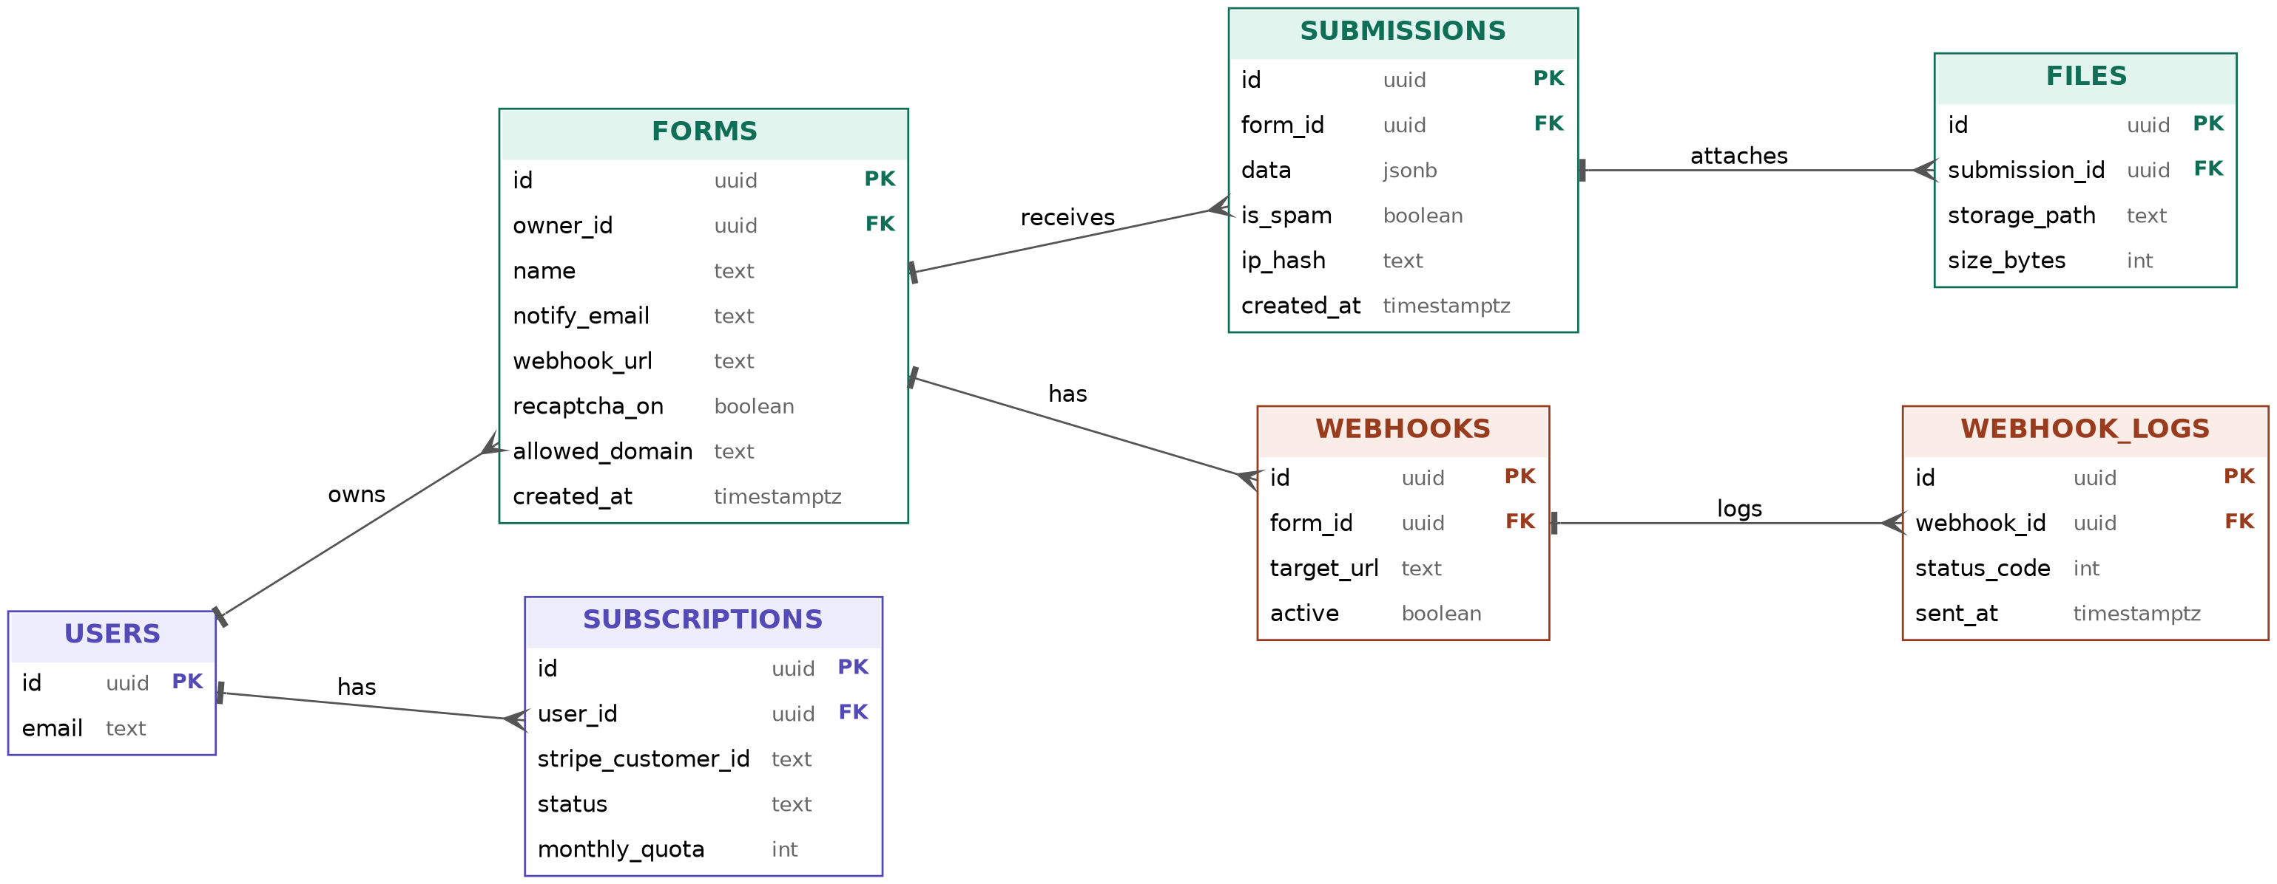

Relationships
Parent table | Child table | Cardinality | Meaning
USERS | FORMS | One to many | A user owns many forms.
USERS | SUBSCRIPTIONS | One to many | A user has a subscription record holding the plan and monthly quota.
FORMS | SUBMISSIONS | One to many | A form receives many submissions.
FORMS | WEBHOOKS | One to many | A form can forward submissions to several webhook URLs.
SUBMISSIONS | FILES | One to many | A submission can have uploaded files attached.
WEBHOOKS | WEBHOOK_LOGS | One to many | Each webhook keeps a log of every delivery attempt.

Table descriptions
Table | Purpose
USERS | Managed by Supabase Auth (auth.users). Holds accounts and sign-in data; not created manually.
FORMS | One row per form. Stores the owner, name, notification email, reCAPTCHA setting and allowed domain.
SUBMISSIONS | One row per response sent to a form. Answers are stored in a jsonb column; is_spam flags junk; ip_hash supports rate limiting.
FILES | Metadata for files uploaded with a submission (storage path and size).
WEBHOOKS | Target URLs a form forwards its submissions to, with an active flag.
WEBHOOK_LOGS | Delivery history for each webhook (HTTP status code and time sent).
SUBSCRIPTIONS | Stripe customer id, plan status and monthly submission quota (50 on the free plan).

Design decisions
- jsonb for submissions: every form has different fields, so the answers are stored as flexible JSON instead of fixed columns.
- Row-level security: enabled on every table so owners can only read and manage their own data. Public submissions are written by server code using the service-role key.
- Hashed IP addresses: ip_hash allows rate limiting without storing raw personal data.
- Spam is kept, not deleted: is_spam lets owners review false positives.
- Legacy column: forms.webhook_url from Week 1 is superseded by the webhooks table, which supports several targets per form.

