NATIONAL UNIVERSITY OF COMPUTER AND EMERGING SCIENCES (FAST-NUCES)
Department of Data Science | Fall 2026
Course: DS3001: Design Analysis and Visualization | Section: BDS-5B
ACADEMIC PROJECT PROPOSAL — PHASE 1
Project Panopticon: Global Cyber Warfare, Internet Censorship & State Surveillance Lakehouse
Team Members | Muhammad Ibrahim (24L-2602) & Safee Akmal (23L-2556)
Academic Program | Bachelor of Science in Data Science (BDS-5B)
Target Platform | Apache Spark on Databricks Community Edition / Azure Cloud
Submission Phase | Phase 1 Deliverables (Domain, Architecture, Governance & FinOps)
GitHub Repository | https://github.com/Muhammad-Ibrahim-001/Project-Panopticon

Executive Summary
In modern geopolitical conflicts and state-sanctioned surveillance, digital communications are actively weaponized. Authoritarian regimes deploy sophisticated telecommunication attacks—including Deep Packet Inspection (DPI), DNS poisoning, and TCP reset (RST) injection—to suppress independent journalism, disrupt political opposition, and sever citizen access to circumvention technologies (VPNs, Tor bridges).
Project Panopticon designs, implements, and evaluates an automated, end-to-end Big Data Lakehouse utilizing the Medallion Architecture (Bronze -> Silver -> Gold) powered by Apache Spark and Delta Lake. The pipeline continuously ingests multi-gigabyte streams of raw network measurement probes, cryptographically sanitizes sensitive activist telemetry under strict data governance standards, enriches network events with global threat intelligence catalogs, and surfaces actionable digital forensic insights via a high-performance Business Intelligence dashboard.

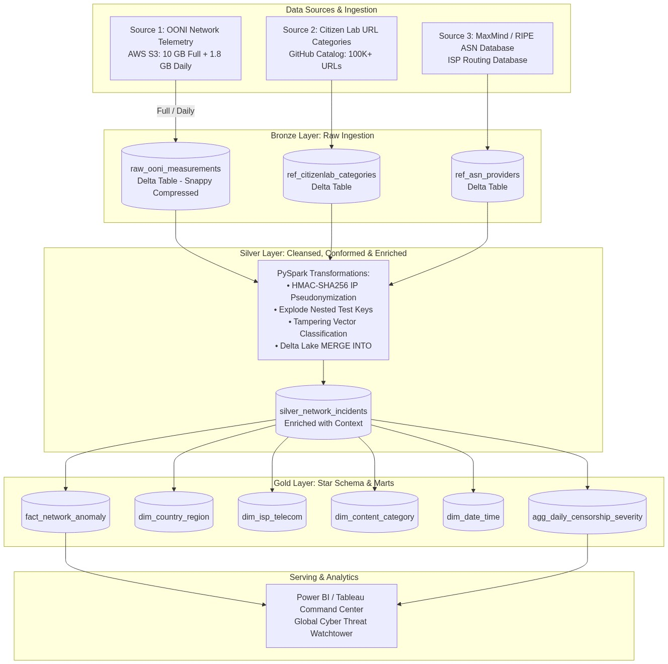
Figure 1: End-to-End Medallion Lakehouse Architecture (Bronze, Silver, Gold)
1. Domain & Source Identification
1.1 Domain Concept
The chosen domain is Cybersecurity Forensics, Digital Human Rights, and Geopolitical Network Telemetry. When civil unrest, military actions, or controversial elections occur, state-controlled telecommunication monopolies alter national routing tables and packet inspection rules. Traditional network monitoring is fragmented; non-governmental organizations (NGOs), investigative journalists, and international telecom regulators require automated, near-real-time digital forensics to distinguish between generic infrastructure outages and state-sponsored digital censorship.
1.2 Exact Data Sources
To construct an enterprise-grade lakehouse, our architecture ingests one primary Big Data telemetry source combined with two contextual reference sources:
1. Primary Telemetry Source (Big Data Stream): Open Observatory of Network Interference (OONI)
• Access Endpoint: Publicly hosted via the AWS Open Data Sponsorship Program (s3://ooni-data-eu-fra/) and queryable via the OONI Measurement API (https://api.ooni.io/api/v1/measurements).
• Data Format: Semi-structured, deeply nested JSON lines (.jsonl.gz).
• Payload Contents: Complete network probe traces capturing DNS resolution queries, TCP three-way handshake attempts, TLS cryptographic negotiation logs, and HTTP response headers across 200+ countries.
2. Context Enrichment Source 1: Citizen Lab Global Censorship Taxonomy
• Access Endpoint: Public GitHub Repository (https://github.com/citizenlab/test-lists).
• Data Format: Structured CSV files by country code.
• Payload Contents: Standardized URL mappings classified into 31 sociological categories (e.g., NEWS, POLITICAL_OPPOSITION, CIRCUMVENTION_TOOLS, HUMAN_RIGHTS, RELIGION).
3. Context Enrichment Source 2: MaxMind GeoLite2 & RIPE NCC Autonomous System Database
• Access Endpoint: Public Autonomous System Numbers (ASN) directory.
• Data Format: Tabular TSV/CSV.
• Payload Contents: Maps raw network autonomous system identifiers (e.g., AS44244) to commercial corporate entities (e.g., Irancell, Rostelecom, Turkcell, Cybernet).
1.3 Ingestion Pattern: Full Load vs. Incremental Load
• Full Load (Historical Baseline): Ingests a continuous historical window spanning 5 to 7 consecutive days across high-surveillance regions (Eastern Europe, Middle East, South Asia). This establishes baseline normal network behavior (standard latency, baseline DNS failure rates, expected server response codes).
• Incremental Load (Change Data Capture / Periodic Batch): Ingests daily 24-hour partitions published to the OONI S3 registry. Captures newly emerging blocks, domain un-blockings, and infrastructure dropouts. Employs Delta Lake's MERGE INTO construct to reconcile measurement status, identify state transitions, and update slowly changing dimensions (SCD Type 2) without reprocessing historical baseline partitions.
2. Data Samples & Volume
2.1 Sample Files in Version Control
The following verified sample payloads have been acquired and pushed to the project repository under data/samples/:
• sample_full_load_ooni.json (~223 KB): 15 raw, uncompressed network probe records capturing heterogeneous test types (web_connectivity, dns_consistency, tcp_connect, tls_handshake).
• sample_incremental_ooni.json (~866 KB): 10 subsequent probe records demonstrating state transitions (websites transitioning from normal to tampered).
• sample_citizenlab_categories.csv (~68 KB): Official Citizen Lab taxonomy mapping target URLs to categorical definitions.
2.2 Volume & Cadence Sizing
Metric Category | Full Load Baseline | Daily Incremental Load | Monthly Projected Volume
Raw File Size (JSON) | 9.8 GB to 10.5 GB | 1.6 GB to 2.1 GB / day | ~50 GB to 65 GB
Record Count (Rows) | ~12,000,000 to 15,000,000 | ~2,000,000 to 2,800,000 | ~75,000,000
Delta Compressed Size | ~1.9 GB to 2.3 GB | ~350 MB to 450 MB / day | ~11 GB to 13 GB
Ingestion Cadence | One-time initial bootstrap | Daily micro-batch (24h window) | Continuous scheduled cron

2.3 Cloud Feasibility & Memory Safeguards
A raw 10 GB JSON dataset expands to over 25 GB in JVM heap memory if read naively with eager schema inference, immediately crashing the 15 GB RAM ceiling of Databricks Community Edition or rapidly consuming student credits on Azure. Our architecture resolves this through three core FinOps patterns:
1. Columnar Storage & Snappy Compression: Writing Bronze directly to Delta Lake collapses repetitive JSON keys and whitespace, achieving a ~78% storage reduction.
2. Streaming Ingestion with Chunked Triggers: The initial 10 GB baseline is ingested via Spark Structured Streaming utilizing .option("maxBytesPerTrigger", "512mb"), processing the volume across sequential micro-batches without spiking driver heap memory.
3. Partition Pruning: Tables are physically partitioned by measurement_date (PARTITIONED BY (measurement_date)). Incremental loads exclusively touch the target date partition, ignoring the 10 GB historical files during query joins.
3. Security, Governance & Regulatory Compliance
3.1 Identification of Sensitive Telemetry & PII
A forensic audit of raw OONI network probes identifies high-risk metadata. Because probes are executed by human activists, investigative journalists, and volunteer citizens inside restrictive territories, exposure of this data poses severe legal and physical threats:
• probe_ip: The public IP address of the testing client (direct PII under GDPR Article 4).
• probe_asn: Autonomous System Number indicating the exact local ISP and geographic routing zone.
• probe_city / probe_cc: The localized geographic presence of the tester.
• input: The tested target URL, which may contain sensitive political, religious, or investigative research paths.
• resolver_ip: The local DNS resolver used, which can trace back to specific university, corporate, or residential subnets.
3.2 High-Level Governance & Privacy Strategy
Data protection policies are enforced at the Bronze -> Silver transition boundary; no unmasked PII is permitted into Silver or Gold analytical layers.
Raw Probe IP: 198.51.100.42
|--> 1. Subnet Truncation (Zero last octet): 198.51.100.0/24
|--> 2. Cryptographic Salted Hash: HMAC-SHA256(198.51.100.42 + Salt)
Result: e3b0c44298fc1c149afbf4c8996fb92427ae41e4649b934ca495991b7852b855

1. Cryptographic Pseudonymization (HMAC-SHA256): Client IP addresses are hashed using a rotating secret salt: sha2(concat(probe_ip, lit(ENV_PEPPER_SECRET)), 256). This preserves longitudinal identity tracking (allowing the pipeline to see if the same probe observed repeated blocks) while ensuring complete one-way cryptographic protection.
2. Subnet Masking: For non-hashed analytical operations, client IP addresses are truncated to their /24 subnet (IPv4) or /48 prefix (IPv6), preventing individual household identification.
3. URL Query-String Cleansing: Target URLs are sanitized using regular expressions to strip tracking parameters, authentication tokens, and user session identifiers prior to Silver ingestion.
4. GDPR Right-to-be-Forgotten Compliance: Delta Lake's ACID transaction capability executes partition-targeted deletion vectors when requested.
4. High-Level Medallion Data Modeling
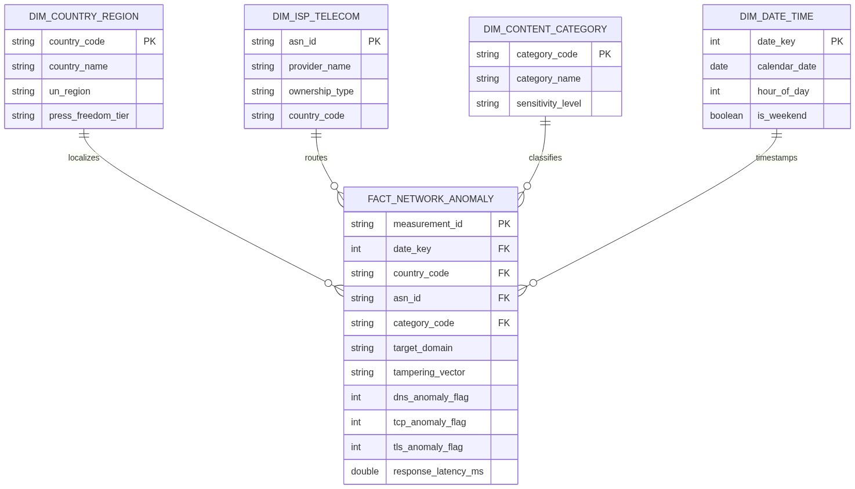
Figure 2: Gold Layer Dimensional Star Schema
4.1 Bronze Layer (Raw Telemetry Landing)
• Direct, unaltered append-only ingestion of source JSON and CSV payloads.
• Ingestion metadata attached: _ingestion_timestamp, _source_file_name, and _batch_run_id for complete data provenance and idempotency auditing.
• Stored as Delta Lake tables with default Snappy compression.
4.2 Silver Layer (Cleansed, Conformed & Enriched)
• Schema Standardization: Casting heterogeneous JSON data types into strong PySpark types (measurement_start_time -> TimestampType, probe_asn -> StringType).
• JSON Array Exploding: Flattening nested network test arrays (test_keys.queries, test_keys.network_events, and test_keys.tcp_connects) into relational tabular rows.
• Multi-Source Joining: Broadcast joins with ref_citizenlab_categories on target domain and lookup joins with ref_asn_providers on probe_asn.
• Tampering Vector Classification Engine: Evaluates raw network error codes into clean categories: DNS_TAMPERING, TCP_RESET_INJECTION, TLS_HANDSHAKE_DROP, and HTTP_BLOCK_PAGE.
• Deduplication: Enforcing deduplication on measurement_id using Delta Lake merge operations.
4.3 Gold Layer (Business Marts & Dimensional Star Schema)
The Gold layer provides high-performance, analytics-ready tables modeled in a Star Schema optimized for analytical reporting:
• Fact Table: fact_network_anomaly (Granularity: One row per confirmed network test failure/anomaly. Measures: dns_anomaly_flag, tcp_anomaly_flag, tls_anomaly_flag, response_latency_ms).
• Dimension Tables: dim_country_region, dim_isp_telecom, dim_content_category, dim_date_time.
• Aggregated Gold Mart: agg_daily_censorship_severity (Precomputed rollups calculating the Censorship Aggression Index: (Total Tampered Tests / Total Tests Conducted) * 100, sliced by country, ASN, category, and date).
5. Business Intelligence & Dashboards
5.1 Core Forensic & Policy Questions Answered
1. What technical attack vector is dominant within a target country during active civil events? (Differentiates between low-cost DNS hijacking vs. enterprise-grade Deep Packet Inspection to determine the technical sophistication of the state apparatus).
2. What content categories experience selective throttling vs. wholesale blackouts? (Proves state intentionality by contrasting failure rates of independent news and VPN portals against e-commerce and banking infrastructure).
3. Which telecommunication providers act as aggressive state censors vs. neutral carriers? (Identifies compliance divergence across competing commercial ISPs within the same jurisdiction).
4. Regulatory Enforcement Latency: How long does it take each individual ISP to comply with an emergency ban directive after the first block is observed nationally?
5. Surgical Censorship vs. Collateral Damage: Measuring whether over-blocking of shared CDNs unintentionally damages domestic banking and online commerce.
5.2 Dashboard Specifications (Power BI / Tableau)
Wireframe Layout for the Executive Single-Screen View:
+--------------------------------------------------------------------------------------------------------+
| PANOPTICON: GLOBAL INTERNET CENSORSHIP & CYBER SURVEILLANCE WATCHTOWER [Filter: Country | Date] |
+-------------------+--------------------+------------------------+--------------------------------------+
| TOTAL PROBE TESTS| ANOMALY BLOCK RATE | CRITICAL BLACKOUT ZONES| DOMINANT ATTACK VECTOR |
| 14,820,491 | 28.4% | 8 COUNTRIES | TCP RST Injection (54.2%) |
+-------------------+--------------------+------------------------+--------------------------------------+
| VISUAL 1: GLOBAL CENSORSHIP SEVERITY MAP | VISUAL 2: ATTACK VECTOR BREAKDOWN |
| (Interactive Choropleth: Green = Free, Red = Severe) | (100% Stacked Bar: By Country & ISP) |
| | +--------------------------------------+ |
| [ Interactive Global Map ] | | Iran Telecom: [TCP RST][DNS][HTTP] | |
| * Clicking any country cross-filters all charts below | | Rostelecom: [DPI Handshake Drop] | |
| | | Turkcell: [DNS Tampering Only] | |
| | +--------------------------------------+ |
+-------------------------------------------------------------+------------------------------------------+
| VISUAL 3: TARGET CATEGORY VULNERABILITY MATRIX | VISUAL 4: CENSORSHIP TIMELINE SPIKE |
| (What gets blocked? News vs. VPNs vs. Social Media) | (Hourly Anomaly % during Crisis/Protest) |
| +--------------------------------------------------------+ | 100%| /~~\ |
| | Circumvention / VPNs: ==================== 89% | | 50%| / \ |
| | Independent News: =============== 64% | | 0%|____/\__/ \______ |
| | Human Rights NGOs: ========== 42% | | 00:00 08:00 16:00 24:00 |
| | General E-Commerce: = 4% | | ^ Protests Begin: Signal Blocked |
| +--------------------------------------------------------+ +------------------------------------------+
+--------------------------------------------------------------------------------------------------------+

Detailed Visual Elements:
• Visual 1: Global Censorship Severity Map (Geospatial Choropleth shaded by Censorship Aggression Index 0-100%).
• Visual 2: Attack Vector Fingerprint Breakdown (100% Stacked Horizontal Bar showing DNS vs. TCP RST vs. TLS Drop by ISP).
• Visual 3: Content Category Vulnerability Matrix (Ranked Bar Chart of failure rates across Citizen Lab categories).
• Visual 4: Crisis Timeline Spike Detector (Dual-Axis Area/Line Chart correlating anomaly spikes with overall test dropouts).
6. Engineering Setup & FinOps Awareness
6.1 Repository Directory Structure
project-panopticon-lakehouse/
|-- README.md
|-- Docs/
| |-- phase1_proposal.md # Formal Phase 1 Project Proposal
| |-- phase1_proposal.docx # Formatted Microsoft Word Document
| `-- assets/ # High-Res Architecture and Star Schema Diagrams
`-- data/
`-- samples/
|-- sample_full_load_ooni.json # Full Load raw telemetry payload (~223 KB)
|-- sample_incremental_ooni.json # Incremental Load delta payload (~866 KB)
`-- sample_citizenlab_categories.csv # Citizen Lab Pakistan & Global URL taxonomy (~68 KB)

6.2 FinOps & Cloud Resource Optimization Strategy
Because execution is hosted on Databricks Community Edition (1 node, 15 GB RAM, 2 vCPUs) or Azure for Students ($100 annual credit ceiling), resource management is an active engineering priority:
1. Shuffle Partition Management: Default Apache Spark instantiates 200 shuffle partitions for joins and aggregations, creating severe context switching and memory allocation overhead on a single-node cluster. We configure spark.conf.set("spark.sql.shuffle.partitions", "16") to balance CPU core utilization.
2. Delta Lake File Compaction & Z-Ordering: Automated compaction and multidimensional clustering (OPTIMIZE silver_network_incidents ZORDER BY (country_code, measurement_date, asn_id)) eliminate metadata overhead from small files.
3. Storage Retention & Vacuum Policies: Historical snapshots pruned with VACUUM RETAIN 7 DAYS to avoid disk quota exhaustion.
4. Cloud Compute Lifecycle: Azure Databricks clusters enforce Auto-Termination at 15 minutes of inactivity to prevent accidental credit loss.
Conclusion & Milestone Roadmap
Milestone Phase | Scheduled Due Date | Core Deliverable Focus
Phase 1 | Submitted | Formal Project Proposal, Sourcing, Governance, Sizing & GitHub Setup
Phase 2 | 10 Oct 2026 | Automated Ingestion Engine, Bronze/Silver Delta Pipelines & PII Masking
Phase 3 | 24 Oct 2026 | Gold Star Schema, Power BI Dashboard Integration & Final Project Report

