Project Panopticon — Final Evaluation Report: Architecture, Decisions, Spark Execution & FinOps
Course context: Cloud Computing (Azure for Students / Databricks) — finalized evaluation report covering architectural diagram, decision log, Spark execution analysis, and Cost & FinOps awareness
Environment: Azure Databricks workspace, serverless compute (Spark Connect) for pipeline notebooks, serverless SQL / AI/BI dashboards for serving
Pipeline: OONI censorship telemetry lakehouse — Bronze (raw) → Silver (conformed) → Gold (dimensional) on Unity Catalog volumes (/Volumes/workspace/default/panopticon/)
Date of evaluation: 2026-10-25 (evidence base) · revised 2026-11-09 (finalized report format)

1. Summary
Panopticon ingests OONI internet-censorship telemetry through an API-only, medallion pipeline on Databricks serverless compute: Bronze preserves the raw OONI payload append-only, Silver conforms it into typed, PII-masked rows with surrogate-key idempotency, and Gold is a star schema (5 dimensions, an event fact, and daily/hourly severity marts) served by a two-page AI/BI dashboard. Every stage writes an audit row to pipeline_execution_logs, which doubles as the project's own compute-consumption telemetry.
Item | Value (evidence)
Audit-logged pipeline runs | 27 runs as of 2026-10-25 (pipeline_execution_logs)
Successful stage duration | 10.8–14.5 s (median ≈ 12.5 s)
Full daily incremental cycle (engine time) | ≈ 2–3 minutes across all Silver child tables and Gold steps
End-to-end wall-clock per daily cycle | ≈ 5–10 minutes (incl. serverless session start, notebook parse, API pull)
Pipeline success rate | ≈ 85% of logged runs
Estimated cost per daily incremental run | ≈ $0.03–$0.07 (serverless list-price range)
Enterprise hourly extrapolation | ≈ $4,000–$18,000 / year (§5.3)
Key findings: at academic scale cost is driven by the number of executions, not data volume (fixed per-run overhead dominates); at enterprise scale the driver inverts to (data volume × frequency) + serving, and frequency is the most expensive knob.

2. Architecture
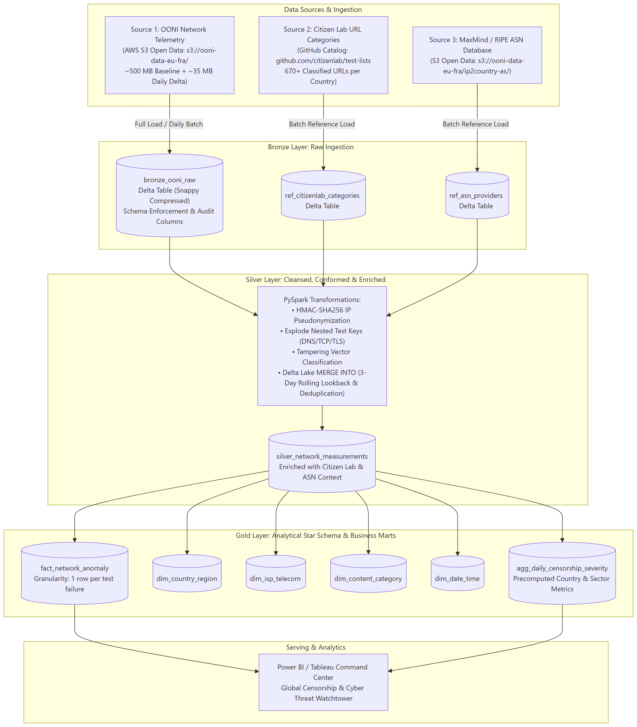
Figure 1. End-to-end flow (committed diagram: Docs/assets/architecture_diagram.svg / .png).
flowchart LR
subgraph SRC["Sources — API only, zero manual uploads"]
OONI["OONI Measurement API / public S3"]
CL["Citizen Lab test-lists — raw.githubusercontent.com"]
end
ING["01_bronze_ingestion<br/>explicit 23-field schema<br/>PERMISSIVE + _corrupt_record"]
BRONZE["BRONZE — bronze_ooni_raw<br/>append-only Delta<br/>partitioned by (probe_cc, measurement_date)"]
SILVER["SILVER — silver_network_measurements<br/>+ DNS/TCP/APP child tables<br/>partitioned by measurement_date<br/>PII masked / hashed at this boundary"]
GOLD["GOLD — star schema<br/>5 dims · fact_network_anomaly<br/>agg_daily / agg_hourly marts (ZORDER)"]
SERVE["Serving — serverless SQL warehouse<br/>AI/BI dashboards (2 pages)<br/>Power BI via Databricks connector"]
QA["quarantine_ooni_raw<br/>(contract violations)"]
AUD["pipeline_execution_logs<br/>(one audit row per stage)"]

OONI --> ING --> BRONZE --> SILVER --> GOLD --> SERVE
CL --> SILVER
ING -.-> QA
SILVER -.-> AUD
GOLD -.-> AUD
Figure 2. Logical data flow. Solid arrows: data flow. Dashed arrows: audit and quarantine records.
Raw → Bronze (`01_bronze_ingestion`). OONI telemetry is fetched programmatically from the measurement API / public S3 (no manual uploads, per project mandate), parsed against an explicit 23-field StructType (inferSchema never used), and appended to bronze_ooni_raw with _source_file, _batch_id, and load_timestamp provenance. JSON syntax corruption is captured by PERMISSIVE mode into _corrupt_record; rows that break the persistence contract go to quarantine_ooni_raw; a sample-contamination barrier (allow_sample_writes=False by default) blocks test/fallback data from production paths.
Bronze → Silver (`02_silver_transformation`). The polymorphic test_keys payload (stored as a string at the Bronze boundary) is exploded and typed; rows are deduplicated on the surrogate measurement_id (OONI measurement_uid when present, else a length-prefixed SHA-256 over six Bronze natural-key parts) via a null-safe <=> MERGE; PII is masked/hashed at this boundary (§3, "PII"); Citizen Lab taxonomy enrichment is applied from the pinned GitHub snapshot.
Silver → Gold (`03_gold_dimensional_modeling`). A window of Silver (rolling lookback, or explicit backfill dates via widgets) builds five dimensions, an event-grain fact, and two pre-aggregated marts (daily and hourly Censorship Aggression Index). Every table is merged idempotently on its business key; OPTIMIZE ... ZORDER BY runs on the fact/mart hot filter columns.
Serving. Gold tables and the audit log are read through a serverless SQL warehouse by the project's AI/BI dashboard (pages: Censorship Command Center, Pipeline Operations & Audit). The same Unity Catalog Gold tables are consumable from Power BI Desktop via the Databricks connector over the SQL warehouse, so the final hop of the diagram applies unchanged for a Power BI deployment.

3. Decision Log
Decision | Alternative | Why
Bronze partitioned by (`probe_cc`, `measurement_date`), append-only | Overwrite/deduplicate in Bronze; date-only partitioning | Bronze is an audit trail of exactly what arrived. Every incremental run and backfill filters on the date window, and country-filtered runs (focus countries default PK/IR/RU) prune by probe_cc; the two-column key mirrors OONI's own S3 partition hierarchy.
Silver partitioned by `measurement_date` only | Also partition Silver by probe_cc | The rolling 3-day lookback (T-3 → T) for late-arriving telemetry is the only hot Silver filter; adding country would multiply tiny partitions at academic scale and slow MERGE targeting.
Gold has no physical partitions; layout maintained by OPTIMIZE ... ZORDER BY — fact & daily mart on (country_code, date_key, asn_id), hourly mart on (country_code, date_time_key) | Hive-style year/month partitioning (the original Phase 1 plan) | Dimensions are tiny; every dashboard query filters country + date, so ZORDER co-locates the rows that are read together and Delta skips non-matching files — without small-partition maintenance. OPTIMIZE runs after each refresh and is wrapped so it never fails the run.
Explicit StructType contracts at every layer (Bronze 23-field schema, Silver required-columns contract, Gold *_SCHEMA objects); inferSchema never used | Schema inference | The schema is the contract — it makes drift visible (see below) and avoids multi-pass inference scans that OOM small compute.
test_keys stored as string at the Bronze boundary, exploded/typed in Silver | Typed nested StructType at Bronze | OONI's test_keys is polymorphic per nettest (blocking can be boolean or string; tor targets is a map; telegram/signal/psiphon have entirely different fields). A static struct silently drops fields or throws AnalysisException; the string boundary survives all of them.
Idempotency via MERGE at every layer: Bronze replaceWhere at partition level; Silver null-safe <=> MERGE on the surrogate key; Gold MERGE that updates only rows whose non-key attributes actually changed (audit columns excluded) | Overwrite, or update-all-matched | Re-running the same batch yields identical lakehouse state — timestamps included — while a re-classified measurement still updates in place.
Gold WHEN NOT MATCHED BY SOURCE → DELETE scoped to the processed window AND country | Unscoped not-matched-by-source delete | A country-filtered run must never remove other countries' rows; the window scope keeps deletes local to what the batch actually recomputed.
Surrogate measurement_id = OONI measurement_uid when present, else length-prefixed SHA-256 of six Bronze natural-key parts | Trust a single upstream identifier | OONI IDs are not always present; a deterministic composite key keeps deduplication reproducible.
Curated static seeds (COUNTRY_SEED UN geoscheme, PRESS_FREEDOM_SEED RSF 2025 red-zone, ISP_OWNERSHIP_SEED, CATEGORY_SEED) joined with broadcast() | Live external lookups, or broadcasting dynamic data | Only small, static lookups (< 10 MB) are broadcast (project guard); curated values are documented, extendable, and never guessed.
dim_date_time built as a full grid (dates × 24 hours) via crossJoin | Only hours actually observed | Blackout hours must appear as zero-measurement rows, so censorship shows up as absence rather than missing data.
Star schema with degenerate dimensions + two pre-aggregated marts at day/hour grain | Expose Silver directly to BI | The Censorship Aggression Index (cai_pct = 100 × attested tampered / total) needs aggregate denominators over all measurements; pre-aggregation keeps dashboard queries short and cheap.
Sample-contamination barrier in Bronze persistence (allow_sample_writes=False default) | Allow academic/test data into production paths | Contract violations abort in ~17–20 s — a data-quality guard that doubles as a cost guard (no expensive writes of contaminated data).

How we handled schema drift
OONI is a live API whose payload shape varies by nettest and evolves over time, so drift is treated as normal input rather than an exception. The handling is layered and each mechanism has a distinct job:
• Syntax corruption (malformed JSON) is caught at ingestion by Spark PERMISSIVE mode into _corrupt_record, and offending rows are preserved in quarantine_ooni_raw — the rest of the batch is never lost.
• Root-column evolution is managed by Delta mergeSchema=true on table writes, so safe additive changes land without a rewrite.
• Polymorphic nested fields (test_keys) are neutralized at the Bronze boundary by storing the payload as a string (see decision log) after the adversarial review catalogued the failure modes: per-nettest fields such as network_events, boolean-vs-string blocking, and tor's map-typed targets that would be silently dropped or would fail analysis under a static struct.
• Contract enforcement downstream: Gold's Silver read declares a SILVER_REQUIRED_COLUMNS contract and raises SilverContractError if Silver lacks a column Gold cannot work without; the 53-test suite pins the JSON schema contracts in data/schemas/ against the notebook's *_SCHEMA objects, so silent drift breaks the build rather than the data.

How we managed PII
OONI telemetry carries direct identifiers (probe_ip, probe_id, resolver_ip) and the tested input URL (which can embed userinfo/query credentials). All were PII-flagged in the adversarial review, including the quasi-identifier risk of the combination probe_cc + probe_asn + target + timestamp. Handling:
• Bronze keeps the raw payload append-only — it is an internal audit trail, never a BI exposure surface — with provenance columns (_source_file, _batch_id).
• Silver is the governed boundary: probe_ip/probe_id/resolver_ip are never carried forward. Instead Silver stores masked_probe_subnet (a /24 mask for IPv4, /48 for IPv6; NULL when the source IP is loopback/unspecified), hashed_resolver_ip = HMAC-SHA256(pepper, resolver_ip) with the pepper supplied via the PEPPER_HASH_SALT environment variable (never committed to the repository), and target_url with userinfo removed and credential/tracking query values redacted (plus a lower-cased target_domain).
• Gold further aggregates away residual quasi-identifier risk: marts are group-bys over country/ASN/category/test-family, and the fact carries only degenerate classification attributes — no IP-derived column survives to BI.
• No credentials are stored in code: public endpoints need no key, and workspace secrets are injected at runtime.

4. Spark Execution Analysis (Spark UI / DAG)
Tooling note. The pipeline runs on serverless Spark Connect, which does not expose the classic Spark UI. The equivalent evidence is the Query Profile (Workspace → Query History, or the "See performance" link under a notebook cell) and the physical plan from explain('formatted') — both show the same scans, exchanges, and stages. (Figure placeholder: capture the Query Profile of the Gold MERGE statement from Query History and save as `assets/gold_agg_query_profile.png`.)
The most complex transformation is the Gold `agg_hourly_censorship_severity` build: read a Silver window, derive conformed keys (hour key, country, test family), aggregate to one row per hour × country × family, and merge into the mart. The plan below was captured live against the Silver table on 2026-11-09 (read-only, window 2026-09-26 → 2026-09-27):
== Physical Plan ==
AdaptiveSparkPlan (6)
+- == Initial Plan ==
PhotonResultStage (5)
+- PhotonColumnarToRow (4)
+- PhotonGroupingAgg (3)
+- PhotonProject (2)
+- PhotonScan parquet (1)

(1) PhotonScan parquet
Location: PreparedDeltaFileIndex [dbfs:/Volumes/workspace/default/panopticon/silver/silver_network_measurements]
PartitionFilters: [isnotnull(measurement_date), (measurement_date >= 2026-09-26), (measurement_date <= 2026-09-27)]
ReadSchema: struct<event_timestamp:timestamp,probe_cc:string,test_name:string,
classification_status:string,ooni_anomaly:boolean,ooni_confirmed:boolean>

(2) PhotonProject — derives date_time_key = cast(date_format(event_timestamp,'yyyyMMddHH') as int),
country_code = upper(trim(probe_cc)), and the test_family CASE expression

(3) PhotonGroupingAgg
Arguments: [date_time_key, country_code, test_family],
[count(1), sum(CASE WHEN (ooni_anomaly OR ooni_confirmed) THEN 1 ELSE 0 END),
sum(CASE WHEN (classification_status = 'CONFIRMED_BLOCKED') THEN 1 ELSE 0 END)]

== Photon Explanation ==
The query is fully supported by Photon.
Figure 3. Physical plan of the Gold hourly-mart aggregation (captured on serverless Spark Connect; abridged to the operators that matter).
How Spark executed it:
• Predicate pushdown / partition pruning. The batch's date window is pushed into the Delta scan (PartitionFilters on measurement_date), so Delta opens only the partitions' files whose min/max statistics match — the 32-column Silver table is not scanned wholesale.
• Column pruning. The ReadSchema carries only the 7 columns the transformation needs; the other 25 Silver columns are never materialized.
• Vectorized execution. Every operator is a Photon columnar operator (PhotonScan/Project/GroupingAgg) — the query is fully supported by Photon, which is why a full stage completes in ~12 s.
• Shuffle behavior. At academic sample scale the grouped aggregate fits in a single partition, so the final plan contains no Exchange (shuffle) at all. At full OONI scale (tens of millions of rows), the group-by keys (date_time_key, country_code, test_family) would force a hash-partition Exchange — a shuffle — and Spark would run a partial (map-side) aggregate before the Exchange to cut the data volume that crosses the network. Shuffles are the expensive part of any such job; keeping the input small via pushdown is what avoids them here.
• The MERGE step (not shown above) joins the aggregate to the mart on the business keys: Delta rewrites only the files containing matched rows and appends new files for inserts; the update fires only when a non-key attribute actually changed (null-safe <=>), which is why an unchanged re-run writes nothing; the not-matched-by-source delete is scoped to the window and country. The mart's ZORDER on (country_code, date_time_key) — applied by the post-refresh OPTIMIZE — co-locates the rows every dashboard filter touches, so the serving-side scans skip files the same way the pipeline side does.

5. Cost & FinOps Awareness

5.1 Observed Compute Consumption (Evidence Base)
All figures below come from the project's own audit framework — the pipeline_execution_logs table at /Volumes/workspace/default/panopticon/logs/pipeline_execution_logs (27 runs logged as of 2026-10-25) and the "Pipeline Operations & Audit" dashboard page.
Metric (per audit-logged stage) | Observed value
Stage duration — successful runs | 10.8–14.5 s (median ≈ 12.5 s)
Stage duration — failed runs | 16.9–19.8 s (wasted compute)
Rows read per stage (academic sample scale) | 4–36 rows
Full daily incremental cycle (Bronze→Silver 4 child-table steps + Silver→Gold agg/dim/fact steps) | ≈ 2–3 minutes of engine time total
End-to-end wall-clock per daily cycle (incl. serverless session start, notebook parse, API pull) | ≈ 5–10 minutes
Pipeline success rate | ≈ 85% of logged runs (failures were early-development PATH_NOT_FOUND and sample-contamination contract violations)
Key FinOps observation at academic scale: cost is driven by the number of executions, not data volume. Each incremental run of the full cycle costs roughly the same whether it processes 15 rows or 15,000, because fixed overhead (serverless session spin-up, plan analysis, notebook interpretation, Delta commit) dominates the ~12 s per-stage runtime.

5.2 Typical Daily Incremental Run — Cost Estimate
Assumptions (verify against the current Azure Databricks pricing page before quoting externally):
• Serverless compute for jobs/notebooks: ≈ $0.55–$0.70 per DBU-hour (list price, tier-dependent)
• Effective DBU burn while a small serverless step is actively running: ≈ 1–2 DBU
• Engine time per full daily cycle: ≈ 3 minutes (from audit logs)
Item | Calculation | Estimate
Engine time per daily run | ~15 stages × ~12.5 s | ≈ 0.05–0.10 DBU-hour
Cost per daily incremental run | 0.05–0.10 DBU-hr × $0.55–$0.70 | ≈ $0.03–$0.07
Monthly (one daily incremental cycle) | 30 runs | < $2.50
Dashboard serving (serverless SQL, sample-scale data) | ad-hoc query bursts | < $1.00/month
Development/debug runs (the real student cost driver) | dozens of interactive notebook sessions | a few $ over the project
Verdict: the entire project lifecycle consumed only a small fraction of the $100 Azure for Students credit. The dominant student-spend category was interactive development and re-runs, not the production-style incremental loads — the runs themselves are effectively free at this data volume. The early "Bronze Persistence CONTRACT VIOLATION" guardrails also proved to be cost guardrails: they abort in ~17–20 s and prevent expensive writes of contaminated data into production tables.

5.3 Enterprise Hourly Extrapolation — Architectural Cost
Scenario: the same architecture promoted to an enterprise censorship-monitoring service over full OONI global telemetry (~1–2M measurements/day ≈ 50k–100k/hour), running hourly → 8,760 pipeline cycles/year.
Cost component | Assumption | Estimated annual cost (USD)
Pipeline compute (Jobs / job cluster) | 3–8 DBU/hr cluster, 10–20 min per hourly cycle, classic jobs-compute rates | $2,000 – $9,000
Ingestion (OONI API / S3 pulls) | bundled into pipeline compute above | (included)
Storage — Delta tables in UC | 1–5 TB/yr incl. Bronze retention + quarantine | $300 – $1,500
Dashboard serving (serverless SQL warehouse) | hourly refreshes + concurrent viewers, ~$14/DBU-hr | $1,500 – $8,000
Monitoring, alerting, audit logging | system tables + budget alerts | < $500
Total architectural estimate |  | ≈ $4,000 – $18,000 / year
Two structural insights for the enterprise design:
1. The cost driver inverts at scale. At student scale cost ≈ per-run overhead; at enterprise scale cost ≈ (data volume × frequency) + serving. The SQL warehouse serving the dashboard can rival or exceed pipeline compute if dashboards aggregate raw-scale data on every view.
2. Frequency is the most expensive knob. Hourly (8,760 runs) vs daily (365 runs) is a 24× multiplier on fixed per-run overhead. Freshness SLA must be priced, not assumed.

5.4 Optimization Strategy
1. Consolidate executions. Replace notebook-driven runs with a single Lakeflow Job per cycle (or Spark Declarative Pipeline) using one job cluster per cycle (or serverless jobs) — amortizes startup/plan overhead across all Silver child tables and Gold steps instead of paying it per notebook.
2. Event-driven ingestion. Use Auto Loader / file-arrival triggers against the OONI public data endpoint instead of a fixed hourly poll — pay only when new data lands; idle hours cost $0.
3. Keep every stage truly incremental. MERGE-based upserts with partition pruning / liquid clustering on date keys so an hourly run reads only that hour's slice, not a rolling scan of Bronze.
4. Pre-aggregate in Gold, materialize for serving. Push aggregations into Gold materialized views and enable dashboard dataset materialization on publish, so viewer traffic hits pre-computed tables and the warehouse runs short, cheap queries with aggressive auto-stop.
5. Storage hygiene. Scheduled OPTIMIZE/VACUUM, quarantine purge policy, and archival of aged raw JSON to cool storage tiers.
6. Price the freshness SLA. Moving from hourly to 4-hourly cuts pipeline compute ~4×; offer a streaming/real-time tier only for focus countries if a use case demands it.
7. FinOps observability. Tag workloads for cost allocation, track spend in system.billing.usage, set budget policies and spend alerts, and review cost-per-run monthly against the audit logs (the project's pipeline_execution_logs already provides per-run duration telemetry to detect drift).

6. Assumptions & Caveats
• DBU rates are Azure list-price approximations and vary by pricing tier, region, and commitment discounts — the dollar figures are order-of-magnitude estimates, not quotes.
• Stage durations are measured from the project's audit logs at academic sample scale; enterprise durations are extrapolated (real OONI-scale hourly volumes would extend per-cycle runtime from ~12 s/stage to minutes/stage, which is reflected in the ranges above).
• The 27-run log includes development/debug failures; the "typical daily incremental run" figure uses only the successful 2026-09-27 batch cycle as the reference workload.
• The physical plan in §4 was captured on 2026-11-09 against the live Silver table on serverless Spark Connect; serverless does not expose the classic Spark UI, so the Query Profile is the authoritative stage-level view (placeholder noted in §4).

Dependency & Impact Note
Documentation only — no code, notebook, or lakehouse state is affected by this file. Evidence sources: pipeline_execution_logs (audit table), notebooks/01_bronze_ingestion, 02_silver_transformation, 03_gold_dimensional_modeling (partition/MERGE/ZORDER/PII decisions verified against source on 2026-11-09), DESCRIBE output for Bronze and Silver tables, the captured Gold physical plan, panopticon_adversarial_review.md, the gold-layer dashboard "Pipeline Operations & Audit" page, and Docs/ project documentation.

