Power BI & Fabric

Planning & Design Document

f

Abstract
This document defines the Planning and Design for UMS Power BI & Fabric project.

Prepared By

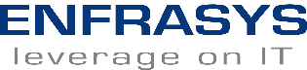

Change Record
Date | Author | Version | Change Reference
30 October 2025 | Megan Raaj Sethu | 1.0 | Create Document
4 November 2025 | Megan Raaj Sethu | 1.1 | Content Update

Distribution List
Name | Position/ Team
Enfrasys Consulting Sdn Bhd | IT Team
UMS | IT Team

Terms of Use
This work may be used “as-is” by any interested party. You may copy, adapt, and redistribute this document for non-commercial use or for your own internal use in a commercial setting.
However, you may not republish this document, nor may you publish or distribute any adaptation of this document for other than non-commercial use or your own internal use, without first obtaining express written approval from Enfrasys Solutions Sdn Bhd.

Disclaimer
The Author and Enfrasys Solutions Sdn Bhd shall have neither liability nor responsibility to any person or entity with respect to the loss or damages arising from the information contained in this work. This work may include inaccuracies or typographical errors and solely represent the opinions of the Author. Changes are periodically made to this document without notice.
Due to the rapid growth of various technologies, the Author and Enfrasys Solutions Sdn Bhd cannot guarantee the accuracy of the information presented after the date of publication.

Trademarks
The names of actual companies, service marks, trademarks or products mentioned herein may be the trademarks of their respective owners. Use of terms within this work should not be regarded as affecting the validity of any trademark or service mark.
Enfrasys Consulting may have patents, patent applications, trademarks, copyrights, or other intellectual property rights covering subject matter in this document. Except as expressly provided in any written license agreement from Enfrasys Solutions Sdn Bhd; the furnishing of this document does not give you any license to those items.

Table of Contents
1 Design Document Sign Off 8
2 Executive Summary 10
2.1 Project Overview 11
2.2 Document Purpose 11
2.3 Document Audience 11
3 Network Design and Decision 12
3.1 Data Gateway 12
4 Roles in Microsoft Fabric 13
4.1 Fabric Administrator Role 13
4.1.1. Assigning Fabric Administrator Role 13
4.1.2. The Fabric Admin Portal 13
4.2 Fabric-native Roles 15
4.2.1. Workspace-level Roles 15
4.2.2. Item-level Roles 17
4.3 UMS Workspace Role and Access 18
5 Fabric Design and Decision 19
5.1 Fabric Data Workflow Design Considerations 20
5.2 Fabric Data Workflow Design Decisions 22
5.3 Fabric Access Design Considerations 23
5.3.1. Access design consideration (Entra Conditional Access) 23
5.4 Fabric Access Design Decisions 25
5.5 Identity and Access Management 26
5.6 Virtual Machine (VM) Size 27
5.7 Resource Organization Design 28
5.7.1. Azure Management Group 28
5.7.2. Naming and Tagging 29
5.8 Governance Consideration 34
5.8.1. Azure Governance Discipline 34
5.8.2. Violation Triggers and Actions 35
5.9 Multi-Factor Authentication 35
6 Security Design and Decision 36
6.1 Azure Network Security Group Design Overview 36
6.1.1. Outbound Security Rules 36
7 AutoML in Microsoft Fabric 38
7.1 Technical Overview 38
7.2 Model Development Approaches in Fabric 39
7.2.1. Assisted AutoML Functionality 39
7.2.2. Manual Machine Learning (Notebook-Based Approach) 39
7.3 AutoML Process Flow in Fabric 40
7.3.1. AutoML Process Flow in Fabric 41
7.3.2. Manual Machine Learning Path 41
7.3.3. Final Output & Visualization 41
7.4 AutoML Process Workflow Design Decisions 42
8 Appendix 43
8.1 Appendix 1 Computing 43
8.1.1. Introduction/Prerequisites 43
8.1.2. Limits and Boundaries 43
8.1.3. Others 43
8.2 Appendix 2 Network 44
8.2.1. Introduction/Prerequisites 44
8.2.2. Limits and Boundaries 44
8.2.3. Others 45
8.3 Appendix 3 Identity & Security 46
8.3.1. Introduction/Prerequisites 46
8.3.2. Limits and Boundaries 46
8.3.3. Others 46
8.4 Appendix 4 Logging & Monitoring 47
8.4.1. Introduction/Prerequisites 47
8.4.2. Limits and Boundaries 47
8.4.3. Others 47
8.5 Appendix 5 Cloud Governance 48
8.6 Appendix 6 On Premise Data Gateway (OPDG) 48
8.7 Appendix 7 Machine Learning 48

Table of Figures
Figure 1 Data Gateway Architecture Overview 12
Figure 2 Admin Portal Button 13
Figure 3 Fabric Components Overview 19
Figure 4 UMS Data Workflow Architecture 20
Figure 5 UMS Conditional Access Design 23
Figure 6 UMS Conditional Access Architecture 24
Figure 7 Azure Roles 26
Figure 8 The four scope levels for organizing Azure Resources 28
Figure 9 Data Science Overview 38
Figure 10 Machine Learning Process Architecture 40

Table of Tables
Table 1 Fabric Administrator Capabilities 14
Table 2 Workspace-level Role Capabilities 16
Table 3 UMS Workspace Roles 18
Table 4 UMS Data Workflow Design Considerations 22
Table 5 UMS user Conditional Access 25
Table 6 UMS Fabric Access Design Decisions 25
Table 7 Identity Mapping 26
Table 8 On-Premises Data Gateway (OPDG) Host VM Specifications 27
Table 9 Naming Convention 29
Table 10 UMS Fabric Naming Convention 30
Table 11 Fabric Short Form Convention 31
Table 12 Suggested Tags 33
Table 13 Cost Management Tools 35
Table 14 Violation Triggers and Actions 35
Table 15 Outbound Port Summary 36
Table 16 Outbound Security Rules for OPDG 37
Table 17 UMS AutoML Process Workflow Design Decisions 42

Design Document Sign Off
We hereby acknowledge that the design document for UMS PowerBI and Fabric Project has been reviewed, and all key aspects have been addressed satisfactorily.
This document has been prepared, reviewed, accepted, and signed off by the following individuals:
Prepared by: | Verified by:
Enfrasys Solutions Sdn Bhd | Enfrasys Solutions Sdn Bhd
Signature:  Megan Raaj Sethu  _________________________________  Name: Megan Raaj A/L Sethu  Designation: Solutions Engineer  Date: 5 November 2025 | Signature:  _________________________________  Name: Wan Razif Muzaffar  Designation: Solutions Specialist  Date: TBC

Reviewed by:
Project Manager
UMS
Name | Signature
Name: Dr. Suraya Binti Alias  Designation:  Date: | _________________________________
Verified by:  Project Director  UMS | Approved by:  Chief Digital Officer  UMS
Signature:  _________________________________  Name: Dr. Farashazillah Binti Yahya  Designation:  Date: | Signature:  _________________________________  Name: Professor Dr. AG. Asri Bin AG. Ibrahim  Designation:  Date:

Executive Summary
The objective of this project is to ensure the successful adoption and operational readiness of Microsoft Fabric by aligning platform capabilities with business needs and user requirements. This includes establishing secure and scalable Fabric capacity with proper governance, enabling seamless data integration through Fabric Data Factory, optimizing data models and analytics in Fabric Data Warehouses, integrating Power BI for business-aligned reporting, and providing comprehensive user support, documentation, and adoption enablement.

Project Overview
This project is scoped to implement Power BI and Fabric to current UMS’s Azure subscription. This is includes creating a Fabric workspace and deploying the first ETL pipeline for UMS. The implementation also covers Power BI integration for business-aligned analytics. This project will deliver one end-to-end dashboard as a blueprint for UMS’s future development and ensure operational readiness through user enablement and documentation.

Document Purpose
The purpose of this document is to detail the design for this solution and the high-level plan for its delivery. Its content is based on information gathered and decisions made during the workshop that were conducted with UMS on 28th October 2025. Decisions made during subsequent planning meetings have also been captured in this document.

Document Audience
This document is intended for the UMS Power BI and Fabric project’s resources including the technical, management and support teams who will be responsible for the solution after it is delivered. It assumes familiarity with Azure, Power BI, and a fundamental working knowledge of Microsoft Fabric.

Network Design and Decision
Networking and connectivity decisions are an equally important foundational aspect of any cloud architecture.

Data Gateway
The on-premises data gateway (OPDG) will be configured to facilitate secure and reliable data transfer between the on-premises SQL Server database and Microsoft Fabric. Since both the source system (SQL Server DBMS) and target analysis platform (Microsoft Fabric) are Microsoft-native services, OPDG ensures seamless interoperability within the Microsoft ecosystem.
The gateway will be installed on an on-premises Virtual Machine (VM) that will serve as the host for managing data connections and authentication. This setup establishes a secure outbound-only communication channel from the VM to the Azure Fabric service, eliminating the need for inbound firewall rules while enabling Fabric to access, refresh, and orchestrate data pipelines from the SQL Server environment.
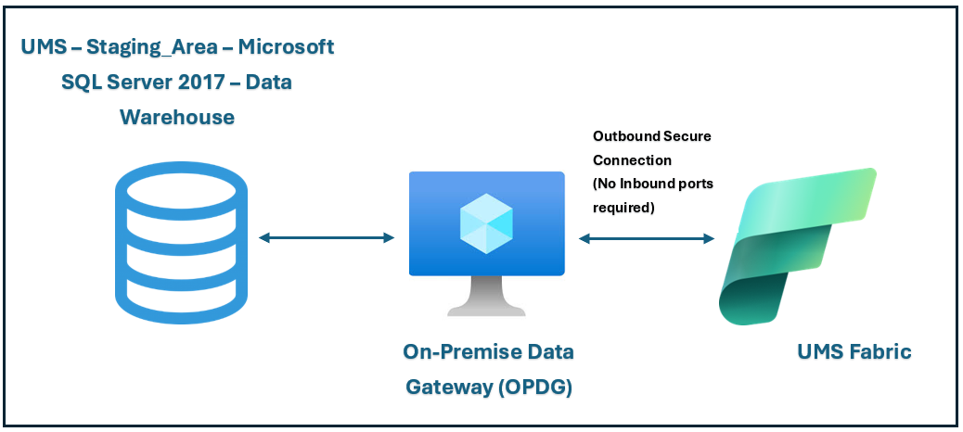
Figure 1 Data Gateway Architecture Overview

Roles in Microsoft Fabric
This section describes two types of roles associated with Microsoft Fabric; those at the Global Service level, assigned from the Microsoft 365/Entra ID admin portal, and those which are assigned within the Fabric service itself. This section of the document will make recommendations for both role-types.

Fabric Administrator Role

Assigning Fabric Administrator Role
Enfrasys’ recommendation to UMS is to have at least one member of the Data Team assigned the Fabric administrator role. This will reduce bottlenecks in service configuration, as changes can be made within the department. UMS should consider applying additional conditional access controls over this privileged account, such as the user with this role of accessing the Fabric service via a PAM tool, to further harden the account/service against compromise scenarios.
Microsoft 365 user administrators are responsible for assigning users to the Fabric Administrator role. This can be done through the Microsoft 365 admin portal or by utilizing a PowerShell script.
Individuals in the Fabric Administrator role are granted full control over organization-wide Microsoft Fabric settings and administrative features, excluding licensing. Once assigned, these users gain access to the Fabric admin portal, which provides them with organizational usage metrics and enables control of Microsoft Fabric features across the organization.

The Fabric Admin Portal
The Fabric admin portal can only be accessed by users with the Fabric administrator role. If a user does not have this role assigned, they will only have access to Capacity Settings if they try to access this configuration service. The portal is accessed by clicking through the following steps:
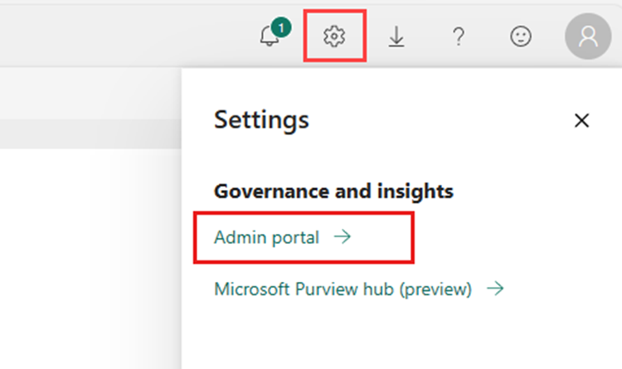
Figure 2 Admin Portal Button

- Sign into Microsoft Fabric with Fabric administrator credentials.
- Select the Settings Menu (cog icon), and from that menu select Admin portal.
Once inside the Fabric admin portal, the Fabric administrator can configure the many controls associated with this service:
Submenu | Description
Tenant settings | Enable, disable, and configure Microsoft Fabric.
Usage metrics | View usage metrics related to your organization.
Users | Manage users in the Microsoft 365 admin portal.
Premium Per User | Configure auto refresh and semantic model workload settings.
Audit logs | Audit Microsoft Fabric activities in the Microsoft Purview compliance portal.
Capacity settings | Manage Microsoft Fabric F, Power BI Premium P, and Power BI Embedded EM and A capacities.
Refresh summary | Schedule refresh on a capacity and view the details of refreshes that occurred.
Embed codes | View and manage the embed codes that have been generated for your organization to share reports publicly.
Organizational visuals | View, add, and manage which type of Power BI visuals users can access across the organization.
Azure connections | Configure and manage connections to Azure resources.
Workspaces | View and manage the workspaces that exist in your organization.
Custom branding | Change the look and feel of the Microsoft Fabric to match your organization's own branding.
Protection metrics | Monitor and track sensitivity label usage and adoption in your organization.
Featured content | Manage the reports, dashboards, and apps that were promoted to the Featured section on your Home page.
Table 1 Fabric Administrator Capabilities

Fabric-native Roles
Appointed Data Team will be responsible for assigning roles/access within the Microsoft Fabric service. The roles are an important component of the security model; they are the service validation tool that, once identity has been confirmed with Entra ID, sets the permissions for exactly how a user is allowed to interact with the Microsoft Fabric service. It is best practice for users to have the least privilege required to fulfil their task; oversharing of access privileges on accounts can lead to more severe security scenarios if the user account is successfully compromised.

Workspace-level Roles
To develop the security baseline for initial deployment, Enfrasys recommends that UMS assign the Data Team security group the Contributor role. Senior team members should have the Member role assigned on a per-user basis, allowing them additional controls over how access to workspaces/items are shared with users outside of the Data Team security group. The Fabric Admin role will be assigned to a single member of the Data Team to configure the service.
Workspace roles are utilized to control access to workspaces and their contents. A Fabric administrator can assign workspace roles to individual users or groups. These roles are specific to a particular workspace and do not extend to other workspaces, the capacity in which the workspace operates, or the tenant.
Workspace-level roles are set at the options menu inside each Fabric workspace. Users and groups can be added to (or removed from) a workspace by users assigned with the Admin or Member role.
There are four workspace roles, each of which applies to all items within the workspace. Users without any of these roles are unable to access the workspace. The roles are as follows:
- Viewer: Can view all content in the workspace but cannot modify it.
- Contributor: Can view and modify all content in the workspace.
- Member: Can view, modify, and share all content in the workspace.
- Admin: Can view, modify, share, and manage all content in the workspace, including managing permissions.

Workspace Role Overview
Below shows the capability of each role in a Workspace:
Capability | Admin | Member | Contributor | Viewer
Update and delete the workspace. | ✅
Add or remove people, including other admins. | ✅
Add members or others with lower permissions. | ✅ | ✅
Allow others to reshare items. | ✅ | ✅
Create or modify database mirroring items. | ✅ | ✅
View and read content of data pipelines, notebooks, Spark job definitions, ML models and experiments, and Event streams. | ✅ | ✅ | ✅ | ✅
View and read content of KQL databases, KQL query-sets, and real-time dashboards. | ✅ | ✅ | ✅ | ✅
Connect to SQL analytics endpoint of Lakehouse or the Warehouse | ✅ | ✅ | ✅ | ✅
Read Lakehouse and Data warehouse data and shortcuts with T-SQL through TDS endpoint. | ✅ | ✅ | ✅ | ✅
Read Lakehouse and Data warehouse data and shortcuts through OneLake APIs and Spark. | ✅ | ✅ | ✅
Read Lakehouse data through Lakehouse explorer. | ✅ | ✅ | ✅
Write or delete data pipelines, notebooks, Spark job definitions, ML models, and experiments, and Event streams. | ✅ | ✅ | ✅
Write or delete Eventhouses, KQL Querysets, Real-Time Dashboards, and schema and data of KQL Databases, Lakehouses, data warehouses, and shortcuts. | ✅ | ✅ | ✅
Execute or cancel execution of notebooks, Spark job definitions, ML models, and experiments. | ✅ | ✅ | ✅
Execute or cancel execution of data pipelines. | ✅ | ✅ | ✅
View execution output of data pipelines, notebooks, ML models and experiments. | ✅ | ✅ | ✅ | ✅
Schedule data refreshes via the on-premises gateway. | ✅ | ✅ | ✅
Table 2 Workspace-level Role Capabilities

Item-level Roles
In the future, there might be external users that invested in the outcomes of a specific data processing of a certain item. Item-level roles should be used to maintain a high degree of segregation within the environment, restricting access to only those Fabric items required to complete a task.
These roles are scenario-based, deployed as and when the need arises, rather than part of a secure deployment baseline. No item-level roles are required to be deployed initially. However, Enfrasys recommends UMS assign access at item-level as the first choice for users who met the description above to follow the security principle of least privilege access.
Item permissions are utilized to control access to individual Fabric items within a workspace. These permissions are specific to a particular item and do not extend to other items. Item permissions enable the management of who can view, modify, and manage individual items within a workspace. They can also be used to grant a user access to a single item in a workspace to which they do not already have access.
When sharing an item with a user or group, item permissions can be configured based on the requirements of that scenario. By default, sharing an item grants the user read permission for that item. Read permissions allow users to view the metadata associated with that item and any reports linked to it. However, read permissions do not permit users to access the underlying data in SQL or OneLake.
Item-level permissions can be set on the following Fabric items:
- Semantic Model  - Data Warehouse  - Data Factory | - Lakehouse  - Data Science  - Real-time Intelligence

UMS Workspace Role and Access
Below table shows roles and person-in-charge (PIC) for this project Workspace as discussed during Design Review:
No. | Workspace Role | Suggested Role | UMS PIC
1 | Workspace Admin | Fabric Admin /  Data Engineer /  Technical Team Lead | - Dr Suraya Binti Alias  - Sektor Analitik Data DARTIC  - PPDM Official  - Mohd. Zamrie Bin Musa  - Noor Afiza Binti Momen  - Ts AG Azihar @ AG KU Azihar Bin AG Tangah
2 | Workspace Contributor | Data Engineer / Business User Admin | - Mohd Khairul Nizam Bin Senu (DB)  - Assie Zaee Petrus (DB)  - Muhaimin Bin Mad Noor (Infra)  - Nuraliah Binti Alias (Infra)  - Chong Tze Chien (Server Security)  - Abdul Latif Matali (Server Security)
3 | Workspace Viewer | Data Analyst /  Stakeholder /  Project Director | Director  - Dr Farashazillah Binti Yahya  Stakeholders  - Roslee Bin Talip  - Dayangku Rozlina BTE PG. Aliuddin  - Norhanieyati Binti Norhaizat  - Zaidie @ Mohd Zaidie Bin Adilai  - Professor Madya TS Dr Mohd Hanafi Bin Ahmad Hijazi
Table 3 UMS Workspace Roles

Fabric Design and Decision
The enterprise-wide foundation for scalable analytics, governance, and artificial intelligence is provided by Microsoft Fabric, a single data platform. Data integration, engineering, science, real-time analytics, and business intelligence can all coexist in a single SaaS experience thanks to Microsoft Fabric. By combining all necessary data tools into a single environment, it is intended to assist data modernization, advanced analytics, and innovation at scale. Figure below shows how Microsoft Fabric component cooperates with each other:
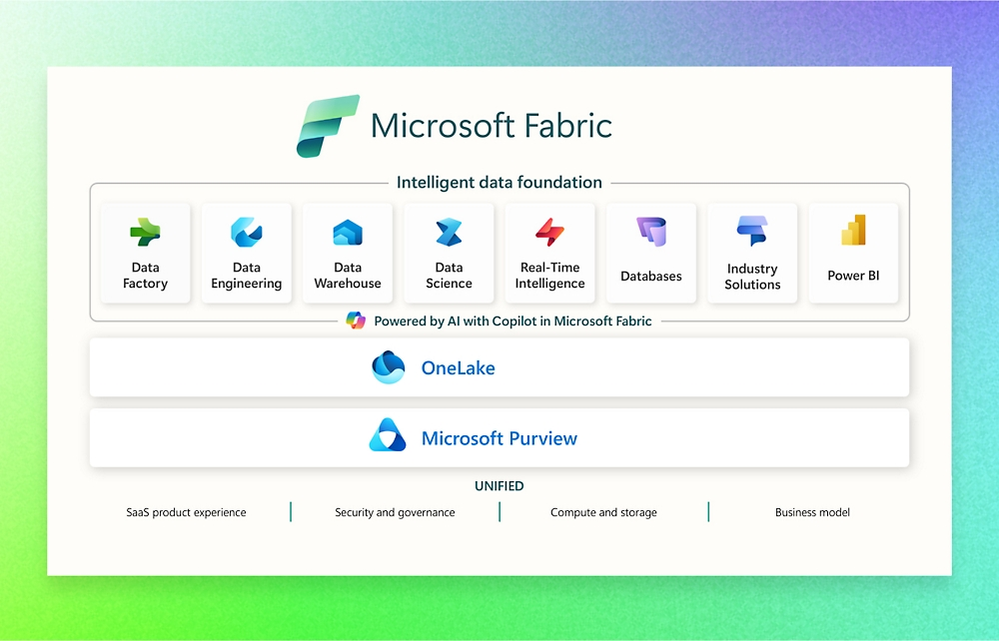
Figure 3 Fabric Components Overview
Fabric environments integrate with enterprise security, identity, and governance frameworks while taking into account end-to-end data requirements, including ingestion, transformation, storage, and visualization. Microsoft Fabric offers a single platform that covers the full data lifecycle, whether working with structured, semi-structured, or real-time data, rather than distinguishing between traditional jobs like data engineer, analyst, or scientist.

Fabric Data Workflow Design Considerations
The figure below shows the architecture for targeted Data Workflow:

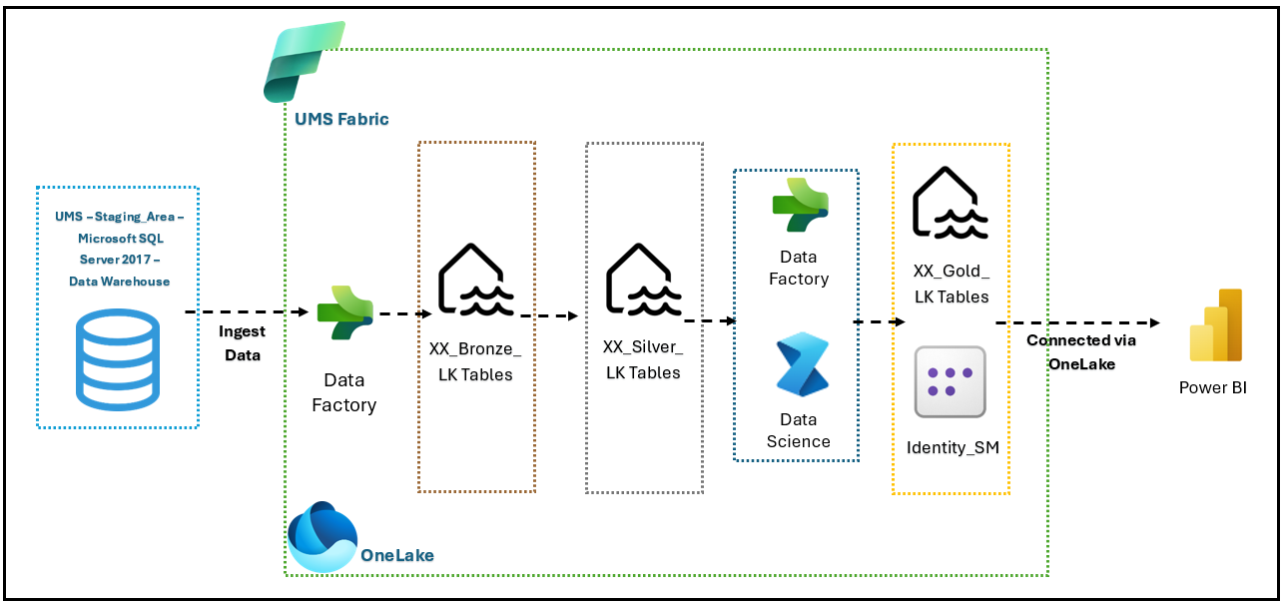
Figure 4 UMS Data Workflow Architecture
The core Fabric platform encompasses a variety of services and resources. Figure 4 shows the logical view of these services.
The diagram above shows the components of UMS PowerBI and Fabric, where the data will be ingested from the On-Premise Data Gateway (OPDG) that contains Microsoft SQL Server Data Warehouse. Key items in this design include:
- Data Factory(pipeline) item will ingest data from Microsoft SQL Server and keep the data inside the Lakehouse.
- Lakehouse will be used for keeping data. Bronze Lakehouse is for cleaned data from ingestion, Silver Lakehouse is to store cleansed data from Bronze Lakehouse, and Gold Lakehouse is to keep transformed or merged data from Silver Lakehouse.
- Dataflow Gen2 will ingest data from one Lakehouse to another Lakehouse.
- AutoML under Data Science will conduct Machine Learning process and push the result to the Lakehouse.
- Based on UMS’s answer in assessment questionnaire, there will be one dashboard for visualization. Hence, by estimation, there will be one Semantic Model for this project, and it will use data from the Gold Lakehouse. Data Modelling will be done in the Semantic Model.
- PowerBI Desktop will be connected to the Semantic Model via OneLake.

Fabric Data Workflow Design Decisions
UMS has chosen the proposed Data Workflow design:
ID | Description | Workloads type
DC01 | Data Pipeline will be used to ingest data from Microsoft SQL Server. | Data Factory
DC02 | The Bronze Lakehouse will store raw/original data ingested from PostgreSQL. | Data Engineering
DC03 | The Silver Lakehouse will store cleansed data sourced from the bronze Lakehouse. | Data Engineering
DC04 | The Gold Lakehouse will store transformed data sourced from the silver Lakehouse. | Data Engineering
DC05 | Data cleansing and transformation for the Silver Lakehouse will be performed using Dataflow Gen2, Notebook and Visual Query in the SQL Analytics Endpoint. | Data Engineering
DC06 | Dataflow Gen2 will be used to move data between Lakehouses (e.g., from bronze to silver or silver to gold). | Data Factory
DC07 | AutoML from Data Science will be used to demonstrate the Machine Learning Process, and the results will be stored in Gold Lakehouse | Data Science
DC08 | Data modeling will be implemented in the Semantic Model, using data from the Gold Lakehouse. | Power BI
DC09 | Power BI Desktop will connect to the Semantic Model via OneLake for data visualization. | Power BI
Table 4 UMS Data Workflow Design Considerations

Fabric Access Design Considerations
For this part, there will be a single consideration, Entra Conditional Access. Below subtopic will elaborate more regarding the selected option:

Access design consideration (Entra Conditional Access)
Below shows the architecture design for Entra Conditional Access:
Conditional Access (CA) is a policy-based access control mechanism provided by Microsoft Entra ID (formerly Azure AD). It allows you to control who can access what, under what conditions based on identity, device state, location, risk level, etc.
Instead of controlling network-level access like Private Link, CA controls identity-level access (user login sessions and service access behavior).
The purpose of using Conditional Access is to:
- Enforce secure access policies across Microsoft Fabric.
- Adaptively respond to risk by enforcing MFA, blocking risky sign-ins, or restricting access.
- Allow or deny access based on context (e.g., location, device, group, risk).

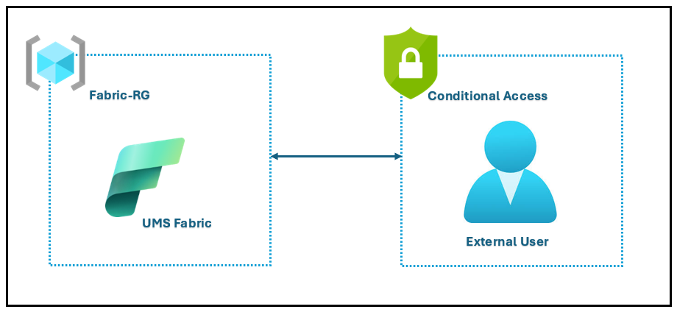
Figure 5 UMS Conditional Access Design
Users can still access Fabric workspace without connecting to internal network, if the allowed user meets the conditions. User organization’s identity is recognized and can be used with secure MFA.

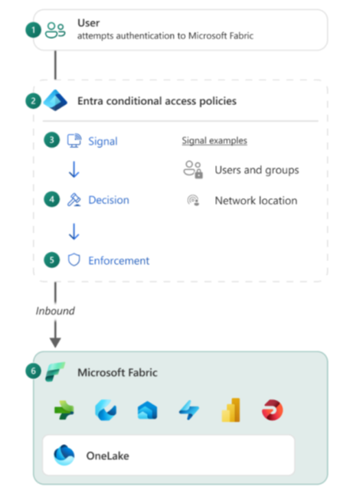
Figure 6 UMS Conditional Access Architecture
To ensure Conditional Access works effectively in Microsoft Fabric, it's recommended to configure a single, unified policy that applies consistently across related services. This policy should include the Power BI Service, Azure Data Explorer, Azure SQL Database, and Azure Storage. Using one common Conditional Access policy across these services helps reduce unexpected login prompts caused by inconsistent or conflicting rules, and it ensures a smoother, more predictable user experience while maintaining a consistent security posture across the entire Fabric ecosystem.

UMS user access to Microsoft Fabric will continue to be managed using Conditional Access policies.
Below table shows UMS user Conditional Access:
No. | UMS user
1 | Direct Access to Fabric
2 | Managed using Conditional Access
3 | Users go through additional validation such as, secure login, and MFA.
4 | Conditional Access policy that includes Power BI Service, Azure Data Explorer, Azure SQL Database, and Azure Storage
Table 5 UMS user Conditional Access
Based on the assessment, UMS account is not eligible for Conditional Access. Therefore, MFA has been enforced at the tenant level.

Fabric Access Design Decisions
UMS has chosen to implement Conditional Access Design for Fabric Access:
No. | Conditional Access
DD01 | Configure Policy in Conditional Access to include Power BI Service, Azure Data Explorer, Azure SQL Database, and Azure Storage
DD02 | Include UMS user inside Conditional Access policy
DD03 | UMS users go through additional verification, MFA, to reduce unexpected login prompts
DD04 | Users able to access Microsoft Fabric’s environment
Table 6 UMS Fabric Access Design Decisions

Identity and Access Management
Identity and access management is a primary security boundary in the public cloud. It is the foundation for any secure and fully compliant architecture.
The Azure Active Directory design and integration must be built to ensure both server and user authentication. Azure RBAC provides detailed access management of resources in Azure. It helps to manage who has access to Azure resources, what they can do with those resources, and what scopes they can access.
The following image shows a suggested pattern for assigning Azure RBAC:
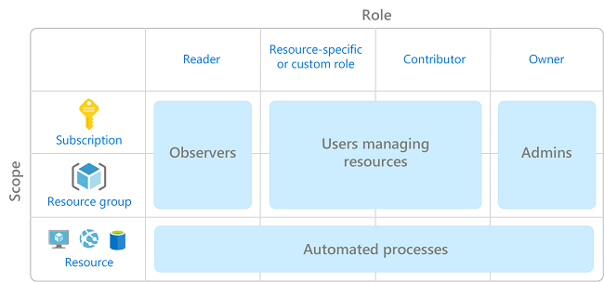
Figure 7 Azure Roles
Following table shows the Fabric RBAC permissions for UMS:
Fabric Role | Assign Scope | RBAC
Fabric Administrator | Fabric Tenant level | Administrator
Workspace Admin | Workspace level | Administrator
Workspace Contributor | Workspace level | Contributor
Table 7 Identity Mapping

Virtual Machine (VM) Size
Tables below describe the on-premises virtual machine specifications required to host the Microsoft On-Premises Data Gateway (OPDG) for data ingestion between the SQL Server Environment and the Microsoft Fabric platform.
Component | Specification
Operating System | Windows 10 (64-bit) or Windows Server 2019 (64-bit)
.NET Framework | Version 4.8
vCPU | 8 cores
RAM | Minimum 8 GB
Table 8 On-Premises Data Gateway (OPDG) Host VM Specifications

Resource Organization Design
Organizing cloud-based resources is critical to securing, managing, and tracking the costs related to workloads.

Azure Management Group
Azure management groups (MG) help you efficiently manage access, policies, and compliance for your subscriptions. Each management group is a container for one or more subscriptions.
Azure provides four levels of management scope: -
- Management groups
- Subscriptions
- Resource groups
- Resources

This inheritance model lets you arrange the subscriptions in your hierarchy so that each subscription follows appropriate policies and security controls.
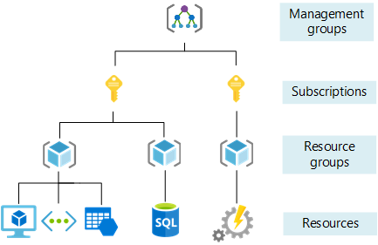
Figure 8 The four scope levels for organizing Azure Resources
MGs will help UMS build a flexible structure of Subscriptions to organize resources into a hierarchy for unified policy and access management. For example, a policy can be applied to an MG that limits the regions available for VM creation. This policy would be applied to all MGs, Subscriptions, and resources under that MG by only allowing VMs/resources to be created in that region.

Naming and Tagging

Naming Convention
Organize the cloud assets to support governance, operational management, and accounting requirements. Well-defined naming and metadata tagging conventions help to quickly locate and manage resources. These conventions also help associate cloud usage costs with business teams via chargeback and show back accounting mechanisms.
The following show the naming convention.
Azure Resources | Name Prefer
Resource Group  (1-80 characters) | <Organization>-<Environment>-<ApplicationName>-<Resource Group>  Organization: UMS  Environment: PROD, DEV, HUB  Application Name: FABRIC  Azure Resource Name: RG  Example:  - UMS-DEV-FABRIC-RG
NIC Card  (1-80 characters) | <VMName><RunningNumber>  VM Name: Same as VM Name  Running Number: XX – defined by Microsoft
Virtual Network  (1-64 characters) | <Organization>-<Environment>-<ResourceName>  Organization: UMS  Environment: PROD, DEV, HUB (4 chars)  Azure Resource Name: VNET  Example:  - UMS-DEV-VNET
Subnet  (1-80 characters) | <Organization>-<ApplicationName>-<Environment>-<ResourceName>  Organization: UMS  Application Name: FABRIC  Tier: DEV  Azure Resource Name: SUBNET  Example:  - UMS-FABRIC-DEV-SUBNET
Table 9 Naming Convention

Fabric Naming Convention

Fabric Resources/Items | Name Prefer
Lakehouse | <Identity>-<Scenario/Activity>-<FabricItemName>  Identity: Student Affairs/Finance  Scenario name: StudentPerformance/StudentFinancialStatus  Activity: Bronze/Silver/Ingest/Transform  Fabric Item Name: LK  Example:  - StudentAffairs_Bronze_LK  - StudentAffairs_Silver_LK
Pipeline | <Identity>-< Scenario /Activity>-<FabricItemName>  Identity: Student Affairs/Finance  Scenario name: StudentPerformance/StudentFinancialStatus  Activity: Bronze/Silver/Ingest/Transform  Fabric Item Name: PL  Example:  - StudentAffairs _Ingest_StagingArea_to_Bronze_PL  - StudentAffairs_Ingest_Bronze_to_Silver_PL
Dataflow | <Identity>-< Scenario /Activity>-<FabricItemName>  Identity: Student Affairs/Finance  Scenario name: StudentPerformance/StudentFinancialStatus  Activity: Bronze/Silver/Ingest/Transform  Fabric Item Name: DF  Example:  - StudentAffairs_Ingest_ Bronze_to_Silver _DF  - StudentAffairs_Transform_Bronze_DF
Semantic Model | <Identity>-< Scenario /Activity>-<FabricItemName>  Identity: Student Affairs/Finance  Scenario name: StudentPerformance/StudentFinancialStatus  Activity: Bronze/Silver/Ingest/Transform  Fabric Item Name: SM  Example:  - StudentAffairs_ StudentPerformance_SM
Report | <Identity>-< Scenario /Activity>-<FabricItemName>  Identity: Student Affairs/Finance  Scenario name: StudentPerformance/StudentFinancialStatus  Activity: Bronze/Silver/Ingest/Transform  Fabric Item Name: Report  Example:  - StudentAffairs_ StudentPerformance_Report
Table 10 UMS Fabric Naming Convention

Application Acronyms

Application Name | Acronyms
Lakehouse | LK
Pipeline | PL
Dataflow | DF
Semantic Model | SM
Power BI | PBI
Data Warehouse | DW

Table 11 Fabric Short Form Convention

Azure Resource Suggested Tags
Tags include information about those assets that could not be included in the resource name. Use the tag information to perform more sophisticated filtering and reporting on resources. These tags to include context about the resource's associated workload or application, operational requirements, and ownership information. This information can be used by IT or business teams to find resources or generate reports about resource usage and billing.
The following tags will guide implementation and processes in all subsequent Cloud Adoption Framework methodologies. Many of the best practices in those methodologies demonstrate automation of cloud operations and governance based on the following tags.
Tag Name | Description | Key and Example Values
Workload name | Name of the workload the resource supports. | WorkloadName  - ControlCharts
Data classification | Sensitivity of data hosted by this resource. | DataClassification  - Non-business  - Public  - General  - Confidential  - Highly confidential
Business criticality | Business impact of the resource or supported workload. | Criticality  - Low  - Medium  - High  - Business unit-critical  - Mission-critical
Business unit | Top-level division of your company that owns the subscription or workload that the resource belongs to. In smaller organizations, this tag might represent a single corporate or shared top-level organizational element. | BusinessUnit  - Finance  - Marketing  - Product name  - Corp  - Shared
Operations commitment | Level of operations support provided for this workload or resource. | OpsCommitment  - Baseline only  - Enhanced baseline  - Platform operations  - Workload operations
Operations team | Team accountable for day-to-day operations. | OpsTeam  - Central IT  - Cloud operations  - ControlCharts team  - MSP-{Managed Service Provider name}
Owner | Application / System Owner | Owner  - <owner name>
OwnerEmail | Application / System Owner Email | OwnerEmail  - <owner email>
Table 12 Suggested Tags

Governance Consideration
Any change to business processes or technology platforms introduces risk to the business. Cloud governance teams, whose members are sometimes known as cloud custodians, are tasked with mitigating these risks with minimal interruption to adoption or innovation efforts.

Azure Governance Discipline
With any cloud platform, there are common governance disciplines that help inform policies and align toolchains. These disciplines guide decisions about the proper level of automation and enforcement of corporate policy across cloud platforms.

Cost Management Tools
The Cost Management discipline focuses on ways of establishing cloud spending plans, allocating cloud budgets, monitoring, and enforcing cloud budgets, detecting costly anomalies, and adjusting the cloud governance plan when actual spending is misaligned.
The following is a list of Azure native tools that can help mature the policies and processes that support this discipline.
Tool | Azure portal | Azure Cost Management + Billing | Power BI Desktop connector | Azure Policy
Budget control | No | Yes | No | Yes
Monitor spending on single resource | Yes | Yes | Yes | No
Monitor spending across multiple resources | No | Yes | Yes | No
Control spending on single resource | Yes, manual sizing | Yes | No | Yes
Enforce spending across multiple resources | No | Yes | No | Yes
Enforce accounting metadata on resources | No | No | No | Yes
Monitor and detect trends | Yes | Yes | Yes | No
Detect spending anomalies | No | Yes | Yes | No
Socialize deviations | No | Yes | Yes | No
Table 13 Cost Management Tools

Violation Triggers and Actions
Each violation trigger should have a corresponding action. Triggered actions should always notify an appropriate IT staff or cloud governance team member when a violation occurs. This notification can lead to a manual review of the compliance issue or kickoff a predefined remediation process depending on the type and severity of the detected violation.
Governance Discipline | Trigger | Action
Cost Management | Monthly cloud spending is more than 20% higher than expected. | Notify the billing unit leader who will begin a review of resource usage.
Security Baseline | Detect suspicious user activity. | Notify the IT security team and disable the suspect user account.
Resource Consistency | CU utilization for a workload is greater than 90%. | Notify the IT operations team and scale out additional resources to handle the load.
Table 14 Violation Triggers and Actions

Multi-Factor Authentication
As identity becomes the core security component, authentication process becomes more important for secure login. In Azure, MFA login is recommended, and Microsoft Authenticator app is recommended for seamless native support.

Security Design and Decision

Azure Network Security Group Design Overview
Enfrasys would configure below rules and associate to all the created networks. Below are the network security group rules and configuration that defined by Enfrasys.

Outbound Security Rules
The Microsoft On-Premises Data Gateway (OPDG) requires outbound-only network connectivity to establish secure communications between on-premises data sources such as SQL Server and Microsoft cloud services such as Fabric, Power BI, and Azure Data Factory. Thus, no inbound ports are required. The gateway connects to Azure Relay and Azure Service Bus using TCP ports 443, 5671, 5672, and 9350-9354, depending on the configuration setup.
The organization’s firewall and proxy servers must be configured to allow outbound connections from the gateway host to the specific Microsoft Fully Qualified Domain Names (FQDNs) or the relevant Azure Service Tags.
Port | Protocol | Purpose
443 (TCP) | HTTPS | Used for Authentication, Azure Relay Communication, telemetry, connectivity checks, and access to Microsoft Fabric, Power BI, and Entra ID services.
5671-5672 (TCP) | AMQP (Advanced Message Queuing Protocol) | Used for Service Bus messaging to establish and maintain Azure Relay connectivity.
9350-9354 (TCP) | Azure Relay | Used by the gateway for Azure Relay connections over TCP for hybrid connectivity and data transfer.
Table 15 Outbound Port Summary

Name | Priority | Source | Source Ports | Destination | Destination Ports | Protocol |  | Access
Allow_OPDG_HTTPS_Services | 130 | VM Private IP Addresses | * | *.servicebus.windows.net, *.download.microsoft.com, *.core.windows.net, *.frontend.clouddatahub.net, *.dfs.fabric.microsoft.com, *.datawarehouse.fabric.microsoft.com,  *.powerbi.com,  *.analysis.windows.net | 443 |  | TCP | Allow
Allow_OPDG_Authentication | 140 | VM Private IP Addresses | * | *.login.windows.net, login.microsoftonline.com, aadcdn.msauth.net, aadcdn.msftauth.net,  *.microsoftonline-p.com,  login.live.com | 443 |  | TCP | Allow
Allow_OPDG_Connectivity_Test | 160 | VM Private IP Addresses | * | *.msftncsi.com | 80 |  | TCP | Allow
Table 16 Outbound Security Rules for OPDG

AutoML in Microsoft Fabric

Technical Overview
The AutoML (Automated Machine Learning) capability in Microsoft Fabric enables users to automatically train, evaluate, and deploy predictive models using integrated low-code/no-code functionality within the Fabric Data Science experience.
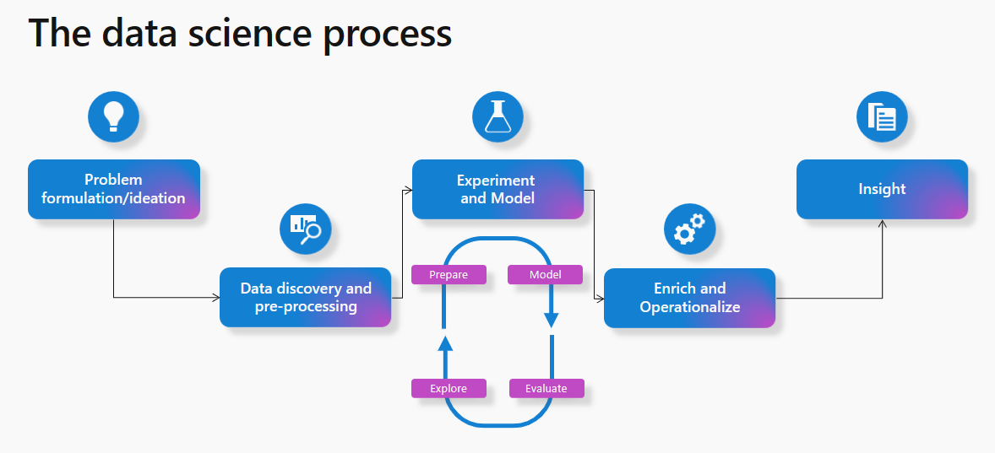
Figure 9 Data Science Overview
The AutoML functionality provides assisted ML workflow for users without deep data science expertise, while still allowing manual customization using Notebooks (PySpark/Python) for advanced model tuning and experimentation.
AutoML supports common supervised learning scenarios such as regression, which can be used for predicting student CGPA, classification that can be used for pass/fail predictions and forecasting for enrollment or financial forecasting.
This approach complements the traditional data science workflow where models are manually developed in Notebooks, ensuring flexibility between automation and manual control depending on business needs and technical expertise.

Model Development Approaches in Fabric
Microsoft Fabric supports two primary approaches for developing machine learning models, Assisted AutoML and Manual Notebook-based Machine Learning. Both methods leverage the unified Fabric environment for data access, training, evaluation, and deployment. The assisted AutoML approach is designed for users who prefer guided, low-code workflows with automated model selection and tuning, while the Notebook-based approach caters to data scientists who require full customization and scripting flexibility using PySpark or Python.

Assisted AutoML Functionality
The Assisted AutoML feature in Microsoft Fabric provides a low-code/no-code environment for building and deploying machine learning models directly within the Fabric Data Science experience. It automates data preparation, feature engineering, algorithm selection, model training, and evaluation, allowing users to quickly generate predictive insights without writing code.

Manual Machine Learning (Notebook-Based Approach)
The Manual Notebook Approach in Microsoft Fabric allows to build custom ML workflows using PySpark, Python, or MLflow within Fabric Notebooks. This method offers complete flexibility and control over data transformation, feature selection and model tuning. The code-based approach allows taking advantage of the Python libraries such as Scikit-learn, MLlib or TensorFlow, further providing deeper access to analytics.

AutoML Process Flow in Fabric
The AutoML process flow in Microsoft Fabric defines the end-to-end sequence of activities involved in building, training, evaluating, and deploying a machine learning model within the unified Fabric environment. The process ensures that predictive analytics can be operationalized seamlessly using existing data pipelines, Lakehouse structures, and integrated services such as Power BI.
The flow will cover every stage, from data preparation and model experimentation to scoring and visualization, providing a standardized framework for both assisted and manual ML development within the Fabric ecosystem.
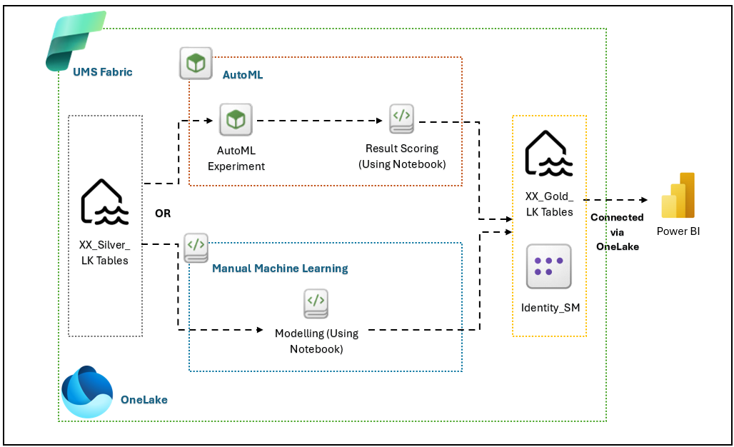
Figure 10 Machine Learning Process Architecture
Enfrasys will provide 2 different approaches to UMS based on Figure 10, where each approach has its own implications.
Starting with the data source, Silver Layer, the curated and cleaned datasets store in the Silver Lakehouse, serve as the foundation for all model training processes. These datasets may include academic, financial or operational attributes relevant to the predictive scenario like student CGPA prediction, financial status classification.
Here, there will be two separate steps that can be taken to achieve the analytics results. Both steps will be further discussed below.

AutoML Process Flow in Fabric
The AutoML module within Fabric automates feature engineering, algorithm selection, and model evaluation. The users can initiate an AutoML Experiment using the silver dataset as input. Once the best model is identified, a Result Scoring Notebook will be triggered, to apply the trained model to new or unseen data. The scored results such as predictions, probabilities, and performance metrics are written into the Gold Lakehouse tables along with the data for dashboard creation in Power BI.

Manual Machine Learning Path
Alternatively, the users also can choose the Manual ML approach using Fabric Notebooks with PySpark or Python. In this path, custom model development, feature engineering and evaluation are performed manually. This approach fosters more flexibility and ability to fine tune the model to achieve satisfactory performance. The resulting model and its predictions are also stored in the Gold Lakehouse tables for consistency with the AutoML output structure. The trained model also can be registered in the Fabric Model Registry (in a separate Notebook) for reuse and lifecycle management.

Final Output & Visualization
The Gold Lakehouse acts as the final repository for scored or modeled results. Each record typically includes identifiers like Student ID, actual values, predicted values and confidence scores. This layer serves as the semantic-ready foundation that can be pushed to Power BI.
By using Direct Lake connectivity via OneLake, Power BI connects directly to the gold tables. The UMS team can create reports and dashboards based on the requirements based on business objectives.

AutoML Process Workflow Design Decisions
UMS has chosen the proposed Data Workflow design:
ID | Description | Workloads type
DE01 | The cleaned data stored in Silver Lakehouse will serve as the input for all machine learning experimentation. The chosen data will be one of the programs selected from the overall Staging DB. | Data Engineering
DE02 | The Project will primarily adopt the Manual Machine Learning approach using Fabric Notebooks (PySpark or Python) to enable custom feature engineering, algorithm tuning, and model optimization. | Data Science
DE03 | Users will perform model training, evaluation, and fine-tuning directly in the Notebook environment to achieve more accurate and explainable results tailored to UMS’s datasets. | Data Science
DE04 | Trained models will be registered in the Fabric Model Registry to support model lifecycle management, versioning, and potential reuse across further adoption. | Data Science
DE05 | Scoring Notebooks will be used to apply trained models to new or unseen data. The scored outputs, predictions, probabilities, and performance metrics will be stored in the Gold Lakehouse. | Data Engineering
DE06 | The Gold Lakehouse will serve as the standardized repository for all modeled or scored results, ensuring consistency between AutoML and manual ML outputs. | Data Engineering
DE07 | The Semantic Model will connect to the Gold Lakehouse via Direct Lake (OneLake) and Data Modelling will be implemented | Power BI
DE08 | Power BI Desktop will connect to the Semantic Model via OneLake for data visualization. | Power BI
Table 17 UMS AutoML Process Workflow Design Decisions

Appendix

Appendix 1 Computing

Introduction/Prerequisites
Azure Computing for Linux: https://docs.microsoft.com/en-us/azure/virtual-machines/linux/quick-create-portal
Azure Computing for Windows: https://docs.microsoft.com/en-us/azure/virtual-machines/windows/quick-create-portal

Limits and Boundaries
Azure Computing for Linux: https://docs.microsoft.com/en-us/azure/azure-resource-manager/management/azure-subscription-service-limits#virtual-machines-limits
Azure Computing for Windows: https://docs.microsoft.com/en-us/azure/azure-resource-manager/management/azure-subscription-service-limits#virtual-machines-limits

Others
Fsv2-series VM Size: https://docs.microsoft.com/en-us/azure/virtual-machines/fsv2-series?toc=/azure/virtual-machines/linux/toc.json&bc=/azure/virtual-machines/linux/breadcrumb/toc.json
Esv3-series VM Size: https://docs.microsoft.com/en-us/azure/virtual-machines/ev3-esv3-series?toc=/azure/virtual-machines/linux/toc.json&bc=/azure/virtual-machines/linux/breadcrumb/toc.json#esv3-series
Dsv3-series VM Size: https://docs.microsoft.com/en-us/azure/virtual-machines/dv3-dsv3-series?toc=/azure/virtual-machines/linux/toc.json&bc=/azure/virtual-machines/linux/breadcrumb/toc.json#dsv3-series
Azure Naming Convention: https://docs.microsoft.com/en-us/azure/cloud-adoption-framework/ready/azure-best-practices/naming-and-tagging

Appendix 2 Network

Introduction/Prerequisites
Azure Virtual Network: https://docs.microsoft.com/en-us/azure/virtual-network/quick-create-portal
Azure VPN Gateway: https://docs.microsoft.com/en-us/azure/vpn-gateway/tutorial-create-gateway-portal
Azure Express Route Gateway: https://docs.microsoft.com/en-us/azure/expressroute/expressroute-howto-add-gateway-portal-resource-manager
Azure Firewall: https://docs.microsoft.com/en-us/azure/firewall/tutorial-firewall-deploy-portal
Azure Application Gateway: https://docs.microsoft.com/en-us/azure/application-gateway/quick-create-portal
Azure Load Balancer: https://docs.microsoft.com/en-us/azure/load-balancer/quickstart-load-balancer-standard-public-portal?tabs=option-1-create-load-balancer-standard
Azure Traffic Manager: https://docs.microsoft.com/en-us/azure/traffic-manager/quickstart-create-traffic-manager-profile

Limits and Boundaries
Azure Virtual Network: https://docs.microsoft.com/en-us/azure/azure-resource-manager/management/azure-subscription-service-limits#networking-limits
Public IP address limits: https://docs.microsoft.com/en-us/azure/azure-resource-manager/management/azure-subscription-service-limits#publicip-address
Azure VPN Gateway: https://docs.microsoft.com/en-us/azure/azure-resource-manager/management/azure-subscription-service-limits#virtual-network-gateway-limits
Azure Express Route Gateway: https://docs.microsoft.com/en-us/azure/azure-resource-manager/management/azure-subscription-service-limits#expressroute-limits
Azure Firewall: https://docs.microsoft.com/en-us/azure/azure-resource-manager/management/azure-subscription-service-limits#azure-firewall-limits
Azure Application Gateway: https://docs.microsoft.com/en-us/azure/azure-resource-manager/management/azure-subscription-service-limits#application-gateway-limits
Azure Load Balancer: https://docs.microsoft.com/en-us/azure/azure-resource-manager/management/azure-subscription-service-limits#load-balancer
Azure Traffic Manager: https://docs.microsoft.com/en-us/azure/azure-resource-manager/management/azure-subscription-service-limits#traffic-manager-limits

Others
P2S VPN Azure AD Authentication: https://docs.microsoft.com/en-us/azure/vpn-gateway/openvpn-azure-ad-tenant
VPN Gateway co-exist ExpressRoute: https://docs.microsoft.com/en-us/azure/expressroute/expressroute-howto-coexist-resource-manager
Azure VPN Azure network routing: https://docs.microsoft.com/en-us/azure/vpn-gateway/vpn-gateway-about-point-to-site-routing#multipeered
Azure VPN On-premise network routing: https://docs.microsoft.com/en-us/azure/vpn-gateway/vpn-gateway-about-point-to-site-routing#multivnets2sbranchbgp
Azure VPN customize route: https://docs.microsoft.com/en-us/azure/vpn-gateway/vpn-gateway-p2s-advertise-custom-routes

Appendix 3 Identity & Security

Introduction/Prerequisites
Azure Network Security Group: https://docs.microsoft.com/en-us/azure/virtual-network/manage-network-security-group#create-a-network-security-group
Azure Security Center: https://docs.microsoft.com/en-us/azure/security-center/security-center-get-started
Azure Active Directory: https://docs.microsoft.com/en-us/azure/active-directory/fundamentals/active-directory-access-create-new-tenant
Azure DDoS Protection: https://docs.microsoft.com/en-us/azure/ddos-protection/manage-ddos-protection

Limits and Boundaries
Azure Network Security Group: https://docs.microsoft.com/en-us/azure/virtual-network/network-security-groups-overview#security-rules
Azure Security Center: https://docs.microsoft.com/en-us/azure/security-center/security-center-os-coverage
Azure Active Directory: https://docs.microsoft.com/en-us/azure/azure-resource-manager/management/azure-subscription-service-limits#active-directory-limits
Azure DDoS Protection: https://docs.microsoft.com/en-us/azure/ddos-protection/ddos-protection-overview

Others
Web Application Gateway: https://docs.microsoft.com/en-us/azure/web-application-firewall/ag/application-gateway-crs-rulegroups-rules?tabs=owasp31

Appendix 4 Logging & Monitoring

Introduction/Prerequisites
Azure Monitor: https://docs.microsoft.com/en-us/azure/azure-monitor/learn/quick-monitor-azure-resource
Azure Log Analytic: https://docs.microsoft.com/en-us/azure/azure-monitor/log-query/get-started-portal
Azure Sentinel: https://docs.microsoft.com/en-us/azure/sentinel/quickstart-onboard

Limits and Boundaries
Azure Monitor: https://docs.microsoft.com/en-us/azure/azure-resource-manager/management/azure-subscription-service-limits#azure-monitor-limits
Azure Log Analytic: https://docs.microsoft.com/en-us/azure/azure-resource-manager/management/azure-subscription-service-limits#log-analytics-workspaces
Azure Sentinel: https://docs.microsoft.com/en-us/azure/sentinel/connect-data-sources

Others
Azure Monitor for VMs: https://docs.microsoft.com/en-us/azure/azure-monitor/insights/vminsights-overview

Appendix 5 Cloud Governance
Azure Blueprint: https://docs.microsoft.com/en-us/azure/governance/blueprints/overview
ISO 27001: https://docs.microsoft.com/bs-latn-ba/azure/governance/blueprints/samples/iso27001/

Appendix 6 On Premise Data Gateway (OPDG)
OPDG Firewall Rules: https://learn.microsoft.com/en-us/answers/questions/511372/on-premise-data-gateway-firewall-rules
OPDG Communication Settings: https://learn.microsoft.com/en-us/data-integration/gateway/service-gateway-communication#ports

Appendix 7 Machine Learning
Data Science Introduction: https://learn.microsoft.com/en-us/fabric/data-science/data-science-overview
End-to-End Scenario: https://learn.microsoft.com/en-us/fabric/data-science/tutorial-data-science-introduction

