Analytics Deployment (Microsoft Fabric)
Planning & Design Document


Abstract
This document defines the Planning and Design for SIRIM Analytics Deployment (Microsoft Fabric) project.

Prepared By


Change Record
Date | Author | Version | Change Reference
[change-record-date] | [change-record-author] | [change-record-version] | [change-record-reference]

Distribution List
Name | Position/ Team
[Client/Entity/Company Name] | [Client/Entity/Company Position]

Terms of Use
This work may be used "as-is" by any interested party. You may copy, adapt, and redistribute this document for non-commercial use or for your own internal use in a commercial setting. However, you may not republish this document, nor may you publish or distribute any adaptation of this document for other than non-commercial use or your own internal use, without first obtaining express written approval from Enfrasys Solutions Sdn Bhd.
Disclaimer
The Author and Enfrasys Solutions Sdn Bhd shall have neither liability nor responsibility to any person or entity with respect to the loss or damages arising from the information contained in this work. This work may include inaccuracies or typographical errors and solely represent the opinions of the Author. Changes are periodically made to this document without notice.Due to the rapid growth of various technologies, the Author and Enfrasys Solutions Sdn Bhd cannot guarantee the accuracy of the information presented after the date of publication.
Trademarks
The names of actual companies, service marks, trademarks or products mentioned herein may be the trademarks of their respective owners. Use of terms within this work should not be regarded as affecting the validity of any trademark or service mark. Enfrasys Consulting may have patents, patent applications, trademarks, copyrights, or other intellectual property rights covering subject matter in this document. Except as expressly provided in any written license agreement from Enfrasys Solutions Sdn Bhd, the furnishing of this document does not give you any license to those items.

1.0 Design Document Sign Off
We hereby acknowledge that the design document for SIRIM Analytics Deployment (Microsoft Fabric) has been reviewed, and all key aspects have been addressed satisfactorily.
This document has been prepared, reviewed, accepted, and signed off by the following individuals:

Prepared by:  Enfrasys Solutions Sdn Bhd  Signature:  ___________________________  Name:  Designation:  Date: | Verified by:  Enfrasys Solutions Sdn Bhd  Signature:  ___________________________  Name:  Designation:  Date:

Reviewed by:
Name | Signature
Name:  Designation:  Date: | ___________________________
Verified by:  [Designation]  [client]  Signature:  ___________________________  Name:  Designation:  Date: | Approved by:  [Designation]  [client]  Signature:  ___________________________  Name:  Designation:  Date:

2.0 Executive Summary
This section provides a concise overview of the SIRIM Berhad Analytics Deployment project, the purpose and scope of this Solution Design Document, and identifies the primary stakeholders involved in its implementation.

2.1 Project Overview
SIRIM Berhad has initiated the Analytics Deployment project to modernize its Human Resource (HR) data management and analytics capabilities. The primary business objective is to establish an end-to-end data workflow—from ingestion through transformation to visualization—specifically tailored to address HR use-cases such as workforce analytics, talent management, and operational reporting. This initiative is strategically aligned with SIRIM Berhad’s broader cloud adoption roadmap, leveraging Microsoft Fabric as the foundational platform.
Microsoft Fabric has been selected for its integrated suite of services, notably Fabric Data Factory for robust data integration and orchestration, and Fabric Synapse for advanced analytics and big data processing. By adopting Fabric, SIRIM Berhad aims to unify disparate HR data sources, streamline data pipelines, and enable actionable insights through scalable, secure, and governed analytics workspaces. This deployment is expected to drive operational efficiency, enhance data-driven decision-making, and support compliance with organizational and regulatory requirements.

2.2 Document Purpose
The purpose of this Solution Design Document is to provide a comprehensive, authoritative blueprint for the deployment of Microsoft Fabric within SIRIM Berhad’s HR analytics environment. It details the architectural decisions, technology components, workflow designs, security controls, resource organization, and governance mechanisms required to ensure a successful and sustainable implementation.
This document serves as the definitive reference for all technical and operational aspects of the project, guiding stakeholders through the rationale behind each design choice and its anticipated business impact. The scope encompasses infrastructure configuration, data workflow orchestration, access and role management, security, governance, and operational best practices. It is intended to facilitate informed decision-making, mitigate risks, and ensure alignment with SIRIM Berhad’s strategic objectives.

2.3 Document Audience
This Solution Design Document is intended for a diverse audience comprising both technical and business stakeholders within SIRIM Berhad and its implementation partners. Key audiences include:
- SIRIM Berhad Executive Leadership (CIO, CTO, HR Director)
- SIRIM Berhad IT Management and Enterprise Architecture Teams
- SIRIM Berhad HR Analytics and Data Science Teams
- Infrastructure and Security Administrators
- Microsoft Fabric Platform Owners and Workspace Administrators
- Data Integration Specialists and Power BI Developers
- Project Managers and Business Analysts
- Enfrasys Solutions Implementation and Support Teams
Each stakeholder group will leverage this document to understand their respective roles, responsibilities, and the technical rationale underpinning the project’s design and execution.

3.0 Network Design and Decision
This section outlines the network architecture and connectivity decisions for SIRIM Berhad’s Microsoft Fabric deployment, focusing on secure integration between on-premises, Azure, and external users.

3.1 Network Connectivity Overview
SIRIM Berhad shall implement a multi-layered Azure network architecture to ensure secure, scalable, and high-performance connectivity across its on-premises infrastructure, Azure cloud resources, and external user access. The design leverages Azure Virtual Networks (VNETs), VNET peering, Site-to-Site (S2S) VPN, and private endpoints to achieve optimal isolation and flexibility.
The core network topology consists of three interconnected Azure VNETs: - VNET 1: Hosts the GatewaySubnet and Virtual Network Gateway, which establishes the S2S VPN connection to SIRIM Berhad’s on-premises network. This VNET acts as the primary ingress/egress point for hybrid connectivity. - VNET 2: Dedicated to Windows Virtual Desktop (WVD) services, enabling secure remote access for external users. VNET 2 is peered with both VNET 1 and Fabric-VNET to facilitate seamless data flow. - Fabric-VNET: Contains the Fabric Resource Group (Fabric-RG) and hosts a Fabric Private Endpoint within a Fabric-Subnet. This configuration ensures that only internal Azure resources can access Fabric services, enforcing strict network isolation.
VNET peering is configured bidirectionally between all three VNETs, allowing low-latency, high-bandwidth communication while maintaining resource isolation and minimizing management overhead. The S2S VPN provides encrypted connectivity between SIRIM Berhad’s on-premises network and Azure, routing traffic through VNET 1 and enabling access to resources in peered VNETs.
The use of private endpoints within Fabric-VNET ensures that Fabric services are only accessible from within the Azure network, blocking public access and reducing the attack surface. This approach aligns with Microsoft’s security best practices for PaaS resources.
The following architecture diagram illustrates the network connectivity design:
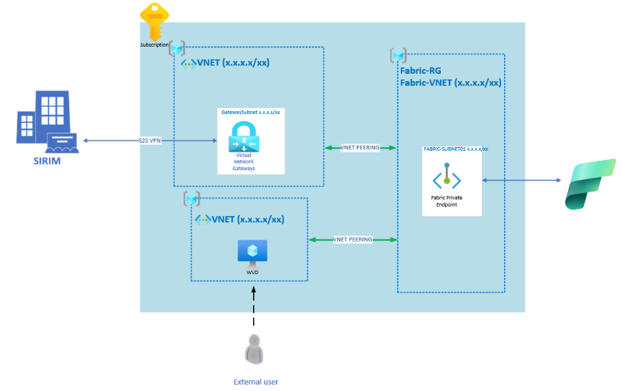
This topology guarantees secure, scalable, and efficient connectivity for SIRIM Berhad’s hybrid workloads, supporting both internal and external user scenarios.

3.2 [Microsoft Fabric] Data Gateway
SIRIM Berhad shall deploy a dedicated Data Gateway Virtual Machine (VM) within the Azure environment to facilitate secure and reliable data transfer between on-premises systems, cloud-hosted databases, and Microsoft Fabric. The Data Gateway VM acts as a bridge, enabling seamless integration and supporting hybrid data workflows.
The Data Gateway agent is installed on a VM named GASPRA, located in the SIRIM-BIGDATA-EDWH-RG resource group. This placement ensures proximity to both the TOPAZ system (connected to a PostgreSQL database) and the SIRIM Fabric service, optimizing data transfer performance and minimizing latency.
Connectivity is established as follows: - The Data Gateway VM interfaces with the TOPAZ system and its PostgreSQL database, supporting bidirectional data flows. - The VM securely transmits data to and from SIRIM Fabric, leveraging Azure’s internal networking and private endpoints. - All communication is routed through Azure VNETs, ensuring that data never traverses public networks, thus maintaining compliance with SIRIM Berhad’s security requirements.
The Data Gateway VM is configured with the following specifications to ensure robust performance and reliability:
VM Name | OS | .NET Version | vCPU | RAM | Disk Size | Network Interface
GASPRA | Windows Server 2019 | .NET 6.0 | 4 | 16 GB | 256 GB | Standard Azure NIC
This configuration provides sufficient compute and memory resources for high-throughput data processing, while the disk size accommodates large data transfers. The use of Windows Server 2019 and .NET 6.0 ensures compatibility with Microsoft Fabric Data Gateway requirements.
The following diagram illustrates the Data Gateway architecture and its role in the data workflow:
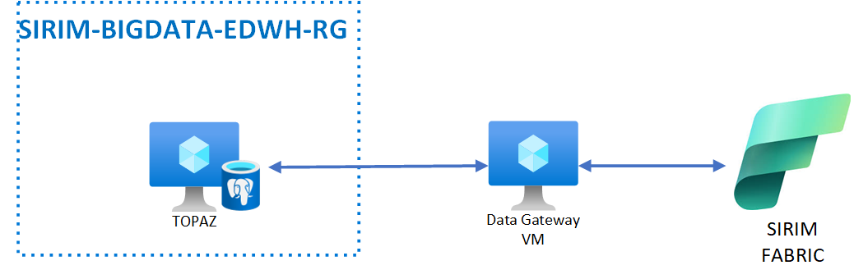
By deploying the Data Gateway VM in this manner, SIRIM Berhad achieves secure, efficient, and scalable data integration between on-premises and cloud-based resources, supporting advanced analytics and business intelligence scenarios in Microsoft Fabric.

4.0 Roles in Microsoft Fabric
This section defines the role-based access model for Microsoft Fabric as implemented for SIRIM Berhad. It details administrator assignment, native workspace roles, item-level permissions, and SIRIM-specific role mappings, including Row-Level Security (RLS) and semantic model access.

4.1 Microsoft Fabric Administrator Role
The Microsoft Fabric Administrator role is critical for managing global workspace settings, user provisioning, and security configurations. SIRIM Berhad shall designate trusted personnel to this role, ensuring proper oversight and governance of all Fabric resources.

Assigning the Role
SIRIM Berhad shall assign the Fabric Administrator role to designated personnel via the Microsoft Fabric Admin Portal. The assignment process involves:
- Identifying eligible candidates with appropriate technical and business authority, such as En Wazir and Puan Solehah.
- Using the Admin Portal to grant the Fabric Admin role, ensuring that only authorized individuals can manage workspaces, permissions, and content lifecycle.
- Periodically reviewing role assignments to maintain compliance and operational integrity.
This approach aligns with Microsoft best practices, minimizing risk by restricting administrative privileges to vetted personnel.

The Admin Portal Capabilities Table
The following table summarizes the capabilities available to Fabric Administrators, highlighting those exclusive to the Admin role:
Capability | Description | Admin Only?
Manage workspace roles and permissions | Add/remove users, assign roles, and configure access controls | Yes
Publish/edit/delete content | Oversee content lifecycle, including dashboards and datasets | Yes
Configure Row-Level Security (RLS) | Define and enforce RLS policies for sensitive data | Yes
Semantic model management | Create, modify, and secure semantic models for reporting | Yes
Audit and activity tracking | Monitor workspace activity and access logs | Yes
Workspace settings management | Configure workspace properties and integrations | Yes
This table clarifies the exclusive capabilities of Fabric Administrators, ensuring SIRIM Berhad maintains strict control over critical workspace functions.

4.2 Microsoft Fabric-native Roles
Microsoft Fabric provides a granular role-based access model at both the workspace and item levels. SIRIM Berhad shall leverage these roles to enforce least-privilege access and operational separation.

Workspace-level Roles
Workspace roles define the scope of actions users can perform within a Fabric workspace. The following table outlines the roles, their capabilities, and associated permissions:
Role | Capabilities | Permissions
Admin | Manage roles, permissions, publish/edit/delete content | Full control; can add/remove users
Contributor | Create/edit/delete own content; limited settings access | Modify own content; cannot manage permissions
Member | Create/edit/delete reports, pipelines; share content | Share and collaborate; no role management
Viewer | View reports/dashboards; no edit/publish rights | Read-only access to workspace content
Workspace-level roles are assigned based on operational requirements, ensuring SIRIM Berhad users have access only to the functions necessary for their duties.

Item-level Roles
Item-level roles provide fine-grained control over individual content objects within a workspace, such as datasets, reports, and pipelines. The following table details item-level permissions:
Item | Role | Permissions
Dataset | Owner | Full control; manage RLS, edit/delete
Report | Contributor | Edit report; cannot publish or delete
Pipeline | Member | Execute pipeline; view logs
Dashboard | Viewer | View dashboard; no modification rights
By applying item-level roles, SIRIM Berhad can restrict access to sensitive data and ensure compliance with internal policies.

4.3 SIRIM Workspace Role and Access
SIRIM Berhad shall implement a structured mapping of personnel to Fabric workspace roles, based on operational needs and group assignments. The following table provides the recommended mapping:
Workspace Role | Suggested Role | SIRIM PIC
Workspace Admin | Fabric Admin/Data Engineer | En Wazir, Puan Solehah
Workspace Contributor | Data Engineer/Business User Admin | Aina, Khairul, Puan Solehah
Workspace Viewer | Data Analyst | Aina, Khairul, Puan Solehah
Workspace Member | Data Engineer | Aina, Khairul, Puan Solehah
This mapping ensures clear accountability and operational efficiency, allowing SIRIM Berhad to maintain a robust access model aligned with business processes.

Row-Level Security (RLS) and Semantic Model Access
SIRIM Berhad shall implement Row-Level Security (RLS) within the semantic model to restrict data visibility based on user roles and group membership. For example, HR staff will only see data relevant to their department, enforced via RLS policies and Microsoft 365 group integration (e.g., sirimmgmt@sirim.my).
Semantic models define table relationships, measures, and calculated columns, serving as the foundation for reporting and analytics. Access to semantic models will be governed by workspace and item-level roles, ensuring only authorized users can view or modify sensitive data.
By combining RLS and semantic modeling, SIRIM Berhad achieves granular data protection and compliance with internal data governance standards.

Refer to Section 5.0 Platform Design and Section 6.0 Governance for detailed access policy and governance configurations.

5.0 Microsoft Fabric Design and Decision
This section details the comprehensive Microsoft Fabric architecture and key design decisions for SIRIM Berhad’s analytics deployment. Each sub-section addresses workflow, access, organization, and governance to ensure secure, scalable, and compliant operations.

5.1 Data Workflow Design Considerations
SIRIM Berhad shall implement a multi-layered data workflow leveraging Azure Data Factory, Lakehouse architecture, and Power BI integration. The following table summarizes the critical workflow considerations, mapped to workload types:
The table below outlines each workflow consideration and its associated workload type.
ID | Description | Workload Type
DC01 | Data Pipeline will be used to ingest data from PostgreSQL. | Data Factory
DC02 | The bronze Lakehouse will store raw/original data ingested from PostgreSQL. | Data Engineering
DC03 | The silver Lakehouse will store cleansed data sourced from the bronze Lakehouse. | Data Engineering
DC04 | The gold Lakehouse will store transformed data sourced from the silver Lakehouse. | Data Engineering
DC05 | Data cleansing and transformation for the bronze and silver Lakehouse will be performed using Visual Query in the SQL Analytics Endpoint. | Data Engineering
DC06 | Dataflow Gen2 will be used to move data between Lakehouses (e.g., from bronze to silver or silver to gold). | Data Factory
DC07 | Data modeling and row-level security (RLS) configurations will be implemented in the Semantic Model, using data from the gold Lakehouse. | Power BI
DC08 | Power BI Desktop will connect to the Semantic Model via OneLake for data visualization. | Power BI
These considerations ensure SIRIM Berhad’s data pipeline is robust, enabling secure ingestion, transformation, and visualization.

5.2 Data Workflow Design Decisions
SIRIM Berhad shall adopt a structured data pipeline, integrating Azure Data Factory, Lakehouse layers (Bronze, Silver, Gold), Synapse Engineering, and Power BI for end-to-end analytics. The workflow is illustrated in the following architecture diagram:
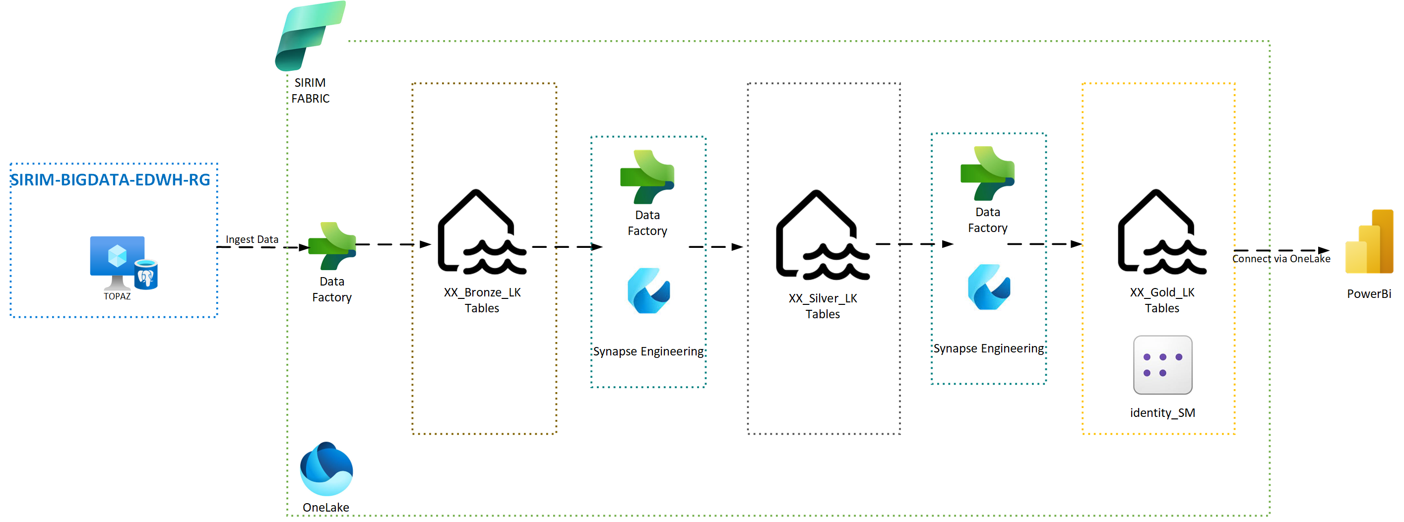

Workflow Steps Summary
- Data is ingested from the TOPAZ source system (PostgreSQL) into the Bronze Lakehouse using Azure Data Factory.
- Data is cleansed and transformed in the Silver Lakehouse via Synapse Engineering and Visual Query.
- Further transformation produces the Gold Lakehouse, optimized for analytics and reporting.
- Dataflow Gen2 orchestrates movement between Lakehouse layers.
- Semantic Models are built using Gold Lakehouse data, with row-level security applied.
- Power BI Desktop connects via OneLake to provide visualization and business intelligence.
This design ensures data lineage, security, and scalability, supporting SIRIM Berhad’s analytics objectives.

5.3 Access Design Considerations
SIRIM Berhad shall enforce strict access controls using Conditional Access, Private Endpoint, and Multi-Factor Authentication (MFA). Each method is detailed below.

Conditional Access
Conditional Access policies are central to securing SIRIM Fabric. Users are required to meet specific conditions before accessing resources such as Power BI Service, Azure Data Explorer, Azure SQL Database, and Azure Storage.
The following table compares access paths for SIRIM users and external users:
No. | SIRIM user | External user
1 | Direct Access to Fabric | Indirect access via Windows Virtual Desktop (WVD)
2 | Managed using Conditional Access | WVD access managed using Network Security Group (NSG)
3 | User go through extra checks like secure login, MFA, etc. | User separated from the actual system using the virtual computer
4 | Conditional Access policy that includes Power BI Service, Azure Data Explorer, Azure SQL Database, and Azure Storage | NSG rule that allow Fabric inbound and outbound
This ensures internal users have direct, policy-controlled access, while external users are isolated and managed through secure desktops.
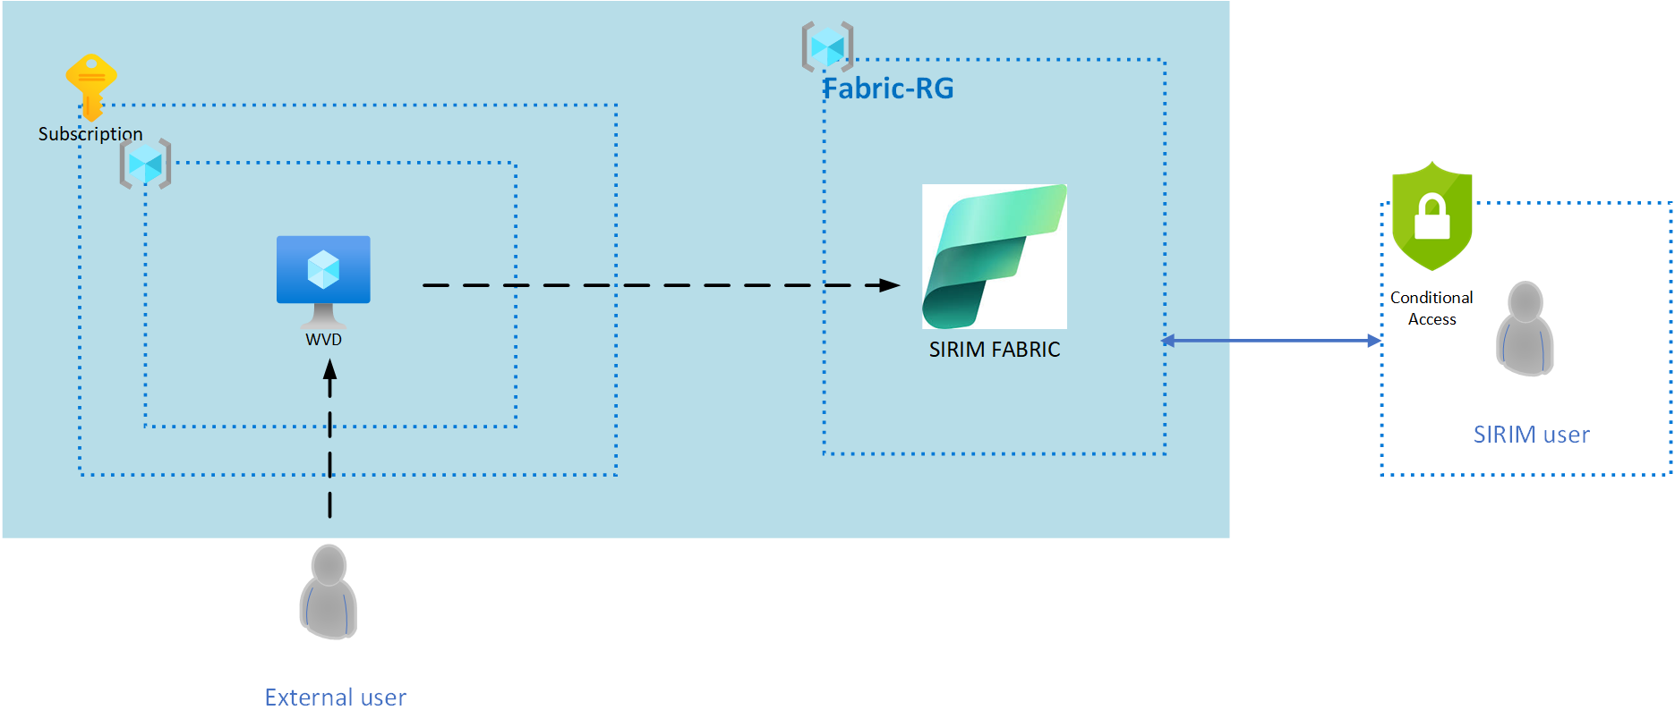

Private Endpoint Consideration
Private Endpoint restricts access to Fabric resources to internal networks only. Users must be connected to the Azure Virtual Network to access Fabric, with public endpoints disabled.

Design limitations include: - Visual query in Warehouse is not supported. - Data copying via Pipeline from and into Data Warehouse is currently not possible. - Power BI does not support Private Link for Fabric datasets (public endpoint required). - Copilot is not supported for Private Endpoint.

Multi-Factor Authentication (MFA)
MFA is enforced for all users accessing SIRIM Fabric. This includes secure login and additional verification steps, ensuring only authenticated users gain access.

5.4 Access Design Decisions
SIRIM Berhad shall implement the following access policies, balancing security and operational requirements. The table below summarizes each policy, its description, final decision, and applicable users.
Policy Name | Description | Final Decision | Applies To
Conditional Access | Enforce access to Power BI, Azure Data Explorer, Azure SQL Database, Azure Storage via policy | Implemented | SIRIM user, External user
Private Endpoint | Restrict Fabric access to internal network, disable public endpoint | Implemented (with limitations) | Internal users
Multi-Factor Authentication | Require MFA for all Fabric access | Enforced | All users
These policies ensure SIRIM Berhad’s analytics environment is secure, compliant, and accessible only to authorized personnel.

5.5 Identity and Access Management
SIRIM Berhad shall integrate Azure Active Directory (Azure AD) for centralized identity management. All user authentication flows are routed through Azure AD, enabling seamless Conditional Access and MFA enforcement.
Azure AD provides: - Single sign-on for all Fabric and related Azure services. - Conditional Access policies, ensuring device compliance and user authentication. - MFA integration, requiring users to verify identity with a second factor. - Role-based access control (RBAC), mapping users to appropriate workspace and item-level roles.
Operationally, this ensures secure, auditable access to all analytics resources, with granular control over user permissions.

5.6 Virtual Machine Size
The Data Gateway agent is installed on a dedicated Virtual Machine (VM), acting as a secure bridge between TOPAZ (PostgreSQL) and SIRIM Fabric. The VM is provisioned with the following specifications:
VM Name | OS | .NET Version | vCPU | RAM | Disk Size | Network Interface
GASPRA | Windows | 4.8 | 4 | 16GB | 128GB | 1Gbps

This configuration ensures reliable, high-throughput data transfer and secure connectivity.

5.7 Resource Organization Design
SIRIM Berhad shall implement a structured resource organization, leveraging Azure Management Groups, consistent naming conventions, and tagging for governance and operational clarity.

Azure Management Groups
Management Groups are used to organize subscriptions and resources hierarchically. SIRIM Berhad’s hierarchy will be:
- Root Management Group
  - SIRIM Production
    - SIRIM Analytics
      - Fabric Resource Group (Fabric-RG)
      - Data Gateway Resource Group
This structure enables granular policy assignment, cost tracking, and compliance enforcement.

Naming and Tagging

Azure Naming Convention
The table below defines naming conventions for Azure resources:
Resource | Abbreviation | Example
Resource Group | RG | Fabric-RG
Virtual Network | VNET | Fabric-VNET
Subnet | SN | Fabric-Subnet
VM | VM | GASPRA-VM
Storage Account | SA | FabricSA

Fabric Naming Convention
No. | Item in Fabric | Naming --
1 | Fabric Capacity | hrdevcapacity01
2 | Workspace | HR_dev_WS
3 | Lakehouse | HR_Bronze_LKHR_Silver_LKEtc..
4 | Dataflow | HR_Bronze_to_Silver_DFHR_Silver_to_Gold_DFEtc..
5 | Semantic Model | HR_HeadcountWorkforce_SMHR_EmployTurnAttrit_SMEtc..
6 | Pipeline | HR_Ingest_Data_PLEtc..
7 | Report | HR_HeadCountWorkForce_Report

Application Acronyms
Acronym | Full Name
HR | Human Resources
LK | Lakehouse
DF | Dataflow
SM | Semantic Model
PL | Pipeline

Suggested Tags
Tag Key | Description | Example Value
Owner | Resource owner | Data Analytics Team
Environment | Deployment environment | Production
CostCenter | Cost tracking | FIN-2024
Project | Project name | SIRIM-Fabric
These conventions and tags streamline resource management, cost tracking, and operational clarity.

5.8 Governance Consideration
SIRIM Berhad shall enforce governance disciplines for cost management and resource compliance, leveraging Azure-native tools and automated triggers.

Governance Disciplines
Cost management and resource compliance are managed via Azure tools, with clear ownership and operational responsibilities.
Tool | Purpose | Owner
Azure Cost Management | Track and optimize spending | Finance/IT
Azure Policy | Enforce resource compliance | IT Security
Azure Monitor | Monitor usage and performance | Analytics Team
Azure Advisor | Recommend optimizations | IT Operations
These tools ensure SIRIM Berhad’s deployment remains cost-effective and compliant.

Violation Triggers and Actions
Automated triggers and actions are defined for governance violations.
Trigger | Action | Responsible Party
Resource exceeds cost threshold | Notify owner, initiate review | Finance/IT
Non-compliant resource detected | Remediate or quarantine resource | IT Security
Unauthorized access attempt | Block access, alert administrator | IT Security
Policy violation (e.g., naming, tagging) | Enforce correction, log incident | IT Operations
This ensures rapid response and accountability for governance breaches.

5.9 Multi-Factor Authentication
Multi-Factor Authentication (MFA) is integrated and enforced for all users accessing SIRIM Fabric. Azure AD Conditional Access policies mandate MFA, requiring users to verify their identity via secondary factors (e.g., mobile app, SMS code) before access is granted.
MFA reduces risk of unauthorized access, aligns with regulatory requirements, and protects sensitive analytics data. SIRIM Berhad shall ensure MFA is enabled for all user accounts, with periodic reviews to maintain compliance.

This section provides SIRIM Berhad with a detailed, actionable blueprint for Microsoft Fabric deployment, ensuring secure, scalable, and compliant analytics operations.

6.0 Security Design and Decision
This section details the security architecture for SIRIM Berhad’s Azure deployment, focusing on Network Security Group (NSG) configuration and encryption mechanisms. All security controls are tailored to SIRIM Berhad’s workload and compliance requirements.

6.1 Azure NSG Overview
We recommend that SIRIM Berhad implement Azure Network Security Groups (NSGs) as the primary mechanism for controlling network traffic to and from Azure resources. NSGs are strategically placed at the subnet level within the WVD (Windows Virtual Desktop) environment to enforce granular inbound and outbound traffic rules, ensuring only authorized access paths are permitted.
NSGs serve as a critical layer of defense in the Azure ecosystem, allowing SIRIM Berhad to define explicit rules for traffic filtering based on source, destination, port, and protocol. By restricting access to only required endpoints and services, NSGs mitigate risks associated with unauthorized access, lateral movement, and exposure to external threats. Placement of NSGs on the WVD subnet ensures that both user sessions and backend services are protected in accordance with SIRIM Berhad’s operational security policies.
The following subsections provide detailed documentation of the inbound and outbound NSG rules implemented for the Fabric solution.

Inbound Rules Table
The table below outlines the inbound NSG rules applied to the WVD subnet. These rules are designed to allow secure access from Azure service tags to the virtual machines, specifically over HTTPS (port 443), while denying all other traffic by default.
Name | Priority | Source | Source Ports | Destination | Destination Ports | Protocol | Access
Allow_Fabric_Inbound | 110 | Service Tag | 443 | Vm Private IP Addresses | * | TCP | Allow
This configuration ensures that only traffic originating from Azure service tags on port 443 is permitted to reach the virtual machines. All other inbound connections are implicitly denied, aligning with zero-trust principles and minimizing exposure to external threats.

Outbound Rules Table
The table below documents the outbound NSG rules configured for the WVD subnet. Outbound traffic from the virtual machines is permitted to Azure service tags over HTTPS, enabling secure communication with Azure services while restricting unnecessary outbound flows.
Name | Priority | Source | Source Ports | Destination | Destination Ports | Protocol | Access
Allow_Fabric_Outbound | 110 | Vm Private IP Addresses | * | Service Tag | 443 | TCP | Allow
By allowing outbound traffic only to Azure service tags on port 443, SIRIM Berhad ensures that virtual machines can interact securely with Azure resources, while preventing unauthorized outbound connections that could lead to data exfiltration or compromise.

6.2 Encryption Design
SIRIM Berhad shall implement encryption mechanisms in accordance with Azure best practices for protecting data at rest and in transit. Although the slide data does not reference specific encryption technologies, we recommend the following design decisions based on the Fabric solution’s requirements:
- Data at Rest: All storage accounts, virtual disks, and databases associated with the Fabric deployment shall be encrypted using Azure Storage Service Encryption (SSE) and Azure Disk Encryption. This leverages Microsoft-managed keys by default, with the option to use customer-managed keys for enhanced control and regulatory compliance.
- Data in Transit: All communications between users, services, and Azure resources shall be encrypted using TLS 1.2 or higher. The NSG configuration enforces HTTPS (port 443) for inbound and outbound traffic, ensuring that all data exchanges are protected from interception and tampering.
- Key Management: SIRIM Berhad shall utilize Azure Key Vault for secure storage and management of encryption keys and secrets. Access to Key Vault will be tightly controlled through role-based access and monitored via Azure Security Center.
Implementing these encryption mechanisms provides robust protection against unauthorized access and data breaches, supporting SIRIM Berhad’s compliance with industry standards and regulatory requirements. The operational impact includes enhanced data confidentiality, integrity, and resilience against evolving cyber threats.
Note: Conditional Access and Multi-Factor Authentication (MFA) are addressed in the Platform Design section. Refer to Section 5.2 for detailed access control and authentication design decisions.

7.0 Microsoft Fabric Data Workflow
This section details the end-to-end data workflow architecture designed for SIRIM Berhad, including ingestion, transformation, and visualization paths, as well as the process flow across Lakehouse layers. All design decisions are documented with technical rationale and business impact.

7.1 Technical Overview
SIRIM Berhad shall implement a structured, scalable, and secure data workflow leveraging Microsoft Fabric and Azure components. The workflow orchestrates data ingestion from the TOPAZ PostgreSQL source, transformation through Azure Synapse, and visualization via Power BI, all governed within the SIRIM Fabric framework.

The above diagram illustrates the integrated data pipeline, which consists of the following stages:
- Data is ingested from the TOPAZ PostgreSQL system using Azure Data Factory.
- Ingested data is stored in the Bronze Lakehouse layer as raw/original data.
- Data transformation and cleansing occur in the Silver Lakehouse, leveraging Azure Synapse Engineering and Visual Query in SQL Analytics Endpoint.
- Curated, aggregated data is stored in the Gold Lakehouse, optimized for analytics and reporting.
- OneLake provides unified storage and seamless access across the pipeline.
- Power BI connects to the Gold Lakehouse via OneLake for business intelligence and visualization.
- The entire workflow is governed and integrated by SIRIM Fabric, ensuring security and compliance.
This architecture enables SIRIM Berhad to achieve robust data management, advanced analytics, and secure access for business users.

7.2 Approach/Paths
The data workflow is divided into three distinct paths: Data Ingestion, Transformation, and Visualization. Each path utilizes specific Azure and Fabric-native tools to ensure efficiency, integrity, and scalability.

Data Ingestion
SIRIM Berhad shall use Azure Data Factory to orchestrate and automate the ingestion of data from the TOPAZ PostgreSQL source system. Data Gateway VM acts as a secure bridge, enabling seamless transfer between on-premises or cloud-based sources and SIRIM Fabric.

Azure Data Factory pipelines are configured to extract data on a scheduled or event-driven basis, ensuring timely and reliable ingestion. The Data Gateway VM, installed within the GASPRA virtual machine, is responsible for secure connectivity and protocol translation, minimizing latency and maximizing throughput. This approach ensures compliance with SIRIM Berhad’s security requirements and supports hybrid deployment scenarios.

Transformation
Data transformation is performed using Azure Synapse Engineering, which processes data from the Bronze layer to the Silver layer, and subsequently from Silver to Gold. Visual Query in the SQL Analytics Endpoint is utilized for cleansing and enrichment tasks, supporting both batch and interactive workloads.
Dataflow Gen2 orchestrates movement between Lakehouse layers, enabling scalable and efficient ETL operations. The transformation logic includes schema mapping, data quality checks, and business rule application, ensuring that only validated and relevant data progresses through the pipeline. This modular approach allows SIRIM Berhad to adapt transformation processes as business requirements evolve.

Visualization
Power BI is designated as the primary visualization tool, connecting to the Gold Lakehouse via OneLake. The Semantic Model is implemented to define table relationships, measures, and calculated columns, supporting self-service analytics and advanced reporting.
Row-level security (RLS) is configured within the Semantic Model, ensuring that users access only the data relevant to their roles. Power BI Desktop is used for report authoring, while Power BI Service enables distribution and consumption of dashboards. This path empowers SIRIM Berhad’s business users with actionable insights, while maintaining strict access controls.

7.3 Process Flow
The data workflow is structured around three Lakehouse layers—Bronze, Silver, and Gold—each representing a distinct phase of data processing and refinement.

Bronze Lakehouse
The Bronze layer stores raw/original data ingested from the TOPAZ PostgreSQL system. Data is landed in its native format, preserving fidelity and enabling traceability. Azure Data Factory pipelines are configured to load data into XX_Bronze_LK tables, with minimal transformation to ensure rapid ingestion.
This approach allows SIRIM Berhad to maintain a comprehensive historical record, supporting auditability and downstream processing.

Silver Lakehouse
The Silver layer contains cleansed and transformed data, sourced from the Bronze Lakehouse. Azure Synapse Engineering and Visual Query in SQL Analytics Endpoint are used to apply data quality checks, normalization, and enrichment.
Dataflow Gen2 facilitates movement between Bronze and Silver layers, orchestrating ETL operations and ensuring consistency. The Silver Lakehouse serves as the foundation for analytics, providing reliable and structured data for further processing.

Gold Lakehouse
The Gold layer stores curated and aggregated data, optimized for analytics and reporting. Transformation logic includes business rule application, aggregation, and calculation of key metrics.
Dataflow Gen2 is used to move refined data from Silver to Gold, ensuring that only high-quality, relevant data is exposed for visualization. The Gold Lakehouse is integrated with OneLake, enabling seamless access by Power BI and other analytics tools.
This phase supports SIRIM Berhad’s business intelligence requirements, delivering actionable insights to stakeholders.

7.4 Design Decisions
The following table summarizes the key design decisions for the data workflow, including rationale and business impact.
The table below documents the critical workflow design considerations, mapped to workload types and justified for SIRIM Berhad’s environment.
ID | Description | Decision | Rationale
DC01 | Data Pipeline will be used to ingest data from PostgreSQL. | Azure Data Factory and Data Gateway VM shall be implemented. | Ensures secure, scalable, and automated ingestion from TOPAZ PostgreSQL, supporting hybrid connectivity.
DC02 | The bronze Lakehouse will store raw/original data ingested from PostgreSQL. | Raw data shall be landed in XX_Bronze_LK tables. | Preserves data fidelity, supports auditability, and enables flexible downstream processing.
DC03 | The silver Lakehouse will store cleansed data sourced from the bronze Lakehouse. | Cleansing and transformation shall be performed using Synapse Engineering and Visual Query. | Provides reliable, structured data for analytics, improves data quality and consistency.
DC04 | The gold Lakehouse will store transformed data sourced from the silver Lakehouse. | Aggregated, curated data shall be stored in XX_Gold_LK tables. | Optimizes data for business intelligence and reporting, supporting actionable insights.
DC05 | Data cleansing and transformation for bronze and silver Lakehouse will be performed using Visual Query in the SQL Analytics Endpoint. | Visual Query shall be used for interactive and batch transformation tasks. | Enables flexible, scalable data processing, supports both ad hoc and scheduled workloads.
DC06 | Dataflow Gen2 will be used to move data between Lakehouses (e.g., from bronze to silver or silver to gold). | Dataflow Gen2 shall orchestrate ETL operations across Lakehouse layers. | Facilitates scalable, efficient movement and transformation, reduces operational complexity.
DC07 | Data modeling and row-level security (RLS) configurations will be implemented in the Semantic Model, using data from the gold Lakehouse. | Semantic Model with RLS shall be configured in Power BI. | Ensures secure, role-based access to data, supports compliance and business requirements.
DC08 | Power BI Desktop will connect to the Semantic Model via OneLake for data visualization. | Power BI shall be used for report authoring and visualization, connecting through OneLake. | Provides seamless access to curated data, empowers business users with advanced analytics and visualization tools.
This structured approach ensures that SIRIM Berhad’s data workflow is robust, secure, and aligned with business objectives, enabling scalable analytics and actionable insights across the organization.

8.0 Appendix
This appendix provides supplementary references, technical documentation, and quota/limit links for SIRIM Berhad’s solution design. Refer to the main sections for all core tables and design artifacts.

Appendix 1 Computing

Introduction/Prerequisites
- Azure Virtual Machines Documentation
- Azure Compute Overview
- Azure VM Series Comparison

Limits and Boundaries
- Azure VM Quotas and Limits
- Azure Subscription Limits
- Azure Region Availability

Others
- Azure VM Best Practices
- Azure Disk Storage Documentation
- Azure Reserved VM Instances

Appendix 2 Network

Introduction/Prerequisites
- Azure Virtual Network Documentation
- Azure Networking Overview
- Azure ExpressRoute Documentation

Limits and Boundaries
- Azure Networking Service Limits
- Virtual Network Peering Limits
- Public IP Address Limits

Others
- Azure Network Security Best Practices
- Azure VPN Gateway Documentation
- Azure Load Balancer Documentation

Appendix 3 Identity & Security

Introduction/Prerequisites
- Azure Active Directory Documentation
- Azure Identity Management Overview
- Azure Security Center Documentation

Limits and Boundaries
- Azure AD Service Limits
- Azure Security Limits
- Conditional Access Limits

Others
- Azure Identity Best Practices
- Azure MFA Documentation
- Azure Privileged Identity Management

Appendix 4 Logging & Monitoring

Introduction/Prerequisites
- Azure Monitor Documentation
- Azure Log Analytics Documentation
- Azure Activity Logs

Limits and Boundaries
- Azure Monitor Limits
- Log Analytics Workspace Limits
- Diagnostic Settings Limits

Others
- Azure Monitoring Best Practices
- Azure Application Insights Documentation
- Azure Alerts Documentation

Appendix 5 Cloud Governance

Introduction/Prerequisites
- Azure Governance Documentation
- Azure Policy Overview
- Azure Management Groups Documentation

Limits and Boundaries
- Azure Policy Limits
- Management Group Limits
- Azure Resource Locks Limits

Others
- Azure Governance Best Practices
- Azure Cost Management Documentation
- Azure Blueprints Documentation

Appendix 6 Microsoft Fabric

Introduction/Prerequisites
- Microsoft Fabric Documentation
- Microsoft Fabric Architecture Overview
- Fabric Admin Portal Documentation

Limits and Boundaries
- Microsoft Fabric Quotas and Limits
- Fabric Workspace Limits
- Fabric Dataflow Limits

Others
- Microsoft Fabric Security Best Practices
- Fabric Monitoring and Logging
- Fabric Role Management Documentation

Appendix 7 Data Workflow

Introduction/Prerequisites
- Azure Data Factory Documentation
- Microsoft Fabric Dataflow Documentation
- Azure Synapse Analytics Documentation

Limits and Boundaries
- Data Factory Quotas and Limits
- Synapse Analytics Limits
- Fabric Dataflow Service Limits

Others
- Data Workflow Best Practices
- Data Integration Patterns
- Data Pipeline Monitoring
Note: For VM specifications, NSG rules, naming conventions, and workflow tables, refer to Sections 5.0, 6.0, and 7.0 of this document.

