Power BI & Fabric
Planning & Design Document


Abstract
This document defines the Planning and Design for UMS Power BI & Fabric project.

Prepared By


Change Record
Date | Author | Version | Change Reference
[change-record-date] | [change-record-author] | [change-record-version] | [change-record-reference]

Distribution List
Name | Position/ Team
[Client/Entity/Company Name] | [Client/Entity/Company Position]

Terms of Use
This work may be used "as-is" by any interested party. You may copy, adapt, and redistribute this document for non-commercial use or for your own internal use in a commercial setting. However, you may not republish this document, nor may you publish or distribute any adaptation of this document for other than non-commercial use or your own internal use, without first obtaining express written approval from Enfrasys Solutions Sdn Bhd.
Disclaimer
The Author and Enfrasys Solutions Sdn Bhd shall have neither liability nor responsibility to any person or entity with respect to the loss or damages arising from the information contained in this work. This work may include inaccuracies or typographical errors and solely represent the opinions of the Author. Changes are periodically made to this document without notice.Due to the rapid growth of various technologies, the Author and Enfrasys Solutions Sdn Bhd cannot guarantee the accuracy of the information presented after the date of publication.
Trademarks
The names of actual companies, service marks, trademarks or products mentioned herein may be the trademarks of their respective owners. Use of terms within this work should not be regarded as affecting the validity of any trademark or service mark. Enfrasys Consulting may have patents, patent applications, trademarks, copyrights, or other intellectual property rights covering subject matter in this document. Except as expressly provided in any written license agreement from Enfrasys Solutions Sdn Bhd, the furnishing of this document does not give you any license to those items.

1.0 Design Document Sign Off
We hereby acknowledge that the design document for UMS Power BI & Fabric has been reviewed, and all key aspects have been addressed satisfactorily.
This document has been prepared, reviewed, accepted, and signed off by the following individuals:

Prepared by:  Enfrasys Solutions Sdn Bhd  Signature:  ___________________________  Name:  Designation:  Date: | Verified by:  Enfrasys Solutions Sdn Bhd  Signature:  ___________________________  Name:  Designation:  Date:

Reviewed by:
Name | Signature
Name:  Designation:  Date: | ___________________________
Verified by:  [Designation]  [client]  Signature:  ___________________________  Name:  Designation:  Date: | Approved by:  [Designation]  [client]  Signature:  ___________________________  Name:  Designation:  Date:

2.0 Executive Summary
This section provides a concise overview of the project context, the purpose of this solution design document, and the intended audience for Universiti Malaysia Sabah’s Microsoft Fabric implementation.

2.1 Project Overview
Universiti Malaysia Sabah (UMS) has initiated a strategic project to modernize its data analytics capabilities by leveraging Microsoft Fabric. The business context centers on enhancing data-driven decision-making and operational efficiency within UMS’s academic and administrative domains. The project scope encompasses the full data workflow—beginning with data ingestion, progressing through transformation and orchestration, and culminating in advanced analytics and visualization.
The primary objectives are to establish a dedicated Microsoft Fabric workspace tailored to UMS’s requirements, implement robust ETL (Extract, Transform, Load) pipelines for seamless data integration, and enable machine learning processes for predictive analytics. Integration with Power BI is a core component, ensuring that business users can access actionable insights via intuitive dashboards and reports. The solution will utilize Fabric Data Factory for data orchestration, Fabric Synapse for big data analytics, and Fabric Data Science for machine learning applications, aligning UMS’s cloud adoption strategy with Microsoft’s latest platform capabilities.

2.2 Document Purpose
The purpose of this Solution Design Document is to provide a comprehensive, authoritative blueprint for implementing Microsoft Fabric at UMS. It details the architectural decisions, component configurations, workflow designs, and governance strategies that will guide the project from initial deployment through operational maturity. This document serves as a foundational reference for all subsequent phases, including implementation, testing, and ongoing management, ensuring that all stakeholders are aligned on technical and business objectives. It is intended to mitigate risks, clarify responsibilities, and establish best practices for the Fabric environment, thereby supporting UMS’s long-term data strategy.

2.3 Document Audience
This document is intended for a broad stakeholder group involved in the UMS Microsoft Fabric project. The primary audience includes:
- Universiti Malaysia Sabah (UMS) executive sponsors, business users, and IT administrators responsible for data analytics and platform management.
- Enfrasys Solutions architects, engineers, and project managers overseeing solution design and implementation.
- UMS business analysts and data scientists leveraging Fabric and Power BI for analytics and machine learning.
- UMS IT operations and security teams tasked with maintaining, securing, and governing the Fabric environment.
By addressing the needs of these stakeholder groups, the document ensures clarity, accountability, and alignment throughout the project lifecycle.

3.0 Network Design and Decision
This section details the network architecture and connectivity decisions for Universiti Malaysia Sabah (UMS), focusing on secure data movement between on-premises and Microsoft Fabric environments.

3.1 Network Connectivity Overview
UMS shall implement a logical network flow that securely connects the UMS Staging Area (SQL Server 2017), the On-Premises Data Gateway (OPDG), and Microsoft Fabric. This design prioritizes secure, reliable data transfer and minimal exposure of on-premises resources.
The network architecture is anchored by the UMS Staging Area, which hosts the Microsoft SQL Server 2017 data warehouse. This environment is strictly on-premises, ensuring that sensitive institutional data remains within the UMS-controlled perimeter until transfer is required. To facilitate integration with Microsoft Fabric, UMS will deploy the OPDG agent within a dedicated Virtual Machine. The gateway acts as an intermediary, enabling secure outbound connectivity to the cloud while eliminating the need for inbound port exposure—a critical best practice for reducing attack surface and preventing unauthorized access.
The OPDG establishes a persistent outbound connection to Microsoft Fabric, specifically targeting workloads such as Data Factory, Synapse, Power BI, and OneLake. This connection is encrypted and authenticated, leveraging Microsoft’s recommended security protocols. The data flow originates from the SQL Server, passes through the OPDG, and is delivered to Fabric for further processing, analytics, and integration. This architecture ensures data integrity, confidentiality, and compliance with UMS’s internal governance policies.
Operationally, this design supports scalable data movement by decoupling on-premises and cloud environments. It allows UMS to maintain control over data egress, monitor gateway activity, and enforce network segmentation. The network flow is depicted in the following architecture diagram, which illustrates the relationship and data movement between the UMS Staging Area, OPDG, and Fabric:
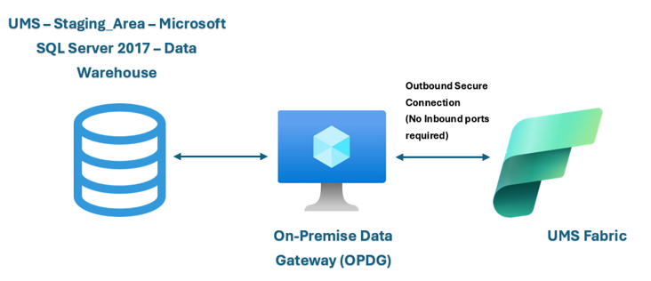
This topology enables UMS to leverage cloud analytics while maintaining robust security and operational oversight of on-premises resources.

3.2 Microsoft Fabric Data Gateway
Universiti Malaysia Sabah shall deploy the On-Premises Data Gateway (OPDG) as the critical bridge between the UMS Staging Area and Microsoft Fabric. The OPDG is installed on a purpose-built Virtual Machine, designed to meet Microsoft’s performance and security requirements for gateway operations.
The OPDG’s primary role is to facilitate secure, reliable data transfer from the on-premises SQL Server 2017 to Fabric services. It operates exclusively via outbound connections, ensuring that no inbound ports are exposed on the UMS network. This approach aligns with Microsoft’s best practices for gateway deployment and minimizes vulnerability to external threats. The gateway agent authenticates using Azure Active Directory credentials, and all traffic is encrypted using TLS, providing assurance of data confidentiality during transit.
From a configuration perspective, the OPDG VM must be provisioned with sufficient resources to handle peak data transfer loads. It should be monitored for availability, throughput, and latency, with alerts configured for any operational anomalies. UMS administrators are responsible for maintaining the gateway’s OS patching, agent updates, and credential rotation, ensuring continuous compliance and operational readiness.
The following table outlines the VM specifications recommended for the OPDG deployment, ensuring optimal performance and security:
The VM specification table below provides a concise summary of the required resources for the OPDG host.
Component | Specification
VM Size | Standard D2s v3
CPU | 2 vCPUs
RAM | 8 GB
Storage | 128 GB SSD
OS | Windows Server 2019/2022
Network | Outbound-only connectivity
Security | TLS encryption, AAD auth
This VM configuration ensures that the OPDG can reliably handle concurrent data transfers, maintain secure connectivity, and scale in response to UMS’s evolving data integration requirements. By adopting this gateway architecture, Universiti Malaysia Sabah positions itself for seamless, secure integration with Microsoft Fabric, enabling advanced analytics and reporting while safeguarding institutional data.

4.0 Roles in Microsoft Fabric
This section details the role architecture and access model for Microsoft Fabric as designed for Universiti Malaysia Sabah (UMS). The following subsections define the administrator role, Fabric-native roles, and the specific UMS workspace role mapping.

4.1 Fabric Administrator Role
The Fabric Administrator role is central to managing the Microsoft Fabric environment at UMS. This role is responsible for overseeing platform configuration, security, and operational governance.

Assigning the Role
UMS shall assign the Fabric Administrator role to personnel with deep technical expertise and organizational authority. The assignment process involves the following steps: - Identification of suitable candidates from Sektor Analitik Data DARTIC and PPDM Official teams, ensuring they possess requisite knowledge of Microsoft Fabric, Power BI, and Azure. - Role assignment is performed via the Microsoft Fabric Admin Portal, where administrators are granted permissions at the tenant or workspace level. - For compliance and auditability, each assignment must be documented, and access periodically reviewed. UMS should maintain a record of all administrators, including their name, department, and justification for assignment. - The role is typically mapped to individuals such as Dr Suraya Binti Alias, Mohd. Zamrie Bin Musa, Noor Afiza Binti Momen, and Ts AG Azihar @ AG KU Azihar Bin AG Tangah, as identified in the workspace role mapping table.
This approach ensures that only authorized and skilled personnel manage critical Fabric components, aligning with best practices for least privilege and operational accountability.

Admin Portal Capabilities
The following table outlines the key capabilities available to Fabric Administrators within the Admin Portal, enabling comprehensive management of the platform.
Capability | Description
Workspace Management | Create, configure, and delete workspaces; manage workspace-level security and access.
User Access Control | Assign, modify, and revoke user roles and permissions across Fabric and Power BI.
Data Governance | Enforce data policies, lineage tracking, and compliance requirements within the workspace.
Resource Monitoring | Monitor usage, performance, and health of Fabric resources and services.
Audit & Compliance | Access audit logs, generate compliance reports, and track changes for regulatory purposes.
Integration Management | Configure integrations with Azure services, Power BI, and external data sources.
These capabilities are critical for ensuring that UMS’s Fabric environment remains secure, compliant, and operationally efficient.

4.2 Fabric-native Roles
Fabric-native roles provide granular access control within Microsoft Fabric, supporting both workspace-level and item-level permissions. UMS shall implement these roles to facilitate secure collaboration and data management.

Workspace-level Roles
Workspace-level roles define the scope of user actions within a Fabric workspace. UMS’s role mapping ensures that each workspace role is assigned to personnel with appropriate responsibilities.
Workspace Role | Suggested Role | UMS PIC
Workspace Admin | Fabric Admin / Data Engineer | Dr Suraya Binti AliasSektor Analitik Data DARTICPPDM OfficialMohd. Zamrie Bin MusaNoor Afiza Binti MomenTs AG Azihar @ AG KU Azihar Bin AG Tangah
Workspace Contributor | Data Engineer / Business User Admin | Mohd Khairul Nizam Bin Senu (DB)Assie Zaee Petrus (DB)Muhaimin Bin Mad Noor (Infra)Nuraliah Binti Alias (Infra)Chong Tze Chien (Server Security)Abdul Latif Matali (Server Security)
Workspace Viewer | Data Analyst / Stakeholder / Project Director | DirectorDr Farashazillah Binti YahyaStakeholdersRoslee Bin TalipDayangku Rozlina BTE PG. AliuddinNorhanieyati Binti NorhaizatZaidie @ Mohd Zaidie Bin AdilaiProfessor Madya TS Dr Mohd Hanafi Bin Ahmad Hijazi
This mapping ensures that each workspace role is aligned with UMS’s organizational structure, supporting accountability and efficient data operations.

Item-level Roles
Item-level roles provide fine-grained control over individual artifacts within a workspace, such as datasets, reports, and dashboards. The following table details the permissions and descriptions for each item-level role.
Item | Permission | Description
Dataset | Read, Write | Access and modify datasets; essential for data engineers and contributors to manage data assets.
Report | View, Edit | View and edit reports; allows analysts and stakeholders to interpret and refine data insights.
Dashboard | View | View dashboards; provides high-level summary access for project directors and stakeholders.
Dataflow | Execute, Modify | Run and modify dataflows; critical for automation and ETL processes managed by data engineers.
Notebook | Execute, Edit | Run and edit notebooks; supports advanced analytics and ML workflows for technical users.
UMS shall enforce item-level permissions to ensure data integrity and prevent unauthorized modifications, thereby supporting secure and collaborative analytics.

4.3 UMS Workspace Role and Access
UMS’s workspace role and access design is tailored to its organizational structure, ensuring that each role is mapped to the appropriate personnel and responsibilities. The following table provides a comprehensive mapping of workspace roles to UMS personnel, supporting operational clarity and compliance.
Workspace Role | UMS PIC | Suggested Role
Workspace Admin | Dr Suraya Binti AliasSektor Analitik Data DARTICPPDM OfficialMohd. Zamrie Bin MusaNoor Afiza Binti MomenTs AG Azihar @ AG KU Azihar Bin AG Tangah | Fabric Admin / Data Engineer
Workspace Contributor | Mohd Khairul Nizam Bin Senu (DB)Assie Zaee Petrus (DB)Muhaimin Bin Mad Noor (Infra)Nuraliah Binti Alias (Infra)Chong Tze Chien (Server Security)Abdul Latif Matali (Server Security) | Data Engineer / Business User Admin
Workspace Viewer | DirectorDr Farashazillah Binti YahyaStakeholdersRoslee Bin TalipDayangku Rozlina BTE PG. AliuddinNorhanieyati Binti NorhaizatZaidie @ Mohd Zaidie Bin AdilaiProfessor Madya TS Dr Mohd Hanafi Bin Ahmad Hijazi | Data Analyst / Stakeholder / Project Director
This mapping supports clear delineation of responsibilities, facilitating secure access and efficient management of Fabric workspaces. Universiti Malaysia Sabah shall periodically review and update role assignments to ensure alignment with organizational changes and evolving data governance requirements.

5.0 Microsoft Fabric Design and Decision
This section details the architectural design and decisions for Universiti Malaysia Sabah’s (UMS) Microsoft Fabric implementation, covering workflow, access, identity, platform sizing, resource organization, governance, and security.

5.1 Workflow Design Considerations
UMS shall implement a multi-layered data workflow leveraging Microsoft Fabric components to ensure robust data ingestion, transformation, and visualization. The following table summarizes key workflow considerations, mapped to workload types:
ID | Description | Workload Type
DC01 | Data Pipeline will be used to ingest data from Microsoft SQL Server. | Data Factory
DC02 | The Bronze Lakehouse will store raw/original data ingested from Microsoft SQL Server. | Data Engineering
DC03 | The Silver Lakehouse will store cleansed data sourced from the bronze Lakehouse. | Data Engineering
DC04 | The Gold Lakehouse will store transformed data sourced from the silver Lakehouse. | Data Engineering
DC05 | Data cleansing and transformation for the Silver Lakehouse will be performed using Dataflow Gen2, Notebook and Visual Query in the SQL Analytics Endpoint. | Data Engineering
DC06 | Dataflow Gen2 will be used to move data between Lakehouses (e.g., from bronze to silver or silver to gold). | Data Factory
DC07 | AutoML from Data Science will be used to demonstrate the Machine Learning Process, and the results will be stored in Gold Lakehouse | Data Science
DC08 | Data modeling will be implemented in the Semantic Model, using data from the Gold Lakehouse. | Power BI
DC09 | Power BI Desktop will connect to the Semantic Model via OneLake for data visualization. | Power BI
These considerations ensure UMS’s data pipeline is optimized for scalability, maintainability, and analytics readiness.
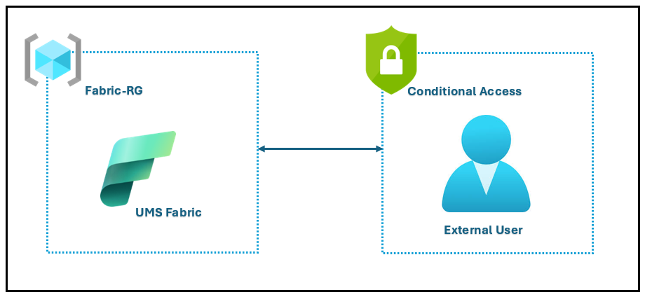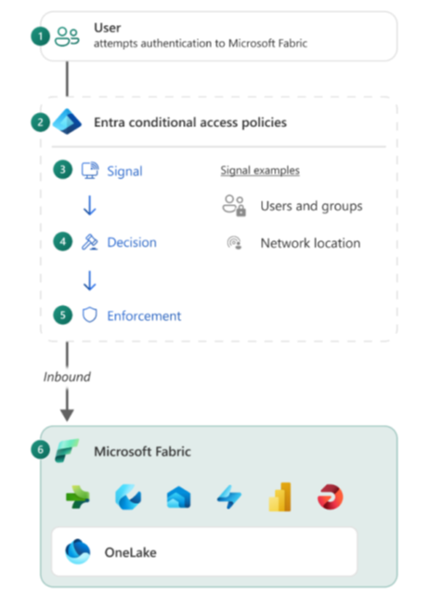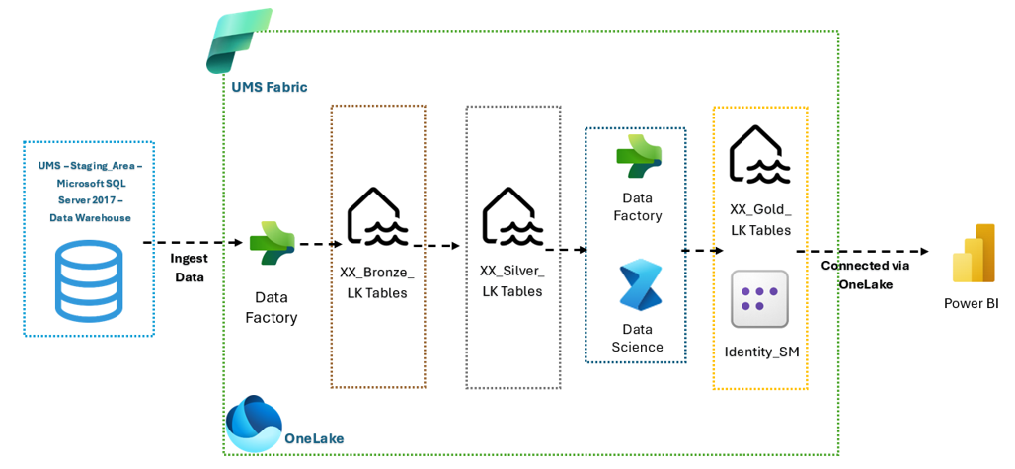

5.2 Workflow Design Decisions
UMS has made several key design decisions to optimize workflow efficiency, security, and user experience. The following table outlines these decisions:
Decision ID | Decision Description
DD01 | Configure Policy in Conditional Access to include Power BI Service, Azure Data Explorer, Azure SQL Database, and Azure Storage
DD02 | Include UMS user inside Conditional Access policy
DD03 | UMS users go through additional verification, MFA, to reduce unexpected login prompts
DD04 | Users able to access Microsoft Fabric’s environment
These decisions are based on UMS’s licensing status, operational requirements, and the need for secure, streamlined access.

5.3 Access Design Considerations
UMS’s access design is shaped by licensing constraints and operational requirements, with a focus on security and user experience. The following subsections detail each access method evaluated:

Conditional Access
Conditional Access was assessed for UMS’s Microsoft Fabric environment to enforce granular access controls. However, due to UMS’s current Microsoft Entra ID licensing (Free tier), Conditional Access cannot be fully implemented. The policy configuration would have included Power BI Service, Azure Data Explorer, Azure SQL Database, and Azure Storage. Additional licensing (P1/P2) is required for full Conditional Access capabilities, which UMS may consider in future phases.

MFA (Multi-Factor Authentication)
Multi-Factor Authentication (MFA) is enforced at the tenant level for all UMS users. This approach mitigates risks associated with credential compromise and ensures a baseline security posture. MFA is compatible with Entra ID Free tier and does not require additional licensing, making it the most practical solution for UMS at this stage.

Private Link
Private Link was evaluated for securing access to Microsoft Fabric resources by restricting connectivity to private endpoints. Due to licensing limitations and complexity in implementation, Private Link has been deferred for future consideration. UMS may revisit this option if advanced security requirements or regulatory mandates arise.

5.4 Access Design Decisions
The following table summarizes UMS’s access design decisions, reflecting the chosen policies and their rationale:
Decision ID | Policy Description
DD01 | Conditional Access policy configuration deferred due to licensing; MFA enforced at tenant level
DD02 | UMS users included in MFA policy to ensure secure authentication
DD03 | Private Link implementation deferred; revisit upon future licensing upgrade
DD04 | Users are able to access Microsoft Fabric’s environment via secure authentication
These decisions balance security, usability, and cost-effectiveness for UMS.

5.5 Identity and Access Management
UMS shall integrate Microsoft Entra ID as the central identity provider for Microsoft Fabric. User authentication will leverage Entra ID’s capabilities, ensuring secure, single sign-on access across all Fabric components. MFA enforcement at the tenant level provides additional security, requiring users to verify their identity through a secondary factor. User provisioning and de-provisioning will be managed via Entra ID, ensuring role-based access and compliance with UMS’s IT governance policies. Integration steps include configuring Entra ID as the authentication source, mapping user roles to Fabric workspaces, and monitoring access logs for anomalous activity.

5.6 Virtual Machine Size
UMS shall deploy the OPDG VM with specifications tailored for optimal performance and compatibility with Microsoft Fabric workloads. The following table details the required specifications:
Component | Specification
Operating System | Windows 10 (64-bit) or Windows Server 2019 (64-bit)
.NET Framework | Version 4.8
vCPU | 8 cores
RAM | Minimum 8 GB
These specifications ensure the VM can handle data processing, integration, and visualization tasks without performance bottlenecks.

5.7 Resource Organization Design
UMS’s resource organization is structured to maximize manageability, consistency, and scalability across Microsoft Fabric deployments.

Azure Management Groups
UMS shall utilize Azure Management Groups to logically organize subscriptions and resources. Management Groups provide hierarchical governance, enabling policy enforcement and cost tracking at scale. UMS will create management groups for each major department or project, aligning with organizational boundaries and facilitating delegated administration.

Naming and Tagging
UMS shall implement a standardized naming convention and tagging strategy to ensure resource discoverability, traceability, and compliance. The following tables outline these conventions:

Azure Naming Convention
Resource | Abbreviation | Example
Subscription | sub | ums-prod-sub
Resource Group | rg | ums-data-rg
Storage Account | st | umsdatast01
VM | vm | ums-data-vm01
Network | vnet | ums-vnet01
Database | db | ums-sqldb01

Fabric Naming Convention
No. | Item in Fabric | Naming --
1 | Fabric Capacity | stagingareadevcapacity01
2 | Workspace | StudentAffairs_dev_WS
3 | Lakehouse | StudentAffairs_Bronze_LKStudentAffairs_Silver_LKEtc…
4 | Dataflow | StudentAffairs_Bronze_to_Silver_DFStudentAffairs_Silver_to_Gold_DFEtc..
5 | Semantic Model | StudentAffairs_StudentPerformance_SM
6 | Pipeline | StudentAffairs_Ingest_Data_PLEtc..
7 | Report | StudentAffairs_StudentPerformance_Report

Application Acronyms
Acronym | Full Name
LK | Lakehouse
DF | Dataflow
SM | Semantic Model
PL | Pipeline
WS | Workspace

Suggested Tags
Tag Key | Description | Example Value
Environment | Deployment environment | Production
Owner | Resource owner | StudentAffairs
CostCenter | Department or project cost center | SA-2024
Project | Project name | StudentPerformance
Compliance | Regulatory compliance status | MY-PII
These conventions streamline resource management and support UMS’s operational and compliance objectives.

5.8 Governance Consideration
UMS shall enforce governance disciplines across Microsoft Fabric resources to ensure cost control, compliance, and operational integrity.

Governance Disciplines with Cost Management Tools
UMS will leverage Azure-native tools for cost management, policy enforcement, and resource optimization. The following table summarizes key tools and their governance discipline:
Azure Tool | Description | Cost Management Discipline
Azure Cost Management | Budget tracking, spend analysis, forecasting | Cost Control
Azure Policy | Resource compliance enforcement | Compliance
Azure Advisor | Resource optimization and recommendations | Optimization
Azure Monitor | Resource usage and performance monitoring | Monitoring
These tools enable UMS to proactively manage resources, enforce policies, and optimize spending.

Violation Triggers and Actions
UMS shall define triggers for policy violations and corresponding actions to maintain governance and mitigate risks. The following table outlines these triggers and actions:
Trigger | Action
Budget threshold exceeded | Notify owner, initiate cost review
Non-compliant resource detected | Auto-remediate or escalate to admin
Unauthorized access attempt | Block access, alert security team
Resource performance degradation | Scale resources, notify operations
This framework ensures UMS’s Fabric environment remains secure, compliant, and cost-effective.

5.9 Multi-Factor Authentication
UMS shall enforce Multi-Factor Authentication (MFA) at the tenant level for all Microsoft Fabric users. This decision is driven by the inability to implement Conditional Access policies with the current Entra ID Free licensing. Tenant-level MFA provides robust protection against credential-based attacks and ensures that only authorized users can access sensitive data and analytics resources. UMS’s IT administrators will monitor MFA enrollment and compliance, ensuring every user completes secondary authentication during sign-in. This approach aligns with security best practices and regulatory requirements, offering a scalable, cost-effective solution until Conditional Access becomes available through future licensing upgrades.

6.0 Security Design and Decision
This section outlines Universiti Malaysia Sabah’s (UMS) network security and encryption strategy for the Azure-hosted On-Premises Data Gateway (OPDG) connecting to Microsoft Fabric and Power BI.

6.1 Azure NSG Overview
UMS shall implement Azure Network Security Groups (NSGs) to enforce strict outbound connectivity controls for the OPDG virtual machine. This approach aligns with Azure networking best practices, ensuring only essential, secure traffic is permitted from the gateway VM to Microsoft cloud endpoints. By restricting outbound traffic via NSG rules, UMS mitigates the risk of unauthorized data exfiltration and maintains compliance with institutional security policies.
The design mandates that all outbound traffic from the OPDG VM is limited to Microsoft services required for authentication, data transfer, and operational health checks. Each rule is crafted to allow only the minimum necessary access, supporting the principle of least privilege and reducing the attack surface.

Outbound Rules
The following table details the outbound NSG rules that UMS shall configure for the OPDG VM. These rules are critical to enable secure communication, authentication, and connectivity verification with Microsoft Fabric, Power BI, and related cloud services.
Name | Priority | Source | Source Ports | Destination | Destination Ports | Protocol | Access
Allow_OPDG_HTTPS_Services | 130 | VM Private IP Addresses | * | .servicebus.windows.net, .download.microsoft.com, .core.windows.net, .frontend.clouddatahub.net, .dfs.fabric.microsoft.com, .datawarehouse.fabric.microsoft.com, .powerbi.com, .analysis.windows.net | 443 | TCP | Allow
Allow_OPDG_Authentication | 140 | VM Private IP Addresses | * | .login.windows.net, login.microsoftonline.com, aadcdn.msauth.net, aadcdn.msftauth.net, .microsoftonline-p.com, login.live.com | 443 | TCP | Allow
Allow_OPDG_Connectivity_Test | 160 | VM Private IP Addresses | * | *.msftncsi.com | 80 | TCP | Allow
These rules collectively ensure that the OPDG VM can securely transmit data, authenticate users, and verify network connectivity. No inbound NSG rules are required for this scenario, as all communication is outbound from the gateway.

6.2 Encryption Design
UMS shall enforce SSL/TLS encryption for all outbound connections from the OPDG VM to Microsoft Fabric, Power BI, and related Azure services. This design decision is rooted in the need to protect sensitive institutional data in transit and to comply with both university and Azure security standards.
All outbound traffic specified in the NSG rules—particularly data exchanges and authentication requests—will utilize HTTPS (TCP port 443) with SSL/TLS. This ensures that data is encrypted end-to-end, preventing interception or tampering during transmission. The OPDG VM is configured to trust Microsoft’s certificate authorities, guaranteeing secure channel establishment with cloud endpoints.
Operationally, this encryption requirement means that UMS administrators must verify that the OPDG VM’s Windows operating system and gateway software are up-to-date, with the latest security patches and cipher suites enabled. Monitoring tools should be deployed to confirm that all outbound connections are successfully negotiated using SSL/TLS, and any anomalies or failed handshakes are promptly investigated.
By mandating SSL/TLS for all outbound communications, UMS demonstrates a commitment to safeguarding university data and maintaining the integrity of its analytics infrastructure. This encryption strategy is a foundational element of the broader security architecture, complementing the NSG-based network controls and supporting compliance with regulatory and institutional mandates.

7.0 AutoML Workflow Design in Microsoft Fabric
This section details the comprehensive AutoML workflow design tailored for Universiti Malaysia Sabah (UMS) within Microsoft Fabric, including both automated and manual machine learning paths.

7.1 Technical Overview
UMS shall implement an integrated machine learning workflow leveraging Microsoft Fabric’s capabilities, combining both AutoML and manual ML approaches. The architecture is designed to streamline data engineering, model development, scoring, and visualization, ensuring robust lifecycle management and operational transparency.
The workflow initiates with data sourced from XX_Silver_LK Tables, representing the cleansed, pre-processed Silver layer within Fabric. This data serves as the foundation for both AutoML experiments and manual ML modeling. AutoML automates model selection, training, and evaluation, while manual ML, executed via Fabric Notebooks (PySpark or Python), empowers data scientists with granular control over feature engineering and algorithm optimization.
Outputs from both paths are stored in XX_Gold_LK Tables—the Gold layer—ensuring standardized, high-quality model results. Identity_SM manages metadata and identity aspects for Gold outputs. OneLake acts as the unified storage layer, facilitating seamless integration with Power BI for advanced visualization and reporting. This architecture supports UMS’s requirement for explainable, reproducible, and scalable machine learning workflows.
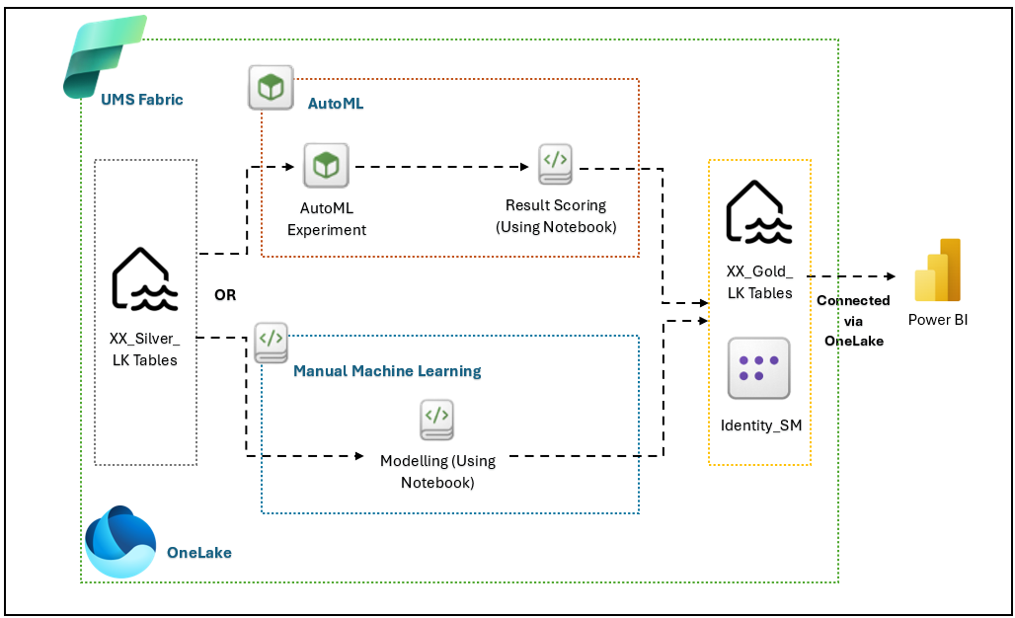

7.2 Approach/Paths
UMS’s workflow design incorporates two distinct paths—AutoML Experiment and Manual Machine Learning—each optimized for specific operational and analytical scenarios.

AutoML Experiment
UMS shall utilize Microsoft Fabric’s AutoML capabilities to automate model development. AutoML Experiment orchestrates the end-to-end process: selecting algorithms, tuning hyperparameters, and training models on Silver Lakehouse data. This path is ideal for rapid prototyping and scenarios where model interpretability is less critical. The output is scored using dedicated notebooks, which evaluate performance metrics and generate predictions for downstream consumption.
Technical configuration involves: - Connecting XX_Silver_LK Tables as input datasets. - Initiating AutoML runs within Fabric, specifying target variables and constraints. - Using scoring notebooks to validate model outputs and store results in XX_Gold_LK Tables. - Ensuring all scored results are tagged and versioned for traceability.
Operational impact: - Reduces manual effort in model selection and tuning. - Accelerates experimentation cycles. - Provides baseline models for comparison with manual approaches.

Manual Machine Learning
UMS shall primarily adopt manual machine learning via Fabric Notebooks, leveraging PySpark or Python for custom feature engineering, algorithm selection, and model optimization. This path is critical for use cases requiring deep domain expertise, explainability, and precise control over model parameters.
Key process steps: - Data scientists access XX_Silver_LK Tables within notebooks. - Custom scripts perform feature engineering, data augmentation, and algorithm selection. - Model training, evaluation, and fine-tuning are executed interactively. - Trained models are registered in the Fabric Model Registry for lifecycle management. - Scoring notebooks apply models to new data, storing outputs in XX_Gold_LK Tables.
Tools used: - Fabric Notebooks (PySpark/Python) - Model Registry for versioning and reuse - Scoring Notebooks for operational inference
Business impact: - Enables tailored solutions for UMS’s unique datasets. - Supports compliance and explainability requirements. - Facilitates iterative improvement and collaborative development.

7.3 Process Flow
The workflow is structured into five distinct phases, each with precise technical and operational requirements.

Data Preparation
UMS shall utilize XX_Silver_LK Tables as the source for all machine learning experimentation. Data is cleansed, transformed, and validated within the Silver Lakehouse, ensuring consistency and quality for downstream modeling. Selection of input datasets is governed by programmatic criteria from the Staging DB, aligning with UMS’s research and operational objectives.
Configuration steps: - Data ingestion from Staging DB to Silver Lakehouse. - Data profiling, cleaning, and schema validation. - Feature selection and transformation pipelines.
Operational impact: - Ensures high-quality, reliable input data. - Reduces risk of model bias and data leakage.

Model Training
Model training is conducted either via AutoML or manual notebooks. For AutoML, the process is automated—algorithms and hyperparameters are selected based on dataset characteristics. For manual ML, data scientists execute custom scripts to optimize models for accuracy and interpretability.
Configuration steps: - Initiate AutoML runs or manual notebook sessions. - Specify training parameters, validation splits, and evaluation metrics. - Monitor training progress and log outcomes.
Operational impact: - Supports both rapid prototyping and deep customization. - Enables tracking of training artifacts for auditability.

Scoring
Scoring notebooks are used to apply trained models to new or unseen data. The process generates predictions, probabilities, and performance metrics, which are stored in XX_Gold_LK Tables. This phase is critical for operational deployment and ongoing model validation.
Configuration steps: - Connect scoring notebooks to Gold Lakehouse. - Apply models to batch or streaming data. - Store scored outputs with metadata for traceability.
Operational impact: - Delivers actionable insights for UMS’s stakeholders. - Supports continuous monitoring and improvement.

Model Registration
UMS shall register all trained models in the Fabric Model Registry. This ensures robust lifecycle management, versioning, and potential reuse across multiple projects. Model metadata, including training parameters and performance metrics, are stored for compliance and reproducibility.
Configuration steps: - Register models post-training via Fabric APIs. - Assign version numbers and tags. - Document model lineage and dependencies.
Operational impact: - Facilitates governance and auditability. - Enables seamless model deployment and reuse.

Visualization
The Gold Lakehouse serves as the standardized repository for all modeled and scored results. Power BI connects to the Semantic Model via OneLake, enabling advanced data modeling and visualization. UMS personnel access dashboards and reports for decision-making, research, and operational monitoring.
Configuration steps: - Configure Semantic Model connections in Power BI Desktop. - Implement Direct Lake connectivity via OneLake. - Design and publish visualizations tailored to UMS’s requirements.
Operational impact: - Empowers data-driven decision-making. - Enhances transparency and stakeholder engagement.

7.4 Design Decisions
The following table summarizes key design considerations and their associated workload types for UMS’s AutoML workflow in Microsoft Fabric.
The table below provides a concise mapping of each major design decision, its description, and the relevant workload type.
ID | Description | Workload Type
DE01 | The cleaned data stored in Silver Lakehouse will serve as the input for all machine learning experimentation. The chosen data will be one of the programs selected from the overall Staging DB. | Data Engineering
DE02 | The Project will primarily adopt the Manual Machine Learning approach using Fabric Notebooks (PySpark or Python) to enable custom feature engineering, algorithm tuning, and model optimization. | Data Science
DE03 | Users will perform model training, evaluation, and fine-tuning directly in the Notebook environment to achieve more accurate and explainable results tailored to UMS’s datasets. | Data Science
DE04 | Trained models will be registered in the Fabric Model Registry to support model lifecycle management, versioning, and potential reuse across further adoption. | Data Science
DE05 | Scoring Notebooks will be used to apply trained models to new or unseen data. The scored outputs, predictions, probabilities, and performance metrics will be stored in the Gold Lakehouse. | Data Engineering
DE06 | The Gold Lakehouse will serve as the standardized repository for all modeled or scored results, ensuring consistency between AutoML and manual ML outputs. | Data Engineering
DE07 | The Semantic Model will connect to the Gold Lakehouse via Direct Lake (OneLake) and Data Modelling will be implemented | Power BI
DE08 | Power BI Desktop will connect to the Semantic Model via OneLake for data visualization. | Power BI
These decisions ensure that UMS’s AutoML workflow is robust, scalable, and aligned with operational, analytical, and governance requirements.

8.0 Appendix
This appendix provides authoritative reference material and supplementary links to support Universiti Malaysia Sabah’s solution design. Each section is organized by technology domain, offering prerequisites, quota boundaries, and further reading.

8.1 Appendix 1 Computing

Introduction/Prerequisites
- Azure Virtual Machines Documentation
- Azure Compute Overview
- Azure Resource Manager Templates

Limits and Boundaries
- Azure VM Size Limits
- Azure Subscription and Service Limits, Quotas, and Constraints
- Azure Compute Quotas

Others
- Azure Spot Virtual Machines
- Azure Managed Disks Documentation
- Azure VM Availability Sets

8.2 Appendix 2 Network

Introduction/Prerequisites
- Azure Virtual Network Documentation
- Azure Network Security Overview
- Azure ExpressRoute Documentation

Limits and Boundaries
- Azure Networking Limits
- Azure VPN Gateway Limits
- Azure Load Balancer Limits

Others
- Azure Private Link Documentation
- Azure DNS Documentation
- Azure Traffic Manager Documentation

8.3 Appendix 3 Identity & Security

Introduction/Prerequisites
- Azure Active Directory Documentation
- Azure Security Center Documentation
- Azure Identity Management Overview

Limits and Boundaries
- Azure AD Service Limits
- Azure Security Center Limits
- Azure Role-Based Access Control Limits

Others
- Azure Conditional Access Documentation
- Azure Key Vault Documentation
- Azure Multi-Factor Authentication

8.4 Appendix 4 Logging & Monitoring

Introduction/Prerequisites
- Azure Monitor Documentation
- Azure Log Analytics Documentation
- Azure Activity Logs Overview

Limits and Boundaries
- Azure Monitor Data Limits
- Log Analytics Workspace Limits
- Azure Diagnostic Settings Limits

Others
- Azure Application Insights Documentation
- Azure Monitor Alerts Documentation
- Azure Sentinel Documentation

8.5 Appendix 5 Cloud Governance

Introduction/Prerequisites
- Azure Governance Documentation
- Azure Policy Documentation
- Azure Management Groups Overview

Limits and Boundaries
- Azure Policy Limits
- Azure Management Groups Limits
- Azure Resource Locks Limits

Others
- Azure Cost Management Documentation
- Azure Blueprints Documentation
- Azure Tagging Best Practices

8.6 Appendix 6 OPDG

Introduction/Prerequisites
- Open Data Protocol (OData) Documentation
- Azure Data Lake Documentation
- Azure Data Factory Documentation

Limits and Boundaries
- Azure Data Lake Storage Limits
- Azure Data Factory Limits
- Azure Data Share Limits

Others
- Azure Synapse Analytics Documentation
- Azure Data Catalog Documentation
- Azure Purview Documentation

8.7 Appendix 7 Machine Learning

Introduction/Prerequisites
- Azure Machine Learning Documentation
- Azure ML Studio Documentation
- Azure Cognitive Services Documentation

Limits and Boundaries
- Azure Machine Learning Quotas and Limits
- Azure ML Compute Instance Limits
- Azure ML Workspace Limits

Others
- Azure ML Pipelines Documentation
- Azure ML Model Deployment Documentation
- Azure ML Security Best Practices
Note: For VM specifications, NSG rules, and naming conventions, refer to Section 4.3 (Platform Design), Section 6.2 (Security Design), and Section 7.1 (Resource Organization Design) respectively.

