Financial Data Analytics Project

Project Overview
This project was completed for a small investment company that manages an equity fund consisting of approximately 150 U.S.-based companies operating across multiple states and industries. The purpose of this analysis is to assist fund managers in evaluating recent company performance and supporting informed portfolio rebalancing decisions.
The analysis uses Python programming to examine financial indicators such as debt, equity, revenue, and profitability. Prior to program development, this document outlines the program logic through a flowchart and pseudocode to demonstrate algorithmic thinking, as required by the task instructions.

System Architecture (Flow Overview)
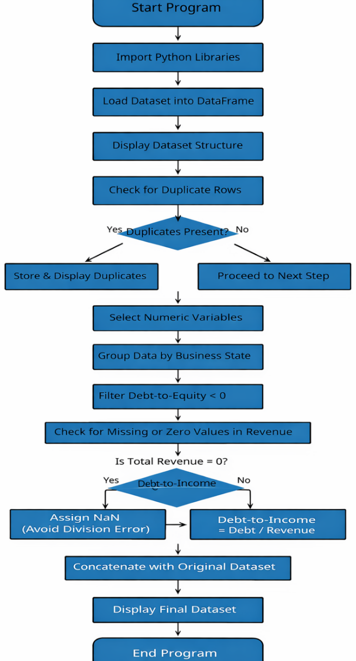
Screenshot should clearly show program flow from data import to final output.

Data Processing Logic
BEGIN

IMPORT required Python libraries

LOAD dataset into data frame df

DISPLAY dataset structure and summary

CHECK for duplicate rows in df

IF duplicate rows exist THEN
STORE duplicate rows
DISPLAY duplicate rows
ELSE
PROCEED to next step
END IF

SELECT all numeric financial variables

GROUP dataset by Business State

CALCULATE mean, median, minimum, and maximum
STORE results in new data frame state_stats

FILTER businesses where Debt-to-Equity ratio < 0
STORE results in negative_de_ratio

CREATE new data frame debt_to_income_df

FOR each record in df:
IF Total Revenue = 0 THEN
SET Debt_to_Income_Ratio = NaN
ELSE
SET Debt_to_Income_Ratio =
Total Long-term Debt / Total Revenue
END IF
END FOR

CONCATENATE debt_to_income_df with original df
STORE as final_df

DISPLAY final_df summary

END

Exploratory Financial Analysis
The analysis begins by examining the structure and quality of the financial dataset to ensure reliability for downstream processing. Duplicate records are identified to prevent distortion in financial insights.
State-level aggregation is then performed to understand geographic variations in financial performance. This helps identify whether certain regions exhibit higher financial stability or increased financial risk concentration across key financial indicators such as revenue, debt, and profitability.
From a business perspective, this segmentation is important because financial risk is not uniformly distributed across regions, and investment exposure may vary significantly by location.
Companies with negative debt-to-equity ratios are then filtered to detect abnormal financial structures or potential reporting inconsistencies, which may indicate higher uncertainty in investment evaluation.
Finally, a debt-to-income ratio is calculated to assess financial leverage. This metric helps understand how dependent companies are on debt relative to their revenue generation capacity, which is critical for evaluating investment risk exposure.

Financial Insights & Risk Interpretation
The analysis reveals several important financial patterns relevant to portfolio decision-making:
- State-level variation indicates that financial performance is not evenly distributed, suggesting that geographic diversification is necessary to reduce concentrated risk exposure.
- Companies with negative debt-to-equity ratios represent financial anomalies or high-risk structures that require further validation before inclusion in investment portfolios.
- Higher debt-to-income ratios indicate increased leverage, meaning such companies are more vulnerable to revenue fluctuations and economic downturns.
- Zero revenue cases highlight the importance of data validation, as financial ratios become unreliable when revenue is absent.
These insights help transform raw financial data into meaningful risk signals for investment evaluation.

Portfolio & Investment Implications
From an investment decision-making perspective, the analysis provides actionable insights for portfolio management:
- Companies with high leverage should be assigned higher risk weightings or monitored closely for financial instability.
- Negative debt-to-equity companies should undergo further financial investigation before being considered for investment allocation.
- Geographic variation in financial performance suggests that portfolio diversification across states can help reduce systemic risk exposure.
- The dataset enables identification of both stable and high-risk companies, supporting informed portfolio rebalancing decisions.
Overall, this analysis supports data-driven investment strategies by converting raw financial metrics into actionable portfolio insights.

Logic Validation & Process Mapping
The flowchart and pseudocode demonstrate one-to-one alignment in structure and logical sequence. Each process and decision point represented in the flowchart corresponds directly to a step in the pseudocode.
Flowchart Step | Corresponding Pseudocode Step
START | BEGIN
Import dataset into DataFrame | LOAD dataset into df
Display dataset structure | DISPLAY dataset summary
Check for duplicate rows | CHECK for duplicate rows
Decision: Are duplicates present? | IF duplicate rows exist THEN
Store & display duplicates | STORE and DISPLAY duplicates
Select numeric variables | SELECT numeric financial variables
Group by Business State | GROUP dataset by Business State
Calculate mean, median, min, max | CALCULATE descriptive statistics
Filter Debt-to-Equity < 0 | FILTER businesses where ratio < 0
Decision: Is Total Revenue = 0? | IF Total Revenue = 0 THEN
Set Debt-to-Income = NaN | SET Debt_to_Income_Ratio = NaN
Else calculate ratio | SET Debt / Revenue
Concatenate new DataFrame | CONCATENATE debt_to_income_df with df
END | END
This structured alignment ensures consistency between the visual representation of the program logic and the written algorithmic instructions. Each decision node in the flowchart is mirrored by conditional statements in the pseudocode, demonstrating clear algorithmic planning and logical accuracy.

References
No external sources were used in the development of this project. All program logic, pseudocode, and analysis were created independently based on the concepts learned during the Analytics Programming (D598) course.

Documentation Standards
This document has been prepared using clear, concise, and professional language appropriate for an academic and business audience. Grammar, spelling, and sentence structure have been carefully reviewed to ensure clarity and accuracy. The organization and formatting of the content support ease of reading and logical understanding of the program planning process.

Appendix: Implementation Evidence
Appendix A: Jupyter Notebook Output Screenshots & Code Implementation
The following screenshots demonstrate the successful execution of the Python program. Each screenshot corresponds directly to a specific analytical step described in the pseudocode and flowchart.

Screenshot 1: Data Import Confirmation (Preview)
Corresponding Python Code:
import pandas as pd
# Load dataset
df = pd.read_excel("D598 Data Set.xlsx")

# Preview first 3 rows
df.head(3)
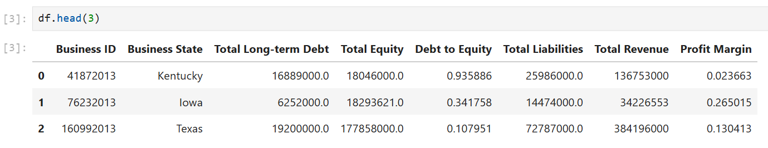
# Dataset structure overview
df.info()

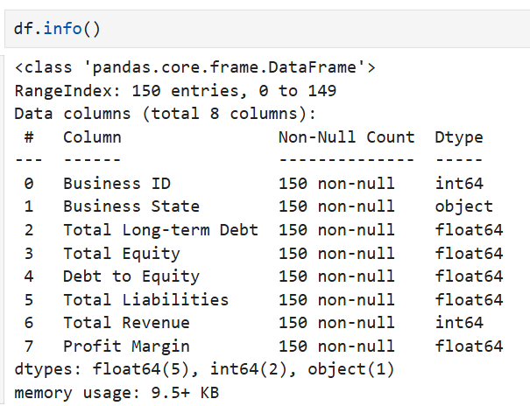

df.shape
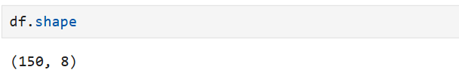

Screenshot 2: Duplicate Rows Identification (Preview)
Corresponding Python Code:
# Identify duplicate rows
duplicate_rows = df[df.duplicated()]
# Display duplicate records
duplicate_rows
# Count total duplicate rows
print("Total duplicate rows:", duplicate_rows.shape[0])
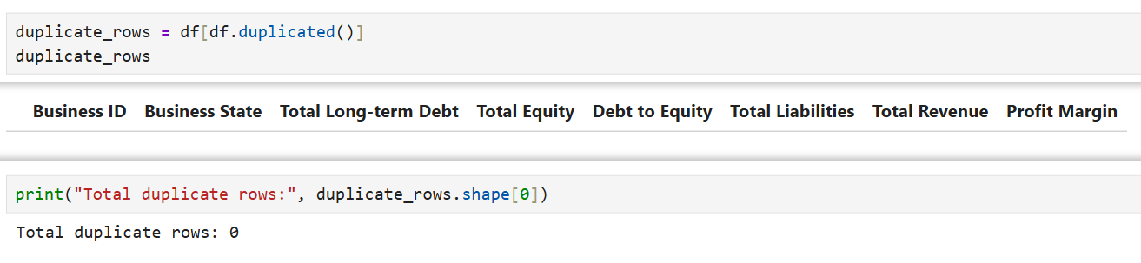
Screenshot 3: Grouped Descriptive Statistics by State (Preview)
Corresponding Python Code:
# Select numeric columns (excluding Business ID)
numeric_columns = df.select_dtypes(include=['int64', 'float64']).columns.drop('Business ID')
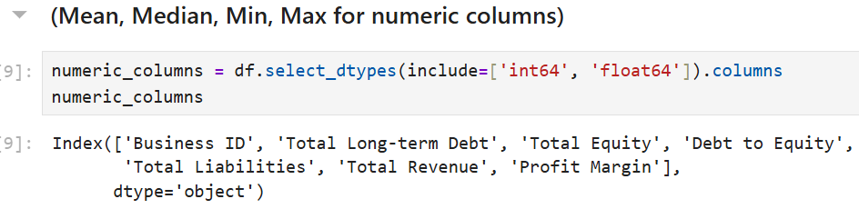
# Group by Business State and calculate descriptive statistics
state_stats = df.groupby("Business State")[numeric_columns].agg(
['mean', 'median', 'min', 'max']
)
# Display grouped statistics
state_stats.head()
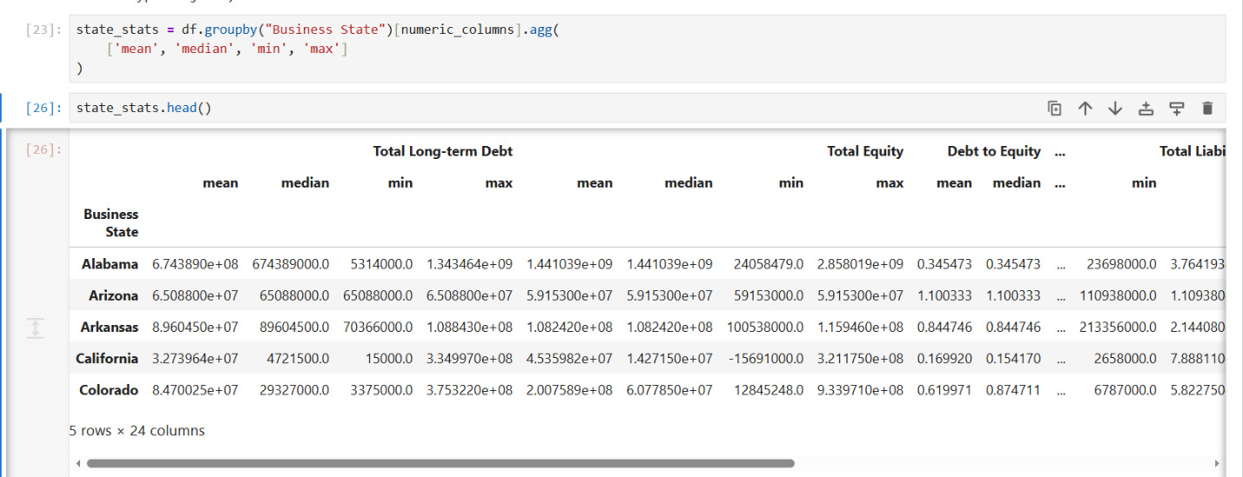

Screenshot 4: Negative Debt-to-Equity Ratio Filter (Preview)
Corresponding Python Code:
# Filter businesses with negative Debt-to-Equity ratio
df["Debt to Income"] = np.where(
df["Total Revenue"] == 0,
np.nan,
df["Total Long-term Debt"] / df["Total Revenue"]
)

# Display filtered records
df.head()

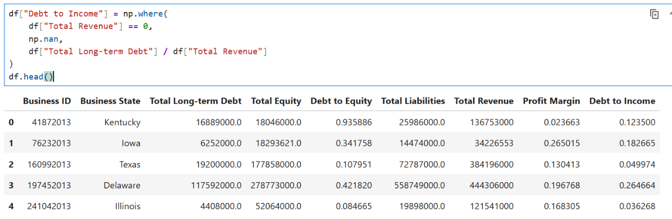

# Count businesses with negative ratio
print("Businesses with negative Debt-to-Equity ratio:", df["Debt to Income"].shape[0])

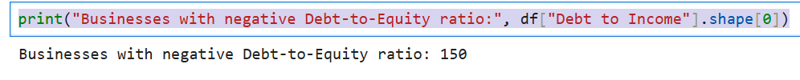

Screenshot 5: Final Concatenated Dataset (Preview)
Corresponding Python Code:
# Create Debt-to-Income Ratio safely
debt_to_income_df = pd.DataFrame()
debt_to_income_df["Debt_to_Income_Ratio"] = np.where(
df["Total Revenue"] == 0,
np.nan,
df["Total Long-term Debt"] / df["Total Revenue"]
)

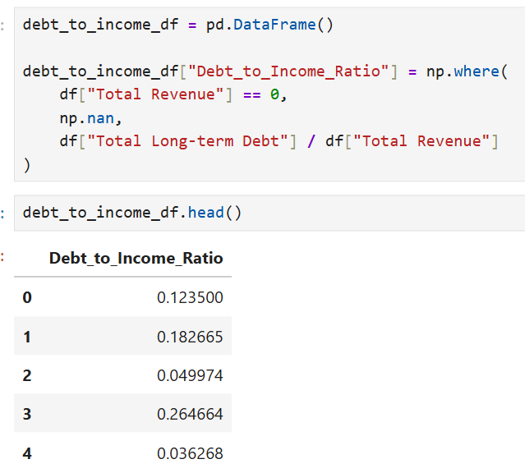
# Concatenate new ratio with original dataset
final_df = pd.concat([df, debt_to_income_df], axis=1)
# Display final dataset
final_df.head()
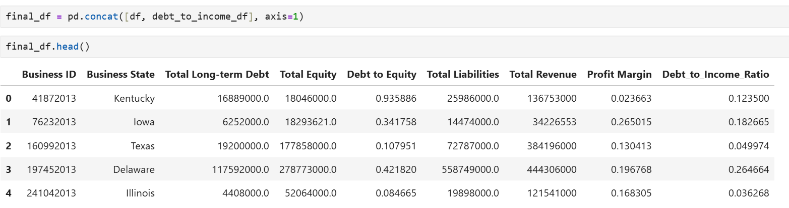
# Final dataset overview
final_df.info()

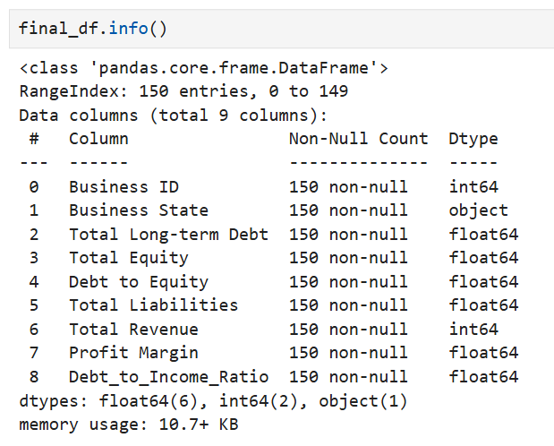

final_df.describe()



