Financial Data Analysis Program Implementation (Python)

Introduction
The project implements a structured financial data analysis pipeline using Python. The goal is to transform raw financial data into actionable insights for investment decision-making, including risk identification, performance aggregation, and ratio-based financial evaluation.

A. Flowchart
The flowchart from Task 1 is reused here as it represents the logical steps for the Python program. It illustrates the flow from data import to the final concatenated output, including decision points for duplicates and negative Debt-to-Equity ratios.
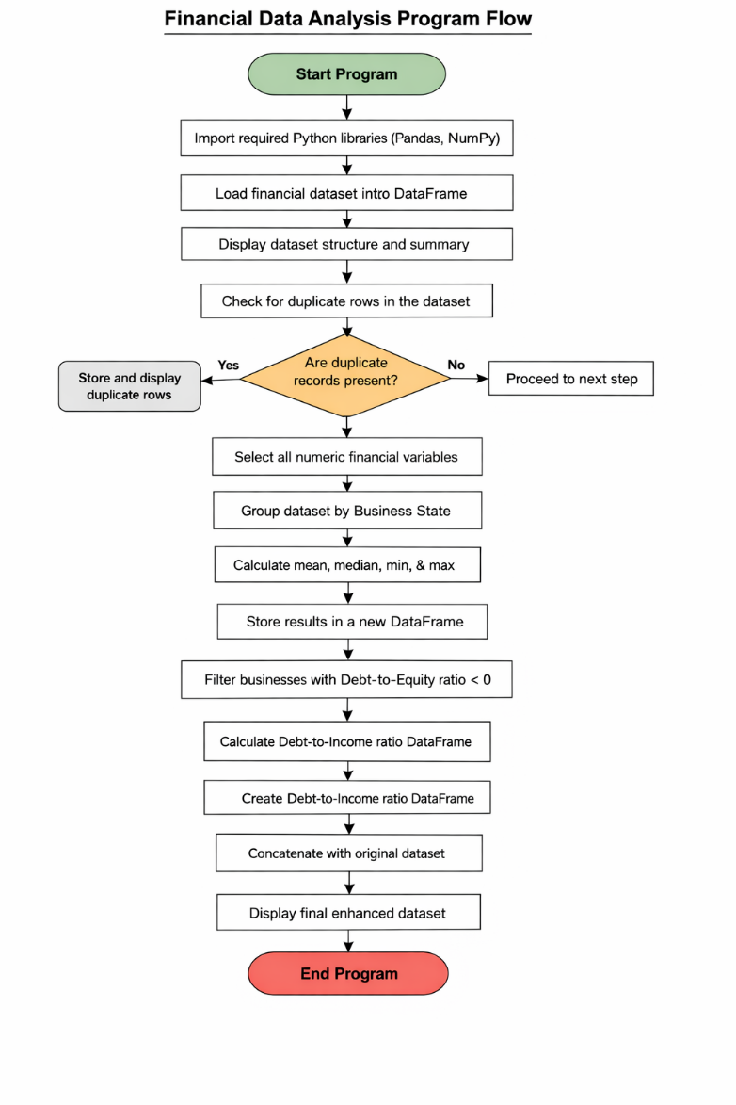

B. Python Program / Code Overview
The program follows a modular pipeline consisting of:
- Data Loading & Exploration
  - Import dataset and validate structure
- Data Quality Check
  - Detect and handle duplicate records
- Statistical Aggregation
  - Group financial metrics by Business State
- Risk Filtering
  - Identify companies with negative Debt-to-Equity ratios
- Feature Engineering
  - Compute Debt-to-Income ratio for leverage analysis
- Final Dataset Construction
  - Merge engineered features with original dataset

C. Screenshots / Output Preview
The following screenshots demonstrate the successful execution of the Python program in Jupyter Notebook:
Screenshot 1: Data Import Confirmation (Preview)
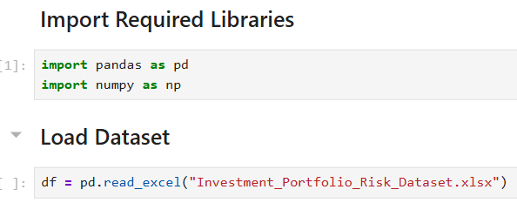
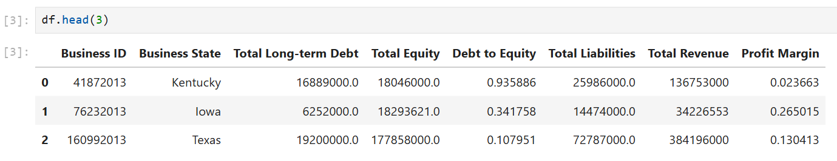
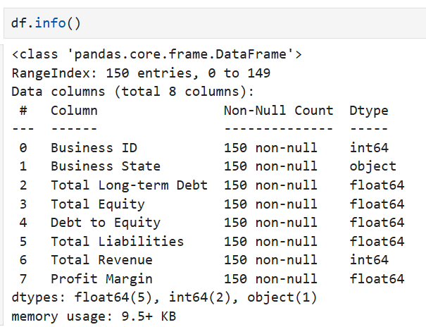
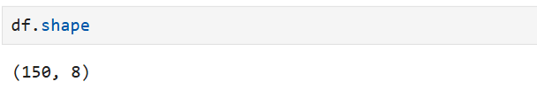

Screenshot 2: Duplicate Rows Identification (Preview)
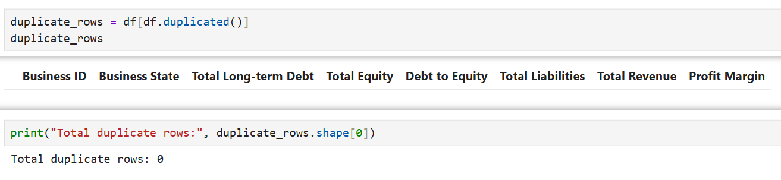
Screenshot 3: Grouped Descriptive Statistics by State (Preview)
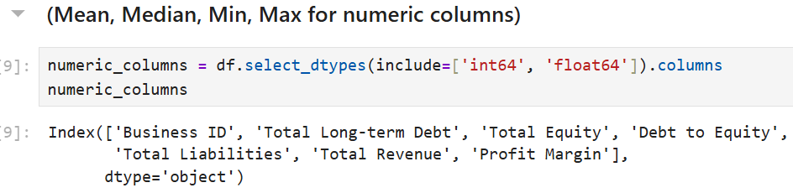
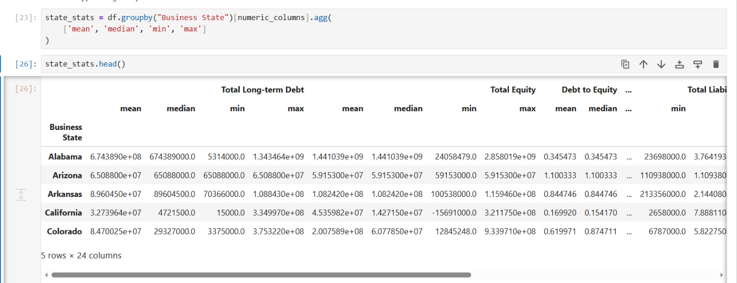

Screenshot 4: Negative Debt-to-Equity Ratio Filter (Preview)
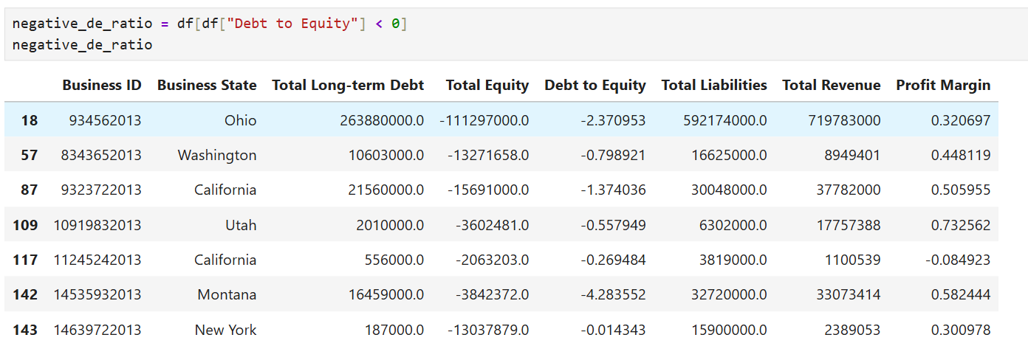
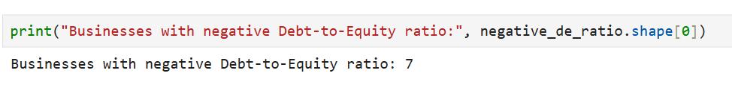
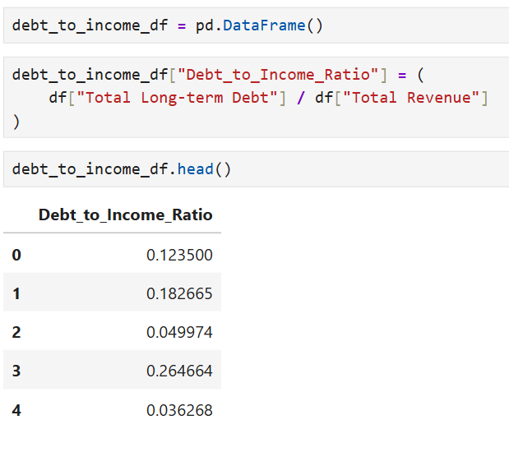
Screenshot 5: Final Concatenated Dataset (Preview)
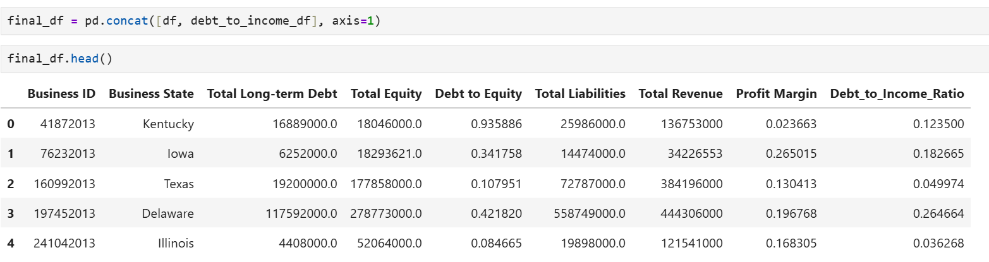

D. Alignment Between Flowchart and Code
The flowchart, pseudocode, and Python implementation are fully aligned. Each logical step, including decision nodes for duplicate detection and financial ratio conditions, is directly mapped to corresponding Python operations, ensuring consistency between design and execution.

E. Sources and References
No external sources were used in the development of this project. All program logic, pseudocode, and analysis were created independently based on the concepts learned during the Analytics Programming.

F. Professional Communication Statement
This document has been prepared using clear, concise, and professional language appropriate for an academic and business audience. All code comments, headings, and outputs are clearly labeled to facilitate interpretation and validation. Grammar, spelling, and sentence structure have been carefully reviewed for clarity and accuracy.

