

**DATABASE**

**PROJECT**

**HOSPITAL MANAGEMENT SYSTEM**

**ENTITIES :**

HOSPITAL

1. **Candidate**

|  |  |  |  |  |  |
| --- | --- | --- | --- | --- | --- |
| Candidate ID | Name | Phone | City |  | Street |

1. **Registration**

|  |  |  |  |  |  |
| --- | --- | --- | --- | --- | --- |
| User ID | Reg NO | password | Candidate ID |  | Admin ID |

1. **Admin**

|  |  |  |
| --- | --- | --- |
| Admin ID | Name | Phone |

1. **Result**

|  |  |  |  |  |  |
| --- | --- | --- | --- | --- | --- |
| Result ID | pass | Fail | score | Candidate ID | Admin ID |

1. **Subject**

|  |  |  |  |
| --- | --- | --- | --- |
| Java | C++ | Networking | Candidate ID |

1. **Deactivation**

|  |  |  |
| --- | --- | --- |
| Log in | Log out | Candidate ID |

1. **Report**

|  |  |  |
| --- | --- | --- |
| Select | Not Select | Admin ID |

1. **Test**

|  |  |  |  |  |
| --- | --- | --- | --- | --- |
| Subject | Test date | Obt marks | Candidate ID | Admin ID |

1. **Candidate Report**

|  |  |  |  |  |
| --- | --- | --- | --- | --- |
| Name | Candidate address | marks | phone | Admin ID |

**ERD Of Online Testing Syst**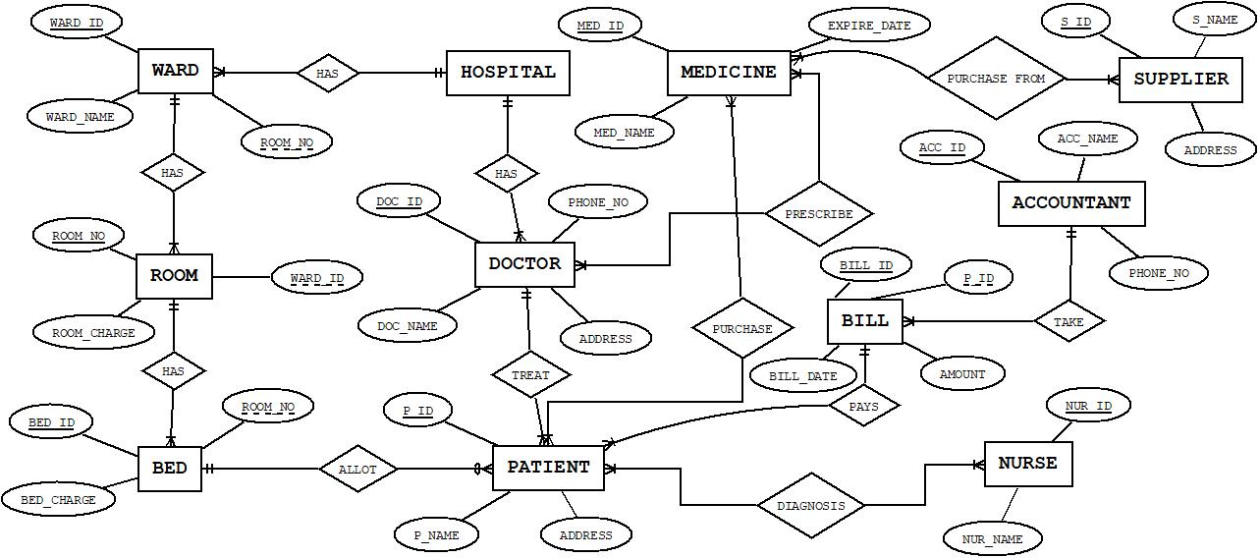

Fig.– Entity Relationship Diagram (ERD) for Hospital Management System

**ORACLE COMMANDS TO CREATE AND INSERT DATA**

**ward**

CREATE TABLE ward

(ward_ID int,ward_name varchar(200),room_no varchar(200));

INSERT INTO ward

VALUES (01,'ARSLAN','1S-20’);

INSERT INTO ward

VALUES ('02','KAMRAN','124124');

INSERT INTO WARD

VALUES ('03','SOHAIB','125125');

select *

from WARD

Candidate_ID Name phone city street

01 ARSLAN 123123 LAHORE ST-1

02 KAMRAN 124124 MULTAN ST-2

03 SOHAIB 125125 FAISLABAD ST-3

04 WAQAS 126126 SHEIKHUPURA ST-4

**REGISTRATION**

CREATE TABLE Reg (userID varchar(20) PRIMARY KEY,RegNo varchar(20),password varchar(20),

candidateID varchar(20),AdminID varchar(20))

INSERT INTO Reg VALUES ('s1','mcf21','pk4567','01','a1');

INSERT INTO Reg VALUES ('s2','mcf22','pk8910','02','a2');

INSERT INTO Reg VALUES ('s3','mcf23','pk1112','03','a3');

INSERT INTO Reg VALUES ('s4','mcf24','pk1314','04','a4');

select *

from Reg

userID RegNo password candidateID AdminID

s1 mcf21 pk4567 01 a1

s2 mcf22 pk8910 02 a2

s3 mcf23 pk1112 03 a3

s4 mcf24 pk1314 04 a4

**ADMIN**

CREATE TABLE Ad (AdminID varchar(20) PRIMARY KEY,Name varchar(20),Phone integer)

INSERT INTO Ad VALUES ('a1','arslan','3456789');

INSERT INTO Ad VALUES ('a2','zaigham','123456');

INSERT INTO Ad VALUES ('a3','waqas','333333');

INSERT INTO Ad VALUES ('a4','tahir','444444');

select *

from Ad

AdminID Name Phone

a1 arslan 3456789

a2 zaigham 123456

a3 waqas 333333

a4 tahir 444444

**RESULT**

CREATE TABLE REsult (ResultID varchar(50) PRIMARY KEY, status varchar(50),score varchar(50),candidateID varchar(50),

admainID varchar(50))

INSERT INTO REsult VALUES ('r1','pass','75','01','a1');

INSERT INTO REsult VALUES ('r2','pass','70','02','a2');

INSERT INTO REsult VALUES ('r3','pass','65','03','a3');

INSERT INTO REsult VALUES ('r4','pass','60','04','a4');

select *

from REsult

ResultID status score candidateID admainID

r1 pass 75 01 a1

r2 pass 70 02 a2

r3 pass 65 03 a3

r4 pass 60 04 a4

**TEST**

CREATE TABLE Test (subject varchar(20),testdate varchar(20),obtmarks varchar(10),candidateID varchar(10),

adminID varchar(20))

INSERT INTO Test VALUES ('comp','30 May','75','02','a2');

INSERT INTO Test VALUES ('science','25 May','65','03','a3');

INSERT INTO Test VALUES ('english','20 May','70','03','a3');

INSERT INTO Test VALUES ('urdu','18 May','65','04','a4');

select *

from Test

subject testdate obtmarks candidateID adminID

comp 30 May 75 02 a2

science 25 May 65 03 a3

english 20 May 70 03 a3

urdu 18 May 65 04 a4

**CANDIDATE RECORD**

CREATE TABLE candidateRecord (Name varchar(20),candidateAddress varchar(30),

marks varchar(255),phone varchar(50),adminID varchar(20))

INSERT INTO candidateRecord VALUES ('usama','lahore','75','123456','a1');

INSERT INTO candidateRecord VALUES ('arslan','sheikhupura','65','333333','a2');

INSERT INTO candidateRecord VALUES ('kamran','faislabad','70','456789','a3');

INSERT INTO candidateRecord VALUES ('sohaib','multan','60','456732','a4');

select *

from candidateRecord

Name candidateAddress marks phone adminID

usama lahore 75 123456 a1

arslan sheikhupura 65 333333 a2

kamran faislabad 70 456789 a3

sohaib multan 60 456732 a4