git clone => copy the project to your local device

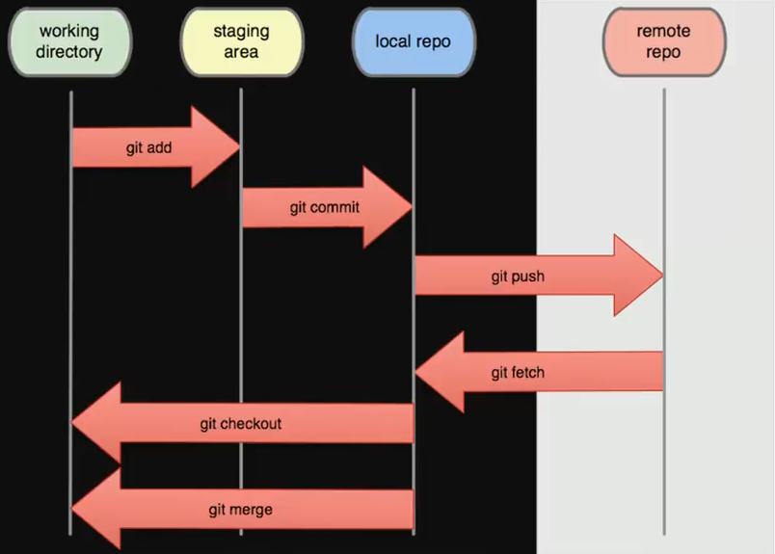

git status => compare between your branch and master

git add filename => add new files to stage

git reset head filename => remove files from stage

git commit –m “Your Comment” => transfer files to from statging to local Repo

git push origin master => push all commits to the Remote Repo

git remote => determine which Repo you Control

git fetch => Add and Show new edits in remote Repo

git merge => Merge new edits in remote Repo with local

git pull => git fetch + git merge

git init => initialize a new git Repo (for new projects)

git push **–u** origin master => pull before push (to take the leatest version of project before pushing it with my edits)

git branch =>to know which branch you stand

git branch branchName => Create new branch

git checkout branchName => Swtich to this branchName

git checkout -b branchName => Create new branch and switch on it

git branch -m newName => Rename Branch

git branch -d branchName => (Safe Delete) Delete this branchName after checking if there is editing on this branch or not

git branch -D branchName => Force Delete this branchName

git merge branchName => merge the branch you stand with the branchName you added

Aliases => Create your own shortcuts

**stach order after add order**

git stash => hide your files in stash box

git stash save “message” => To hide files with message

git stash list => show list of stash boxs

git stash pop => cut and restore the last files in the stash box

git stash pop stach@{2} => cut and restore files number 2 in the stash box

git stash apply => Copy and restore the last files in the stash box

git stash drop => Delete the last files in the stash box

git stash drop stach@{2} => Delete files number 2 in the stash box

git stash clear => Delete all stash boxs

git stash show => show details of last files in the stash box

git stash show stach@{2} => show details of files number 2 in the stash box