PROJECT REPORT

ON

PokéWiki: A Pokémon Team Builder & Explorer
Submitted by:
Muhammad Momin Irfan – 23014119-041
Ayesha Sadiqa – 23014119-157
Javeriya Aslam – 23014119-181
Department of Computer Science
Semester 5th
Evening – Fall 2025

TABLE OF CONTENTS
- Abstract
- Chapter 1: Introduction
  - 1.1 Introduction
  - 1.2 Problem Statement
  - 1.3 Objectives
  - 1.4 Project Scope
- Chapter 2: System Analysis
  - 2.1 Existing Systems
  - 2.2 Proposed System
  - 2.3 Feasibility Study
- Chapter 3: System Requirements
  - 3.1 Functional Requirements
  - 3.2 Non-Functional Requirements
  - 3.3 Hardware & Software Requirements
- Chapter 4: System Design
  - 4.1 System Architecture (MERN Stack)
  - 4.2 Database Design (Schema)
  - 4.3 Component Structure
- Chapter 5: Implementation Details
  - 5.1 Technology Stack Description
  - 5.2 Module Description
  - 5.3 Key Code Implementation
- Chapter 6: Testing & Screenshots
  - 6.1 Test Cases
  - 6.2 User Interface (Screenshots)
- Chapter 7: Conclusion & Future Scope
- References

ABSTRACT
"PokéWiki" is a web-based application designed for Pokémon enthusiasts and competitive players. While there are many resources available for viewing Pokémon statistics, few offer a streamlined, integrated experience for building and managing competitive teams. This project bridges that gap by combining a comprehensive database (Pokedex) with a personalized Team Builder feature.
Built using the MERN Stack (MongoDB, Express.js, React.js, Node.js), the application allows users to search for Pokémon, view detailed statistics including abilities and held items, and create custom battle teams. The system implements secure user authentication using JSON Web Tokens (JWT) and password hashing to ensure data privacy. The result is a responsive, single-page application (SPA) that provides a seamless user experience across devices.

CHAPTER 1: INTRODUCTION

1.1 Introduction
The world of competitive gaming requires deep strategic planning. In Pokémon, players must select a team of six creatures, considering complex factors like Type advantages, base statistics, abilities, and held items. "PokéWiki" serves as a digital companion for these players. It fetches real-time data from the external PokéAPI to ensure accuracy and provides a user-friendly interface for team management.

1.2 Problem Statement
Current online resources for Pokémon data suffer from several issues:
- Information Overload: Sites like Bulbapedia or Serebii are information-dense and difficult to navigate on mobile devices.
- Lack of Integration: Users often have to use one site to look up stats and a completely different app to write down their teams.
- Poor UX/UI: Many existing team builders are text-heavy and lack visual feedback (sprites, type badges).
- Data Persistence: Simple tools often rely on browser cookies, meaning users lose their teams if they clear their cache.

1.3 Objectives
The primary objectives of this project are:
- To create a responsive Single Page Application (SPA) using React.js.
- To implement a RESTful API backend using Node.js and Express.
- To integrate the third-party PokéAPI for retrieving Pokémon data.
- To design a secure authentication system (Signup/Login) to protect user data.
- To allow users to Create, Read, Update, and Delete (CRUD) competitive teams saved in a MongoDB database.

1.4 Project Scope
The current scope includes:
- User Registration and Login.
- Browsing the Pokedex with search and filter functionality.
- Viewing detailed pages for individual Pokémon (Stats, Types, Abilities).
- Creating named teams (e.g., "Gym Battle", "Fire Team").
- Adding up to 6 Pokémon per team with customization (Held Item, Ability).
- Persistence of data in a cloud-based database.

CHAPTER 2: SYSTEM ANALYSIS

2.1 Existing Systems
- Showdown: Excellent for battle simulation but has a steep learning curve for beginners.
- Wiki Sites: Great for reading lore but lack interactive tools.

2.2 Proposed System
PokéWiki proposes a hybrid approach. It offers the visual appeal of a wiki with the functionality of a utility tool.
- User-Centric: Focuses on the "My Team" dashboard.
- Visual: Uses badges, progress bars for stats, and high-quality sprites.
- Secure: Users own their data via MongoDB accounts.

2.3 Feasibility Study
- Technical: The project uses open-source technologies (JavaScript ecosystem) and free APIs, making it highly feasible.
- Economic: Hosting can be done on free tiers (Vercel for frontend, Render/Heroku for backend, MongoDB Atlas for database), resulting in zero cost.
- Operational: The interface is intuitive, requiring no training for the end-user.

CHAPTER 3: SYSTEM REQUIREMENTS

3.1 Functional Requirements
- Authentication:
  - System must verify email and password.
  - Passwords must be hashed before storage.
- Pokedex Management:
  - Users can search for Pokémon by name.
  - System must display Type effectiveness and Base Stats.
- Team Management:
  - Users can create a new team with a custom name.
  - Users can add a Pokémon to a specific team from the details page.
  - Users cannot add more than 6 Pokémon to a single team.
  - Users can delete teams or remove individual members.

3.2 Non-Functional Requirements
- Performance: Pages should load in under 2 seconds.
- Scalability: The database should handle multiple users and teams.
- Reliability: The app should handle API errors gracefully (e.g., if PokéAPI is down).
- Security: Routes like /favorites must be protected from unauthorized access.

3.3 Hardware & Software Requirements
Software:
- Operating System: Windows 10/11, macOS, or Linux.
- Code Editor: Visual Studio Code.
- Runtime Environment: Node.js (v14 or higher).
- Database: MongoDB (Cloud Atlas).
- Browser: Google Chrome / Firefox.
Hardware:
- Processor: Intel Core i3 or higher.
- RAM: 4GB minimum.
- Internet: Required for fetching API data.

CHAPTER 4: SYSTEM DESIGN

4.1 System Architecture
The application follows the MVC (Model-View-Controller) pattern, adapted for the MERN stack.
- Frontend (View): React.js handles the UI. It communicates with the backend via Axios/Fetch.
- Backend (Controller): Express.js receives requests, processes logic, and talks to the database.
- Database (Model): MongoDB stores the data in JSON-like documents.
[Insert a simple box diagram here: React Client <--> Node/Express Server <--> MongoDB Database]

4.2 Database Design (Schema)
The database consists of two primary collections: Users and Teams.
1. User Schema (User.js)
Stores user credentials.
| Field | Type | Description |
| :--- | :--- | :--- |
| _id | ObjectId | Unique Key (Auto-generated) |
| name | String | User's display name |
| email | String | Unique email address |
| password | String | Hashed password string |
| createdAt | Date | Timestamp of registration |
2. Team Schema (Team.js)
Stores the team data and links it to a user.
| Field | Type | Description |
| :--- | :--- | :--- |
| user | ObjectId | Foreign Key linking to User collection |
| name | String | Name of the team (e.g., "Team Alpha") |
| members | Array | List of Pokémon objects (Max 6) |
| createdAt | Date | Timestamp of creation |
Member Object Structure (inside Team):
- id (Number): Pokedex ID
- name (String): Pokémon Name
- image (String): URL of the sprite
- types (Array): ['Fire', 'Flying']
- selectedAbility (String): The chosen ability
- heldItem (String): The chosen item

CHAPTER 5: IMPLEMENTATION DETAILS

5.1 Technology Stack
- Frontend: React (Vite) with React Router v6 for navigation. CSS modules are used for styling.
- State Management: Context API (AuthContext) is used to manage global user state and team updates without prop drilling.
- Backend: Node.js with Express. Middleware like cors and express.json are used.
- Security: bcryptjs is used for hashing passwords and jsonwebtoken (JWT) for session management.

5.2 Key Code Implementation
A. Authentication Middleware (auth.js)
This middleware ensures that only logged-in users can access the Team routes.
JavaScript
const jwt = require('jsonwebtoken');

module.exports = function (req, res, next) {
// Get token from header
const token = req.header('x-auth-token');

// Check if not token
if (!token) {
return res.status(401).json({ msg: 'No token, authorization denied' });
}

// Verify token
try {
const decoded = jwt.verify(token, process.env.JWT_SECRET);
req.user = decoded.user; // Adds user ID to the request
next();
} catch (err) {
res.status(401).json({ msg: 'Token is not valid' });
}
};
B. Adding a Member to a Team (Frontend Logic)
This function in AuthContext handles the immediate UI update (Optimistic UI) and the backend save.
JavaScript
const addToTeam = async (teamId, memberData) => {
const token = localStorage.getItem('token');

// 1. Find local team
const team = user.teams.find(t => t._id === teamId);
if (!team) return;

// 2. Create updated member list
const updatedMembers = [...team.members, memberData];

try {
// 3. Save to Backend
const res = await fetch(`http://localhost:5000/api/teams/${teamId}`, {
method: 'PUT',
headers: {
'Content-Type': 'application/json',
'x-auth-token': token
},
body: JSON.stringify({ members: updatedMembers })
});

const updatedTeamData = await res.json();

// 4. Update Global State
const newTeamsList = user.teams.map(t =>
t._id === teamId ? updatedTeamData : t
);
setUser({ ...user, teams: newTeamsList });
} catch (err) {
console.error("Add failed", err);
}
};

CHAPTER 6: TESTING & RESULTS

6.1 Test Cases
Test Case ID | Test Description | Expected Output | Actual Status
TC-01 | User enters valid email/password on Login | Redirect to Home, show "Logout" button | Pass
TC-02 | User clicks "Create Team" | New empty team appears in Dashboard | Pass
TC-03 | User tries to add 7th Pokémon | Alert: "Team is full (6/6)" | Pass
TC-04 | User clicks Delete Team | Confirmation popup -> Team removed | Pass
TC-05 | User refreshes page | User stays logged in, Scroll resets to top | Pass
TC-06 | Unauthorized access to /favorites | Redirect to Login page | Pass

6.2 Screenshots
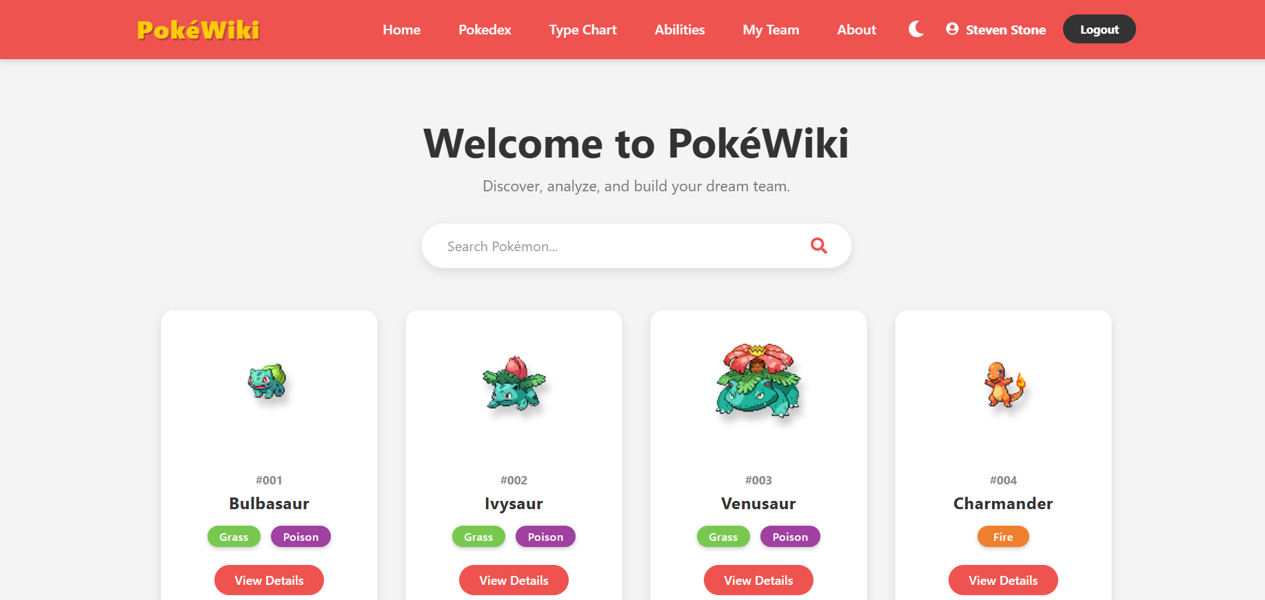

Dark Mode
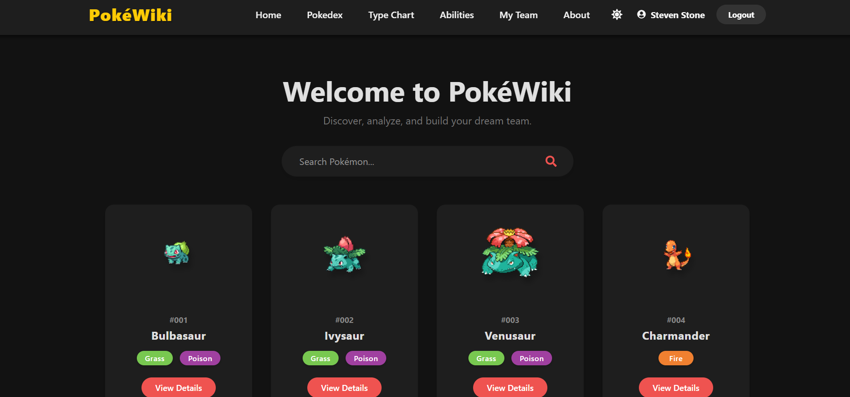
Fig 6.1: Home Page
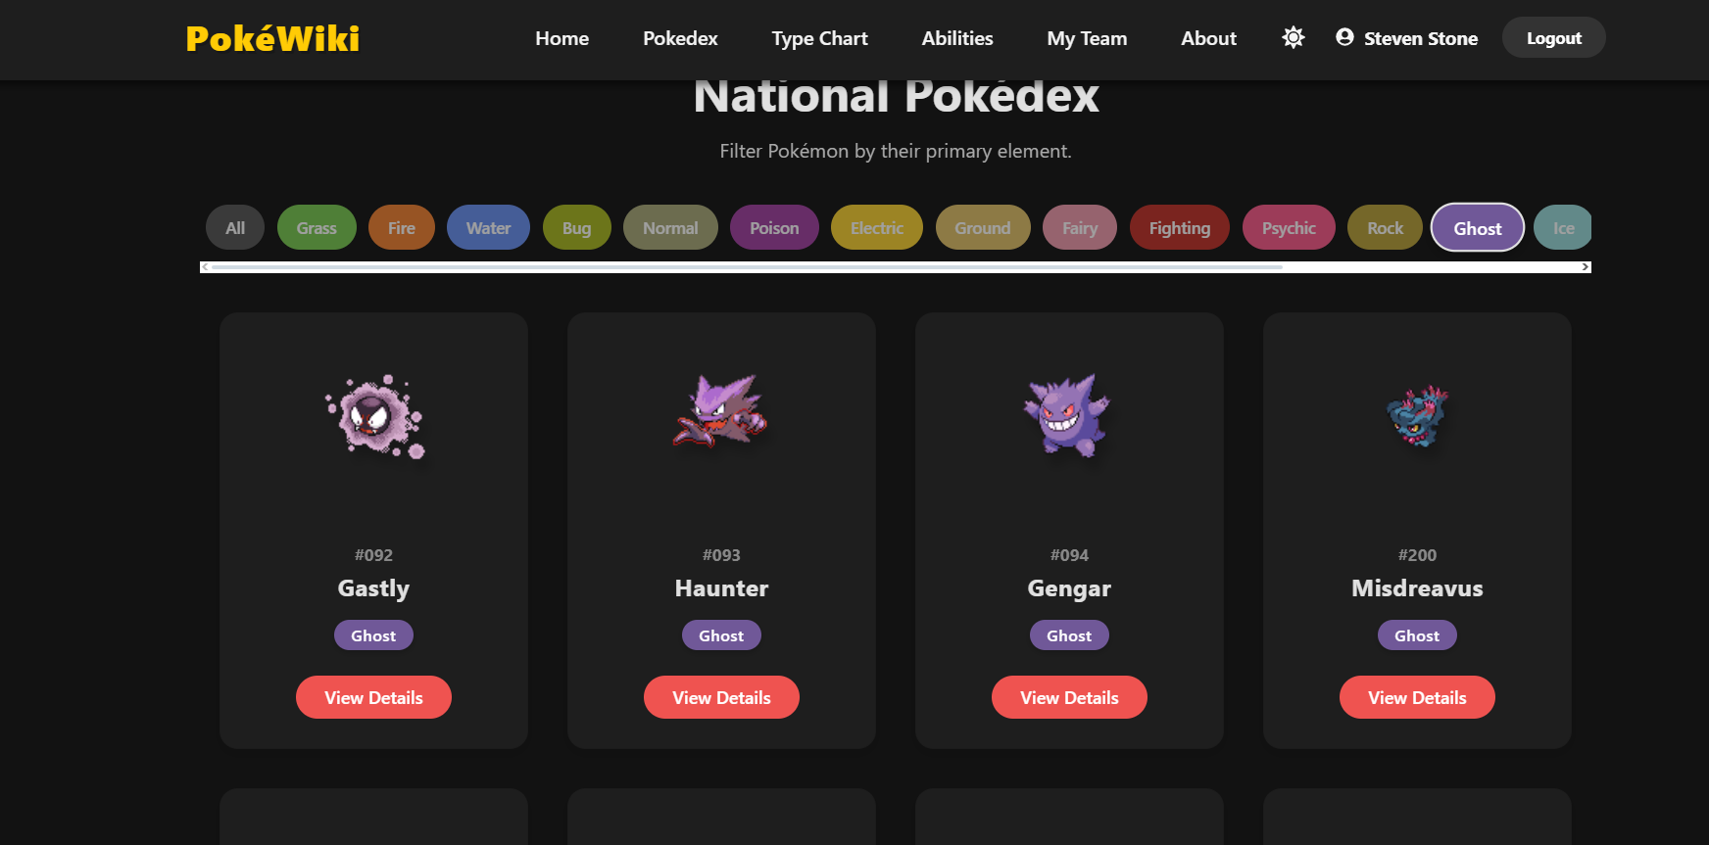
Fig 6.2: Pokedex Interface
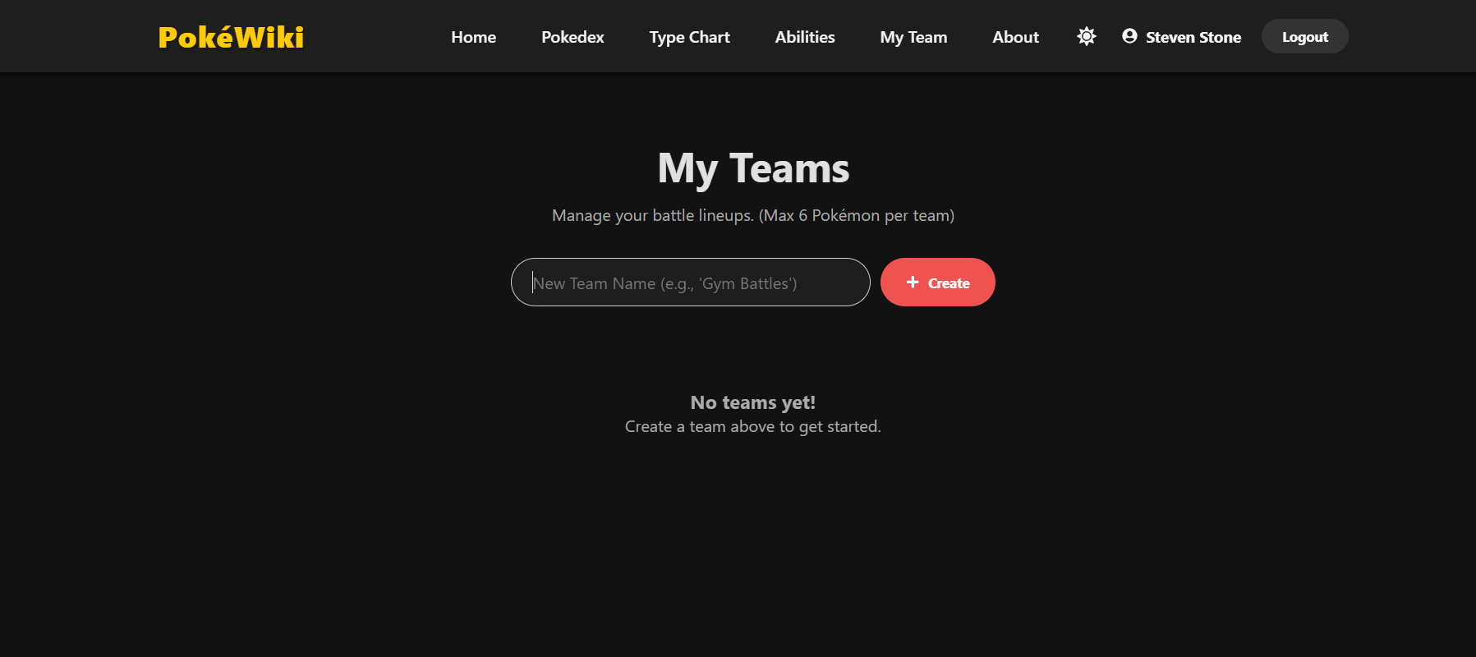
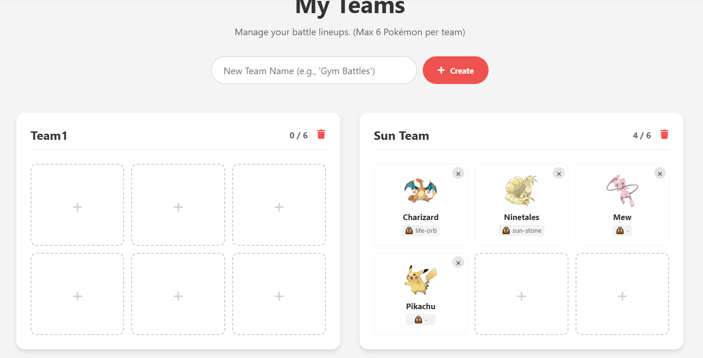
Fig 6.3: Team Management Dashboard
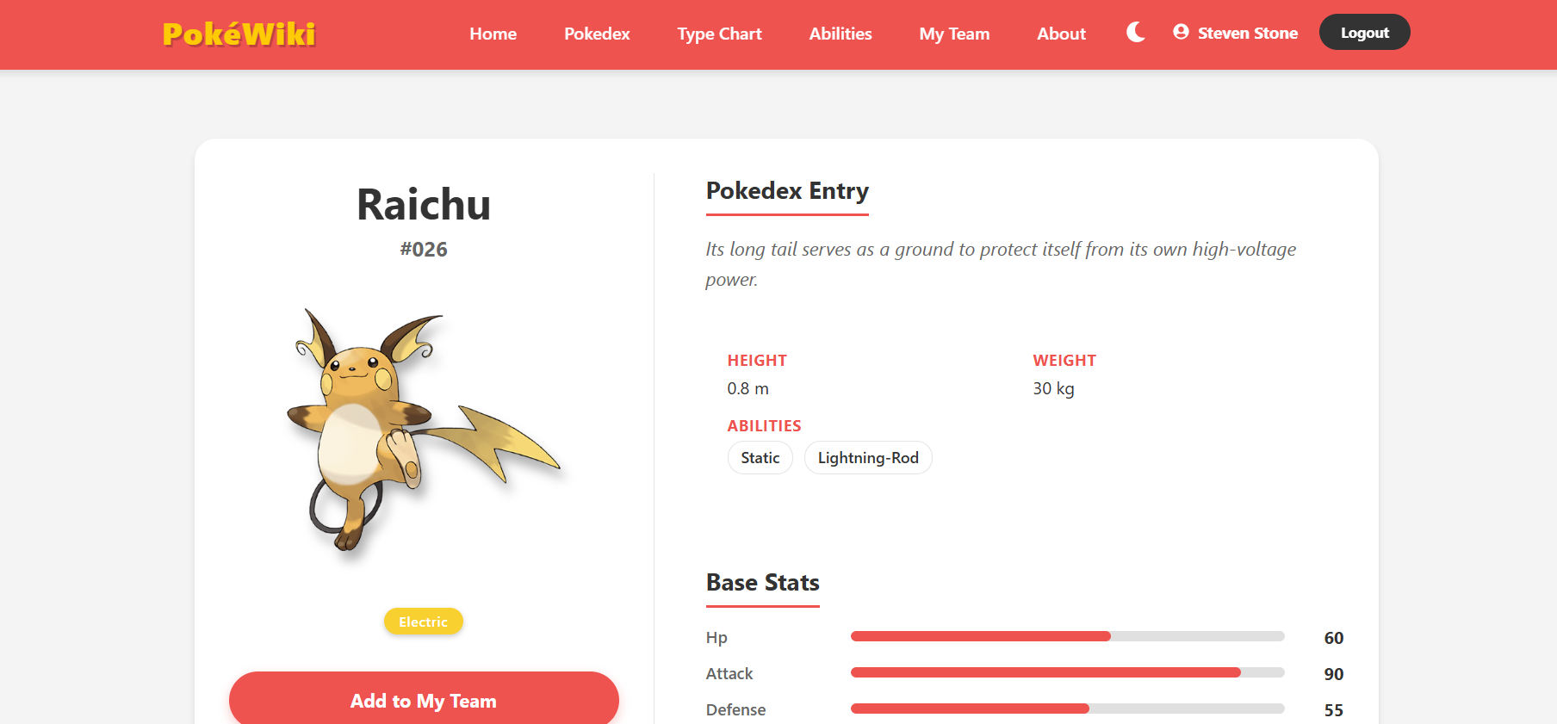
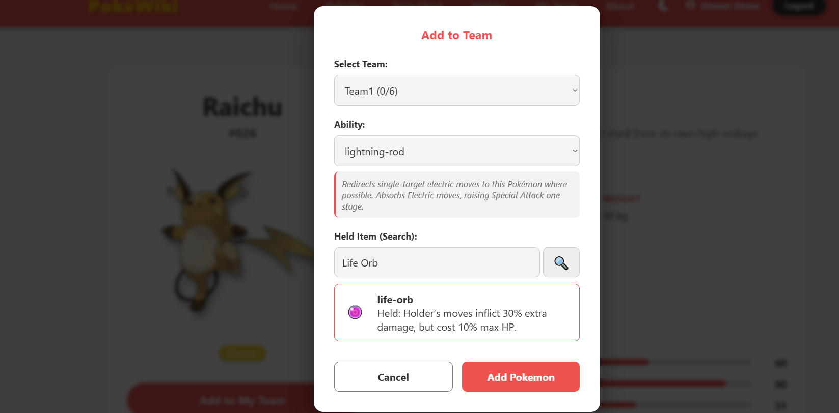
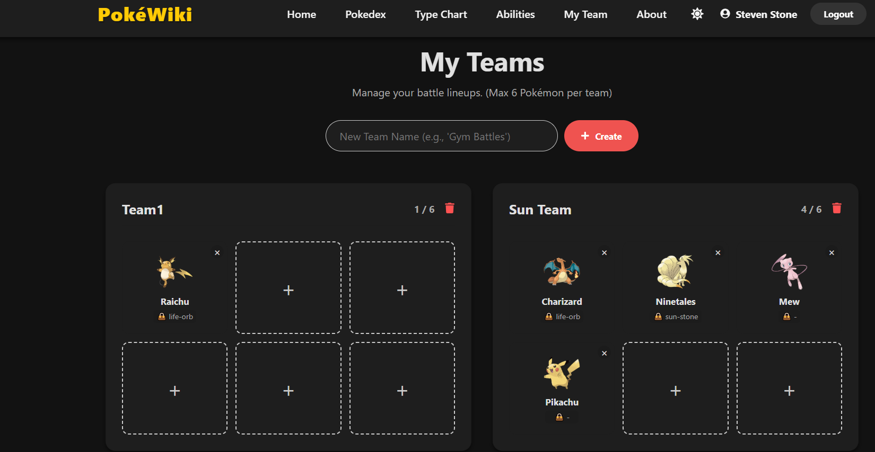
Fig 6.4: Selection Modal
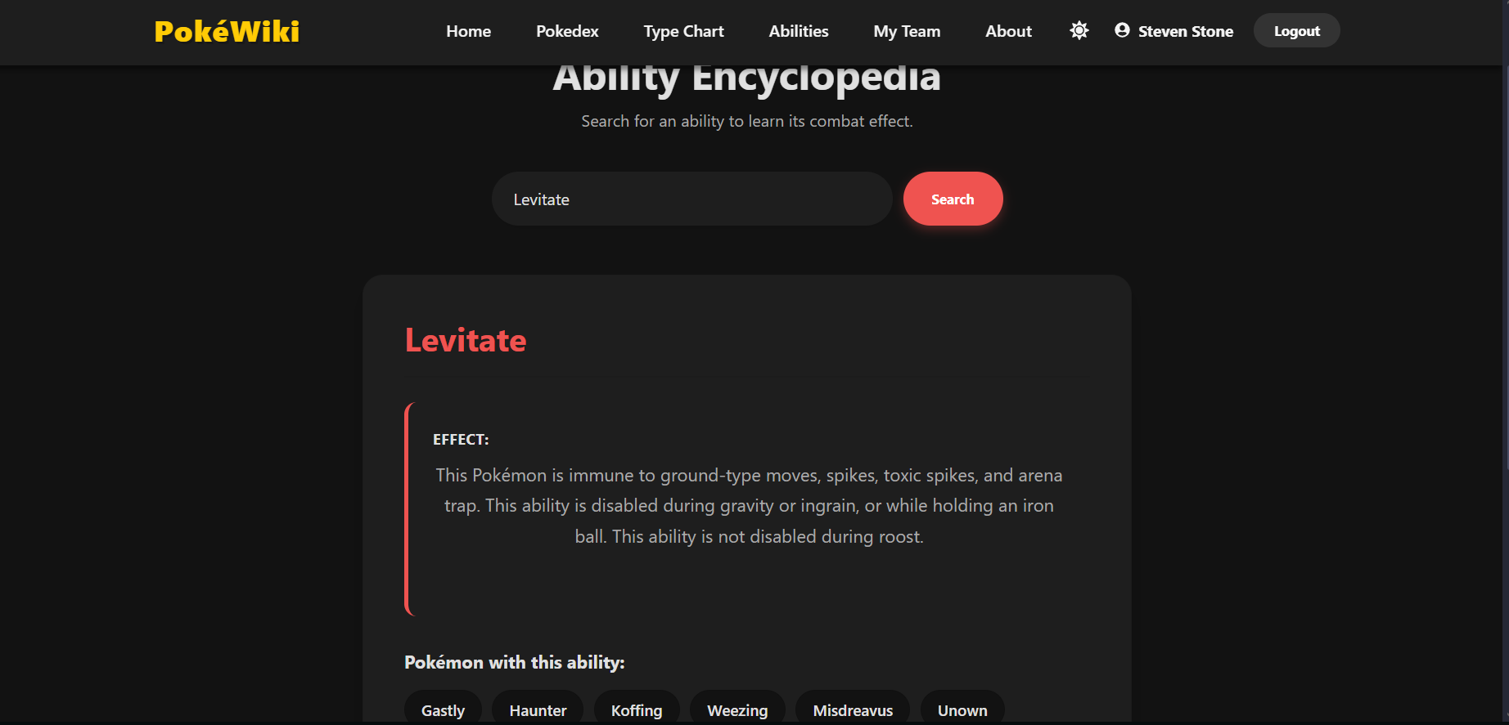
Fig 6.s: Abilities Page
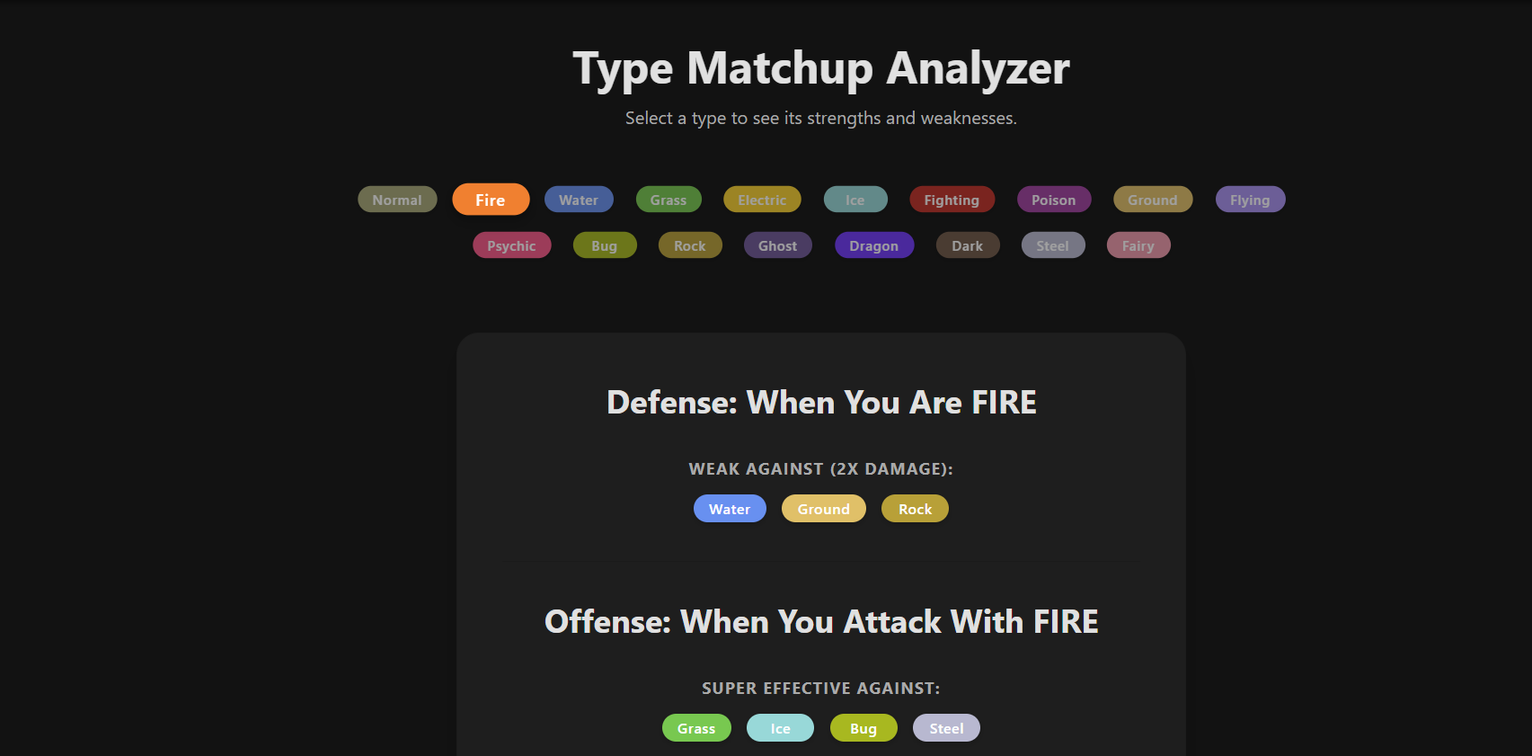
Fig 6.4: Type Chart Page

CHAPTER 7: CONCLUSION & FUTURE SCOPE

7.1 Conclusion
The "PokéWiki" project successfully demonstrates the power of the MERN stack in building dynamic, data-driven applications. We achieved all primary objectives: secure authentication, database persistence, and a responsive frontend. The application solves the problem of scattered Pokémon data by unifying the Pokedex and Team Builder into one cohesive interface. The use of React Hooks and Context API ensured that the application remains fast and the code remains maintainable.

7.2 Limitations
- Currently, the app relies on the external PokéAPI, so it requires an active internet connection.
- There is no "Battle Simulator" logic implemented yet; it is purely for team planning.

7.3 Future Scope
- Battle Simulator: Implementing the logic to allow two teams to battle using their stats and moves.
- Public Sharing: Allowing users to generate a "Share Link" so others can view their teams.
- Move Sets: Expanding the database to include detailed Move data (Damage, Accuracy) for every Pokémon.
- Social Features: Adding comments or "Likes" to popular team builds.

REFERENCES
- React Documentation: https://react.dev/
- PokéAPI Documentation: https://pokeapi.co/
- MongoDB Manual: https://www.mongodb.com/docs/
- Express.js Routing Guide: https://expressjs.com/en/guide/routing.html
- Node.js API: https://nodejs.org/api/

