 ***Comsats University Islamabad,***

***Vehari Campus***

(Assignment #2)

**subject** :

Mobile Application Developement

**Submitted by :**

Muhammad Mudsar

**Submitted to :**

Sir, Muhammad Abdullah

**Reg no :**

(FA19-BCS-047)

**Date:**

(18-03-2022)

## Counter Dice Code:

import 'package:flutter/material.dart';  
import 'dart:math';  
  
void main() {  
 runApp(MaterialApp(  
 debugShowCheckedModeBanner: false,  
 home: Scaffold(  
 backgroundColor: Colors.*green*,  
 appBar: AppBar(  
 title: Text(  
 " Let's play The Game ",  
 style: TextStyle(  
 color: Colors.*yellow*,  
 fontWeight: FontWeight.*bold*,  
 ),  
 ),  
 backgroundColor: Colors.*purpleAccent*,  
 ),  
 body: DicePage(),  
 ),  
 ));  
}  
  
class DicePage extends StatefulWidget {  
 @override  
 _DicePageState createState() => _DicePageState();  
}  
  
class _DicePageState extends State<DicePage> {  
 String rolled_dice_by = 'None';  
 int top_left = 1;  
 int top_right = 6;  
 int bottom_left = 6;  
 int bottom_right = 1;  
 var t1 = 0;  
 var t2 = 0;  
 var t3 = 0;  
 var t4 = 0;  
 var wi=30;  
 var temp = 0;  
 var temp2=0;  
  
 int checkmefirst(){  
 setState(( ) {  
 if(t1==wi)  
 {  
 temp=1;}  
 else if(t2==wi)  
 {  
 temp=2;}  
 else if(t3==wi)  
 {  
 temp=3;}  
 else if(t4==wi)  
 {  
 temp=4;}  
 else  
 {  
 temp=0;}  
 return temp;  
 });  
 }  
  
  
  
  
 Expanded left() {  
 return Expanded(  
 child: TextButton(  
 onPressed: () {  
 setState(() {  
 rolled_dice_by = '';  
 rolled_dice_by = 'Palyer 1';  
 top_left = Random().nextInt(5) + 1;  
 t1 = t1 + top_left;  
 });  
 },  
 child: Image.asset(  
 'images/dice$top_left.png',  
 height: 100,  
 width: 100,  
 color: Colors.*black*,  
 ),  
 ),  
 );  
 }  
  
 Expanded right() {  
 return Expanded(  
 child: TextButton(  
 onPressed: () {  
 setState(() {  
 rolled_dice_by = '';  
 rolled_dice_by = 'Player 2';  
 top_right = Random().nextInt(5) + 1;  
 t2 = t2 + top_right;  
 });  
 },  
 child: Image.asset(  
 'images/dice$top_right.png',  
 height: 100,  
 width: 100,  
 color: Colors.*redAccent*,  
 ),  
 ),  
 );  
 }  
  
 Expanded upper() {  
 return Expanded(  
 child: TextButton(  
 onPressed: () {  
 setState(() {  
 rolled_dice_by = '';  
 rolled_dice_by = 'Player 3';  
 bottom_left = Random().nextInt(5) + 1;  
 t3 = t3 + bottom_left;  
 });  
 },  
 child: Image.asset(  
 'images/dice$bottom_left.png',  
 color: Colors.*redAccent*,  
 height: 100,  
 width: 100,  
 ),  
 ),  
 );  
 }  
  
 Expanded lower() {  
 return Expanded(  
 child: TextButton(  
 onPressed: () {  
 setState(() {  
 rolled_dice_by = '';  
 rolled_dice_by = 'Player 4';  
 bottom_right = Random().nextInt(5) + 1;  
 t4 = t4 + bottom_right;  
 checkmefirst();  
 });  
 },  
 child: Image.asset(  
 'images/dice$bottom_right.png',  
 height: 100,  
 width: 100,  
 color: Colors.*black*,  
 ),  
 ),  
 );  
 }  
  
 Container top_dices() {  
 return Container(  
 child: Row(  
 children: [  
 left(),  
 right(),  
  
 ],  
 ),  
 );  
 }  
  
 Container bottom_dices() {  
 return Container(  
 child: Row(  
 children: [  
 upper(),  
 lower(),  
 ],  
 ),  
 );  
 }  
  
 @override  
 Widget build(BuildContext context) {  
 return Column(  
 children: [  
 Container(  
 child: Column(  
 crossAxisAlignment: CrossAxisAlignment.stretch,  
 children: [  
 Padding(  
 padding: EdgeInsets.fromLTRB(10.0, 30.0, 10.0, 10.0),  
 child: Column(  
 crossAxisAlignment: CrossAxisAlignment.center,  
 children: [  
 Text(  
 'Dice Rolled By: $rolled_dice_by'.toString(),  
 style: TextStyle(  
 color: Colors.*red*.shade500,  
 fontSize: 25,  
 fontWeight: FontWeight.*bold*,  
 ),  
 ),  
 SizedBox(  
 height: 20.0,  
 ),  
 Text(  
 'Score is: ' +  
 (top_left + top_right + bottom_left + bottom_right)  
 .toString(),  
 style: TextStyle(  
 color: Colors.*green*.shade500,  
 fontSize: 25,  
 fontWeight: FontWeight.*bold*,  
 ),  
 ),  
 ],  
 ),  
 )  
 ],  
 ),  
 ),  
 SizedBox(  
 height: 90.0,  
 ),  
 top_dices(),  
 SizedBox(  
 height: 60.0,  
 ),  
 bottom_dices(), //x  
 Container(  
 child: Column(  
 crossAxisAlignment: CrossAxisAlignment.stretch,  
 children: [  
 Padding(  
 padding: EdgeInsets.fromLTRB(10.0, 30.0, 10.0, 10.0),  
 child: Column(  
 crossAxisAlignment: CrossAxisAlignment.center,  
 children: [  
 Text( 'Score is: ' +  
 (top_left + top_right + bottom_left + bottom_right)  
 .toString(),  
  
 style: TextStyle(  
 color: Colors.*red*.shade500,  
 fontSize: 25,  
 fontWeight: FontWeight.*bold*,  
 ),  
 ),  
 Text( 'Dice1 : $t1 \nDice2: $t2\nDice3: $t3\nDice4: $t4',maxLines: 15,  
 style: TextStyle(fontSize: 16.0 ,fontWeight:FontWeight.*bold*,color: Colors.*black*) ,  
 ),  
  
  
 SizedBox(  
 height: 10.0,  
  
  
 ),  
  
  
 Text(  
 'The Winner is player: $temp'.toString(),  
 style: TextStyle(  
 color: Colors.*cyanAccent*,  
 fontSize: 25,  
 fontWeight: FontWeight.*bold*,  
 ),  
 ),  
 ElevatedButton(  
 style: ButtonStyle(  
 shape: MaterialStateProperty.*all*<RoundedRectangleBorder>(  
 RoundedRectangleBorder(  
 borderRadius: BorderRadius.circular(20.0),  
 side: BorderSide(  
 color: Colors.*amberAccent*,  
 width: 2.0,  
 ),  
 ),  
 ),  
 ),  
 child: Text('See winner'),  
  
 onPressed: () {  
 checkmefirst();  
 },  
 ),  
 ],  
 ),  
 )  
 ],  
 ),  
 ),  
  
 ],  
 );  
 }  
}

# ScreenShot:

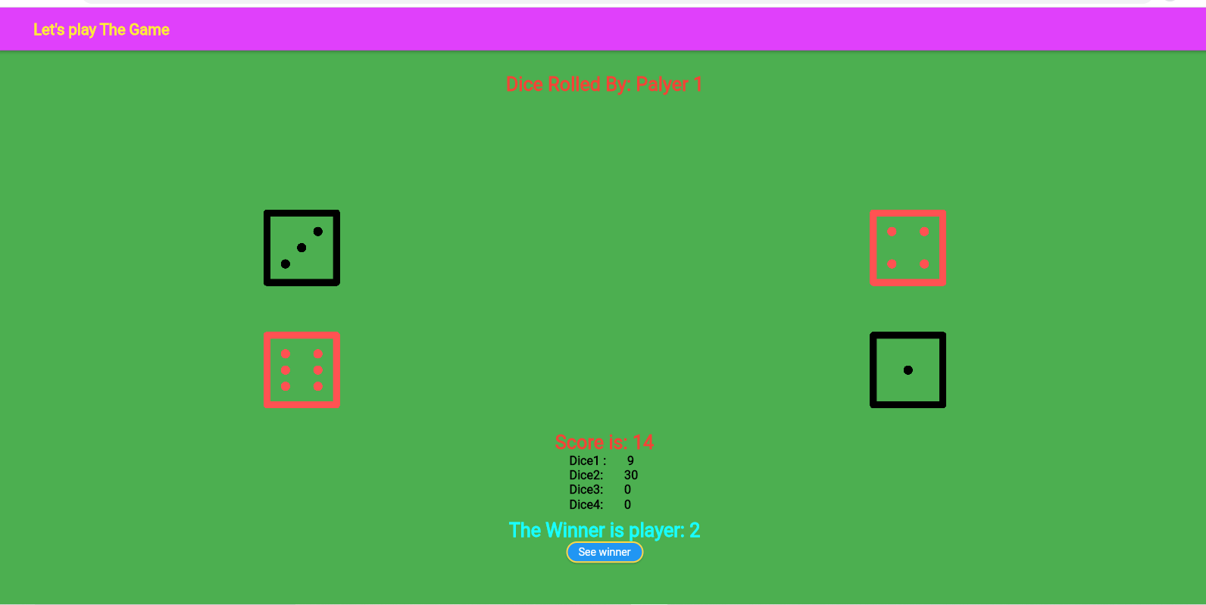

# Pubspect.Yaml:

name: assignsat  
description: A new Flutter project.  
  
*# The following line prevents the package from being accidentally published to  
# pub.dev using `flutter pub publish`. This is preferred for private packages.*publish_to: 'none' *# Remove this line if you wish to publish to pub.dev  
  
# The following defines the version and build number for your application.  
# A version number is three numbers separated by dots, like 1.2.43  
# followed by an optional build number separated by a +.  
# Both the version and the builder number may be overridden in flutter  
# build by specifying --build-name and --build-number, respectively.  
# In Android, build-name is used as versionName while build-number used as versionCode.  
# Read more about Android versioning at https://developer.android.com/studio/publish/versioning  
# In iOS, build-name is used as CFBundleShortVersionString while build-number used as CFBundleVersion.  
# Read more about iOS versioning at  
# https://developer.apple.com/library/archive/documentation/General/Reference/InfoPlistKeyReference/Articles/CoreFoundationKeys.html*version: 1.0.0+1  
environment:  
 sdk: ">=2.7.0 <3.0.0"  
  
dependencies:  
 flutter:  
 sdk: flutter  
  
  
 *# The following adds the Cupertino Icons font to your application.  
 # Use with the CupertinoIcons class for iOS style icons.* cupertino_icons: ^1.0.0  
  
dev_dependencies:  
 flutter_test:  
 sdk: flutter  
  
*# For information on the generic Dart part of this file, see the  
# following page: https://dart.dev/tools/pub/pubspec  
  
# The following section is specific to Flutter.*flutter:  
  
 *# The following line ensures that the Material Icons font is  
 # included with your application, so that you can use the icons in  
 # the material Icons class.* uses-material-design: true  
  
 *# To add assets to your application, add an assets section, like this:* assets:  
 - images/  
  
  
 *# An image asset can refer to one or more resolution-specific "variants", see  
 # https://flutter.dev/assets-and-images/#resolution-aware.  
  
 # For details regarding adding assets from package dependencies, see  
 # https://flutter.dev/assets-and-images/#from-packages  
  
 # To add custom fonts to your application, add a fonts section here,  
 # in this "flutter" section. Each entry in this list should have a  
 # "family" key with the font family name, and a "fonts" key with a  
 # list giving the asset and other descriptors for the font. For  
 # example:  
 # fonts:  
 # - family: Schyler  
 # fonts:  
 # - asset: fonts/Schyler-Regular.ttf  
 # - asset: fonts/Schyler-Italic.ttf  
 # style: italic  
 # - family: Trajan Pro  
 # fonts:  
 # - asset: fonts/TrajanPro.ttf  
 # - asset: fonts/TrajanPro_Bold.ttf  
 # weight: 700  
 #  
 # For details regarding fonts from package dependencies,  
 # see https://flutter.dev/custom-fonts/#from-packages*