Project 1: Enterprise Agentic RAG Platform
A production-grade agentic RAG system with multi-step LLM reasoning, hybrid retrieval (vector + knowledge graph), self-hosted 70B inference on autoscaling GPU infrastructure, and full IaC on AWS EKS.

Impact at a Glance
Metric | Value
LLM scale | Llama-3-70B (AWQ 4-bit) served via vLLM on Ray Serve
Retrieval | Hybrid: Qdrant (vector) + Neo4j (graph) merged via asyncio.gather
Cost reduction | ~70% via Spot GPU instances + scale-to-zero
Idle cost | $0 — Ray autoscaler + Karpenter scale to zero when no traffic
Cache hit latency | ~40ms (semantic cache, 0.95 threshold)
Full pipeline | 7 stages: LB → Ingress → JWT → Cache → LangGraph → Stream → Persist
Estimated monthly cost | $1.1K – $2.9K (production, traffic-variable)
Infra | Terraform (VPC, EKS, Aurora, ElastiCache, S3) + Karpenter + Helm
Observability | OpenTelemetry + Prometheus + structured JSON logs
Evaluation | RAGAS + LLM-as-judge + Locust load testing

1. Product Overview

What It Is
An AI document-intelligence platform that lets enterprise users query large document corpora (PDF, DOCX, HTML) and receive accurate, cited, streaming answers in real time.

What Makes It Different
Most RAG systems are a single embedding lookup + LLM call. This platform is a multi-node agentic pipeline with hybrid retrieval, self-hosted inference, and elastic GPU infrastructure.
Dimension | Standard RAG | This Platform
Retrieval | Vector-only | Hybrid: Vector (Qdrant) + Graph (Neo4j)
Orchestration | Linear chain | LangGraph state machine (planner → retriever → responder)
Inference | External API (OpenAI) | Self-hosted Llama-3-70B via vLLM on Ray Serve
Query processing | Raw query | Query rewriting + HyDE + coreference resolution
Caching | Exact-match | Semantic cache (0.95 cosine threshold)
Scaling | Static servers | Scale-to-zero with Karpenter + Ray Autoscaler
Ingestion | Manual / sync | Async Ray Data pipeline triggered by S3 events
Code execution | None | Sandboxed Python interpreter (no network, 512MB, 10s)

Target Users
- Enterprise teams querying internal docs (finance, legal, engineering)
- AI engineers building RAG systems on Kubernetes
- Platform teams needing a reference architecture for agentic AI on AWS

2. Tech Stack

Core Application
Layer | Technology | Purpose
API Framework | FastAPI 0.109 | Async HTTP + streaming (NDJSON)
Validation | Pydantic 2.6 | Request/response schemas
Agent Orchestration | LangGraph 0.0.21 | State machine for multi-step reasoning
Auth | python-jose 3.3 | JWT (HS256) bearer validation
ORM | SQLAlchemy 2.0 + asyncpg | Async Postgres access
Logging | Structured JSON | Machine-readable, trace-correlated

AI / ML
Layer | Technology | Purpose
LLM Inference | vLLM 0.3.0 | High-throughput serving (PagedAttention)
Base Model | Meta-Llama-3-70B-Instruct | Instruction-tuned 70B
Quantization | AWQ 4-bit | Fits 70B on 1 × A10G GPU
Embeddings | BGE-M3 (BAAI) | Multilingual dense + sparse
Reranker | BGE-Reranker-v2-m3 | Cross-encoder re-ranking
Token Counting | tiktoken 0.5 | Context-window management
Query Enhancement | HyDE + coreference | LLM-driven query rewriting

Data / Storage
Layer | Technology | Purpose
Vector DB | Qdrant 1.7.3 | Semantic search + cache
Knowledge Graph | Neo4j 5.16 | Entity/relationship storage
Relational | Aurora PostgreSQL Serverless v2 | Chat history, audit trails
Cache / Rate Limit | ElastiCache Redis 7 | Token bucket + health
Object Storage | AWS S3 | Documents with versioning
Local Mock | MinIO | Offline dev without AWS

Infra & DevOps
Layer | Technology | Purpose
IaC | Terraform 1.5+ | VPC, EKS, RDS, ElastiCache, S3
Orchestration | Kubernetes (EKS 1.29) | Workload scheduling
Autoscaler | Karpenter | Just-in-time EC2 provisioning
Package Mgmt | Helm 3.x | Qdrant, Neo4j, API deployment
Ingress | Nginx / Kong | TLS + rate limiting (Lua)
Secrets | External Secrets Operator | AWS Secrets Manager → K8s
Container | Docker | Build

Observability
Layer | Technology | Purpose
Tracing | OpenTelemetry 1.22 | Distributed request tracing
Metrics | Prometheus Client 0.19 | Counters + histograms
Health | /health/liveness + /health/readiness | K8s probes
Load Test | Locust | Streaming load testing

3. System Architecture

3.1 High-Level Architecture

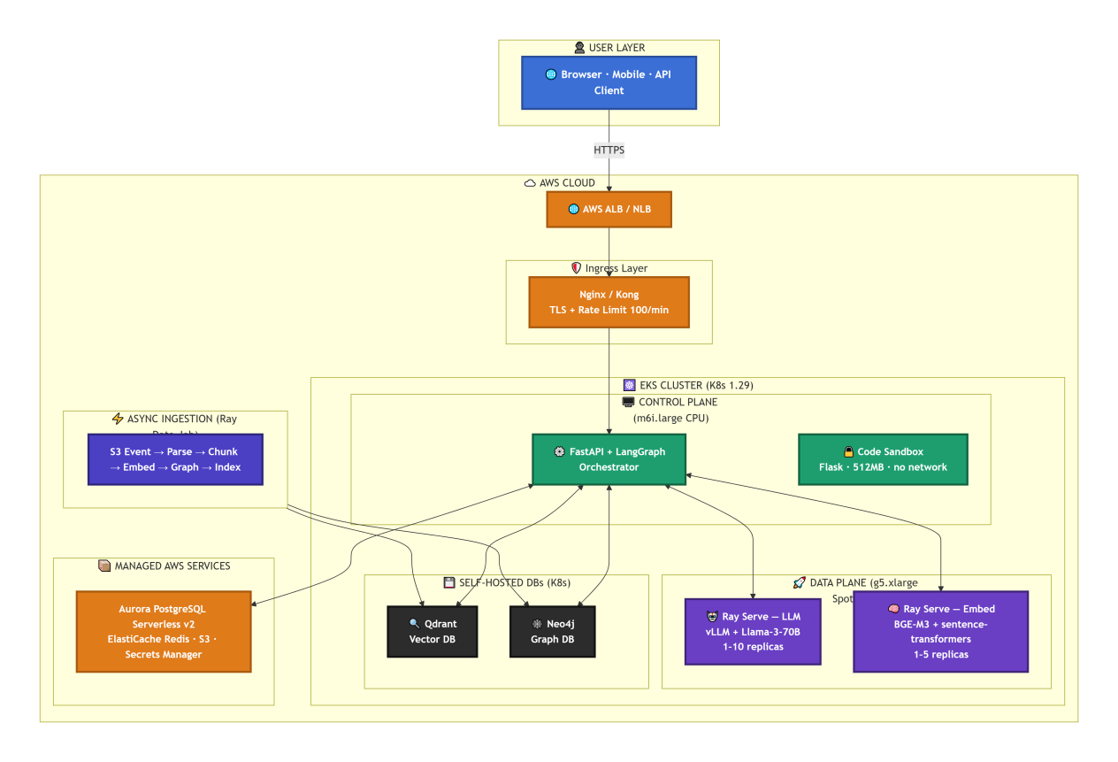

3.2 Control Plane vs Data Plane
Plane | Runs On | Handles | Scaling
Control | CPU nodes (m6i.large) | HTTP, auth, agent orchestration, business logic | Karpenter: 2–5 nodes
Data | GPU nodes (g5.xlarge Spot) | LLM inference, embedding, graph extraction | Ray Autoscaler: 0–20 nodes
Why this separation matters: CPU work never competes with GPU work for resources. Cost scales with actual AI usage, not with request count.

4. Request Flow (7-Step Pipeline)

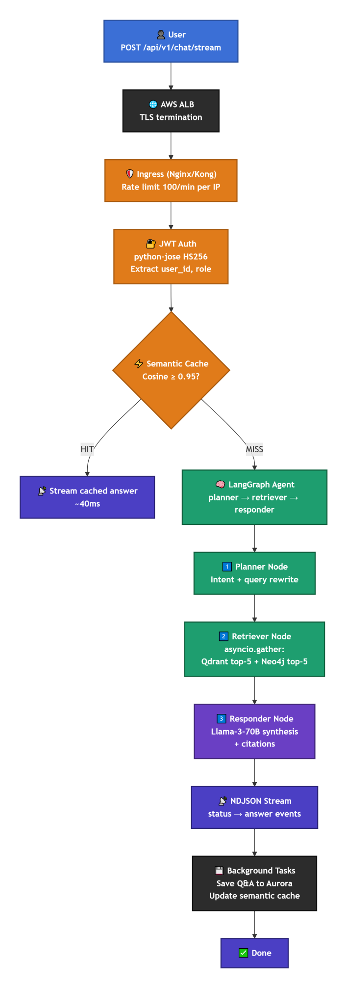

NDJSON Streaming Format
{"type": "status", "node": "planner", "session_id": "abc-123", "info": "Completed step: planner"}
{"type": "status", "node": "retriever", "session_id": "abc-123", "info": "Completed step: retriever"}
{"type": "answer", "content": "Based on the Q3 report, the financial risks include...", "session_id": "abc-123"}

Why NDJSON over SSE: Explicit event typing lets the frontend render per-node progress without parsing freeform text.

5. Agent System (LangGraph State Machine)

5.1 State Definition
class AgentState(TypedDict):
messages: Annotated[List[dict], operator.add] # Append-only history
documents: List[str] # Retrieved context
current_query: str # Refined query
plan: List[str] # Planner scratchpad

5.2 Graph Topology

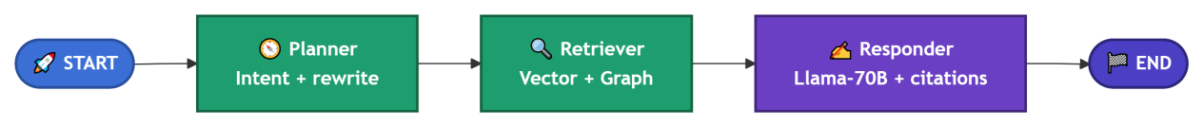

5.3 Node Specs
Node | Purpose | Key Config
Planner | Intent classify + query rewrite | Temp 0.0, JSON output, fallback to retrieve on parse failure
Retriever | Hybrid retrieval | asyncio.gather: Qdrant top-5 + Neo4j top-5, dedupe, graph prioritized for facts
Responder | Answer synthesis | Temp 0.3, cites sources, returns "I don't know" when context insufficient

6. Data Ingestion Pipeline

6.1 Trigger
S3 Event → Lambda/SQS → Ray Job Submission

6.2 Pipeline 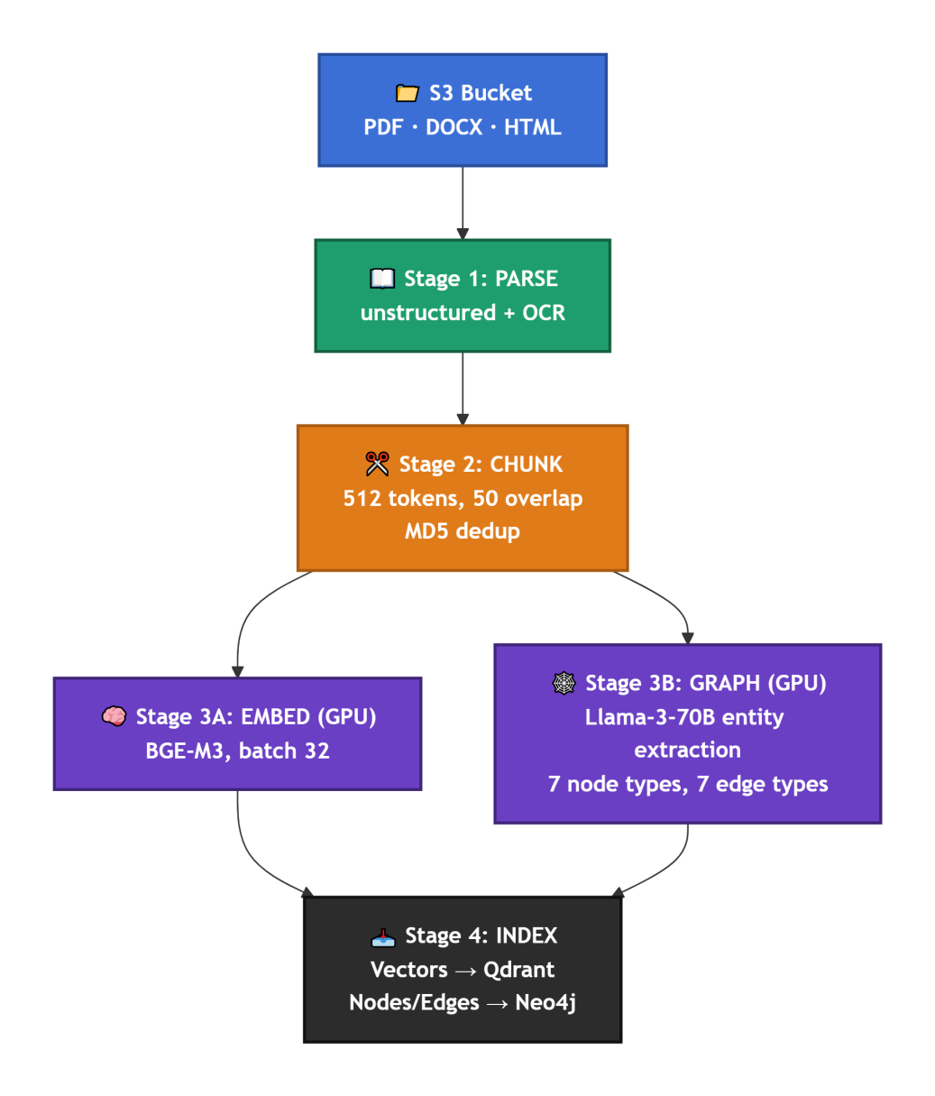

6.3 Knowledge Graph Schema
Type | Values
Node labels | Person, Organization, Location, Concept, Document, Event, Product
Edge types | WORKS_FOR, LOCATED_IN, RELATES_TO, MENTIONS, PART_OF, CREATED_BY, HAS_FEATURE
Why a knowledge graph on top of vectors: Vectors answer "what's similar?" Graphs answer "what's connected?" — critical for factual multi-hop questions.

Semantic Cache

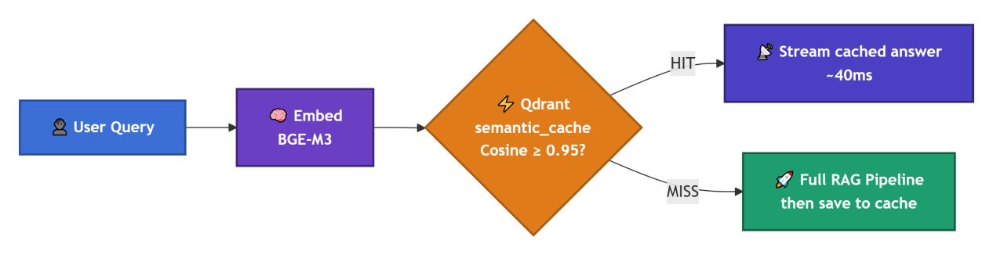

Impact: Every cache hit saves a full GPU inference call. At high traffic, this is the difference between a $5K/month GPU bill and a $1.5K/month one.

8. Infrastructure (Terraform)

8.1 VPC — 10.0.0.0/16
Tier | CIDRs | Purpose
Public | 10.0.1-3.0/24 | ALB, NAT Gateways
Private | 10.0.101-103.0/24 | EKS nodes
Database | 10.0.201-203.0/24 | Aurora, Redis

8.2 Managed Services
Service | Config
EKS | v1.29, m6i.large system nodes (2–5), OIDC/IRSA enabled
Aurora PostgreSQL | Serverless v2, 2 instances, 2–64 ACU auto-scaling
ElastiCache Redis | cache.t4g.medium, 2 replicas, at-rest + transit encryption
S3 | Versioning, Transfer Acceleration, Intelligent Tiering

9. Kubernetes Deployment

9.1 Karpenter Provisioners
Provisioner | Instances | Limit | TTL
CPU | m6i, c6i, r6i (Spot) | 1000 CPU | —
GPU | g5, p4d (Spot + OD) | 100 GPUs | 30s after empty

9.2 Ray Cluster
Component | Config
Head | 2 CPU, no tasks
CPU workers | 1–50 nodes, 8 CPU / 32GB
GPU workers | 0–20 nodes, 1 GPU

9.3 Ray Serve
Service | Model | Replicas | GPU
LLM | Llama-3-70B (AWQ) | 1–10 | 1 × A10G
Embed | BGE-M3 | 1–5 | 0.5 GPU

9.4 Helm
Qdrant (3 replicas, 50Gi) · Neo4j (1 server, 100Gi) · API service

10. Security Model
Layer | Mechanism
Auth | JWT HS256 (python-jose), Bearer token validation
Network | VPC private subnets, Security Groups (VPC CIDR only)
K8s | NetworkPolicy (sandbox: deny all egress)
IAM | IRSA: pod-level roles (ingestion → S3, API → no S3)
Secrets | External Secrets Operator → AWS Secrets Manager (1h refresh)
Sandbox | Non-root (UID 1000), 10s timeout, 512MB RAM, no network

11. Observability
Component | Tech | Purpose
Tracing | OpenTelemetry 1.22 | Distributed request tracing
Metrics | Prometheus | chat_requests, llm_latency, cache_hits
Logs | JSON structured | Machine-readable, trace-correlated
Health | /health/liveness, /health/readiness | K8s probes

12. Performance & Cost

12.1 Cost-Reduction Strategies
Strategy | Savings
Spot GPU instances | ~70%
Scale-to-zero (Ray + Karpenter) | 100% when idle
Semantic cache | Reduces GPU inference calls
AWQ 4-bit quantization | Fits 70B on 1 × A10G
Aurora Serverless v2 | Pay per ACU
Graviton Redis | ~20% cheaper

12.2 Estimated Monthly Cost
$1,100 – $2,900 (production, traffic-variable)

13. Evaluation
Method | Metrics
RAGAS | Faithfulness, Answer Relevancy, Context Precision, Context Recall
LLM Judge | 1–5 scoring with reasoning
Locust | Streaming load test: P50 / P95 / P99 latency
Golden Dataset | 20 Kubernetes QA pairs with ground truth

Project 2: AI Resume & Career Builder SaaS
Status: Live / Production
Live Demo: https://www.gethirevault.com/
Tagline: 8 AI career tools in one platform — ATS-optimized resumes, cover letters, voice mock interviews, skills-gap analysis, job match, and career-path planning.

One-Line Summary
A production SaaS that takes a job seeker from raw resume + target JD to a 90%+ ATS-covered resume, tailored cover letter, scored voice mock interview, skill-gap roadmap, and ranked job matches — with a freemium subscription model.

Impact at a Glance
- 90%+ ATS keyword coverage on tailored resumes
- Two explainable scores — ats_parse_score (bot coverage) + recruiter_fit_score (gated human fit
- Voice + text mock interviews with per-answer 0–10 scoring and continuation guard
- Live-validated learning resources per missing skill (4-tier cascade)
- Deterministic scoring — LLMs extract/match/judge; score math is pure code with a golden-set regression suite

Tech Stack
Layer | Technology
Framework | Next.js 15 (App Router), TypeScript 5, React 18
Styling | Tailwind CSS 3, Framer Motion 11
Auth | Clerk (edge middleware, route protection)
Database | Supabase PostgreSQL
ORM | Drizzle ORM + drizzle-kit
AI Provider | DeepInfra (OpenAI-compatible) — DeepSeek-V4-Pro/Flash, Qwen2.5-72B, Claude Sonnet, Gemini Flash
AI Orchestration | LangChain/LangGraph-pattern node graph (extractor → matcher → scorer → gate → critic)
Search / Enrichment | TinyFish Search + Fetch API · Arbeitnow job API
Embeddings / Matching | Vector similarity + exact/fuzzy + LLM judge (hybrid matcher)
Caching | Upstash Redis (learning-resource TTL 7d, parse cache in Postgres)
Rate Limiting | Upstash sliding-window (per-feature + shared ai ceiling)
Speech | Deepgram STT (nova-3 WebSocket) · Browser SpeechSynthesis TTS
PDF / DOCX | @react-pdf/renderer · docx
Email | AWS SES
Billing | Creem
Testing | Vitest (unit + golden/live evals)
CI/CD | GitHub Actions

Problem → Solution

Real problem | What this app does
ATS rejects 75% of resumes before a human sees them | DeepInfra LLM injects JD keywords, expands acronyms, mirrors exact phrases, groups skills into scannable one-line categories
"Optimizing" for a JD silently strips real skills | JD-gated source-coverage reconcile (resumeReconcile.ts) restores dropped skills inventory only grows
Single opaque ATS score users can't trust | Two scores: ats_parse_score (literal bot coverage) + recruiter_fit_score (gated human fit), with explainable gates[]
No interview practice without a human | Voice + text mock interviewer streams questions, scores each answer 0–10, never self-ends early
"What skill am I missing?" has no actionable answer | 4-tier learning-resource cascade returns live-validated official docs/courses per missing skill
Career path is guesswork | Structured LLM progression plan with promotion/lateral/certification milestones and real learning links

App Flow

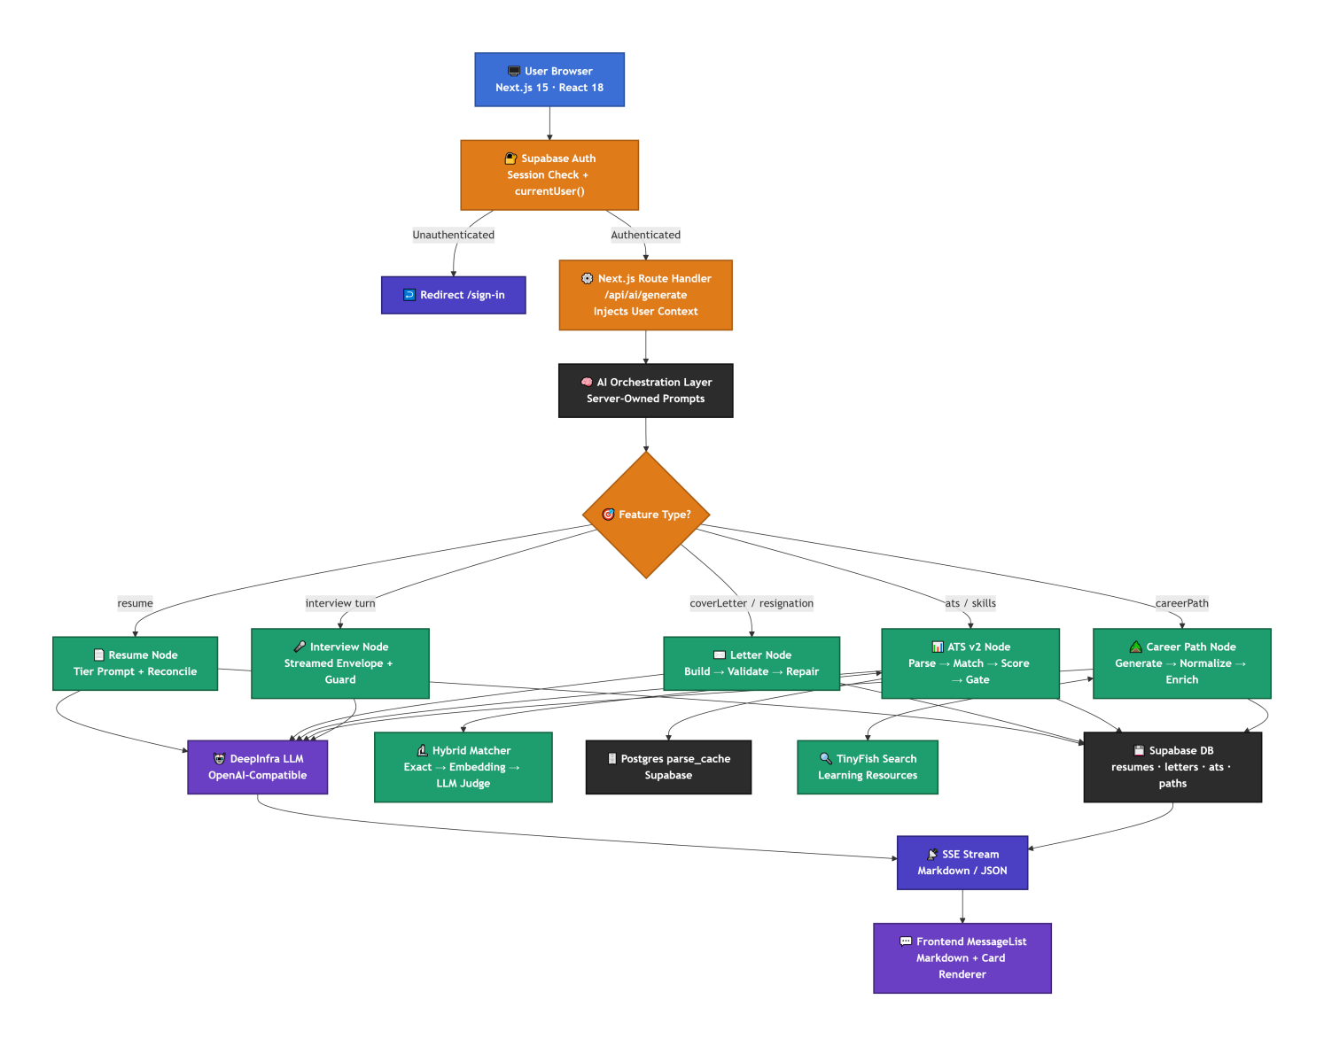

AI-Powered Interview Pipeline

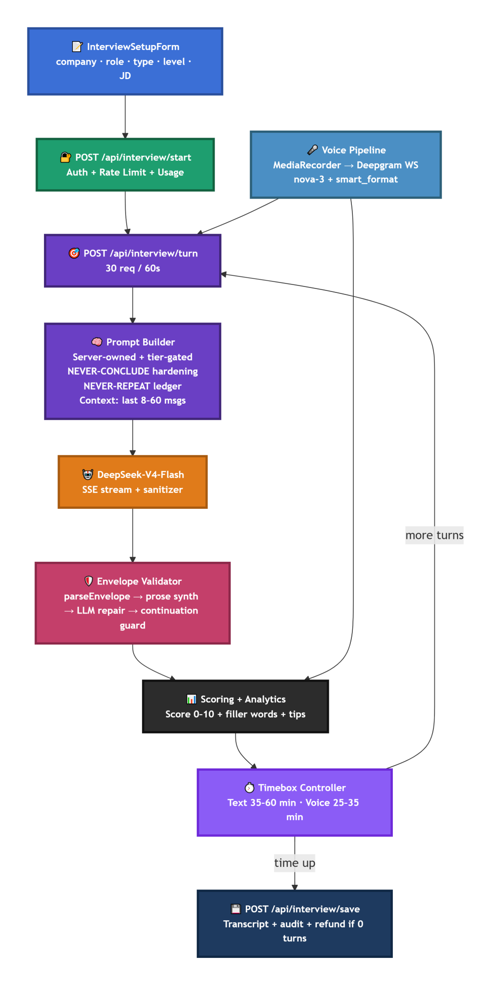

Key engineering decisions:

Decision | Rationale
Envelope contract + sanitizer | Model output is validated before it reaches the user no self-concluding, no repeating
Continuation guard | Forces a next question if the model tries to end early while time remains
Deterministic scoring extraction | Score 0–10 parsed from envelope or prose, never trusting the LLM's arithmetic
Filler-word detection (18-word list) | Objective feedback beyond the score
Timebox controller | Free/paid/voice modes each have their own minute budget; auto-end at limit

ATS Scoring Pipeline

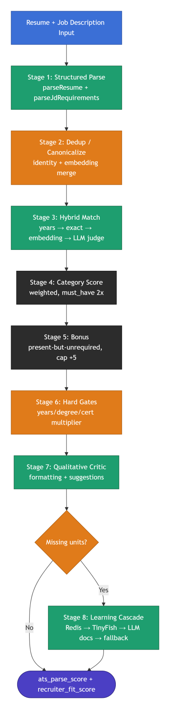

Resume Generation Pipeline

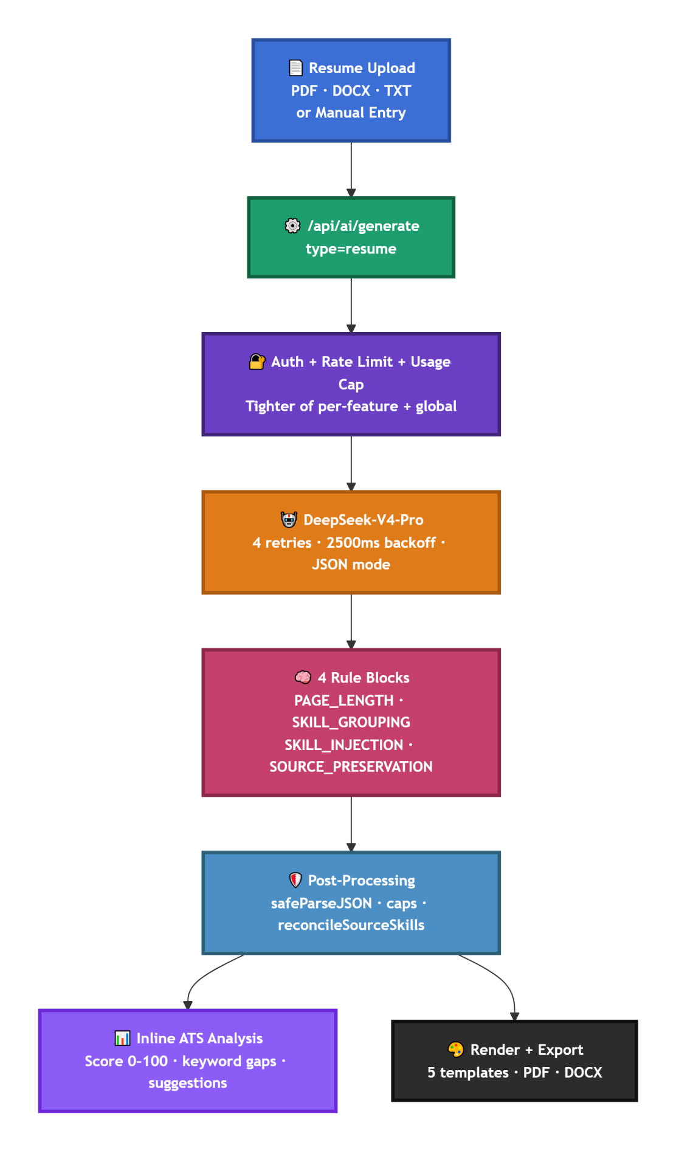

The 4 rule blocks (prompt engineering):
Rule Block | Purpose
PAGE_LENGTH_RULES | Experience-aware length caps (< 5y: 2 pages, 5–10y: 3 pages)
TECHNICAL_SKILLS_GROUPING | Context-aware categories, 3–6 groups, JD keywords first
SKILL_INJECTION_RULES | Deep JD extraction, acronym expansion, exact-phrase mirroring, ownership language
SOURCE_PRESERVATION_RULES | Candidate's original skills are the source of truth — optimizing only ADDS
The critical guardrail — reconcileSourceSkills: JD-gated source coverage restores any dropped skills into an "Additional Skills" group. Resume inventory only grows, never shrinks.

Request Sequence

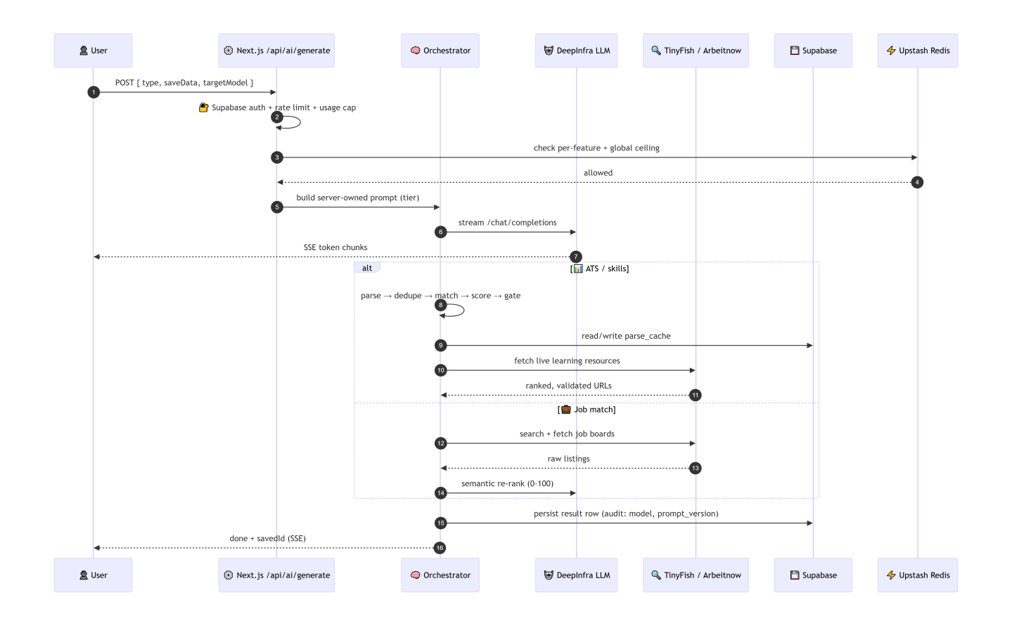

CI/CD Pipeline

Website url: https://www.gethirevault.com/

Project 3: TrueHorizon AI Travel Planner Agent

Summary
A conversational AI travel planner that collects trip requirements through guided chat (with rich UI cards), runs a LangGraph agent pipeline over live flights, hotels, and activities, and streams back a personalized day-by-day itinerary — persisted per user.

Impact at a Glance
- First token < 1.5s p50 — end-to-end SSE streaming from FastAPI → Next.js → browser
- Full itinerary < 30s p95 — multi-provider retrieval (SerpAPI + Tavily) + Bedrock Claude Sonnet streaming
- ≥ 90% session completion — conversational intake reaches "all fields collected" in one pass
- Authenticated edge proxy — Clerk session + server-injected X-User-Email (client never trusted)
- One-command local boot — docker-compose up runs frontend + backend together
- Green CI/CD — Ruff + ESLint gates every PR; backend image published to GHCR on merge

Tech Stack
Layer | Techology
Frontend | Next.js 16 (App Router), React 19, TypeScript, Tailwind v4, shadcn/Radix
Auth | Clerk (@clerk/nextjs) — session at edge
Backend | FastAPI (Python 3.12), uvicorn, structlog
Agent Orchestration | LangGraph + LangChain (stateful graph + MemorySaver)
LLM | AWS Bedrock — Claude Sonnet
Retrieval | SerpAPI (Google Flights + Hotels), Tavily (activity search)
Persistence | Convex (trip documents)
Security | Arcjet (rate limiting — planned), Clerk auth, env-only secrets
Containerization | Docker, docker-compose
CI/CD | GitHub Actions, GHCR

Flow of System
A user opens a chat, describes the trip conversationally, and answers follow-up questions (free text or UI selection cards). Once all fields are collected, an agent pipeline runs live searches and streams back a structured itinerary, saved to their account.

Step 1 : Conversational Intake
The agent must collect: destination, origin, departure_date, return_date, budget, travelers, days (+ optional preferences).
- Exactly one missing field is prompted at a time (guided, not overwhelming).
- Free-text answers are parsed by a deterministic extractor , date regex, budget synonyms, traveler labels, preference keyword match.
- Structured UI cards (budget_card, traveler_card, days_card, preferences_card) are offered per field.
- Card selections are converted to natural-language turns and fed back into the pipeline — the agent never knows whether input came from typing or tapping.
Example:
User: "I want 5 days in Tokyo from Dubai in March, mid-range budget, I love food and culture."
Agent: extracts destination, origin, days, budget, preferences → asks only for travelers and departure_date via card.

Step 2 : Agent Pipeline (LangGraph)
Once all fields are collected, the LangGraph supervisor-orchestrated graph runs in sequence:
Flights → Hotels → Activities → Itinerary → Persist
Each node reports back to the graph (via TripState TypedDict), which validates before moving on.
Node | Provider | Output
Flights | SerpAPI (Google Flights) | Top 3 real flight options
Hotels | SerpAPI (Google Hotels) | Top 3 real hotel options
Activities | Tavily | Top 5 preference-weighted results
Itinerary | Bedrock Claude Sonnet (streaming) | Structured markdown itinerary

Step 3 : Itinerary Generation (Streaming)
The Bedrock Claude Sonnet call streams token-by-token to the user via SSE. Structured markdown output:
Overview → Flights → Hotels → Daily Itinerary → Activities → Budget Breakdown → Travel Tips
Why streaming matters: first token under 1.5s p50 gives users instant feedback while the full 30s generation completes.

Step 4 : Persistence
The completed trip is saved via Convex mutation with the full trip document (destination, dates, budget, travelers, itinerary markdown, embedded flights/hotels/activities arrays).
- GET /trips lists user trips
- GET /trips/{id} fetches a single trip.

Step 5 — Output
User sees the streamed itinerary in the browser (markdown + typing indicator), and the trip is retrievable later via their account.

System Architecture

High-Level Architecture

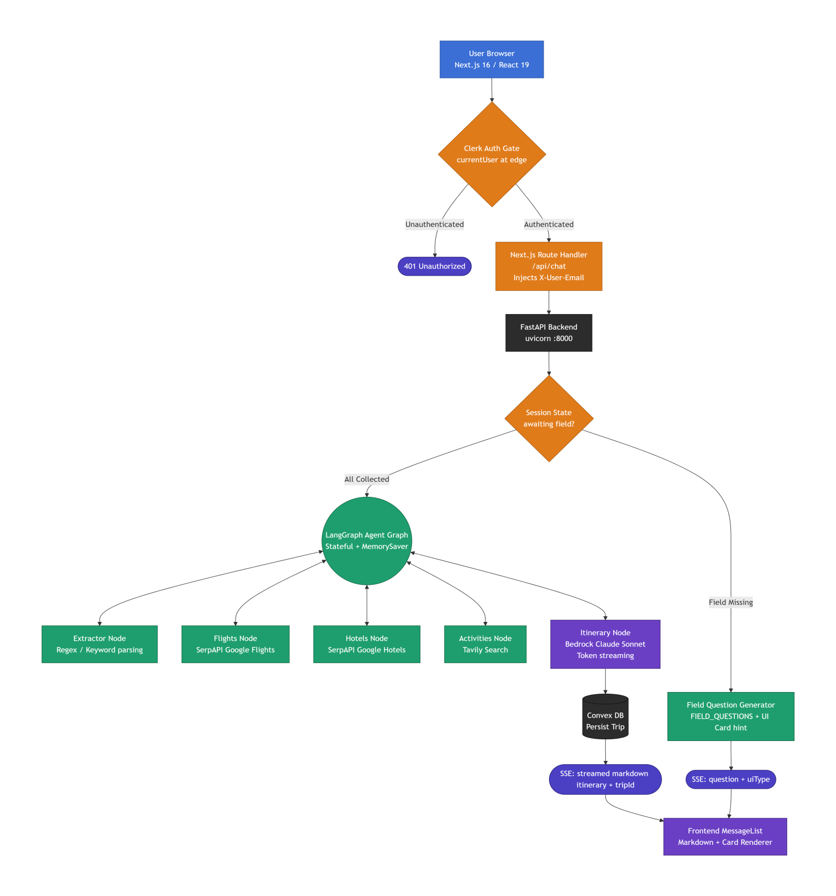

Runtime Sequence (happy path)

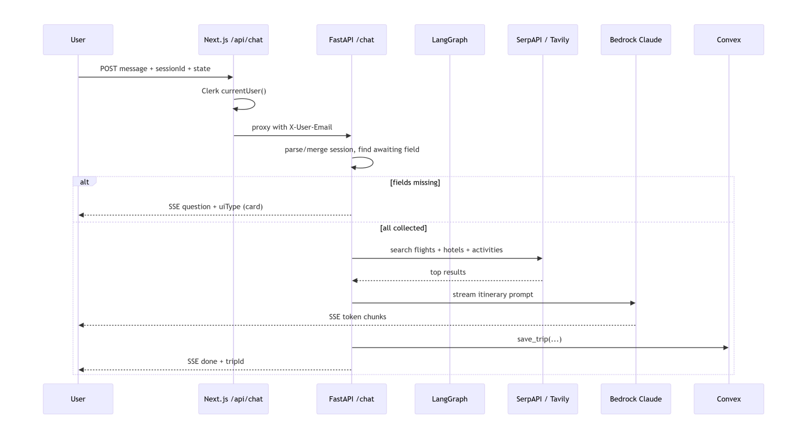

Infrastructure & CI/CD

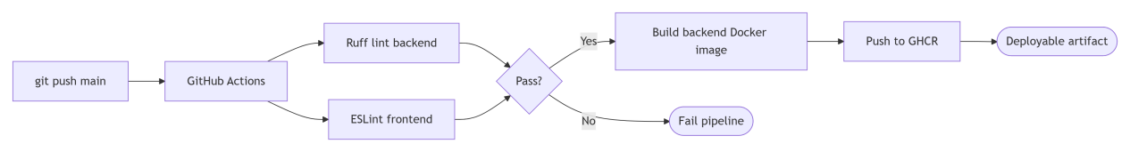

Why This Architecture Matters
Design Choice | Why
Deterministic extractor + LLM | Free-text parsing is fast and predictable; LLM only generates the itinerary
Field-by-field intake | Guided UX → ≥ 90% session completion in one pass
UI cards + free text parity | Same downstream pipeline handles both — no branching complexity
SSE end-to-end | First-token under 1.5s p50 keeps users engaged during 30s generation
Clerk at edge + server-injected header | Client can never spoof identity
Graceful degradation | Missing activities still produce an itinerary — user gets value
Convex embedded documents | Denormalized for read speed; normalized model in roadmap
Docker-compose one-command boot | Reviewers can run it in 60 seconds

Project 4: AI-Powered Course Generator (Text · Video · Both)
One-line summary:
An end-to-end AI course generation platform that turns a natural-language prompt into a complete, multi-chapter course — as text, video, or both — using a LangGraph supervisor-orchestrated RAG pipeline, multi-tenant Pinecone knowledge isolation, RAGAS quality gating, and KEDA-autoscaled Kubernetes video rendering on AWS EKS.

Impact at a Glance
- ~40% generation cost reduction via RedisVL semantic caching (0.95 similarity gate).
- Multi-tenant isolation — user-uploaded documents are scoped by metadata (user_id), so no cross-user leakage is possible even on a shared Pinecone index.
- Elastic video rendering — KEDA scales Remotion worker pods from 0 → hundreds based on Redis queue depth; idle cost = $0.
- Quality-gated output — RAGAS enforces faithfulness ≥ 0.85, hallucination ≤ 0.05, with up to 2 regeneration loops before shipping.
- Typical latency: text course ~8–12s; video course ~60–90s (parallel pods).
- Concurrency: pipeline handles ~500 concurrent generations on 2× t3.medium; rendering scales horizontally without limit.

Tech Stack
App Layer: TypeScript, Python, Next.js, Supabase (auth + storage)
AI Orchestration: LangChain, LangGraph (supervisor-orchestrated agents), DeepInfra (LLM inference)
Retrieval: Pinecone (vector DB), RedisVL (semantic cache), TinyFish (search + fetch-to-Markdown)
Evaluation: RAGAS (faithfulness, accuracy, precision/recall, hallucination)
Media: Remotion (React-based programmatic video), Deepgram (word-level STT timestamps), gTTS (narration audio)
Infra: AWS (ECS, EKS, S3, SES), Docker, Kubernetes, KEDA (queue-driven autoscaler), Redis (job queue)
Transactional Email: AWS SES (password resets, course-completion notifications, support replies)

Flow of System
A user enters a query describing the desired course, selects difficulty (easy / medium / hard) and output type (text / video / both), and clicks Generate.

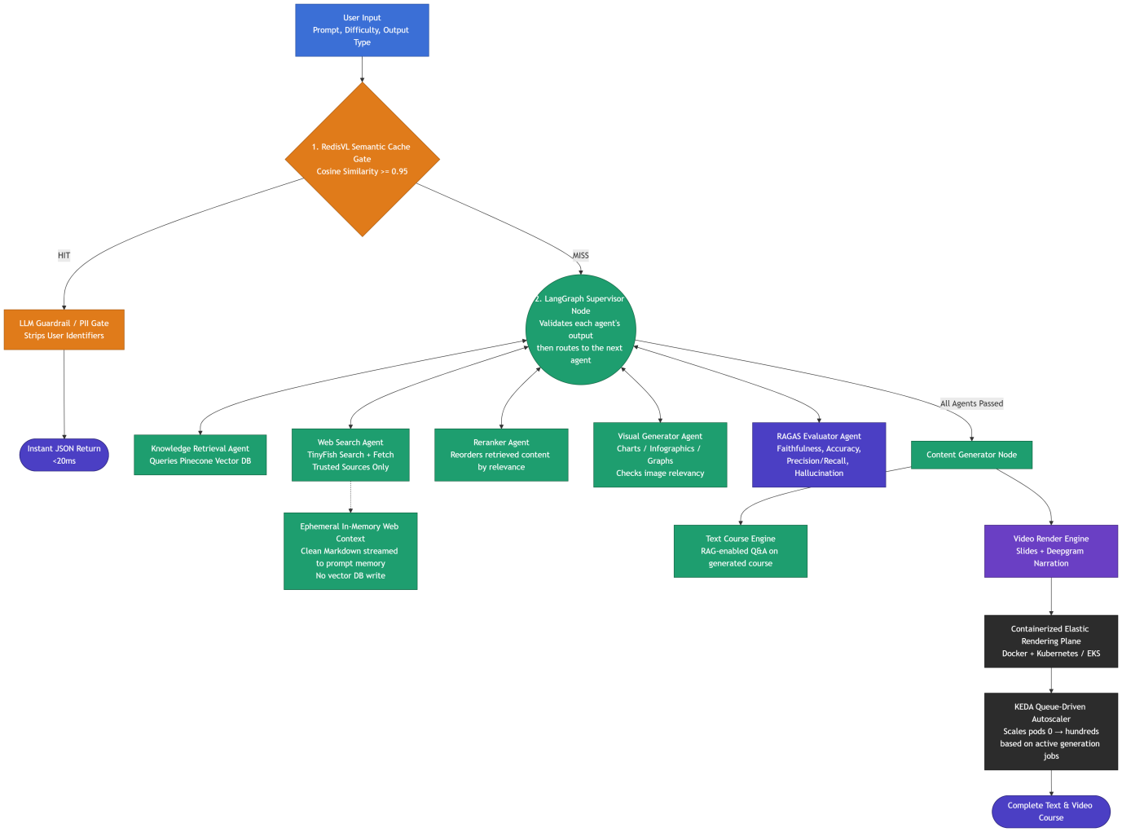

Step 1 : Semantic Cache Check
Query → RedisVL semantic cache gate (cosine similarity ≥ 0.95)
Purpose: two differently-worded queries with the same intent return the same cached course instead of regenerating from scratch.
Example:
- User 1: "Create a 4-week Python course outline for complete beginners covering variables, loops, functions, and basic projects."
- User 2: "Generate a 4-week beginner Python syllabus covering basic variables, loops, functions, and simple starter projects."
Both match at ≥ 0.95 similarity.
- Cache HIT → passes through an LLM Guardrail / PII Gate (confirms no sensitive data from the original requester leaks out) → returned as an instant JSON response (~20ms).
- Cache MISS → proceeds to the full agent pipeline.

Impact: reduces generation cost by ~40%, since near-duplicate courses don't need full regeneration.

Step 2 : Supervisor-Orchestrated Retrieval & Preparation (on cache miss)
The LangGraph Supervisor Node is the central hub. It does not chain agents directly to one another — every agent performs its task and reports its result back to the Supervisor, which validates that output before deciding which agent runs next. No agent talks to another agent directly.
Supervisor routing order:
1. Knowledge Retrieval Agent — Queries Pinecone for relevant course content chunks, returns chunks + a confidence score to the Supervisor.
- If confidence is high → Supervisor skips web search.
- If confidence is high → Supervisor skips web search.

- Web Search Agent (TinyFish)
Triggered only when Pinecone confidence is low or topic coverage is thin. Searches only trusted, community-vetted sources: Brilliant.org, 3Blue1Brown, Khan Academy, NetworkLessons.com, Cisco NetAcad, KodeKloud, MIT OpenCourseWare, TeachYourselfCS.com, Nand2Tetris.
- Uses TinyFish Search API to find target URLs, then TinyFish Fetch API to convert pages into clean Markdown.
- Content is ephemeral / in-memory only — streamed directly into prompt context, never written to Pinecone. This avoids vector-store bloat and embedding duplication.
- Reports retrieved content back to the Supervisor.

- Reranker Agent:
Reorders the combined retrieved content (from Pinecone and/or TinyFish) by relevance to the query, so the most relevant material is used first. Reports back to Supervisor.
- Visual Generator Agent:
Pre-generates candidate visuals (infographics, charts, diagrams) where relevant — heavily used in ML/data-science courses. Validates each image's relevancy to the retrieved context before accepting it. Reports accepted candidates back to Supervisor. (Content Generator later picks which candidate visuals to place in which slides.)
Once all four agents have reported passing results, Supervisor routes to the Content Generator Node.

Step 3: Content Generator Node
The LLM generates the final course content: chapter structure, text, and narration script, using the reranked, validated context. It also decides which visual renders on which slide (choosing from the Visual Generator's validated candidates).

Step 4: RAGAS Evaluator Agent (Quality Gate)
Scores the generated output against the retrieved context using:
- Faithfulness is the output grounded in context (not hallucinated)?
- Answer accuracy correctness against retrieved facts.
- Context precision did we retrieve mostly relevant chunks?
- Context recall did we retrieve everything needed?
- Hallucination rate % of fabricated claims.
Why this gate exists: LLMs are non-deterministic and prone to hallucination, bias, and toxicity. Output can't be trusted without being checked against what was actually retrieved.
Thresholds:
- Pass → faithfulness ≥ 0.85 AND hallucination ≤ 0.05 AND answer accuracy ≥ 0.80.
- Fail → Supervisor routes back to Content Generator Node only (not the whole pipeline), with failure feedback.
Step 5: Output Branching
Text Course Engine Runs directly on the Next.js server. Renders the course as text with interactive RAG Q&A over the generated course content. No Docker / Kubernetes needed. If the user selected Text only, the flow ends here.
Video Render Engine Prepares slide definitions, narration script, and pushes a render job to the Redis/SQS queue. This is the logical orchestration step; the actual rendering happens in the containerized plane below.
Both Supervisor fans out to Text and Video engines in parallel. Text is available immediately (~10s); the video URL is returned when the render queue completes (~60–90s).

Step 6: Containerized Elastic Rendering Plane (Docker + Kubernetes / EKS)
Video rendering is CPU/GPU-heavy (30 seconds – 5 minutes per course) and can't run on the Next.js server without blocking other users.
- Docker packages the renderer's full toolchain — Remotion, Chrome Headless, FFmpeg, Python (caption_service.py for Deepgram timestamp alignment), fonts/codecs — into a single portable image that runs identically anywhere.
- Kubernetes (AWS EKS) runs each render job as a pod (one container = one job), and can run hundreds of pods in parallel across machines when demand spikes.
- KEDA (Kubernetes Event-Driven Autoscaler) watches the Redis/SQS job queue and scales pods from 0 → hundreds based on active job count — 0 pods ($0 cost) when idle, scaling up within seconds when jobs arrive.

Step 7: Remotion Worker Pods
Each pod runs the Docker image and performs the actual render:
- Remotion generates slide frames.
- FFmpeg stitches them into an MP4.
- Deepgram's word-level timestamps are applied for synced captions (consumed by ChapterVideo.tsx on playback).
Final MP4 uploads to S3 / Supabase Storage.
Pod terminates on completion; KEDA scales the pod count back down as the queue empties.

Step 8: Output
User receives the complete course:
- Text version served from Next.js with RAG Q&A.
- Video version as an MP4 URL with slides, Deepgram narration, and time-synced captions.
- AWS SES sends course-completion notifications and password-reset emails.

Document Ingestion Pipeline (Multi-Tenant)
Separate from the generation pipeline, this handles how documents get into Pinecone in the first place, for two types of contributors.

1. Admin-Uploaded Documents (Global / Shared)
- Admin uploads trusted reference documents (textbooks, curated course material) through an admin panel.

- Embedded and stored in Pinecone as global / shared vectors, accessible to all users during course generation.

- Used as the baseline trusted knowledge base the Knowledge Retrieval Agent pulls from by default.

2. User-Uploaded Documents (Private / Multi-Tenant)
- Any user can upload their own documents before generating a course to:
- Use as source material for a specific course generation, or
- Store for reuse across future generations.
- On upload, each document is tagged with the uploading user's user_id and email as metadata alongside its embedding.
- This metadata is what enforces multi-tenancy — it's not separate databases per user, it's the same Pinecone index with per-vector ownership tags.

Multi-Tenant Isolation at Retrieval Time
When the Knowledge Retrieval Agent queries Pinecone during course generation, it applies a metadata filter keyed on the requesting user's ID — not just similarity search.
This guarantees:
- User A's uploaded documents are only ever retrieved for User A's course generations.
- User B cannot access, retrieve, or have their generation influenced by User A's private documents — even if User B's topic is semantically similar.
- Admin-uploaded documents remain the exception — they carry a scope: "global" tag instead of a user_id, so they match for every user's queries.

Flow
- User (or Admin) uploads a document.
- Document is parsed, chunked, and embedded.
- Vectors are upserted into Pinecone with metadata:
- Admin doc → { scope: "global" }
- User doc → { scope: "private", user_id: "...", email: "..." }

- At generation time, Knowledge Retrieval Agent queries Pinecone with:
filter: (scope == "global") OR (user_id == <current_user>)
- Retrieved chunks are restricted to only what the requesting user is allowed to see — global content plus their own private uploads, never another user's private uploads.

Why This Architecture Matters

Semantic cache before pipeline | ~40% cost reduction on duplicate-intent queries
Supervisor as hub (not chain) | Central validation, no runaway agent-to-agent calls
Pinecone primary + TinyFish fallback | Fast + auditable primary path; fresh coverage for new topics
TinyFish content never embedded | Avoids vector-store bloat and near-duplicate embeddings
RAGAS post-generation, with retry cap | Prevents hallucinated or low-faithfulness courses from shipping
KEDA queue-driven autoscaling | Video rendering is bursty and expensive pay only for work done
Metadata-scoped retrieval | Multi-tenant isolation without per-user databases

Testing, Monitoring & Operations
- RAGAS regression suite — re-scores past generations against a frozen context corpus to catch prompt regressions before deploy.
- Pinecone retrieval tests — assert per-user isolation with mocked user_id filters (no cross-tenant leakage in CI).
- KEDA scaling tests — synthetic queue load to verify 0 → N pod scaling within SLA.
- Monitoring: Prometheus + Grafana on EKS (pod count, queue depth, render duration, RAGAS pass rate); CloudWatch alarms on failure rate.
- Cost observability: per-course cost tracked (LLM tokens + Pinecone reads + render compute minutes).

