Assignment 04

**Tasks:**

1. Download and Install free R Studio version from the following link. (1 Mark) <https://www.rstudio.com/products/rstudio/download/>

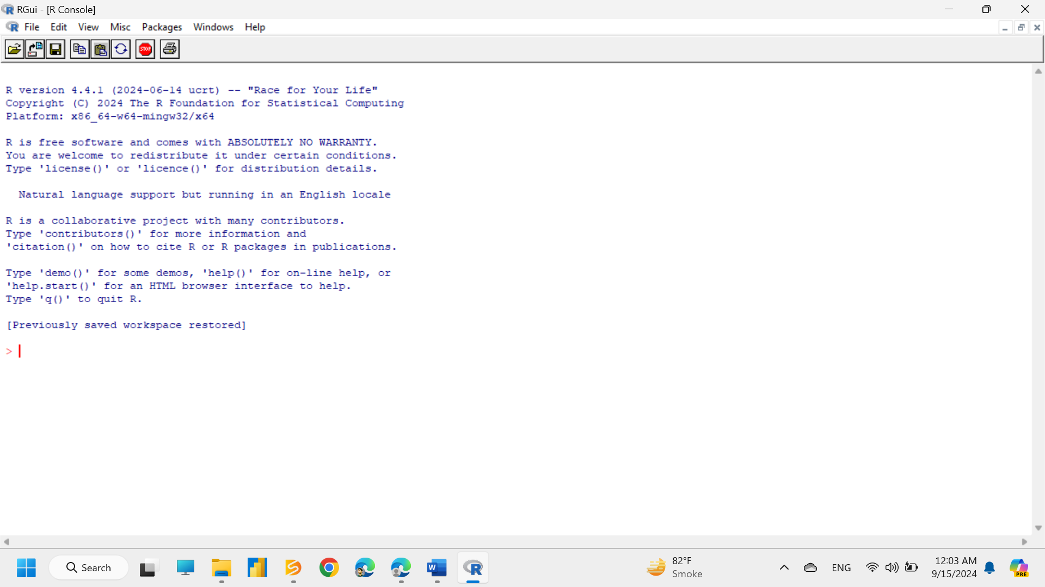

1. Download the dataset from the following link and load the dataset in R Studio. (2 Mark) <https://www.kaggle.com/datasets/akshaydattatraykhare/car-details-dataset>

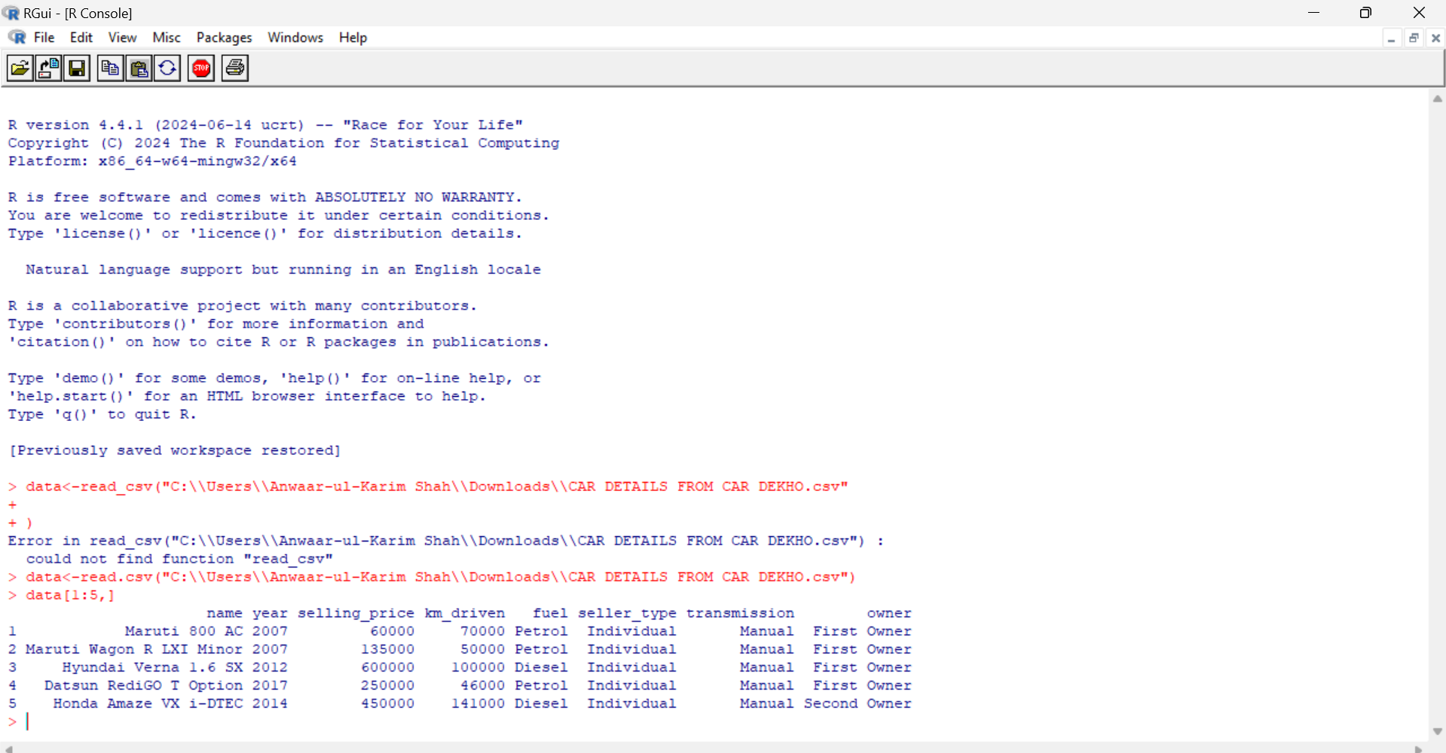

1. Use the following R commands for car details dataset. (3 Mark)

|  |  |  |
| --- | --- | --- |
| head(dataset_variable) | tail(dataset_variable) | names(dataset_variable) |

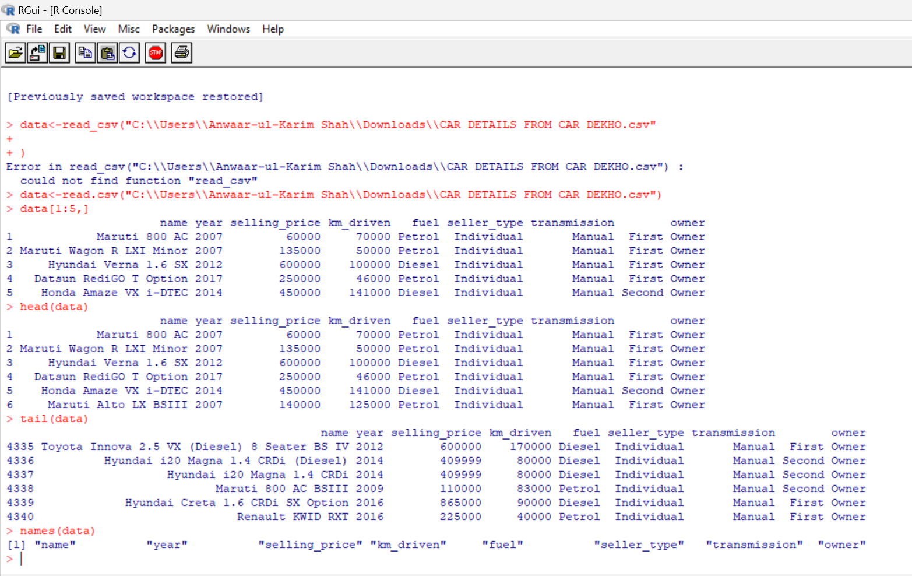

1. Create boxplot using boxplot(column_name) command for selling_price column. (2 Mark) 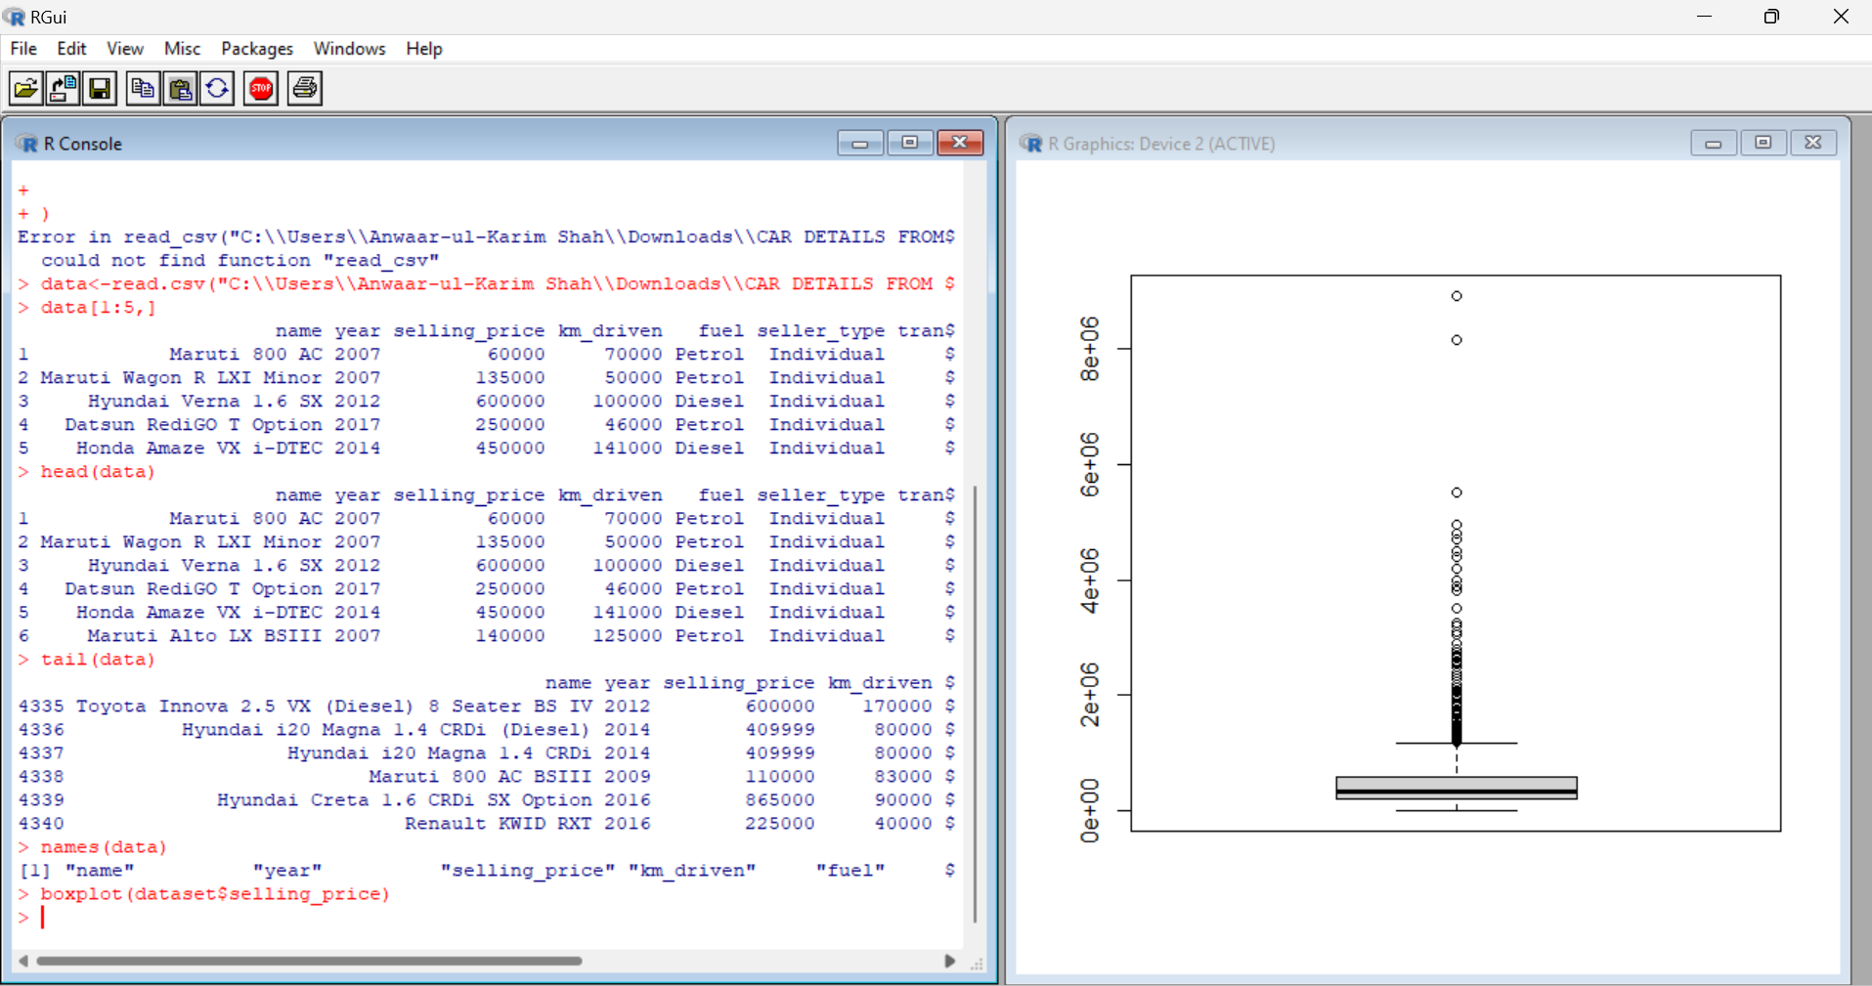
2. 5) Create histogram using hist(column_name) command for km_driven column. (2 Mark)

|  |
| --- |
|  |