
Final Year Project
GridGuard AI for Smart Electric Grids
Project Team:
Muhammad Rohan Ali
2380246
Muhammad Hadi
2380242
Project Supervisor:
Khawaja Mohiuddin
Date of Submission: 30-09-2026
Submitted in partial fulfillment of the requirements for the degree of
Bachelor of Science in Software Engineering
in the
Faculty of Computing and Engineering Sciences
Shaheed Zulfiqar Ali Bhutto Institute of Science and Technology
University
(SZABIST University) Karachi Campus

Contents
1. Introduction 3
2. Objective 4
3. Problem Description 5
4. Target Industry 5
5. Methodology 6
5.1 Overall System Approach 6
5.2 Data Sources and Dataset Preparation 7
5.3 Simulated Substations and Non-IID Data 7
5.4 Federated Learning Process 7
5.5 Agentic AI Architecture 7
5.5 Trustworthy AI and Explainability 8
5.6 Dashboard and Demonstration 8
6. Project Scope 8
6.1 In-Scope Features 9
7. Feasibility Study 9
7.1 Resource Requirement 9
8. Tools/Technology 10
10. Expertise of the Team Members 10
11. Milestones 10
11.1 FYP-I Features 11
11.2 FYP-II Features 11
11.3 Gantt Chart 11
13. Work Breakdown Structure 12
13.1 FYP-I Work Breakdown Structure 12
13.2 FYP-II Work Breakdown Structure 12
13.3 Development Phases 13
14. References 13

1. Introduction
GridGuard AI for Smart Electric Grids is a software-based smart-grid intelligence platform designed to support monitoring, prediction, fault awareness, and operator decision-making. The project combines Federated Machine Learning, Edge AI, Agentic AI, Explainable AI and Trustworthy AI in one practical system. The project does not require a real electrical grid or physical high-voltage equipment. Instead, it creates a controlled software simulation of multiple substations and uses public electricity data together with simulated smart-grid events. This approach makes the system safe to build, test, and demonstrate as a Final Year Project.
A smart electric grid produces large amounts of data from loads, meters, and equipment. Human operators cannot continuously inspect every reading, especially when the number of monitored devices grows. GridGuard AI will use machine learning to learn normal patterns and detect changes such as unusual load, abnormal voltage or current, rising equipment risk, and possible forecasting.
The project uses three to four simulated substations. Each substation has its own local dataset and behaves as a separate client. The local data can represent different operating patterns such as residential, industrial and commercial. This creates non-IID data, meaning that each client does not have exactly the same type of data. The FYP specifically describes this model of simulated substations, local training, federated aggregation, and agent-based decision support.
Instead of sending raw local data to a central database, each simulated substation trains a local model and sends only the model update to the federated server. The server combines the updates to create a global model and sends the new model back to the clients. This repeated process allows the substations to learn together while keeping their raw datasets in their local environments. This follows the federated learning flow.
Above the AI models, GridGuard AI will use specialized agents. The Forecast Agent estimates future demand. The Fault Agent checks for electrical and equipment problems. The Security Agent looks for suspicious or abnormal operating behavior. The Decision Agent combines these results and prepares a recommended action for a human operator. The design therefore moves from raw readings to prediction, from prediction to explanation, and from explanation to a controlled recommendation. The human operator remains responsible for the final decision.
The final system will be presented through an interactive dashboard. The dashboard will show the condition of all simulated substations, current and predicted demand, active alerts, model explanations, federated learning rounds, and recommended actions. It will also make the privacy idea visible by showing that local raw data remains with the substation while only model updates are shared with the federated server.
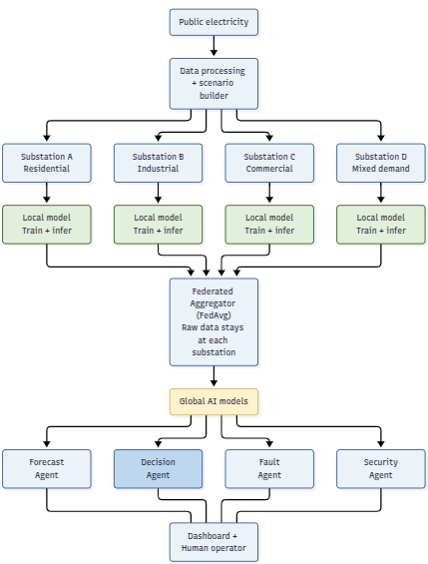
Figure 1. Proposed GridGuard AI architecture and data flow.

2. Objective
To design and develop a software-based smart-grid intelligence system that uses federated learning across simulated substations to detect abnormal grid conditions, forecast electricity demand, estimate equipment failure risk, and support resource planning through AI agents. The system will use explainable AI, data handling, and a human-in-the-loop decision process to provide understandable and controlled recommendations through an interactive dashboard.

The main objectives are to:
- Create three to four simulated substation clients with different local data patterns.
- Prepare public electricity data and controlled simulated grid and equipment events for model training and testing.
- Develop Fault, Security, Anomaly, Forecast Agents that turn model results into useful operator information.
- Add Explainable AI features such as SHAP-based explanations, trust worthiness of AI and human approval before any recommended action is accepted.
- Develop a dashboard that clearly demonstrates model performance, alerts, explanations, and recommended actions.

3. Problem Description
Electric grids generate a continuous stream of data from electricity demand, voltage, current, frequency, and equipment condition sensors. However, most of this monitoring is still done manually or through simple threshold-based checks, meaning unusual changes in equipment behaviour or sudden load spikes are often missed or detected too late and also raise human error. When utilities try to apply machine learning for prediction, the traditional approach requires collecting all raw operational data from every substation into one central location, which raises serious privacy and data-sharing concerns, especially when different substations belong to different organizations or serve different areas. A further challenge is that substations do not behave identically; a residential area has evening demand peaks, a commercial zone peaks during business hours, and an industrial area draws heavy, steady power around the clock, so treating all substations as if they share the same data pattern is unrealistic. Even when a prediction model does raise an alert, the operator is left with only a number or a warning label, with no clear explanation of why the alert was triggered or what action should be taken next. These combined issues of late detection, privacy concerns with centralized data, unrealistic uniform data assumptions, and unexplained predictions make it difficult for grid operators to respond quickly and confidently. GridGuard AI addresses these gaps by simulating multiple substations with different real-world patterns, keeping each substation's data local, training shared models through federated learning, and using explainable AI agents to provide clear, traceable recommendations to a human operator, all within a safe software-based environment.

4. Target Industry
Primary industry: Energy and Utilities - Smart Electric Grids.
- Electric power utilities and distribution companies for grid monitoring and planning support.
- Substation monitoring and maintenance teams for early warning and equipment risk awareness.
- Energy management and grid analytics teams for demand forecasting, anomaly detection, and resource planning.
- Research and training environments where safe software-based smart-grid simulations are needed.
The project is designed as decision support rather than direct grid control. This makes it suitable as an academic prototype while still representing a realistic software workflow for the energy sector.

5. Methodology
The project will follow an incremental software and machine learning development process. The first stage will define the data model and simulation rules. The second stage will build and test local machine learning models. The third stage will add federated learning, followed by the agent layer, explainability, API services, and the dashboard. Finally, the system will be evaluated using controlled experiments.

5.1 Overall System Approach
- Collect and review public electricity data. The initial dataset will be the UCI ElectricityLoadDiagrams20112014 dataset and others. A second public electricity dataset, such as the UCI Individual Household Electric Power Consumption dataset, may be used for additional electrical-feature experiments.
- Clean the raw data, handle missing values where required, standardize time formats, and split the data into training, validation, and testing periods.
- Create three to four simulated substations with different data distributions. The planned profiles are residential, industrial and commercial.
- Run federated learning rounds using the Flower framework. The server sends the current global model to clients, receives model updates, aggregates them, and produces a new global model.
- Run the models at the simulated edge nodes. Predictions and alerts can be sent to the application layer without sending the complete raw training dataset.
- Pass the model outputs to the agents. The agents will use their own responsibilities instead of asking one model to perform every task.
- Generate explanations using SHAP where applicable so the operator can see the main input features that affected a prediction.
- Display all important information through the web dashboard and record key decisions and events.

5.2 Data Sources and Dataset Preparation
The project will not depend on collecting real electrical data from a power company. The main training source will be public electricity data. The UCI ElectricityLoadDiagrams20112014 suitable for demand-forecasting experiments and for creating multiple simulated clients. The UCI Individual Household Electric Power Consumption dataset contains almost four years of measurements and several electrical quantities, including active power, reactive power, voltage, current intensity, and sub-metering values. It can be used for additional abnormal-consumption or electrical-pattern experiments.

5.3 Simulated Substations and Non-IID Data
The project will simulate three to four independent substations in software. They will not be physical locations. Each substation will run as a separate process or client program and will have its own local dataset. The data distributions will intentionally differ. For example, the residential client can show stronger evening peaks, the industrial client can show long high-load periods during working hours, and the mixed client can combine several patterns. This is the non-IID condition described.
The reason for using non-IID data is to make the federated experiment more meaningful. A simple random split could make all clients look nearly identical. In the proposed system, the clients will have real differences, so the team can compare local model behavior, federated model behavior, and the effect of different client distributions.

5.4 Federated Learning Process
Federated learning will be implemented using Flower. A global model will first be initialized. During each round, the server sends the current model to the participating simulated substations. Each substation trains the model on its own local data and returns a model update rather than its raw records. The server aggregates these updates using the Federated Averaging (FedAvg) approach and produces the next global model. This cycle continues for a fixed number of rounds or until the model performance becomes stable.
The dashboard will record federated round number, participating clients, local performance, global performance, training time, and communication count. A second experiment will compare centralized training, in which all data is combined, with federated training. The comparison will focus on performance and the amount of raw data shared.

5.5 Agentic AI Architecture
The agent layer will be goal-based and tool-using. Each agent has a specific responsibility and receives structured outputs from the machine learning services. The agents do not directly control physical equipment. Their role is to monitor, analyze, coordinate, and recommend.
Agent | Main question | Inputs | Output
Forecast Agent | What is likely to happen next? | Load history, time features, history | Demand/generation forecast and trend
Fault Agent | Is equipment or the grid showing a fault? | Voltage, current, load, temperature, vibration, model score | Fault class, risk probability, severity
Security Agent | Is the observed behavior suspicious or abnormal? | Operational patterns, anomaly score | Security/operational anomaly alert

5.5 Trustworthy AI and Explainability
GridGuard AI uses five simple controls:
- Confidence/Risk: Shows how confident the model is in its prediction.
- SHAP: Explains important factors such as temperature, vibration, and load.
- Audit Trail: Records alerts, model versions, recommendations, and operator actions.
- Fallback Rules: Uses predefined rules when the model is unavailable or confidence is too low.
- Human Approval: The final decision always remains with the human operator.
The dashboard will show explanations in simple language, for example: “High failure risk due to abnormal temperature, increased vibration, and rising load.” SHAP supports understanding the prediction but does not guarantee that the model is always correct.

5.6 Dashboard and Demonstration
The dashboard will have four main views. The first is the Grid Overview page, showing all four simulated substations, system demand, predicted demand, grid health, and active alerts. The second is a Substation Detail page, showing local readings, equipment status, risk, explanation, and recommendation. The third is the Federated Learning page, showing rounds, client participation, local versus global performance, and the fact that only updates are sent to the aggregator. The fourth is the Decision Support page, showing how the Forecast, Fault, and Security Agents produced a combined recommendation. These views are based on the demonstration screens described in the supplied guide.

6. Project Scope
The scope defines what GridGuard AI will and will not build. The project is intentionally software-based so that the team can demonstrate advanced AI concepts without requiring access to a live electrical grid.

6.1 In-Scope Features
- Three to Four software-simulated substations acting as independent federated clients.
- Public electricity time-series data preparation and controlled smart-grid scenario simulation.
- Local training and inference at simulated edge clients.
- Federated model aggregation using a practical FedAvg-based workflow.
- Demand forecasting and, where data is available, forecasting generation.
- Fault detection, abnormal-condition monitoring, and equipment failure-risk estimation.
- Security and operational anomaly alerts based on simulated events and model outputs.
- Forecast, Fault, Security Agents.
- SHAP-based explanation for selected model predictions.
- Dashboard, API layer, logs, model metrics, alerts, and operator recommendations.
- Comparison of centralized, local, and federated learning under non-IID data.

7. Feasibility Study
The project is feasible within a one-year FYP because it is based mainly on open-source software, public datasets, and software simulation. The team does not need to purchase a transformer, sensors, or grid hardware. A standard laptop can run a small number of simulated clients, while an optional GPU can reduce model-training time. The major feasibility challenge is scope management, so the project will be developed in stages: first one client, then multiple clients, then federated learning, and finally the agent and dashboard layers.

7.1 Resource Requirement
Resource | Requirement | Purpose
Computer / Laptop | Standard development laptop; optional GPU | Python development, local model training, Docker, dashboard
Programming | Python 3.x | Data processing, machine learning, agents, APIs
ML libraries | PyTorch, scikit-learn, Flower, SHAP, Pandas | Model training, federated learning, explainability
Backend | FastAPI | API services and model integration
Dashboard | Streamlit or React | Interactive monitoring and demonstration
Containerization | Docker / Docker Compose | Run server and multiple simulated substations consistently
Data | Public electricity datasets + simulated scenarios | Training and evaluation
Version control | Git / GitHub or equivalent | Source control, collaboration, experiment tracking
Documentation | Word / diagramming tools | Proposal, reports, diagrams, and FYP defense material

8. Tools/Technology
Category | Tools / Technologies | Use in project
Operating environment | Windows / Linux | Development and local simulation
Programming | Python | Core system language
Machine learning | PyTorch, scikit-learn | Forecasting, classification, anomaly models
Federated learning | Flower | Client-server simulation and model aggregation
Explainable AI | SHAP | Feature contribution and model explanation
Data processing | Pandas, NumPy | Cleaning, transformation, feature engineering
Backend API | FastAPI | Service endpoints and integration
Dashboard | Streamlit or React | Monitoring and demonstration UI
Containerization | Docker, Docker Compose | Repeatable multi-client simulation
Version control | Git | Source code management and teamwork
Documentation | Microsoft Word / diagramming software | Proposal, diagrams, testing records

10. Expertise of the Team Members
The project requires a mixed set of software engineering and machine learning skills. The team may not begin with advanced knowledge of the energy domain, so the first part of FYP-I includes structured learning of smart-grid basics, time-series data, federated learning, and trustworthy AI. This reduces the risk of implementing a tool without understanding its meaning.
The project is of equal interest to both members because it combines software development, artificial intelligence, distributed systems, and a real industrial domain. The final implementation will use shared coding standards, Git version control, peer review, and joint testing so that knowledge is not limited to one team member.

11. Milestones
The one-year project will be divided into FYP-I and FYP-II. FYP-I will establish the problem, data, baseline models, simulation environment, and initial federated learning workflow. FYP-II will complete the full federated system, agent layer, explainability, dashboard, testing, evaluation, and final documentation.

11.1 FYP-I Features
- Detailed requirements and smart-grid domain study.
- Public dataset acquisition, cleaning, feature selection, and data dictionary.
- Three to Four simulated substation profiles and non-IID partitioning.
- Baseline demand forecasting model.
- Baseline anomaly detection model.
- Equipment event and fault simulation module.
- Initial Flower-based federated learning prototype with at least two clients.
- Initial backend/API and a simple monitoring page for development testing.

11.2 FYP-II Features
- Four-client federated learning workflow with repeated rounds.
- Federated demand forecasting and abnormal-condition models.
- Equipment failure-risk model and security/operational anomaly monitoring.
- Forecast, Fault, Security Agents.
- SHAP-based explanation view and confidence information.
- Human-in-the-loop recommendation
- Complete FastAPI service layer and dashboard.
- Centralized vs federated and non-IID evaluation experiments.
- Final testing, documentation, presentation, and demonstration scenario.

11.3 Gantt Chart
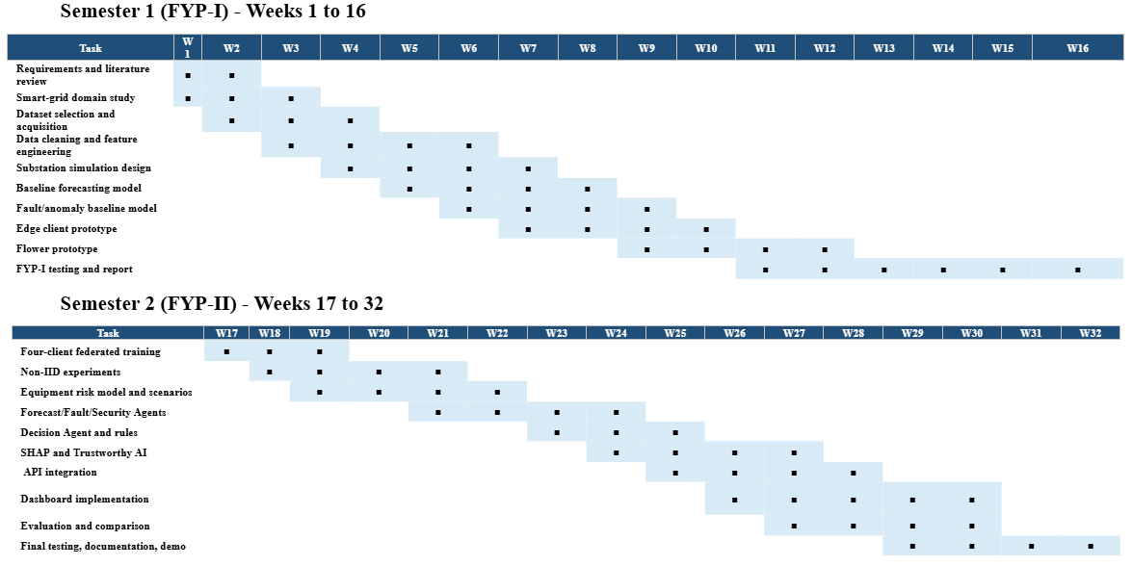

13. Work Breakdown Structure
The WBS divides the project into manageable tasks for each semester. The first semester focuses on understanding, data, simulation, baseline models, and the first federated prototype. The second semester focuses on the complete federated system, agentic layer, trustworthy AI, dashboard, evaluation, and final delivery.

13.1 FYP-I Work Breakdown Structure
WBS ID | Task / Sub-task | Deliverable / Milestone
1.1 | Requirements gathering and project study | Approved requirements and problem definition
1.2 | Smart-grid and federated learning study | Domain notes and architecture draft
1.3 | Review public datasets | Dataset comparison and selection
1.4 | Data cleaning | Reproducible preprocessing pipeline
1.5 | Feature engineering | Feature list and data dictionary
1.6 | Four substation simulation | Client profiles and non-IID partitions
1.7 | Baseline demand forecasting | Baseline forecasting model
1.8 | Fault/anomaly baseline | Initial detection model
1.9 | Edge client prototype | Local training/inference service
1.10 | Flower prototype | Two-client FL round working
1.11 | Initial evaluation | Local vs early federated results
1.12 | FYP-I report and review | Semester report and presentation

13.2 FYP-II Work Breakdown Structure
WBS ID | Task / Sub-task | Deliverable / Milestone
2.1 | Four-client federated training | Complete multi-client workflow
2.2 | Non-IID experiments | Client-distribution comparison
2.3 | Equipment risk simulation/model | Failure-risk module
2.4 | Forecast Agent | Forecast agent service
2.5 | Fault Agent | Fault agent service
2.6 | Security Agent | Security/anomaly agent service
2.7 | Decision Agent | Rule-based coordination and recommendation
2.8 | Trustworthy AI | SHAP, confidence, audit trail, human approval
2.9 | Dashboard | Grid overview, substation, FL, decision pages
2.10 | Full evaluation | Centralized/local/federated/non-IID results
2.11 | Testing, documentation, final demo | Final report, user guide, defense/demo

13.3 Development Phases
Phase | Purpose | Main work | Exit condition
Phase 1 - Understand | Build project knowledge | Domain study, requirements, references | Team can explain problem and flow
Phase 2 - Prepare data | Make reliable inputs | Datasets, cleaning, features, simulation | Data pipeline runs end-to-end
Phase 3 - Build AI | Create working models | Baseline models, local clients | Local prediction works
Phase 4 - Federate | Combine clients without raw-data transfer | Flower, FedAvg, non-IID evaluation | Global model improves / works across clients
Phase 5 - Add agents | Turn predictions into decisions | Four agents and rules | Scenario creates traceable recommendation
Phase 6 - Trust | Make AI understandable | SHAP, confidence, logs, human approval | Alert contains explanation and control
Phase 7 - Present | Build usable demonstration | API, dashboard, tests, documentation | Complete FYP demo runs from one workflow

14. References
[1] Trindade, Alberto. "ElectricityLoadDiagrams20112014." UCI Machine Learning Repository, dataset 321, donated 2015. Available from: https://archive.ics.uci.edu/dataset/321/electricityloaddiagrams20112014.
[2] Hebrail, Georges, and Alice Berard. "Individual Household Electric Power Consumption." UCI Machine Learning Repository, dataset 235. DOI: 10.24432/C58K54. Available from: https://archive.ics.uci.edu/dataset/235/individual%2Bhousehold%2Belectric%2Bpower%2Bconsumption.
[3] PyTorch. "PyTorch Documentation." Available from: https://pytorch.org/docs/stable/. Accessed September 20, 2026.
[4] Scikit-learn developers. "Scikit-learn User Guide and API Reference." Available from: https://scikit-learn.org/stable/. Accessed September 20, 2026.
[5] FastAPI. "FastAPI Documentation." Available from: https://fastapi.tiangolo.com/. Accessed September 20, 2026.
[6] Docker. "Docker Documentation." Available from: https://docs.docker.com/. Accessed September 20, 2026.

