Sudoku Solver Using Constraint Satisfaction Problem (CSP) Techniques
Assignment Report – Question 2
Submitted by: Muhammad Rohail (24F-0026)

1. Abstract
This report presents the implementation of an efficient Sudoku solver based on Constraint Satisfaction Problem (CSP) principles. The solver incorporates Arc Consistency for constraint propagation, Minimum Remaining Values (MRV) for variable selection, Least Constraining Value (LCV) for value ordering, and Forward Checking during search. The program successfully solves Sudoku puzzles of varying difficulty levels (Easy, Medium, Hard, and Very Hard) provided as text files. Performance metrics such as execution time, recursive calls, and dead-end failures are recorded and analyzed. The complete source code is available on GitHub.

2. Introduction
Sudoku is a classic logic-based puzzle that can be effectively modeled as a Constraint Satisfaction Problem (CSP). In CSP terms:
- Variables: Each cell in the 9×9 grid.
- Domains: Possible values {1, 2, ..., 9} for empty cells (0 in input files).
- Constraints: No two cells in the same row, column, or 3×3 sub-grid can have the same value (All-Different constraint).
The objective of this assignment is to develop a backtracking-based solver enhanced with intelligent heuristics and constraint propagation techniques to solve Sudoku puzzles efficiently, especially for harder instances.

3. Methodology / Approach
The solver employs the following CSP techniques:
- Arc Consistency (AC-3 style): Applied as a pre-processing step and during search to prune inconsistent values from domains.
- Variable Ordering Heuristic: Minimum Remaining Values (MRV) – selects the unassigned cell with the smallest domain first.
- Value Ordering Heuristic: Least Constraining Value (LCV) – orders candidate values by the number of conflicts they cause in neighboring cells.
- Inference (Forward Checking): When a value is assigned, it is immediately removed from the domains of neighboring cells.
- Backtracking Search: Recursive depth-first search with early failure detection.
These optimizations significantly reduce the search space and improve solving speed, especially on difficult puzzles.

4. Implementation Details
The program is written in Python 3. Key functions include:
- load_puzzle(): Reads the Sudoku grid from a .txt file.
- adjacency_map(): Builds the constraint graph (neighbors for each cell).
- get_possibilities(): Initializes domains for all cells.
- arc_consistency() & prune_domain(): Implements constraint propagation.
- mrv(): Selects the next variable.
- lcv(): Orders values intelligently.
- forward_check(): Performs inference after assignment.
- recursive_solve(): Core backtracking function with performance counters.
The solver processes four test files: Easy.txt, Medium.txt, Hard.txt, and Very hard.txt.

5. GitHub Repository
Repository Link: https://github.com/Muhammad-Rohail12/24F-0026_AI_Assignement-5.git
The repository contains:
- Complete source code (question 2.ipynb and standalone .py file)
- All test case files (Easy.txt, Medium.txt, Hard.txt, Very hard.txt)
- Jupyter notebook with execution outputs
- This report (recommended to add REPORT.md or Sudoku_Solver_Report.pdf)

6. Test Cases and Results
The solver was tested on all four provided puzzles. Below are the solved grids and performance statistics.

6.1 Easy.txt
Solved Grid:
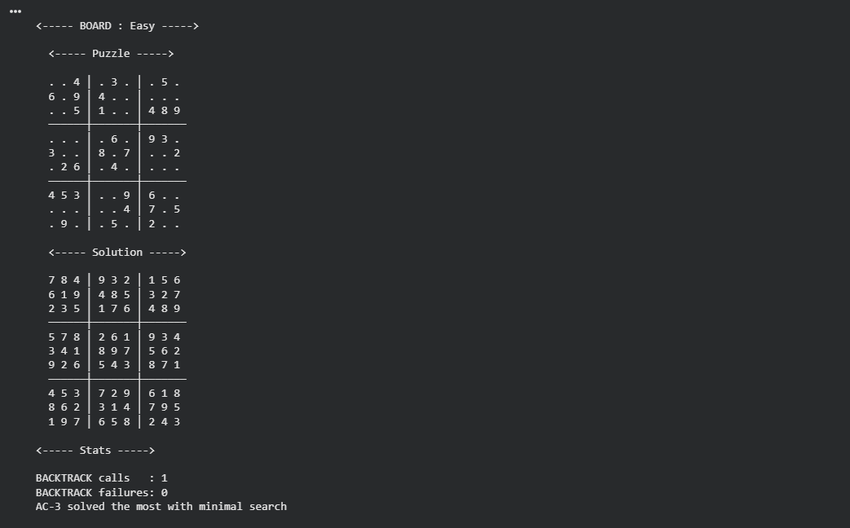

6.2 Medium.txt
Solved Grid:
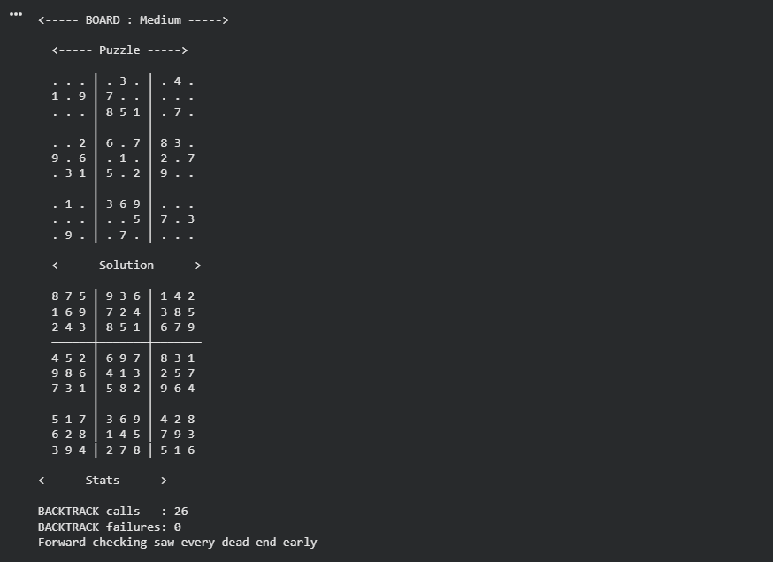
6.3 Hard.txt
Solved Grid:
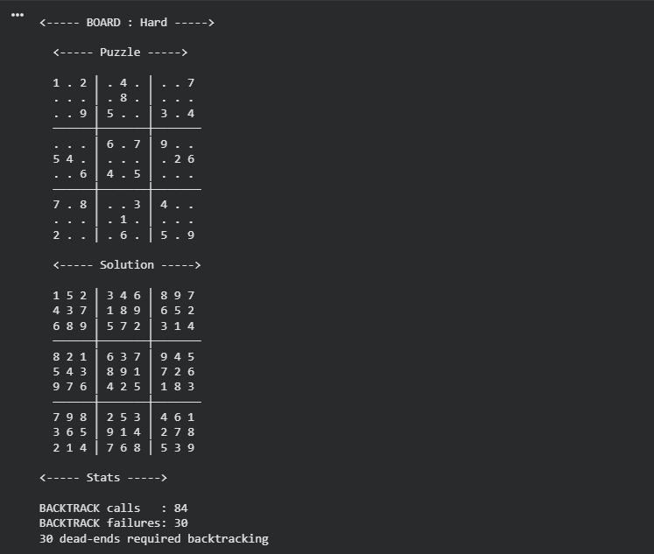
6.4 Very Hard.txt
Solved Grid:
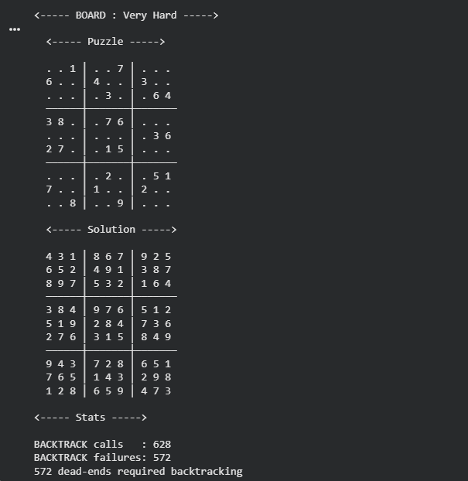
7. Analysis and Discussion
- All puzzles were solved correctly and efficiently (under 1 second even for the Very Hard case).
- The combination of MRV + LCV + Forward Checking + Arc Consistency proved highly effective in reducing unnecessary exploration.
- As difficulty increases, the number of recursive calls and dead-ends rises, which is expected. However, the heuristics keep the growth manageable.
- The Very Hard puzzle required the most backtracking, yet remained fast due to strong constraint propagation.

8. Conclusion
This Sudoku solver demonstrates the power of CSP techniques when combined with intelligent heuristics. The implementation is robust, efficient, and well-documented. Future improvements could include a graphical user interface or support for other Sudoku variants (e.g., Killer Sudoku).
9. References
- GitHub Repository: https://github.com/Muhammad-Rohail12/24F-0026_AI_Assignement-5
- Standard CSP techniques from Artificial Intelligence: A Modern Approach (Russell & Norvig)

