Name: Alishba Shahid
Lab Task 2: Online Course Registration System

Task A: Defect Hunt
For this task, I reviewed the requirement set to identify at least 15 defects based on the provided rules.
Inconsistencies:
- R2 vs. R3: R2 states that the system will not allow registration after the deadline, but R3 says late registration is allowed for 3 days after the deadline. These directly contradict each other on when registration closes.
- R5 vs. R16: R5 says students can register even if a course is full. However, R16 says the system should use a waitlist when seats are full. The waitlist would never work if students can just bypass it.
- R9 vs. R10: R9 says the system prevents schedule conflicts, but R10 allows overlapping times if one course is online. This means R9 is not universally true and conflicts with R10's exception.
- R13 vs. R15: R13 allows dropping a course until Week 6, but R15 says course drops aren't allowed after "the deadline". This is conflicting if "the deadline" isn't specifically defined as Week 6.
- R18 vs. R19: R18 says waitlisted students are enrolled in the exact order they joined, while R19 says final-year students get priority. The system logic will conflict on whether to enroll the first person on the list or a final-year student who joined later.
Incompleteness Defects:
6. R6: The requirement just says, "The system shall send confirmation". It's missing important details: what is being confirmed, how is it sent (email or SMS?), and when does it send?
7. R8: This rule allows prerequisites to be ignored with "instructor approval", but it is incomplete because it doesn't explain how the instructor inputs this approval into the system (like an override code).
8. R12: It mentions students can take up to 24 credit hours with "advisor approval” but fails to define the system mechanism for the advisor to grant this permission digitally.
9. R14: It says the system will "charge a fee" for dropping courses after Week 2. This is incomplete because it doesn't state the fee amount or how the system processes the charge.
10. R17: It says waitlisted students will "automatically be enrolled" when a seat opens, but it doesn't mention if the student gets notified or how long they must pay the new tuition balance.

Ambiguities:
11. R3: The term "Late registration" is ambiguous. Does this mean the student has to pay a late fee, or is it just a normal registration that happens to be later?
12. R10: The phrase "occurring at the same time" is unclear. Does this mean the classes have the exact same start and end time, or just that they overlap by 10 minutes?
13. R15: The phrase "the deadline" is ambiguous. The document mentions multiple timeframes (Week 2, Week 6), so it's unclear which specific deadline this refers to.

Unverifiable Requirements:
14. R20: "Students shall be able to register quickly" is completely subjective. We cannot write a test case for "quickly" unless there is a specific time limit given (e.g., under 3 seconds).
15. R1: "The system shall allow students to register for courses" is too broad to test. It needs to specify conditions, like "currently enrolled students with no account holds."

Task B: Defect Logging
GitHub Link:
https://github.com/Muhammad-Rohail12/Online-Course-Registration-Lab/issues
Screenshots:
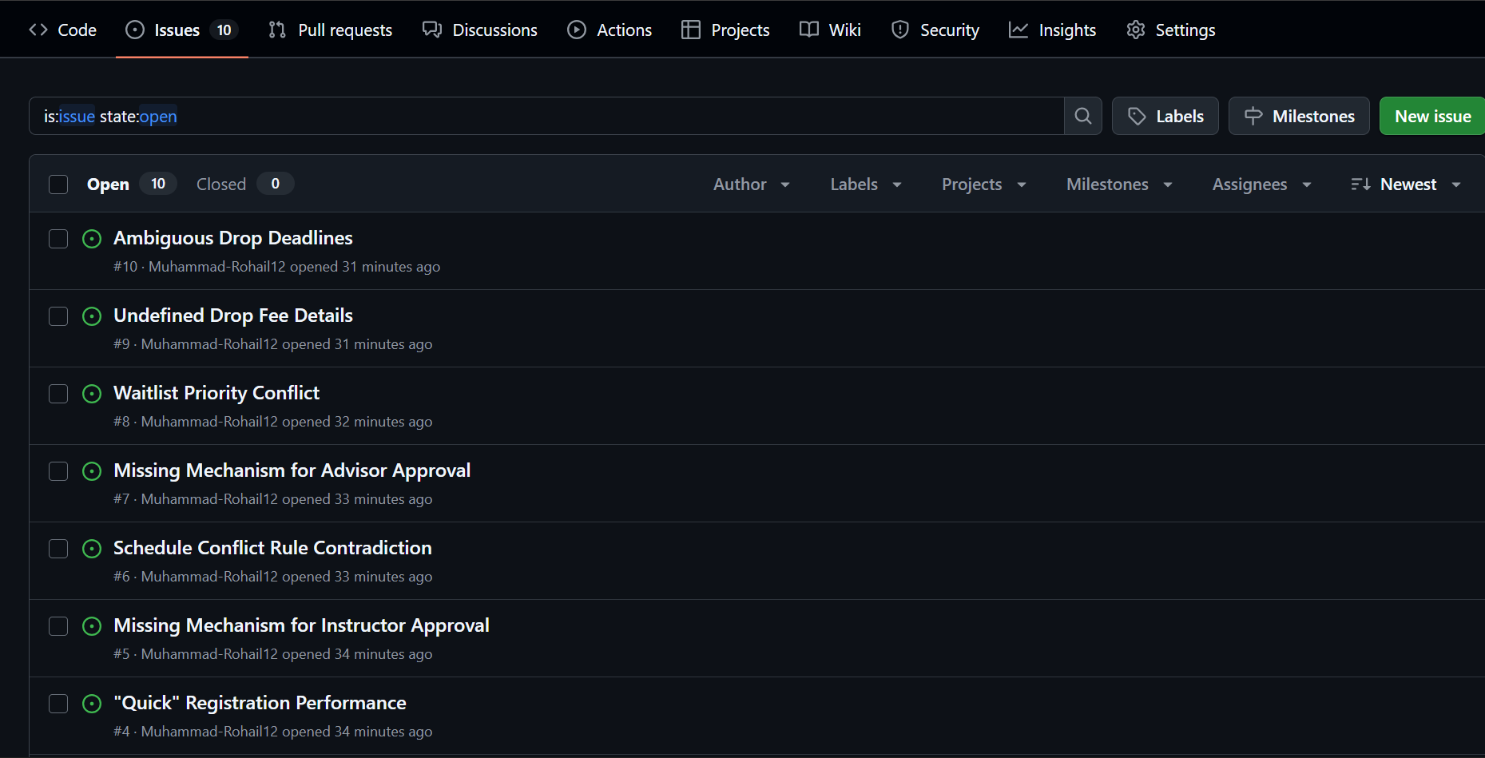

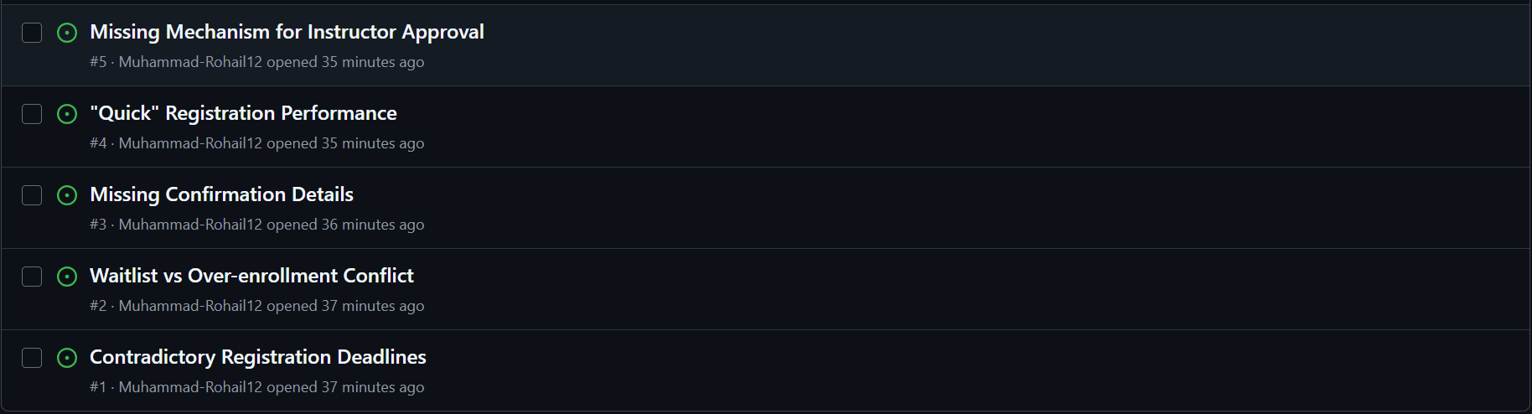

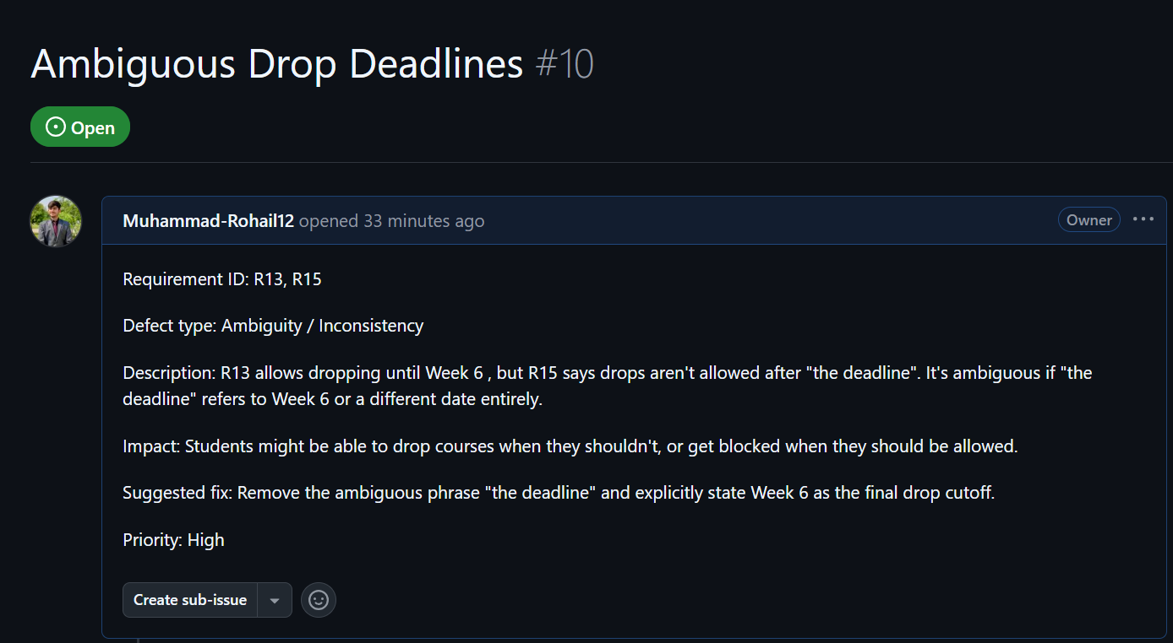

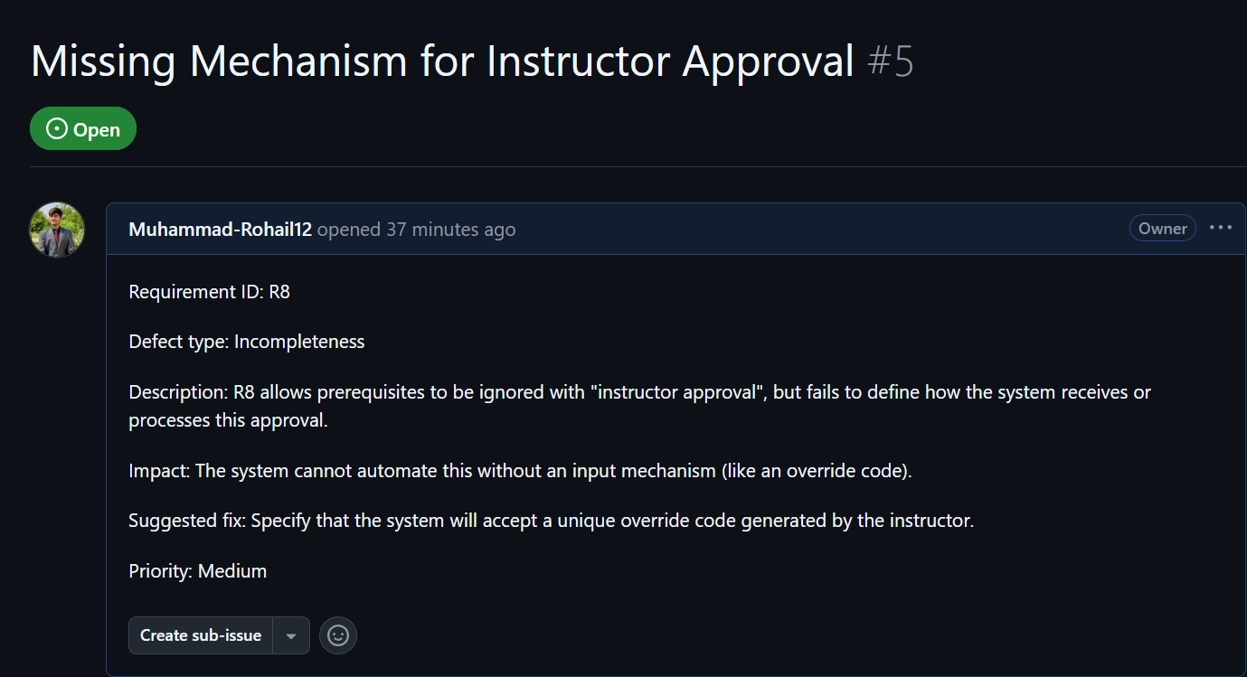

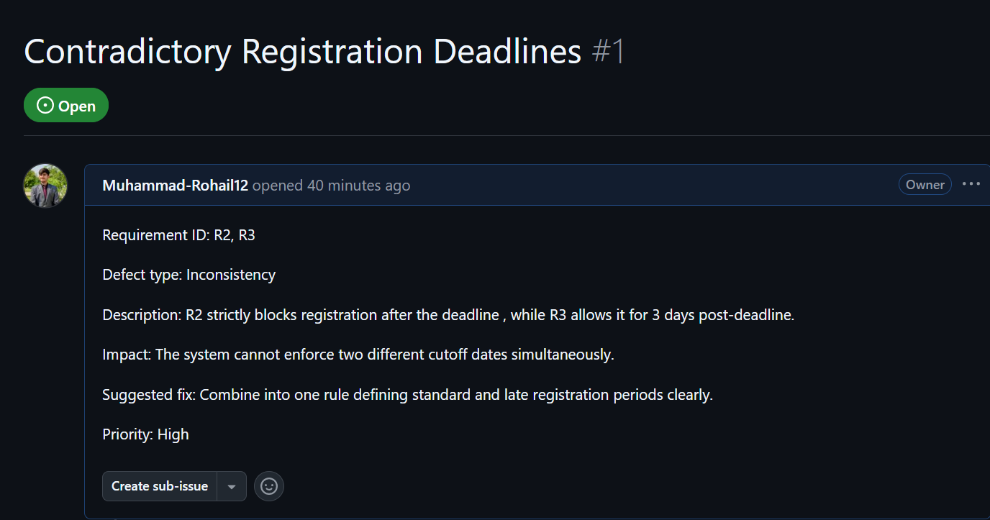
Task C: Rewrite Requirements
For this task, I rewrote 8 of the flawed requirements to make them clear, testable, non-conflicting, and complete.
- (Fixing R2 & R3): The system shall close standard registration on the designated semester deadline but will allow late registration (subject to applicable late fees) for exactly 72 hours immediately following that deadline.
- (Fixing R5 & R16): When a course reaches maximum seat capacity, the system shall block direct registration and instead provide the student with a prompt to join a waitlist.
- (Fixing R6): The system shall automatically send a confirmation email to the student's registered university email address within 5 minutes of a successful course registration or drop.
- (Fixing R9 & R10): The system shall prevent a student from registering for courses with overlapping scheduled times, unless one of the overlapping courses is officially designated in the system as an 'Asynchronous Online' course.
- (Fixing R18 & R19): When a seat becomes available, the system shall enroll waitlisted students in the chronological order they joined, with the exception that 'Final-Year' students shall automatically be prioritized and moved to the top of the waitlist queue.
- (Fixing R14): The system shall automatically add a $50.00 drop fee to the student's financial account balance if a course is dropped after the end of Week 2.
- (Fixing R11 & R12): The system shall restrict standard student registration to a maximum of 18 credit hours per semester, unless an academic advisor inputs an override code on the student's profile to raise the limit to 24 credit hours.
- (Fixing R20): The system shall process a registration request and return a success or failure screen within 3.0 seconds of the user clicking the submit button under standard server load.

