BSCS-II

Dual Axis Solar Tracking System

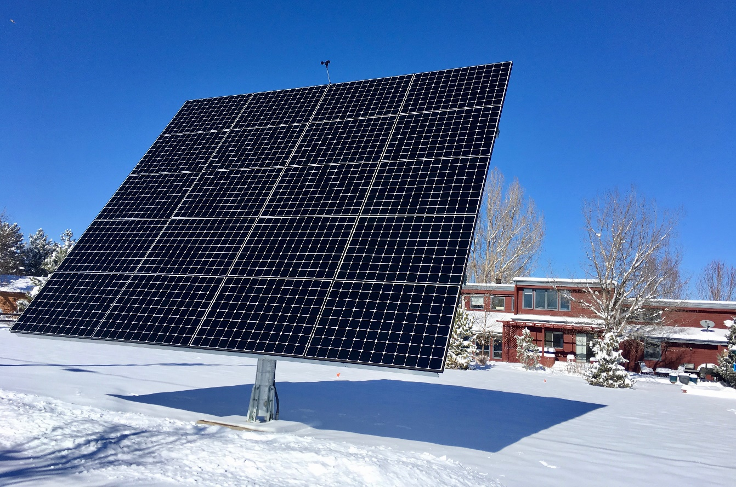

# Dual Axis Solar Tracking System

**BSCS Second Year, Section C (2018)**

***Department of UBIT, University of Karachi.***

**Abstract:**

Solar energy is a renewable, easy to use, readily available, and a sustainable, inexhaustible source of energy. This makes solar technology highly attractive and promising. It uses solar cells to convert solar energy into electrical energy. The most effective way of getting more energy out of a solar panel is to have it track the sun, which makes the smart solar energy tracking system the most apt method of utilizing the maximum possible solar energy through the solar cell, thereby maximizing power generation. We use LDR's (Light Detecting Resistors) as sensors and two servomotors to direct the position of the solar panel, based on the code that is uploaded to the Arduino Uno controller, to achieve active and automated solar energy tracking in real time.

**Introduction:**

A solar tracker is a device that changes its orientation to follow the sun's path and maximize solar energy capture, by directing the photovoltaic solar panel toward the sun to harness more sunlight. The basic idea of a solar tracker is to be able to tilt the solar panel in the direction that the sun moves, thereby ensuring that it receives the maximum possible solar energy at all times. Tracking systems are classified into two categories based on their type of rotation: Single axis solar tracker and Dual axis solar tracker.

**Background:**

Solar energy has been harnessed by humans since the ancient times, when they would construct homes and buildings in a way to receive the maximum possible sunlight. As of today, our modern world is powered from non-renewable resources like fossil fuels, which not only are unsustainable but also have numerous consequences. The average person cannot produce their own electricity, and has to rely on purchasing it. This is where utilizing solar energy can make a meaningful difference. Solar energy is everywhere, readily available and easily accessible. It can be used to create electricity once relatively simpler equipment is set up, and prevents one from having to rely on purchasing electricity from external energy producers and from facing the many problems like power shortages that come hand in hand. Our project is an attempt to materialize this idea, and showcase the exploitation of solar energy as the cheaper, more efficient and cleaner alternative to the conventional form of energy sources, in the form of a solar tracker.

**Types of Solar Trackers:**

**Single Axis Solar Tracker:** It rotates on one axis, moving back and forth in a single direction. It is relatively much simpler and easier to make, but because its movement is restricted to only one place - either horizontal or vertical - it is less effective in harnessing solar energy and performs less efficiently than its counterpart, the dual axis solar tracker.

**Dual Axis Solar Tracker:** It allows simultaneous rotation along the horizontal and vertical directions. and thus is able to more effectively follow the sun, leading to much better performance and higher power generation.Our project is based on such a dual axis solar tracker.

**Design:**

The solar panel is initially placed flat on the mechanical structure. The panel captures the entire light incident on it and converts it into electrical energy with the help of semiconductor layers. The charge controller, connected directly to the panel, stabilizes the electrical output in order to minimize any fluctuations in the voltage and current values. The charge controller feeds the battery which is charged to its maximum potential.

The central component of the system is the Arudino Uno. The Arduino handles all the logical calculations that are required for the system to perform. A 7 or 9 Volt battery is used to power the Arduino, which takes analog input from LDRs and provides power to the servomotors.

Depending upon the position of the sun, the Arduino analyses the signals received from the LDRs. Depending on which of the two LDRs has more light incident on it, its resistance and hence the magnitude of current flowing into the Arduino will vary. This variation is then translated into the input signals for the motors. The servomotors, which are connected to the shaft that has the panel mounted on it, are responsible for dual axis movement of the panel. This causes the panel to tilt in the direction of the LDR offering the least resistance and thus, ensures that there is maximum light incident on the panel. This significantly increases the quantity of light energy captured and converted into electricity.

Two micro servos in the 9g size have been used. Four light sensitivity detecting resistors, also known as LDRs, act as the sensors. They work by adjusting their resistance level based on how much light strikes them. The more light, the less resistance they have. The system program works by comparing the resistance of the four sensors and moving the servos. The sensitivity of the sensors completely depends on the code. Likewise with servos, the code is set up such that they can only move within a certain predefined area (to prevent possible damage to the rest of the project) and at a set speed. These two aspects can be controlled by making changes to the code that is uploaded to the Arduino.

The charge controller is placed between the output of the solar panel and the input of the battery. When the intensity of sunlight is high the solar panel produces more electrical output, and when sunlight is less intense the output of the panel is less. Charge controller is used to stabilize the variation in electrical input to the battery. It also prevents over charging of the battery thereby increasing its life span.

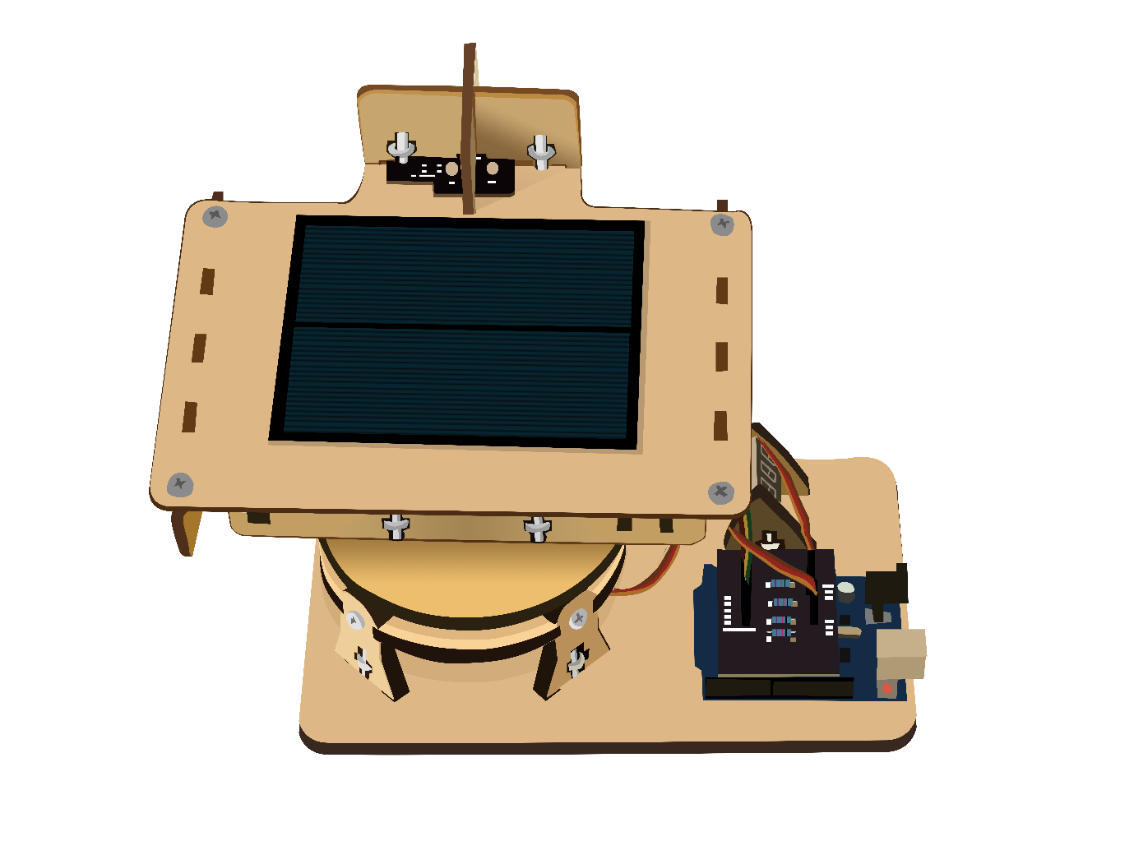

Software Programming of the Arduino Uno:

STEP 1: Start

STEP 2: Declare Servo horizontal and vertical

STEP 3: SET servo horizontal with 180

STEP 4: SET Horizontal servo Limit high with 180

STEP 5: SET Horizontal servo limit low with 65

STEP 6: SET servo vertical with 45

STEP 7: SET Vertical Servo limit high with 80

STEP 8: SET Vertical servo limit low with 15

STEP 9: Connect top left LDR with analog pin number 0

STEP 10: Connect top right LDR with analog pin number 1

STEP 11: Connect down left LDR with analog pin number 2

STEP 12: Connect down right LDR with analog pin number 3

STEP 13: FUNCTION setup

STEP 13.1: Connect Servo Horizontal with pin number9

STEP 13.2: Connect Servo Vertical with pin number10

STEP 13.3: SET Servo Horizontal with 180

STEP 13.4: SET Servo Vertical with 45

STEP 13.5: Apply delay function

STEP 14: End setup FUNCTION

STEP 15: FUNCTION Loop

STEP 15.1: READ all LDR values and assign into a variable

STEP 15.2: SET delay time with 10

STEP 15.3: SET Tolerance with 50

STEP 15.4: SUM Top left and top right LDR values

STEP 15.5: Take average above sum by divided by 2 and assign into a variable

STEP 15.6: SUM down left and top right LDR values

STEP 15.7: Take average above sum by divided by 2 and assign into a variable

STEP 15.8: SUM Top left and down left LDR values

STEP 15.9: Take average above sum by divided by 2 and assign into a variable

STEP 15.10: SUM Top right and downright LDR values

STEP 15.11: Take average above sum by divided by 2 and assign into a variable

STEP 15.12: Take difference between variable of step 15.5 and 15.7

STEP 15.14: Take difference between variable of step 15.9 and 15.11

STEP 15.15: PRINT variable of STEP 15.5 by serial communication

STEP 15.16: PRINT variable of STEP 15.7 by serial communication

STEP 15.17: PRINT variable of STEP 15.9 by serial communication

STEP 15.19: PRINT variable of STEP 15.11 by serial communication

STEP 15.20: PRINT delay time by serial communication

STEP 15.21: PRINT tolerance by serial communication

STEP 15.22: IF (-1* tolerance is greater than vertical difference OR vertical difference

Is greater than tolerance)

STEP 15.22.1: IF Average top is greater than average down

STEP 15.22.1.1: SET Servo vertical = Servo vertical+1

STEP 15.22.1.2: IF vertical servo is greater than vertical servo limit high

STEP 15.22.1.2.1: SET vertical servo=servo limit high

STEP 15.22.2: ELSE IF Average Top is less than average down

STEP 15.22.2.1: SET Servo vertical = Servo vertical-1

STEP 15.22.2.2: IF vertical servo<vertical servo limit high

STEP 15.22.2.2.1: SET vertical servo=servo limit low

STEP 15.22.3: WRITE servo vertical on vertical

STEP 15.23: IF (-1* tolerance is greater than horizontal difference OR horizontal difference

Is greater than tolerance)

STEP 15.23.1: IF Average left is greater than average right

STEP 15.23.1.1: SET Servo horizontal = Servo horizontal-1

STEP 15.23.1.2: IF horizontal servo is less than horizontal servo limit high

STEP 15.23.1.2.1: SET horizontal servo=servo limit low

STEP 15.23.2: ELSE IF Average left is less than average right

STEP 15.23.2.1: SET Servo horizontal = Servo horizontal+1

STEP 15.23.2.2: IF horizontal servo is greater than horizontal servo limit high

STEP 15.23.2.2.1: SET horizontal servo=servo limit high

STEP 15.23.3: WRITE servo horizontal on horizontal

STEP 15.24: Apply delay function with parameters of delay time

STEP 15.25: END

**Conclusion:**

Dual-axis tracking utilizes solar panels with relatively greater efficiency, generating 40% more power from each panel. The same power can be attained with fewer panels or frames, thus reducing the project's upfront costs. Alternatively, the same number of panels as originally planned can be used while generating 40% more power. Either of the two methods can be employed depending on the ultimate objectives and the financial specifics of the project.

**Acknowledgement:**

Our special thanks and sincere gratitude to Mr Khurram Iqbal, from the Institute of Space and Planetary Astrophysics of the University of Karachi, whose courteous encouragement and guidance was the foremost contribution to this educational project.

References:

<https://www.browndoggadgets.com/pages/dual-axis-solar-tracker>

<https://www.solarpowerworldonline.com/2017/09/dual-axis-solar-tracker/>

<http://www.instructables.com/id/Simple-Dual-Axis-Solar-Tracker/>