

SOFTWARE REQUIREMENT SPECIFICATION

STUDENT ADMISSION MANAGEMENT SYSTEM

Date: 7.March.2022

Prepared by:

Arshiya Tariq 16252005

Syed Ali Hussain Naqvi

Muhammad Salman

Ziyad Hussain

**Table of Content**

**1.INTRODUCTION**

**1.1Purpose:**

The main objective of the project is to provide the admission to the users(students) in a simple way. This project is useful for students and institutions for getting the admissions in simple manner. By a result analyzer with subject status and marks is an application tool for displaying the results in secure way.

The system is intended for the student. And the privileges that are provided to student are to read and execute his/her result by providing user name and password for secure login and in case of new student the registration is available. And the guest user has the privilege only to read.

The whole admission analyzer will be under the control of the administrator and the school server as the full privileges to read, write and execute the result. And admin gives the privileges to the student and the guest user to access the result. The student can share or download his/her result.

**System Feature**

**Users / Actors of System**

1. Student
2. Admin
3. School Server
4. Student Features (Privileges)

* He/she needs to create an account.
* He/she add personal information in admission form.
* He/she submit admission form.
* He/she giving online entry test on website
* Generate/Download fee voucher.
* Generate/Download Report of Entry Test Results and Percentage in PDF Format
* Generate/Download Report of all Results in PDF Format

1. Admin Features(privileges)

* He/she is a super user who enjoys all the privileges .
* Add, Update, Display or Delete Students Data .
* Add, Update, Display or Delete Student Admission.
* View Results of each student and their Percentage.
* Download Result Report as PDF format.
* Backup and Restore Records of students.

1. School Server Feature (Privileges)

* He/she have an access to saw everyone account.
* He/she declare result of entry test

**Functional Requirements of** **Student Admission management System**

Now we can mention all the functional requirements for student admission management system and define some of them. The functional requirements for student admission management system are given below

* It is necessary to create an account.
* Student shall give an entry test.
* Result will be provided on student portal.
* Admin shall Maintain Records
* Admin shall Maintain Student Records.

**Non-Functional Requirements of Student Admission management System**

* In this system, the authentication of the user is an important factor. In this system, user authentication will be done by login by user name and password and classified by user type. Users will get access to the system as permissions are classified for that type of user.
* The system has a consistent interface so that the system is easy to use and in the interface of our system buttons and forms are used to enter data related to a specific module.

**Inverse Requirements of Student Admission management System**

* He/she who obtained less than 50% marks in entry test don’t show their result on website.
* He/she don’t have Transfer Certificate don’t give them admission.

**Hardware Requirements of the College Management System**

**System:** P IV or above.

**RAM:** 1GB or above.

**Hard Disk:** 10GB or above.

**Operating System:** Windows& or above.

**Software platform:** Visual studio 2010, SQL Server, .Net Framework 3.5.

**[Meeting with** **School management] meeting minutes**

|  |  |
| --- | --- |
| Location: | [at Al Jauhar Grammar School] |
| Date: | [27th Feb 2022] |
| Time: | [11:00 AM ] |
| Attendees: | [Mr. Syed Ali Hussain Naqvi, Miss Arshiya Tariq, Mr. Muhammad Salman, Mr. Ziyad Hussain] |
|  | [Sir Mairaj ( Principal ), Sir Kashan (Admin)] |

**Agenda items**

1.Collect information about existing system.

2.Discuss the features of admission system.

3.Discuss the reasons for shifting from Existing system to the new system.

4.Discuss the admission policy and criteria.

**Meetings Notes**

•School management uses Ms. Access based admission system and keeps the records in excels.

•Current system has a GUI Student Entry form and Fees voucher is generating thorough excel sheet manually. Student get fee voucher from school.

•Management tired of using MS excels and MS access and want to reduce work load.

•All the data is on local HDD of school admin PC. Online cloud database is needed

•For New system Student can apply online for admission as the school wants to reduce work load.

•Student can generate fee voucher online and submit fees in any HBL bank branch.

•Montessori student do not require entry test.

•Minimum age for admission is 4 years in Montessori. It can be changed in future therefore Admission system has customized settings for admission criteria for each class.

•Students get registered by using online system.

•System should select students according to criteria (Entered in admission criteria section) and give list of students eligible for admission test.

•Teacher can enter marks of admission test against each student.

•And system should capable of selecting students based on their test marks and admission criteria.

•Admin can select and reject student manually.

•Reports are needed. Report should show the percentage of students failed and passed.

**Conclusion**

School Management currently using MS access-based admission system, and want to upgrade to well managed online plate form, where students can register online ,apply online, generate fees voucher online and they can see their Entry test results on line. Admin can manage admission system, admission policies/criteria and student database

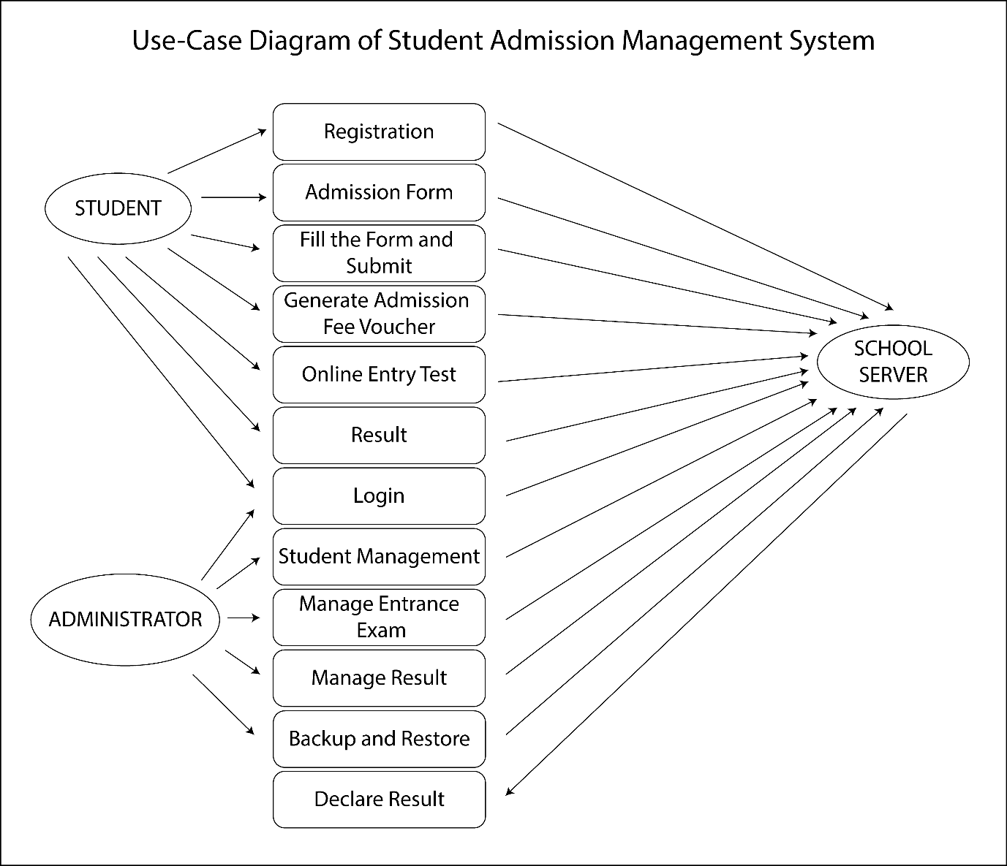

Use case diagram of Student Admission management System application software is used by three categories of school server, administrators and students.