Muhammad Salman

IU05-0322-0038

Assignment-3

QUESTION 1)

Digital Clock with 7-Segment Display
- Scenario: Build a digital clock that displays hours and minutes (HH:MM).
- Task: Interface the AVR with four common-cathode 7-segment displays (using multiplexing for display efficiency). Use a Timer configured to generate a $1\text{ Hz}$ interrupt to increment the seconds counter, which then updates the minutes and hours.
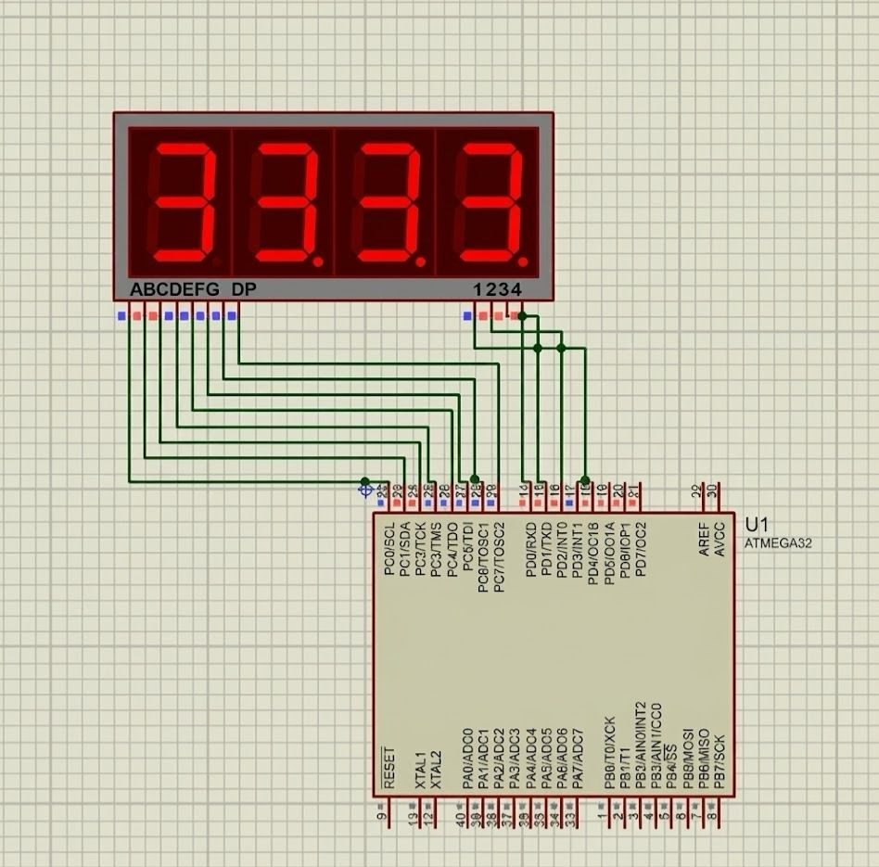

CODE :

#define F_CPU 8000000UL

#include <avr/io.h>
#include <util/delay.h>
#include <avr/interrupt.h>

volatile uint8_t seconds = 0;
volatile uint8_t minutes = 30;
volatile uint8_t hours = 12;

const uint8_t SEGMENT_MAP[] = {
0x3F,
0x06,
0x5B,
0x4F,
0x66,
0x6D,
0x7D,
0x07,
0x7F,
0x6F
};

void timer1_init()
{
TCCR1B |= (1 << WGM12);
TCCR1B |= (1 << CS12);
OCR1A = 31249;
TIMSK |= (1 << OCIE1A);
}

ISR(TIMER1_COMPA_vect)
{
seconds++;

if (seconds >= 60)
{
seconds = 0;
minutes++;

if (minutes >= 60)
{
minutes = 0;
hours++;

if (hours >= 24)
{
hours = 0;
}
}
}
}

void display_digit(uint8_t digit_pos, uint8_t value)
{

PORTD = 0xFF;

PORTC = SEGMENT_MAP[value];

PORTD &= ~(1 << digit_pos);

_delay_ms(5);
}

int main(void)
{

DDRC = 0xFF;
DDRD = 0x0F;
MCUCSR |= (1<<JTD);
MCUCSR |= (1<<JTD);

timer1_init();

sei();

while(1)
{

uint8_t min_ones = minutes % 10;
uint8_t min_tens = minutes / 10;
uint8_t hr_ones = hours % 10;
uint8_t hr_tens = hours / 10;

display_digit(0, min_ones);

display_digit(1, min_tens);

display_digit(2, hr_ones);

display_digit(3, hr_tens);
}
}

QUESTION 2)

Doorbell Simulator with Persistent Ring
- Scenario: A doorbell system where a brief press results in a continuous ring for 3 seconds.
- Task: Use a push button input. When pressed, an output LED (simulating the bell) turns $\text{ON}$ and stays $\text{ON}$ for exactly 3 seconds, then turns $\text{OFF}$.
- Concepts: Timing control (_delay_ms() or simple Timer), Edge detection.

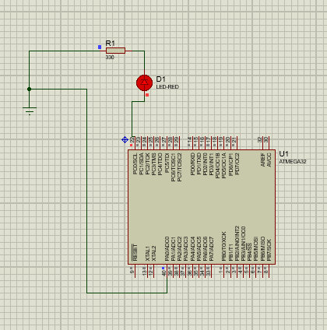

Code :

#define F_CPU 8000000UL // 8 MHz Clock

#include <avr/io.h>
#include <util/delay.h>

int main(void)
{
DDRC |= (1 << PC0); // Set PC0 as Output
PORTC &= ~(1 << PC0); // Initially turn LED OFF

DDRA &= ~(1 << PA0); // Set PA0 as Input
PORTA |= (1 << PA0); // Enable Internal Pull-up Resistor on PA0

while(1)
{
if (!(PINA & (1 << PA0))) // Agar PA0 Low (0)
{
_delay_ms(50);
if (!(PINA & (1 << PA0)))
{
PORTC |= (1 << PC0);
_delay_ms(3000);
PORTC &= ~(1 << PC0);
}
}
}
}

QUESTION 3)

Automatic Pet Feeder Timer
- Scenario: Design a system that dispenses pet food exactly once every 12 hours.
- Task: Use a Timer to track time. When 12 hours have elapsed, activate an output pin (simulating a servo motor or solenoid) for $500\text{ ms}$ to release food, then reset the timer.
- Concepts: Timer/Counter for long time delays, Fixed interval timing.
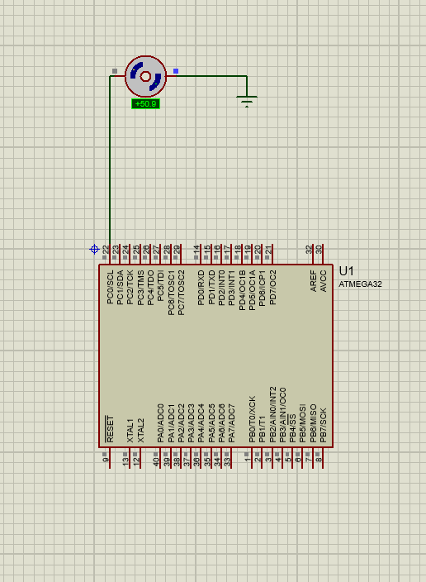
Code :

#define F_CPU 8000000UL

#include <avr/io.h>
#include <avr/interrupt.h>
#include <util/delay.h>

#define FEED_INTERVAL_SECONDS 5

volatile uint32_t seconds_counter = 0;
volatile uint8_t feed_flag = 0;

---
void timer1_init()
{

TCCR1B |= (1 << WGM12);

TCCR1B |= (1 << CS12);
OCR1A = 31249;
TIMSK |= (1 << OCIE1A);
}
ISR(TIMER1_COMPA_vect)
{
seconds_counter++;

if (seconds_counter >= FEED_INTERVAL_SECONDS)
{
feed_flag = 1;
seconds_counter = 0;
}
}

int main(void)
{
DDRC |= (1 << PC0);
PORTC &= ~(1 << PC0);
timer1_init();
sei();

while(1)
{
if (feed_flag == 1)
{

PORTC |= (1 << PC0);

_delay_ms(500);
PORTC &= ~(1 << PC0);
feed_flag = 0;
}
}
}

