**NODEmcu/ESP8266**:

An open source IoT platform. It includes firmware which runs on the ESP8266 Wi-Fi SoC from Espressif Systems, and hardware, which is based on the ESP-12 module.

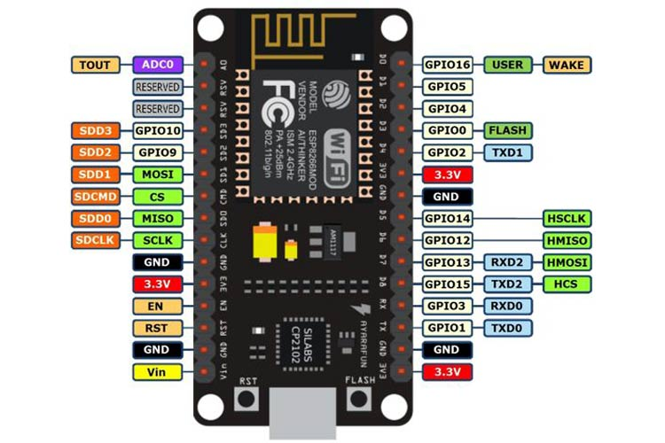

Features:

* Wi-Fi Module – ESP-12E module similar to ESP-12 module but with 6 extra GPIOs.
* USB – micro USB port for power, programming and debugging
* Headers – 2x 2.54mm 15-pin header with access to GPIOs, SPI, UART, ADC, and power pinsMisc – Reset and Flash buttons
* Power – 5V via micro USB port
* Dimensions – 49 x 24.5 x 13mm

**Smoke sensor**:

MQ2 is one of the commonly used gas sensors in MQ sensor series. It is a Metal Oxide Semiconductor (MOS) type Gas Sensor also known as Chemiresistors as the detection is based upon change of resistance of the sensing material when the Gas comes in contact with the material. Using a simple voltage divider network, concentrations of gas can be detected.

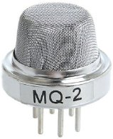

It can detect LPG, Smoke, Alcohol, Propane, Hydrogen, Methane and Carbon Monoxide concentrations anywhere from 200 to 10000ppm

**Water Level Indicator:**

The Water Level Indicator employs a simple mechanism to detect and indicate the water level in an overhead tank or any other water container.

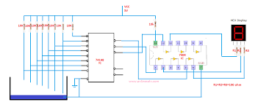

The sensing is done by using a set of nine probes which are placed at nine different levels on the tank walls (with probe 9 to probe 1 placed in increasing order of height, common probe (i.e. a supply carrying probe) is placed at the base of the tank). The level 8 represents the “tank full” condition while level 0 represents the “tank empty” condition.

**Burglar alarm:**

A burglar alarm is basically an intruder alert system used to prevent theft/robbery and protect one’s premises. Burglar alarms or alert systems can be designed in different ways; from very simple sound alarm system to the advanced and feature rich system which will send SMS alerts, activate sound alarm, turn ON lights, turn ON CCTV cameras, close the main gate etc. The cost of building burglar alarm will go up with more features and new 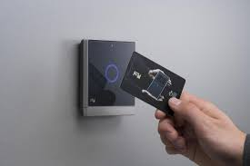technologies incorporated into the system.

Here we are trying to implement a simple magnetic sensor attached to the door, which gets triggered when opened without authentication. An RFID is given to the members, so they can authenticate their entry.

**Cloud computing:**

We connect the home with the family staying there through the technology of cloud computing.

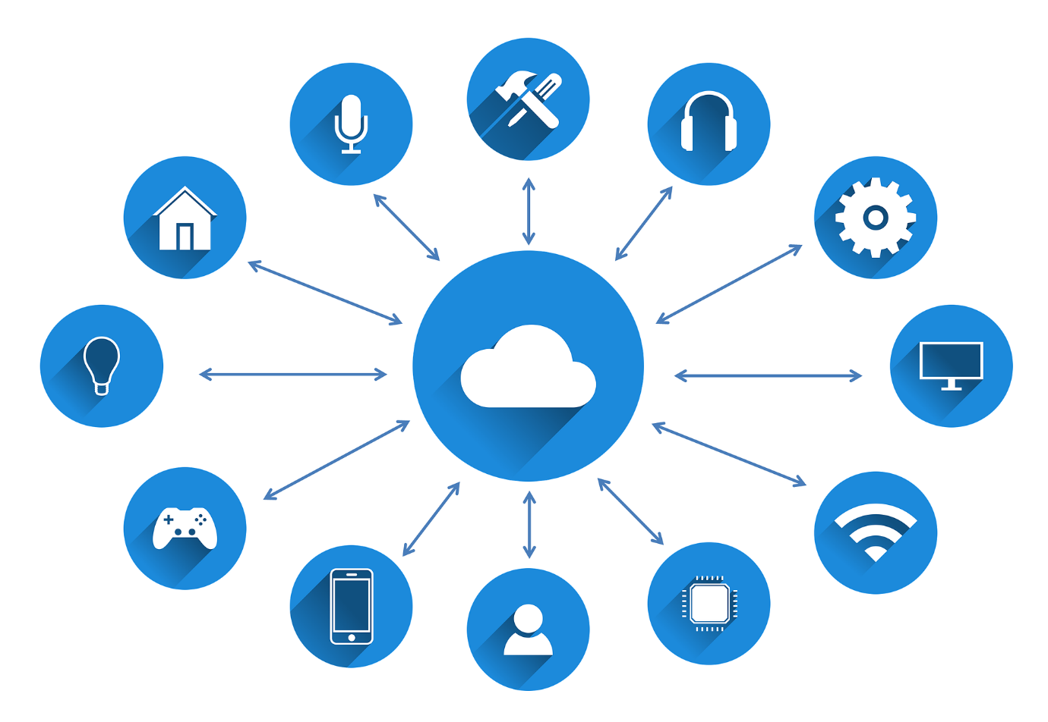

They are able to completely assess the data of mostly everything in the house and their current status. Moreover, they will be able to control the working of all these components remotely through any authenticated device.