

# **Comsats University Islamabad**

# **Lahore Campus**

**Subject:**

**Object Oriented Programming**

**Submitted to:**

**Sir Shahid Bhatti**

**Submitted by:**

**Muhammad Sameer Yaseen**

**Registration No:**

**SP24-BSE-085**

**Section:**

**A**

**Assignment NO 02**

**Question:**

**Make a data entry form using JavaFX.**

**LAYOUT**

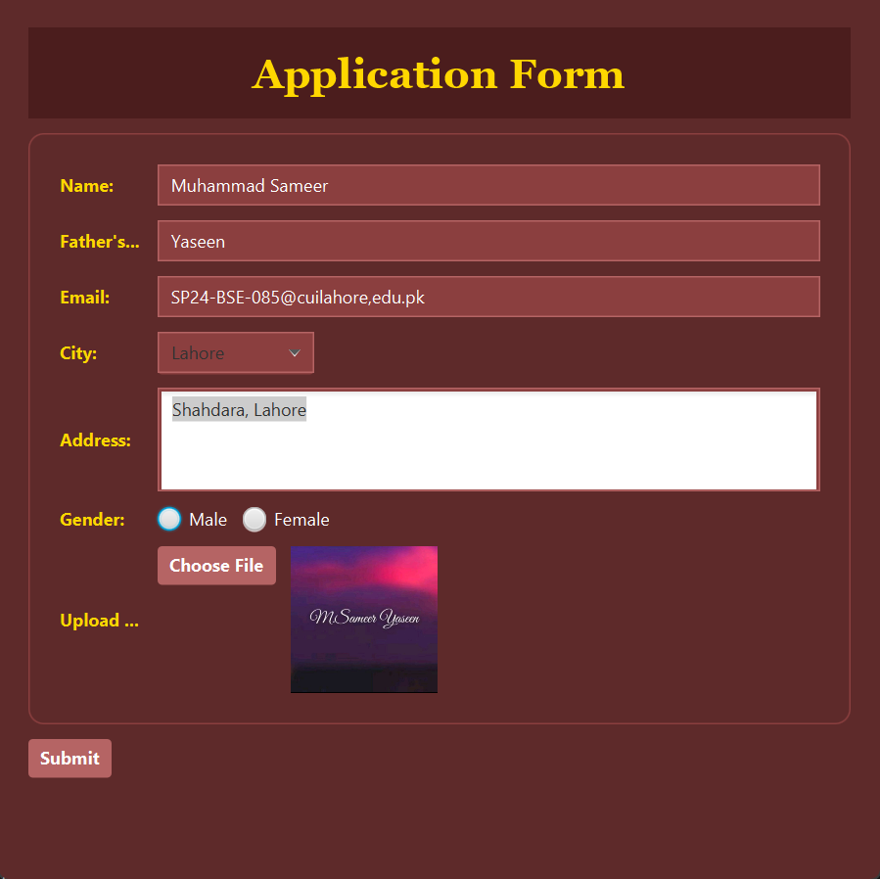

**Submitted Data**

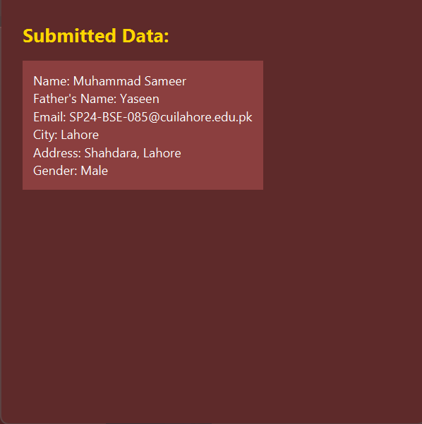

**Snippets**

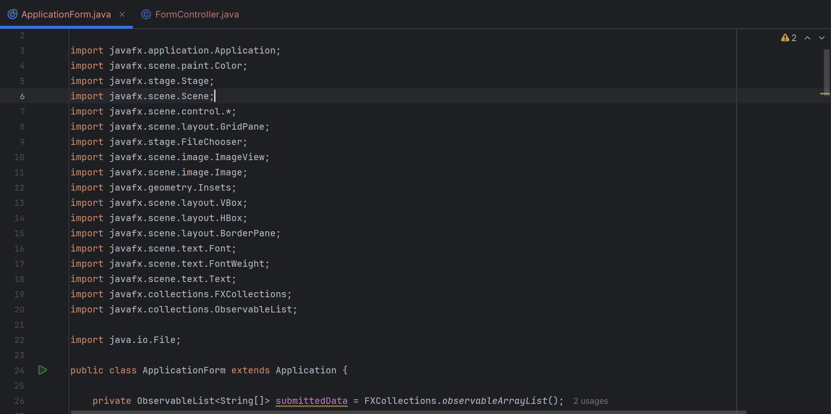

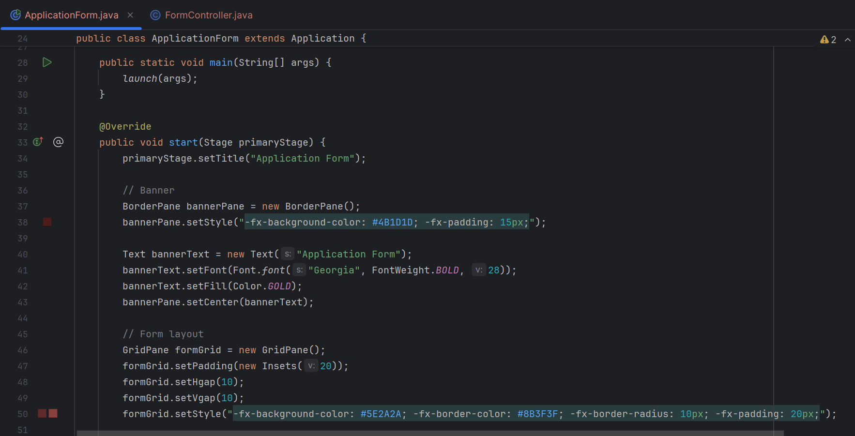

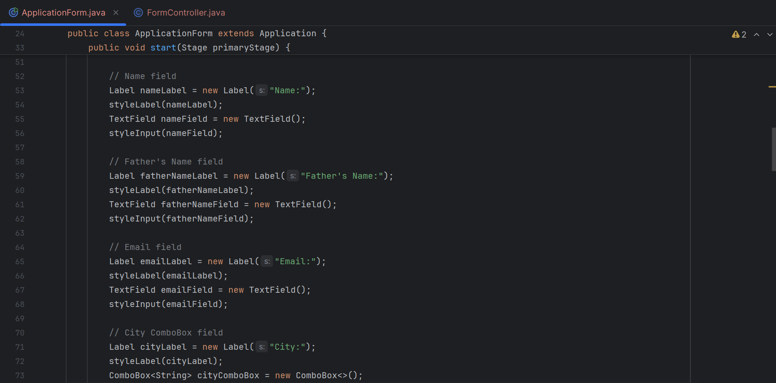

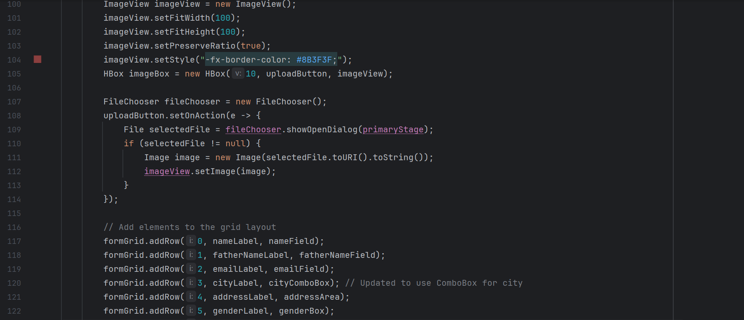

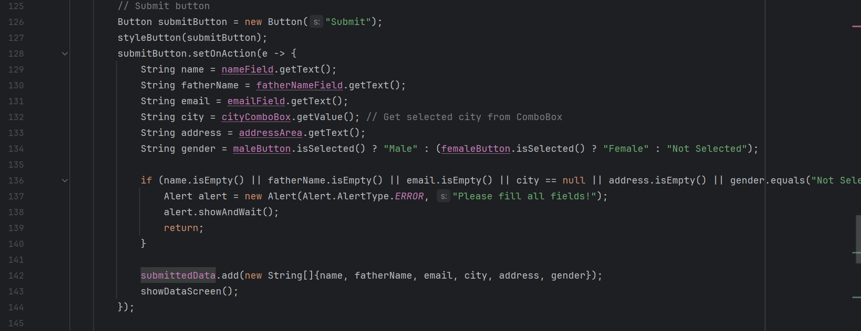



**Zip file:**

