Big O Notation
Made by shah fahad
- What is Big O Notation?
Big O focuses on the worst case scenario. If you are searching for a name in phonebook, Big O assume the name is one the very last page. It ignores small details and focuses on the big picture.

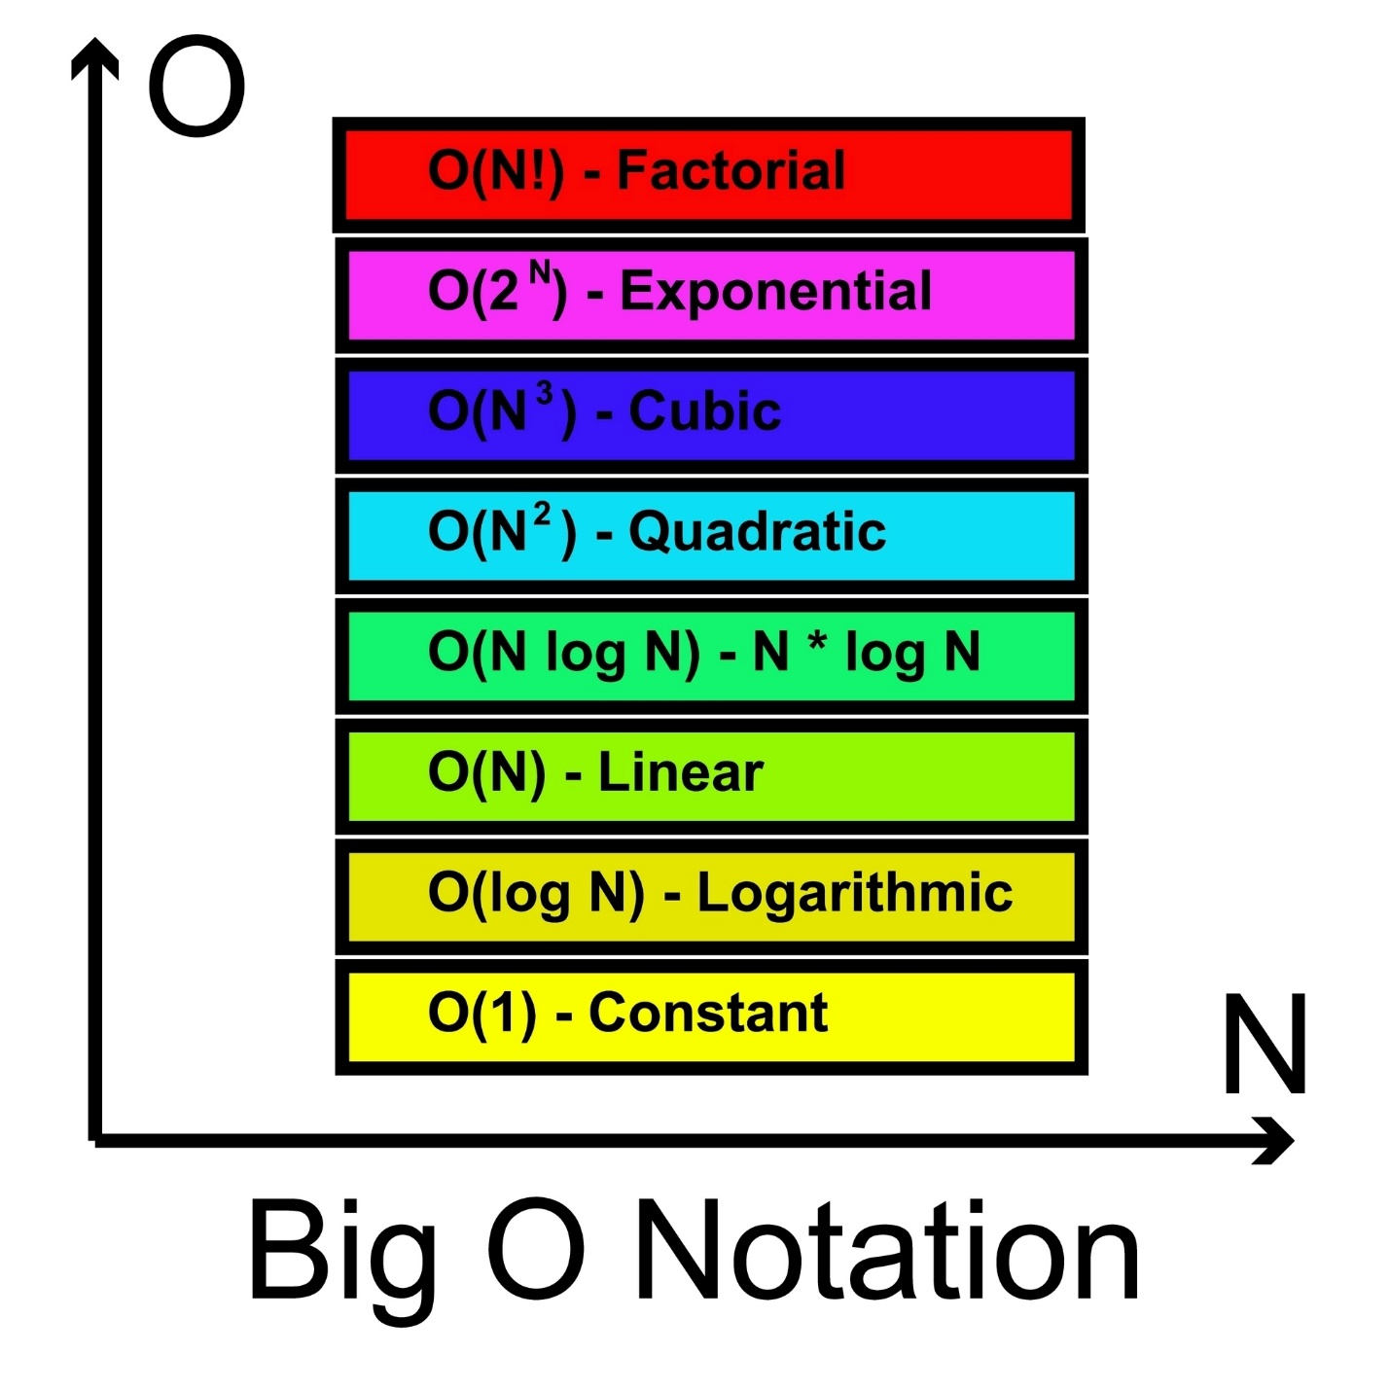

- According to the time equation.
Time= a * n + b.
def simple_loop(n):
x = 10 # Step 1
for i in range(n): # Step 2
print(i) # Step 3
Where:
Suppose that we have to deliver 1000 pizzas .
b -> fixed time : Time taken to start bike and packing the pizzas etc.
a -> time per unit -> Time taken to deliver one pizza.
n -> quantity -> how many pizza we have to deliver.

- We do not write O(a*n + b). We have to convert it, in order to do so we have 2 Rules.
- Keep the fastest growing term
If n = one million
And a=2
1million *2= 2 million
Here b is nothing to do with it so we remove b
Time = a *n
- Drop the constant
Here we identify that which term is making the equation bigger. Here a is doing that.
Time = n
Or time = O(n)
- We have to know these
- O(1)- constant time
The code take the same amount of time regardless of whether you have 10 items or million.
def get_first_item(items): return items[0] # Always 1 step

- O(n) – Linear time
If the list grows by n, the time grows by n
def print_all_items(items):
for item in items: # Runs 'n' times
print(item)

- O(n^2) – Quadratic time
Usually seem with nested loops. If you have 10 items, it take 100 steps
def print_pairs(items):
for first in items: # Runs n times
for second in items: # Runs n times for every 'first'
print(first, second)
- Why Big O ignores a and b:
In Big O, we simplify everything. As n become massive (like a billion), the “+b” becomes insignificant, and the multiplier “a” matters less than the fact that its growing linearly. Thus, an + b is simplified to O(n)

- Suppose that we have to find the duplicate item in the list.

def find_duplicates_slow(nums):
for i in range(len(nums)): # Outer loop: n times
for j in range(i + 1, len(nums)): # Inner loop: n times
if nums[i] == nums[j]: # Comparison
return True
return False
Why O(n^2): You have a loop inside a loop. If you have 100 items, you might perform up to $100 \times 100 = 10,000$ comparisons.
The Math: This follows the Time = an^2 + bn + c logic. Even if we ignore the constants, the n^2 dominates.

2. The "Optimized" Approach (O(n))
In this method, we use a Hash Set. As we look at each number, we "check it off" in our set. Checking a set takes constant time.
Python
def find_duplicates_fast(nums):
seen = set() # Create an empty set
for num in nums: # Loop runs exactly n times
if num in seen: # Checking a set is O(1)
return True
seen.add(num) # Adding to a set is O(1)
return False
Why it's O(n): We only walk through the list once. If there are 100 items, we do roughly 100 steps.
The Trade-off: This is faster, but it uses more Space Complexity because we had to create a set to store the numbers.

3. Comparison for your Word Doc
You can use this table to show the massive difference in "steps" taken as the list of numbers grows:
Number of Elements (n) | Brute Force Steps (n2) | Optimized Steps (n)
10 | 100 | 10
1,000 | 1,000,000 | 1,000
1,000,000 | 1,000,000,000,000 | 1,000,000

- Now we understand space complexity
Binary search it the best example for space complexity

Binary Search is famous for being very fast (O(log n) time), but its space complexity depends entirely on how you write the code.

1. Iterative Binary Search (O(1) Space)
This version uses a simple while loop. It only creates a few variables (low, high, mid) regardless of how big the list is.
Python
def binary_search_iterative(arr, target):
low = 0
high = len(arr) - 1

while low <= high:
mid = (low + high) // 2
if arr[mid] == target:
return mid
elif arr[mid] < target:
low = mid + 1
else:
high = mid - 1
return -1
Space Complexity: O(1) (Constant Space).
Why: Whether the list has 10 items or 10 billion, you only ever need those three integer variables. The memory usage stays "flat."

2. Recursive Binary Search (O(log n) Space)
In recursion, the function calls itself. Each time a function calls itself, the computer adds a "layer" to the Call Stack in memory to keep track of where it is.
Python
def binary_search_recursive(arr, low, high, target):
if low > high:
return -1

mid = (low + high) // 2
if arr[mid] == target:
return mid
elif arr[mid] > target:
# A new "frame" is added to the stack memory here
return binary_search_recursive(arr, low, mid - 1, target)
else:
# A new "frame" is added to the stack memory here
return binary_search_recursive(arr, mid + 1, high, target)
Space Complexity: O(log n) (Logarithmic Space).
Why: For a list of size n, the function will call itself log n times before it finishes. Each call stays in memory until the base case is reached.

Summary for your Word Document
You can use this table to show your readers the trade-off:
Method | Time Complexity | Space Complexity | Why?
Iterative | O(log n) | O(1) | Uses a loop; no extramery for calls.
Recursive | O(log n) | O(log n) | Uses the "Call Stack" for each split.
Analogy for Space Complexity: > Imagine you are organizing a deck of cards.
O(1) Space: You organize them in your hands.
O(n) Space: You need to lay every card out on a separate table to see them all at once. The "table space" you need grows as your deck grows.

Would you like me to help you format a "Cheat Sheet" section that combines both Time and Space complexity for all common algorithms?

