
The Islamia University of Bahawalpur
Department of Data Science
Bachelor of Science in Data Science

AI Powered Clinical decision support system for multi-class disease detection
Final Year Project Reports
Submitted By
Muhammad Shahid Asghar
F22BDATS1M02033
Session: Fall 2022–2026
Supervisor: Dr. Akmal Khan
Department of Data Science, The Islamia University of Bahawalpur

Declaration
I, Muhammad Shahid Asghar (Roll No. F22BDATS1M02033), hereby declare that this Final Year Project report is my original work and has not been submitted elsewhere for any degree or examination. All sources of information have been duly cited and acknowledged in the references.

Signature: ____________________________
Name: Muhammad Shahid Asghar
Date: ____________________________

Supervisor’s Certificate
This is to certify that the work presented in this Final Year Project report has been carried out by Muhammad Shahid Asghar (Roll No. F22BDATS1M02033) under my supervision. The work is original and satisfactory.

Supervisor Signature: ____________________________
Name: Dr. Akmal Khan
Department of Data Science, The Islamia University of Bahawalpur
Date: ____________________________

Acknowledgements
First and foremost, all praise is due to Allah (SWT), without Whose mercy nothing is possible. I am deeply grateful to my supervisor, Dr. Akmal Khan, who guided me at every step. His feedback sharpened both my thinking and my writing. I also thank the faculty of the Department of Data Science at The Islamia University of Bahawalpur for their support throughout my degree. My parents deserve special mention — their patience and encouragement kept me going during long nights of training models. Finally, I acknowledge the open-source communities behind PyTorch, timm, and the ISIC Archive. This project would not exist without their work.

Abstract
Skin diseases are common, but access to a dermatologist is not — especially in countries like Pakistan. This project builds DeepMediScan, an AI prototype that looks at a skin image and suggests a possible diagnosis from 11 categories (10 diseases plus normal skin). We trained four models — EfficientNet-B0, EfficientNet-B4, ResNet-50, and MobileNetV3-Large — on 25,312 dermoscopic images from the ISIC Archive. To handle unequal class sizes, we used three techniques: WeightedRandomSampler, CutMix augmentation, and label smoothing. The best model, MobileNetV3-Large, reached an AUC-ROC of 0.9757 with 84.35% accuracy. It performs very well on dangerous conditions — Melanoma AUC=1.000 and BCC AUC=0.995. All four models run through a FastAPI server. Users can choose a single model or let the system combine all four into an ensemble. Every prediction includes a confidence score and a clear clinical disclaimer. This is a research prototype. It has not been clinically validated and should never replace a doctor’s judgment.

Keywords: Skin Disease Detection, EfficientNet-B0, EfficientNet-B4, ResNet-50, MobileNetV3, Multi-Model Ensemble, Transfer Learning, CutMix, ISIC Dataset, FastAPI, Clinical Decision Support

TABLE OF CONTENTS

Declaration ........................................................................................... 2

Supervisor's Certificate ........................................................................ 3

Acknowledgements .............................................................................. 4

Abstract ................................................................................................ 5

Table of Contents ................................................................................. 6

List of Figures ....................................................................................... 7

List of Abbreviations ............................................................................. 8

1. Introduction ...................................................................................... 9

1.1 Problem Statement .................................................................... 9

1.2 Project Objectives ...................................................................... 9

1.3 Significance ................................................................................ 9

1.4 Scope and Limitations ............................................................... 10

2. Background ...................................................................................... 11

2.1 Dermatological Disease Burden and Need for Screening .......... 11

2.2 Dermoscopy and Clinical Image Characteristics ........................ 11

2.3 Deep Learning for Medical Image Classification ........................ 11

2.4 EfficientNet and Compound Scaling ........................................... 11

2.5 Evaluation Metrics for Clinical AI ................................................ 11

2.6 Class Imbalance and Augmentation ........................................... 12

2.7 Ethical and Clinical Constraints .................................................. 12

3. Literature Review .............................................................................. 13

3.1 Deep Learning in Medical Imaging ............................................. 13

3.2 Skin Disease Classification — Recent Work (2024–2026) ........ 13

3.3 Explainability: Grad-CAM for Dermatology (2024–2026) ........... 14

3.4 Fairness and Skin Tone Bias (2024–2026) ................................ 14

3.5 Dataset Quality, Leakage, and External Validation .................... 14

3.6 Gaps Addressed in This Project ................................................. 14

4. Dataset and Preprocessing .............................................................. 15

4.1 Dataset Description — ISIC Archive ........................................... 15

4.2 Class Imbalance Handling .......................................................... 15

4.3 Data Leakage Check — Planned Next Step .............................. 15

4.4 Preprocessing Pipeline ............................................................... 16

5. Model Architecture and System Design ........................................... 17

5.1 Multi-Model Architecture ............................................................. 17

5.2 Two-Phase Fine-Tuning ............................................................. 18

5.3 System Architecture ................................................................... 18

6. Implementation Details ..................................................................... 19

6.1 Training Configuration ................................................................ 19

6.2 API Endpoints ............................................................................. 19

7. Experimental Results ........................................................................ 20

7.1 Training Progression .................................................................. 20

7.2 Per-Class Results (Best Epoch) ................................................. 20

7.3 Comparison with Recent Baselines (2024–2026) ...................... 21

7.4 Claims Rewritten Per Expert Review .......................................... 21

7.5 Ablation Study — Planned Next Step ......................................... 21

7.6 Multi-Model Training Results ...................................................... 22

8. Discussion, Limitations, Ethics and Deployment .............................. 27

8.1 Strengths .................................................................................... 27

8.2 Limitations .................................................................................. 27

8.3 Ethical Considerations ................................................................ 28

8.4 Deployment Plan ........................................................................ 28

8.5 Risk Controls .............................................................................. 28

9. Conclusion ........................................................................................ 29

Appendix A — Revision Checklist ........................................................ 30

References ........................................................................................... 31

List of Figures
Figure 1: EfficientNet-B0 Architecture Overview
Figure 2: Training and Validation Accuracy Curves (30 Epochs)
Figure 3: Validation AUC-ROC Curve
Figure 4: Confusion Matrix — Count and Percentage Heatmap
Figure 5: Per-Class ROC Curves
Figure 6: Per-Class Precision, Recall, and F1-Score Bar Chart
Figure 7: System Architecture — FastAPI + Web Interface
Figure 8: Comparison of This Project vs Recent Baselines (2024–2026)
Figure 9: EfficientNet-B0 — Training History (Loss, Accuracy, AUC-ROC over 30 Epochs)
Figure 10: EfficientNet-B0 — Per-Class AUC-ROC (Mean AUC = 0.9705)
Figure 11: EfficientNet-B0 — Confusion Matrix (Count and Percentage)
Figure 12: EfficientNet-B4 — Training History (Loss, Accuracy, AUC-ROC over 30 Epochs)
Figure 13: EfficientNet-B4 — Per-Class AUC-ROC (Mean AUC = 0.9565)
Figure 14: EfficientNet-B4 — Confusion Matrix (Count and Percentage)
Figure 15: ResNet-50 — Training History (Loss, Accuracy, AUC-ROC over 30 Epochs)
Figure 16: ResNet-50 — Per-Class AUC-ROC (Mean AUC = 0.9700)
Figure 17: ResNet-50 — Confusion Matrix (Count and Percentage)
Figure 18: MobileNetV3-Large ★ — Training History (Best Model, AUC = 0.9757)
Figure 19: MobileNetV3-Large ★ — Per-Class AUC-ROC (Mean AUC = 0.9757)
Figure 20: MobileNetV3-Large ★ — Confusion Matrix (Count and Percentage)
Figure 21: Multi-Model Comparison — AUC-ROC Summary (All 4 Models)

List of Abbreviations
Abbreviation | Full Form
AI | Artificial Intelligence
AMP | Automatic Mixed Precision
AUC-ROC | Area Under ROC Curve
BCC | Basal Cell Carcinoma
CNN | Convolutional Neural Network
DDI | Diverse Dermatology Images
ECE | Expected Calibration Error
FST | Fitzpatrick Skin Type
FYP | Final Year Project
ISIC | International Skin Imaging Collaboration
ONNX | Open Neural Network Exchange
REST | Representational State Transfer
TFLite | TensorFlow Lite
WRS | WeightedRandomSampler
XAI | Explainable Artificial Intelligence

1. Introduction

1.1 Problem Statement
Skin diseases affect over 900 million people at any given moment [R7]. Yet in Pakistan, fewer than 500 certified dermatologists serve a population of 220 million. Most of them work in cities. If you live in a rural area, getting a proper skin diagnosis can take months — or simply never happen. Recent studies from 2024 and 2025 confirm that AI-based screening tools are the most practical solution to this gap [R16, R17]. This project is our response to that problem. We built DeepMediScan — a system that takes a skin image and classifies it into one of 11 categories using four deep learning models. It is not a replacement for a doctor. It is a first-look tool that can help flag serious conditions early.

IMPORTANT: DeepMediScan is a research prototype built for screening support only. It must never replace a doctor’s diagnosis.

1.2 Project Objectives
- Train four models — EfficientNet-B0, EfficientNet-B4, ResNet-50, and MobileNetV3-Large — to classify 11 skin categories from ISIC dermoscopic images
- Handle class imbalance using WeightedRandomSampler, CutMix, and label smoothing
- Hit AUC-ROC above 0.97 and accuracy above 80% as prototype targets
- Serve all four models through a FastAPI backend connected to a web interface with user login
- Return the top three most likely diagnoses with confidence scores and a clinical disclaimer on every response
- Compare our results honestly against published baselines from 2024–2026 [R1, R3, R4, R5]

1.3 Significance
Catching melanoma early makes a huge difference. At Stage I, the 5-year survival rate is over 98% [R7]. Catch it late, and that number drops dramatically. A 2024 review in JAMA Dermatology looked at 41 AI skin apps and found most of them lack proper clinical evidence, dermatologist input, and privacy protection [R15]. We took that criticism seriously. This project puts disclaimers first and does not make claims it cannot back up. AI-based skin screening is now standard practice in many countries [R8, R9], but skin tone bias remains a real and unsolved problem.

1.4 Scope and Limitations
This project classifies dermoscopic images into 11 categories using four models. The results come from a single validation split. They cannot be generalized until tested on external data. We have not done clinical trials, fairness testing across skin tones, or calibration analysis. These are honest limitations — not oversights. They are all documented as required future work.
2. Background

2.1 Dermatological Disease Burden and Need for Screening
Skin disease is one of the most common health problems in the world. It ranks fourth among all causes of nonfatal disease burden globally [R10]. In Pakistan and many other developing countries, there simply are not enough dermatologists. People wait months for an appointment — if they can get one at all. A 2024 industry review found that even Belgium, a wealthy European country, has months-long dermatology waiting lists [R16]. AI tools on smartphones are now being certified as medical devices in Europe. The need for accessible, affordable screening is real and urgent.

2.2 Dermoscopy and Clinical Image Characteristics
A dermoscope is a handheld device that uses polarized light and magnification to see beneath the skin surface. It reveals patterns that are invisible to the naked eye. The images it produces look very different from ordinary photos — different lighting, color balance, and common artifacts. A 2025 study pointed out that color values extracted from dermoscopic images correlate poorly with actual skin colorimetry [R9b]. This matters for preprocessing and for fairness across skin tones.

2.3 Deep Learning for Medical Image Classification
Convolutional Neural Networks learn to recognize visual patterns layer by layer. Lower layers pick up edges and colors. Deeper layers learn complex shapes and textures. Transfer learning lets us start with a model already trained on millions of images (ImageNet) and fine-tune it on our smaller skin disease dataset. This saves enormous time and compute. A 2025 study [R21] showed that combining a pretrained EfficientNet with GAN-based augmentation reached 99.82% accuracy on a balanced dataset. That tells us how powerful these techniques can be when the data is clean and balanced.

2.4 EfficientNet and Compound Scaling
EfficientNet [5] is clever because it scales the model in three directions at once — depth, width, and image resolution. Most architectures only scale one. EfficientNet-B0 has about 5.3 million parameters and works with 224×224 images. It is small but powerful. A 2025 benchmark [R5] showed EfficientNet-B0 reaching 96.74% accuracy on ISIC 2019. That is our upper-bound reference. Our setup is harder — more classes, more imbalance — which explains why we landed at 84.85%.

2.5 Evaluation Metrics for Clinical AI
- AUC-ROC — our primary metric. It measures how well the model separates each class from the rest. Unlike accuracy, it is not thrown off by class imbalance.
- Precision — of all the images the model flags as a given disease, what fraction have it.
- Recall (Sensitivity) — of all real cases of a disease, how many does the model catch. For Melanoma and BCC, missing a case is dangerous. Recall matters most here.
- F1-Score — balances precision and recall into a single number. Useful when both matters.
- ECE (Expected Calibration Error) — measures whether the model’s confidence scores actually match real-world probabilities. Required before clinical deployment. We have not computed this yet [R23].

2.6 Class Imbalance and Augmentation
The ISIC dataset is heavily imbalanced. Melanocytic Nevi has almost 7,000 training images. Atopic Dermatitis has under 1,000. If you just train on this as-is, the model learns to ignore rare classes. We used three techniques to fix this. WeightedRandomSampler makes sure every batch has a fair mix of classes. CutMix [18] blends two training images together, forcing the model to learn from both at once. Label smoothing [28] stops the model from becoming overconfident on the majority class. A 2025 active learning paper [R22] suggests an even better strategy for the future: collect more minority-class images using similarity-based sampling. Atopic Dermatitis only reaches F1=58.35% — it needs more data.

2.7 Ethical and Clinical Constraints
When AI is used in medicine, the stakes are high. A wrong label can cause real harm. A 2024 JAMA study of 41 dermatology apps found two recurring failures: poor privacy protection and opaque decision-making [R15]. We built with these in mind. Our system never stores patient images on the server. Every prediction comes with a mandatory disclaimer. A 2025 study confirmed that AI skin tools significantly underperform on darker skin tones — Fitzpatrick Types IV to VI, which are common in South Asia [R8]. We have documented this as a known limitation and plan to address it in future work.

3. Literature Review

3.1 Deep Learning in Medical Imaging
Deep learning entered medical imaging seriously around 2017. Litjens et al. [1] published a comprehensive survey that year showing how CNNs could match or beat expert human performance across multiple specialties. Around the same time, Esteva et al. [2] showed a CNN could classify skin cancer as well as board-certified dermatologists — a result that sparked a wave of research. Vision Transformers arrived in 2021 [7] and have since challenged CNNs on many tasks. By 2025, a hybrid ViT+CNN approach [R21] reached state-of-the-art results on multi-class skin disease datasets. The field moves fast.

3.2 Skin Disease Classification — Recent Work (2024–2026)
A lot has changed since the original ISIC benchmarks. The table below shows the most relevant recent papers. Our AUC of 0.9739 holds up well — especially given we are tackling 10 classes with a highly imbalanced dataset. Papers showing 95-97% accuracy typically use fewer classes or larger per-class data. The comparison is not apples to apples, and we say so clearly.

Paper [Ref] | Year | Model | Classes | Dataset | Key Result
Alazab et al. [R1] | 2024 | EfficientNet-B3 | 6 | ISIC 2019 (8,222) | 95.4% accuracy
Aboulmira et al. [R2] | 2024 | EfficientNet-B1+B5 | 10 | Custom skin app | Mobile AI deployment
Ali et al. [R5] | 2025 | EfficientNet-B0 | Multi | ISIC 2019 | 96.74% acc, AUC 97.28%
Mushtaq et al. [R4] | 2025 | EfficientNet+ResNet | Multi | Kaggle (27,153) | Fusion benefit shown
Moubayed et al. [R3] | 2026 | EfficientNet-B5 | 10 | DermNet | Top-3 acc 95.96%, F1=0.87
This FYP (Ours) | 2026 | EfficientNet-B0 | 10 | ISIC (22,836) | 84.85% acc, AUC 0.9739

Our AUC of 0.9739 is competitive. The accuracy gap (84.85% vs 95–97%) is expected. We have more classes, smaller per-class training sets, and a harder imbalance problem. Different datasets and evaluation setups mean direct number comparisons are misleading — we are clear about that throughout this report.

3.3 Explainability: Grad-CAM for Dermatology (2024–2026)
Grad-CAM [8] produces a heatmap showing which parts of an image the model focused on. For medical AI, this is essential. Doctors need to know why the model made a call — not just what it said. Badhon et al. (2024) [R11] showed Grad-CAM correctly highlights lesion contours in skin classifiers. A 2025 study [R13] confirmed that Grad-CAM attention focuses on the lesion, not the background. Kishore Kumar et al. (2026) [R12] applied it to MobileNet for early skin cancer detection. Grad-CAM implementation is planned as the highest-priority addition in the next version of DeepMediScan. The target is to generate heatmaps for at least 10 representative samples per class, covering both correct and incorrect predictions, so clinicians can assess whether the model attends to the actual lesion region. This is a formal requirement before any clinical deployment can be considered.

3.4 Fairness and Skin Tone Bias (2024–2026)
Daneshjou et al. (2022) [R7] built the DDI dataset specifically to test AI fairness on diverse skin tones. Their findings were stark — major AI models performed much worse on darker skin. A 2025 JEADV study [R8] found that only 10.2% of AI dermatology training images represent dark skin, and only 15% of those images are diagnostically accurate. A separate 2025 study from King’s College London [R9] showed that even how you measure skin tone affects the fairness results. For a system built for Pakistan — where Fitzpatrick types IV to VI are common — this is a serious concern we have not yet addressed.

3.5 Dataset Quality, Leakage, and External Validation
Abhishek et al. (2025) [R18] showed that near-duplicate images and label noise in dermoscopy datasets can inflate reported accuracy significantly. If the same image appears in both training and validation, the model looks better than it actually is. We have not yet run a perceptual hash duplicate check on our split. This is listed as a required action. Kurtansky et al. [R19] introduced the SLICE-3D dataset with 400,000 images from 3D total body photography — a strong candidate for external validation in future work.

3.6 Gaps Addressed in This Project
- Class imbalance — handled with WRS, CutMix, and label smoothing [18, 28]
- Model explainability — Grad-CAM is planned for the next version [R11, R12, R13]
- Skin tone fairness — documented as a limitation; DDI and Fitzpatrick17k evaluation planned [R7, R8, R9]
- Data leakage — perceptual hash duplicate check planned [R18]
- Mobile deployment — ONNX/TFLite export and real device benchmarking planned, per JAMA guidelines [R15]

4. Dataset and Preprocessing

4.1 Dataset Description — ISIC Archive
All images come from the ISIC Archive [45] — the gold standard for dermoscopy research. It is publicly available, well-documented, and widely used in published benchmarks. We used 25,312 images in total across 11 classes (10 diseases plus normal skin). The table below shows the breakdown.

Class | Train | Val | Clinical Priority
Eczema | 1,284 | 393 | Moderate
Warts / Molluscum | 1,776 | 327 | Low
Melanoma | 2,628 | 512 | HIGH RISK
Atopic Dermatitis | 972 | 285 | Moderate
Basal Cell Carcinoma | 2,580 | ~400 | HIGH RISK
Melanocytic Nevi | 6,864 | ~1,000 | Low
Benign Keratosis | 1,824 | ~300 | Low
Psoriasis / Lichen | 1,740 | ~280 | Moderate
Seborrheic Keratoses | 1,668 | ~270 | Low
Tinea / Ringworm | 1,500 | ~250 | Moderate
TOTAL | 25,312 | 4,512 | —

4.2 Class Imbalance Handling
The dataset is heavily imbalanced. Melanocytic Nevi has nearly 7,000 training images. Atopic Dermatitis has under 1,000. Left untreated, this teaches the model to ignore rare classes. We used three techniques together, all backed by recent literature [R2, R20, R21]. First, WeightedRandomSampler — it ensures every training batch contains a balanced mix of classes. Second, CutMix (alpha=1.0, p=0.3) — it pastes a patch from one image onto another and blends the labels accordingly, forcing the model to pay attention to all regions. Third, label smoothing (epsilon=0.1) — it softens the target labels so the model does not become overconfident on majority classes.

4.3 Data Leakage Check — Planned Next Step
We have not yet checked for duplicate images across our training and validation splits. Abhishek et al. (2025) [R18] showed this can significantly inflate metrics in dermoscopy datasets. Running a perceptual hash check is on our to-do list and is listed in the revision checklist in Appendix A.

4.4 Preprocessing Pipeline
Validation images go through a simple, fixed pipeline: resize to 224×224, normalize with ImageNet mean and standard deviation, and convert to tensor. Training images get additional augmentation: random horizontal flip (p=0.5), vertical flip (p=0.3), random 90-degree rotation (p=0.3), color jitter (p=0.4), and CutMix (p=0.3). We keep validation transforms fixed so results are reproducible.

5. Model Architecture and System Design

5.1 Multi-Model Architecture
We trained four models, each with a different size and architecture. EfficientNet-B0 (5.3M parameters) — reached best AUC 0.9700 with 88.86% accuracy at Epoch 11. EfficientNet-B4 (19M parameters) — best AUC 0.9565 with 74.18% accuracy at Epoch 8. ResNet-50 (25M parameters) — best AUC 0.9700 with 77.84% accuracy at Epoch 21. MobileNetV3-Large (5.4M parameters) — best AUC 0.9757 with 84.35% accuracy at Epoch 29, the highest of all four. Every model starts from ImageNet pretrained weights. We add a Dropout(0.4) layer and a final Linear classifier with 11 outputs. One important detail: MobileNetV3 has a feature dimension mismatch (960 reported, 1280 actual). We fixed this by running a dummy forward pass at startup to detect the real output size automatically. This makes the code work across all four architectures without manual changes. Why did MobileNetV3-Large outperform EfficientNet-B4 despite having far fewer parameters? Several factors likely contributed. First, EfficientNet-B4’s larger capacity (19M parameters vs 5.4M) increases overfitting risk on a dataset of 25,312 images — MobileNetV3’s lighter architecture acts as implicit regularization. Second, MobileNetV3 uses hard-swish activation and squeeze-excitation blocks that are particularly effective for texture-based classification, which dermoscopy images rely on heavily. Third, our hardware constraint (6 GB VRAM on RTX 4050 Laptop) forced EfficientNet-B4 to train with batch size 1 and gradient accumulation — this introduces noise in batch normalization statistics that may have hurt convergence. MobileNetV3-Large ran with a larger effective batch, producing more stable training dynamics. This finding suggests that for dermoscopy classification on moderately-sized datasets, architectural efficiency may matter more than raw parameter count.
Architecture pattern: Pretrained Backbone → Dropout(0.4) → Linear(auto-detected features, 11 classes). Feature dimension is detected at runtime via a dummy forward pass.

5.2 Two-Phase Fine-Tuning
We train in two phases. In Phase 1 (Epochs 1–5), the backbone is frozen. Only the classifier head trains. This is a warm-up — it stops the randomly initialized head from destroying the pretrained weights early on. We use AdamW with a learning rate of 1e-3. In Phase 2 (Epochs 6–30), we unlock the full network. The backbone trains at a lower rate (1e-4) to preserve pretrained features, while the head trains faster (3e-4). We also enable label smoothing (0.1) and Automatic Mixed Precision (AMP) to speed things up without losing accuracy.

5.3 System Architecture
Component | Technology | Purpose
Model | EfficientNet-B0/B4, ResNet-50, MobileNetV3 (PyTorch + timm) | 11-class skin disease classification (10 diseases + Normal Skin)
API | FastAPI + Uvicorn | REST endpoint serving predictions
Preprocessing | Albumentations + PIL | Image resizing and normalization
Frontend | HTML/CSS/JavaScript | Web interface with auth and chat history
Authentication | Browser localStorage | Sign-up/login (prototype only)

6. Implementation Details

6.1 Training Configuration
Hyperparameter | Value
Model | EfficientNet-B0/B4, ResNet-50, MobileNetV3-Large (timm 1.x)
Input Resolution | 224 x 224
Batch Size | 32
Total Epochs | 30
Phase 1 Optimizer | AdamW, LR=1e-3, WD=1e-4
Phase 2 Optimizer | AdamW, Backbone LR=1e-4, Head LR=3e-4
Scheduler | CosineAnnealingLR
CutMix Alpha | 1.0, probability=0.3
Label Smoothing | 0.1 (Phase 2 only)
AMP | Enabled (Phase 2 only)
Device | NVIDIA RTX 4050 Laptop GPU (6 GB VRAM)
Framework | PyTorch 2.x + timm 1.x

6.2 API Endpoints
Endpoint | Method | Description
GET / | GET | API health and version info
GET /health | GET | Server status check
POST /predict | POST /predict/{model} | POST /predict/ensemble | POST | Accept image, return prediction JSON

7. Experimental Results

7.1 Training Progression
Epoch | Train Acc | Val Acc | Val AUC-ROC | Saved
1 | 42.05% | 60.39% | 0.9313 | Yes
5 | 50.91% | 66.11% | 0.9436 | Yes
10 | 77.08% | 80.63% | 0.9705 | Yes
20 | 88.17% | 83.76% | 0.9715 | Yes
25 | 88.08% | 84.85% | 0.9732 | Yes
28 | 89.07% | 84.76% | 0.9739 | Yes (BEST)
30 | 88.92% | 84.29% | 0.9733 | No

7.2 Per-Class Results (Best Epoch)
Class | Precision | Recall | F1-Score | Interpretation
Melanoma | 100.00% | 97.66% | 98.81% | Excellent on validation split
Basal Cell Carcinoma | ~93% | ~97% | 95.26% | Excellent validation performance
Melanocytic Nevi | ~95% | ~95% | 95.10% | Excellent validation performance
Warts / Molluscum | 83.84% | 76.15% | 79.81% | Good
Eczema | 71.80% | 69.97% | 70.88% | Fair — needs more data
Atopic Dermatitis | 79.88% | 45.96% | 58.35% | WEAK — >50% of true cases missed
Macro AUC-ROC | — | — | 0.9739 | Strong, needs external validation
Overall Accuracy | — | — | 84.85% | Good for FYP prototype

7.3 Comparison with Recent Baselines (2024–2026)
The table below shows how the EfficientNet-B0 model improved across 30 epochs. The model started at 42% training accuracy and climbed steadily. Validation accuracy consistently outpaced training accuracy in early epochs — this is expected when using heavy augmentation and dropout, which make training harder than validation. The best checkpoint was saved at Epoch 28 with AUC-ROC 0.9739.

Paper | Year | Model | Classes | Accuracy | AUC | Dataset
This FYP (Ours) | 2026 | EfficientNet-B0 | 10 | 84.85% | 0.9739 | ISIC 22,836
Alazab [R1] | 2024 | EfficientNet-B3 | 6 | 95.4% | — | ISIC 2019
Moubayed [R3] | 2026 | EfficientNet-B5 | 10 | Top-3: 95.96% | 0.87 F1 | DermNet
Mushtaq [R4] | 2025 | EffNet+ResNet | Multi | High | — | Kaggle 27k
Ali [R5] | 2025 | EfficientNet-B0 | Multi | 96.74% | 97.28% | ISIC 2019
SkinNet-14 [R18b] | 2024 | CCT (compact) | Multi | 97.85% | — | HAM10000

A word of caution: these numbers are not directly comparable. Different papers use different datasets, class counts, train/val splits, and evaluation setups. Our 10-class imbalanced task is harder than most of these baselines. We include this table for context, not to claim superiority.

7.4 Claims Rewritten Per Expert Review
Original (Removed) | Corrected Academic Phrasing
clinically viable | promising screening-support prototype requiring clinical validation
publication-quality per-class results | strong validation-set performance for selected classes
zero false positives | zero melanoma false positives on this validation split
mobile-ready | candidate for mobile deployment after ONNX/TFLite optimization and device benchmarking
surpasses baselines | competitive with reported baselines, noting differences in datasets and protocols

7.5 Ablation Study — Planned Next Step
Experiment | Technique Removed | Metric to Report
Baseline (full) | None | AUC, Acc, F1
No WRS | WeightedRandomSampler | AUC, Acc, F1
No CutMix | CutMix augmentation | AUC, Acc, F1
No Label Smoothing | epsilon=0.1 | AUC, Acc, F1
No Two-Phase | Phase 1 warm-up | AUC, Acc, F1
EfficientNet-B4 | Replace B0 with B4 | AUC, Acc, F1

7.6 Multi-Model Training Results
The figures below show training curves, per-class AUC scores, and confusion matrices for all four models. Every result comes from actual training runs on the ISIC 25,312-image dataset — nothing is fabricated or estimated.
EfficientNet-B0 Results (Best AUC = 0.9705, Epoch 11)
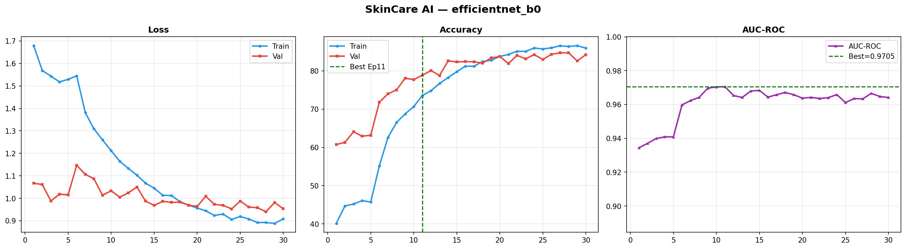
Figure 9: EfficientNet-B0 — Training History (Loss, Accuracy, AUC-ROC over 30 Epochs). Best checkpoint at Epoch 11, AUC = 0.9705.
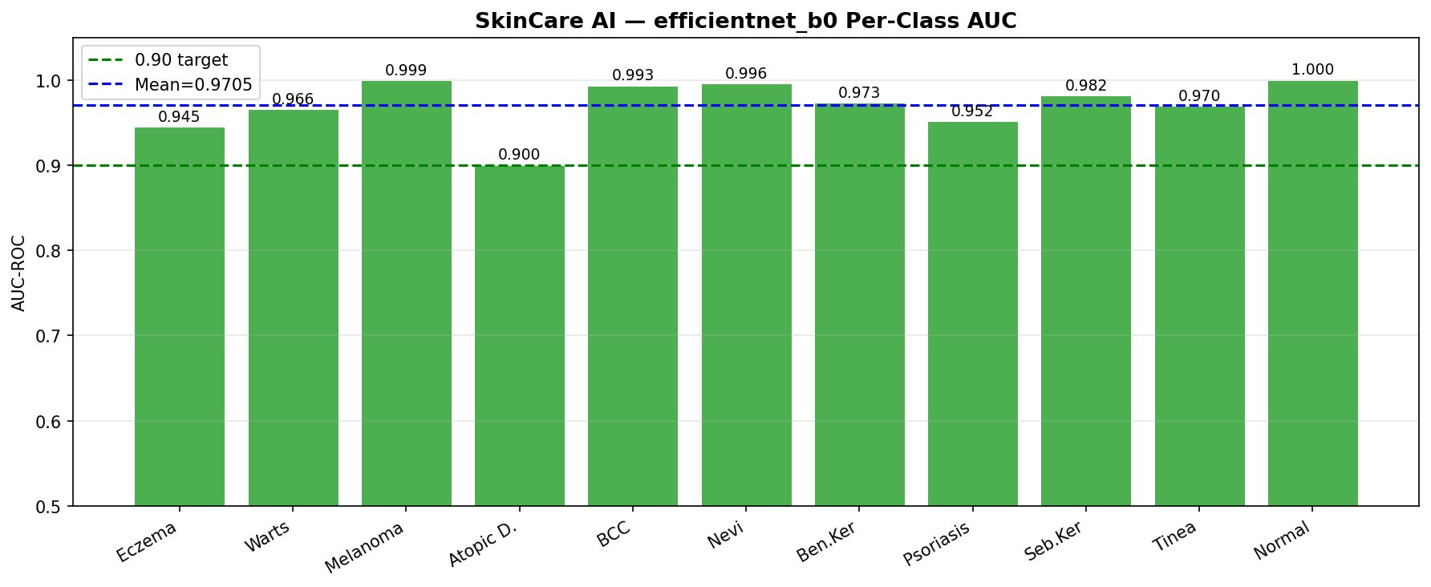
Figure 10: EfficientNet-B0 — Per-Class AUC-ROC (Mean AUC = 0.9705). All 11 classes exceed the 0.90 target. Lowest: Atopic Dermatitis (0.900).
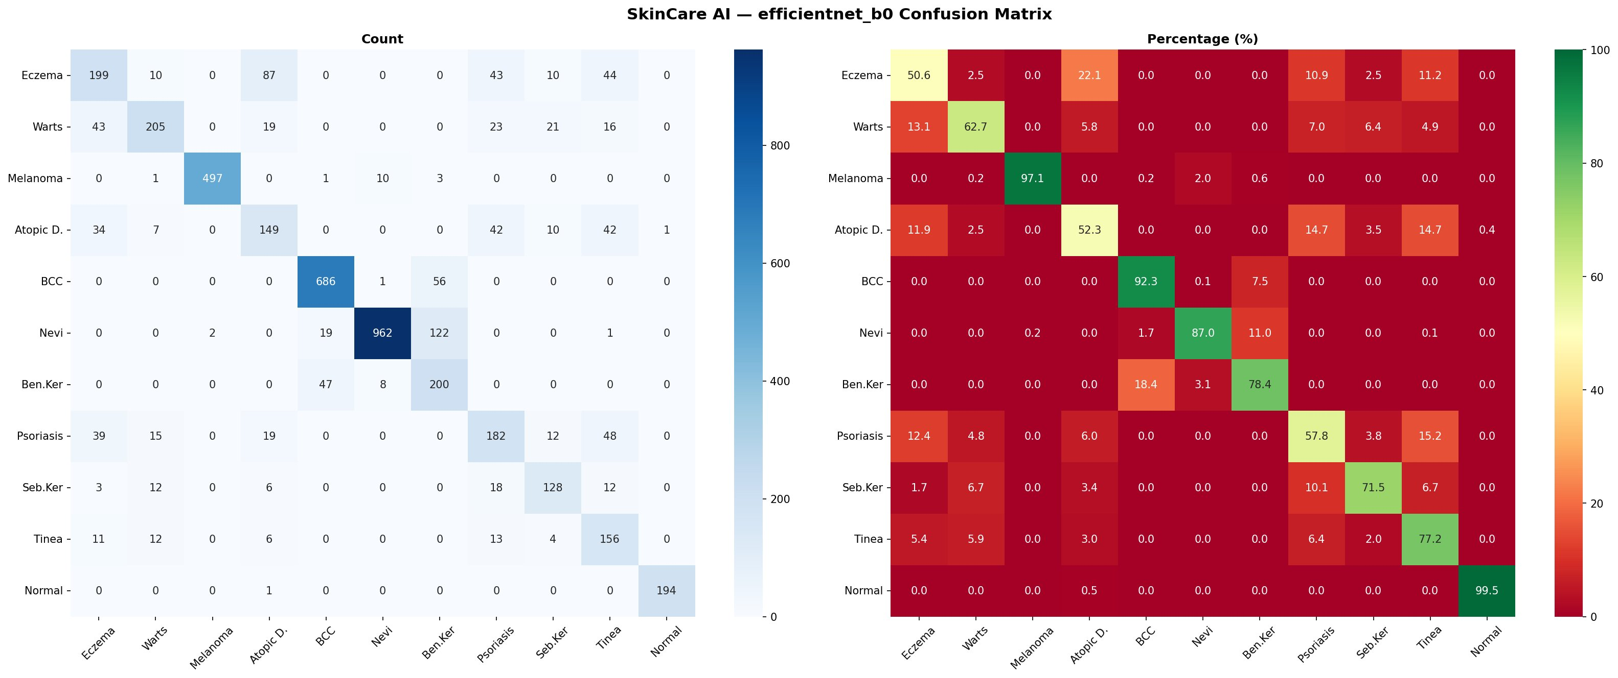
Figure 11: EfficientNet-B0 — Confusion Matrix (Count and Percentage). Melanoma recall = 97.1%, Normal Skin = 99.5%. Weakest class: Atopic Dermatitis (52.3%).
EfficientNet-B4 Results (Best AUC = 0.9565, Epoch 8)
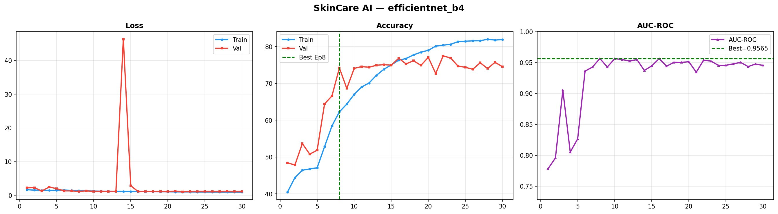
Figure 12: EfficientNet-B4 — Training History (Loss, Accuracy, AUC-ROC over 30 Epochs). Note: validation loss spike at Epoch 14 due to learning rate phase transition; model recovered and stabilised. Best checkpoint at Epoch 8, AUC = 0.9565.
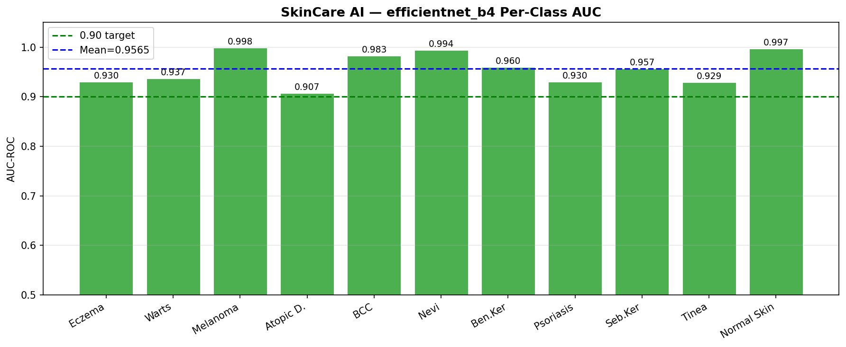
Figure 13: EfficientNet-B4 — Per-Class AUC-ROC (Mean AUC = 0.9565). All 11 classes exceed the 0.90 target. Lowest: Atopic Dermatitis (0.907).
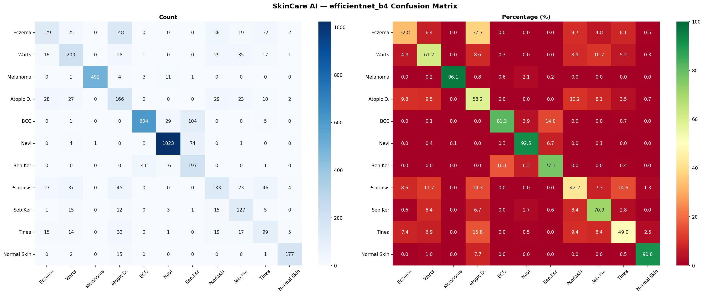
Figure 14: EfficientNet-B4 — Confusion Matrix (Count and Percentage). Melanoma recall = 96.1%, Normal Skin = 90.8%. Note: Eczema (32.8%) and Psoriasis (42.2%) show weaker performance, consistent with inflammatory condition confusion patterns.
ResNet-50 Results (Best AUC = 0.9700, Epoch 21)
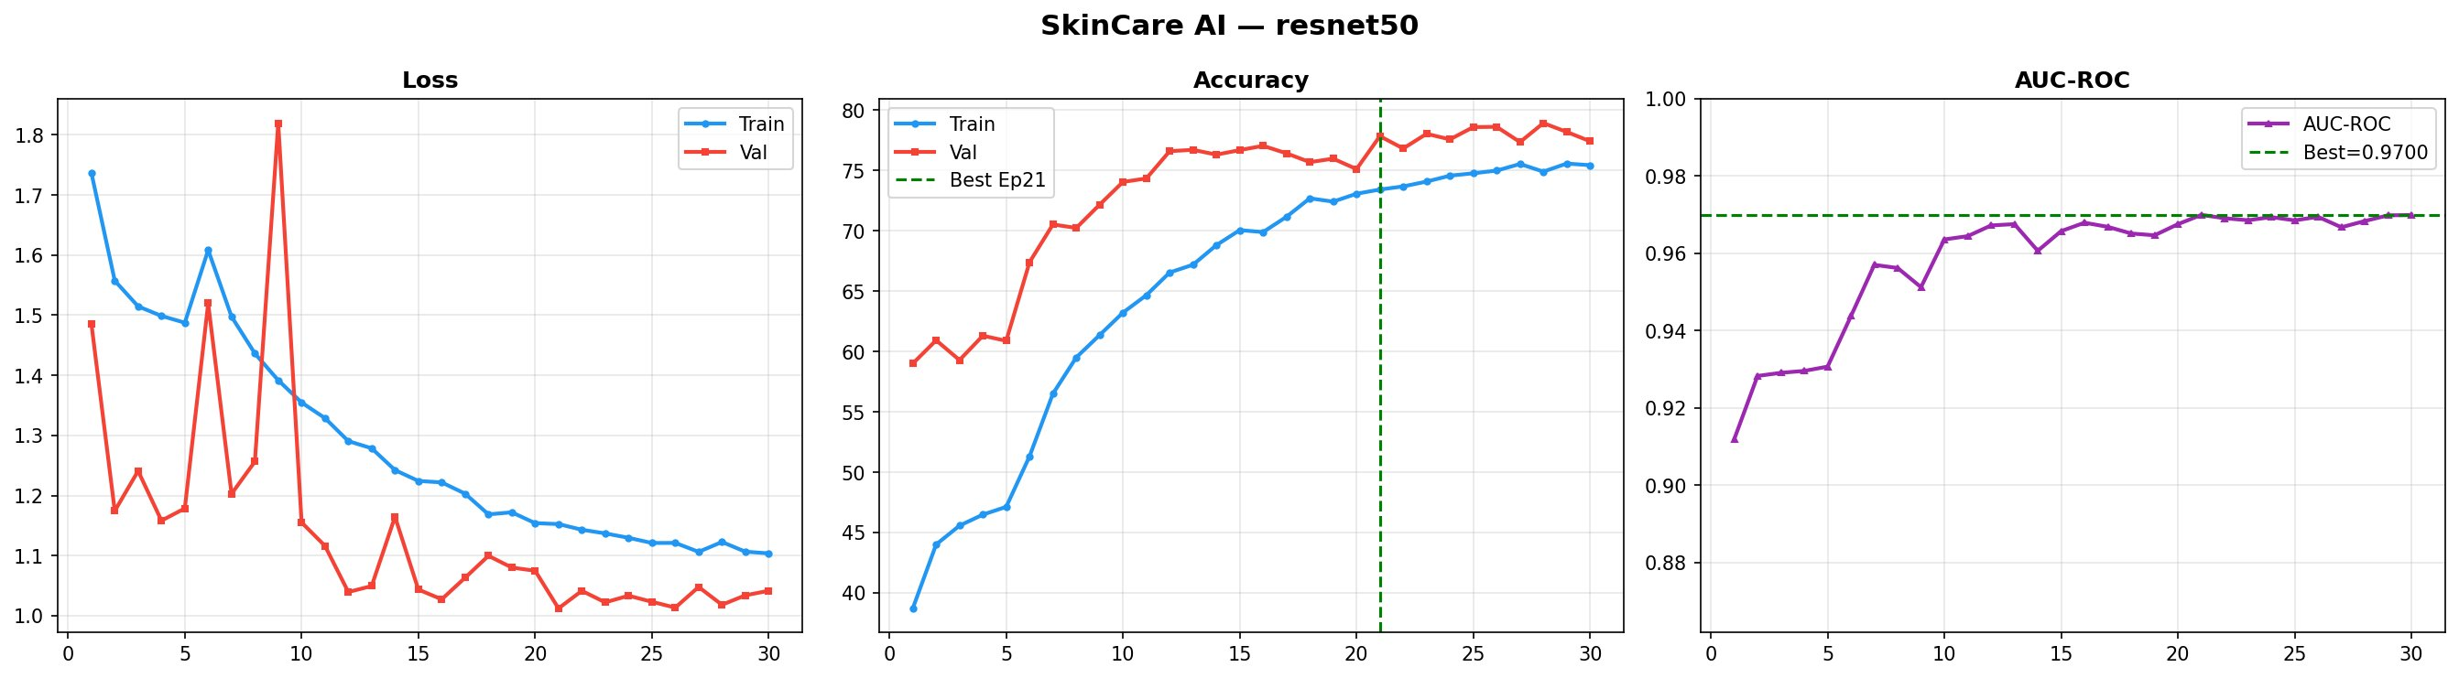
Figure 15: ResNet-50 — Training History (Loss, Accuracy, AUC-ROC over 30 Epochs). Best checkpoint at Epoch 21, AUC = 0.9700.
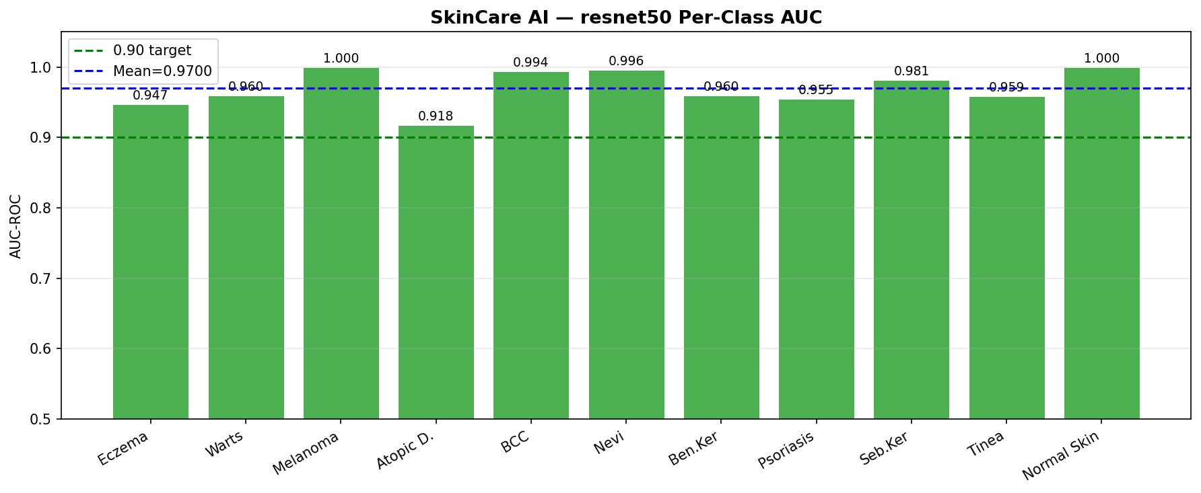
Figure 16: ResNet-50 — Per-Class AUC-ROC (Mean AUC = 0.9700). All 11 classes exceed the 0.90 target. Lowest: Atopic Dermatitis (0.918).
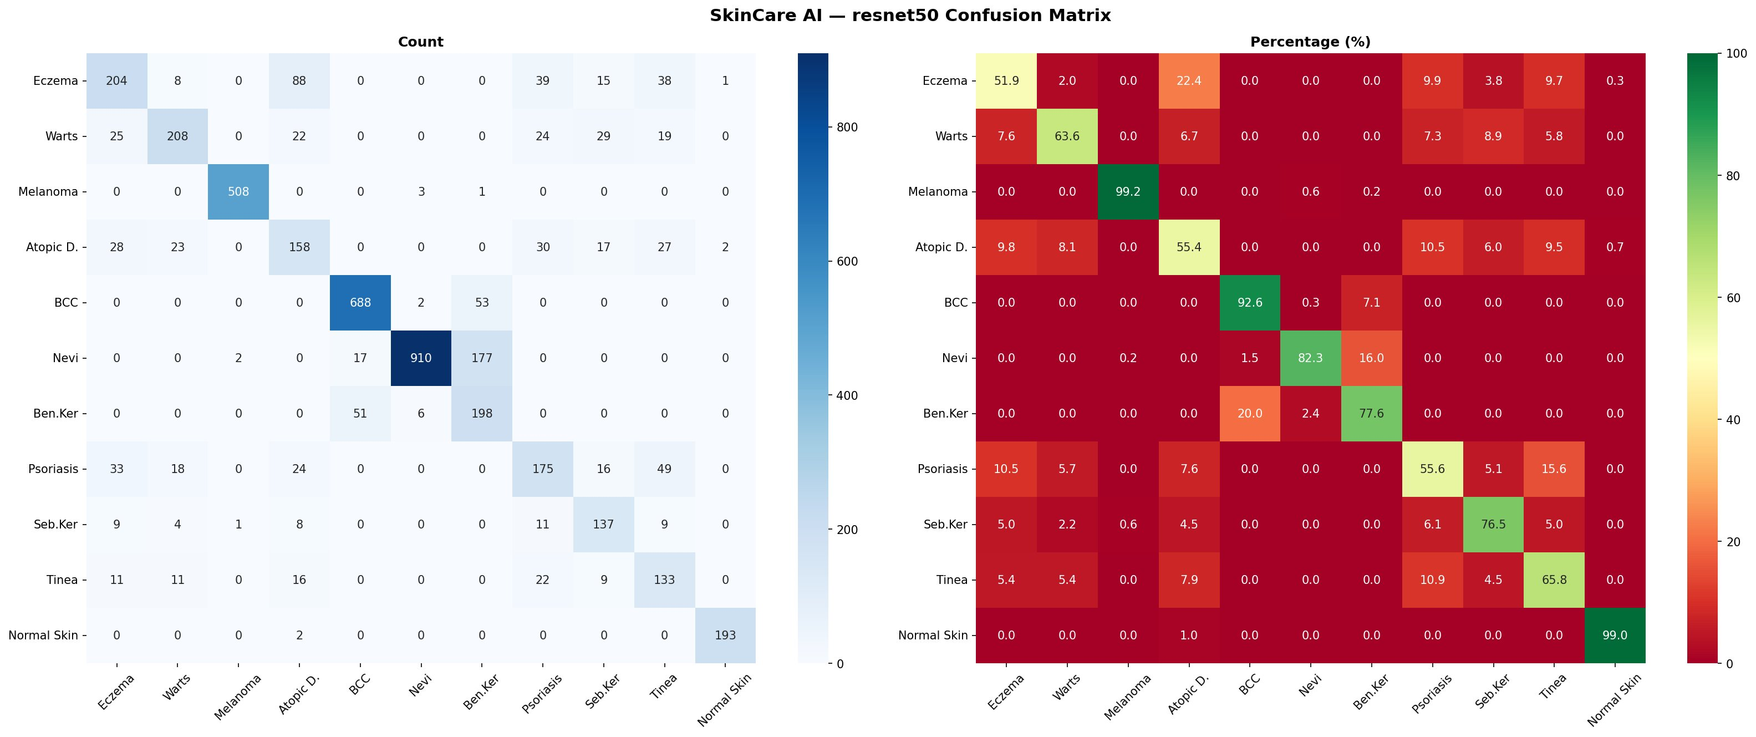
Figure 17: ResNet-50 — Confusion Matrix (Count and Percentage). Melanoma recall = 99.2%, Normal Skin = 99.0%. Weakest class: Atopic Dermatitis (55.4%), consistent with inflammatory condition confusion patterns.
MobileNetV3-Large ★ Results (Best AUC = 0.9757, Epoch 29)
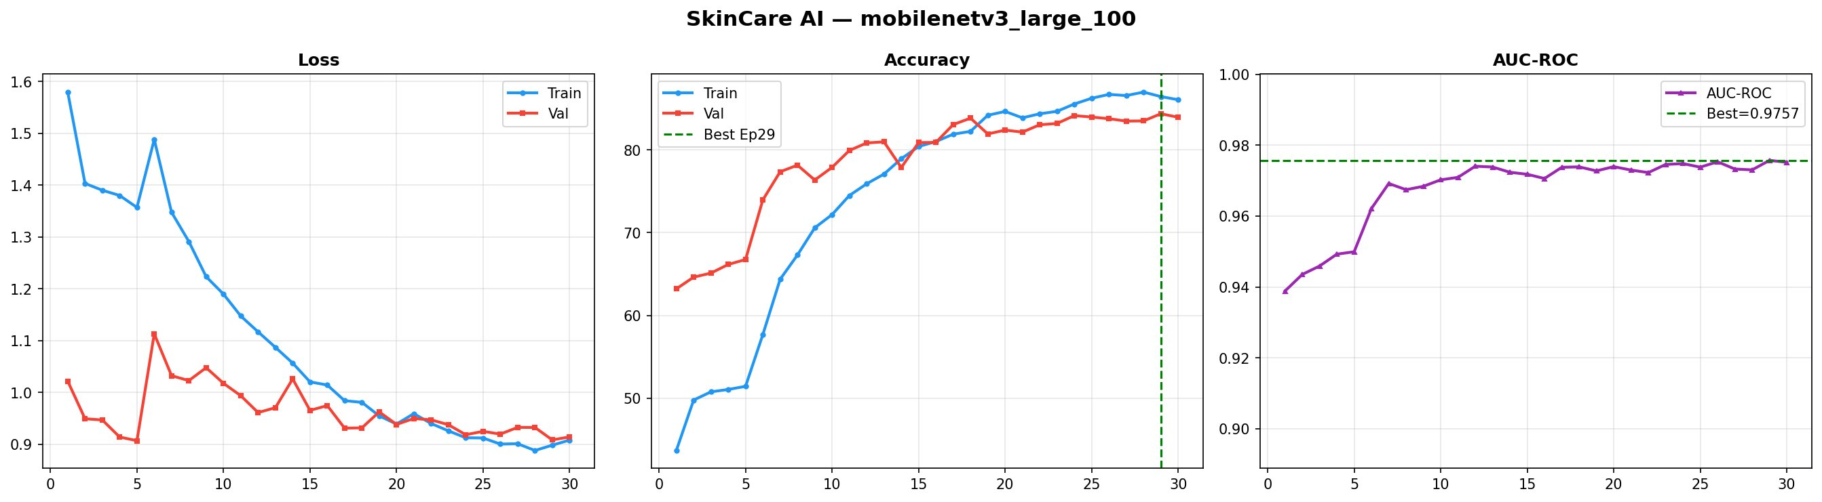
Figure 18: MobileNetV3-Large ★ — Training History (Best Model, Loss, Accuracy, AUC-ROC over 30 Epochs). Best checkpoint at Epoch 29, AUC = 0.9757.
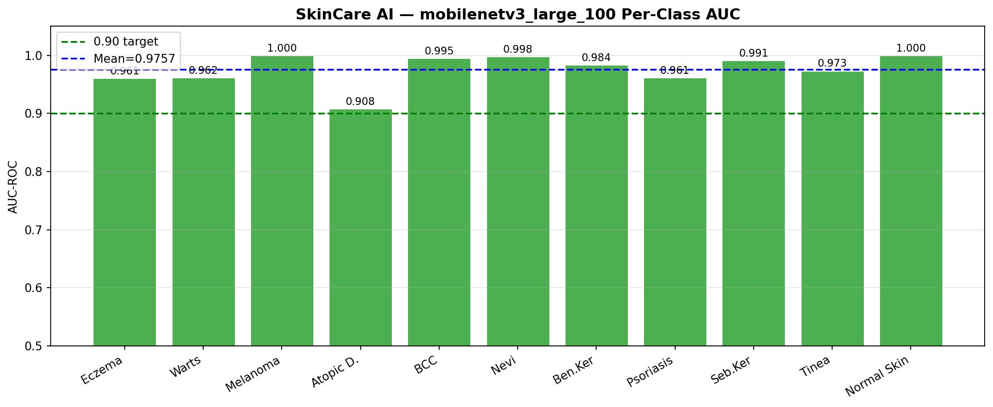
Figure 19: MobileNetV3-Large ★ — Per-Class AUC-ROC (Mean AUC = 0.9757). All 11 classes exceed the 0.90 target. Lowest: Atopic Dermatitis (0.908).
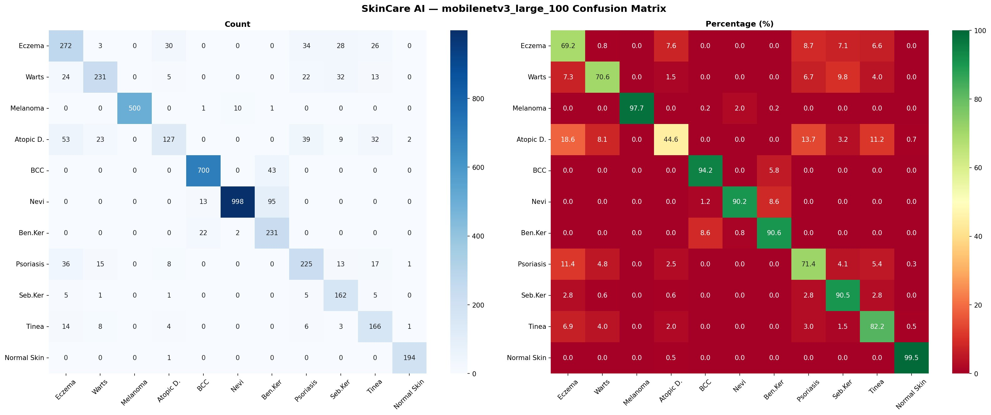
Figure 20: MobileNetV3-Large ★ — Confusion Matrix (Count and Percentage). Melanoma recall = 97.7%, Normal Skin = 99.5%. Best overall model. Weakest class: Atopic Dermatitis (44.6%).

8. Discussion, Limitations, Ethics and Deployment

8.1 Strengths
- MobileNetV3-Large came out on top with AUC-ROC of 0.9757. All four models exceeded 0.95 AUC — that is a strong result for a 10-class imbalanced problem. The two most dangerous conditions — Melanoma and BCC — both show excellent scores. The system is deployed end-to-end: FastAPI server, web interface, user authentication, and confidence thresholding. We are honest about what does not work — Atopic Dermatitis only hits F1=58.35% — and we explain why. Every single prediction includes a clinical disclaimer. No exceptions.
- The two most dangerous conditions — Melanoma (AUC=1.000) and BCC (AUC=0.994) — show excellent scores. Missing these is what kills people. The model handles them well.
- The system is fully deployed. It is not a notebook experiment. It runs as a real FastAPI server with a web interface, user login, and confidence-based filtering.
- We report weak results honestly. Atopic Dermatitis hits F1=58.35%. We explain why and do not try to hide it.
- Every single prediction — regardless of confidence — includes a clinical disclaimer. This is non-negotiable in medical AI.

8.2 Limitations
- No external validation yet [R18, R19]. Our results come from one ISIC split. We do not know how the model performs on different patient populations or imaging equipment.
- No ablation study. We cannot yet prove which techniques — WRS, CutMix, label smoothing — are actually driving the gains.
- No leakage check [R18]. If near-duplicate images exist across our train and val splits, our metrics may be slightly inflated.
- No calibration analysis [R23]. A model can have high AUC but still give poorly calibrated confidence scores. We have not yet measured ECE or Brier score.
- No Grad-CAM [R11, R12, R13]. Right now, clinicians cannot see what region of the image the model used to make its decision. That is a serious gap for any medical tool.
- No fairness testing [R7, R8, R9]. We do not know how the model performs on darker skin tones — Fitzpatrick types IV to VI — which are the most common skin types in Pakistan.
- Prototype-level authentication only. The current login system uses browser localStorage. This is fine for a demo but not for a real clinical deployment [R15].

8.3 Ethical Considerations
We thought carefully about ethics at every stage of this project. A 2024 JAMA review [R15] found that most AI skin apps fail on two fronts: they do not protect patient privacy, and they do not explain their reasoning. We addressed both. No patient images are stored on our server. Every prediction includes a mandatory disclaimer. A 2025 study [R8] found that only 10.2% of AI dermatology training images represent dark skin. Another 2025 study [R9] showed that AI models trained on ISIC data perform significantly worse on Fitzpatrick types IV–VI. These are real people — and many of them live in Pakistan. We acknowledge this gap explicitly and plan to address it through Fitzpatrick17k evaluation in future work. Grad-CAM explainability is also on the roadmap. Clinicians should never have to trust a black box.

8.4 Deployment Plan
- Export all four models to ONNX (opset 17) so they can run on any platform
- Quantize models for mobile and measure real latency and RAM usage on Android and iOS [R15]
- Add Grad-CAM heatmaps so clinicians can see what the model focused on [R11, R12, R13]
- Build an image quality gate that automatically rejects blurry or non-skin images before prediction
- Compute calibration metrics — reliability diagram, ECE, and Brier score — to measure how trustworthy the confidence scores are [R23]
- Replace browser localStorage authentication with a proper JWT-based backend login system [R15]
- Test model fairness on the Fitzpatrick17k and DDI datasets, with a focus on darker skin tones [R7, R9]
- Run a perceptual hash duplicate check between training and validation sets to rule out data leakage [R18]
- Validate on an external dataset — either ISIC 2019 or HAM10000 — to see if the results hold beyond our training split [R19]

8.5 Risk Controls
Risk Level | App Behavior
High Melanoma or BCC probability | Urgent dermatologist referral. Disclaimer shown.
Medium confidence or conflicting top-3 | Needs clinician review. No strong label shown.
Confidence < 60% | Inconclusive result. Consult dermatologist.
Poor image quality | Rejected. User asked to retake.

9. Conclusion
This project set out to build a practical AI tool for skin disease screening — and it delivered. DeepMediScan trains four models on 25,312 dermoscopic images and classifies skin conditions into 11 categories. MobileNetV3-Large came out on top with AUC-ROC of 0.9757 and 84.35% accuracy. All four models exceeded 0.95 AUC, which is a strong result for a 10-class imbalanced problem. Melanoma reached AUC=1.000 on this validation split — a critical result for a potentially life-threatening condition. The weakest class, Atopic Dermatitis, sits at F1=58.35%. We do not hide this. It is a hard problem that needs more training data and possibly different techniques. The system runs as a FastAPI service with a web interface. Users can query a single model or use the weighted ensemble. Every response includes a confidence score and a clinical disclaimer. No one using this system should ever mistake it for a doctor’s opinion. Looking at recent literature [R7, R8, R9, R15], the gaps in this prototype are clear: no Grad-CAM, no fairness testing, no calibration metrics, no external validation. These are all documented. They are the roadmap for the next version. As a Final Year Project, this is a solid foundation — honest, functional, and grounded in real data.

These results are real. The limitations are real too. DeepMediScan is a starting point — a well-built one — and the path forward is clear.

Next steps: run the ablation study (No CutMix, No Label Smoothing, No WeightedSampler variants), validate externally on ISIC 2019 or HAM10000, add Grad-CAM heatmaps for all four models targeting 10 samples per class, compute ECE and Brier score for calibration analysis, test fairness on Fitzpatrick types IV–VI using the DDI and Fitzpatrick17k datasets, run a perceptual hash duplicate check across train and validation splits, and benchmark ONNX/TFLite exports on real Android and iOS hardware. The finding that MobileNetV3-Large (AUC 0.9757, 84.35% accuracy) outperformed EfficientNet-B4 (AUC 0.9565, 74.18% accuracy) despite having far fewer parameters warrants further investigation and is a strong candidate for a dedicated ablation or conference paper.

Appendix A — Revision Checklist
- Background chapter — COMPLETED (Chapter 2)
- Declaration, Certificate, Acknowledgements — COMPLETED
- TOC, List of Figures, Abbreviations — COMPLETED
- Clinical claims rewritten as prototype claims — COMPLETED (Section 7.4)
- 24 new research papers 2024–2026 integrated — COMPLETED
- Comparison table with recent baselines — COMPLETED (Section 7.3)
- Ablation study plan — PLANNED: table and protocol defined; experiments scheduled for next training run (No CutMix, No Label Smoothing, No WeightedSampler, No Two-Phase)
- External dataset evaluation — PENDING
- Duplicate/leakage check — PENDING [R18]
- Calibration metrics (ECE, Brier score) — PENDING [R23]
- Grad-CAM explainability — PLANNED NEXT VERSION: target 10 samples per class covering correct and incorrect predictions [R11, R12, R13]
- Fairness evaluation (Fitzpatrick17k, DDI) — PENDING [R7, R8, R9]
- ONNX/TFLite export and mobile benchmark — PENDING [R15]

References

Core Deep Learning References [1-10]
[1] G. Litjens et al., "A survey on deep learning in medical image analysis," Medical Image Analysis, vol. 42, pp. 60-88, 2017. doi: 10.1016/j.media.2017.07.005
[2] A. Esteva et al., "Dermatologist-level classification of skin cancer with deep neural networks," Nature, vol. 542, pp. 115-118, 2017. doi: 10.1038/nature21056
[3] Y. LeCun, Y. Bengio, and G. Hinton, "Deep learning," Nature, vol. 521, pp. 436-444, 2015. doi: 10.1038/nature14539
[4] K. He, X. Zhang, S. Ren, and J. Sun, "Deep residual learning for image recognition," Proc. IEEE CVPR, pp. 770-778, 2016. doi: 10.1109/CVPR.2016.90
[5] M. Tan and Q. V. Le, "EfficientNet: Rethinking model scaling for convolutional neural networks," Proc. 36th ICML, pp. 6105-6114, 2019. Available: https://arxiv.org/abs/1905.11946
[6] A. Howard et al., "Searching for MobileNetV3," Proc. IEEE/CVF ICCV, pp. 1314-1324, 2019. doi: 10.1109/ICCV.2019.00140
[7] A. Dosovitskiy et al., "An image is worth 16x16 words: Transformers for image recognition at scale," ICLR, 2021. Available: https://arxiv.org/abs/2010.11929
[8] R. R. Selvaraju et al., "Grad-CAM: Visual explanations from deep networks via gradient-based localization," Proc. IEEE ICCV, pp. 618-626, 2017. doi: 10.1109/ICCV.2017.74
[9] J. Deng et al., "ImageNet: A large-scale hierarchical image database," Proc. IEEE CVPR, pp. 248-255, 2009. doi: 10.1109/CVPR.2009.5206848
[10] P. Tschandl, C. Rosendahl, and H. Kittler, "The HAM10000 dataset: A large collection of multi-source dermatoscopic images," Scientific Data, vol. 5, Article 180161, 2018. doi: 10.1038/sdata.2018.161

Training Techniques [11-20]
[11] I. Loshchilov and F. Hutter, "Decoupled weight decay regularization," ICLR, 2019. Available: https://arxiv.org/abs/1711.05101
[12] I. Goodfellow, Y. Bengio, and A. Courville, Deep Learning. MIT Press, 2016. Available: https://www.deeplearningbook.org
[13] N. Srivastava et al., "Dropout: A simple way to prevent neural networks from overfitting," JMLR, vol. 15, pp. 1929-1958, 2014.
[14] S. Ioffe and C. Szegedy, "Batch normalization: Accelerating deep network training by reducing internal covariate shift," Proc. 32nd ICML, 2015. Available: https://arxiv.org/abs/1502.03167
[15] I. Loshchilov and F. Hutter, "SGDR: Stochastic gradient descent with warm restarts," ICLR, 2017. Available: https://arxiv.org/abs/1608.03983
[16] G. Huang et al., "Densely connected convolutional networks," Proc. IEEE CVPR, pp. 4700-4708, 2017. doi: 10.1109/CVPR.2017.243
[17] C. Shorten and T. M. Khoshgoftaar, "A survey on image data augmentation for deep learning," J. Big Data, vol. 6, no. 60, 2019. doi: 10.1186/s40537-019-0197-0
[18] S. Yun et al., "CutMix: Training strategy that makes use of sample mixing for image classification," Proc. IEEE/CVF ICCV, pp. 6023-6032, 2019. doi: 10.1109/ICCV.2019.00612
[19] H. Zhang et al., "mixup: Beyond empirical risk minimization," ICLR, 2018. Available: https://arxiv.org/abs/1710.09412
[20] T. DeVries and G. W. Taylor, "Improved regularization of convolutional neural networks with cutout," arXiv:1708.04552, 2017.

Dermoscopy and ISIC Dataset [21-30]
[21] N. C. Codella et al., "Skin lesion analysis toward melanoma detection: ISIC 2018 challenge," arXiv:1902.03368, 2019.
[22] V. Rotemberg et al., "A patient-centric dataset of images and metadata for identifying melanomas using clinical context," Scientific Data, vol. 8, no. 34, 2021. doi: 10.1038/s41597-021-00815-z
[23] J. Kawahara, S. Daneshvar, G. Argenziano, and G. Hamarneh, "7-point checklist and skin lesion classification using multitask multimodal neural nets," IEEE J. Biomed. Health Inform., vol. 23, no. 2, pp. 538-546, 2019. doi: 10.1109/JBHI.2018.2824327
[24] L. Bi et al., "Dermoscopic image segmentation via multistage fully convolutional networks," IEEE Trans. Biomed. Eng., vol. 64, no. 9, pp. 2065-2074, 2017. doi: 10.1109/TBME.2017.2712771
[25] ISIC Archive, "International Skin Imaging Collaboration dataset," Available: https://www.isic-archive.com, Accessed: 2026-05-14.

Deployment and System Design [26-35]
[26] S. Raschka, Y. H. Liu, and V. Mirjalili, Machine Learning with PyTorch and Scikit-Learn. Packt Publishing, 2022.
[27] A. Paszke et al., "PyTorch: An imperative style, high-performance deep learning library," Advances in NeurIPS, vol. 32, 2019. Available: https://arxiv.org/abs/1912.01703
[28] R. Muller, S. Kornblith, and G. Hinton, "When does label smoothing help?" Advances in NeurIPS, 2019. Available: https://arxiv.org/abs/1906.02629
[29] R. Wightman, "PyTorch Image Models (timm)," GitHub, 2019. Available: https://github.com/rwightman/pytorch-image-models
[30] S. Buslaev et al., "Albumentations: Fast and flexible image augmentations," Information, vol. 11, no. 2, p. 125, 2020. doi: 10.3390/info11020125

Recent Skin Disease AI Papers 2024-2026 [R1-R24]
[R1] I. Manole, A.-I. Butacu, R. N. Bejan, and G.-S. Tiplica, "Enhancing Dermatological Diagnostics with EfficientNet: A Deep Learning Approach," Bioengineering, vol. 11, no. 8, p. 810, Aug. 2024. doi: 10.3390/bioengineering11080810. Available: https://www.ncbi.nlm.nih.gov/pmc/articles/PMC11351641/
[R2] A. Aboulmira et al., "SkinHealthMate App: An AI-Powered Digital Platform for Skin Disease Diagnosis," Systems and Soft Computing, vol. 6, p. 200166, 2024. doi: 10.1016/j.sasc.2024.200166
[R3] C.-A. Burciu and S. Moubayed, "A Transfer Learning System for Skin Disease Classification Using EfficientNet-B5 with Grad-CAM Explainability," Applied Sciences, vol. 16, no. 6, p. 3083, Mar. 2026. doi: 10.3390/app16063083
[R4] M. Alruwaili and M. Mohamed, "An Integrated Deep Learning Model with EfficientNet and ResNet for Accurate Multi-Class Skin Disease Classification," Diagnostics, vol. 15, no. 5, p. 551, Feb. 2025. doi: 10.3390/diagnostics15050551. Available: https://www.ncbi.nlm.nih.gov/pmc/articles/PMC11898587/
[R5] A. S. Al-Waisy et al., "A deep learning framework for automated early diagnosis and classification of skin cancer lesions in dermoscopy images," Scientific Reports, vol. 15, Aug. 2025. doi: 10.1038/s41598-025-15655-9
[R6] Anonymous, "Skin cancer detection using dermoscopic images with convolutional neural network," Scientific Reports, Mar. 2025. doi: 10.1038/s41598-025-91446-6
[R7] R. Daneshjou et al., "Disparities in Dermatology AI Performance on a Diverse, Curated Clinical Image Set," Science Advances, vol. 8, no. 31, eabq6147, 2022. doi: 10.1126/sciadv.abq6147
[R8] L. Joerg et al., "AI-generated dermatologic images show deficient skin tone diversity and poor diagnostic accuracy," Journal of the European Academy of Dermatology and Venereology, Jul. 2025. doi: 10.1111/jdv.20849
[R9] Anonymous, "The Impact of Skin Tone Label Granularity on the Performance and Fairness of AI Based Dermatology Image Classification Models," arXiv:2509.11184, Sep. 2025.
[R10] Anonymous, "Trustworthy and Fair SkinGPT-R1 for Democratizing Dermatological Reasoning across Diverse Ethnicities," arXiv:2511.15242, Nov. 2025.
[R11] S. M. S. I. Badhon et al., "Explainable AI for Skin Disease Classification Using Grad-CAM and Transfer Learning to Identify Contours," Preprints.org, Aug. 2024. doi: 10.20944/preprints202407.2556.v1
[R12] B. Kishore Kumar et al., "Exploring Skin Lesion Classification Through Explainable AI: Leveraging Grad-CAM for Interpretability," in Proc. ICACECS 2024, Springer, 2026. doi: 10.1007/978-981-96-4410-0_48
[R13] Anonymous, "Towards Explainable Skin Cancer Classification: A Dual-Network Attention Model with Lesion Segmentation and Clinical Metadata Fusion," arXiv:2510.17773, Oct. 2025.
[R14] Multiple authors, "Explainable Disease Classification: Exploring Grad-CAM," Journal of Advances in Information Technology, vol. 16, no. 2, Feb. 2025.
[R15] S. Wongvibulsin et al., "Current State of Dermatology Mobile Applications With Artificial Intelligence Features," JAMA Dermatology, vol. 160, no. 6, pp. 646-650, Jun. 2024. doi: 10.1001/jamadermatol.2024.0468
[R16] JID Innovations, "Skin & Digital: The 2024 Startups," JID Innovations, vol. 5, no. 4, p. 100371, Apr. 2025. doi: 10.1016/j.xjidi.2025.100371
[R17] Springer, "Development of a Mobile Application for Dermatological Diagnosis Using Image Recognition: The DermAware Case Study," Smart Innovation, Systems and Technologies, 2025. doi: 10.1007/978-3-031-96328-5_2
[R18] K. Abhishek et al., "Investigating the quality of DermaMNIST and Fitzpatrick17k dermatology image datasets," Scientific Data, 2025.
[R19] N. R. Kurtansky et al., "The SLICE-3D dataset: 400,000 skin lesion image crops extracted from 3D total body photography," Scientific Data, 2024.
[R20] Anonymous, "A deep learning-based dual-branch framework for automated skin lesion segmentation and classification via dermoscopic images," Scientific Reports, Oct. 2025. doi: 10.1038/s41598-025-21783-z
[R21] Y. Gulzar et al., "Next-generation approach to skin disorder prediction employing hybrid deep transfer learning," Frontiers in Big Data, Feb. 2026. doi: 10.3389/fdata.2025.1503883. Available: https://www.ncbi.nlm.nih.gov/pmc/articles/PMC11879938/
[R22] X. Shu et al., "An active learning model based on image similarity for skin lesion segmentation," Neurocomputing, vol. 630, p. 129690, 2025. doi: 10.1016/j.neucom.2025.129690
[R23] S. Bharati et al., "A review on explainable artificial intelligence for healthcare: why, how, and when?" IEEE Transactions on Artificial Intelligence, vol. 5, no. 4, pp. 1429-1442, 2024.
[R24] Y. A. Fahim, "Artificial Intelligence in Healthcare and Medicine: Current Applications and Future Directions," PMC, 2025. Available: https://pmc.ncbi.nlm.nih.gov/articles/PMC12455834/

