HTML TASK # 02 – FORMATING TAGS

01 - Write the following text using proper HTML Tags.

02- All tags should be used according to HTML tags definition and W3C validation.

03- There should be no HTML absolute tag in your website.

For example, <u>.

04 - Use Proper text alignment as done in the sample paragraph.

05 - Each HTML element should have its necessary attributes.

For example, <link rel=”stylesheet” href=”mystyle.css”>

06 - There should be proper spacing before and after each element.

07 - Content Spacing from the left and right sides should be equal.

08 - If the browser do not find the exact image path, it should display “dgaps-image” text instead of that image.

09 - Show the proper Title of your website.

For example “My Blogging Site” for Personal Blog.

10 - When the user hover over any image, link,button it must show the tilte of that element.

11 - Use HTML Semantic tags to show the content on the page. I-e <sidebar>

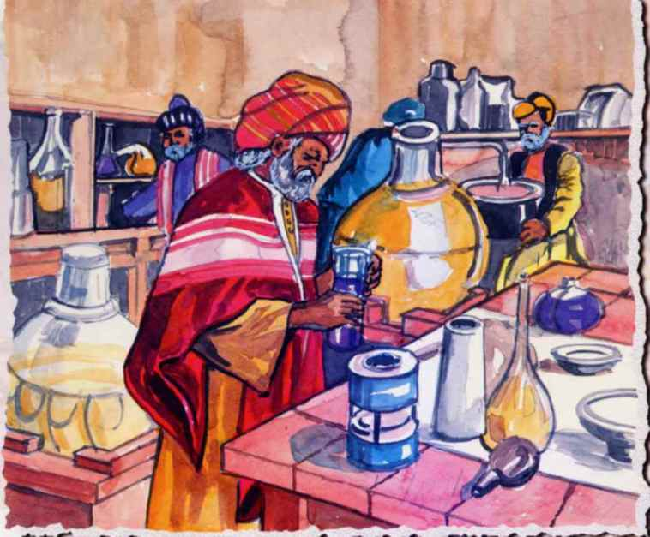

Contribution of Muslims in Modern Science

The contribution of Muslims to the conception, growth and development of Chemistry is unforgettable. It is as immense as in other branches of science. Chemistry is one of the great parts of science study in which Muslims have made *significant contributions* and they developed it to a *high degree of perfection*. For their contributions, they are considered supreme authorities in this branch of science.

**Jabir Ibn Hayyan** was born in around 702 AD. He is known as the father of modern Chemistry along with **Zakariya Razi**, who is one of the greatest scientists in Chemistry. He was engaged in making gold by mixing different substances. He discovered many important substances such as *Sulphuric Acid* ***(H2SO4****)*, *Hydrochloric Acid* ***(HCl)****,* *Nitric Acid* ***(HN03)*** *etc*. The Muslims introduced experiments in the whole scientific method which was previously done by just theories not ~~practical implementation~~.

**Abu Rayhan Al-Bayruni** and **Ibn Khaldun** refuted the theory of the conversion of metals. They were not only the pioneers of Chemistry during mediaeval times, but also they are considered to be authoritative figures in the modern age of Chemistry. The modern Chemistry owes a great deal to the genius of these Muslim luminaries. Muslims of today should strive to make contributions in different disciplines of knowledge and science like the Muslim scholars in the past and bring glory to their own country as well.

“It is highly probable that but for the Arabs, modern European civilization would never have arisen at all; it is absolutely certain that but for them, it would not have assumed that character which has enabled it to transcend all previous phases of evolution.”

__By Robert Briffault from *The Making of Humanity*

[**KNOW MORE**](https://en.wikipedia.org/wiki/Alchemy_and_chemistry_in_the_medieval_Islamic_world)

Acknowledgement By IUPAC

The IUPAC ­­­­­­­­is an international federation of [National Adhering Organizations](https://en.wikipedia.org/wiki/National_Adhering_Organizations) that represents chemists in individual countries. It is a member of the [International Science Council](https://en.wikipedia.org/wiki/International_Science_Council) (ISC).

IUPAC is registered in [Zürich](https://en.wikipedia.org/wiki/Z%C3%BCrich), [Switzerland](https://en.wikipedia.org/wiki/Switzerland), and the administrative office, known as the "IUPAC Secretariat", is in:

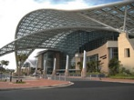

[*Research Triangle Park*](https://en.wikipedia.org/wiki/Research_Triangle_Park)*,*

[*North Carolina*](https://en.wikipedia.org/wiki/North_Carolina)*,*

[*United States*](https://en.wikipedia.org/wiki/United_States) *of America*

Following is the List of Some Famous Muslim Scientists

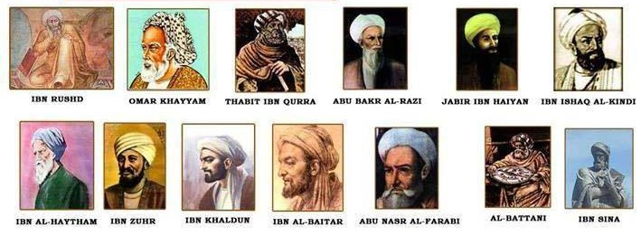

Affordable Web Services

All our services are offered at competitive market rates which offer excellent value for your money.

Great Support

We have a robust support structure which you can utilize 24/7, getting answers to all queries.

We Are On Time and Budget

You can stay assured that we will never go over budget as fees are paid up front.

Services provided by our Company

We provide our excellent services in the following areas.

* Software Development
* Website Development
* Android Apps Development
* Graphics Designing
* Search Engine Optimization

Our Professional Team of Experts

We have a professional team of experts skilled in:

1. HTML

2. CSS

3. Bootstrap

4. JavaScript

5. JQuery

6. PHP

7. Laravel

8. [More Fields](https://dgaps.com)

Copyrights ©2020. All Rights Reserved by Digital Applications