HTML TASK # 01 – BASIC TAGS

01 - Write the following text using proper HTML Tags.

02- All tags should be used according to HTML tags definition and W3C validation.

03- There should be no HTML absolute tag in your website.

For example, **<u>**.

04 - Use Proper text alignment as done in the sample paragraph.

05 - Each HTML element should have its necessary attributes.

For example, <link **rel**=”stylesheet” **href**=”mystyle.css”>

06 - There should be proper spacing before and after each element.

07 - Content Spacing from the left and right sides should be equal.

08 – If the browser do not find the exact image path, it should display “dgaps-image” text instead of that image.

09 – Show the proper Title of your website.

For example “My Blogging Site” for Personal Blog.



DIGITAL APPLICATIONS

Introduction

Digital Applications is one of the most **Popular Software Companies in Pakistan**. Our *highly professional team* will get your project running quickly and realize your IT goals. We are experienced in *developing IT solutions* that cater to *all your business needs* and let your business flourish organically. Our holistic approach to SEO Friendly Websites and Software Development will not only make your design look great, but they will also be able to perform and meet you expectations. We are known as **Best Software Company in Pakistan** in delivering end to end IT solutions for a business.

Digital Applications is *Top Rated Software* House in Pakistan at the forefront of the technological revolution of our world where every business is trying to make a mark, and with our help, you can do just that.

Our portfolio includes a lot of successful websites that are now performing according to our customer’s expectations. We put creativity as our cornerstone, delivering stellar websites that are geared towards growing your business and our results driven approach will bring in instant rewards for you. A website is a quintessential element in increasing the credibility of an organization, and we believe that we are one of the Most Popular &**Best Software Houses in Pakistan** to execute your vision and deliver a high quality responsive website that can really put your business in the global stage.

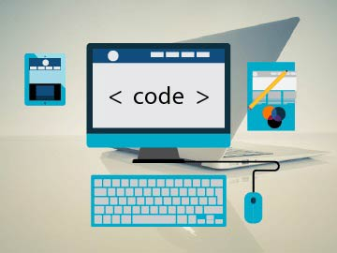[Visit our Official Website](https://dgaps.com)

Why to Choose Digital Applications

Affordable Web Services

All our services are offered at competitive market rates which offer excellent value for your money.

Great Support

We have a robust support structure which you can utilize 24/7, getting answers to all queries.

We Are On Time and Budget

You can stay assured that we will never go over budget as fees are paid up front.

Services provided by our Company

We provide our excellent services in the following areas.

* Software Development
* Website Development
* Android Apps Development
* Graphics Designing
* Search Engine Optimization

Our Professional Team of Experts

We have a professional team of experts skilled in:

1. HTML

2. CSS

3. Bootstrap

4. JavaScript

5. JQuery

6. PHP

7. Laravel

8. [More Fields](https://dgaps.com)

Copyrights ©2020. All Rights Reserved by Digital Applications