HTML TASK # 03 – ADVANCED TAGS

01 - Write the following text using proper HTML Tags.

02- All tags should be used according to HTML tags definition and W3C validation.

03- There should be no HTML absolute tag in your website.

For example, <u>.

04 - Use Proper text alignment as done in the sample paragraph.

05 - Each HTML element should have its necessary attributes.

For example, <link rel=”stylesheet” href=”mystyle.css”>

06 - There should be proper spacing before and after each element.

07 - Content Spacing from the left and right sides should be equal.

08 – If the browser do not find the exact image path, it should display “dgaps-image” text instead of that image.

09 – Show the proper Title of your website.

For example “My Blogging Site” for Personal Blog.

10 - When the user hover over any image, link,button it must show the tilte of that element.

11 - Use HTML Semantic tags to show the content on the page. I-e <sidebar>

12 – Embed youtube videos in portfolio section.

13 – Show Success and Error Messages for different input in the Registration form.

14 – Use multiline textbox for Address text in the form.

15 – Use All necessary meta tags for your webpage.

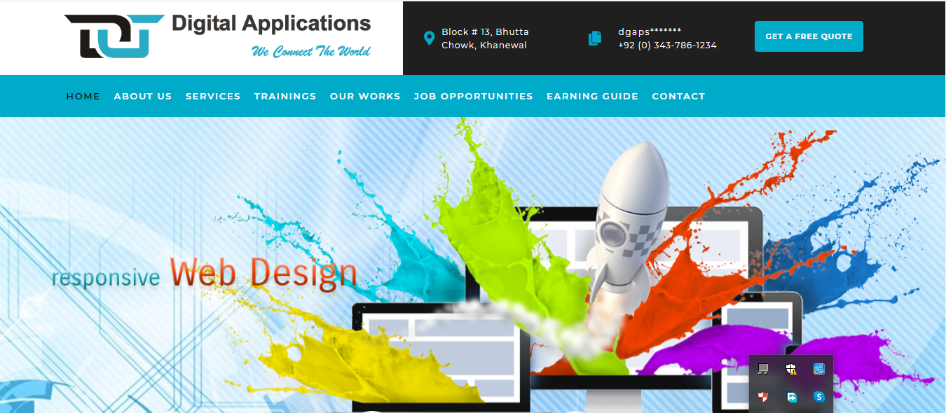

About Us

Digital Applications is one of the most **Popular Software Companies in Pakistan**. Our *highly professional team* will get your project running quickly and realize your IT goals. We are experienced in *developing IT solutions* that cater to *all your business needs* and let your business flourish organically. Our holistic approach to SEO Friendly Websites and Software Development will not only make your design look great, but they will also be able to perform and meet you expectations. We are known as **Best Software Company in Pakistan** in delivering end to end IT solutions for a business.

Digital Applications is *Top Rated Software* House in Pakistan at the forefront of the technological revolution of our world where every business is trying to make a mark, and with our help, you can do just that.

**OUR PROJECTS**



Our portfolio includes a lot of successful websites that are now performing according to our customer’s expectations. We put creativity as our cornerstone, delivering stellar websites that are geared towards growing your business and our results driven approach will bring in instant rewards for you. A website is a quintessential element in increasing the credibility of an organization, and we believe that we are one of the Most Popular &**Best Software Houses in Pakistan** to execute your vision and deliver a high quality responsive website that can really put your business in the global stage.

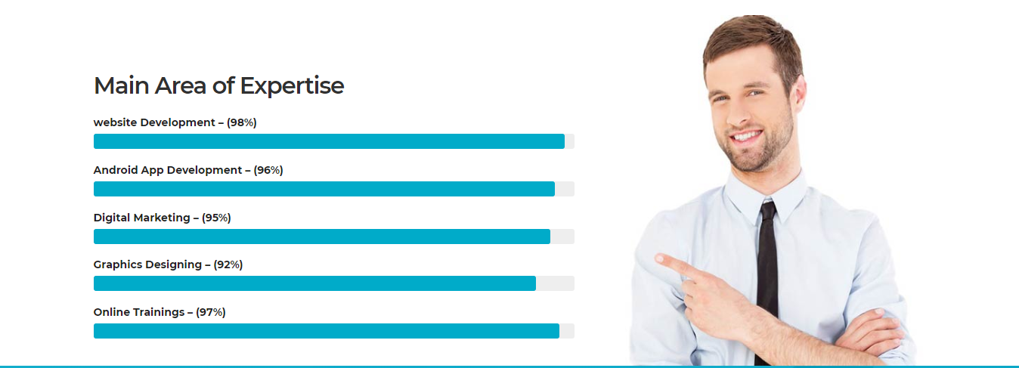

Member Registration

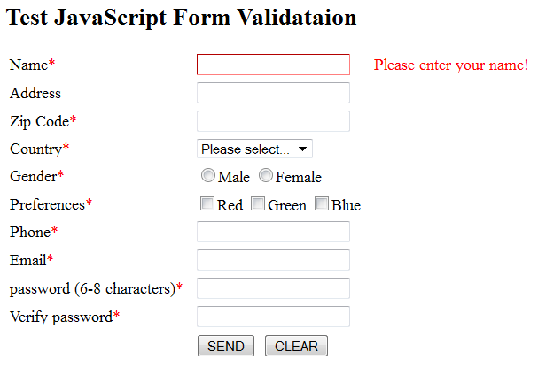

Our Working Routine

