C++ Notes

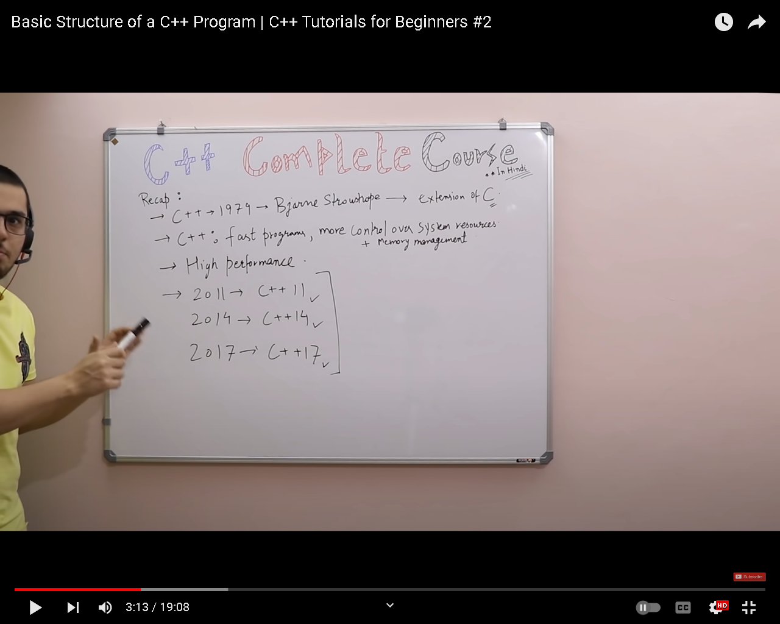
Namespace:
In C++, a namespace is a feature that allows you to group related variables, functions, and classes together under a single name. This can help prevent naming conflicts between different libraries and reduce the chance of naming collisions in large codebases.
Variable can be defined as a container to hold data. Variables are of different types, for example:
- Int-> Int is used to store integer data e.g (-1, 2, 5,-9, 3, 100).
- Float-> Float is used to store decimal numbers e.g (0.5, 1.05, 3.5, 10.5)
- Char-> Char is used to store a single character e.g. ('a', 'b',' c', 'd')
- Boolean-> Boolean is used to store "true" or "false."
- Double-> Double is also used to store decimal numbers but has more precision than float, e.g. (10.5895758440339...)
Here is an example to understand variables: int sum = 34; means that sum is an integer variable that holds value '34' in memory.
Syntax for Declaring Variables in C++
- Data_type Variable_name = Value;
- Ex: int a=4; char letter = ‘p’;
- Ex: int a=4, b=6;
Variable Scope
The scope of a variable is the region in the program where the existence of that variable is valid. For example, consider this analogy - if one person travels to another country illegally, we will not consider that country as its scope because he doesn't have the necessary documents to stay in that country.
Base on scope, variables can be classified into two types:
- Local variables
- Global variables
Local variables:
Local variables are declared inside the braces of any function and can be assessed only from there.
Global variables:
Global variables are declared outside any function and can be accessed from anywhere.
Data Types
Data types define the type of data that a variable can hold; for example, an integer variable can hold integer data, a character can hold character data, etc.
Data types in C++ are categorized into three groups:
- Built-in
- User-defined
- Derived
1. Built-in Data Types in C++:
- Int
- Float
- Char
- Double
- Boolean
2. User-Defined Data Types in C++:
- Struct
- Union
- Enum
Note: We will discuss the concepts of user-defined data types in another lecture. For now, understanding that these are user-defined data types is enough.
3. Derived Data Types in C++:
- Array
- Pointer
- Function
Note: We will discuss the concept of derived data types in another lecture. For now, understanding that these are derived data types is enough.
Basic Input and Output in C++
C++ language comes with different libraries, which helps us in performing input/output operations. In C++ sequence of bytes corresponding to input and output are commonly known as streams. There are two types of streams:
Input stream
In the input stream, the direction of the flow of bytes occurs from the input device (for ex keyboard) to the main memory.
Output stream
In output stream, the direction of flow of bytes occurs from main memory to the output device (for ex-display)
Important Points
- The sign "<<" is called insertion operator
- The sign ">>" is called extraction operator
- "cout" keyword is used to print
- "cin" keyword is used to take input at run time.
Reserved keywords in C++
Reserved keywords are those keywords that are used by the language itself, which is why these keywords are not available for re-definition or overloading. In short, you cannot create variables with these names. A list of reserved keywords is shown in figure 3.
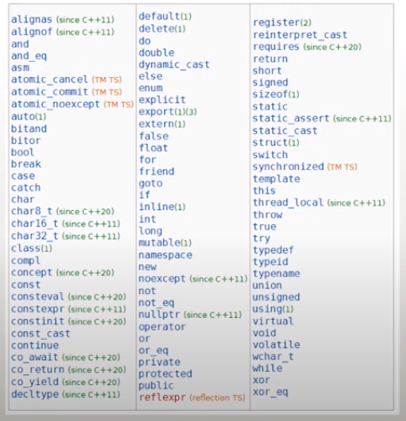
Header Files in C++
"#include" is used in C++ to import header files in our C++ program. The reason to introduce the "<iostream>" header file into our program is that functions like "cout" and "cin" are defined in that header file. There are two types of header files:
System Header Files
System header files ships with the compiler. For example, “#include <iostream>”. To see the references for header files click here
User-Defined Header Files
The programmer writes User-defined header files himself. To include your header file in the program, you first need to make a header file in the current directory, and then you can add it.
Operators in C++
Operators are used for producing output by performing various types of calculations on two or more inputs. In this lecture, we will see the operators in C++.
Arithmetic Operators
Arithmetic operators are used for performing mathematical operations like (+, -, *).
- The function "a+b", will add a and b values and print them.
- The function "a-b "will subtract a and b values and print them.
- The function "a*b" will multiply a and b values and print them.
- The function "a/b ", will divide a and b values and print them.
- The function "a%b ", will take the modulus of a and b values and print them.
- The function "a++" will first print the value of a and then increment it by 1.
- The function "a--", will first print the value of a and then decrement it by 1.
- The function "++a", will first increment it by one and then print its value.
- The function "--a", will first decrement it by one and then print its value.
Reference Variable
Reference variables can be defined as another name for an already existing variable. These are also called an alias. For example, let us say we have a variable with the name of "sum", but we also want to use the same variable with the name of "add", to do that we will make a reference variable with the name of "add".
Typecasting
Typecasting can be defined as converting one data type into another.
Manipulator
In C++ programming, language manipulators are used in the formatting of output. The two most commonly used manipulators are: "endl" and "setw".
- "endl" is used for the next line.
- "setw" is used to specify the width of the output.
Control Structures in C++
The work of control structures is to give flow and logic to a program. There are three types of basic control structures in C++.

Sequence Structure
Sequence structure refers to the sequence in which program execute instructions one after another
Selection Structure
Selection structure refers to the execution of instruction according to the selected condition, which can be either true or false. There are two ways to implement selection structures, by “if-else statements” or by “switch case statements”.
If Else Statements in C++
As we have discussed the concepts of the different control structure, If else statements are used to implement a selection structure.
n switch-case statements, the value of the variable is tested with all the cases
Loops in C++
Loops are block statements, which keeps on repeatedly executing until a specified condition is met. There are three types of loops in C++
- For loop in C++
- While loop in C++
- Do While in C++
These loops also called iterative approach.
For Loop in C++
For loop help us to run some specific code repeatedly until the specified condition is met.
While Loop in C++
While loop helps us to run some specific code repeatedly until the specified condition is met
Do-While Loop in C++
The do-while loop helps us to run some specific code repeatedly until a specified condition is met.
Break Statements
We had already discussed a little bit about break statements in switch statements. Today we will see the working of break statements in loops. Break statements in loops are used to terminate the loop.
Continue Statements in C++
Continue statements are somewhat similar to break statements. The main difference is that the break statement entirely terminates the loop, but the continue statement only terminates the current iteration.
Pointers in C++
A pointer is a data type which holds the address of other data type. The “&” operator is called “address off" operator, and the "*” operator is called “value at” dereference operator. An example program for pointers is shown in figure 1.
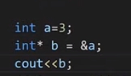
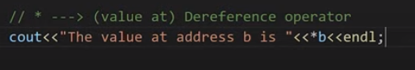
VOID POINTER:
It is used in for every datatype.

Pointer to Pointer
Pointer to Pointer is a simple concept, in which we store the address of one Pointer to another pointer. It doesn't store the value of the variable directly, but rather the location in memory where the value is stored. An example program for Pointer to Pointer is shown in figure 7.
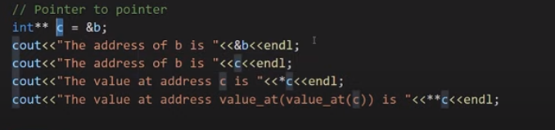
Output:
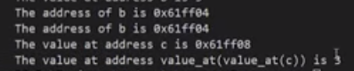
Note:
*c=b=&a ---------------(For address of a which is same in all)
**c=*b=a ---------------(For Values which are same)
&c≠&b≠&a ---------------(For addresses which different)

What are Arrays in C++
- An array is a collection of items which are of the similar type stored in contiguous memory locations.
OR
- An array is a block cells of memory which stores similar data type.
- Sometimes, a simple variable is not enough to hold all the data.
- For example, let’s say we want to store the marks of 2500 students; initializing 2500 different variable for this task is not feasible.
- To solve this problem, we can define an array with size 2500 that can hold the marks of all students.
- For example int marks[2500];
- It is used for the purpose of easily assessibility.
- Value of array can be change.
- Array starts from 0 not from 1.
Array Index:
In C++, the index of an array is an integer value that represents the position of an element within the array. Array indexing starts at 0, which means the first element of the array has an index of 0, the second element has an index of 1, the third element has an index of 2, and so on.
Pointers and Arrays
Storing the address of an array into pointer is different than storing the address of a variable into the pointer because the name of the array is an address of the first index of an array. So to use ampersand "&" with the array name for assigning the address to a pointer is wrong.
- &Marks --> Wrong
- Marks --> address of the first block
Example:
int* p = marks;
cout<<"The value of marks[0] is "<<*p<<endl;

int marks[] = {23, 45, 56, 89};
cout<<marks[0]<<endl;
cout<<marks[1]<<endl;
cout<<marks[2]<<endl;
cout<<marks[3]<<endl;

Functions in C++
Functions are the main part of top-down structured programming. We break the code into small pieces and make functions of that code. Functions help us to reuse the code easily.
int sum(int a, int b){
int c = a+b;
return c;
}

Return Value:
In C++, a return value is the value that a function returns to the caller when the function completes its execution. When a function is called, the caller provides any necessary arguments to the function, and the function executes its code to perform its task. At the end of its execution, the function can return a value back to the caller.
Actual Parameter:
In C++, an actual parameter is a value or an expression that is passed to a function when the function is called. Actual parameters are also known as arguments or actual arguments.
Example:
int result = add(3, 4);
Formal Parameter:
In C++, a formal parameter is a variable that is declared as part of a function's parameter list. A formal parameter is also known as a parameter or a formal argument. Formal parameters are used to receive values from the caller of the function.
Example:
void printSum(int a, int b);
Note: you can also use formal and actual parameters with same variables
Function Prototype in C++
The function prototype is the template of the function which tells the details of the function e.g(name, parameters) to the compiler. Function prototypes help us to define a function after the function call.
Example:
// Function prototype
int sum(int a, int b);
Note:
You can also write without variables this as in above main function but you have to write the function with variables in after the main function.
int sum(int ,int );

Inline Function:
Inline functions are used to reduce the function call. When one function is being called multiply times in the program it increases the execution time, so inline function is used to reduce time and increase program efficiency. If the inline function is being used when the function is called, the inline function expands the whole function code at the point of a function call, instead of running the function. Inline functions are considered to be used when the function is small.Only recommended in simple function.
Disadvantages:
- it will not perform well when function is large.
- Not recommended in recursion.
- Inline is not recommended when static variables are being used in the function.
- Not recommended in loop and switch.
- Sometimes compiler doesn’t accept request for inline functon.

Example:
inline int product(int a, int b){
return a*b;
}
Static variable:
It is used in function that initialize at once and persists throughout the lifetime of the program.
Example:
int product(int a, int b){
\\initialize only once and c will not equal to 0\\
static int c=0;
c=c+1;
return a*b*c;
}
Default Arguments:
Default arguments are those values which are used by the function if we don’t input our value. It is recommended to write default arguments after the other arguments
Example:
float moneyReceived(int currentMoney, float factor=1.04){
return currentMoney * factor;
}

int main(){
int money = 100000;
cout<<"If you have "<<money<<" Rs in your bank account, you will recive "<<moneyReceived(money)<< "Rs after 1 year"<<endl;
cout<<"For VIP: If you have "<<money<<" Rs in your bank account, you will recive "<<moneyReceived(money, 1.1)<< " Rs after 1 year";
return 0;
}
Note:
Default Arguments must be written on later than compulsory argument.
Constant Arguments:
Constant arguments are used when you don’t want your values to be changed or modified by the function.
Argument:
An argument is the actual value that is passed to a function or method when it is called, and it corresponds to the parameter defined in the function's signature. It provides the necessary data or inputs for the function to perform its task.

Passing Argument to a function

Call by Value:
Call by value is a method in C++ to pass the values to the function arguments. In case of call by value the copies of actual parameters are sent to the formal parameter, which means that if we change the values inside the function that will not affect the actual values.
Call by Reference:
A call by the pointer is a method in C++ to pass the values to the function arguments. In the case of call by pointer, the address of actual parameters is sent to the formal parameter, which means that if we change the values inside the function that will affect the actual values.
Methods:
There are two methods for it.
First: We use address of actual parameters as such that we write “&” with formal parameters.
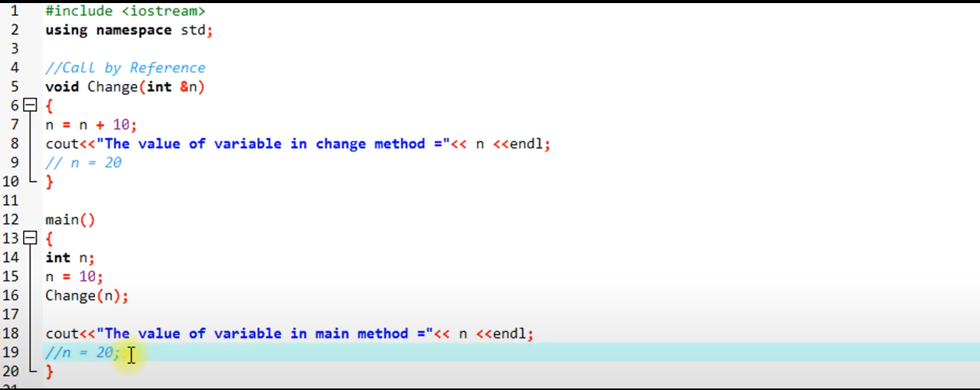
Second: We use address of actual parameters as such that we write “*” with formal parameters.
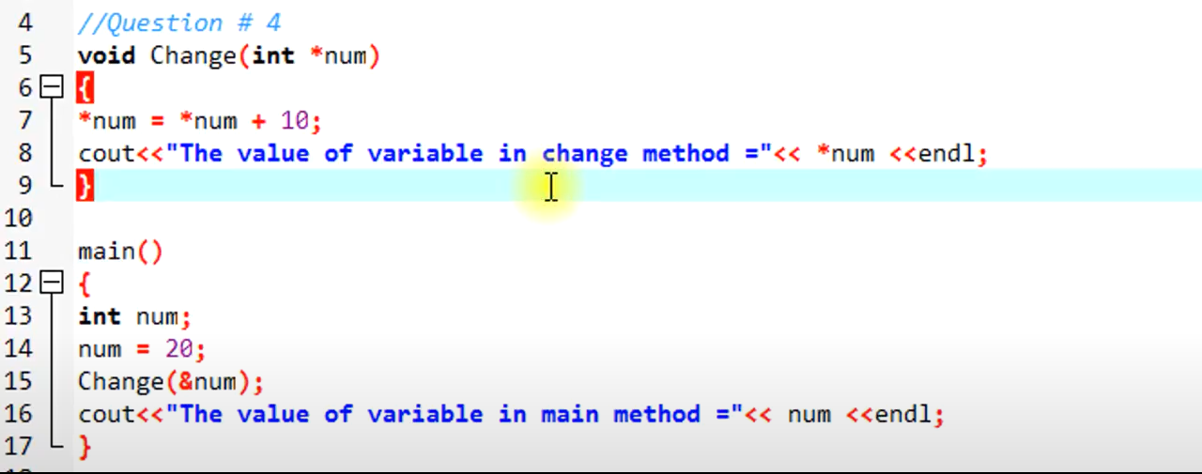

Recursion and Recursive Function:
When a function calls itself it is called recursion and the function which is calling itself is called a recursive function. The recursive function consists of a base case and recursive condition. It is very important to add a base case in recursive function otherwise recursive function will never stop executing.
Example:
int factorial(int n){
if (n<=1){
return 1;
}
return n * factorial(n-1);
}
Function Overloading:
Function overloading is a process to make more than one function with the same name but different parameters, numbers, or sequence.

Example:
int sum(float a, int b){
cout<<"Using function with 2 arguments"<<endl;
return a+b;
}

int sum(int a, int b, int c){
cout<<"Using function with 3 arguments"<<endl;
return a+b+c;
}
int main(){
cout<<"The sum of 3 and 6 is "<<sum(3,6)<<endl;
cout<<"The sum of 3, 7 and 6 is "<<sum(3, 7, 6)<<endl;
return 0;
}

User Defined Datatypes
Structures in C++
The structure is a user-defined data type that is available in C++. Structures are used to combine different types of data types, just like an array is used to combine the same type of data types.
Example:
struct employee
{
/* data */
int eId;
char favChar;
float salary;
};
Unions in C++
Unions are similar to structures but they provide better memory management then structures. Unions use shared memory so only 1 variable can be used at a time.
Example:
struct employee
{
/* data */
int eId;
char favChar;
float salary;
};
Enums in C++
Enums are user-defined types which consist of named constants. Enums are used to make the program more readable.
Example:
int main(){
enum Meal{ breakfast, lunch, dinner};
Meal m1 = lunch;
cout<<m1;
return 0;
}

Why Object-Oriented Programming?
Before we discuss object-oriented programming, we need to learn why we need object-oriented programming?
- C++ language was designed with the main intention of adding object-oriented programming to C language
- As the size of the program increases readability, maintainability, and bug-free nature of the program decrease.
- This was the major problem with languages like C which relied upon functions or procedure (hence the name procedural programming language)
- As a result, the possibility of not addressing the problem adequately was high
- Also, data was almost neglected, data security was easily compromised
- Using classes solves this problem by modeling program as a real-world scenario
Difference between Procedure Oriented Programming and Object-Oriented Programming
Procedure Oriented Programming (POP)
- Consists of writing a set of instruction for the computer to follow
- The main focus is on functions and not on the flow of data
- Functions can either use local or global data
- Data moves openly from function to function
Object-Oriented Programming (OOP)
- Works on the concept of classes and object
- A class is a template to create objects
- Treats data as a critical element
- Decomposes the problem in objects and builds data and functions around the objects
Basic Concepts in Object-Oriented Programming
- Classes - Basic template for creating objects
- Objects – Basic run-time entities
- Data Abstraction & Encapsulation – Wrapping data and functions into a single unit
Data abstraction refers to the process of representing the essential features of a class while hiding the unnecessary details. It focuses on providing a high-level view of the class and its functionalities, without exposing the implementation details.
Encapsulation refers to the bundling of data and related functions (methods) within a class. It enables the concept of data hiding, where the internal state of an object is protected and can only be accessed through the defined public interface.
- Inheritance – Properties of one class can be inherited into others
Inheritance is a fundamental concept in object-oriented programming that allows you to create new classes based on existing classes. It enables the creation of a hierarchy of classes, where a derived class inherits the properties (data members and member functions) of a base class. In C++, inheritance is implemented using the class keyword.
- Polymorphism – Ability to take more than one forms
Polymorphism is a key concept in object-oriented programming that allows objects of different classes to be treated as objects of a common base class. It enables the use of a single interface to represent multiple types of objects, providing flexibility and code reusability.
- Dynamic Binding – Code which will execute is not known until the program runs
Dynamic binding, also known as late binding or runtime polymorphism, is a feature of object-oriented programming languages like C++ that allows the appropriate function implementation to be determined at runtime based on the actual type of the object. It enables the use of a single interface to represent multiple types of objects and provides flexibility and extensibility in code.
- Message Passing – message (Information) call format
Message passing in C++ refers to the communication and interaction between objects or components by sending and receiving messages. It is a fundamental concept in object-oriented programming and is often used to achieve loose coupling and modularity in software design.
Benefits of Object-Oriented Programming
- Better code reusability using objects and inheritance
- Principle of data hiding helps build secure systems
- Multiple Objects can co-exist without any interference
- Software complexity can be easily managed

Why use classes instead of structures
Classes and structures are somewhat the same but still, they have some differences. For example, we cannot hide data in structures which means that everything is public and can be accessed easily which is a major drawback of the structure because structures cannot be used where data security is a major concern. Another drawback of structures is that we cannot add functions in it.
Classes in C++
Classes are user-defined data-types and are a template for creating objects. Classes consist of variables and functions which are also called class members.
Public Access Modifier in C++
All the variables and functions declared under public access modifier will be available for everyone. They can be accessed both inside and outside the class. Dot (.) operator is used in the program to access public data members directly.
Private Access Modifier in C++ confused
All the variables and functions declared under a private access modifier can only be used inside the class. They are not permissible to be used by any object or function outside the class.
The purpose of making variables private is to encapsulate them and hide their implementation detail

Static Data Members in C++
When a static data member is created, there is only a single copy of the data member which is shared between all the objects of the class. As we have discussed in our previous lecture that if the data members are not static then every object has an individual copy of the data member and it is not shared.
Static Methods in C++
When a static method is created, they become independent of any object and class. Static methods can only access static data members and static methods. Static methods can only be accessed using the scope resolution operator.

Constructors in C++
A constructor is a special member function with the same name as the class. The constructor doesn’t have a return type. Constructors are used to initialize the objects of its class. Constructors are automatically invoked whenever an object is created.
Important Characteristics of Constructors in C++
- A constructor should be declared in the public section of the class
- They are automatically invoked whenever the object is created
- They cannot return values and do not have return types
- It can have default arguments
- We cannot refer to their address
Parameterized and Default Constructors in C++
Parameterized constructors are those constructors that take one or more parameters. Default constructors are those constructors that take no parameters. The main things to note here are that constructors are written in the public section of the class and the constructors don’t have a return type.

Copy Constructor in C++
A copy constructor is a type of constructor that creates a copy of another object. If we want one object to resemble another object we can use a copy constructor. If no copy constructor is written in the program compiler will supply its own copy constructor.
When no copy constructor is found, compiler supplies its own copy constructor

Dynamic Initialization of Objects Using Constructors
The dynamic initialization of the object means that the object is initialized at the runtime. Dynamic initialization of the object using a constructor is beneficial when the data is of different formats

Friend Function in C++
Friend functions are those functions that have the right to access the private data members of class even though they are not defined inside the class. It is necessary to write the prototype of the friend function. One main thing to note here is that if we have written the prototype for the friend function in the class it will not make that function a member of the class.
Properties of Friend Function
- Not in the scope of the class
- Since it is not in the scope of the class, it cannot be called from the object of that class, for example, sumComplex() is invalid
- A friend function can be invoked without the help of any object
- Usually contain objects as arguments
- Can be declared under the public or private access modifier, it will not make any difference
- It cannot access the members directly by their names, it needs (object_name.member_name) to access any member.

Inheritance in C++ an Overview
- Reusability is a very important feature of OOPs
- In C++ we can reuse a class and add additional features to it
- Reusing classes saves time and money
- Reusing already tested and debugged classes will save a lot of effort of developing and debugging the same thing again
What is Inheritance in C++?
- The concept of reusability in C++ is supported using inheritance
- We can reuse the properties of an existing class by inheriting it
- The existing class is called a base class
- The new class which is inherited from the base class is called a derived class
- Reusing classes saves time and money
- There are different types of inheritance in C++
Forms of Inheritance in C++
- Single Inheritance
- Multiple Inheritance
- Hierarchical Inheritance
- Multilevel Inheritance
- Hybrid Inheritance
Single Inheritance in C++
Single inheritance is a type of inheritance in which a derived class is inherited with only one base class. For example, we have two classes “employee” and “programmer”. If the “programmer” class is inherited from the “employee” class which means that the “programmer” class can now implement the functionalities of the “employee” class.
Multiple Inheritances in C++
Multiple inheritances are a type of inheritance in which one derived class is inherited with more than one base class. For example, we have three classes “employee”, “assistant” and “programmer”. If the “programmer” class is inherited from the “employee” and “assistant” class which means that the “programmer” class can now implement the functionalities of the “employee” and “assistant” class.
Hierarchical Inheritance
A hierarchical inheritance is a type of inheritance in which several derived classes are inherited from a single base class. For example, we have three classes “employee”, “manager” and “programmer”. If the “programmer” and “manager” classes are inherited from the “employee” class which means that the “programmer” and “manager” class can now implement the functionalities of the “employee” class.
Multilevel Inheritance in C++
Multilevel inheritance is a type of inheritance in which one derived class is inherited from another derived class. For example, we have three classes “animal”, “mammal” and “cow”. If the “mammal” class is inherited from the “animal” class and “cow” class is inherited from “mammal” which means that the “mammal” class can now implement the functionalities of “animal” and “cow” class can now implement the functionalities of “mammal” class.
Hybrid Inheritance in C++
Hybrid inheritance is a combination of multiple inheritance and multilevel inheritance. In hybrid inheritance, a class is derived from two classes as in multiple inheritances. However, one of the parent classes is not a base class. For example, we have four classes “animal”, “mammal”, “bird”, and “bat”. If “mammal” and “bird” classes are inherited from the “animal” class and “bat” class is inherited from “mammal” and “bird” classes which means that “mammal” and “bird” classes can now implement the functionalities of “animal” class and “bat” class can now implement the functionalities of “mammal” and “bird” classes.

rotected Access Modifiers in C++
Protected access modifiers are similar to the private access modifiers but protected access modifiers can be accessed in the derived class whereas private access modifiers cannot be accessed in the derived class. A table is shown below which shows the behavior of access modifiers when they are derived “public”, “private”, and “protected”.
 | Public Derivation | Private Derivation | Protected Derivation
Private members | Not Inherited | Not Inherited | Not Inherited
Protected members | Protected | Private | Protected
Public members | Public | Private | Protected
As shown in the table,
- If the class is inherited in public mode then its private members cannot be inherited in child class.
- If the class is inherited in public mode then its protected members are protected and can be accessed in child class.
- If the class is inherited in public mode then its public members are public and can be accessed inside child class and outside the class.
- If the class is inherited in private mode then its private members cannot be inherited in child class.
- If the class is inherited in private mode then its protected members are private and cannot be accessed in child class.
- If the class is inherited in private mode then its public members are private and cannot be accessed in child class.
- If the class is inherited in protected mode then its private members cannot be inherited in child class.
- If the class is inherited in protected mode then its protected members are protected and can be accessed in child class.
- If the class is inherited in protected mode then its public members are protected and can be accessed in child class.

Ambiguity in inheritance can be defined as when one class is derived for two or more base classes then there are chances that the base classes have functions with the same name. So it will confuse derived class to choose from similar name functions. To solve this ambiguity scope resolution operator is used “::”

Virtual Base Class in C++
In C++, a virtual base class is a class that is intended to be used as a base class in an inheritance hierarchy where multiple paths lead to the same base class. The use of virtual base classes helps avoid the "diamond problem," which is a complication that arises in multiple inheritance scenarios.
The virtual base class is a concept used in multiple inheritances to prevent ambiguity between multiple instances. For example: suppose we created a class “A” and two classes “B” and “C”, are being derived from class “A”. But once we create a class “D” which is being derived from class “B” and “C” as shown in figure 1.
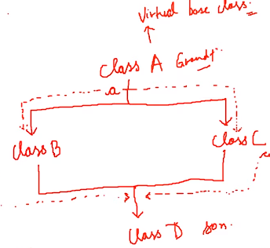
Figure 1: Virtual Base Class Example Diagram
As shown in figure 1,
- Class “A” is a parent class of two classes “B” and “C”
- And both “B” and “C” classes are the parent of class “D”
The main thing to note here is that the data members and member functions of class “A” will be inherited twice in class “D” because class “B” and “C” are the parent classes of class “D” and they both are being derived from class “A”.
So when the class “D” will try to access the data member or member function of class “A” it will cause ambiguity for the compiler and the compiler will throw an error. To solve this ambiguity we will make class “A” as a virtual base class. To make a virtual base class “virtual” keyword is used.
When one class is made virtual then only one copy of its data member and member function is passed to the classes inheriting it.

Diamond Problem:
The "diamond problem" is a term in object-oriented programming that refers to an issue that can arise in languages that support multiple inheritance, where a class inherits from two or more classes that have a common base class. This situation creates ambiguity in the inheritance hierarchy, leading to challenges in defining and accessing shared base class members

The new operator is used to dynamically allocate memory on the heap for an object or an array of objects. And delete operator is used to deallocate the memory
Dynamic memory allocation is the process of assigning the memory space during the execution time or the run time.
Operator overloading:
Operator overloading is a feature in C++ that allows you to define how an operator behaves for user-defined types. With operator overloading, you can provide a specific meaning to an operator when used with objects of your class. This makes it easier to work with user-defined types in a way that is more natural and intuitive.
- Key Points:
  - Overloaded operators must maintain their original meaning (unless the context justifies a different behavior).
  - Some operators cannot be overloaded (e.g., . and ::).
  - Overloaded operators can be member functions or global functions.
- Commonly Overloaded Operators:
  - +, -, *, / (arithmetic operators)
  - ==, !=, <, > (comparison operators)
  - +=, -=, *=, /= (compound assignment operators)
  - <<, >> (stream insertion/extraction operators)
Polymorphism in C++
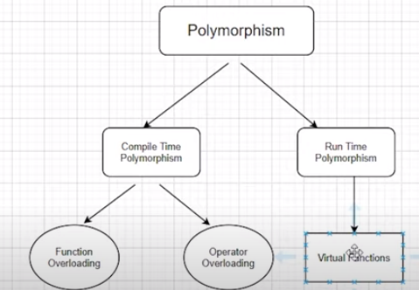
“Poly” means several and “morphism” means form. So we can say that polymorphism is something that has several forms or we can say it as one name and multiple forms. There are two types of polymorphism:
- Compile-time polymorphism
- Run time polymorphism
Compile Time Polymorphism(Static Polymorphism)
In compile-time polymorphism, it is already known which function will run. Compile-time polymorphism is also called early binding, which means that you are already bound to the function call and you know that this function is going to run. There are two types of compile-time polymorphism:
- Function Overloading
This is a feature that lets us create more than one function and the functions have the same names but their parameters need to be different. If function overloading is done in the program and function calls are made the compiler already knows that which functions to execute.
- Operator Overloading
This is a feature that lets us define operators working for some specific tasks. For example, we can overload the operator “+” and define its functionality to add two strings. Operator loading is also an example of compile-time polymorphism because the compiler already knows at the compile time which operator has to perform the task.
Run Time Polymorphism(Dynamic Polymorphism)
In the run-time polymorphism, the compiler doesn’t know already what will happen at run time. Run time polymorphism is also called late binding. The run time polymorphism is considered slow because function calls are decided at run time. Run time polymorphism can be achieved from the virtual function.
- Virtual Function
A function that is in the parent class but redefined in the child class is called a virtual function. “virtual” keyword is used to declare a virtual function.

Upcasting:
In C++ refers to the process of converting a pointer or reference of a derived class type to a pointer or reference of a base class type. This conversion is considered safe and is implicitly supported by the language. Upcasting allows you to treat objects of a derived class as if they were objects of the base class.
Virtual Functions in C++
A member function in the base class which is declared using virtual keyword is called virtual functions. They can be redefined in the derived class

Memory Leaks:
A memory leak occurs in a computer program when it allocates memory (such as creating an object or an array) but fails to release or deallocate that memory when it is no longer needed. As a result, the program retains memory that cannot be accessed or used, leading to a gradual consumption of system resources. Over time, if not addressed, memory leaks can lead to performance issues and eventually cause the program or system to crash.

Pure Virtual Functions in C++
Pure virtual function is a function that doesn’t perform any operation and the function is declared by assigning the value 0 to it. Pure virtual functions are declared in abstract classes.
Abstract Base Class in C++
Abstract base class is a class that has at least one pure virtual function in its body. The classes which are inheriting the base class must need to override the virtual function of the abstract class otherwise compiler will throw an error.

What exactly is stream in C++?
In C++, a stream refers to a sequence of characters that are transferred between the program and input/output (I/O) devices

What is DRY principle in coding?
DRY stands for "Don't Repeat Yourself," and it is a principle in software development that promotes code reusability and maintainability. The DRY principle emphasizes that each piece of knowledge or logic within a system should have a single, unambiguous representation. In other words, you should avoid duplicating code or logic in multiple places.

What is the meaning of generic programming?
Generic programming is a programming paradigm that aims to create reusable, flexible, and abstract code by allowing types to be specified later, usually at the time of instantiation. The key idea behind generic programming is to write algorithms and data structures that can operate on a variety of data types without sacrificing performance or type safety.
Generic programming is like making a flexible recipe that works with different ingredients. Instead of specifying exactly which ingredients to use, you create a recipe that can work with various ingredients when you decide to cook.

What is a template in C++ programming?
In C++, a template is a feature that allows you to write generic programs. It enables you to create functions and classes that can work with any data type, rather than being tied to a specific type. Templates provide a way to write code once and use it with different data types without duplicating the code.
A template is believed to escalate the potential of C++ several fold by giving it the ability to define data types as parameters making it useful to reduce repetitions of the same declaration of classes for different data types. Declaring classes for every other data type(which if counted is way too much) in the very first place violates the DRY( Don’t Repeat Yourself) rule of programming and on the other doesn't completely utilise the potential of C++.

It is very analogous to when we said classes are the templates for objects, here templates itself are the templates of the classes. That is, what classes are for objects, templates are for classes.
Why templates?
- DRY Rule:
To understand the reason behind using templates, we will have to understand the effort behind declaring classes for different data types. Suppose we want to have a vector for each of the three(can be more) data types, int, float and char. Then we’ll obviously write the whole thing again and again making it awfully difficult. This is where the saviour comes, the templates. It helps parametrizing the data type and declaring it once in the source code suffice. Very similar to what we do in functions. It is because of this, also called, ‘parameterized classes’.
- Generic Programming:
It is called generic, because it is sufficient to declare a template once, it becomes general and it works all along for all the data types.
Refer to the schematic below:
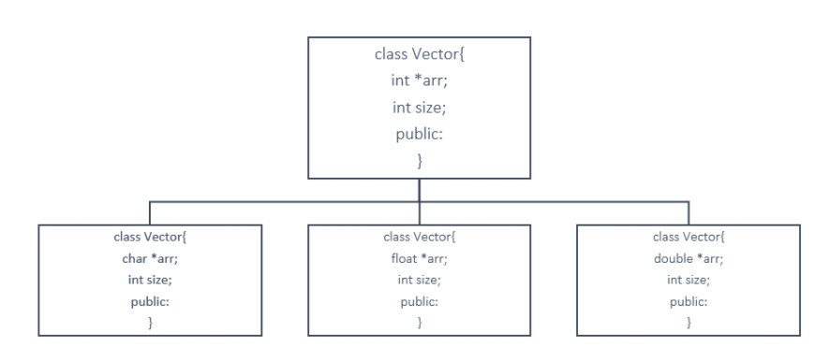
We had to copy the same thing again and again for different data types, but a template solves it all. Refer to the syntax section for how.

Why is this important for competitive programmers?
- Competitive programming is a part of various environments, be it job interviews, coding contests and all, and if you’re in one of those environments, you’ll be given limited time to code your program.
- So, suppose you want in your program, a resizable array, or sort an array or any other data structure. or search for some element in your container.
- You will always try to code a function which will execute the above mentioned things, and end up losing a great amount of time. But here is when you will use STL.
An STL is a library of generic functions and classes which saves you time and energy which you would have spent constructing for your use. This helps you reuse these well tested classes and functions umpteenth number of times according to your own convenience.
To put this simply, STL is used because it is not a good idea to reinvent something which is already built and can be used to innovate things further. Suppose you go to a company who builds cars, they will not ask you to start from scratch, but to start from where it is left. This is the basic idea behind using STL.
COMPONENTS OF STL:
We have three components in STL:
- Containers
- Algorithm
- Iterators
Let’s deal with them individually;
Containers:
Container is an object which stores data. We have different containers having their own benefits. These are the implemented template classes for our use, which can be used just by including this library. You can even customise these template classes.
Algorithms:
Algorithms are a set of instructions which manipulates the input data to arrive at some desired result. In STL, we have already written algorithms, for example, to sort some data structure, or search some element in an array. These algorithms use template functions.
Iterators:
Iterators are objects which refer to an element in a container. And we handle them very much similarly to a pointer. Their basic job is to connect algorithms to the container and play a vital role in manipulation of the data.

STL (Standard Template Library):
STL, or Standard Template Library, is a powerful set of C++ template classes to provide general-purpose classes and functions with templates that implement many popular and commonly used algorithms and data structures. It is a part of the C++ Standard Library and provides several generic classes and functions with templates that implement many popular and commonly used algorithms and data structures like vectors, lists, queues, and stacks.
Components of STL:
- Algorithms:
  - STL provides a collection of algorithms for tasks such as searching, sorting, and modifying elements in a sequence.
  - Examples include sort(), find(), transform(), and reverse().
- Containers:
  - Containers are objects that store data. STL provides various types of containers like vectors, lists, queues, stacks, and maps.
  - Examples include vector, list, queue, stack, and map.
- Functions:
  - STL provides several function objects (functors) and functions that can be used with algorithms to define custom behavior.
  - Examples include greater<>, less<>, and plus<>.
- Iterators:
  - Iterators are objects that allow the traversal of elements in a container. They act as a bridge between algorithms and containers.
  - Examples include begin(), end(), advance(), and next().
Uses of STL:
- Code Reusability:
  - STL components provide generic and reusable algorithms and data structures, allowing developers to write efficient code without reinventing the wheel.
- Productivity:
  - STL simplifies complex data structures and algorithms, reducing the amount of code a programmer needs to write and maintain.
- Efficiency:
  - STL algorithms are highly optimized, often outperforming hand-written implementations.
- Consistency:
  - STL provides a consistent and well-tested framework, ensuring that the same algorithms and data structures are used across different projects.
- Ease of Learning:
  - Once a developer understands the basic concepts of STL, it becomes easier to work with different containers and algorithms, promoting a consistent coding style.
- Compatibility:
  - STL is part of the C++ standard, making code written with STL highly portable across different compilers and platforms.

Containers, objects which store data, Algorithms, set of procedures to process data, and Iterators, objects which point to some element in a container. Today, in this tutorial, we will be interested in discussing more about containers.
Containers are themselves of three types:
- Sequence Containers
- Associative Containers
- Derived Containers

- Sequence Containers
A sequence container stores that data in a linear fashion. Refer to the illustration below to understand what storing something in a linear fashion means.
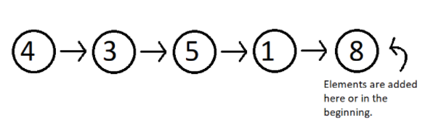
Figure 1: Elements stored in a linear fashion
Sequence containers include Vector, List, Dequeue etc. These are some of the most used sequence containers.
- Associative Containers
An associative container is designed in such a way that enhances the accessing of some element in that container. It is very much used when the user wants to fastly reach some element. Some of these containers are, Set, Multiset, Map, Multimap etc. They store their data in a tree-like structure.
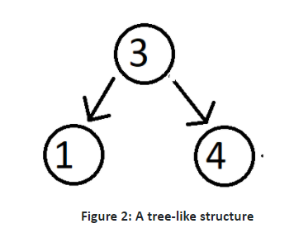
- Derived Containers
As the name suggests, these containers are derived from either the sequence or the associative containers. They often provide you with some better methods to deal with your data. They deal with real life modelling. Some examples of derived containers are Stack, Queue, Priority Queue, etc. The following illustration give you the idea of how a stack works.
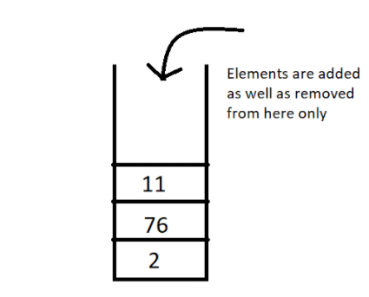
Figure 3: A stack, works on the first in first out [FIFO] method
Now since we have got the basic idea of all the three types of containers, a question which might arise is when to use which. So, let’s deal with that,
In sequence containers, we have Vectors, which has following properties:
- Faster random access to elements in comparison to array
- Slower insertion and deletion at some random position, except at the end.
- Faster insertion at the end.

In Lists, we have,
- Random accessing elements is too slow, because every element is traversed using pointers.
- Insertion and deletion at any position is relatively faster, because they only use pointers, which can easily be manipulated.
Composition:
Composition in object-oriented programming is a way to model relationships between classes where one class contains another class as a part

Difference between Abstract class and interface?
Ans: Abstract Class: An abstract class in C++ is a class that contains at least one pure virtual function. It may also contain non-pure virtual functions and data members. Abstract classes can have constructors and destructors.
Interface: It serves as a pure abstract base class and defines a contract for classes that implement it.

Virtual Base Class:

A virtual base class is a class that is intended to be inherited virtually by derived classes. When a base class is declared as virtual, it means that only a single instance of that base class will be inherited by multiple derived classes, even if those derived classes are derived from the base class through multiple paths in the inheritance hierarchy.
In summary, virtual base classes are used to avoid the creation of multiple instances of a base class in the object hierarchy, ensuring that only one instance is shared among all derived classes. This helps to resolve ambiguities and ensures correct behavior in complex inheritance hierarchies.

