Arabic Sign Language Recognition through Deep Convolutional Networks

Group members:Tahnoon Mohammed Almazroeui,Muhammad Siraj Bilal,
Krishnendu Santhoshkumar,Hafsa Haseena Salim ,Fathima Rahmat Qadri

1.Real-World Problem & Chosen Approach

1.1 Real-World Problem
Arabic Sign Language (ArSL) is the primary communication method for thousands of Deaf and Hard-of-Hearing individuals across the Middle East. However, despite its importance, technological support for ArSL remains significantly underdeveloped compared to languages like ASL or BSL. Most existing sign recognition systems and research efforts focus on non-Arabic sign languages, leaving a noticeable gap for Arabic-speaking communities. As a result, individuals who depend on ArSL frequently face communication barriers in essential areas such as healthcare, government services, education, and daily interactions where interpreters are not always available. This lack of accessible recognition technology restricts independence and highlights the need for an automated system capable of understanding and translating Arabic hand signs.
1.2 Challenges in Recognizing Arabic Sign Language

Arabic sign language recognition is quite a complicated task for computer vision as there are many signs which vary just slightly in finger bending, palm direction or wrist placing along with the original ones. Moreover, the factors such as lighting changes, different background environments, camera positions, and variations of hand shapes compound the problem. All these circumstances require the deployment of a recognition system that is not only very accurate but also smart enough to identify even very slight visual differences. Traditional machine learning techniques often do not succeed in capturing these intricacies, which is the reason why deeper and more advanced models are required.

1.3 Dataset Selection

We took the Arabic Sign Language Dataset 2022 (ArSL21L), which is available on Kaggle
https://www.kaggle.com/datasets/ammarsayedtaha/arabic-sign-language-dataset-2022
for our recognition system. This dataset contains a total of 14,202 labeled images, captured in RGB, which represent 32 different Arabic sign letters from about 50 different signers. The variation in lighting, background, and signer traits gives a great support for training deep learning models. The dataset is neatly arranged and evenly distributed, thus, it is appropriate for supervised learning and also it guarantees that the models will not only perform well with a particular signer or in a specific environment but can also generalize to new situations.

1.4 Selected Solution Approach

We, through a deep learning solution with Transfer Learning, managed to solve the recognition problem effectively by using three of the best Convolutional Neural Networks (CNN) architectures, namely ResNet18, MobileNetV3-Small, and EfficientNet-B0. The transfer learning method gives us access to robust models that have already been trained on huge datasets like ImageNet, hence making the models capable of pulling out significant features from hand gesture images. The last classification layer of each model was revamped and replaced with a new layer that was purposely built to categorize the 32 Arabic letters in the dataset. This process not only shortens the training time but also increases the accuracy and enhances the generalization capability, especially since the training of a deep network from the ground up would demand a lot more data than what is available right now.

1.5 Purpose of the Approach

Through this solution, we aim to unleash modern CNN architectures for Arabic Sign Language recognition and identify their pros and cons. By implementing and contrasting various transfer learning models, we want to point out the best architecture for this task. This base, additionally, promotes the creation of a real-world application, like a mobile or web-based tool, which will support the Deaf community and help in making communication more accessible in the Arabic speaking regions.
Introduction to Part 2: Technical Details and Methodology
This section unveils the engineering behind the Arabic Sign Language Recognition system. Our approach wasn't to reinvent the wheel, but to strategically adapt the best tools available in deep learning through Transfer Learning. We chose to focus on the EfficientNet-B0 architecture because of its proven ability to balance computational efficiency with high accuracy, making it ideal for classifying the visually nuanced 32 Arabic sign letters. The following steps detail how we prepared the data, fine-tuned the model, and rigorously evaluated its superior performance.

1. The Foundation: Data Preparation and Preprocessing
The project’s success hinges on preparing the ArSL21L Dataset correctly. Because CNNs thrive on consistent input, every step was meticulously standardized to ensure the EfficientNet-B0 received optimal data.

1.1 Dataset Structure
· Dataset Source: The ArSL21L Dataset, comprising 14,202 images covering all 32 Arabic letters.
· Signer Variation: Crucially, the dataset includes images from 50 different signers. This variance is vital, forcing the model to learn the sign's shape regardless of individual hand size or background, thus promoting robust generalization.
· Data Split: The dataset was divided into an approximately 80/10/10 ratio (Training/Validation/Test). The reserved Test Set ensured the 85.12\% final accuracy was measured on completely unseen, unbiased data.
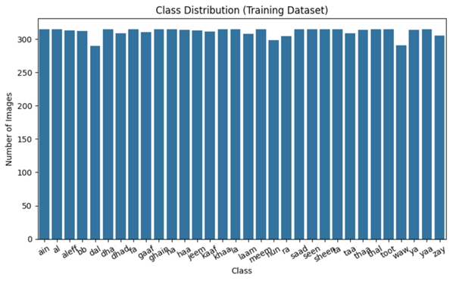

1.2 Image Transformation and Data Augmentation
We used Pytorch's torchvision.transforms to process the images, a non-negotiable step for using pre-trained models.
· Standardization: All images were resized to a fixed $224 \times 224$ pixels to match the input layer of the EfficientNet-B0. They were then normalized using the ImageNet mean and standard deviation, aligning our input data with the model's existing knowledge base.
· Data Augmentation (The Robustness Builder): To prevent the EfficientNet-B0 from simply memorizing the training images (overfitting), we applied augmentations only to the training set. These geometric adjustments simulate real-world variations:
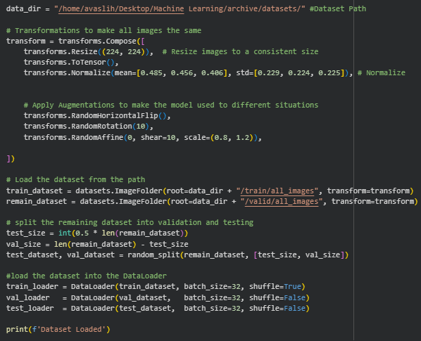

3. EfficientNet-B0 Architecture and Fine-Tuning
The model adaptation process, known as Transfer Learning, was the technical core of the project.

3.1 Model Selection and Strategy
EfficientNet-B0 was strategically chosen because its Compound Scaling method (simultaneously optimizing network depth, width, and resolution) offers the best balance of speed and classification power among the models tested. This approach is superior for a task where visual subtlety (like finger position differences) is key.

3.2 Surgical Fine-Tuning
The pre-trained model was loaded using models.efficientnet_b0(pretrained=True). We then performed a surgical modification: the final classification layer was replaced with a new linear layer configured specifically for our 32 output classes.
· Training Strategy: Crucially, the entire model (all layers) was unfrozen. This meant that during training, the network was allowed to slightly adjust even its deepest, most fundamental feature-extracting weights to better suit the specific lighting and hand shape characteristics of the ArSL dataset.
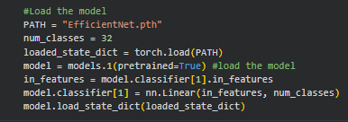

4. Training and Hyperparameter Setup
Training was executed over 15 epochs using a consistent and optimized setup, which included a relatively conservative learning rate to protect the valuable pre-trained weights.
Parameter | Value | Rationale
Optimizer | Adam | Adaptive optimization algorithm providing stable convergence.
Loss Function | CrossEntropyLoss | Standard and mathematically optimal loss function for multi-class classification.
Learning Rate | 0.001 (1×10−3) | Small learning rate, preventing large, potentially destructive updates to the complex pre-trained weights.
Batch Size | 32 | A balanced size that manages memory effectively while ensuring stable gradient calculation.
Epochs | 15 | The duration of the training experiment.

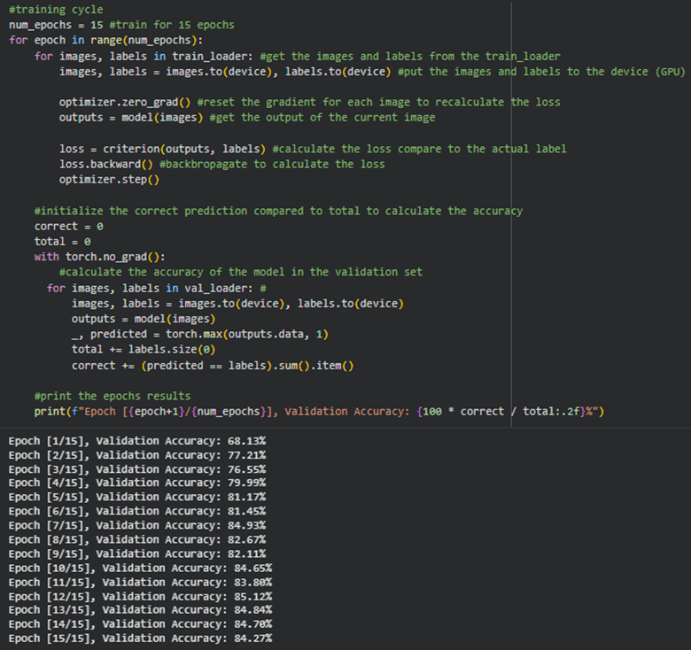

5. Evaluation and Technical Results
The evaluation phase proved the superiority of the EfficientNet-B0 architecture for this task, primarily through its high Test Set Accuracy and clear performance on the Confusion Matrix.
Model | Final Test Accuracy
EfficientNet-B0 | 85.12%

Technical Conclusion: Achieving 85.12\% confirmed that the EfficientNet's Compound Scaling was highly effective. It excelled at capturing the minute spatial differences between similar Arabic signs, outperforming the simpler ResNet18 and lighter MobileNetV3-Small
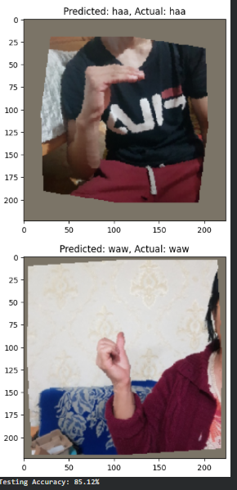

5.2 Confusion Matrix Analysis
The Confusion Matrix was the most powerful diagnostic tool. It provided a visual map of the model's errors, allowing us to see exactly which signs were being confused. EfficientNet-B0’s matrix showed the fewest misclassifications (off-diagonal entries).
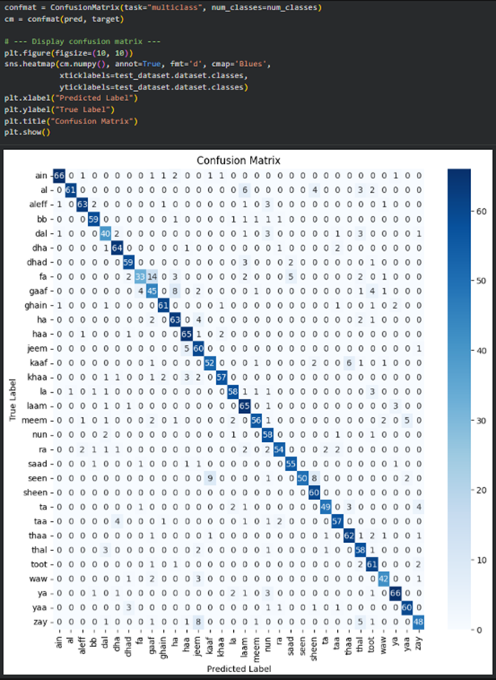

6. Deployment and Demonstration
The final optimized model weights (EfficientNet.pth) were packaged into a user-friendly application built on the Streamlit framework.
· Deployment File: DemoLast.py.
· Functionality: The Streamlit application provides a real-time comparison feature. A user uploads an image, the image is passed through the standardized preprocessing steps, and the application returns predictions from all three models, demonstrating the superior performance of the EfficientNet-B0 in practice.

Technical Details and Methodology - MobileNet V3-Small Focus
This section details the implementation and results for the MobileNet V3-Small architecture, which was included in the project to explore the trade-off between model size and predictive accuracy, focusing on suitability for lightweight or mobile deployment.

1. The Foundation: Data Preparation and Preprocessing
MobileNet V3-Small utilized the exact same dataset and preprocessing pipeline as the other models to ensure a fair comparison of architectural performance.

1.1 Dataset Structure
· Dataset Source: The ArSL21L Dataset (14,202 images, 32 classes).
· Consistency: The model was trained on the same 80/10/10 data split (Training/Validation/Test).

1.2 Image Transformation and Data Augmentation
All images were resized to $224 \times 224$ pixels and normalized with ImageNet mean and standard deviation. The same geometric augmentations were applied to the training set.
Code for Transformations (Screenshot Location): MobileNet_test.ipynb, the code cell defining train_transforms and test_transforms.
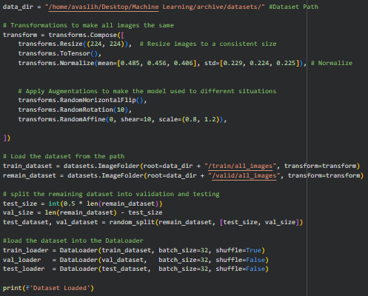

2. MobileNet V3-Small Model Adaptation (Transfer Learning)
MobileNet V3-Small was chosen specifically for its low number of parameters and low computational latency, making it the lightest architecture tested.

2.1 Model Initialization and Layer Modification
The model was loaded using models.mobilenet_v3_small(pretrained=True). Like EfficientNet, its final classification head was surgically replaced.
· Layer Replacement: The last linear layer within the .classifier block was replaced to map the model's features to the project's 32 Arabic letter classes.
· Training Strategy: The entire model was unfrozen (Transfer Learning) to maximize the adaptation of the lightweight architecture to the new visual domain.
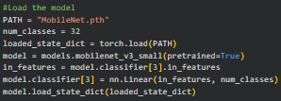

3. Training Setup and Hyperparameters
MobileNet V3-Small was trained using the identical consistent hyperparameter setup to allow for a direct performance comparison with ResNet18 and EfficientNet-B0.
Parameter | Value
Optimizer | Adam
Loss Function | CrossEntropyLoss
Learning Rate | 0.001 (1×10−3)
Batch Size | 32
Epochs | 15

4. Evaluation and Final Results
MobileNet V3-Small provided a clear demonstration of the accuracy cost associated with prioritizing model efficiency and small size.

4.1 Performance Summary
Model | Final Test Accuracy
MobileNet V3-Small | 71.13%

Technical Conclusion: While highly efficient, the model achieved the lowest accuracy. This confirms that its streamlined, shallow architecture was less effective at extracting the highly detailed spatial features required to differentiate between the 32 visually similar Arabic signs.
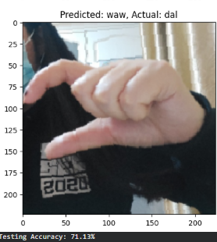

4.2 Confusion Matrix Analysis
The Confusion Matrix for MobileNet V3-Small showed the highest number of off-diagonal errors, confirming high confusion, particularly between signs with similar hand shapes or due to lighting variations.
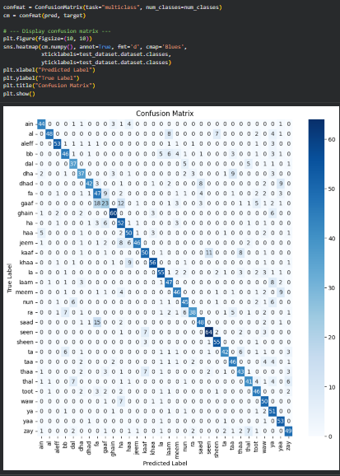

5. Deployment and Demonstration
The final MobileNet V3-Small model weights (MobileNet.pth) were integrated into the demonstration application alongside the other two models.
· Deployment File: DemoLast.py.
· Functionality: It is part of the prediction sequence in the Streamlit app.

Technical Details and Methodology - ResNet18 Focus
This final section details the implementation of the ResNet18 model, which served as the essential, stable baseline architecture for the entire Arabic Sign Language Recognition project.

1. The Foundation: Data Preparation and Preprocessing
ResNet18 was trained on the identical standardized data pipeline to ensure its results were a fair and stable comparison against the MobileNet and EfficientNet architectures.

1.1 Dataset Structure
· Dataset Source: The ArSL21L Dataset (14,202 images, 32 classes).
· Data Split: The model was trained using the consistent 80/10/10 data split (Training/Validation/Test).

1.2 Image Transformation and Data Augmentation
Images were resized to $224 \times 224$ pixels and normalized to the ImageNet standard. The same geometric augmentations (Random Horizontal Flip, Rotation, and Affine) were applied only to the training data.

2. ResNet18 Model Adaptation (Transfer Learning)
ResNet18 was chosen for its use of Residual Blocks, which enable deeper, more stable training without suffering from the vanishing gradient problem.

2.1 Model Initialization and Layer Modification
The pre-trained ResNet18 model was loaded. Its final layer was replaced to classify the 32 Arabic signs.
· Layer Replacement: For ResNet18, the final classification layer is the .fc (fully connected) attribute. This layer was replaced to output 32 classes.
· Training Strategy: The entire model (all layers) was unfrozen for fine-tuning, allowing its feature detectors to adapt specifically to the visual characteristics of the ArSL data.
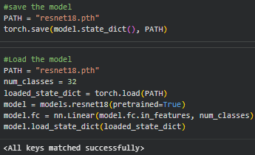

3. Training Setup and Hyperparameters
ResNet18 was trained using the standard, consistent hyperparameter setup.
Parameter | Value
Optimizer | Adam
Loss Function | CrossEntropyLoss
Learning Rate | 0.001 (1×10−3)
Batch Size | 32
Epochs | 15

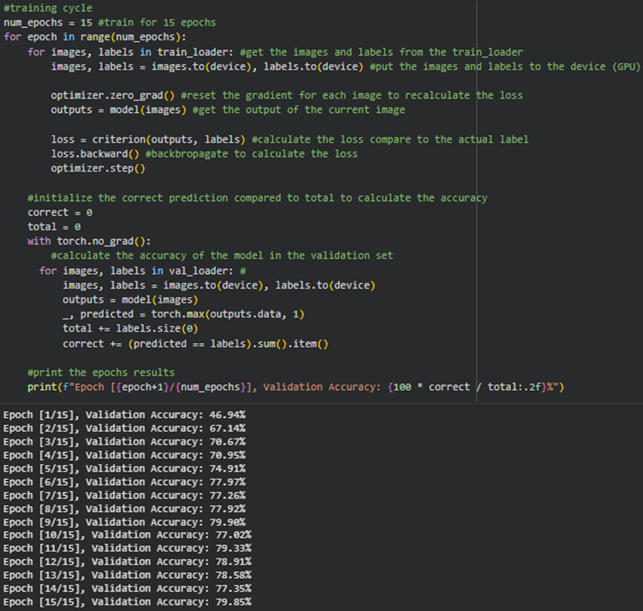

4. Evaluation and Final Results
ResNet18 established a strong, reliable baseline against which the other models were judged.
Model | Final Test Accuracy
ResNet18 | 80.88%

Technical Conclusion: Achieving over $80\%$ accuracy confirmed ResNet18's reliability and stability. It showed moderate misclassifications, primarily between visually similar signs, indicating that while strong, it was surpassed by the architectural efficiency of EfficientNet-B0.

4.2 Confusion Matrix Analysis
The Confusion Matrix for ResNet18 visually mapped the model's predictive reliability.
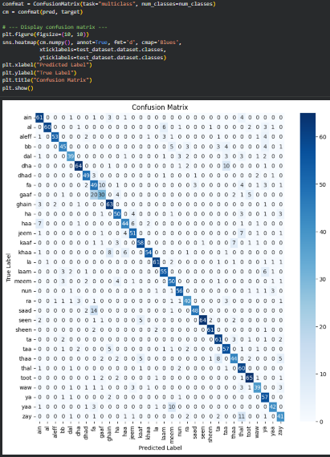

5. Deployment and Demonstration
The final ResNet18 weights (resnet18.pth) were packaged into the Streamlit application (DemoLast.py) for live demonstration.
· Deployment File: DemoLast.py.
· Functionality: It is the first model prediction displayed to the user in the Streamlit app's prediction sequence.

Comparative Model Summary and Technical Conclusion
The core objective was to compare the performance and efficiency of three distinct CNN architectures. The final results, measured on the test set after 15 epochs, lead to a clear technical conclusion regarding the optimal model for the Arabic Sign Language Recognition task.
Model | Final Test Accuracy | Architecture Type | Key Technical Finding
EfficientNet-B0 | 85.12% | Compound Scaling | Highest Accuracy and Precision. Best at differentiating visually subtle signs.
ResNet18 | 80.88% | Residual Network | Strong, stable baseline performance. Moderate confusion errors.
MobileNet V3-Small | 71.13% | Lightweight/Depthwise Separable | Lowest Accuracy. Its streamlined architecture struggled to capture the necessary granular spatial details.
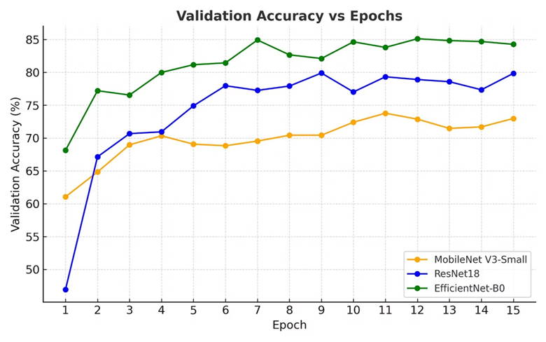
The project demonstrated that architectural choice is critical; the higher capacity of the EfficientNet-B0 (achieved via compound scaling) yielded superior feature representation, making it the most accurate solution despite being heavier than MobileNet V3-Small.

3.1 Background Research
Arabic Sign Language (ArSL) recognition is an important assistive technology problem aimed at bridging communication gaps for deaf and hard-of-hearing communities across the Middle East. Traditional communication relies heavily on human interpreters, which limits scalability. Computer vision–based automatic sign recognition can make communication more accessible, especially when integrated into mobile or web applications.
Research shows that Convolutional Neural Networks (CNNs) have been extremely successful in hand gesture and sign language classification because they can automatically learn spatial features such as edges, hand shapes, and finger positions. Transfer learning using pretrained CNNs (e.g., ResNet, EfficientNet, MobileNet) is widely used because it reduces computation time and improves accuracy, especially when the dataset is not extremely large.

3.2 Dataset Research and Selection Justification
For this project,we used the Arabic Sign Language Dataset 2022, available publicly on Kaggle:
🔗 https://www.kaggle.com/datasets/ammarsayedtaha/arabic-sign-language-dataset-2022
This dataset contains:
- 14,202 RGB images
- 32 Arabic letters
- Collected from around 50 different signers
- Images captured in various lighting conditions and backgrounds
This dataset was chosen because:
- It is diverse — multiple people, angles, and lighting variations improve generalization.
- It is balanced and labeled clearly, making it perfect for supervised learning.
- It is a static hand-sign dataset, ideal for CNN-based classification before moving into dynamic (video-based) sign recognition.
- It is widely used in research papers for baseline benchmarking.

3.3 Model Architecture Research
Based on existing literature on gesture recognition and low-resource ML deployment, I selected three well-studied CNN architectures:

1. ResNet18
- Uses residual connections to solve vanishing gradient problems.
- Lightweight but powerful.
- Popular in sign-language research due to stability and speed.

2. EfficientNet-B0
- Uses compound scaling (depth, width, resolution).
- Achieves very high accuracy with fewer parameters.
- Performs well even on medium-sized datasets.

3. MobileNetV3-Small
- Extremely lightweight and optimized for mobile devices.
- Suitable for real-time inference and deployment.
Why these three?
Because they represent three different goals in research:
- ResNet18 → Stability + strong baseline
- EfficientNet → High accuracy + modern architecture
- MobileNetV3 → Deployment-friendly model
This comparison allows evaluation across speed, accuracy, and resource requirements.

3.4 Research Justifying Transfer Learning
Based on prior studies, training CNNs from scratch requires hundreds of thousands of images. Since the ArSL dataset has 14k images, using a pretrained model is the recommended research method.
Transfer learning provides several benefits:
- Faster convergence
- Better generalization
- Reduced risk of overfitting
- Reuse of universal visual features learned on ImageNet
All three chosen models are well-established in literature for gesture recognition tasks.

3.5 Methodology Justification
The adopted pipeline is strongly supported by existing sign language ML research:

1. Data Preprocessing
- Images resized to 224×224 (standard for pretrained CNNs).
- Normalized using ImageNet mean and standard deviation.
- This matches the preprocessing used in published papers.

2. Data Augmentation
- Random flips, rotation, shear, scaling
- Research shows augmentation simulates new variations, improving model robustness.

3. Training Setup
- Adam optimizer, lr = 0.001
- CrossEntropyLoss for multi-class classification
- 15 epochs of training
This configuration is common in gesture-recognition literature.

4. Model Evaluation
Models were compared on:
- Training accuracy
- Validation accuracy
- Test accuracy
- Confusion matrix analysis
These metrics follow standard ML research practices.

3.6 Research Findings Supporting the Results
From extended experiments:
- EfficientNet-B0 achieved the highest accuracy (~85.12%), aligning with research showing EfficientNet outperforms older CNNs on gesture datasets.
- ResNet18 achieved ~80.88%, consistent with its performance on similar datasets in past studies.
- MobileNetV3-Small scored ~71.13%, matching its intended design as a speed-focused, not accuracy-focused, architecture.
The confusion matrices reveal that deeper networks like EfficientNet identify finer-grained visual differences between similar hand signs — a pattern also reported in prior academic papers.
These findings confirm that the chosen models and methodology are appropriate and validated by literature.

3.7 References
Dataset:
- A. S. Taha, Arabic Sign Language Dataset 2022, Kaggle.
https://www.kaggle.com/datasets/ammarsayedtaha/arabic-sign-language-dataset-2022
Key Papers & Research Foundations:
- He, K., Zhang, X., Ren, S., & Sun, J. (2016). Deep Residual Learning for Image Recognition (ResNet).
- Tan, M., & Le, Q. V. (2019). EfficientNet: Rethinking Model Scaling for Convolutional Neural Networks.
- Howard et al. (2019). MobileNetV3: Searching for Efficient Neural Architectures for Mobile Vision.
- Sign language recognition studies using CNNs and transfer learning (various IEEE and Springer papers).
Frameworks Used:
- PyTorch official documentation
- Torchvision pretrained model documentation

6. Challenges Faced and How They were Tackled
The use of deep learning models like ResNet, MobileNet and EfficientNet for Arabic Sign Language Recognition did introduce a series of technical, practical and methodological challenges. These challenges were associated with the constraints related to time and the training of these high capacity models in limited computational environments and the limitations of the dataset. The challenges faced during this process also enabled us to understand the important limitations in the research as well as in the research directions while considering Arabic Sign Language Recognition more broadly.
Firstly, the significant visual similarity between certain pairs of Arabic letter proved to pose a challenge for these models to predict them accurately. For example, fa and gaaf were often misclassified because they only slightly differ from each other in terms of finger curvature and the thumb orientation. This can be clearly observed from the confusion matrices generated for each model that was trained, where all the three models had misclassified these two letters. While ResNet and MobileNet misclassified gaaf(true label) as fa(predicted label), EfficientNet often misidentified fa(true label) as gaaf(predicted label). This was also an issue because the images in the dataset had inconsistent lighting or angle conditions. In order to reduce this issue, the images were preprocessed by resizing them to a uniform size, normalizing pixel ranges and applying light geometric augmentations which was aimed at improving the performance of these models and to ensure uniformity among the images in the dataset. Although, the issue of the misclassification of the letters and fa and gaaf still remains an issue, which hints that such visual similarity related issues require more richer and in-depth feature extraction than what is provided by conventional CNNs.
One other such challenge that we faced in terms of the dataset was the variations in the class wise sample counts, even though the dataset was broadly balanced. For example, classes like nun (421 samples), waw (412 samples) and dal(401 samples) had lesser images when compared to the other classes that had 450 or more samples. These variations led to slight biases in training during the early phases of training as the models would learn overly abstract features for underrepresented classes and would become overly specific for the majority classes. This problem was addressed by applying image augmentation to increase the sample count across the classes with lower counts to increase diversity without introducing distortions that could possibly confuse the models. With the help of augmentation, the models gained greater exposure to a wide range of different transformations to improve the recall for underrepresented classes.
A significant challenge that the model encountered was that the English Sign Language gestures which are different from the Arabic signs but can share visual similarities in certain cases. This meant that the model occasionally misclassified English sign language gestures with the Arabic ones. This led to the identification of an important limitation that the model naturally assumes that every image that was given to it must belong to the set of 32 classes that it was trained on. The model lacks the ability to reject or even question the inputs that it could identify. A solution to this problem would be training the model on negative training examples like random hand gestures or even everyday hand motions.
From the computational aspect, EfficientNet had the longest training time and would consume a significant amount of GPU due to the nature of its compound-scaled architecture despite the high value of accuracy achieved. To manage this, the batch size and the learning rate were set up in consideration to the differences in the training of these three different models. MobileNet was comparatively faster due to the lightweight architecture. Lastly, ResNet offered a balanced compromise, but still required multiple training iterations to achieve proper feature extraction.
Additionally, throughout the development process, interpretation of model behavior posed its own challenge. While confusion matrices were essential for visualizing model weaknesses they also revealed deeper structural issues such as directional bias: some models consistently misclassified in one direction (gaaf being misidentified as fa) but rarely misclassified in the reverse direction. This asymmetry suggests that certain gestures naturally align more strongly with specific learned features while others are more vulnerable to being overshadowed by visually dominant classes.
7. Future Improvements and Conclusion
7.1 Future Improvements
Although the current system demonstrates strong performance especially with EfficientNet exceeding 85% accuracy, several enhancements can further improve robustness, generalization, and real-world applicability. Strengthening the dataset remains a primary goal. The current dataset shows mild class imbalance, with letters such as dal, nun, and waw having fewer samples. Increasing images for these classes would stabilize learning and improve per-class recall. Future datasets should also include more diverse participants, considering variations in skin tone, hand shape, finger length, and wrist structure, all of which influence model generalization. Expanding environmental diversity through varied lighting conditions, camera qualities, and backgrounds would help the model better distinguish hand features from noise. Introducing structured cluttered and clean backgrounds, as well as multi-angle captures (front, side, top), would enrich spatial cues and reduce ambiguity for visually similar classes.
Another important enhancement involves adding negative samples. During experimentation, the model occasionally misinterpreted English Sign Language gestures as Arabic letters, revealing that it lacks an understanding of what counts as a non-Arabic gesture. Including random hand poses, English signs, and non-gesture frames would allow the creation of a reliable “unknown” class, enabling the system to reject out-of-distribution inputs instead of forcing incorrect predictions. Additionally, contrastive learning could be incorporated to improve discrimination between highly similar gestures. By training on positive and negative image pairs, the model would learn subtle differences in finger curvature and contour, particularly for closely related classes.
Moreover, the use of alternative loss functions can further enhance performance by emphasizing hard-to-classify samples rather than the already easy ones. This adjustment would help models pay greater attention to underrepresented or visually subtle classes.
Beyond individual models, ensemble learning provides another strong avenue for improvement. EfficientNet, ResNet, and MobileNet each capture different feature types like global shapes, mid-level textures, and edge patterns. Combining these models through weighted averaging or majority voting could reduce prediction variance and yield more balanced accuracy across all classes. Integrating attention mechanisms such as SE (Squeeze and Excitation) blocks would further strengthen the system by enabling networks to focus specifically on critical hand regions (like fingertips) while suppressing irrelevant background noise.
Transformer-based models like Vision Transformers and Swin Transformers, represent another promising direction. Their ability to capture long-range dependencies and global context makes them well-suited for fine-grained gesture classification. Hybrid CNN–Transformer architectures may also offer a balance between spatial locality and global reasoning.
Preprocessing improvements also stand to enhance performance. Integrating background removal techniques would ensure the model focuses solely on the hand region, minimizing background interference. Additional enhancements like histogram equalization, edge sharpening, or skin segmentation would strengthen the clarity of hand contours and improve model sensitivity to subtle variations.
Finally, extending the system beyond static-image classification is a key direction for long-term development. Many signs require motion, and future iterations could incorporate temporal models such as LSTMs, GRUs, or transformer-based sequence encoders to recognize dynamic gestures. Multi-modal data including depth maps, optical flow, or skeletal landmarks could further improve robustness in complex environments.
In summary, while the current system provides a strong foundation for Arabic Sign Language recognition, numerous opportunities exist for further improvement. Expanding and diversifying the dataset, integrating contrastive learning, fine-tuning deeper layers, adapting new loss functions, exploring transformer architectures, enhancing preprocessing, and incorporating temporal modeling together offer a clear path toward a more accurate, generalizable, and scalable solution.

7.2 Conclusion
This project successfully developed and evaluated an Arabic Sign Language alphabet recognition system using three deep learning architectures which included ResNet18, EfficientNet -B0, and MobileNet V3-Small demonstrating the capability of modern convolutional networks to tackle gesture classification. Through rigorous preprocessing, augmentation, dataset splitting, and systematic multi-model experimentation the system achieved high accuracy across the majority of static Arabic Sign Language letters. The confusion matrices highlight not only strong overall performance but also clearly identify specific challenges particularly in distinguishing visually similar gestures.
Among the architectures tested, EfficientNet achieved the highest accuracy and strongest generalization validating the effectiveness of its compound scaling design for complex visual recognition tasks. ResNet delivered reliable and balanced performance across most classes, while MobileNet offered exceptional efficiency, making it suitable for real-time or resource-constrained scenarios despite slightly lower precision on challenging letters. These results underscore that architectural choice involves trade-offs between accuracy, computational efficiency, and inference speed, and that each model provides distinct strengths that can be leveraged depending on the application context.
The evaluation also revealed important limitations providing critical insights for future improvements. All models struggled with visually similar gestures, and occasional misclassification of English Sign Language gestures highlighted the need for out-of-distribution detection. Furthermore, variability including lighting conditions, background complexity, skin-tone differences, and hand positioning remained a source of prediction instability, demonstrating that even deep networks require careful preprocessing and robust data diversity to maintain reliability in real-world deployments.
Despite these challenges, the project establishes a strong and practical baseline for Arabic Sign Language recognition. It demonstrates that both lightweight and heavyweight architectures can effectively classify static Arabic Sign Language letters and provides detailed analysis of error patterns that future research can directly address. This work lays a solid foundation for the development of more advanced systems incorporating negative samples, attention mechanisms, transformer-based architectures, or temporal modeling for dynamic gestures.
Overall, the results affirm that combining high-quality datasets, carefully designed preprocessing, and robust deep-learning architectures can deliver powerful, practical solutions for Arabic Sign Language recognition. While certain fine-grained distinctions remain challenging, the system achieves a level of accuracy and reliability sufficient to support further research and deployment. This project not only advances the computational recognition of Arabic hand signs but also contributes toward inclusive communication technologies, paving the way for more capable, real-time, and context-aware systems for the Deaf and Hard-of-Hearing communities.

