**CC-215-L: Database Systems Lab**

*Faculty of Computing & Information Technology*



**BS(IT/CS) Morning - Fall 2023**

**LAB – 01**

**The objective of this lab is to:**

1. Introduction to SQL basics
2. Select, Where clauses
3. In, Alias, Between
4. Operators (Logical + Arithmetic)

**Course & Lab Instructor:** Dr. Asif Sohail

* **IMPORTANT INSTRUCTION**
  + - **WRITE THE QUERY ON YOUR WORD DOCUMENT AS WELL AS ALSO PASTE THE SCREENSHOT OF THE SCREEN ON THE WORD DOCUMENT**
    - **For Example:** 
      * **Question: Write a Query to Display all Employees Records**
      * **Answer:** SELECT * FROM EMP

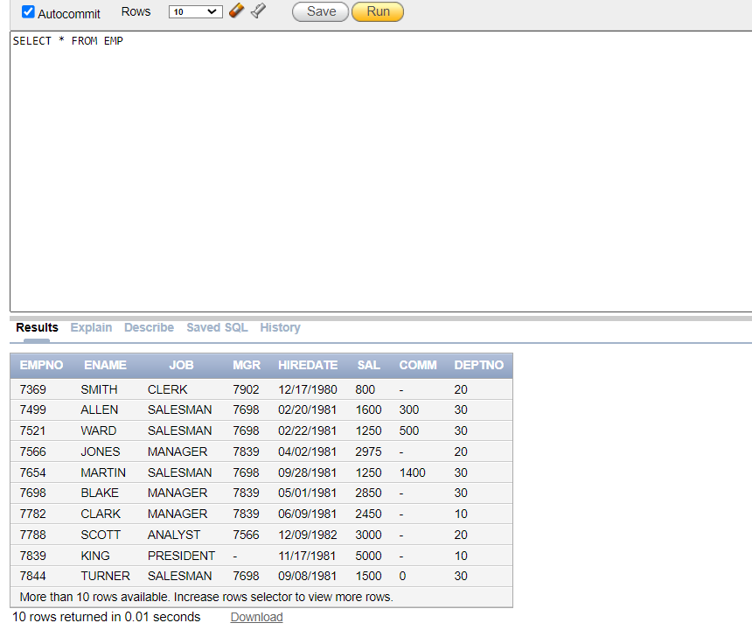

**LAB TIMING : 90 MINS**

**TOTAL MARKS : 40**

**Task 01: [5 marks]**

* Oracle Configuration (3 Marks)
* Scripts Uploading (2 marks)

**Task 02: [15 marks]**

1. Write an SQL query to display the names of all departments.

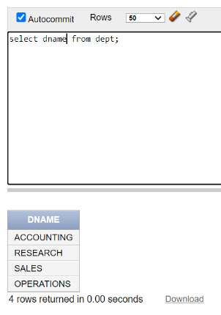

1. Write an SQL query that display the employees working in department 20.

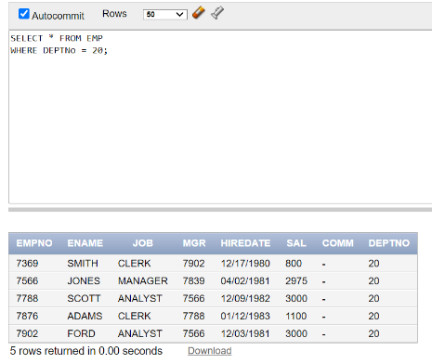

1. Write an SQL query to display the Location of Department no 40.

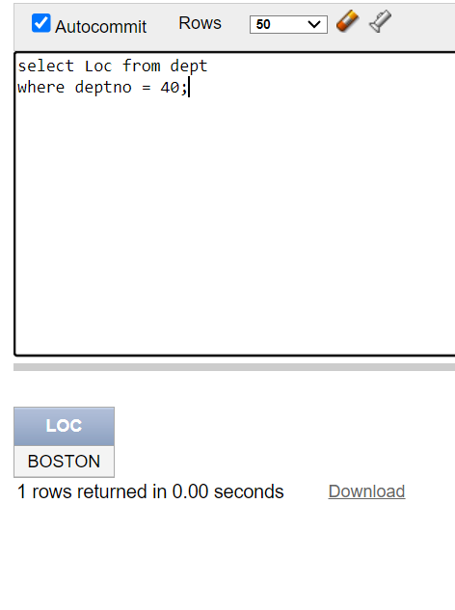

1. Write an SQL query to display job and salary details of the employee “**KING”.**

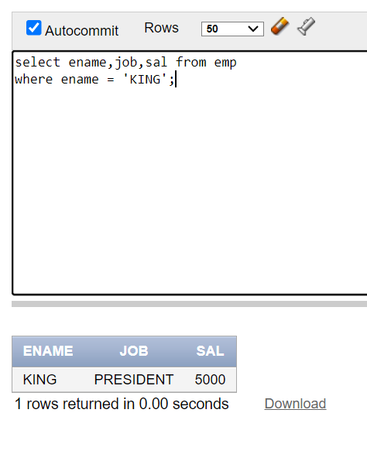

1. Write an SQL query to display the name and salary of the employee who works as a ‘Clerk’ or ‘Salesman’.

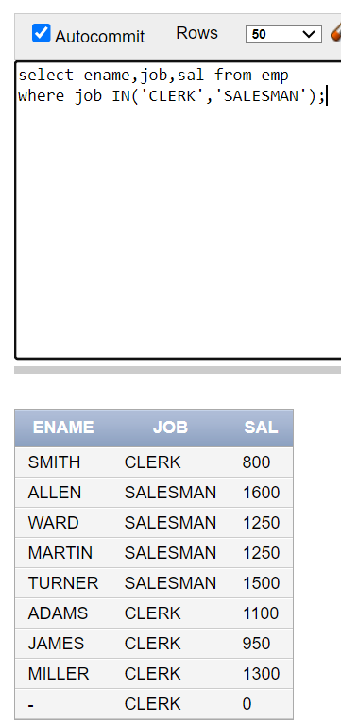

1. Write an SQL query that displays **ENAME,JOB,SAL** and calculates the **Annual Salary** of employees. The column containing annual salary must be named as “Employees Annual Salary”.

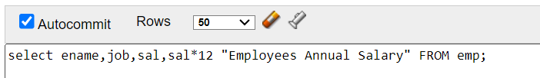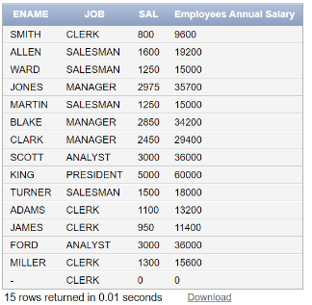

1. Write an SQL query that display the employee’s data working in either department 20 or 30. (Use of OR operator is not allowed)

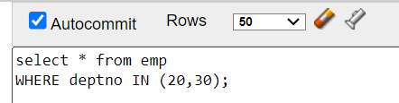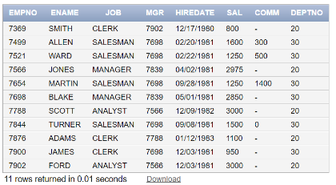

1. Write an SQL query to display the EMPNO,ENAME,JOB,SAL of those employees whose salaries lies in the range of **(1000-2500).**

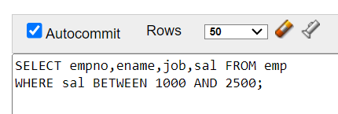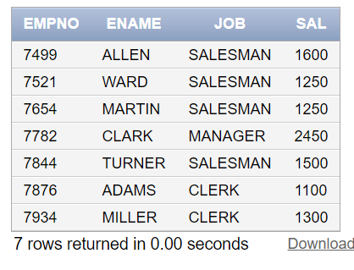

1. Write an SQL query that outputs the following.

Ans:- SELECT ename AS EMPLOYEE, job AS PLACEMENT FROM emp;

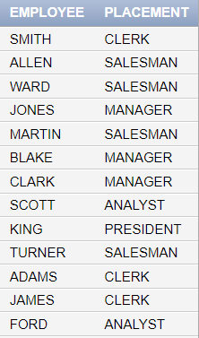

1. Write an SQL query to display all the Salesmen earning more than 1200.

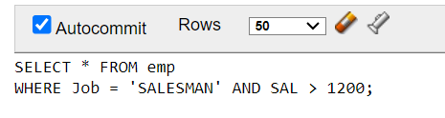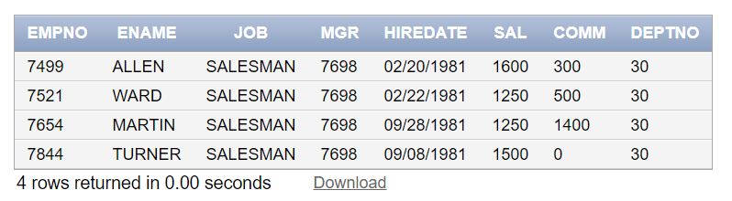

1. Write an SQL query to display records of employees who either belong to the Managing Department number 30 or are Analysts.

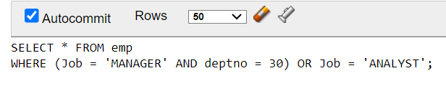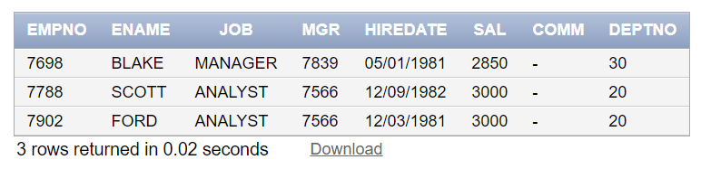

1. Write an SQL query which displays the employees working under manager (7698).

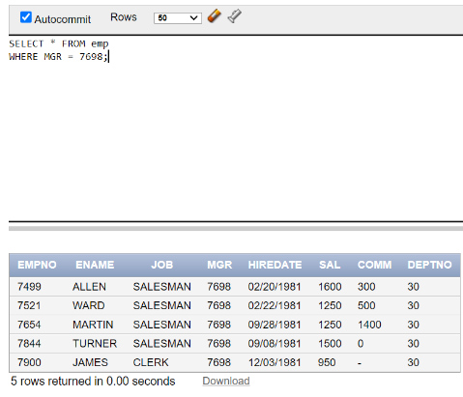

1. Write an SQL query the displays a column named “MONTHLY SAL” and “BONUS SALARY” for all the CLERKS. NOTE: ***“BONUS SALARY IS 10% of monthly salary”.*** Display the name of the employees alongside.

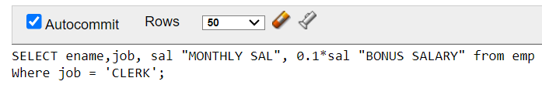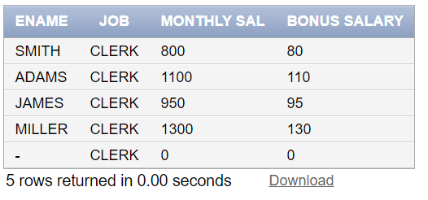

1. Write an SQL query to display employees hired after “02/20/1981”.

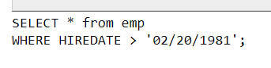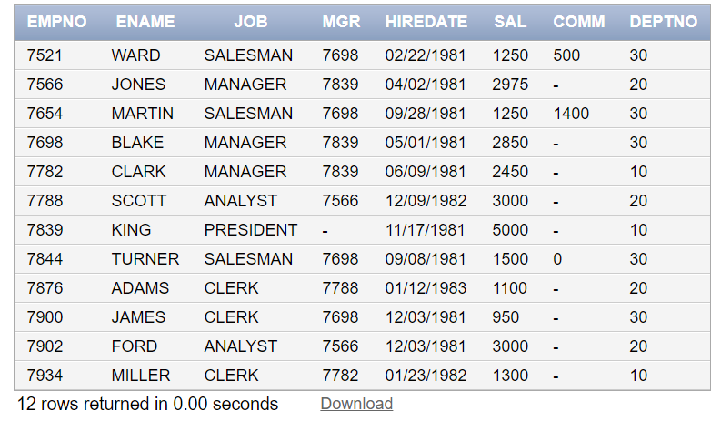

1. Display the quote “O Captain! My Captain!” multiple times as shown below.

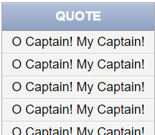

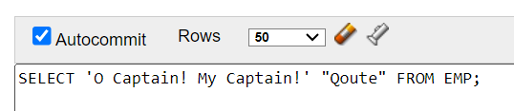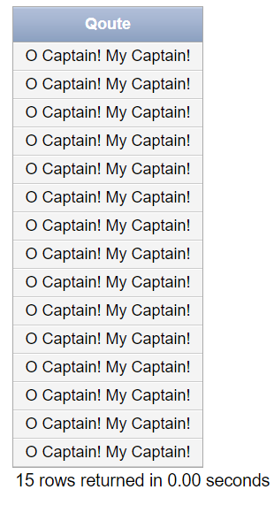

**Task 02: [10 marks]**

1. Write an SQL query to display ENAME, JOB , SAL , YEARLY SALARY of the employee who earns more than 15000 per annum and also earns monthly commission.

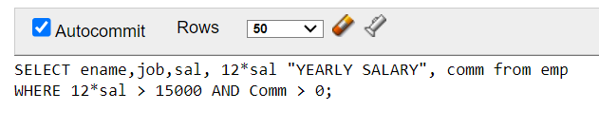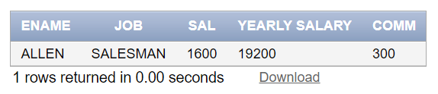

1. List all employees who either have a commission or their salary is between 1500 and 2500 but are not in department 30.

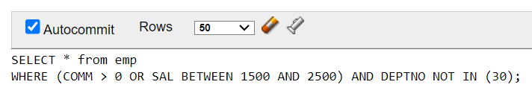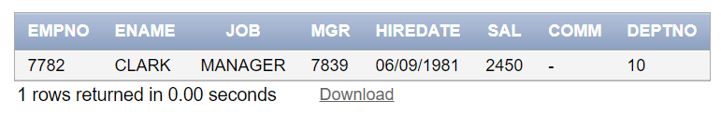

1. Retrieve the employees whose salary, when increased 50%, is greater than 2000, and their commission is less than 500. Also show increased salary with proper alias.

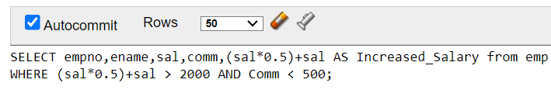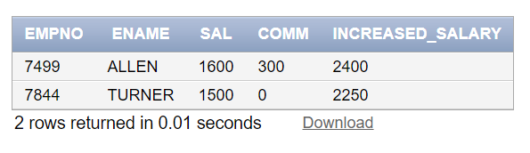

1. The company has decided to impose **15%** of **Indirect taxes** on the **quarterly Salary** on the Salesman working in department 30. The tax is applied after each quarter.

Write an SQL query to display the “**Quarterly Taxed Income**” and “**Total Tax Collected**” after the completion of year along with EMPNO, ENAME, JOB***.***

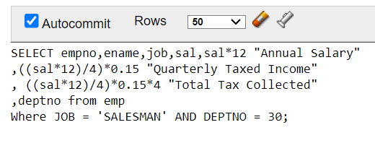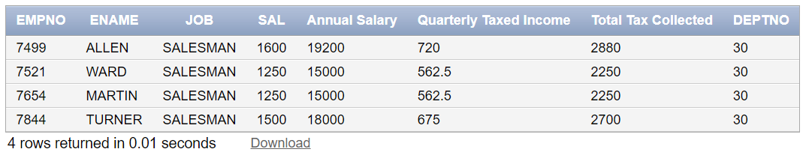

1. The company has implemented a new compensation strategy for its clerical staff. Employees in this category will receive a bonus equivalent to 25% of their annual salary. Additionally, the company is providing a yearly education allowance for their children, calculated as 10% of the resultant salaries after the bonus is applied, which will then be deducted from the total. Write an SQL Query to display the “Annual Salary” of employees, “Bonus”, “Increased Salary”, “Education Allowance” and “Final Salary”.

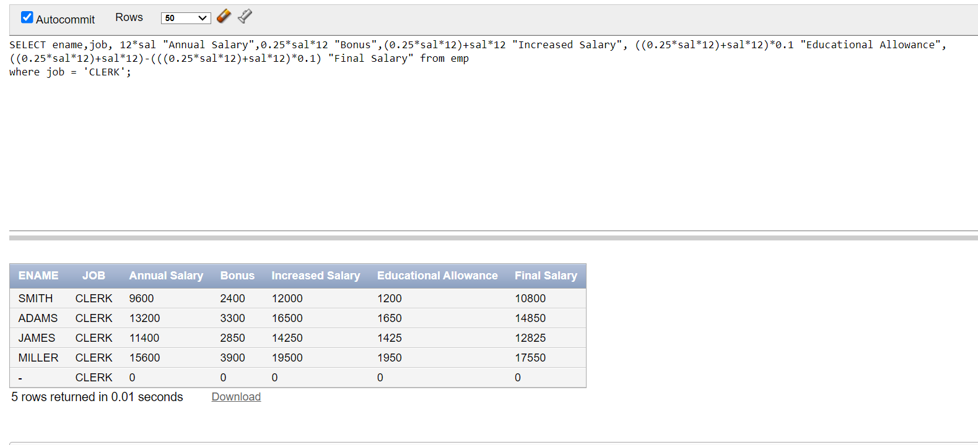

**Task 03: [6 marks]**

1. The company gives employees three different allowances based on their salary:

**Medical Allowance:** 10% of the employee's salary

**House Rent Allowance (HRA):** 15% of the employee's salary

**Transport Allowance:** 5% of the employee's salary

Write an SQL query to calculate each allowance separately and also calculate the total allowance for each employee. Display the employee's name, salary, each individual allowance, and the total allowance. Use proper aliasing for each column.

1. Display all the employees whose name starts with the letter B. (Use of “Like” keyword is not allowed).

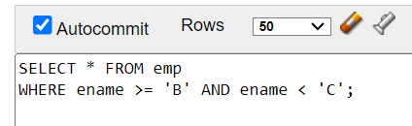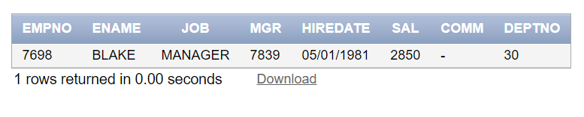

**Task 04: [4 marks]**

**VIVA VOCE**