**CC-215-L: Database Systems Lab**

*Faculty of Computing & Information Technology*



**BS(IT/CS) Morning - Fall 2023**

**LAB – 02**

**The objective of this lab is to:**

1. NVL
2. Concatenation
3. Like Operator, Order By Clause
4. Character & Number Functions

**Course & Lab Instructor:** Dr. Asif Sohail

**LAB TIMING : 90 MINS**

**TOTAL MARKS : 45**

* **Kindly paste the query as well as result table screenshot as a result of each task**

**Task 01: [15 marks]**

1. Write an SQL query to display the names of all employees starting with the letter ‘S’.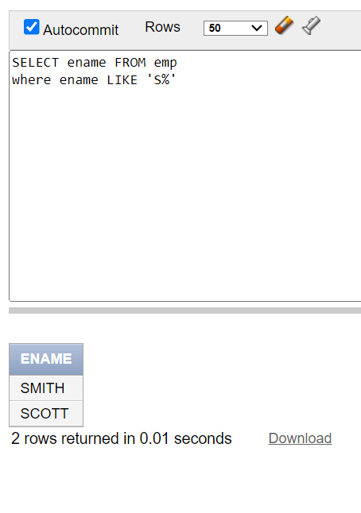
2. Display the employees who earns “NO COMMISION”.

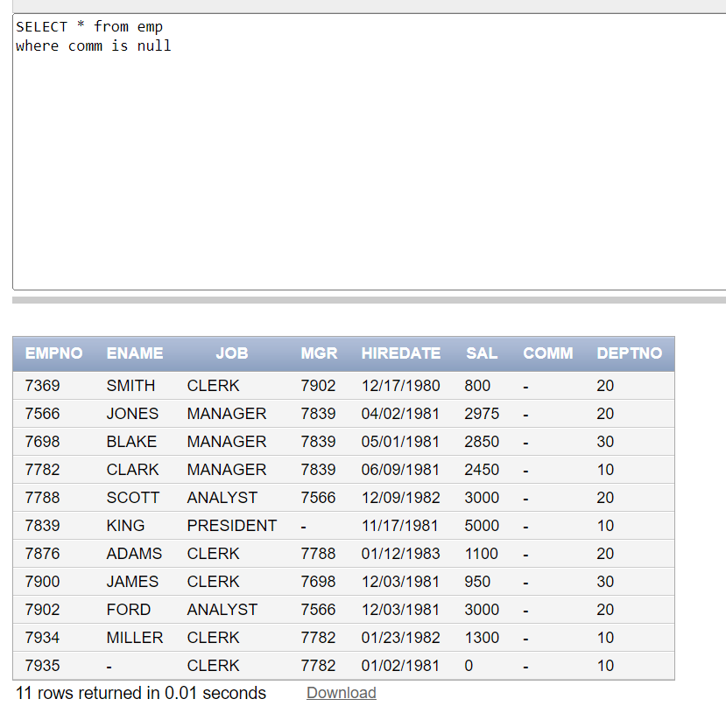

1. Display the current month. The column name should also mention “Current Month”.

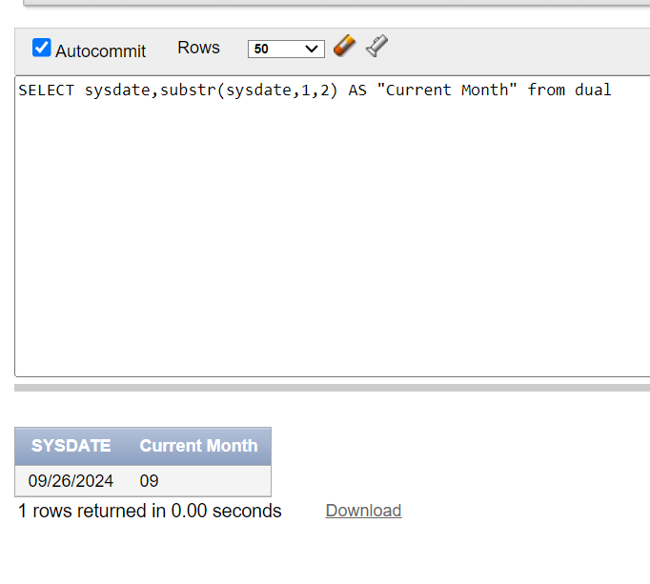

1. Display the Employees Annual salary having Annual Salary Greater than 20,000.

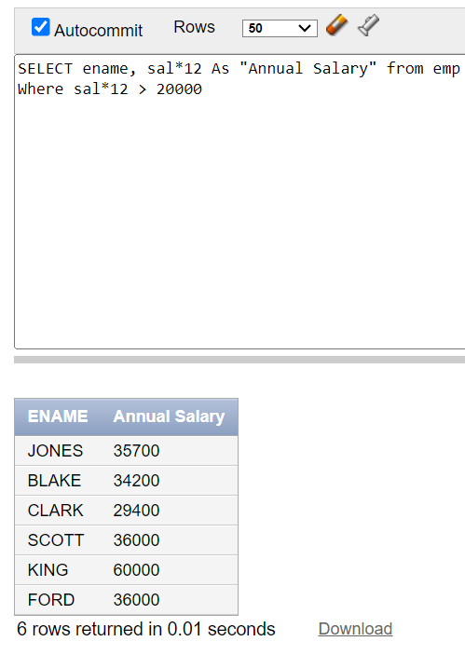

1. List the names of employees whose salary is an even number.

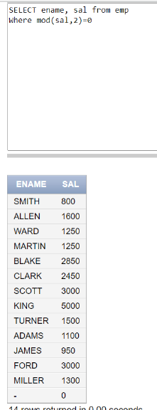

1. Display the names of employee in lower letter case.

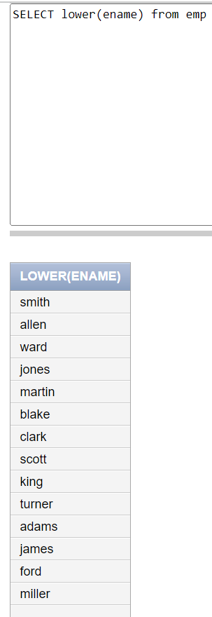

1. Display the employees earning salaries in the multiple of 500.Employee earning nothing should not be displayed.

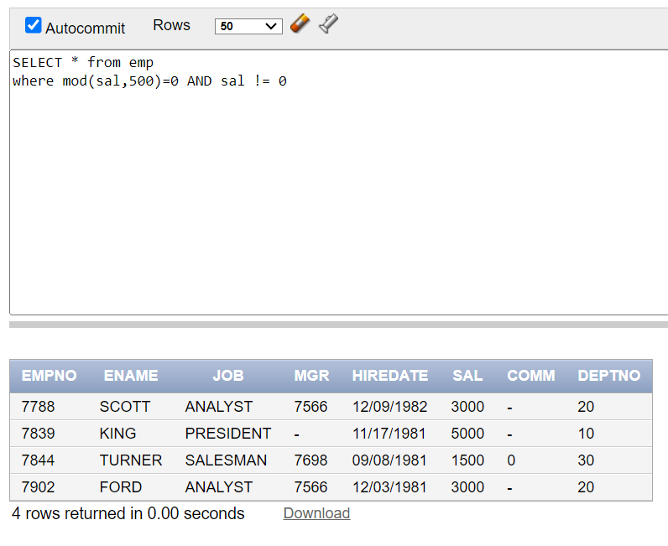

1. Find the second occurrence index of the word “OR” in the string “CORPORATE FLOOR”.

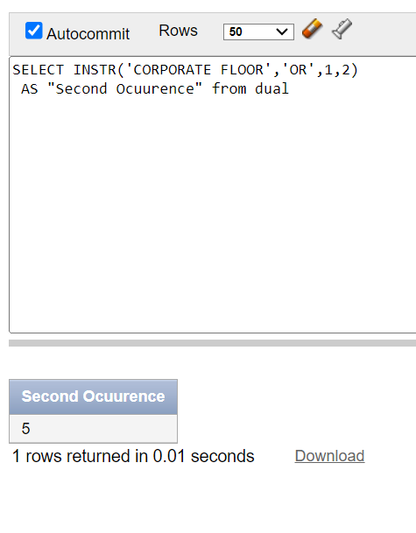

1. Display Ename,JOB and find the per/day salary of the employees. The salary should be rounded off upto 2 decimal places.

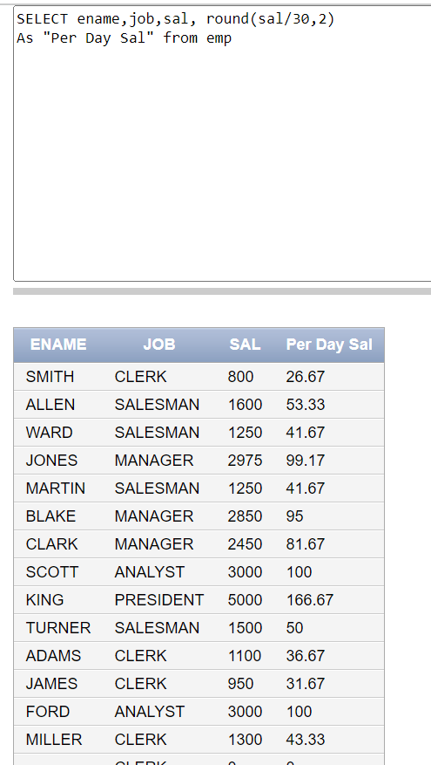

1. Display the following output. Don’t use CONCAT FUNCTION.

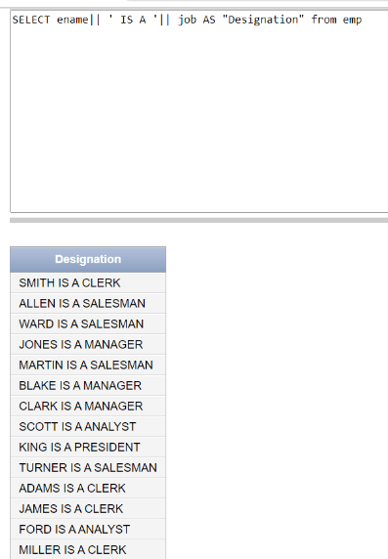

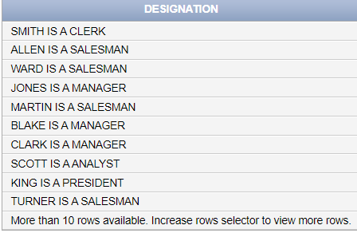

1. Display the enames as the combination of first two letters and last two letters. Such as “Smith as Smth” etc.

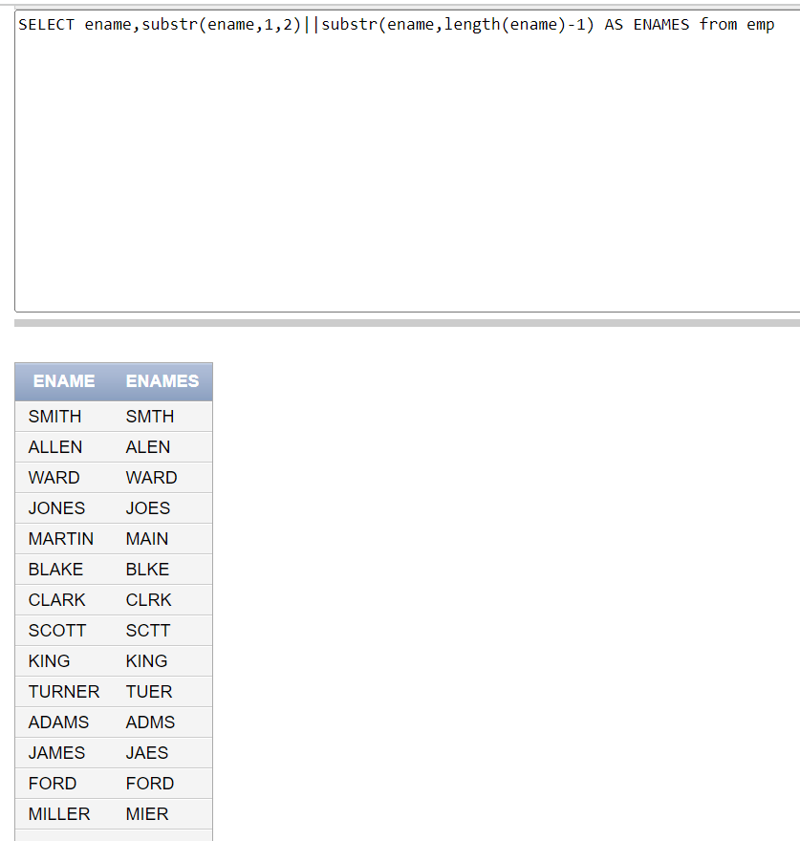

1. List the employees hired in 1980 or 1981.

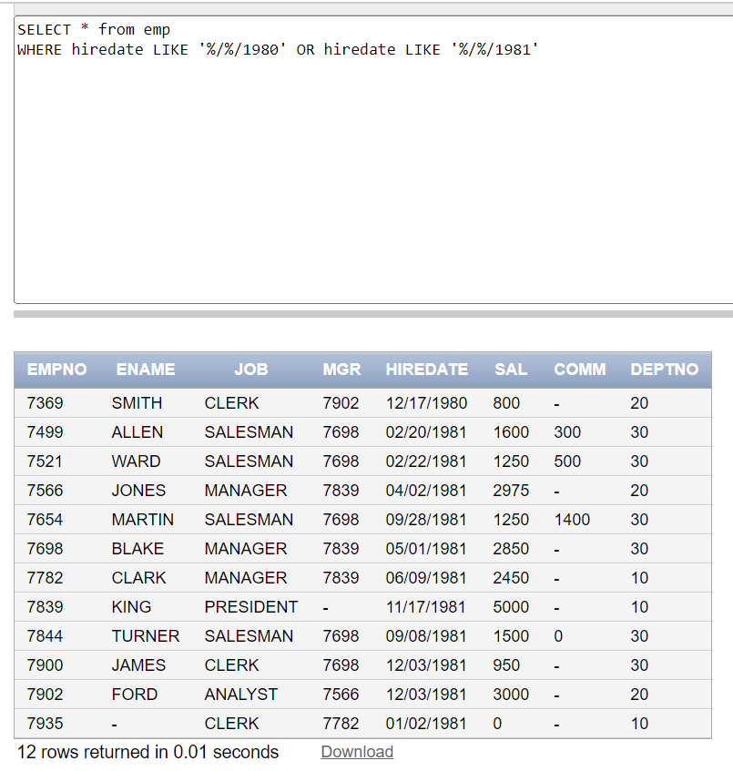

1. List all employees in decreasing order of commission (Commission should be considered 0 when null).

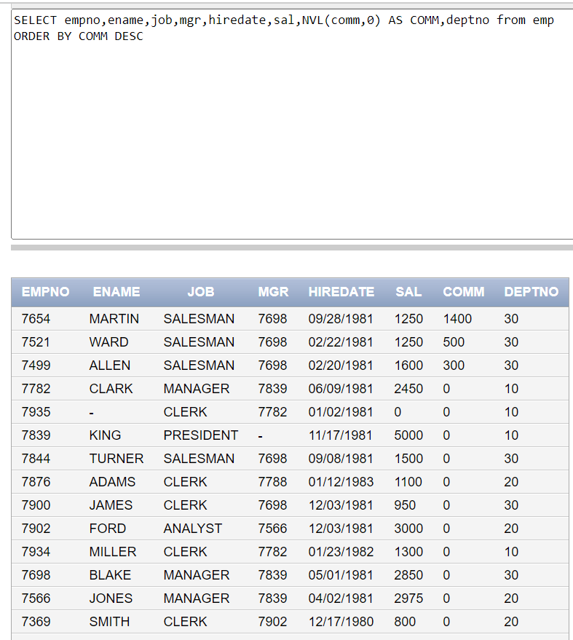

1. Display salary in format given below.

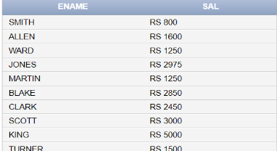

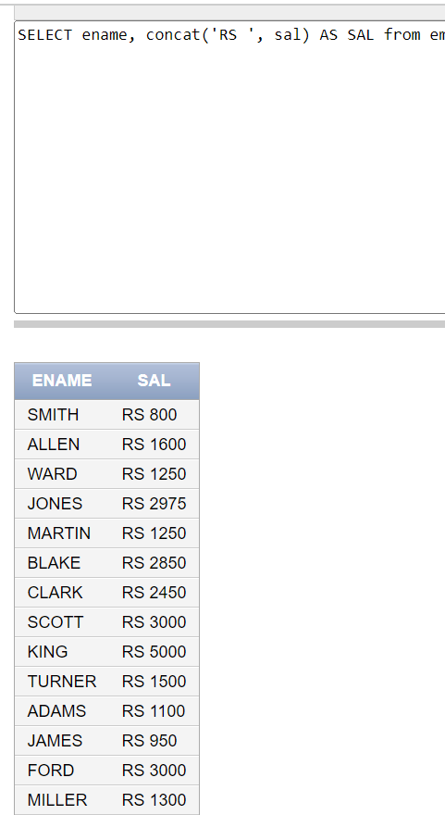

1. Find the experience of employee in years.

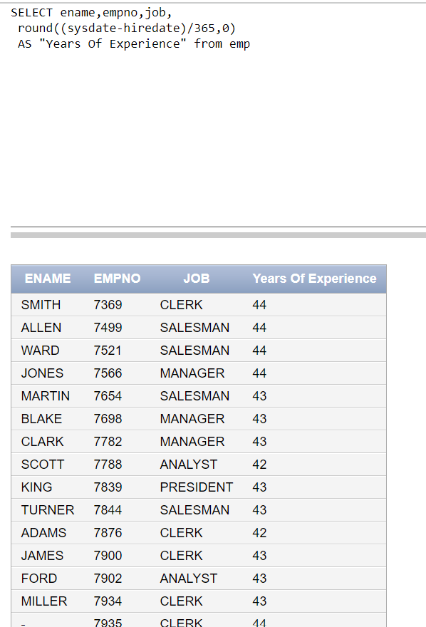

HINT: **SYSDATE – HIREDATE tells the total number of days**

**Task 02: [16 marks]**

1. Write an SQL query to display the name of the employee having “A” as a third letter.

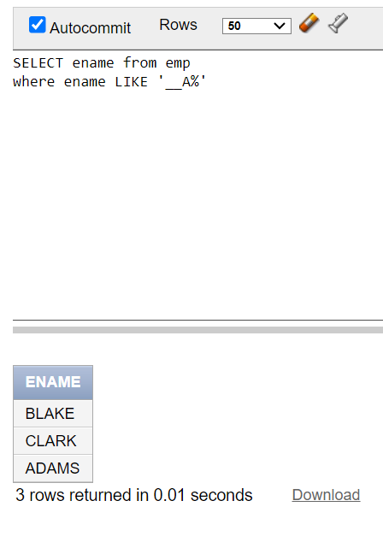

1. Find the occurrences of Letter ‘T’ in names of the employee.

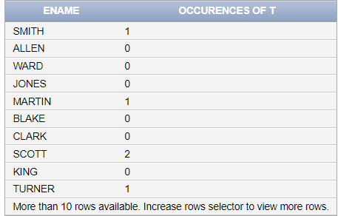

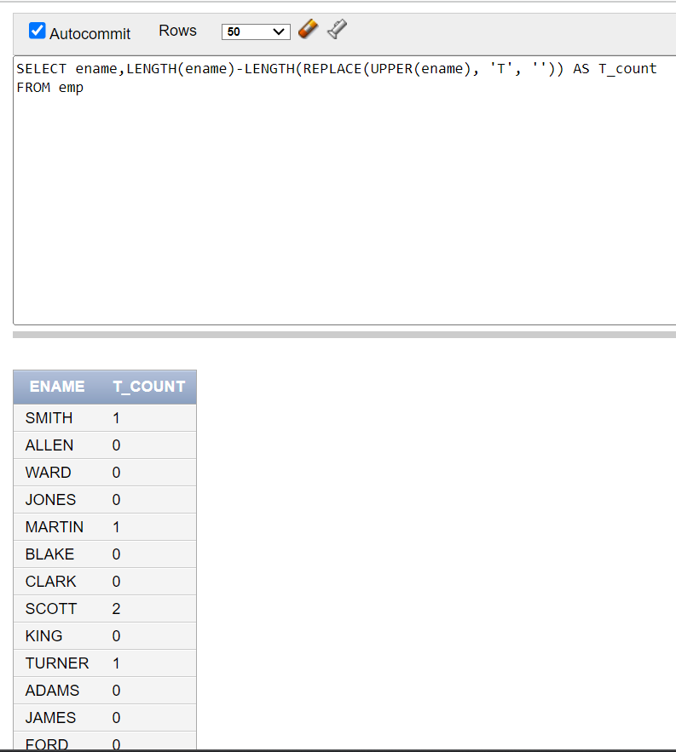

1. Find the total words in the name of each student in PUCIT table. For example, the name “Hazeez Haider” has two words.

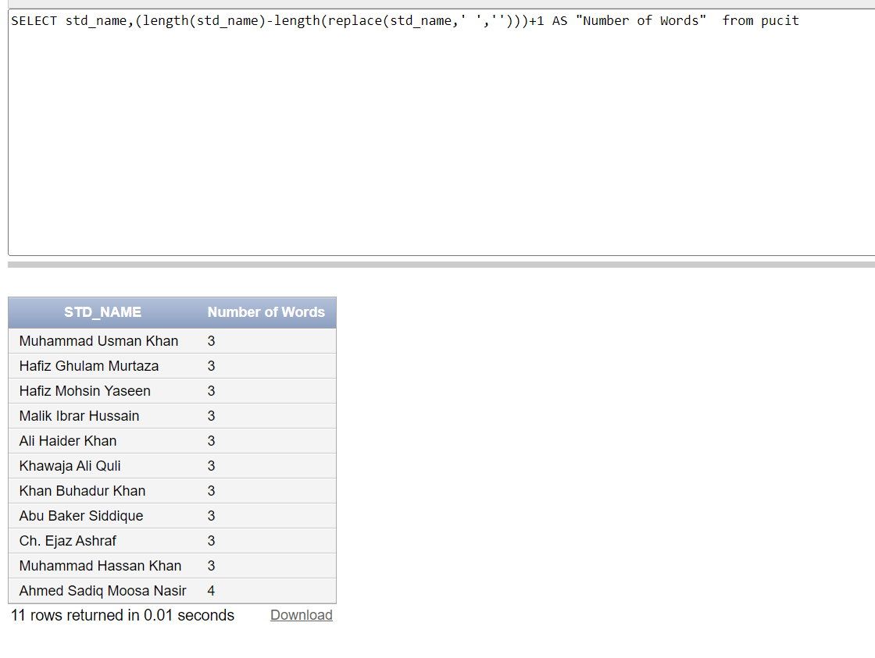

1. Write an SQL query that contains Letter ‘L’ on second position and ends with ‘E’ in employees’ names. (Use of **Character** Functions is not allowed)

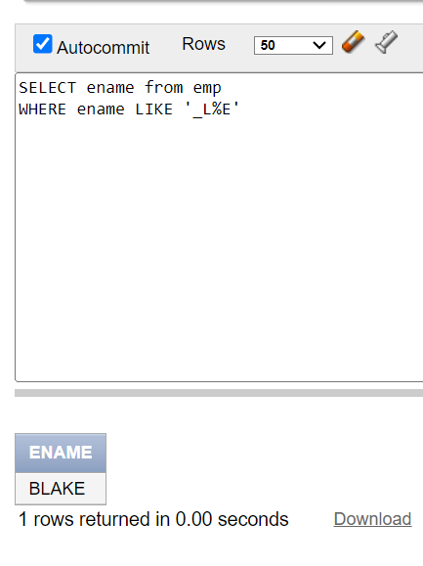

1. Display the EMPNO along with its reversed number.

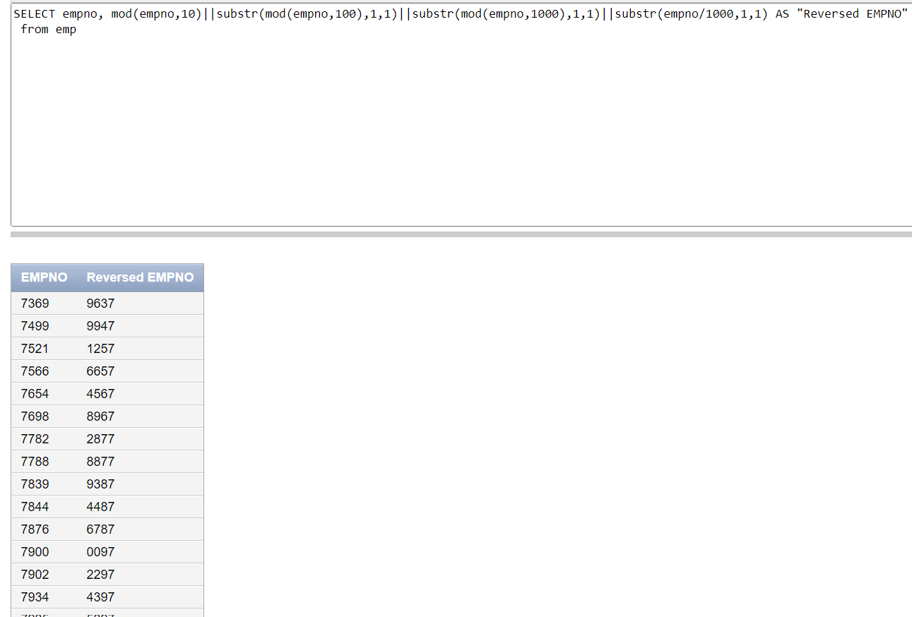

1. Write an SQL query to display the ename such that the first and last letters are in lowercase, while the rest are in uppercase. For example: 'sMITh', 'aLLEn'.

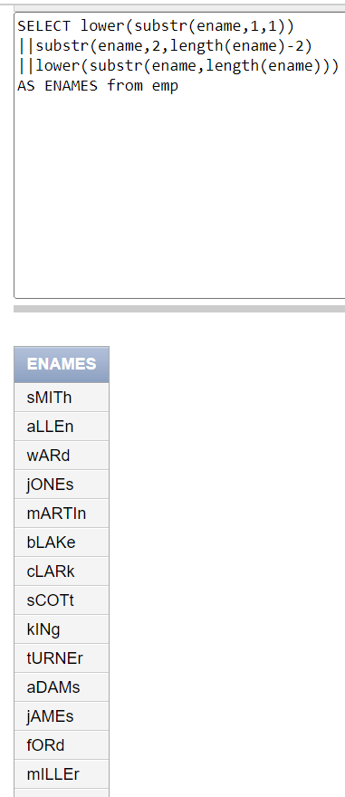

1. Write an SQL query that first extracts the day from the Hiredate. Then, display the corresponding week number for that day. For example, Day number 17 lies in the 3rd week.

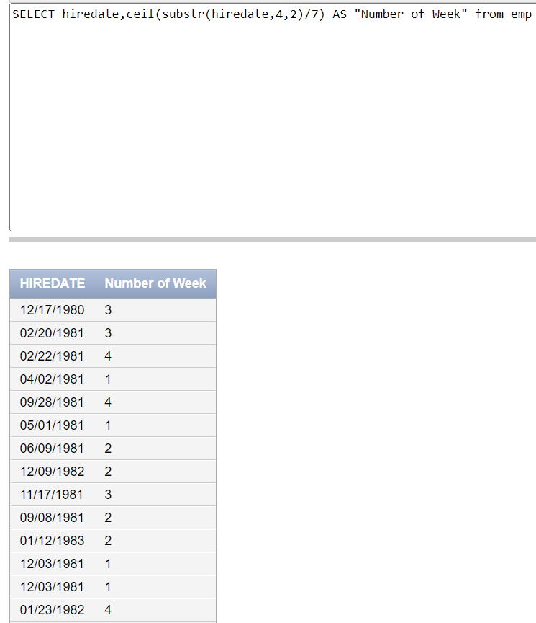

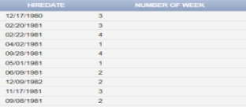

1. Create a Salary Bar (Histogram) as shown. You can use “█” symbol to create the chart.

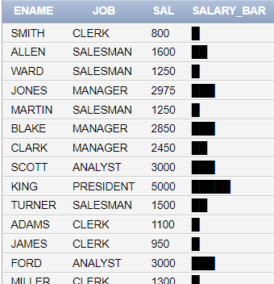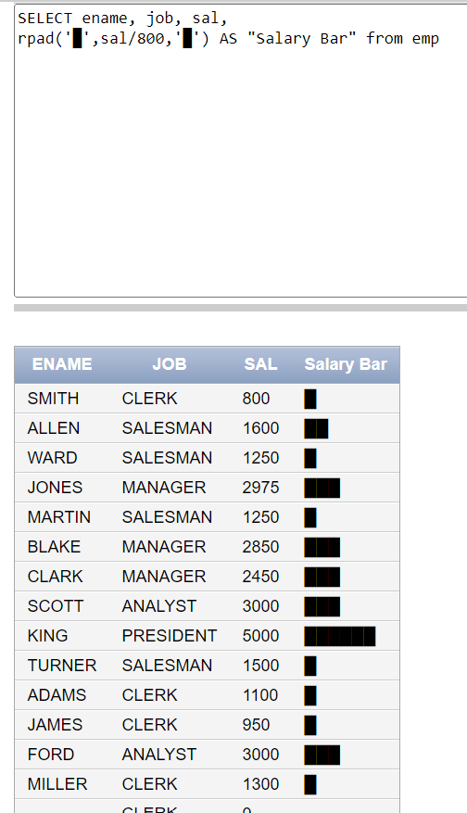

**Task 03: [9 marks]**

* + - 1. Write an SQL query to Display the odd length names in the following format.

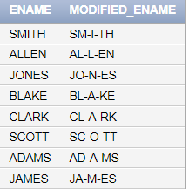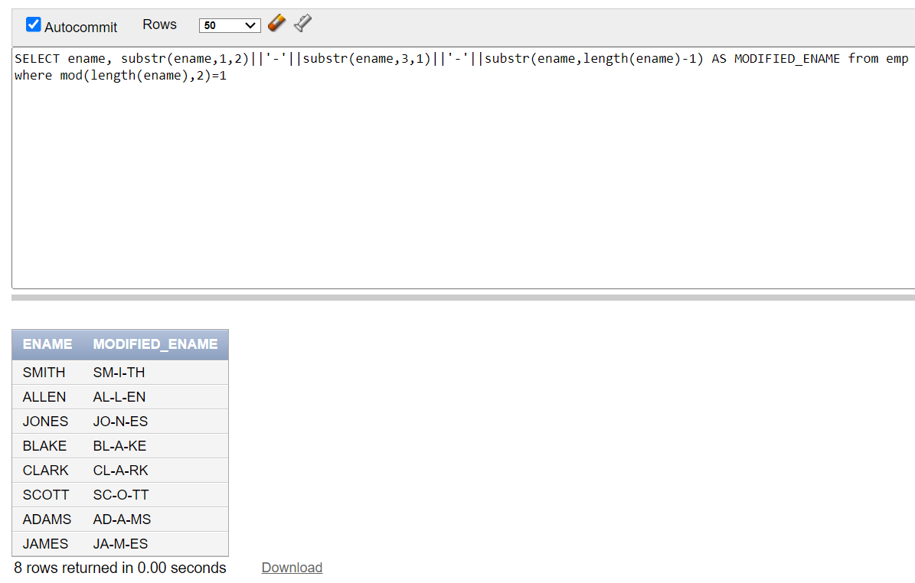

* + - 1. Write a query that achieves the following:

Round Salaries: Round each employee's salary to the nearest hundred.

Set Commission: For employees with no commission, set their commission to 15% of their salary.

Calculate Final Salary: Add the updated salary and updated commission to get the final salary.

Calculate Annual Salary: Using final salary, calculate the annual salary of each employee.

Sort and Display: Display the table in ascending order based on the annual salary.

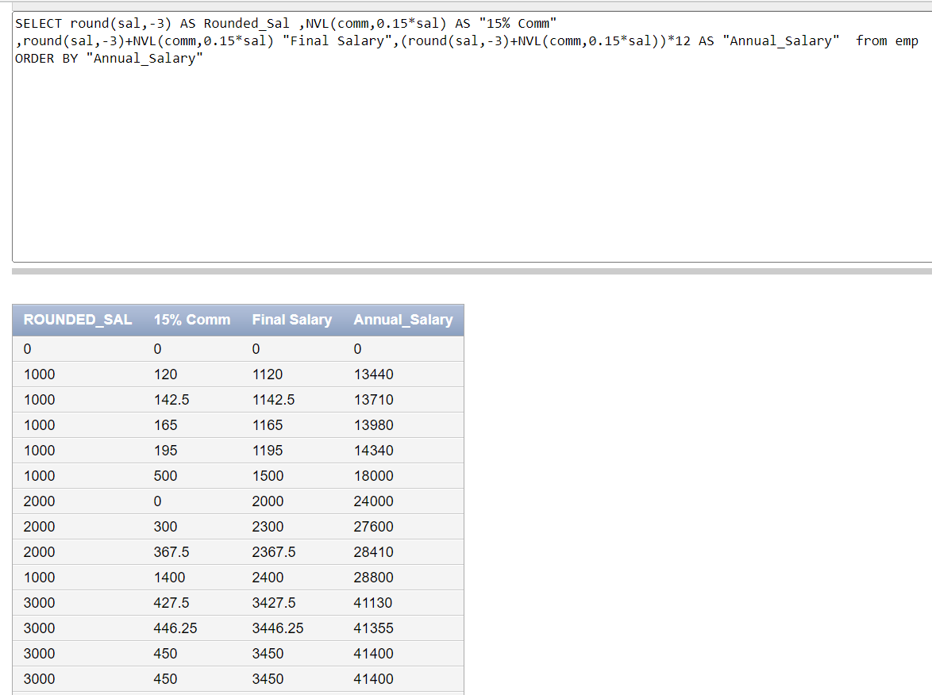

* + - 1. Display the names of employees after removing the last two letters from each name. Additionally, replace each vowel in the remaining part of the name with a corresponding digit. For example ‘A’ is replaced by ‘1’.

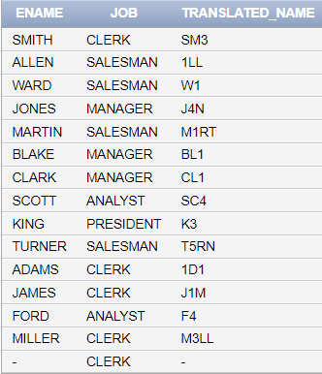

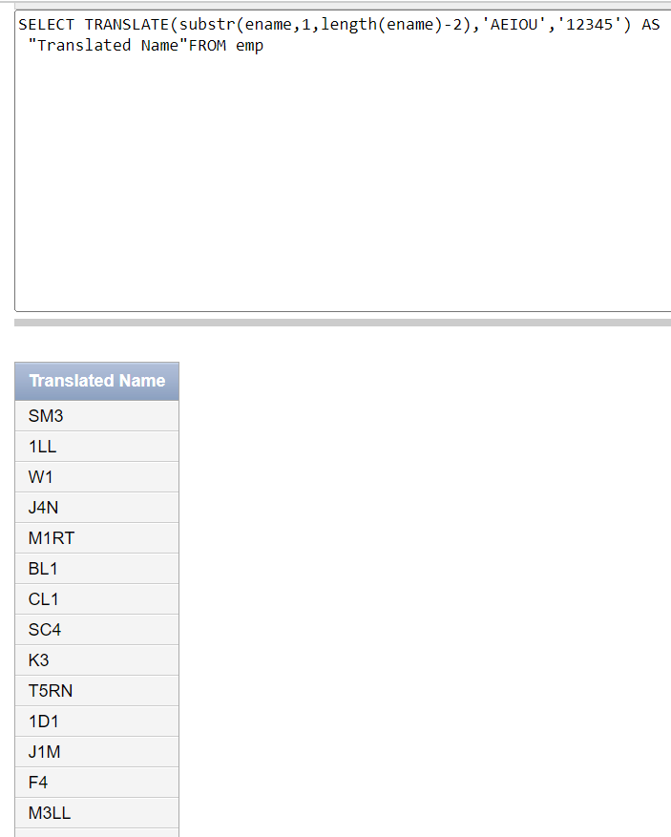

**Task 04: [5 marks]**

**VIVA VOCE**