

**Gym management system**

**Submitted by**

**Group 1**

**Name:**Farjana Rahman Fahima

**ID:**1721320642

**Name:** Muhammad Syed

**ID:** 1713084642

**Submitted To**

Fahimul Hoque Shuvo

**Course Name:** Database management system

**Course Code:** CSE311

**Submission Date:** 04.01.2022

**Introduction**

Our project is basically presents a gym management system. Those who will operate the

software, they will be able to add or update the information of all the members

of their center and calculate their income and expenditure etc. and sell exercise

equipment through this one software. On the other hand, users can buy exercise

equipment at home and users can become a member of that organization by

purchasing a membership package and as a result they will get some special

benefits.

* At the same time, it will do two things like sell products and update all

the information of the members in the database

* Also Users can become members via online
* People can buy exercise equipment online at home and improve their health

**Goal**

* Our goal is to bring people under a particular application.
* Also provide them a new system. By which they can enjoy more benefits in one application and by which the seller and the consumer could get all benefits.
* And to make this project acceptable to more people in the future.

**Target Audience and Customers**

* Our main audience are health conscious men, women and children of all ages who like to change their lifestyle. Just as they can buy products at home, so they can also subscribe membership at home.
* Basically, our target customers are those who run the fitness center. There are many people who have created a separate website application for buying and selling products and have created a separate application for their gym management system.

**Project Background**

Actually, we have some target audience for this project. Our target customers are those who run the fitness center. However, the gym owner’s target customers include individuals who are health conscious and passionate to lead a healthy life. So, it is open to people of all ages.

Basically when we were discussing this project we visited different websites and tried to find out what is related to this but we saw Either a fitness center sells their fitness equipment or they keep their members’ information in a specific database but they have never done these two things together by a single software.

**Proposed Solution**

As the pandemic causes more restrictions, this system will enable members to book and schedule their own time slots through online. This will eventually decline the risk of being infected. This system will arrange a benefits to both parties. Besides, customers will able to buy gym equipment’s and certain products through online. Moreover, certain facilities like personal trainer, Buy Membership Online, Discount offer etc. will be available for the members only.

* Our goal is to bring people under a particular application
* Our project will provide an application by which two tasks are completed simultaneously
* The task will not be an easy one but we will try to do our best.

**Table**

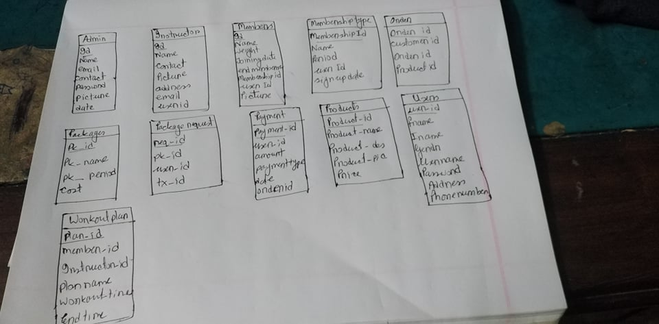

**How works**

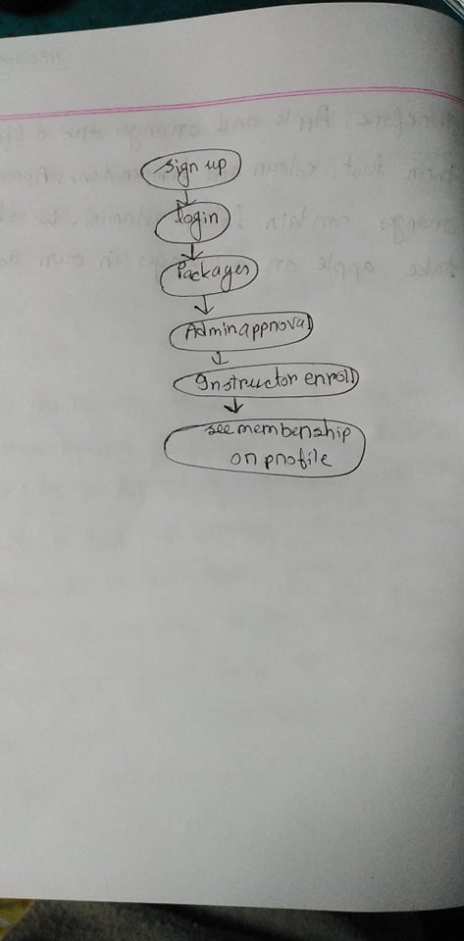

**Limitation**

We weren't able to add some functions here.

* Such a trainer will not be able to set any time slot on his own.
* Trainer can’t be use the admin panel. He or she have to contact with the owner of the GYM. they will update everything.

**Future Work**

Our Future Plan is to add some Function or Update This System –

* User can get home training option.
* Women can hire personal female Trainer
* User can select Any Area. Any City. And can chose or be a member his nearest GYM form our Website.
* Online Consultation
* ETC

**Reference**

* <https://superfitgym.com.bd/>
* <http://www.elbgymbd.com/>
* <https://www.lovelycoding.org/gym-management-system/>
* https://www.youtube.com/watch?v=gB48RAxJJTM

**Conclusion**

We hope that this site will be able to successfully meet the needs of customers and vendors more than all the other website currently on the market and everyone will be able to avail their services under a single application. As a result, those who used to create two separate website at a higher cost will now be able to perform multiple tasks in one.