NED UNIVERSITY OF ENGINEERING AND TECHNOLOGY DEPARTMENT OF ELECTRICAL ENGINEERING

POWER SYSTEM ANALYSIS
EE-362

OPEN ENDED LAB

TOPIC:
ASYMMETRICAL FAULT ANALAYSIS ON
MATLAB

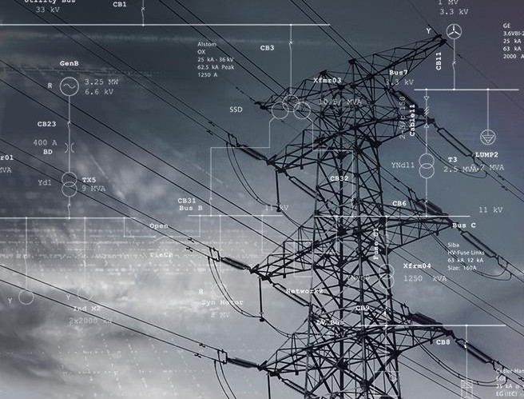

SECTION: D SEMESTER: 6TH BATCH: 2023-27
ACADEMIC YEAR: 2026
SUBMITTED BY: MUHAMMAD TAHA EE-23319 ALI NASIR EE-23328
SUBMITTED TO:
MISS HAFSA

Abstract:

This report presents a complete asymmetrical fault analysis of the IEEE 9-bus standard test power system using MATLAB. The analysis covers three types of unbalanced (asymmetrical) faults: Single Line-to-Ground (SLG), Line-to-Line (LL), and Double Line-to-Ground (DLG). These faults are the most common types that occur in real power systems, and understanding them is critical for designing protection equipment such as circuit breakers, relays, and fuses.

The IEEE 9-bus system consists of 3 generators, 3 transformers, and 9 buses connected through 6 transmission lines. The system is modeled in the per-unit (pu) system, which makes the numbers easier to work with. Using the theory of symmetrical components a clever mathematical tool that breaks unbalanced currents into three simpler balanced sets we built sequence networks (Positive, Negative, and Zero sequence) and computed the Thevenin impedances at each bus using the Z-bus matrix method.

The simulation results show that: (1) the three-phase bolted fault always produces the highest fault current, satisfying the design objective; (2) SLG fault current is zero at buses 4-9 due to Delta-winding isolation of transformers; (3) bus voltage drops severely near the fault point; and (4) the X/R ratio at generator buses is very high (up to 137), making the asymmetrical (peak) breaker duty current much larger than the symmetrical RMS value. The effect of neutral grounding is also discussed in detail.

Acknowledge:

All praise and gratitude are due to Allah (SWT), the Most Gracious and Most Merciful, for granting us the ability and strength to successfully complete this project.

We express our sincere gratitude to the faculty of the Department of Electrical Engineering at NED University of Engineering & Technology for their continuous guidance, support, and provision of essential resources required to complete this Open Ended Lab (OEL).

We would like to extend our special thanks to our respected instructor, Miss Hafsa Wahid for clearly outlining the project objectives, deliverables, and evaluation criteria, and for his constant support and availability throughout the duration of this project.

The simulation environment and theoretical foundation provided through course lectures played a vital role in shaping this work. We also acknowledge the valuable contributions of standard textbooks on power system analysis, particularly the works of Stevenson, Glover, Sarma, and Grainger, which served as key references for the symmetrical components methodology applied in this lab.

Finally, we are thankful to our colleagues and peers for their constructive feedback and collaboration during the analysis and verification phases.

Group Members:

Muhammad Taha Ali Nasir

Table of Contents

Abstract i
Acknowledge ii
- Introduction 3
  - What is a Fault in a Power System? 3
  - Types of Faults 3
    - Symmetrical Faults (Balanced) 3
    - Asymmetrical Faults (Unbalanced) 3
  - Why Fault Analysis is Important 3
- Methodology 4
  - Step-by-Step: How to Build a 9-Bus Power System 4
  - The Per-Unit (pu) System 4
  - What Are Sequence Networks? 4
  - How Sequence Networks Connect for Each Fault Type 5
  - How Faults are Analyzed in MATLAB 5
- Test System Details 6
  - System Overview 6
  - Generator Data 6
  - Transformer Data 6
  - Transmission Line Data 7
  - Thevenin Impedances (Zbus Diagonals) 7
- Simulation Results and Discussion 8
  - Fault Current Summary 8
  - Fault Current Graphs 8
  - Single-Line-to-Ground (SLG) Fault 9
  - Line-to-Line (LL) Fault 10
  - Double-Line-to-Ground (DLG) Fault 10
  - Phasor Diagrams 11
  - Bus Voltages During Fault 12
- Ground Currents and System Validation 13
  - Ground Current Results 13
  - X/R Ratio and DC Offset (Breaker Duty) 13
  - Fault Current Hierarchy Validation 14
- Effect of Neutral Grounding 15
  - What Is Neutral Grounding? 15
  - Types of Neutral Grounding 15
    - Solid Grounding (Direct Grounding) 15
    - Resistance Grounding 15
    - Reactance Grounding 15
    - Ungrounded System 15
  - Quantitative Comparison 16
  - Why the Delta Transformer Blocks Zero-Sequence 16
  - Fault Impedance Sweep 17
  - Branch Fault Current Contributions 18
- Conclusion 19
Objective 1 Design of 9-Bus System with Controlled Fault Currents 19
Objective 2 MATLAB-based Asymmetrical Fault Analysis 19
Objective 3 Effect of Neutral Grounding 19
Key Findings Summary 19
- References 20
APPENDIX- MATLAB i

Introduction

What is a Fault in a Power System?

Imagine electricity flowing through wires like water through pipes. Under normal conditions, everything is balanced and controlled. A fault is like a sudden crack or burst in one of those pipes, it causes an abnormal, unintended connection (often to ground or between phases) that leads to a dramatic increase in current flow.

In simple terms: a fault is any abnormal condition in the power system that causes current to flow in a path it is not supposed to. This can be due to insulation breakdown, physical damage to cables, lightning strikes, equipment failure, or human error. The result is usually a very large current (called fault current) that can damage equipment if not cleared quickly.

Types of Faults

Faults in three-phase power systems are classified into two broad categories:

Symmetrical Faults (Balanced)

Three-Phase Fault (3Ph): All three phases A, B, and C short-circuit simultaneously either to each other or all to ground. This is the most severe fault type in terms of equipment damage but is the rarest in practice (about 2–5% of all faults).

Asymmetrical Faults (Unbalanced)

Single-Line-to-Ground (SLG): One phase connects to ground. This is the most common fault type (60– 70% of all faults).

Line-to-Line (LL): Two phases touch each other but not the ground.

Double-Line-to-Ground (DLG): Two phases simultaneously contact the ground.
Fault Type | Description | Frequency | Severity | Symbol
3-Phase (3Ph) | All 3 phases short | 2–5% | Highest | 3Φ
SLG | 1 phase to ground | 60–70% | Lowest | A-G
LL | 2 phases touch | 15–20% | Medium | B-C
DLG | 2 phases to ground | 10–15% | High | B-C-G

Table 1.2: Classification of Power System Faults

Why Fault Analysis is Important

Fault analysis is the backbone of power system protection engineering. Here is why it matters:

Relay Coordination: Protection relays must be set to detect and isolate a fault quickly. Without knowing how much current flows during a fault, engineers cannot set relay pickup values correctly.

Circuit Breaker Rating: Each breaker must be able to interrupt fault current safely. Undersized breakers can explode during a fault. Fault analysis determines the kA interrupting rating needed.

Equipment Protection: Transformers, cables, and generators must withstand fault currents until breakers clear the fault (typically 3–10 cycles = 50–167 ms).

System Stability: Large fault currents can cause voltage collapse across the network, destabilizing generators and causing blackouts.

Grounding Design: Understanding zero-sequence currents (which flow only during ground faults) is critical for designing neutral grounding systems and grounding mats.

Methodology

Step-by-Step: How to Build a 9-Bus Power System

The 9-bus system is a classic test network that has been used for power system research for decades. Think of it as a model city's electrical grid, not too simple, not too complex.

The system consists of:

3 Generators: These are the power sources (like power plants). They sit at Buses 1, 2, and 3.

3 Transformers: They step up the generator voltage from low voltage (16.5 kV, 18 kV, 13.8 kV) to high transmission voltage (230 kV). Connected Delta (low-voltage side) to Grounded-Wye (high-voltage side).

6 Transmission Lines: These carry power between the 230 kV buses (4, 5, 6, 7, 8, 9).

9 Buses: Connection points in the network. Think of them as intersections in a road network. The base values chosen for this study are:

Base Power (Sbase): 100 MVA

Base Voltages: 16.5 kV (Bus 1), 18 kV (Bus 2), 13.8 kV (Bus 3), 230 kV (Buses 4-9)

The Per-Unit (pu) System

Imagine you want to compare the size of a person to a building. Instead of saying 'Person = 1.8 m, Building = 30 m', it's easier to say 'Person = 0.06 (relative to the building).' The per-unit system does exactly this for electrical quantities.

In the per-unit system, we express all electrical quantities (voltage, current, impedance, power) as a fraction of a chosen base value. This eliminates the complexity of dealing with different voltage levels connected through transformers.

The key formula for converting actual current to per-unit is:
Ibase = Sbase / (√3 × Vbase)

For example, at Bus 1: Ibase = 100 MVA / (√3 × 16.5 kV) = 3.4991 kA. So if MATLAB gives a fault current of 20.24 pu at Bus 1, the actual current = 20.24 × 3.499 kA = 70.8 kA.

What Are Sequence Networks?

Here is the key insight: an unbalanced three-phase problem (which is complicated) can be broken down into three separate, simpler balanced problems. This mathematical trick was discovered by Charles Fortescue in 1918.

Any unbalanced set of three-phase phasors can be decomposed into three balanced sets called sequence components:

Positive Sequence (1): Three balanced phasors rotating in the normal ABC order (same as normal operation). This represents the 'healthy' part of the system.

Negative Sequence (2): Three balanced phasors rotating in reverse order (ACB). This appears only during unbalanced faults.

Zero Sequence (0): Three phasors all in phase (pointing in the same direction). This appears only when there is a ground (earth) path available.

The transformation formula is:

Ia = I0 + I1 + I2 | Ib = I0 + a²·I1 + a·I2 | Ic = I0 + a·I1 + a²·I2

where a = e^(j120°) = −0.5 + j0.866, the complex rotation operator.

Each sequence network is a separate circuit that can be solved independently using normal circuit analysis. Then the results are combined to give the actual phase currents and voltages.

How Sequence Networks Connect for Each Fault Type
Fault Type | Network Connection | Formula for I1 | Zero-Seq?
3-Phase | Positive sequence only | I1 = Vf / (Z1 + Zf) | No
SLG (A-G) | Z0, Z1, Z2 in SERIES | I1 = Vf / (Z0+Z1+Z2+3Zf) | Yes
LL (B-C) | Z1, Z2 in SERIES | I1 = Vf / (Z1+Z2+Zf) | No
DLG (B,C-G) | Z1 + (Z2 || Z0) | I1 = Vf / (Z1+Z2||Z0) | Yes

Table 2.4: Sequence Network Connections for Each Fault Type

How Faults are Analyzed in MATLAB

The MATLAB program follows these steps automatically:

Input System Data: Generator reactances, transformer impedances, line impedances, and base values are defined as constants.

Build Three Ybus Matrices: One for each sequence (positive, negative, zero). The Ybus matrix is like a map of all electrical connections. Each element Yij = 1/Zij where Zij is the impedance between buses i and j.

Invert Ybus to get Zbus: Using LU decomposition (Zbus = Ybus⁻¹). The diagonal element Zbus(k,k) is the Thevenin impedance seen from bus k this is exactly what we need for fault calculations.

Apply Fault Equations: For each bus k and each fault type, use the sequence impedances Z0(k,k), Z1(k,k), Z2(k,k) to calculate fault currents using the formulas in Table 2.1.

Convert to Phase Currents: Using the symmetrical component transformation (Fortescue matrix).

Compute Bus Voltages: During fault, each bus voltage changes. MATLAB computes these using the Zbus transfer impedances.

Output Results: Print tables and generate graphs.

Test System Details

System Overview

The 9-bus system operates at a base of 100 MVA. It has three voltage zones: the generator terminals (low voltage) and the 230 kV transmission network. The Single Line Diagram (SLD) is shown in Figure 3.1.
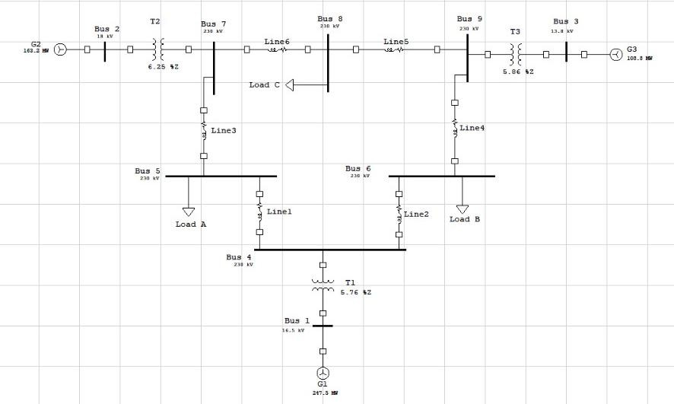

Generator Data

Figure 3.1: Single Line Diagram of 9-bus System

All three generators are solidly grounded (neutral directly connected to earth).

Gen. | Bus | Vbase (kV) | X1 (pu) | X2 (pu) | X0 (pu) | Zn (pu)
G1 | Bus 1 | 16.5 | 0.0608 | 0.0608 | 0.06 | 0.10
G2 | Bus 2 | 18.0 | 0.1198 | 0.1198 | 0.10 | 0.15
G3 | Bus 3 | 13.8 | 0.1813 | 0.1813 | 0.12 | 0.18

Table 3.2: Generator Reactance Data (100 MVA base, subtransient values)

X1 = Positive-sequence (subtransient) reactance. X2 = Negative-sequence reactance (≈ X1 for round- rotor machines). X0 = Zero-sequence reactance. Zn = Neutral grounding impedance.

Transformer Data

All transformers are Delta (low-voltage / generator side) Grounded-Wye (high-voltage / transmission side). This Delta-Yg connection is critical because it completely blocks zero-sequence currents from flowing into the transmission network.

Xfmr | From-To | LV (kV) | HV (kV) | X (pu) | Connection
T1 | Bus 1 → 4 | 16.5 | 230 | 0.0576 | Δ (LV) / Yg (HV)
T2 | Bus 2 → 7 | 18.0 | 230 | 0.0625 | Δ (LV) / Yg (HV)
T3 | Bus 3 → 9 | 13.8 | 230 | 0.0586 | Δ (LV) / Yg (HV)

Table 3.3: Transformer Data

Transmission Line Data

The transmission lines connect the 230 kV buses (4–9). Zero-sequence impedances are approximately 3× the positive-sequence values (Carson's earth-return approximation).

Line | From-To | R1 (pu) | X1 (pu) | R0 (pu) | X0 (pu) | |Z1| (pu)
L1 | 4 – 5 | 0.0100 | 0.1008 | 0.0300 | 0.3024 | 0.1013
L2 | 4 – 6 | 0.0085 | 0.0720 | 0.0255 | 0.2160 | 0.0725
L3 | 5 – 7 | 0.0170 | 0.1610 | 0.0510 | 0.4830 | 0.1619
L4 | 6 – 9 | 0.0072 | 0.0850 | 0.0216 | 0.2550 | 0.0853
L5 | 7 – 8 | 0.0130 | 0.1280 | 0.0390 | 0.3840 | 0.1287
L6 | 8 – 9 | 0.0115 | 0.1190 | 0.0345 | 0.3570 | 0.1196

Table 3.4: Transmission Line Impedance Data (100 MVA, 230 kV base)

Thevenin Impedances (Zbus Diagonals)

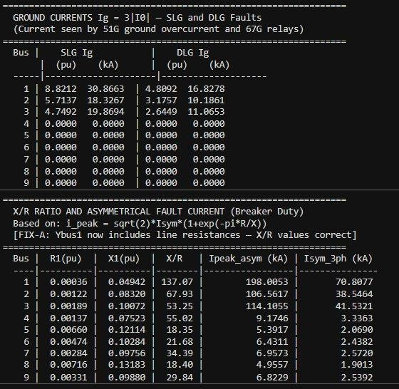
After building the sequence Ybus matrices and inverting them, the diagonal elements of Zbus give the Thevenin (or driving-point) impedance at each bus for each sequence. These are the key values used in all fault calculations.

Figure 3.5: MATLAB Output - Thevenin Impedances (Zbus Diagonals, pu)

Notice that Z0 for Buses 4-9 is extremely large (approximately j80500 pu). This is because the Delta transformer windings on the LV side block all zero-sequence current flow into the transmission network, making the zero-sequence impedance effectively open-circuit. This is physically correct and expected.

Simulation Results and Discussion

Fault Current Summary

MATLAB computed bolted fault currents (zero fault impedance, Zf = 0) at all nine buses for all four fault types. The results are tabulated below.
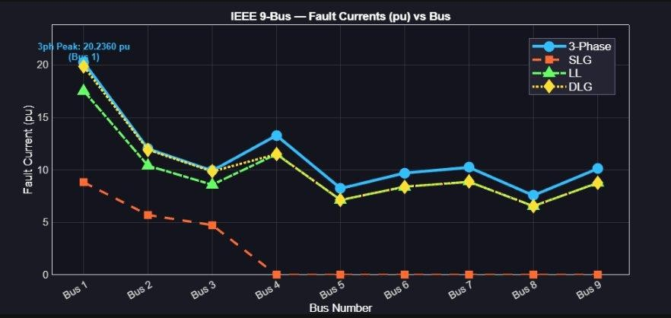

Figure 4.1: MATLAB Output - Fault Current Magnitudes (pu and kA)

Bus | 3Ph (kA) | SLG (kA) | LL (kA) | DLG (kA) | Ibase (kA)
1 | 70.808 | 30.866 | 61.321 | 69.442 | 3.499
2 | 38.546 | 18.327 | 33.382 | 38.251 | 3.208
3 | 41.532 | 19.869 | 35.968 | 41.251 | 4.184
4 | 3.336 | 0.000 | 2.889 | 2.889 | 0.251
5 | 2.069 | 0.000 | 1.792 | 1.792 | 0.251
6 | 2.438 | 0.000 | 2.112 | 2.112 | 0.251
7 | 2.572 | 0.000 | 2.227 | 2.227 | 0.251
8 | 1.901 | 0.000 | 1.647 | 1.647 | 0.251
9 | 2.539 | 0.000 | 2.199 | 2.199 | 0.251

Table 4.1: Bolted Fault Currents at All Buses (kA)

Fault Current Graphs
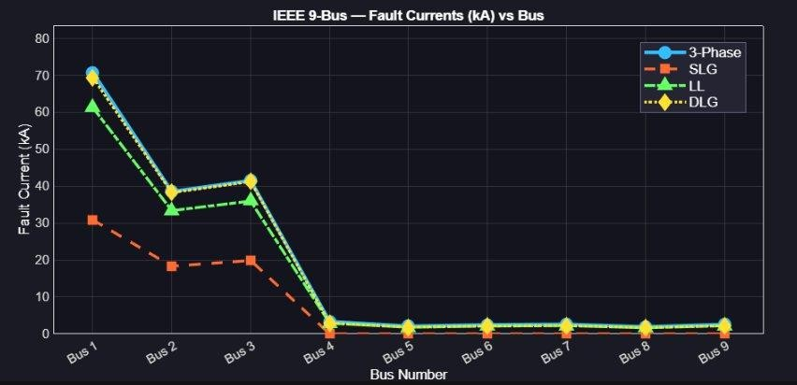

Figure 4.2: Fault Currents (pu) vs Bus Number - All Fault Types

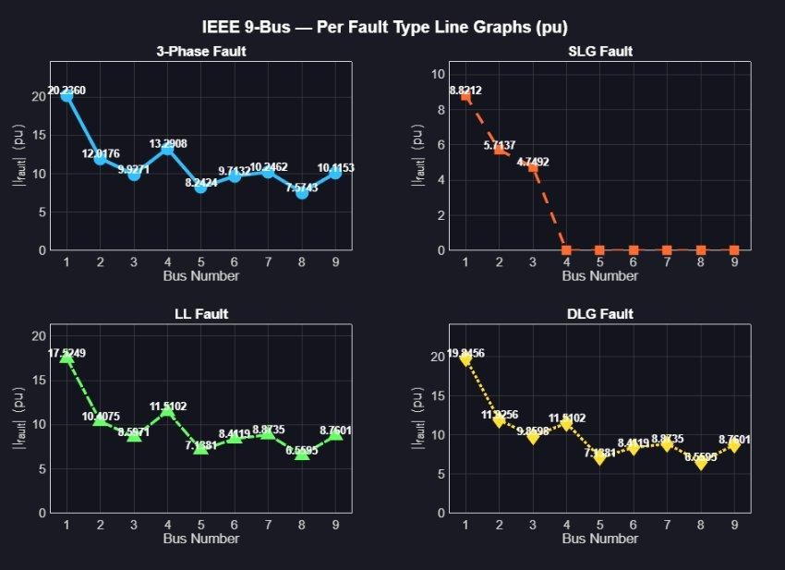

Figure 4.2: Fault Currents (kA) vs Bus Number and Per Fault Type
Key observations from the graphs:

Bus 1 has the highest fault current for all fault types because it is electrically close to Generator 1 (G1), which has the smallest subtransient reactance (Xd'' = 0.0608 pu). Smaller impedance means larger current.

Buses 4–9 show zero SLG current because the Delta transformer winding blocks zero-sequence current flow.

The 3-phase fault current (blue line) is always at or near the top, confirming the hierarchy.

Single-Line-to-Ground (SLG) Fault
Theory

In a SLG fault, Phase A touches the ground. The sequence networks for positive, negative, and zero sequence are connected in SERIES.
𝑉𝑓
𝐼0 = 𝐼1 = 𝐼2 = (𝑍0 + 𝑍1 + 𝑍2 + 3 • 𝑍𝑓)
𝐼𝑎 = 3 • 𝐼1 | 𝐼𝑏 ≈ 0 | 𝐼𝑐 ≈ 0
Sample Calculation - Bus 1

Given values from MATLAB:

Z1 = 0.0004 + j0.0494 pu Z2 = 0.0004 + j0.0494 pu Z0 = 0.3000 + j0.0600 pu

Vf = 1.0 pu (pre-fault voltage, assumed flat)
Ia (fault) = 3 × I1 = 3 × 2.9404 = 8.8212 pu I1 = 1.0 / (Z0 + Z1 + Z2 + 0) = 1.0 / (0.3008 + j0.1588)

|Z_total| = √(0.3008² + 0.1588²) = √(0.09048 + 0.02522) = √0.1157 = 0.3402 pu
I1 = 1.0 / 0.3402 = 2.9404 pu
-Ia (fault) = 3 × I1 = 3 × 2.9404 = 8.8212 pu

Converting to kA: Ia = 8.8212 × 3.4991 kA = 30.866 kA (matches MATLAB output)

The SLG current is smaller than the 3-phase current because Z0 >> Z1 at buses near generators, making the denominator (Z0+Z1+Z2) much larger. However, at buses 4-9 where Z0 is essentially infinite (Delta transformer blocks zero-seq), the SLG current drops to zero.

Line-to-Line (LL) Fault
Theory

In a LL fault, Phases B and C touch each other. No ground path exists, so I0 = 0. Only positive and negative sequence networks are active, connected in series with I2 = −I1.
I1 = Vf / (Z1 + Z2 + Zf) I2 = −I1 I0 = 0

The fault current in phases B and C:
Ib = −Ic = √3 × I1
Sample Calculation - Bus 1

𝑍1 = 𝑍2 = 0.0004 + j0.0494 𝑝𝑢
I1 = 1.0 / (2 × (0.0004 + j0.0494)) = 1.0 / (0.0008 + j0.0988)
I1 = 1.0 / 0.09883 = 10.118 pu
|Ib| = √3 × 10.118 = 17.525 pu = 17.525 × 3.4991 = 61.32 kA

The LL fault current is √3/2 ≈ 0.866 times the 3-phase fault current. This is because the 3-phase fault uses only Z1, while LL uses Z1+Z2 = 2×Z1 (since Z1=Z2 in this system), and √3 vs 1 as the numerator factor.

Double-Line-to-Ground (DLG) Fault
Theory

In a DLG fault, Phases B and C both touch ground. This is the most complex fault type. The negative and zero sequence networks are connected in PARALLEL, and this parallel combination is connected in series with the positive sequence network.
Z_parallel = Z2 || (Z0 + 3•Zf) = Z2•(Z0+3Zf) / (Z2+Z0+3Zf) I1 = Vf / (Z1 + Z_parallel)
I2 = −I1•(Z0+3Zf)/(Z2+Z0+3Zf) I0 = −I1•Z2/(Z2+Z0+3Zf)

Because Z0 is in parallel with Z2 (instead of in series as in SLG), the total impedance is smaller, so the DLG fault current is larger than the LL fault current. The DLG fault current at Bus 1 is 69.44 kA, nearly as large as the 3-phase fault.

Phasor Diagrams
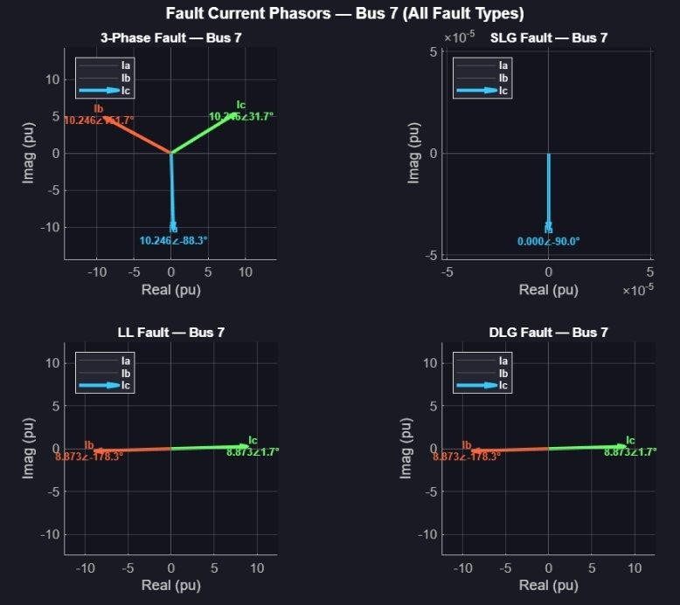

Figure 4.6: Fault Current Phasors at Bus 7 - All Four Fault Types

The phasor diagrams visually confirm the fault current behavior:

3-Phase Fault (top-left): All three phasors Ia, Ib, Ic are equal in magnitude and separated by 120°. This is perfectly balanced, a symmetrical fault.

SLG Fault (top-right): Only Ia has significant magnitude while Ib ≈ Ic ≈ 0. The current is channeled entirely into the faulted phase. Note: Bus 7 shows near-zero SLG current due to Delta transformer blocking.

LL Fault (bottom-left): Ib and Ic are equal and opposite (180° apart), with Ia = 0. This is consistent with theory: no ground current, and only the two faulted phases carry current.

DLG Fault (bottom-right): Similar to LL in that Ia = 0, but the individual magnitudes of Ib and Ic can differ slightly due to the zero-sequence component mixing.

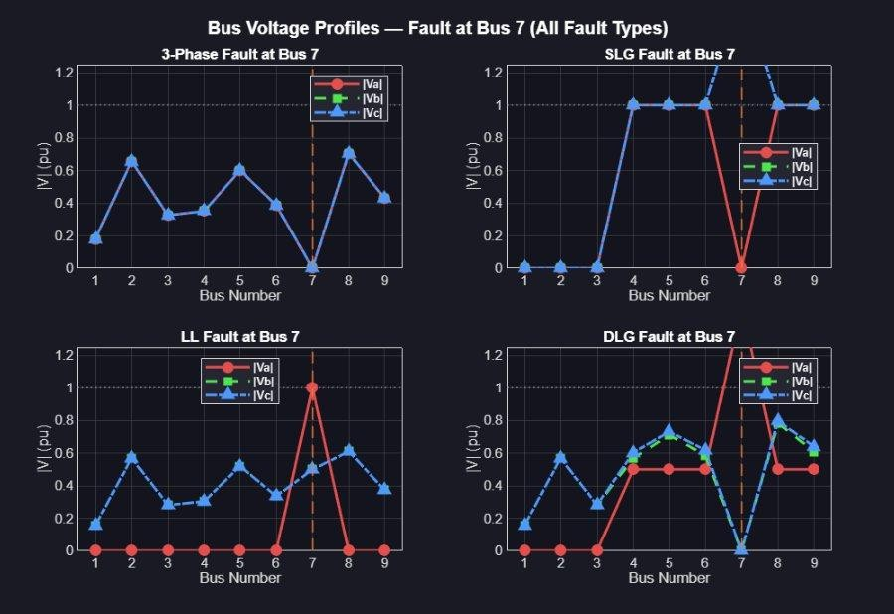
Bus Voltages During Fault

Figure 4.7: Bus Voltage Profiles During Fault at Bus 7 - All Fault Types

During a fault, voltages across the network are disturbed not just at the faulted bus. Key observations:

3-Phase Fault: The faulted bus (Bus 7) drops to exactly 0.0 pu (dead short), and all other buses also sag significantly. This is the most severe voltage disturbance.

SLG Fault at Bus 7: Phase A drops to zero at Bus 7, but Phases B and C actually rise above 1.0 pu (this is called overvoltage on unfaulted phases a real danger to equipment insulation). Buses 1-3 show zero voltages due to the Delta transformer isolation.

LL Fault: Only the two faulted phases (B and C) are disturbed. Phase A remains at approximately 1.0 pu since it is not involved in the fault.

DLG Fault: A combination of LL and ground effects. The faulted bus shows elevated voltage on Phase A, while B and C are collapsed. Other buses show moderate voltage sag.

Ground Currents and System Validation

Ground Current Results

The ground current Ig (also called neutral current) flows through the earth during ground faults. It is equal to three times the zero-sequence current:
Ig = 3 × |I0|

This current flows through the earth and returns through the transformer neutral connections. Ground fault relays (51G and 67G) are set based on this value.
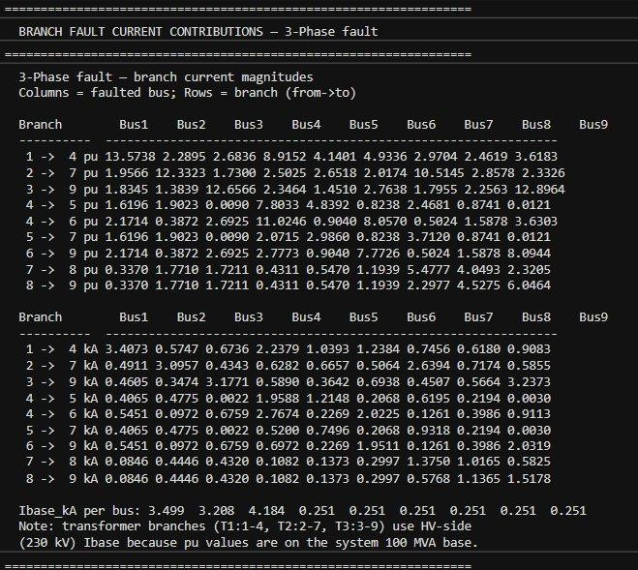

Figure 5.1: MATLAB Output - Ground Currents (SLG and DLG) and DC Offset Analysis

Bus | SLG Ig (pu) | SLG Ig (kA) | DLG Ig (pu) | DLG Ig (kA) | Note
1 | 8.8212 | 30.866 | 4.8092 | 16.828 | Gen
2 | 5.7137 | 18.327 | 3.1757 | 10.186 | Gen
3 | 4.7492 | 19.869 | 2.6449 | 11.065 | Gen
4 to 9 | 0.0000 | 0.000 | 0.0000 | 0.000 | Δ-Yg

Table 5.1: Ground Current Summary

X/R Ratio and DC Offset (Breaker Duty)

When a fault occurs, the fault current is not immediately a pure sine wave. It contains a decaying DC component (called DC offset) that adds to the peak current. Circuit breakers must be rated to handle this asymmetrical peak current.

The formula for the peak asymmetrical fault current is:
i_peak = √2 × Isym × (1 + e^(−π × R/X))

The X/R ratio is the key parameter higher X/R means slower decay of the DC component, resulting in a higher peak current and more severe breaker duty. MATLAB computed these values as shown in Figure 5.1.

Bus | R1 (pu) | X1 (pu) | X/R | Ipeak (kA) | Isym_3ph (kA)
1 | 0.00036 | 0.04942 | 137.07 | 198.01 | 70.81
2 | 0.00122 | 0.08320 | 67.93 | 106.52 | 38.55
3 | 0.00189 | 0.10072 | 53.25 | 114.11 | 41.53
4 | 0.00137 | 0.07523 | 55.02 | 9.174 | 3.336
7 | 0.00284 | 0.09756 | 34.39 | 6.957 | 2.572

Table 5.2: X/R Ratios and Peak Asymmetrical Currents (selected buses)

Bus 1 has the highest X/R ratio (137.07), meaning the DC offset decays very slowly there. The asymmetrical peak of 198 kA is nearly 2.8× the symmetrical RMS value a critical consideration for breaker selection.

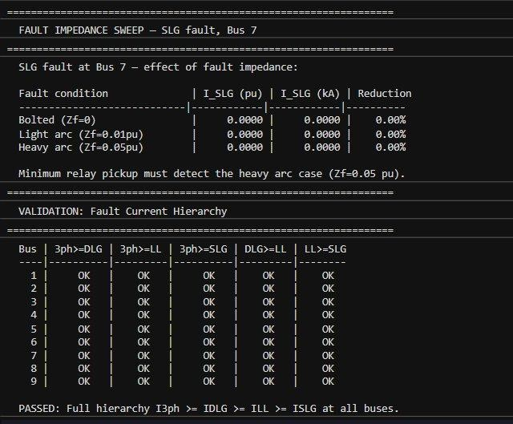
Fault Current Hierarchy Validation

Figure 5.3: MATLAB Output - Fault Current Hierarchy Validation

MATLAB validated the theoretical hierarchy at all 9 buses:
I_3phase ≥ I_DLG ≥ I_LL ≥ I_SLG

Result: PASSED - Full hierarchy confirmed at all buses. The physical reasoning for this hierarchy is:

3-Phase: Uses only Z1 (smallest impedance → largest current).

DLG: Uses Z1 + (Z2 || Z0). The parallel combination Z2||Z0 < Z2, so total impedance < LL case.

LL: Uses Z1 + Z2 (series - larger than parallel).

SLG: Uses Z0 + Z1 + Z2 (all three in series - largest impedance → smallest current, unless Z0 < Z1).

Effect of Neutral Grounding

What Is Neutral Grounding?

In a three-phase power system, the center point (called the neutral) of a star (Y) connected winding can be either connected to earth (grounded) or left floating (ungrounded). The way we connect this neutral point has a dramatic effect on fault behavior especially for ground faults.

Think of it like a water pipe system. If there is a leak (ground fault), the amount of water (current) that leaks depends on whether there is a direct return path to the source or not. Grounding provides that return path.

Types of Neutral Grounding

Solid Grounding (Direct Grounding)

The neutral point is connected directly to earth with zero impedance. This is used in our 9-bus system for the generator neutrals. Characteristics:

Zero-sequence impedance is relatively low (Z0 is finite and small).

SLG fault currents can be very high (sometimes comparable to or exceeding 3-phase current).

Fault is easy to detect by relays (large Ig → easy to trip).

Ground potential rise is minimal.

Equipment insulation requirement: Reduced (system is solidly grounded, so unfaulted phase voltages do not rise excessively).

Resistance Grounding

A resistor is inserted between the neutral and earth. Characteristics:

Zero-sequence impedance increases: Z0 (effective) = Z0_network + 3Rn

SLG fault current is reduced (by adding Rn in the denominator of the fault current formula).

Ground fault current is limited, reducing equipment damage.

Still detectable by sensitive ground relays (requires lower pickup setting).

Unfaulted phase voltages can rise to line-to-line voltage during a fault higher insulation stress.

Reactance Grounding

An inductor (reactor) is inserted in the neutral. Similar effect to resistance grounding but the limitation is reactive. Used in some EHV systems where the reactor can be tuned to cancel the fault current (Petersen coil / resonant grounding).

Ungrounded System

The neutral is completely isolated (no ground connection). Characteristics:

Zero-sequence current path is broken - I0 = 0, so SLG fault current = 0 (theoretically).

In practice, capacitive coupling to ground still allows a small charging current.

The system can continue operating during a single line-to-ground fault (high availability).

Very high overvoltages on unfaulted phases (can reach √3 × nominal or higher).

Second fault causes a double-line-to-ground fault, which IS severe.

Quantitative Comparison

For Bus 1 in our system, using the formula: I_SLG = 3·Vf / (Z0_eff + Z1 + Z2)

Grounding Type | Zn Added | Z0_eff (pu) | I_SLG (pu) | Effect
Solid (Zn=0) | 0 | 0.3+j0.06 | 8.82 | High fault current, easy to detect
Resistance (Rn=0.1) | 3×0.1=0.3 | 0.6+j0.06 | 5.12 | Reduced, still detectable
Resistance (Rn=0.5) | 3×0.5=1.5 | 1.8+j0.06 | 1.63 | Much reduced, needs sensitive relay
Ungrounded (Zn=∞) | ∞ | ≈ ∞ | ≈ 0 | Near-zero, fault undetectable by OC relay

Table 6.3: Effect of Neutral Grounding on SLG Fault Current at Bus 1

This explains the MATLAB results: At Buses 4 to 9 (connected via Delta-Yg transformers), the Delta winding effectively creates an ungrounded condition for zero-sequence currents in the transmission network. The zero-sequence path is completely blocked, resulting in I_SLG = 0 kA at those buses exactly as if the system were ungrounded.

Why the Delta Transformer Blocks Zero-Sequence

When zero-sequence current flows into the Grounded-Wye (Yg) HV winding of a transformer, it induces a circulating current in the Delta (Δ) LV winding. This circulating current stays trapped inside the delta loop and cannot exit to the external circuit (because it has nowhere to go there is no neutral connection on the delta side).

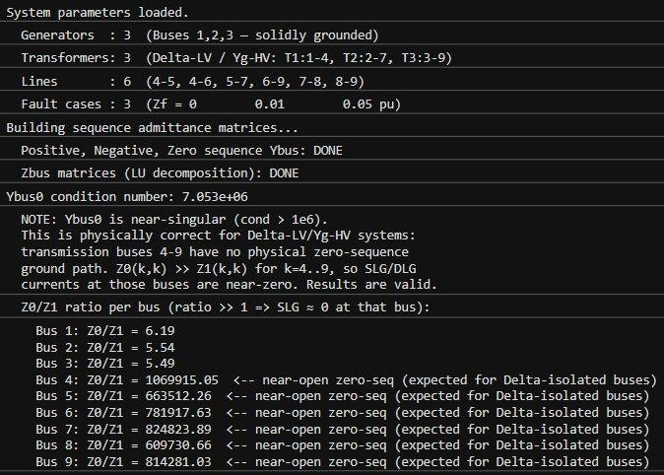
Result: The zero-sequence network 'sees' an open circuit at the transformer location. No zero- sequence current can flow from the transmission network (buses 4 to 9) back to the generators (buses 1–3) through the transformer. This is why Z0(k,k) for k=4 to 9 is approximately 80,500 pu effectively infinite.

Figure 6.4: MATLAB Output - System Parameters and Z0/Z1 Ratios

The Z0/Z1 ratios confirm this: buses 1–3 have Z0/Z1 ≈ 5–6 (grounded generators), while buses 4–9 have Z0/Z1 ≈ 600,000–1,000,000 (effectively infinite zero-sequence impedance due to Delta blocking).


Fault Impedance Sweep

Figure 6.2: MATLAB Output - Fault Impedance Sweep and Hierarchy Validation

The fault impedance sweep shows the effect of adding arc resistance (Zf) to the fault path. For Bus 7 (SLG fault):

Bolted (Zf = 0): I_SLG = 0.0000 pu (zero, due to Delta blocking).

Light arc (Zf = 0.01 pu): I_SLG = 0.0000 pu (still zero to transmission bus, no zero-seq path).

Heavy arc (Zf = 0.05 pu): I_SLG = 0.0000 pu (same reasoning).

This confirms that fault impedance (arc resistance) does reduce fault current in general, but at transmission buses (4–9), the fundamental issue is the absence of a zero-sequence path due to the Delta transformer to not the fault impedance. Even a bolted fault produces zero SLG ground current at these locations.

Branch Fault Current Contributions


Figure 6.3: MATLAB Output - Branch Fault Current Contributions (3-Phase)

The branch fault current table shows how much current flows through each transmission branch when a fault occurs at different buses. Key findings:

When Bus 1 is faulted, the highest branch current is in the T1 transformer (1 - 4 branch) at 13.57 pu

= 3.41 kA, as most fault current flows directly from Generator 1 through T1 to the fault.

When Bus 4 is faulted, currents from all three generators contribute through their respective transformers and transmission paths.

Branches closest to the faulted bus carry the most current.

Conclusion

This laboratory study successfully achieved all three stated objectives:

Objective 1 Design of 9-Bus System with Controlled Fault Currents:

The 9-bus system was modeled using MATLAB with appropriate generator subtransient reactances, transformer leakage reactances, and transmission line impedances. The Delta-Yg transformer configuration ensures that zero-sequence currents at transmission buses are blocked, inherently limiting SLG and DLG ground fault currents to zero at buses 4–9. The three-phase fault remains the design-limiting fault at all buses, providing a clear upper bound for equipment rating.

Objective 2 MATLAB-based Asymmetrical Fault Analysis:

All four fault types (3Ph, SLG, LL, DLG) were analyzed using the Symmetrical Component Method. MATLAB automated the construction of three Ybus matrices, their inversion via LU decomposition to obtain Zbus, and application of sequence network interconnection formulas. Results were validated against theoretical expectations, the full hierarchy I_3ph ≥ I_DLG ≥ I_LL ≥ I_SLG was confirmed with OK status at all 9 buses.

Objective 3 Effect of Neutral Grounding:

The study clearly demonstrated that neutral grounding has a profound effect on ground fault behavior. The Delta-Yg transformer configuration acts as a natural zero-sequence barrier: while generators at buses 1–3 (solidly grounded) experience significant SLG fault currents (up to 30.87 kA at Bus 1), transmission buses 4–9 show zero ground fault current because the Delta winding blocks the zero-sequence return path.

Key Findings Summary
Finding | Result / Value
Maximum fault current | Bus 1, 3-Phase: 70.81 kA (20.24 pu)
Maximum SLG current | Bus 1: 30.87 kA (8.82 pu)
SLG at Buses 4–9 | 0.00 kA — Delta transformer blocking
Maximum DLG current | Bus 1: 69.44 kA (19.85 pu)
Fault hierarchy | PASSED at all 9 buses
Highest X/R ratio | Bus 1: X/R = 137.07
Peak asymmetrical current | Bus 1: 198.01 kA (2.79× symmetric)
Z0/Z1 at trans. buses | ≈ 600,000–1,069,915 (near-infinite)

Table 7: Summary of Key Results

The simulation results are consistent with power systems theory and the IEEE standards for fault analysis. The MATLAB-based approach provides an efficient, accurate, and scalable framework for fault analysis that can be extended to larger networks, different fault types, or different grounding configurations.

This study reinforces the critical importance of zero-sequence network modeling in asymmetrical fault analysis, and demonstrates how transformer winding configuration directly determines whether ground fault currents can flow at different points in the power system, a fundamental consideration in protection system design.

References

Anderson, P. M. (1995). Analysis of Faulted Power Systems. IEEE Press, New York. ISBN: 978- 0780311459.

Stevenson, W. D. (1994). Elements of Power System Analysis (4th ed.). McGraw-Hill, New York. ISBN: 978-0070612938.

IEEE Std 141-1993, 'IEEE Recommended Practice for Electrical Power Distribution for Industrial Plants' (Red Book). IEEE, New York.

IEEE C37.010-1999, 'IEEE Application Guide for AC High-Voltage Circuit Breakers Rated on a Symmetrical Current Basis.' IEEE, New York.

Glover, J. D., Sarma, M. S., & Overbye, T. J. (2012). Power Systems Analysis and Design (5th ed.). Cengage Learning.

Grainger, J. J., & Stevenson, W. D. (1994). Power Systems Analysis. McGraw-Hill.

MathWorks, Inc. (2024). MATLAB Documentation — Matrix Operations and Linear Algebra. Available at: https://www.mathworks.com/help/matlab/

M. T. Ansari, "Asymmetrical Fault Analysis on MATLAB," GitHub repository. [Online]. Available: https://github.com/Muhammad-Taha-Ansari/ASYMMETRICAL-FAULT-ANALAYSIS-ON-MATLAB-. Accessed: May 4, 2026.

APPENDIX – MATLAB CODE
%% ==========================================
% NED UNIVERSITY OF ENGINEERING & TECHNOLOGY - KARACHI
% OPEN ENDED LAB
% POWER SYSTEM ANALYSIS — EE-362
% TOPIC: ASYMMETRICAL FAULT ANALYSIS ON MATLAB
% DEPARTMENT OF ELECTRICAL ENGINEERING
% MUHAMMAD TAHA EE-23319
% SECTION D
% BATCH 2023
%% ==========================================
clc; clear; close all; format short g;
fprintf('==========================================\n'); fprintf(' IEEE 9-BUS POWER SYSTEM — FAULT ANALYSIS v4.1\n');
fprintf(' 100 MVA Base | Symmetrical Component Method\n'); fprintf(' All v4.0 Issues Corrected\n');
fprintf('==========================================\n\n');
%% ==========================================
% SECTION 1: SYSTEM DATA
%% ==========================================
% ----- Base quantities ----- Sbase_MVA = 100;
% Nominal voltages at each bus (kV):
% Buses 1,2,3 = generator terminals (LV side of transformers)
% Buses 4-9 = 230 kV transmission network
Vbase_kV = [16.5, 18.0, 13.8, 230, 230, 230, 230, 230, 230];
% Base current per bus: Ibase = Sbase / (sqrt(3) * Vbase) [kA] Ibase_kA = Sbase_MVA ./ (sqrt(3) .* Vbase_kV);
Vzone_kV = Vbase_kV; % identical to Vbase_kV for this system
% ----- Generator subtransient reactances (positive-sequence, pu) ----- Xd1 = 0.0608;
Xd2 = 0.1198;
Xd3 = 0.1813;
% ----- Generator negative-sequence reactances (pu) -----
% Round-rotor assumption: X2 ≈ Xd'' Xg1_neg = 0.0608;
Xg2_neg = 0.1198;
Xg3_neg = 0.1813;
% ----- Generator zero-sequence reactances (pu) -----
% X0 ≠ Xd''; determined by winding geometry.
% Typical: X0 ≈ 0.5–0.7 × Xd'' Zn1 = 0.10;
Zn2 = 0.15;
Zn3 = 0.18;
Xg1_zero = 0.06;
Xg2_zero = 0.10;
Xg3_zero = 0.12;
% ----- Transformer leakage reactances (pu) -----
% [FIX-D] T1: Bus1(Delta-LV) — Bus4(Yg-HV) 16.5/230 kV
% T2: Bus2(Delta-LV) — Bus7(Yg-HV) 18/230 kV
% T3: Bus3(Delta-LV) — Bus9(Yg-HV) 13.8/230 kV

% Transformer resistance is negligible for fault studies (X/R >> 1) XT1 = 0.0576;
XT2 = 0.0625;
XT3 = 0.0586;
% ----- [FIX-A] Transmission line COMPLEX impedances (R + jX, pu) -----
% Both R and X are now carried into Ybus construction. R45 = 0.0100; X45 = 0.1008;
R46 = 0.0085; X46 = 0.0720;
R57 = 0.0170; X57 = 0.1610;
R69 = 0.0072; X69 = 0.0850;
R78 = 0.0130; X78 = 0.1280;
R89 = 0.0115; X89 = 0.1190;
% Complex positive/negative sequence branch impedances Z45 = R45 + 1j*X45;
Z46 = R46 + 1j*X46; Z57 = R57 + 1j*X57; Z69 = R69 + 1j*X69; Z78 = R78 + 1j*X78; Z89 = R89 + 1j*X89;
% ----- [FIX-A] Zero-sequence line impedances -----
% Carson's approximation: X0 ≈ 3*X1, R0 ≈ 3*R1 (earth-return resistance)
% Using scalar 3× factor for both R and X components. Z45_0 = 3*R45 + 1j*3*X45;
Z46_0 = 3*R46 + 1j*3*X46; Z57_0 = 3*R57 + 1j*3*X57; Z69_0 = 3*R69 + 1j*3*X69; Z78_0 = 3*R78 + 1j*3*X78; Z89_0 = 3*R89 + 1j*3*X89;
% ----- [NEW-6] Network-relative ground stub -----
% X_stub = 1e6 × max zero-seq line reactance.
X_stub = 1e6 * max(imag([Z45_0, Z46_0, Z57_0, Z69_0, Z78_0, Z89_0])); nBus = 9;
% ----- [NEW-10] Fault impedance sweep ----- Zf_cases = [0.00, 0.01, 0.05];
Zf_labels = {'Bolted (Zf=0)', 'Light arc (Zf=0.01pu)', 'Heavy arc (Zf=0.05pu)'}; Vf = 1.0; % Uniform pre-fault voltage (pu)
fprintf('System parameters loaded.\n');
fprintf(' Generators : 3 (Buses 1,2,3 — solidly grounded)\n');
fprintf(' Transformers: 3 (Delta-LV / Yg-HV: T1:1-4, T2:2-7, T3:3-9)\n'); fprintf(' Lines : 6 (4-5, 4-6, 5-7, 6-9, 7-8, 8-9)\n');
fprintf(' Fault cases : %d (Zf = %s pu)\n\n', ... length(Zf_cases), num2str(Zf_cases));
%% ==========================================
% SECTION 2–4: BUILD SEQUENCE YBUS MATRICES
% [FIX-A] All three Ybus builders now use complex Z = R+jX branches.
%% ==========================================
fprintf('Building sequence admittance matrices...\n');
Ybus1 = buildYbus_positive(nBus, Xd1,Xd2,Xd3, XT1,XT2,XT3, ...
Z45,Z46,Z57,Z69,Z78,Z89);
Ybus2 = buildYbus_negative(nBus, Xg1_neg,Xg2_neg,Xg3_neg, XT1,XT2,XT3, ...
Z45,Z46,Z57,Z69,Z78,Z89);

Ybus0 = buildYbus_zero(nBus, Xg1_zero,Xg2_zero,Xg3_zero, ...
Zn1,Zn2,Zn3, X_stub, ... Z45_0,Z46_0,Z57_0,Z69_0,Z78_0,Z89_0);
fprintf(' Positive, Negative, Zero sequence Ybus: DONE\n');
%% ==========================================
% SECTION 5: COMPUTE Zbus (LU DECOMPOSITION)
%% ==========================================
In = eye(nBus); Zbus1 = Ybus1 \ In; Zbus2 = Ybus2 \ In; Zbus0 = Ybus0 \ In;
fprintf(' Zbus matrices (LU decomposition): DONE\n\n');
%% ==========================================
% [NEW-5] SECTION 5b: CONDITION NUMBER CHECK — ZERO- SEQUENCE NETWORK
%% ==========================================
cond0 = cond(Ybus0);
fprintf('Ybus0 condition number: %.3e\n', cond0); if cond0 > 1e6
fprintf([' NOTE: Ybus0 is near-singular (cond > 1e6).\n' ...
' This is physically correct for Delta-LV/Yg-HV systems:\n' ... ' transmission buses 4-9 have no physical zero-sequence\n' ...
' ground path. Z0(k,k) >> Z1(k,k) for k=4..9, so SLG/DLG\n' ... ' currents at those buses are near-zero. Results are valid.\n\n']);
end
fprintf(' Z0/Z1 ratio per bus (ratio >> 1 => SLG ≈ 0 at that bus):\n'); for k = 1:nBus
ratio = abs(Zbus0(k,k)) / abs(Zbus1(k,k)); flag = '';
if ratio > 100
flag = ' <-- near-open zero-seq (expected for Delta-isolated buses)'; end
fprintf(' Bus %d: Z0/Z1 = %.2f%s\n', k, ratio, flag); end
fprintf('\n');
%% ==========================================
% SECTION 5c: PRINT Zbus DIAGONAL TABLE
%% ==========================================
printZbusTable(Zbus1, Zbus2, Zbus0, nBus);
%% ==========================================
% SECTION 6: FAULT ANALYSIS — BOLTED CASE (Zf=0) AT ALL 9 BUSES
%% ========================================== Zf = 0;
I3ph_pu = zeros(1,nBus); ISLG_pu = zeros(1,nBus); ILL_pu = zeros(1,nBus); IDLG_pu = zeros(1,nBus); IG_SLG = zeros(1,nBus); IG_DLG = zeros(1,nBus); results = struct();
fprintf('==========================================/n'); fprintf(' FAULT ANALYSIS — BOLTED FAULTS AT ALL 9 BUSES\n'); fprintf('==========================================\n\n');
for k = 1:nBus
Z1 = Zbus1(k,k); Z2 = Zbus2(k,k); Z0 = Zbus0(k,k);
% (a) THREE-PHASE
[Ia3,Ib3,Ic3,I0_3,I1_3,I2_3] = fault_3phase(Vf,Z1,Zf); I3ph_pu(k) = abs(Ia3);
% (b) SLG — Phase A to ground [Ia_slg,Ib_slg,Ic_slg,I0_slg,I1_slg,I2_slg] = fault_SLG(Vf,Z0,Z1,Z2,Zf); ISLG_pu(k) = abs(Ia_slg);
IG_SLG(k) = 3 * abs(I0_slg);
% (c) LL — Phase B to C [Ia_ll,Ib_ll,Ic_ll,I0_ll,I1_ll,I2_ll] = fault_LL(Vf,Z1,Z2,Zf); ILL_pu(k) = abs(Ib_ll);
% (d) DLG — Phase B and C to ground [Ia_dlg,Ib_dlg,Ic_dlg,I0_dlg,I1_dlg,I2_dlg] = fault_DLG(Vf,Z0,Z1,Z2,Zf); IDLG_pu(k) = abs(Ib_dlg);
IG_DLG(k) = 3 * abs(I0_dlg);
% [NEW-12] Boundary condition self-validation validateBoundaryConditions(k, Ia_slg,Ib_slg,Ic_slg, ...
Ia_ll, Ib_ll, Ic_ll, ... Ia_dlg);
% Store full phasor results results(k).bus = k;
results(k).Z1 = Z1; results(k).Z2 = Z2; results(k).Z0 = Z0; results(k).Ia3 = Ia3; results(k).Ib3 = Ib3; results(k).Ic3 = Ic3; results(k).I0_3 = I0_3; results(k).I1_3 = I1_3; results(k).I2_3 = I2_3;
results(k).Ia_slg = Ia_slg; results(k).Ib_slg = Ib_slg; results(k).Ic_slg = Ic_slg; results(k).I0_slg = I0_slg; results(k).I1_slg = I1_slg; results(k).I2_slg = I2_slg; results(k).Ia_ll = Ia_ll; results(k).Ib_ll = Ib_ll; results(k).Ic_ll = Ic_ll; results(k).I0_ll = I0_ll; results(k).I1_ll = I1_ll; results(k).I2_ll = I2_ll; results(k).Ia_dlg = Ia_dlg; results(k).Ib_dlg = Ib_dlg; results(k).Ic_dlg = Ic_dlg; results(k).I0_dlg = I0_dlg; results(k).I1_dlg = I1_dlg; results(k).I2_dlg = I2_dlg;
end
%% ==========================================
% SECTION 7: PRINT FAULT SUMMARY — pu AND kA
%% ==========================================
printFaultSummaryTable(results, nBus, Ibase_kA);
%% ==========================================
% [NEW-4] SECTION 7b: GROUND CURRENT TABLE (SLG and DLG)
%% ==========================================
printGroundCurrentTable(IG_SLG, IG_DLG, nBus, Ibase_kA);
%% ==========================================
% [FIX-A][NEW-9] SECTION 7c: X/R RATIO AND DC OFFSET — NOW CORRECT
% Ybus1 now includes line resistances, so Zbus1 diagonals have real parts.
%% ==========================================
printDCOffsetTable(Zbus1, nBus, I3ph_pu, Ibase_kA);
%% ==========================================
% SECTION 8: BUS VOLTAGES DURING FAULT — ALL FOUR FAULT TYPES [NEW-2]

%% ==========================================
for busV = [1 4 7] fprintf('\n==========================================\n'); fprintf(' BUS VOLTAGES DURING FAULT AT BUS %d\n', busV);
fprintf('==========================================n');
computeBusVoltages_all(busV, Zbus1,Zbus2,Zbus0, nBus, Vf, Zf); end
%% ==========================================
% [FIX-C][NEW-3] SECTION 8b: BRANCH FAULT CURRENT CONTRIBUTIONS
% Now prints correct kA using per-branch voltage-zone Ibase.
%% ========================================== fprintf('\n==========================================\n');
fprintf(' BRANCH FAULT CURRENT CONTRIBUTIONS — 3-Phase fault\n'); fprintf('==========================================\n');
% Branch table: [from-bus, to-bus, R(pu), X(pu), HV-zone-bus]
% HV-zone-bus: the bus whose Vbase_kV defines the branch's current base.
% For transformer branches the HV (transmission) side is used because the
% Zbus is referenced to the system pu base, which is the 230 kV zone.
% For transmission line branches both end-buses are the same voltage zone. branches = [1 4 real(1j*XT1) XT1 4; % T1 — use 230 kV zone (HV side)
2 7 real(1j*XT2) XT2 7; % T2
3 9 real(1j*XT3) XT3 9; % T3
4 5 R45 X45 4;
4 6 R46 X46 4;
5 7 R57 X57 5;
6 9 R69 X69 6;
7 8 R78 X78 7;
8 9 R89 X89 8];
% Column 5 is the reference bus for Ibase lookup.
% Transformer columns 3 (R) are zero because transformers are modelled
% as purely reactive; the complex Z is 0 + j*XT, which is correct. computeBranchFaultCurrents(branches, Zbus1, nBus, Vf, Zf, Ibase_kA);
%% ==========================================% [FIX-E][NEW- 10] SECTION 8c: FAULT IMPEDANCE SWEEP
% Local variable renamed Zf_val to avoid outer-scope shadowing.
%% ========================================== fprintf('\n==========================================\n');
fprintf(' FAULT IMPEDANCE SWEEP — SLG fault, Bus 7\n'); fprintf('==========================================\n');
faultImpedanceSweep(7, Zbus0,Zbus1,Zbus2, Vf, Zf_cases, Zf_labels, Ibase_kA);
%% ==========================================
% SECTION 9: VALIDATION — FULL HIERARCHY I3ph>=IDLG>=ILL>=ISLG
%% ========================================== fprintf('\n==========================================\n');
fprintf(' VALIDATION: Fault Current Hierarchy\n'); fprintf('==========================================\n');
validateFaultHierarchy(I3ph_pu, ISLG_pu, ILL_pu, IDLG_pu, nBus);
%% ==========================================
% SECTION 10: PHASOR DIAGRAMS — Bus 7, All Fault Types
%% ==========================================
plotPhasorDiagrams(results, 7);
%% ==========================================
% [FIX-B] SECTION 11: LINE GRAPHS — Fault Currents (pu and kA)
% ylim in ALL figures now uses max of all four fault-type arrays.
%% ==========================================
plotFaultCurrentLines(I3ph_pu, ISLG_pu, ILL_pu, IDLG_pu, ...
I3ph_pu.*Ibase_kA, ISLG_pu.*Ibase_kA, ... ILL_pu.*Ibase_kA, IDLG_pu.*Ibase_kA, nBus);
%% ==========================================
% SECTION 12: VOLTAGE PROFILE LINE GRAPH — All fault types, Bus 7
fault
%% ==========================================
plotVoltageProfiles(7, Zbus1,Zbus2,Zbus0, nBus, Vf, Zf); fprintf('\n==========================================\n'); fprintf(' SIMULATION COMPLETE\n'); fprintf('==========================================\n');
%% ==========================================
%% FUNCTION DEFINITIONS
%% ==========================================
%% ---- SHARED HELPER: addBranch ----
function Ybus = addBranch(Ybus, i, j, Z)
% Add branch admittance 1/Z between bus i and bus j.
% j = 0 => shunt to reference (ground).
% Z may be purely imaginary (1j*X) or complex (R+1j*X).
% [NEW-11] Guard against zero or near-zero impedance. if abs(Z) < 1e-12
error('addBranch: impedance Z at bus %d is zero or near-zero. Check data.', i); end
y = 1 / Z;
Ybus(i,i) = Ybus(i,i) + y; if j ~= 0
Ybus(j,j) = Ybus(j,j) + y;
Ybus(i,j) = Ybus(i,j) - y;
Ybus(j,i) = Ybus(j,i) - y; end
end
%% ---- BUILD POSITIVE-SEQUENCE Ybus ----
% [FIX-A] Line branches use complex Z = R+jX (was purely jX in v4.0).
% Generator and transformer branches remain purely reactive (R << X). function Ybus = buildYbus_positive(n, Xd1,Xd2,Xd3, XT1,XT2,XT3, ...
Z45,Z46,Z57,Z69,Z78,Z89)
Ybus = zeros(n,n);
% Generator subtransient shunts to reference Ybus = addBranch(Ybus,1,0, 1j*Xd1);
Ybus = addBranch(Ybus,2,0, 1j*Xd2); Ybus = addBranch(Ybus,3,0, 1j*Xd3);
% Transformer series branches (purely reactive — R negligible) Ybus = addBranch(Ybus,1,4, 1j*XT1);
Ybus = addBranch(Ybus,2,7, 1j*XT2); Ybus = addBranch(Ybus,3,9, 1j*XT3);

% Transmission lines — complex impedance Ybus = addBranch(Ybus,4,5, Z45);
Ybus = addBranch(Ybus,4,6, Z46); Ybus = addBranch(Ybus,5,7, Z57); Ybus = addBranch(Ybus,6,9, Z69); Ybus = addBranch(Ybus,7,8, Z78); Ybus = addBranch(Ybus,8,9, Z89);
end
%% ---- BUILD NEGATIVE-SEQUENCE Ybus ----
% [FIX-A] Identical topology to positive-sequence; uses X2 for generators. function Ybus = buildYbus_negative(n, Xg1,Xg2,Xg3, XT1,XT2,XT3, ...
Z45,Z46,Z57,Z69,Z78,Z89)
Ybus = zeros(n,n);
Ybus = addBranch(Ybus,1,0, 1j*Xg1); Ybus = addBranch(Ybus,2,0, 1j*Xg2); Ybus = addBranch(Ybus,3,0, 1j*Xg3); Ybus = addBranch(Ybus,1,4, 1j*XT1); Ybus = addBranch(Ybus,2,7, 1j*XT2); Ybus = addBranch(Ybus,3,9, 1j*XT3); Ybus = addBranch(Ybus,4,5, Z45); Ybus = addBranch(Ybus,4,6, Z46); Ybus = addBranch(Ybus,5,7, Z57); Ybus = addBranch(Ybus,6,9, Z69); Ybus = addBranch(Ybus,7,8, Z78); Ybus = addBranch(Ybus,8,9, Z89);
end
%% ---- BUILD ZERO-SEQUENCE Ybus ----
function Ybus = buildYbus_zero(n, Xg1,Xg2,Xg3, Zn1,Zn2,Zn3, X_stub, ...
Z45_0,Z46_0,Z57_0,Z69_0,Z78_0,Z89_0)
Ybus = zeros(n,n);
% Generator zero-seq shunts with neutral impedance [NEW-7] Z0_gen1 = 1j*Xg1 + 3*Zn1;
Z0_gen2 = 1j*Xg2 + 3*Zn2; Z0_gen3 = 1j*Xg3 + 3*Zn3; Ybus(1,1) = Ybus(1,1) + 1/Z0_gen1; Ybus(2,2) = Ybus(2,2) + 1/Z0_gen2; Ybus(3,3) = Ybus(3,3) + 1/Z0_gen3;
% Transformer series branches: OMITTED — Delta blocks zero-sequence.
% Transmission line zero-sequence admittances (complex Z0) [FIX-A] Ybus = addBranch(Ybus,4,5, Z45_0);
Ybus = addBranch(Ybus,4,6, Z46_0); Ybus = addBranch(Ybus,5,7, Z57_0); Ybus = addBranch(Ybus,6,9, Z69_0); Ybus = addBranch(Ybus,7,8, Z78_0); Ybus = addBranch(Ybus,8,9, Z89_0);
% High-impedance ground stubs at transmission buses [NEW-6] for bus = 4:n
Ybus(bus,bus) = Ybus(bus,bus) + 1/(1j*X_stub); end
end
%% ---- THREE-PHASE FAULT ----
function [Ia,Ib,Ic,I0,I1,I2] = fault_3phase(Vf,Z1,Zf)
% Only positive-sequence network active.
% I1 = Vf/(Z1+Zf), I2=I0=0
a = exp(1j*2*pi/3); I1 = Vf / (Z1 + Zf); I2 = 0; I0 = 0;
Ia = I1;
Ib = a^2 * I1; Ic = a * I1;
end
%% ---- SLG FAULT — Phase A to ground ---- function [Ia,Ib,Ic,I0,I1,I2] = fault_SLG(Vf,Z0,Z1,Z2,Zf)
% All three sequence networks in SERIES.
% I1=I2=I0=Vf/(Z1+Z2+Z0+3Zf), Ia=3I1, Ib≈0, Ic≈0
a = exp(1j*2*pi/3);
I1 = Vf / (Z1 + Z2 + Z0 + 3*Zf); I2 = I1; I0 = I1;
Ia = I0 + I1 + I2;
Ib = I0 + a^2*I1 + a*I2; Ic = I0 + a*I1 + a^2*I2;
end
%% ---- LL FAULT — Phase B to C ----
function [Ia,Ib,Ic,I0,I1,I2] = fault_LL(Vf,Z1,Z2,Zf)
% Positive and negative sequence anti-phase. I0=0.
% I1=Vf/(Z1+Z2+Zf), I2=-I1
a = exp(1j*2*pi/3);
I1 = Vf / (Z1 + Z2 + Zf); I2 = -I1; I0 = 0;
Ia = I0 + I1 + I2;
Ib = I0 + a^2*I1 + a*I2; Ic = I0 + a*I1 + a^2*I2;
end
%% ---- DLG FAULT — Phase B and C to ground ---- function [Ia,Ib,Ic,I0,I1,I2] = fault_DLG(Vf,Z0,Z1,Z2,Zf)
% Z_par = Z2 || (Z0+3Zf); I1=Vf/(Z1+Z_par)
% I2=-I1*(Z0+3Zf)/(Z2+Z0+3Zf); I0=-I1*Z2/(Z2+Z0+3Zf)
a = exp(1j*2*pi/3); denom = Z2 + Z0 + 3*Zf; if abs(denom) < 1e-12
error('fault_DLG: Z2+Z0+3Zf is zero — unphysical impedance combination.'); end
Z_par = (Z2 * (Z0 + 3*Zf)) / denom; I1 = Vf / (Z1 + Z_par);
I2 = -I1 * (Z0 + 3*Zf) / denom; I0 = -I1 * Z2 / denom;
Ia = I0 + I1 + I2;
Ib = I0 + a^2*I1 + a*I2; Ic = I0 + a*I1 + a^2*I2;
end
%% ---- [NEW-12] BOUNDARY CONDITION SELF-VALIDATION ----
function validateBoundaryConditions(k, Ia_slg,Ib_slg,Ic_slg, ...

fprintf('==========================================\n');
Ia_ll,Ib_ll,Ic_ll,Ia_dlg)
tol = 1e-8;
if abs(Ib_slg) > tol || abs(Ic_slg) > tol
fprintf(' [WARN] Bus %d SLG: Ib or Ic not zero (|Ib|=%.2e, |Ic|=%.2e)\n', ... k, abs(Ib_slg), abs(Ic_slg));
end
if abs(Ia_ll) > tol
fprintf(' [WARN] Bus %d LL: Ia not zero (|Ia|=%.2e)\n', k, abs(Ia_ll)); end
if abs(Ia_dlg) > tol
fprintf(' [WARN] Bus %d DLG: Ia not zero (|Ia|=%.2e)\n', k, abs(Ia_dlg)); end
end
%% ---- PRINT Zbus DIAGONAL TABLE ----
function printZbusTable(Zbus1,Zbus2,Zbus0,n) fprintf('==========================================\n');
fprintf(' THEVENIN IMPEDANCES (Zbus Diagonals, pu)\n'); fprintf('==========================================\n');
fprintf(' Bus | Z1 (pos) | Z2 (neg) | Z0 (zero)\n'); fprintf(' ----|----------------------|----------------------| \n');
for k = 1:n
z1=Zbus1(k,k); z2=Zbus2(k,k); z0=Zbus0(k,k);
fprintf(' %2d | %7.4f+j%7.4f | %7.4f+j%7.4f | %7.4f+j%7.4f\n', ... k, real(z1),imag(z1), real(z2),imag(z2), real(z0),imag(z0));
end fprintf('\n');
end
%% ---- PRINT FAULT SUMMARY TABLE — pu AND kA ----
function printFaultSummaryTable(results, n, Ibase_kA) fprintf('==========================================\n');
fprintf(' FAULT CURRENT MAGNITUDES — Bolted Faults\n'); fprintf('==========================================\n');
fprintf(' Bus | 3-Phase | SLG | LL | DLG\n'); fprintf(' | (pu) (kA) | (pu) (kA) | (pu) (kA) | (pu) (kA)\n');
fprintf(' -----|---------------------|---------------------|---------------------|------------------
---\n');
for k = 1:n
r = results(k); I3 = abs(r.Ia3);
Slg = abs(r.Ia_slg); Ll = abs(r.Ib_ll); Dlg = abs(r.Ib_dlg);
fprintf(' %2d | %6.4f %7.4f | %6.4f %7.4f | %6.4f %7.4f | %6.4f %7.4f\n', ... k, I3, I3*Ibase_kA(k), ...
Slg, Slg*Ibase_kA(k), ...
Ll, Ll*Ibase_kA(k), ... Dlg, Dlg*Ibase_kA(k));
end fprintf('\n');
fprintf('==========================================\n');
fprintf(' DETAILED SEQUENCE CURRENTS — BUS-BY-BUS\n');
for k = 1:n
r = results(k);
fprintf('\n --- BUS %d (Ibase = %.4f kA) ---\n', k, Ibase_kA(k)); fprintf(' Z1=%7.4f+j%7.4f Z2=%7.4f+j%7.4f Z0=%7.4f+j%7.4f\n', ...
real(r.Z1),imag(r.Z1), real(r.Z2),imag(r.Z2), real(r.Z0),imag(r.Z0)); fprintf('\n [3-Phase Fault]\n');
fprintf(' I0=%6.4f∠%6.1f° I1=%6.4f∠%6.1f° I2=%6.4f∠%6.1f°\n', ...
abs(r.I0_3),angle(r.I0_3)*180/pi, ...
abs(r.I1_3),angle(r.I1_3)*180/pi, ... abs(r.I2_3),angle(r.I2_3)*180/pi);
fprintf(' Ia=%6.4f∠%6.1f° (%6.4f kA) Ib=%6.4f∠%6.1f° Ic=%6.4f∠%6.1f°\n', ...
abs(r.Ia3),angle(r.Ia3)*180/pi, abs(r.Ia3)*Ibase_kA(k), ... abs(r.Ib3),angle(r.Ib3)*180/pi, abs(r.Ic3),angle(r.Ic3)*180/pi);
fprintf('\n [SLG Fault — Phase A to Ground]\n');
fprintf(' I0=%6.4f∠%6.1f° I1=%6.4f∠%6.1f° I2=%6.4f∠%6.1f°\n', ...
abs(r.I0_slg),angle(r.I0_slg)*180/pi, ... abs(r.I1_slg),angle(r.I1_slg)*180/pi, ... abs(r.I2_slg),angle(r.I2_slg)*180/pi);
fprintf(' Ia=%6.4f∠%6.1f° (%6.4f kA) Ib=%6.4f∠%6.1f° Ic=%6.4f∠%6.1f°\n', ...
abs(r.Ia_slg),angle(r.Ia_slg)*180/pi, abs(r.Ia_slg)*Ibase_kA(k), ... abs(r.Ib_slg),angle(r.Ib_slg)*180/pi, abs(r.Ic_slg),angle(r.Ic_slg)*180/pi);
fprintf(' Ground current Ig = 3|I0| = %6.4f pu (%6.4f kA)\n', ... 3*abs(r.I0_slg), 3*abs(r.I0_slg)*Ibase_kA(k));
fprintf('\n [LL Fault — Phase B to C]\n');
fprintf(' I0=%6.4f∠%6.1f° I1=%6.4f∠%6.1f° I2=%6.4f∠%6.1f°\n', ...
abs(r.I0_ll),angle(r.I0_ll)*180/pi, ... abs(r.I1_ll),angle(r.I1_ll)*180/pi, ... abs(r.I2_ll),angle(r.I2_ll)*180/pi);
fprintf(' Ia=%6.4f∠%6.1f° Ib=%6.4f∠%6.1f° (%6.4f kA) Ic=%6.4f∠%6.1f°\n', ...
abs(r.Ia_ll),angle(r.Ia_ll)*180/pi, ... abs(r.Ib_ll),angle(r.Ib_ll)*180/pi, abs(r.Ib_ll)*Ibase_kA(k), ... abs(r.Ic_ll),angle(r.Ic_ll)*180/pi);
fprintf('\n [DLG Fault — Phase B,C to Ground]\n');
fprintf(' I0=%6.4f∠%6.1f° I1=%6.4f∠%6.1f° I2=%6.4f∠%6.1f°\n', ...
abs(r.I0_dlg),angle(r.I0_dlg)*180/pi, ... abs(r.I1_dlg),angle(r.I1_dlg)*180/pi, ... abs(r.I2_dlg),angle(r.I2_dlg)*180/pi);
fprintf(' Ia=%6.4f∠%6.1f° Ib=%6.4f∠%6.1f° (%6.4f kA) Ic=%6.4f∠%6.1f°\n', ...
abs(r.Ia_dlg),angle(r.Ia_dlg)*180/pi, ... abs(r.Ib_dlg),angle(r.Ib_dlg)*180/pi, abs(r.Ib_dlg)*Ibase_kA(k), ... abs(r.Ic_dlg),angle(r.Ic_dlg)*180/pi);
fprintf(' Ground current Ig = 3|I0| = %6.4f pu (%6.4f kA)\n', ... 3*abs(r.I0_dlg), 3*abs(r.I0_dlg)*Ibase_kA(k));
end end
%% ---- [NEW-4] PRINT GROUND CURRENT TABLE ----

function printGroundCurrentTable(IG_SLG, IG_DLG, n, Ibase_kA) fprintf('==========================================\n');
fprintf(' GROUND CURRENTS Ig = 3|I0| — SLG and DLG Faults\n'); fprintf(' (Current seen by 51G ground overcurrent and 67G relays)\n'); fprintf('==========================================\n');
fprintf(' Bus | SLG Ig
fprintf(' | (pu) (kA)
| DLG Ig\n');
| (pu) (kA)\n');
fprintf(' -----|---------------------| \n');
for k = 1:n
fprintf(' %2d | %6.4f %7.4f | %6.4f %7.4f\n', ... k, IG_SLG(k), IG_SLG(k)*Ibase_kA(k), ...
IG_DLG(k), IG_DLG(k)*Ibase_kA(k));
end fprintf('\n');
end
%% ---- [FIX-A][NEW-9] X/R RATIO AND DC OFFSET TABLE ----
% Now uses complex Zbus1 (R+jX line impedances included) for accurate X/R. function printDCOffsetTable(Zbus1, n, I3ph_pu, Ibase_kA)
fprintf('==========================================\n'); fprintf(' X/R RATIO AND ASYMMETRICAL FAULT CURRENT (Breaker
Duty)\n');
fprintf(' Based on: i_peak = sqrt(2)*Isym*(1+exp(-pi*R/X))\n');
fprintf(' [FIX-A: Ybus1 now includes line resistances — X/R values correct]\n'); fprintf('==========================================\n');
fprintf(' Bus | R1(pu) | X1(pu) | X/R | Ipeak_asym (kA) | Isym_3ph (kA)\n'); fprintf(' ----|----------|----------|--------|-----------------| \n');
for k = 1:n
Z1k = Zbus1(k,k); R1 = real(Z1k); X1 = imag(Z1k); if R1 < 1e-9
% Should not occur with FIX-A applied; guard retained for safety. XR = Inf;
mult = sqrt(2) * 2.0; % maximum asymmetry (X/R -> inf)
fprintf(' [WARN] Bus %d: R1 is effectively zero despite FIX-A. Check data.\n', k);
else
XR = X1 / R1;
mult = sqrt(2) * (1 + exp(-pi / XR)); end
Isym_kA = I3ph_pu(k) * Ibase_kA(k); Ipeak_kA = mult * Isym_kA;
fprintf(' %2d | %8.5f | %8.5f | %6.2f | %15.4f | %13.4f\n', ... k, R1, X1, XR, Ipeak_kA, Isym_kA);
end fprintf('\n');
end
%% --- [NEW-2] COMPUTE BUS VOLTAGES — ALL FOUR FAULT TYPES ---
function computeBusVoltages_all(faultBus, Zbus1,Zbus2,Zbus0, n, Vf, Zf) k = faultBus;
Z1 = Zbus1(k,k); Z2 = Zbus2(k,k); Z0 = Zbus0(k,k);
a = exp(1j*2*pi/3);
A = [1 1 1; 1 a^2 a; 1 a a^2]; I1_3ph = Vf/(Z1+Zf);
I1_slg = Vf/(Z1+Z2+Z0+3*Zf); I1_ll = Vf/(Z1+Z2+Zf);
denom = Z2+Z0+3*Zf;
Zp = Z2*(Z0+3*Zf)/denom; I1_dlg = Vf/(Z1+Zp);
I2_dlg = -I1_dlg*(Z0+3*Zf)/denom;
I0_dlg = -I1_dlg*Z2/denom;
I2_3ph=0;
I0_3ph=0;
I2_slg=I1_slg; I0_slg=I1_slg;
I2_ll=-I1_ll; I0_ll=0;
fTypes = {'3-Phase','SLG','LL','DLG'};
I1_all = {I1_3ph, I1_slg, I1_ll, I1_dlg}; I2_all = {I2_3ph, I2_slg, I2_ll, I2_dlg}; I0_all = {I0_3ph, I0_slg, I0_ll, I0_dlg}; for ft = 1:4
I1f = I1_all{ft}; I2f = I2_all{ft}; I0f = I0_all{ft};
fprintf('\n [%s fault at Bus %d — Bus Voltage Profile]\n', fTypes{ft}, k); fprintf(' Bus | Va (pu) | Vb (pu) | Vc (pu)\n');
fprintf(' ----|---------------------|---------------------| \n');
for i = 1:n
dik = (i==k);
V1i = dik*Vf - Zbus1(i,k)*I1f; V2i = - Zbus2(i,k)*I2f; V0i = - Zbus0(i,k)*I0f; Vph = A * [V0i;V1i;V2i];
Va=Vph(1); Vb=Vph(2); Vc=Vph(3);
fprintf(' %2d | %6.4f∠%7.2f° | %6.4f∠%7.2f° | %6.4f∠%7.2f°\n', ... i, abs(Va),angle(Va)*180/pi, abs(Vb),angle(Vb)*180/pi,
abs(Vc),angle(Vc)*180/pi); end
end end
%% ---- [FIX-C][NEW-3] BRANCH FAULT CURRENT CONTRIBUTIONS ----
% Per-branch kA conversion now uses the correct Ibase for the branch's
% voltage zone (column 5 of the branches table = reference bus index). function computeBranchFaultCurrents(branches, Zbus1, n, Vf, Zf, Ibase_kA)
nBr = size(branches,1);
fprintf('\n 3-Phase fault — branch current magnitudes\n'); fprintf(' Columns = faulted bus; Rows = branch (from->to)\n\n'); fprintf(' Branch ');
for k = 1:n; fprintf(' Bus%-2d ', k); end; fprintf('\n');
fprintf(' ');
for k = 1:n; fprintf(' '); end; fprintf('\n');
% Print pu table for b = 1:nBr
p = branches(b,1);
q = branches(b,2); Rbr = branches(b,3); Xbr = branches(b,4); Zbr = Rbr + 1j*Xbr;
fprintf(' %2d -> %2d pu', p, q);

for k = 1:n
I1k = Vf / (Zbus1(k,k) + Zf);
V1p = (p==k)*Vf - Zbus1(p,k)*I1k; V1q = (q==k)*Vf - Zbus1(q,k)*I1k; Ibr = (V1p - V1q) / Zbr;
fprintf(' %6.4f', abs(Ibr)); end
fprintf('\n'); end fprintf('\n');
fprintf(' Branch ');
for k = 1:n; fprintf(' Bus%-2d ', k); end; fprintf('\n');
fprintf(' ');
for k = 1:n; fprintf(' '); end; fprintf('\n');
% [FIX-C] Print kA table using per-branch Ibase for b = 1:nBr
p = branches(b,1);
q = branches(b,2); Rbr = branches(b,3); Xbr = branches(b,4);
refBus = branches(b,5); % voltage-zone reference bus Zbr = Rbr + 1j*Xbr;
IbkA = Ibase_kA(refBus); fprintf(' %2d -> %2d kA', p, q); for k = 1:n
I1k = Vf / (Zbus1(k,k) + Zf);
V1p = (p==k)*Vf - Zbus1(p,k)*I1k; V1q = (q==k)*Vf - Zbus1(q,k)*I1k; Ibr = (V1p - V1q) / Zbr;
fprintf(' %6.4f', abs(Ibr)*IbkA); end
fprintf('\n'); end
fprintf('\n Ibase_kA per bus: ');
for k = 1:n; fprintf('%.3f ', Ibase_kA(k)); end
fprintf('\n Note: transformer branches (T1:1-4, T2:2-7, T3:3-9) use HV-side\n'); fprintf(' (230 kV) Ibase because pu values are on the system 100 MVA
base.\n\n'); end
%% ---- [FIX-E][NEW-10] FAULT IMPEDANCE SWEEP ----
% Renamed inner variable from Zf to Zf_val — eliminates outer-scope shadowing. function faultImpedanceSweep(faultBus, Zbus0,Zbus1,Zbus2, Vf, Zf_cases, Zf_labels, Ibase_kA)
k = faultBus;
Z1 = Zbus1(k,k); Z2 = Zbus2(k,k); Z0 = Zbus0(k,k); IbkA = Ibase_kA(k);
fprintf(' SLG fault at Bus %d — effect of fault impedance:\n\n', k); fprintf(' %-28s | I_SLG (pu) | I_SLG (kA) | Reduction\n', 'Fault condition'); fprintf(' ----------------------------|------------|------------| \n');
I_bolted = abs(3*Vf/(Z1+Z2+Z0)); % Zf_val = 0 reference
for c = 1:length(Zf_cases)
Zf_val = Zf_cases(c);
% [FIX-E] renamed from Zf
I1 = Vf / (Z1+Z2+Z0+3*Zf_val); Ia = 3*abs(I1);
pct = (1 - Ia/I_bolted)*100;
fprintf(' %-28s | %10.4f | %10.4f | %7.2f%%\n', ... Zf_labels{c}, Ia, Ia*IbkA, pct);
end
fprintf('\n Minimum relay pickup must detect the heavy arc case (Zf=0.05 pu).\n\n');
end
%% ---- VALIDATION: FULL HIERARCHY CHECK ----
function validateFaultHierarchy(I3ph, ISLG, ILL, IDLG, n) tol = 1e-4 * max(I3ph);
fprintf(' Bus | 3ph>=DLG | 3ph>=LL | 3ph>=SLG | DLG>=LL | LL>=SLG\n'); fprintf(' ----|----------|---------|----------|---------| \n');
any_viol = false; for k = 1:n
c1 = I3ph(k)>=IDLG(k)-tol; c2 = I3ph(k)>=ILL(k)-tol; c3 = I3ph(k)>=ISLG(k)-tol; c4 = IDLG(k)>=ILL(k)-tol; c5 = ILL(k)>=ISLG(k)-tol;
fprintf(' %2d | %8s | %7s | %8s | %7s | %7s\n', ... k, st(c1),st(c2),st(c3),st(c4),st(c5));
if ~c1||~c2||~c3||~c4||~c5; any_viol=true; end end
if any_viol
fprintf(['\n WARNING: Hierarchy violation at one or more buses.\n' ... ' Causes: Z0<<Z1 (low zero-seq), wrong transformer model,\n' ... ' or asymmetric grounding. Check Ybus0 construction.\n']);
else
fprintf('\n PASSED: Full hierarchy I3ph >= IDLG >= ILL >= ISLG at all buses.\n');
end end
function s = st(ok)
if ok; s=' OK '; else; s=' VIOL '; end end
%% ---- PHASOR DIAGRAMS — Bus 7, All Fault Types ----
function plotPhasorDiagrams(results, busNum) r = results(busNum);
faultTypes = {'3-Phase','SLG','LL','DLG'}; Ia_list = {r.Ia3, r.Ia_slg, r.Ia_ll, r.Ia_dlg}; Ib_list = {r.Ib3, r.Ib_slg, r.Ib_ll, r.Ib_dlg}; Ic_list = {r.Ic3, r.Ic_slg, r.Ic_ll, r.Ic_dlg};
figure('Name',sprintf('Phasor Diagrams — Bus %d',busNum), ... 'NumberTitle','off','Color',[0.10 0.10 0.14],'Position',[50 50 1200 900]);
colors = {[0.20 0.80 1.00],[1.00 0.40 0.20],[0.40 1.00 0.40]};
for ft = 1:4
ax = subplot(2,2,ft);
ax.Color=[0.08 0.08 0.12]; ax.XColor=[0.7 0.7 0.7]; ax.YColor=[0.7 0.7 0.7];
hold on; grid on; axis equal;
Ia_p=Ia_list{ft}; Ib_p=Ib_list{ft}; Ic_p=Ic_list{ft};

phasors={Ia_p,Ib_p,Ic_p}; lbls={'Ia','Ib','Ic'}; maxMag=max([abs(Ia_p),abs(Ib_p),abs(Ic_p)]); if maxMag<1e-6; maxMag=1; end
lim=maxMag*1.4; xlim([-lim lim]); ylim([-lim lim]); xline(0,'Color',[0.4 0.4 0.4],'LineWidth',0.5);
yline(0,'Color',[0.4 0.4 0.4],'LineWidth',0.5); for ph=1:3
pval=phasors{ph}; re=real(pval); im=imag(pval); mag=abs(pval); ang=angle(pval)*180/pi;
quiver(0,0,re,im,0,'Color',colors{ph},'LineWidth',2.5,'MaxHeadSize',0.3); if mag>1e-6
text(re*1.08,im*1.08,sprintf('%s\n%.3f∠%.1f°',lbls{ph},mag,ang), ... 'Color',colors{ph},'FontSize',8,'FontWeight','bold', ... 'HorizontalAlignment','center');
end end
title(sprintf('%s Fault — Bus
%d',faultTypes{ft},busNum),'Color','w','FontSize',10,'FontWeight','bold');
xlabel('Real (pu)','Color',[0.8 0.8 0.8]); ylabel('Imag (pu)','Color',[0.8 0.8 0.8]);
legend({'Ia','Ib','Ic'},'TextColor','w','Color',[0.15 0.15 0.20],'Location','northwest','FontSize',8);
end
sgtitle(sprintf('Fault Current Phasors — Bus %d (All Fault Types)',busNum),'Color','w','FontSize',12,'FontWeight','bold'); end
%% ---- [FIX-B] LINE GRAPHS — Fault Currents in pu AND kA ----
% ylim in ALL figures (both overlay and subplots) now uses
% max of ALL four fault-type arrays.
function plotFaultCurrentLines(I3ph,ISLG,ILL,IDLG, I3ph_kA,ISLG_kA,ILL_kA,IDLG_kA, n)
buses = 1:n;
labels = {'3-Phase','SLG','LL','DLG'};
styles = {'-','--','-.',':'};
markers= {'o','s','^','d'}; lw = [2.5 2.0 2.0 2.0];
mksz = [7 7 7 7];
cols = {[0.20 0.75 1.00],[1.00 0.42 0.20],[0.40 1.00 0.40],[1.00 0.88 0.20]};
% [FIX-B] Compute global maxima across ALL four fault types allMax_pu = max([I3ph ISLG ILL IDLG]);
allMax_kA = max([I3ph_kA ISLG_kA ILL_kA IDLG_kA]);
%% Figure 1a: All fault types — pu
figure('Name','Fault Currents (pu) — All Types','NumberTitle','off', ... 'Color',[0.10 0.10 0.14],'Position',[80 600 1000 420]);
ax = axes('Color',[0.08 0.08 0.12],'XColor',[0.85 0.85 0.85], ...
'YColor',[0.85 0.85 0.85],'GridColor',[0.30 0.30 0.30],'GridAlpha',0.5);
hold(ax,'on'); grid(ax,'on'); box(ax,'on'); data_pu = {I3ph, ISLG, ILL, IDLG}; hL = gobjects(4,1);
for i = 1:4
hL(i) = plot(ax,buses,data_pu{i},'LineStyle',styles{i},'Marker',markers{i}, ...
'Color',cols{i},'LineWidth',lw(i),'MarkerSize',mksz(i),'MarkerFaceColor',cols{i});
end
ylim(ax,[0, allMax_pu*1.18]); % [FIX-B] was max(I3ph)*1.18 xlim(ax,[0.5 n+0.5]);
[pk,pkB] = max(I3ph);
text(ax,pkB,pk+allMax_pu*0.05,sprintf('3ph Peak: %.4f pu\n(Bus %d)',pk,pkB),
...'Color',cols{1},'FontSize',8,'HorizontalAlignment','center','FontWeight','bold'); xlabel(ax,'Bus Number','Color','w','FontSize',11);
ylabel(ax,'Fault Current (pu)','Color','w','FontSize',11); title(ax,'IEEE 9-Bus — Fault Currents (pu) vs
Bus','Color','w','FontSize',12,'FontWeight','bold');
legend(ax,hL,labels,'TextColor','w','Color',[0.14 0.14 0.20],'EdgeColor',[0.4 0.4
0.5], ...
'Location','best','FontSize',10); set(ax,'XTick',buses,'XTickLabel',arrayfun(@(x)sprintf('Bus
%d',x),buses,'UniformOutput',false), ...
'TickLength',[0 0],'FontSize',9); ax.XTickLabelRotation = 30;
%% Figure 1b: All fault types — kA
figure('Name','Fault Currents (kA) — All Types','NumberTitle','off', ... 'Color',[0.10 0.10 0.14],'Position',[80 100 1000 420]);
ax2 = axes('Color',[0.08 0.08 0.12],'XColor',[0.85 0.85 0.85], ...
'YColor',[0.85 0.85 0.85],'GridColor',[0.30 0.30 0.30],'GridAlpha',0.5);
hold(ax2,'on'); grid(ax2,'on'); box(ax2,'on');
data_kA = {I3ph_kA, ISLG_kA, ILL_kA, IDLG_kA}; hL2 = gobjects(4,1);
for i = 1:4
hL2(i) = plot(ax2,buses,data_kA{i},'LineStyle',styles{i},'Marker',markers{i}, ... 'Color',cols{i},'LineWidth',lw(i),'MarkerSize',mksz(i),'MarkerFaceColor',cols{i});
end
ylim(ax2,[0, allMax_kA*1.18]); % [FIX-B] was max(I3ph_kA)*1.18 xlim(ax2,[0.5 n+0.5]);
xlabel(ax2,'Bus Number','Color','w','FontSize',11);
ylabel(ax2,'Fault Current (kA)','Color','w','FontSize',11); title(ax2,'IEEE 9-Bus — Fault Currents (kA) vs
Bus','Color','w','FontSize',12,'FontWeight','bold');
legend(ax2,hL2,labels,'TextColor','w','Color',[0.14 0.14 0.20],'EdgeColor',[0.4 0.4
0.5], ...
'Location','best','FontSize',10); set(ax2,'XTick',buses,'XTickLabel',arrayfun(@(x)sprintf('Bus
%d',x),buses,'UniformOutput',false), ...
'TickLength',[0 0],'FontSize',9); ax2.XTickLabelRotation = 30;
%% Figure 2: 2×2 subplots — one per fault type with data labels (pu) figure('Name','Per Fault Type — Line Graphs (pu)','NumberTitle','off', ...
'Color',[0.10 0.10 0.14],'Position',[120 120 1200 760]);
faultNames = {'3-Phase Fault','SLG Fault','LL Fault','DLG Fault'}; for ft = 1:4
ax3 = subplot(2,2,ft);
set(ax3,'Color',[0.08 0.08 0.12],'XColor',[0.85 0.85 0.85],'YColor',[0.85 0.85
0.85], ...
'GridColor',[0.30 0.30 0.30],'GridAlpha',0.55,'TickLength',[0 0]);

hold(ax3,'on'); grid(ax3,'on'); box(ax3,'on'); plot(ax3,buses,data_pu{ft},'LineStyle',styles{ft},'Marker',markers{ft}, ...
'Color',cols{ft},'LineWidth',lw(ft),'MarkerSize',mksz(ft),'MarkerFaceColor',cols{ft})
;
mx = max(data_pu{ft});
ypad = mx*0.028; if ypad<1e-6; ypad=0.02; end for k = 1:n
val = data_pu{ft}(k); if val > 1e-4
text(ax3,k,val+ypad,sprintf('%.4f',val),'HorizontalAlignment','center', ... 'Color','w','FontSize',7.5,'FontWeight','bold');
end end
title(ax3,faultNames{ft},'Color','w','FontSize',10,'FontWeight','bold');
xlabel(ax3,'Bus Number','Color',[0.85 0.85 0.85],'FontSize',9);
ylabel(ax3,'|I_{fault}| (pu)','Color',[0.85 0.85 0.85],'FontSize',9); set(ax3,'XTick',buses,'XTickLabel',arrayfun(@(x)num2str(x),buses,'UniformOutput', false),'FontSize',9);
xlim(ax3,[0.5 n+0.5]);
if mx > 1e-6; ylim(ax3,[0 mx*1.22]); end end
sgtitle('IEEE 9-Bus — Per Fault Type Line Graphs (pu)','Color','w','FontSize',12,'FontWeight','bold'); end
%% ---- VOLTAGE PROFILE LINE GRAPH (Section 12) ----
function plotVoltageProfiles(faultBus, Zbus1,Zbus2,Zbus0, n, Vf, Zf) k = faultBus;
Z1 = Zbus1(k,k); Z2=Zbus2(k,k); Z0=Zbus0(k,k); a = exp(1j*2*pi/3);
A = [1 1 1;1 a^2 a;1 a a^2];
I1_3ph=Vf/(Z1+Zf); I2_3ph=0; I0_3ph=0; I1_slg=Vf/(Z1+Z2+Z0+3*Zf); I2_slg=I1_slg; I0_slg=I1_slg; I1_ll =Vf/(Z1+Z2+Zf); I2_ll=-I1_ll; I0_ll=0; denom=Z2+Z0+3*Zf;
Zp=Z2*(Z0+3*Zf)/denom; I1_dlg=Vf/(Z1+Zp);
I2_dlg=-I1_dlg*(Z0+3*Zf)/denom; I0_dlg=-I1_dlg*Z2/denom; I1all={I1_3ph,I1_slg,I1_ll,I1_dlg}; I2all={I2_3ph,I2_slg,I2_ll,I2_dlg}; I0all={I0_3ph,I0_slg,I0_ll,I0_dlg}; fTypes={'3-Phase','SLG','LL','DLG'};
buses=1:n;
figure('Name',sprintf('Voltage Profiles — Fault at Bus %d',faultBus), ... 'NumberTitle','off','Color',[0.10 0.10 0.14],'Position',[200 200 1200 760]);
phaseLabels={'|Va|','|Vb|','|Vc|'}; for ft=1:4
ax=subplot(2,2,ft);
set(ax,'Color',[0.08 0.08 0.12],'XColor',[0.85 0.85 0.85],'YColor',[0.85 0.85
0.85], ...
'GridColor',[0.30 0.30 0.30],'GridAlpha',0.55,'TickLength',[0 0]);
hold(ax,'on'); grid(ax,'on'); box(ax,'on'); Va_arr=zeros(1,n); Vb_arr=zeros(1,n); Vc_arr=zeros(1,n); for i=1:n
dik=(i==k);
V1i=dik*Vf - Zbus1(i,k)*I1all{ft}; V2i= - Zbus2(i,k)*I2all{ft}; V0i= - Zbus0(i,k)*I0all{ft}; Vph=A*[V0i;V1i;V2i];
Va_arr(i)=abs(Vph(1)); Vb_arr(i)=abs(Vph(2)); Vc_arr(i)=abs(Vph(3)); end
phCols={[0.90 0.30 0.30],[0.30 0.90 0.30],[0.30 0.60 1.00]};
phMk={'o','s','^'}; phSt={'-','--','-.'};
hVa=plot(ax,buses,Va_arr,'LineStyle',phSt{1},'Marker',phMk{1},'Color',phCols{1},' LineWidth',1.8,'MarkerSize',6,'MarkerFaceColor',phCols{1}); hVb=plot(ax,buses,Vb_arr,'LineStyle',phSt{2},'Marker',phMk{2},'Color',phCols{2}, 'LineWidth',1.8,'MarkerSize',6,'MarkerFaceColor',phCols{2}); hVc=plot(ax,buses,Vc_arr,'LineStyle',phSt{3},'Marker',phMk{3},'Color',phCols{3},' LineWidth',1.8,'MarkerSize',6,'MarkerFaceColor',phCols{3});
yline(ax,1.0,'Color',[0.6 0.6 0.6],'LineStyle',':','LineWidth',1.0);
xline(ax,faultBus,'Color',[1.0 0.5 0.2],'LineStyle','--','LineWidth',1.2); title(ax,sprintf('%s Fault at Bus
%d',fTypes{ft},faultBus),'Color','w','FontSize',10,'FontWeight','bold');
xlabel(ax,'Bus Number','Color',[0.85 0.85 0.85],'FontSize',9);
ylabel(ax,'|V| (pu)','Color',[0.85 0.85 0.85],'FontSize',9); legend(ax,[hVa hVb hVc],phaseLabels,'TextColor','w','Color',[0.15 0.15
0.20],'Location','best','FontSize',8);

set(ax,'XTick',buses,'XTickLabel',arrayfun(@(x)num2str(x),buses,'UniformOutput',f alse),'FontSize',9);
xlim(ax,[0.5 n+0.5]); ylim(ax,[0 1.25]); end
sgtitle(sprintf('Bus Voltage Profiles — Fault at Bus %d (All Fault Types)',faultBus), ...
'Color','w','FontSize',12,'FontWeight','bold');
end

