Complex Engineering Problem for Embedded Systems (EE-354)
1. Project Title:
Smart Temperature and Humidity Monitoring System Using ATmega328P.
2. Abstract:
This project presents the design and implementation of a Smart Temperature and Humidity Monitoring System using the ATmega328P microcontroller. The system is developed to accurately measure ambient temperature and relative humidity using suitable digital sensors and to display the measured data in real time through a user-friendly display interface. The ATmega328P serves as the central processing unit, handling sensor data acquisition, signal processing, and peripheral control. The system is designed with an emphasis on reliability, low power consumption, and ease of integration, making it suitable for applications such as environmental monitoring, smart homes, laboratories, and industrial automation. Hardware components including sensors, display modules, and supporting circuitry are carefully selected and interfaced to ensure stable operation. The system architecture, working principle, and implementation methodology are discussed, along with performance evaluation under different environmental conditions. The results demonstrate accurate sensing, efficient data processing, and responsive display output. This project provides a practical and cost-effective solution for real-time temperature and humidity monitoring using an embedded system approach.
3. Design Objectives:
- Accurate real-time measurement of temperature and humidity.
- User-friendly display interface for visualizing measurements.
- Local and/or cloud-based data logging for monitoring and analysis.
- Modular, low-power, and reliable embedded system suitable for smart home or lab applications.
- Optional alert mechanism for threshold conditions.
4. Resource Identification
Human Resource (Project Team)
S.No. | Name | Roll No. | Section
1 | Muhammad Taha* | EE-23319 | D
2 | Ali Nasir | EE-23328 | D
3 | Farzam Shaikh | EE-23326 | B
4 | Ahmed Abbas | EE-23325 | B

Hardware Resource Identification
S. No. | Hardware Component/Equipment Name | Where/How to acquire
1 | ATmega328P Microcontroller | -
2 | SHT20/SHT21 Temperature & Humidity Sensor | -
3 | 16×2 Character OLED Module | -
4 | Veroboard | -
5 | Connecting wires | -
6 | Buzzer | -
7 | Battery pack (9V) | -

Software Resource Identification
S. No. | Software Name | Where/How to acquire
1 | Code::Block | Official website: https://www.codeblocks.org/ (free download)
2 | Arduino IDE | Official website: https://www.arduino.cc (free download)
3 | Proteus | Official website: https://www.labcenter.com/ (free download)
4 | Tinkercad | Official website: https://www.tinkercad.com/ (free download)

5. Project Objective Statement
The objective of this project is to propose and plan the development of a smart temperature and humidity monitoring system based on the ATmega328P microcontroller. The project aims to study suitable temperature and humidity sensors, identify appropriate hardware and software resources, and design a preliminary system architecture for real-time environmental monitoring.
The focus at this stage is on understanding sensor interfacing techniques, microcontroller-based data acquisition, and display integration through simulation and initial design analysis. The project also intends to evaluate the feasibility of adding features such as alert mechanisms and data logging in later stages. This preliminary phase establishes the technical foundation and design direction for the complete implementation of the system in subsequent phases.
6. Project Deliverables
The following deliverables are expected to be completed and submitted as part of the preliminary phase of the project:
- Project Proposal and Design Documentation
A detailed preliminary report including project objectives, literature review, system overview, block diagram, resource identification, and planned methodology.
- Preliminary System Architecture and Block Diagram
A conceptual block diagram showing the interaction between the ATmega328P, temperature and humidity sensor, display module, buzzer, and power supply.
- Initial Circuit Design and Simulation Plan
Draft circuit schematics and a proposed simulation setup using tools such as Proteus or Tinkercad to validate sensor interfacing and display functionality.
- Software Design Strategy
An outline of the embedded software structure, including flowcharts or pseudocode describing sensor data acquisition, processing, display control, and alert logic.
- Project Timeline and Gantt Chart
A planned timeline and Gantt chart defining project phases, task distribution, and expected milestones for successful project completion.
7. Resource Allocation and Time Scheduling
Hardware/Software Resource Allocation
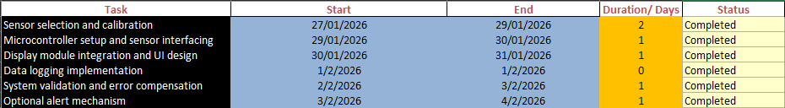
Time Scheduling
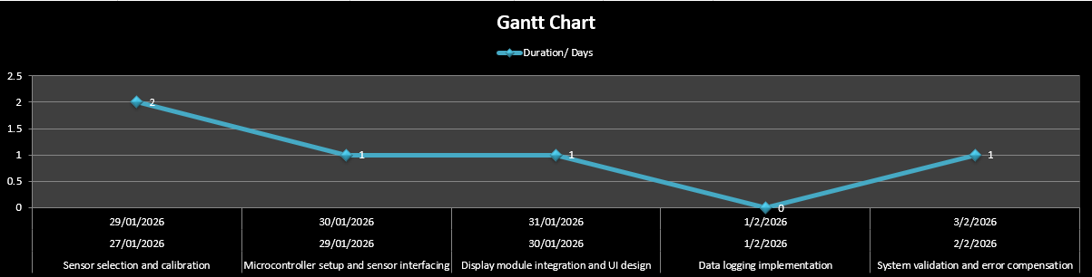
9. Risk Assessment
Risk Assessment
- Sensor Malfunction or Inaccuracy
- Temperature and humidity sensors may give incorrect readings. Mitigation: Calibrate sensors and keep spare units.
- Microcontroller Failure
- ATmega328P may fail due to static or power issues. Mitigation: Use proper precautions and backup microcontroller.
- Communication/Interfacing Errors
- I2C connection between sensor and microcontroller may fail. Mitigation: Follow datasheet, test modules individually, and simulate connections.
- Power Supply Instability
- Unstable voltage can affect system operation. Mitigation: Use regulated supply and filtering capacitors.
- Software Bugs
- Code errors can cause malfunction of data acquisition or display. Mitigation: Test code modules separately and simulate logic before hardware implementation.
10. References
[1] Sensirion AG, SHT20 - Digital Humidity Sensor Datasheet, Datasheet, Rev. A2, 2014. [Online]. Available: https://sensirion.com/media/documents/CCDE1377/635000A2/Sensirion_Datasheet_Humidity_Sensor_SHT20.pdf
[2] Sensirion AG, SHT21 - Digital Humidity Sensor Datasheet, Datasheet, Rev. 94, 2014. [Online]. Available: https://sensirion.com/media/documents/120BBE4C/63500094/Sensirion_Datasheet_Humidity_Sensor_SHT21.pdf
[3] Microchip Technology Inc., ATmega328 - 8-bit AVR Microcontroller Datasheet. [Online]. Available: https://en.wikipedia.org/wiki/ATmega328
[4] M. T. Ansari, Humidity and Temperature Sensor Project Repository, GitHub, 2026. [Online]. Available: https://github.com/Muhammad-Taha-Ansari/Humidity-And-Temperature-Sensor
Submission at the time of Evaluation

Skill(s) to be assessed | Extent of Achievement
 | 50% | 65% | 80% | 100%
Resource identification and allocation | Unable to identify and allocate | Partial identification and allocation | Partial identification or Partial allocation | Complete identification and allocation
Task identification and scheduling | Unable to identify and schedule | Partial identification and poor scheduling | Partial identification or Poor scheduling | Complete identification and proper scheduling
Bill of Materials (BOM) and budgeting | No BOM and budgeting | Incomplete BOM and budgeting | Complete BOM and budgeting with errors | Complete BOM and budgeting with no errors
Risk assessment and management | Unable to identify risks and unable to propose mitigation plan | Identifies risks correctly but unable to propose mitigation plan | Partial risk identification and partial mitigation plan proposed | Comprehensive risk assessment and mitigation plan presented

Skill(s) to be assessed | Extent of Achievement
 | 50% | 65% | 80% | 100%
Resource identification and allocation | Unable to identify and allocate | Partial identification and allocation | Partial identification or Partial allocation | Complete identification and allocation
Task identification and scheduling | Unable to identify and schedule | Partial identification and poor scheduling | Partial identification or Poor scheduling | Complete identification and proper scheduling
Bill of Materials (BOM) and budgeting | No BOM and budgeting | Incomplete BOM and budgeting | Complete BOM and budgeting with errors | Complete BOM and budgeting with no errors
Risk assessment and management | Unable to identify risks and unable to propose mitigation plan | Identifies risks correctly but unable to propose mitigation plan | Partial risk identification and partial mitigation plan proposed | Comprehensive risk assessment and mitigation plan presented

Skill(s) to be assessed | Extent of Achievement
 | 50% | 65% | 80% | 100%
Resource identification and allocation | Unable to identify and allocate | Partial identification and allocation | Partial identification or Partial allocation | Complete identification and allocation
Task identification and scheduling | Unable to identify and schedule | Partial identification and poor scheduling | Partial identification or Poor scheduling | Complete identification and proper scheduling
Bill of Materials (BOM) and budgeting | No BOM and budgeting | Incomplete BOM and budgeting | Complete BOM and budgeting with errors | Complete BOM and budgeting with no errors
Risk assessment and management | Unable to identify risks and unable to propose mitigation plan | Identifies risks correctly but unable to propose mitigation plan | Partial risk identification and partial mitigation plan proposed | Comprehensive risk assessment and mitigation plan presented

Skill(s) to be assessed | Extent of Achievement
 | 50% | 65% | 80% | 100%
Resource identification and allocation | Unable to identify and allocate | Partial identification and allocation | Partial identification or Partial allocation | Complete identification and allocation
Task identification and scheduling | Unable to identify and schedule | Partial identification and poor scheduling | Partial identification or Poor scheduling | Complete identification and proper scheduling
Bill of Materials (BOM) and budgeting | No BOM and budgeting | Incomplete BOM and budgeting | Complete BOM and budgeting with errors | Complete BOM and budgeting with no errors
Risk assessment and management | Unable to identify risks and unable to propose mitigation plan | Identifies risks correctly but unable to propose mitigation plan | Partial risk identification and partial mitigation plan proposed | Comprehensive risk assessment and mitigation plan presented

