Cloud Computing
Project 3
Automated Multi-Tier Application Deployment

Section: B

Team Members
Muhammad Taha 22i-0870
Arshaq Kirmani 22i-0834

1.
Containerization (Docker)

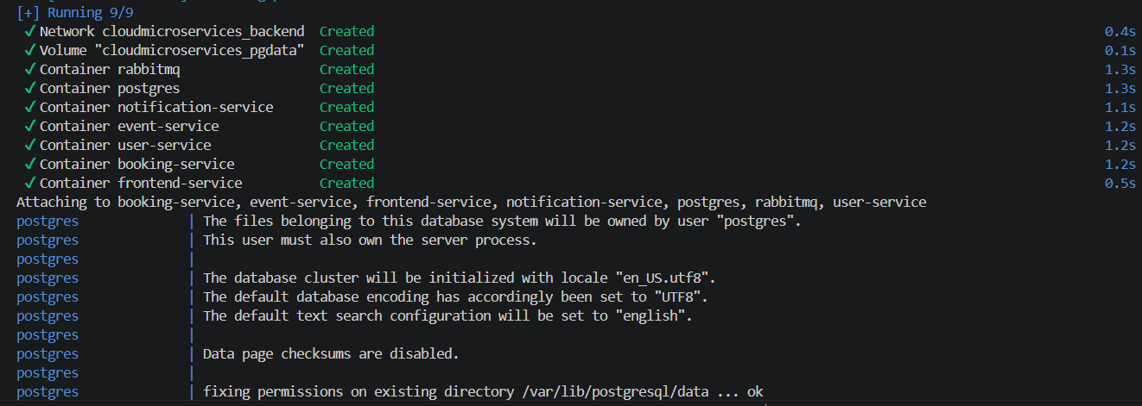

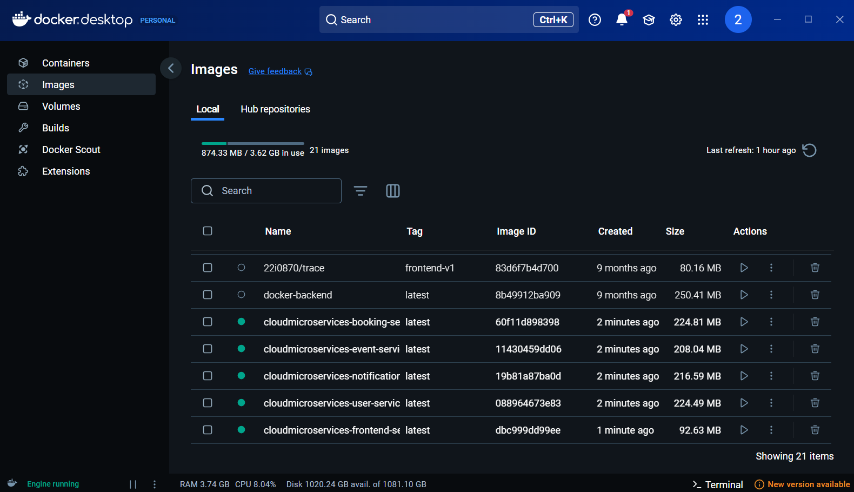
2.
Infrastructure as Code (Terraform)

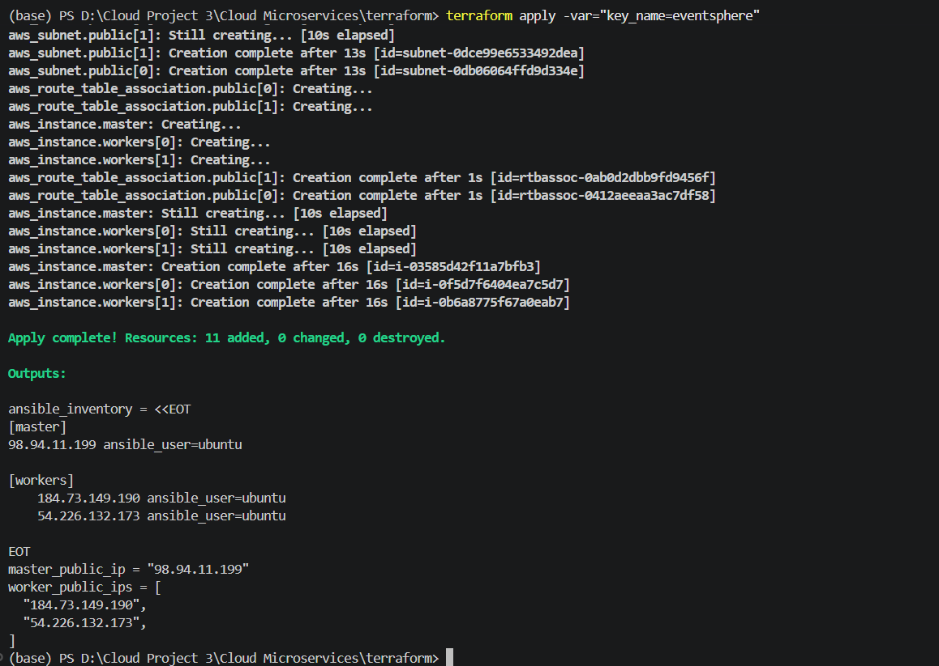
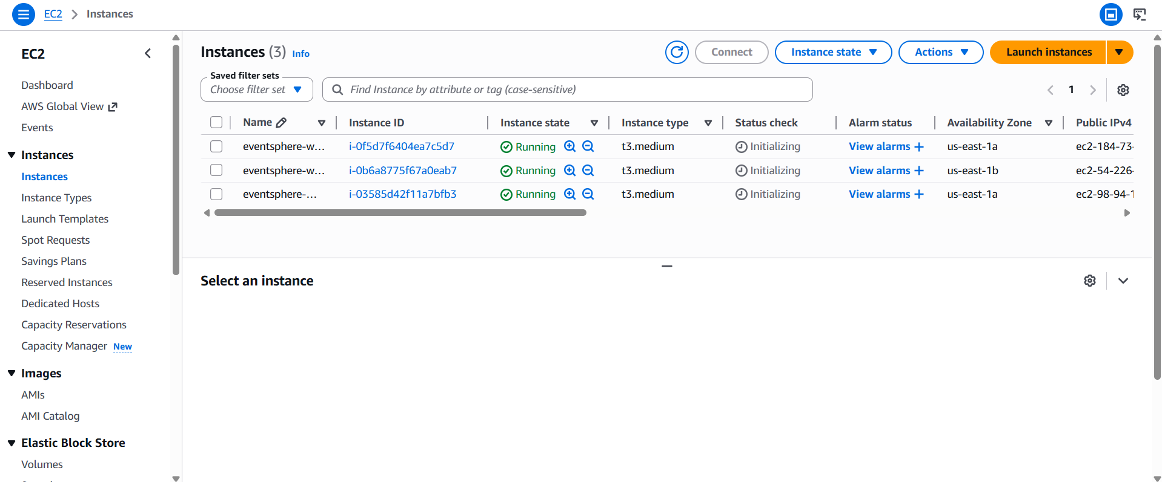
3.
Configuration as Code (Ansible)

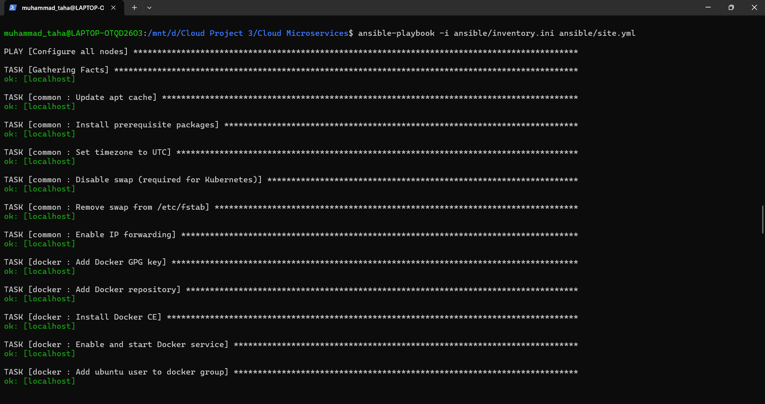
4.
Cluster (Kubernetes Manifests)

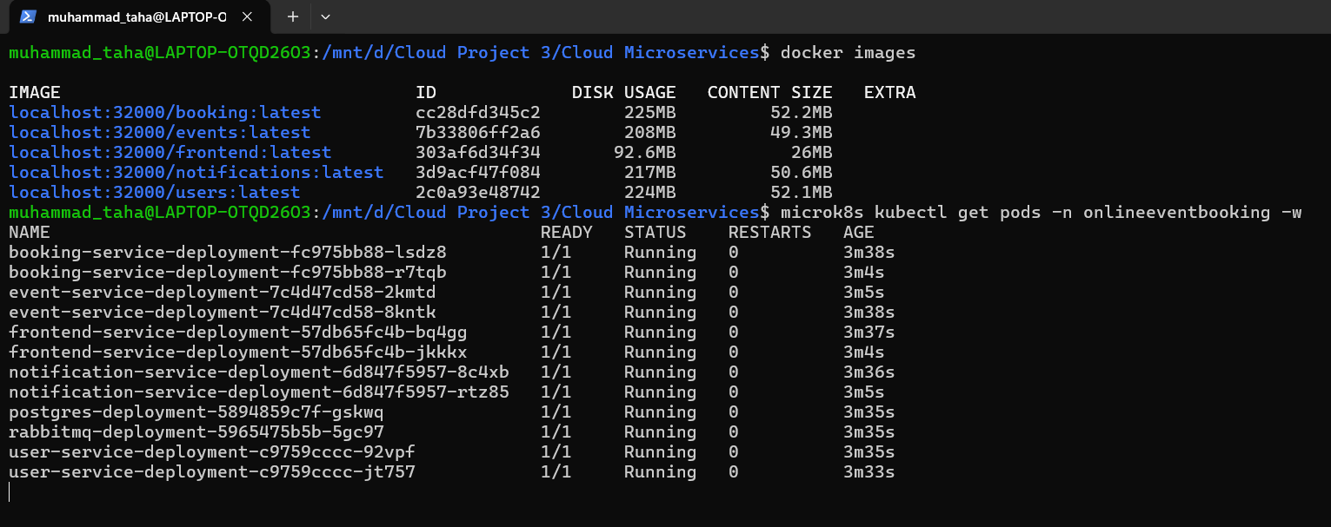
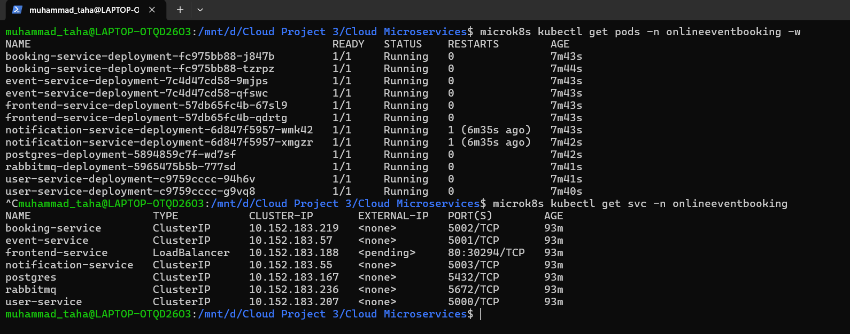
5.
CI/CD Pipeline (GitHub Actions & ArgoCD)

