**Project**

**CS435 Parallel and Distributed Processing**

**Muhammad Talha**

**BEE-13-C**

**Part - 1**

**All nodes in the HPC cluster:**

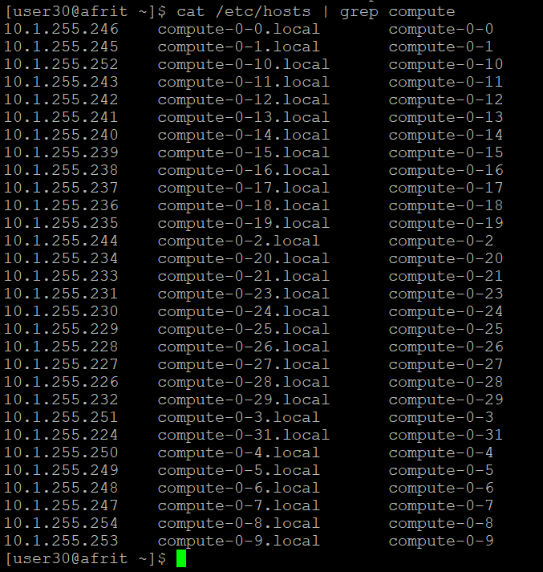

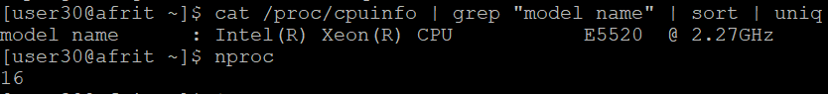

**Busy nodes(Users):**

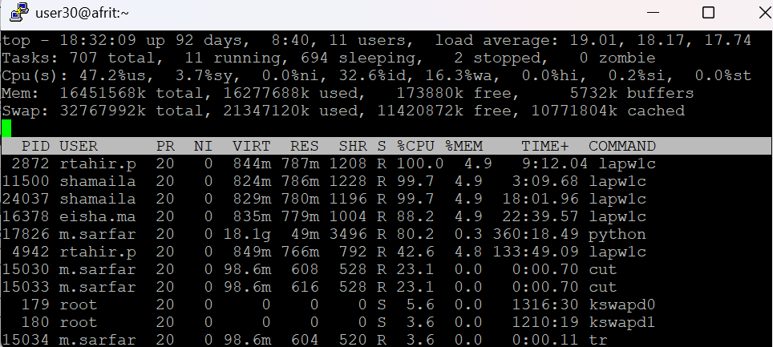

**CPU Specs of compute nodes:**

**Compute-0-10:**

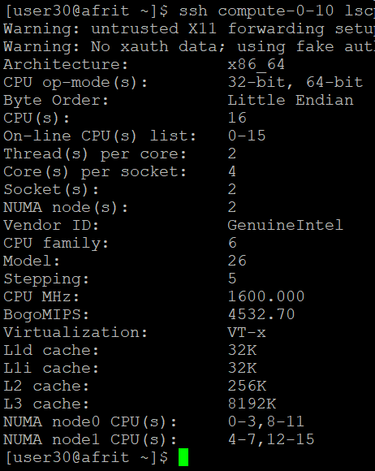

**Compute-0-0:**

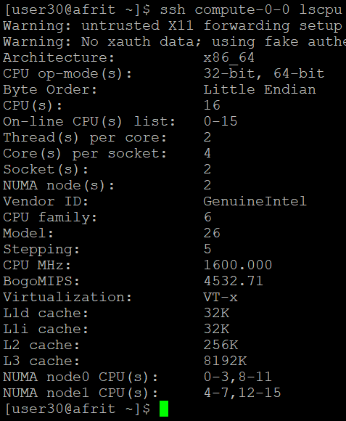

**Compute-0-23:**

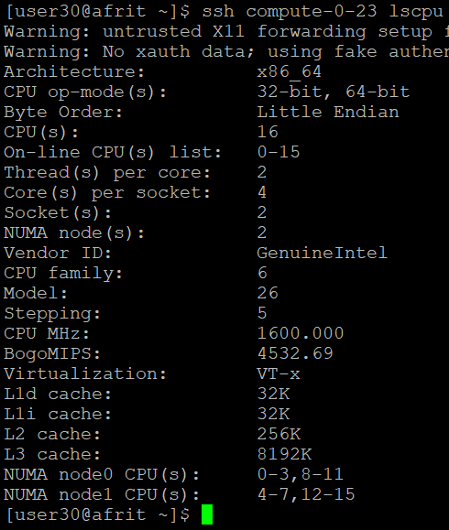

**Other compute nodes also have the same specs:**

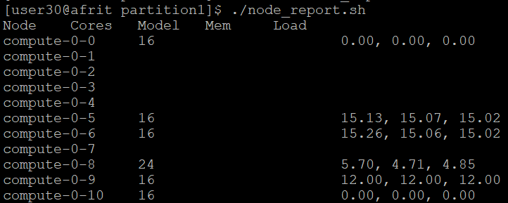

**Part 2:**

**Using MPI:**

**Using OpenMP:**

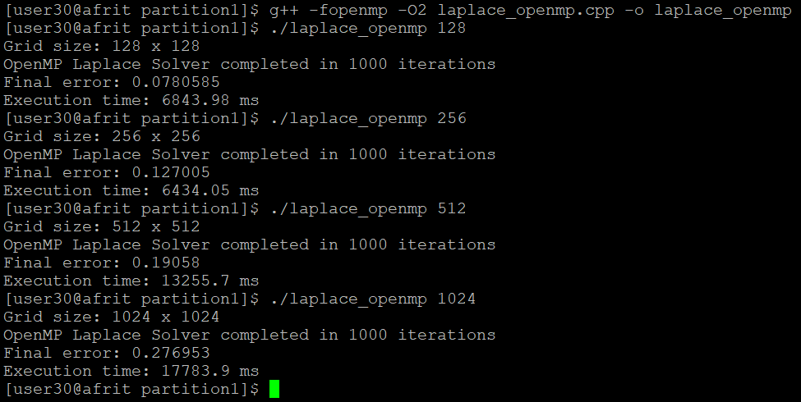

**Performance comparison Graph:**

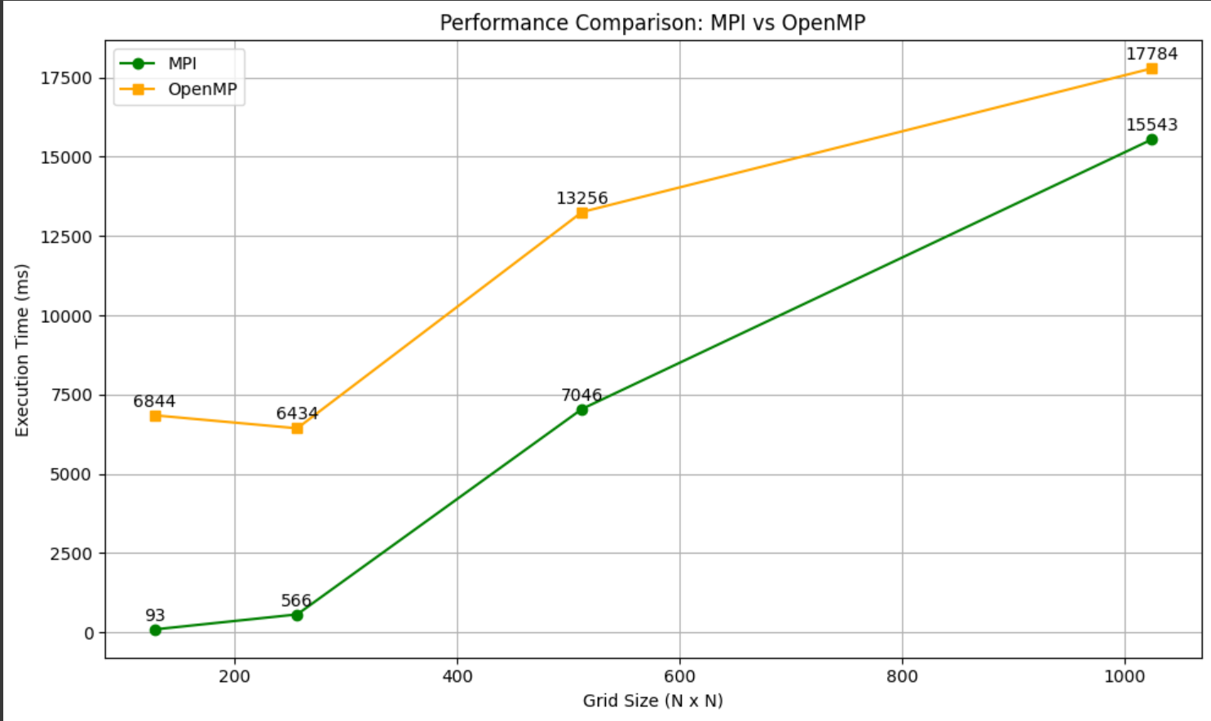

**Performance Bottlenecks Encountered:**

1. **Communication Overhead in MPI**
   * In the MPI implementation, each process needs to exchange boundary (ghost) rows with its neighbors at every iteration.
   * This interprocess communication using MPI_Sendrecv introduces latency, especially when the number of processes or the grid size increases.
   * For smaller domains (like 128×128), MPI performs extremely well, but for larger domains, the communication overhead increases non-linearly.
2. **Load Imbalance & Domain Partitioning**
   * The grid was split equally across processes (N % P == 0), but if N isn't divisible by the number of processes, the program had to exit.
   * This constraint limits scalability or flexibility unless load balancing or dynamic partitioning is introduced.
3. **OpenMP Cache Pressure and Memory Bandwidth**
   * For OpenMP, the bottleneck was memory access patterns. Threads updating large shared 2D arrays caused cache thrashing and memory bandwidth saturation.
   * Performance plateaued and even degraded at larger grid sizes (e.g., 128 vs 256 had almost no difference).

**Problems faced and resolved:**

| **Problem** | **Description** | **Status** | **Fix** |
| --- | --- | --- | --- |
| >> template error | Compiler couldn't parse vector<vector<T>> | Resolved | Changed to vector<vector<T> > |
| -02 not recognized | Typo: used -0 instead of -O | Resolved | Corrected to -O2 |
| MPI not scaling | Code didn't handle N % P != 0 | Resolved (basic) | Added input check with error |
| PBS tools missing | Couldn't use pbsnodes, qstat, qhost | Unresolved | used fallback SSH-based analysis |
| can't resolve group | Group resolution error in PBS/Grid Engine | Unresolved | Workaround: collected node info via SSH, uptime, lscpu |
| Node access restrictions | Ran into problems with running tools on compute nodes | Resolved | Returned to login node for control commands |
| OpenMP slower at small sizes | No real benefit at 128x128 grid | Expected | Noted as architectural overhead, used MPI for small grids |