**Flowchart:**

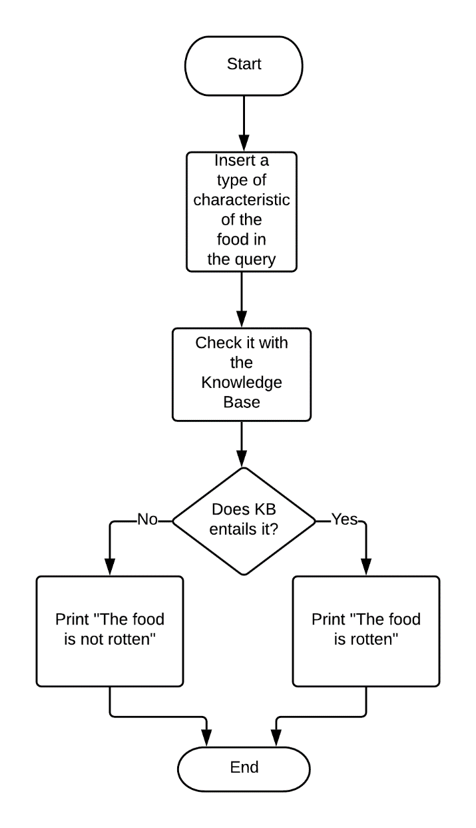

**Explanation:**

**Goal:**

Having spoiled food can lead to serious food poisoning. The goal of this project is to preventing people from having spoiled food unknowingly by detecting whether the food is having rotten or not using AI.

**Working procedure:**

The program takes a character of a food and checks whether the knowledge base entails the feature. If the knowledge base of the program entails the feature then it prints the food is rotten. Otherwise it shows the food is not rotten. That’s how a person know his or her food is safe to eat.

**Things can be done in future:**

In this current stage, only the program has been created. In the future smell sensor, mold test kit and texture analyzer can be used with the for implementing it in real-life and achieve the ability to detect rotten food with 100% accuracy.

**Source code:**

# Rotten food detector  
  
from logic import *  
rotten = Symbol("The food is rotten")  
fresh = Symbol("The food is fresh")  
mold = Symbol("There is visible mold on the food")  
stink = Symbol("The food has bad smell")   
discoloration = Symbol("The color of the food has changed")  
changed_texture = Symbol("The texture of food has changed ")   
  
knowldege = And(  
 Implication(Not(And(And(mold, stink), And(discoloration, changed_texture))), fresh),  
  
 Or(rotten, fresh),  
 Not(And(rotten, fresh)),  
 rotten  
)  
  
if model_check(knowldege, Not(discoloration)) == True:  
 print("The food is rotten")  
  
else:  
 print("The food is not rotten")

Hello! I am Rownok Zahan Rupa. Currently, I am studying computer science and engineering at City University.