Question 1:
Server Configuration (DHCP Setup):
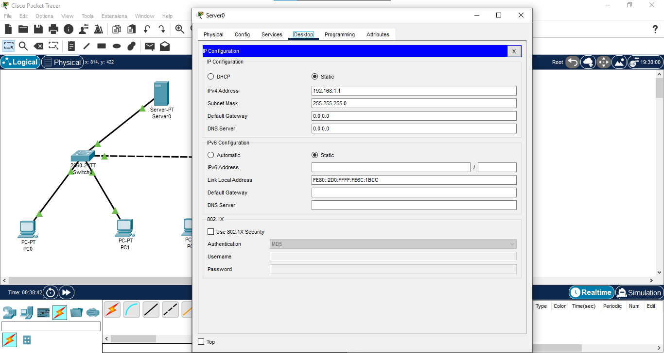
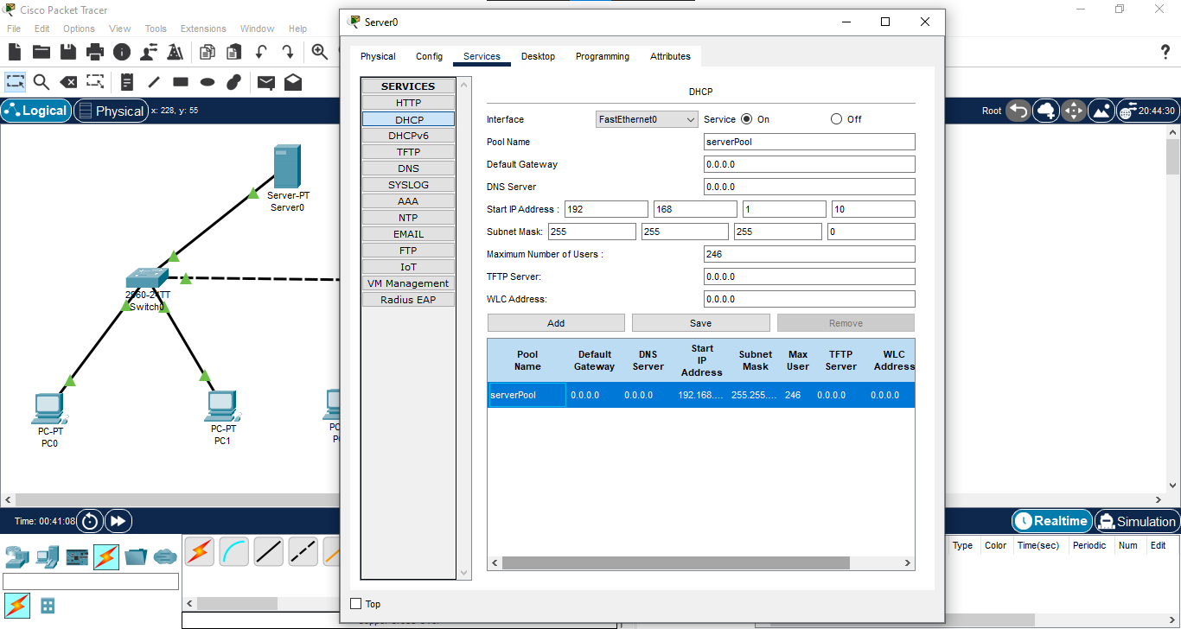

PCs Configuration:
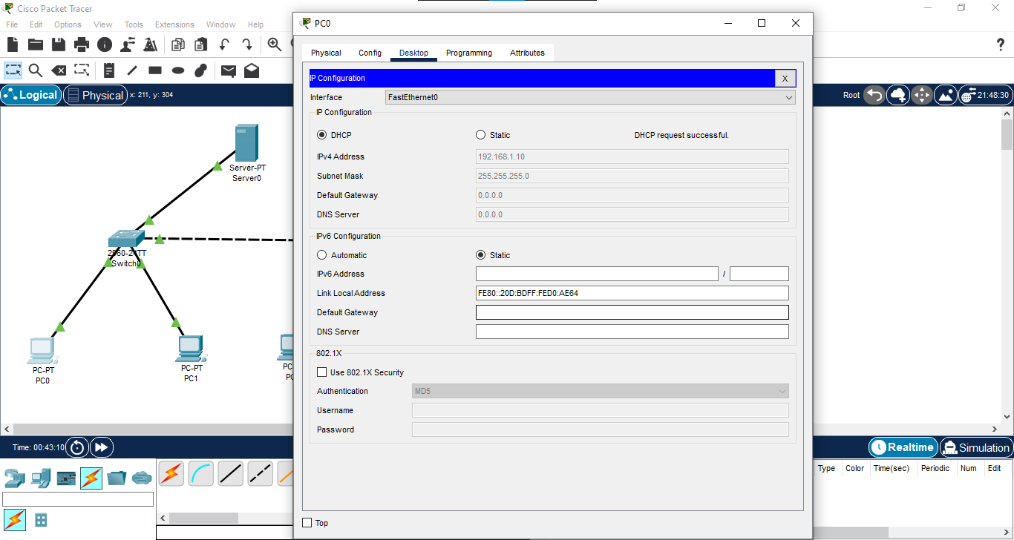
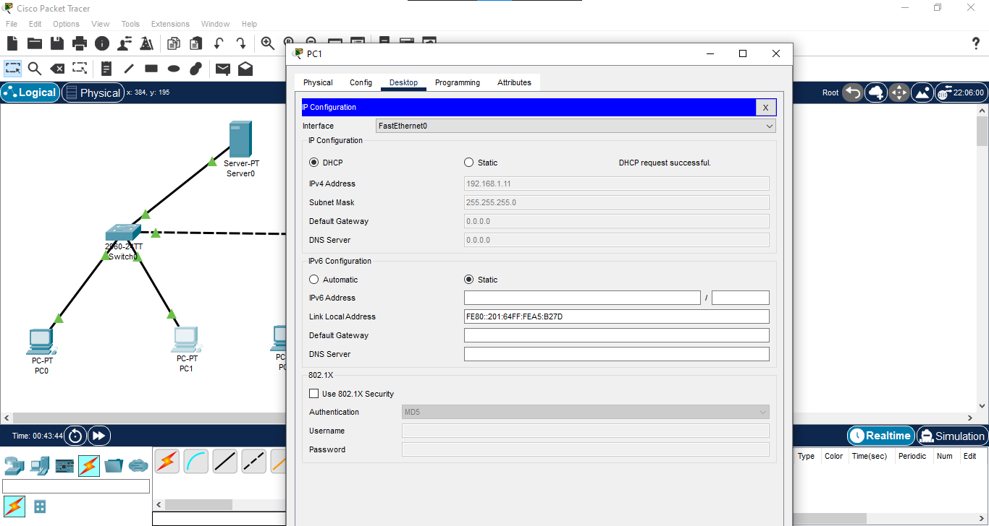
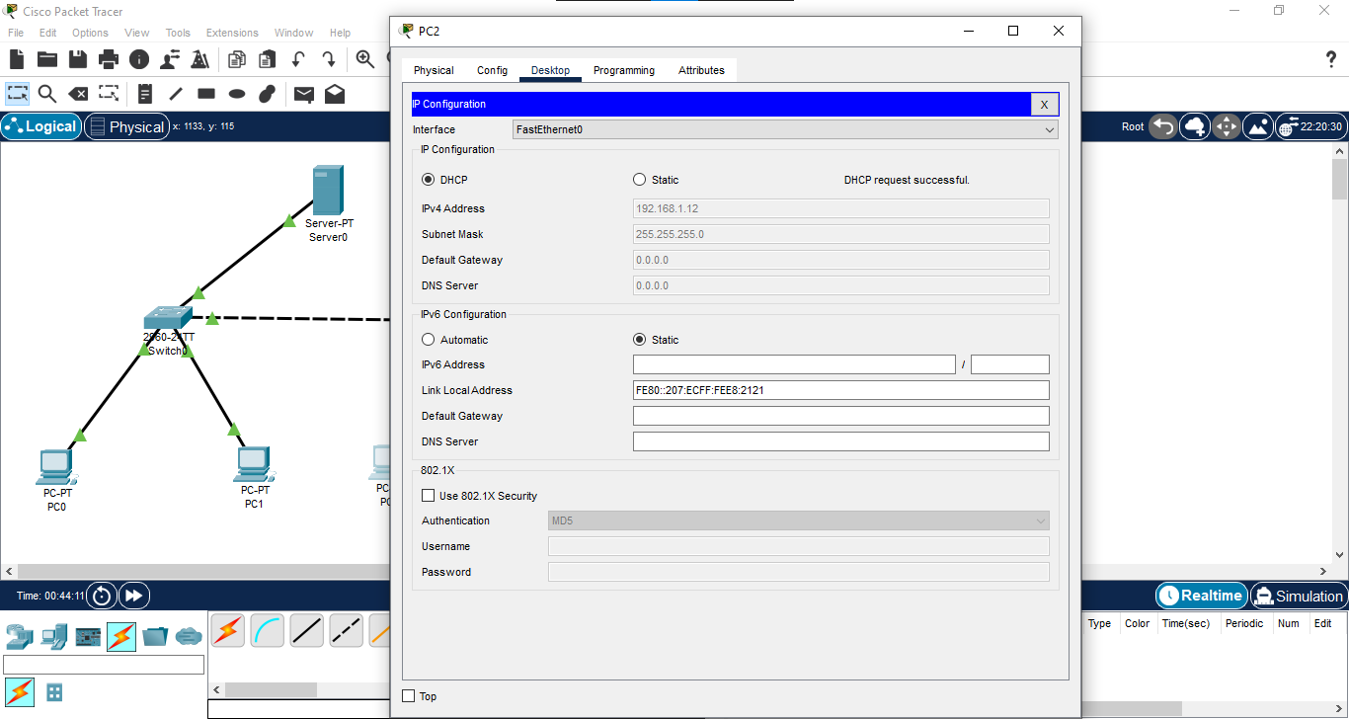
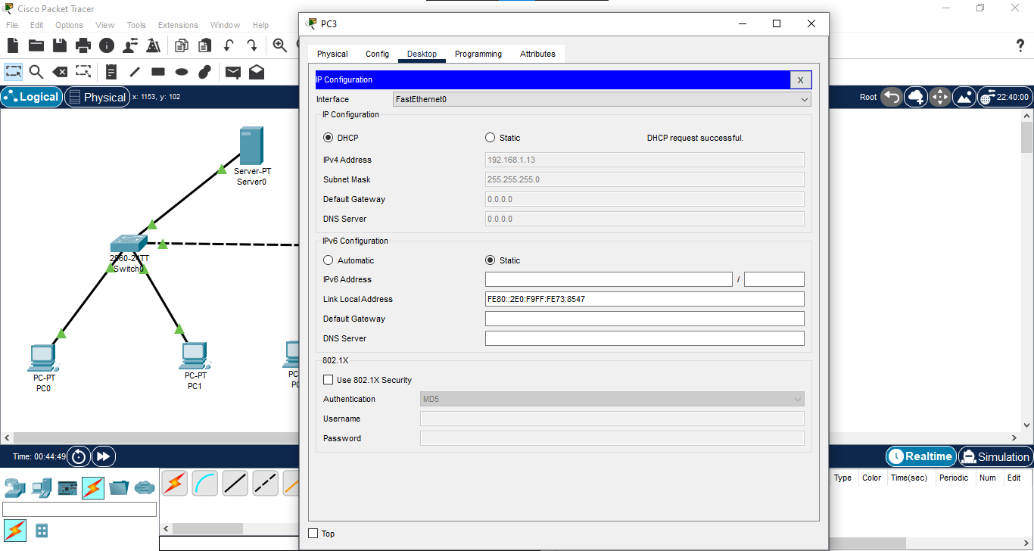

Checking Connectivity:
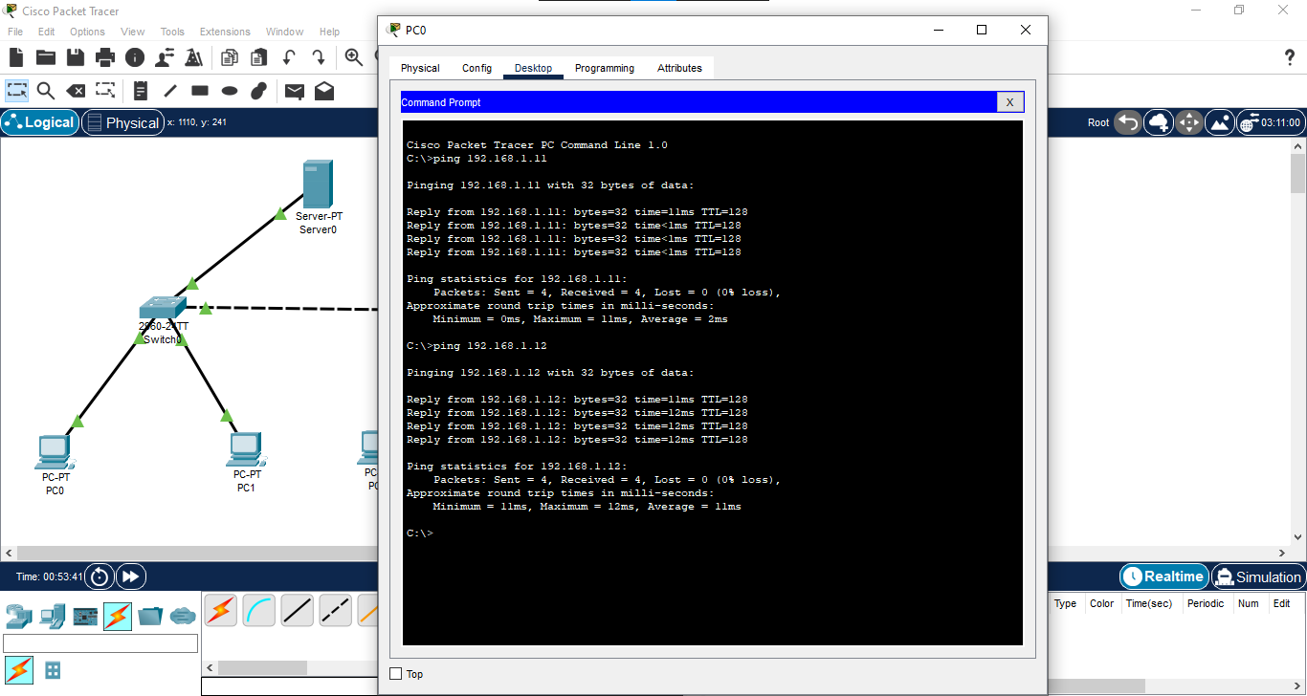

Packet Header Format of ARP:
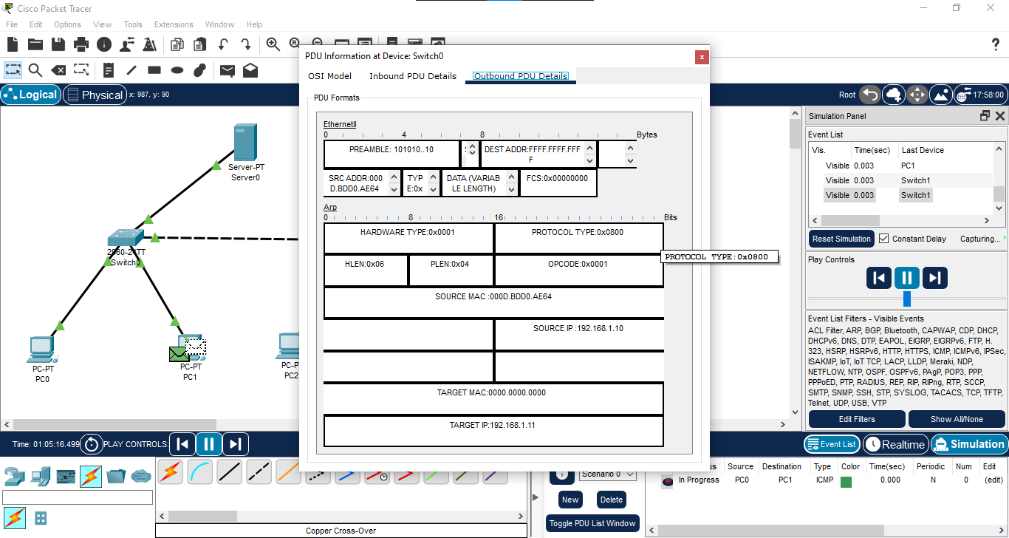

Device Functionalities:
1. PC: It is used to send or receive data and uses IP/MAC addresses.
2. Switch: It connects devices in a LAN and forwards data based on MAC addresses.
3. Server: It Provides services (like DHCP, Web, File) to the network.

Question 2:
A Hub broadcasts messages to all connected devices while a Switch is intelligent and forwards messages only to the specific device matching the destination MAC address.

Question 3:
- Straight-through cable
- Straight-through cable
- Cross-over cable

Question 4:
Constructing Network:
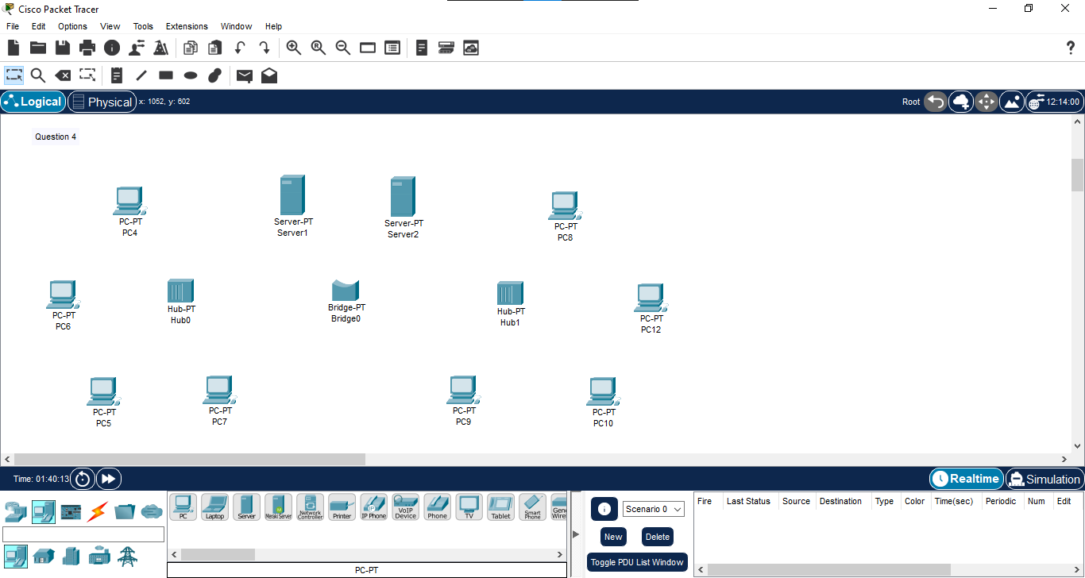
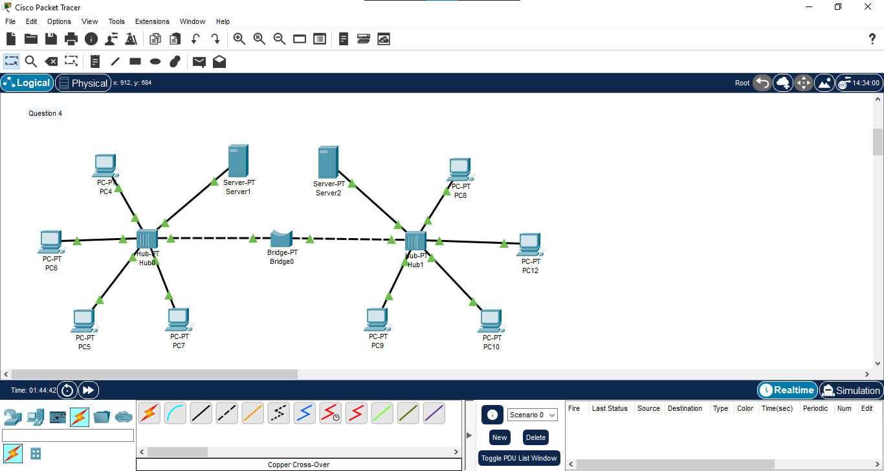

PCs Configuration:
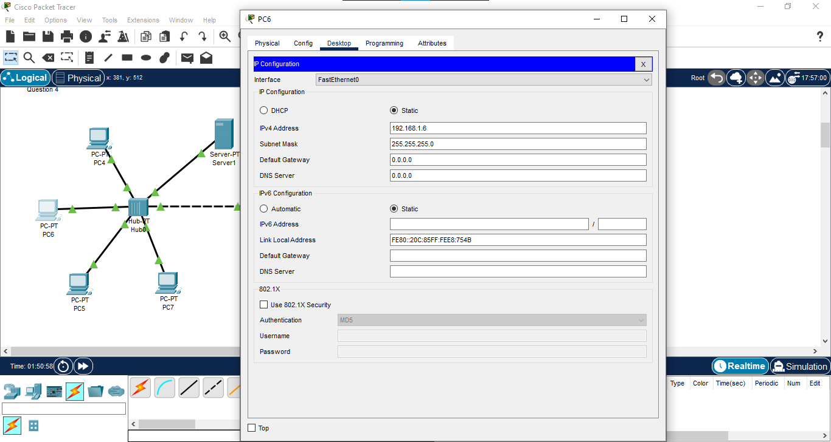

Sever Configuration:
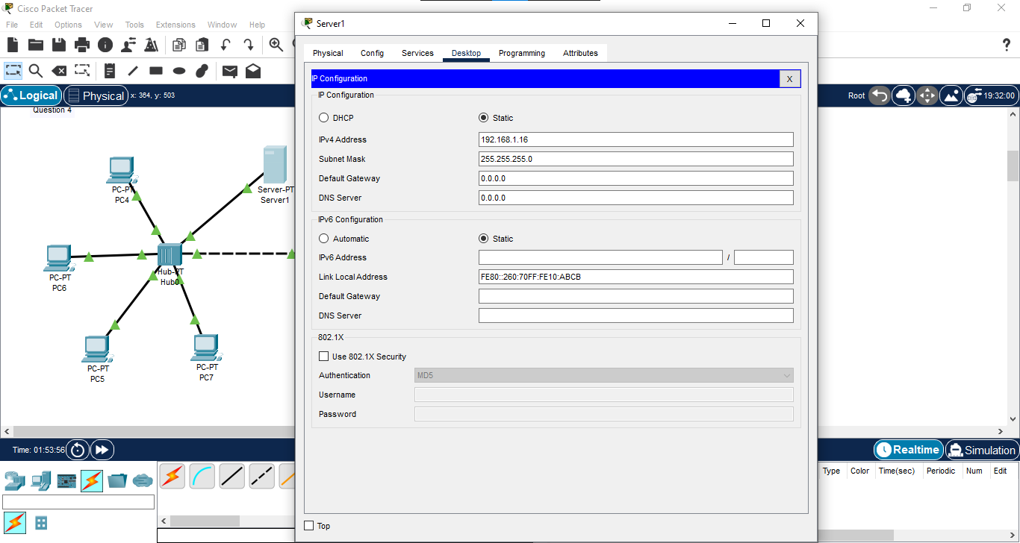

Testing Ping:
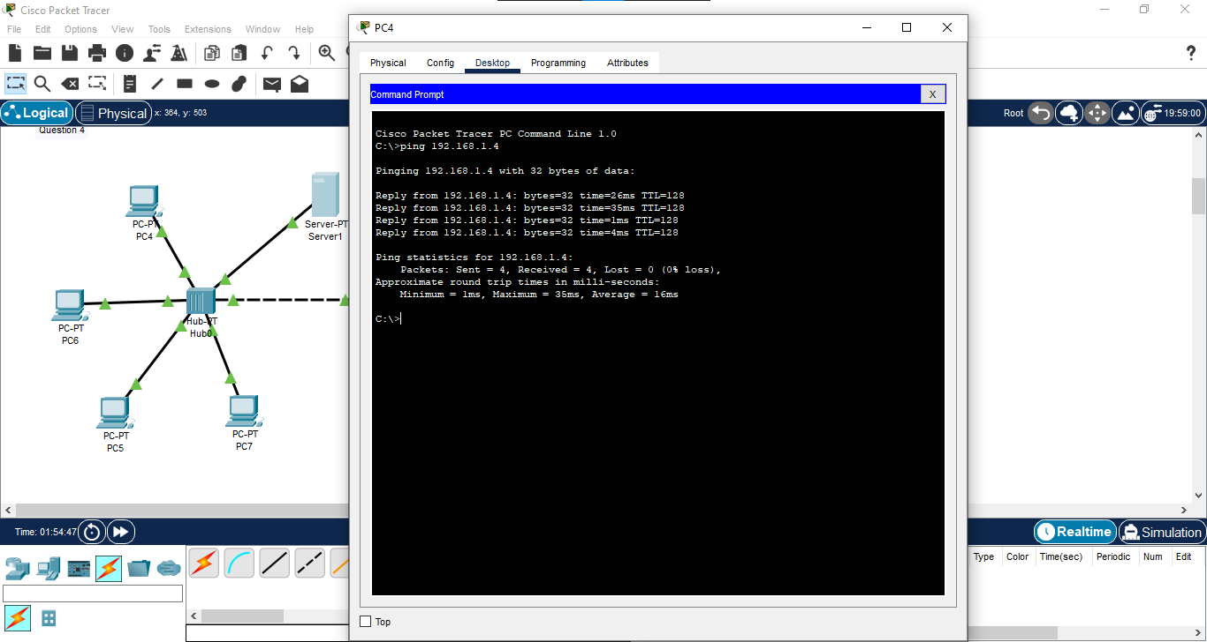

Bridge Working:
A bridge connects two network segments at the Data Link Layer (Layer 2). It uses MAC addresses to filter traffic, effectively splitting the network into separate collision domains. This helps reduce traffic congestion and improves performance.

