Exercise 1:
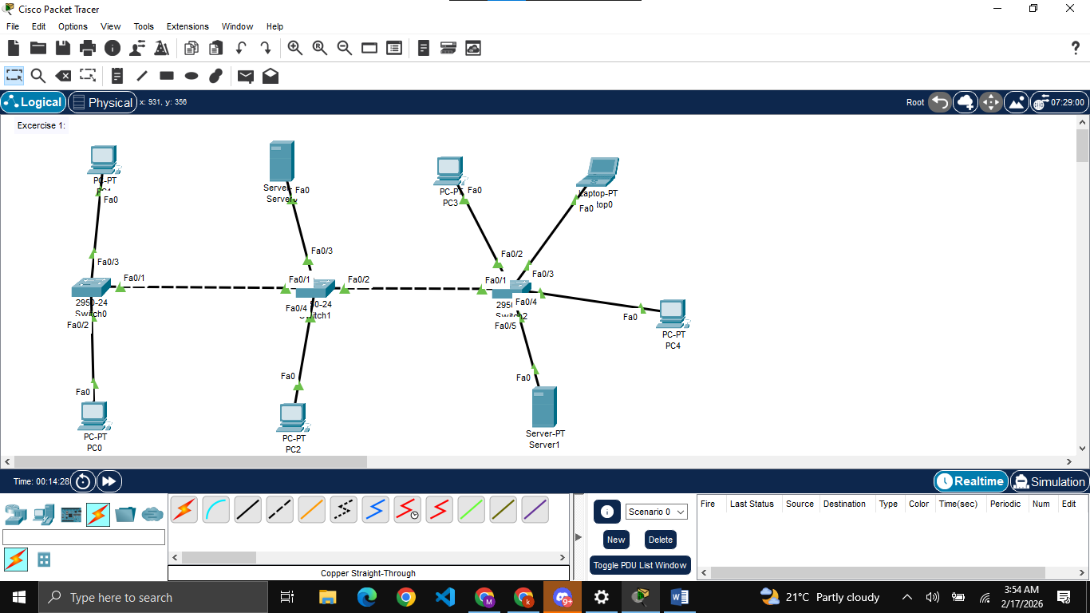
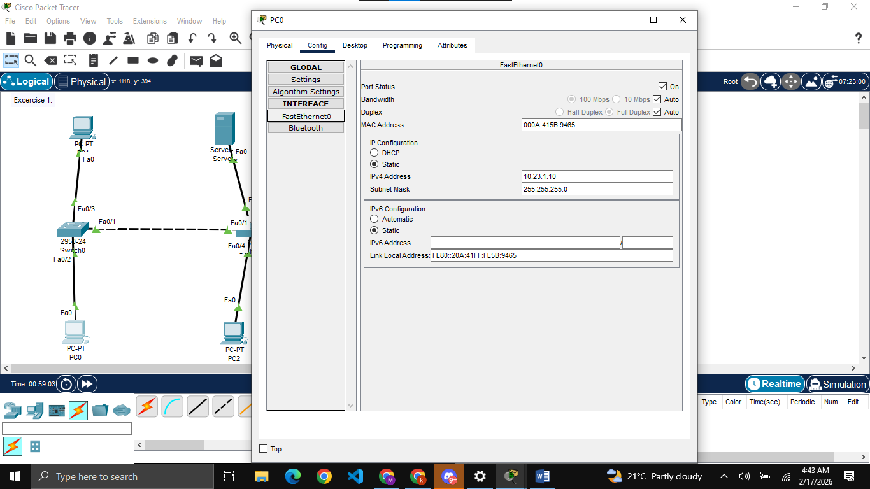
This is how I am assigning IPs to all the devices. The reason of using the IP “10.23.1.10” is because my roll number is “0023” but when I am trying to use IP “00.23.1.10”, it was giving me error, so I have decided to use “10.23.1.10” and so on for other devices.
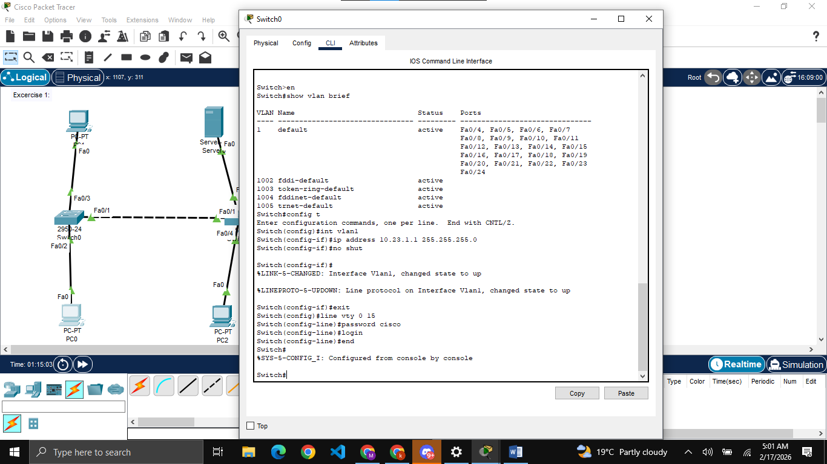
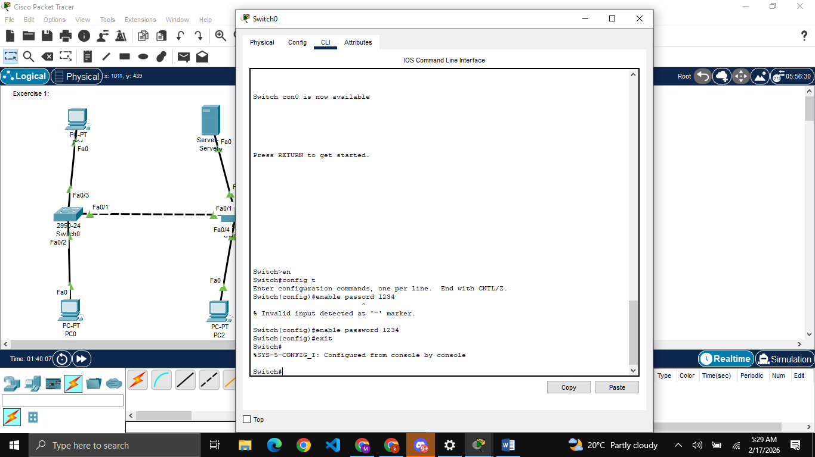
Same for other 2 switches with only difference in IPs.

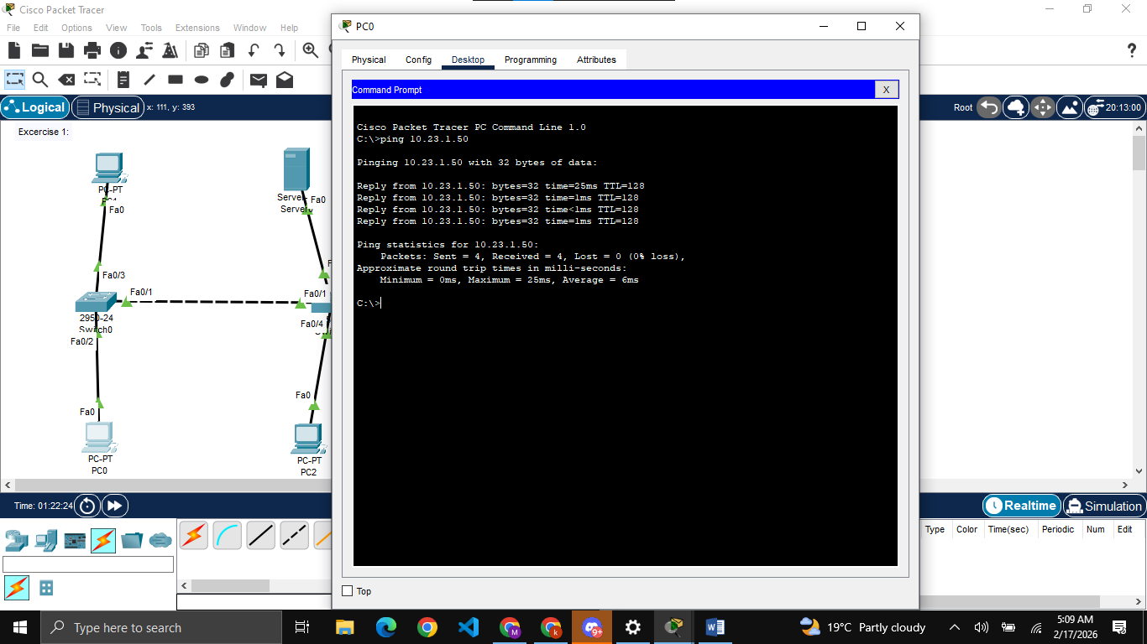
Ping the server from PC0

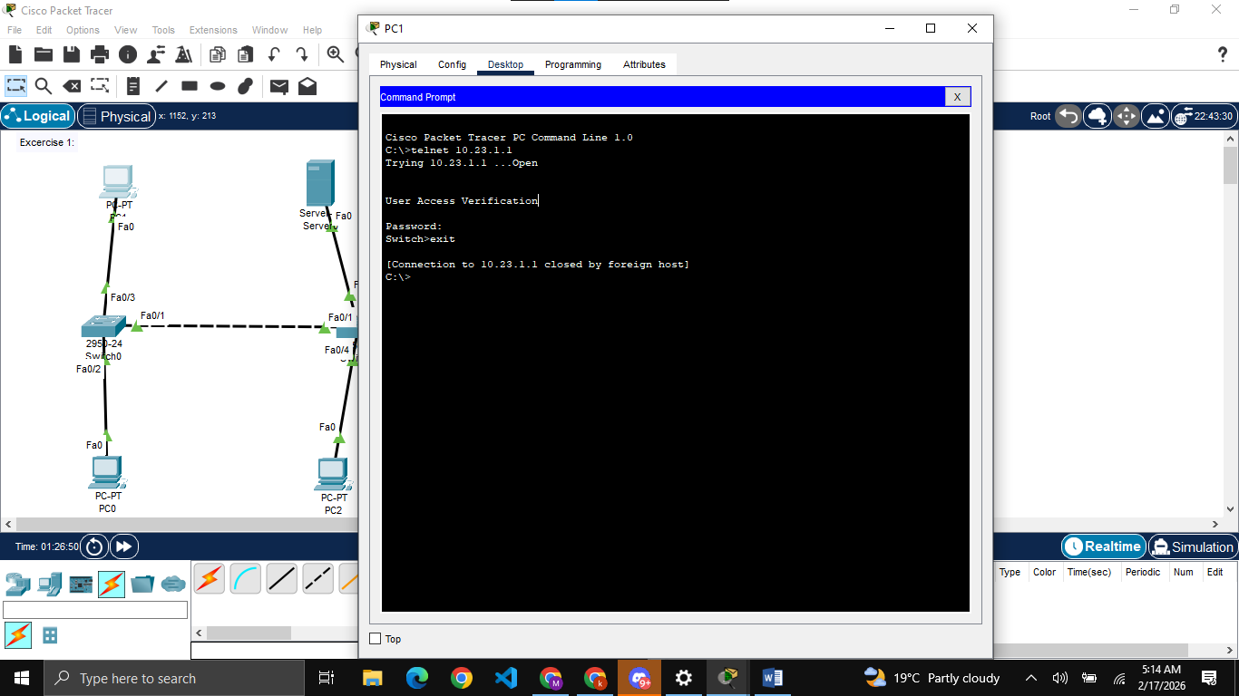
Verifying the telnet connection, doing same for switch 1 and switch 2, for switch 1 using PC2 and for switch3 using PC3
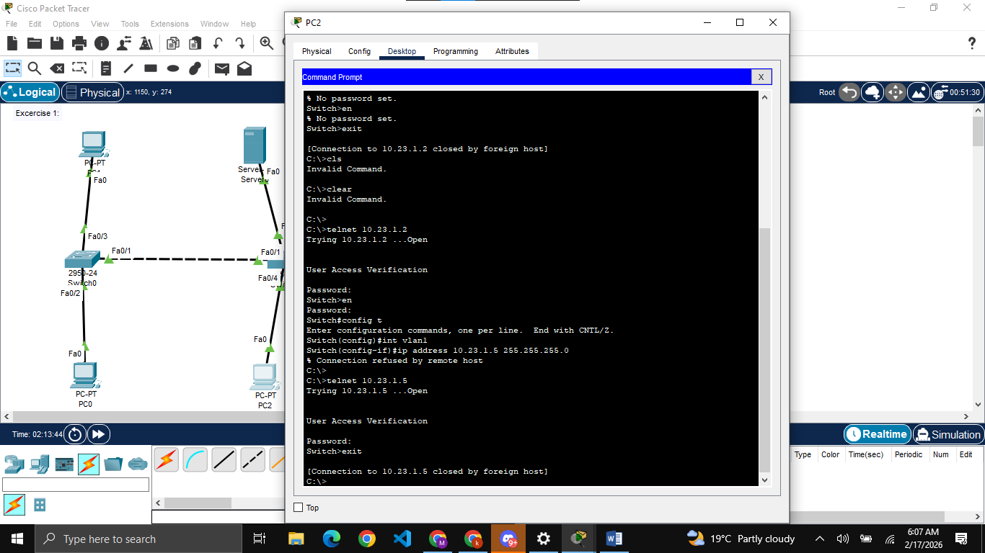
Changing the IP of switch 2 using PC 2.

Exercise 2:
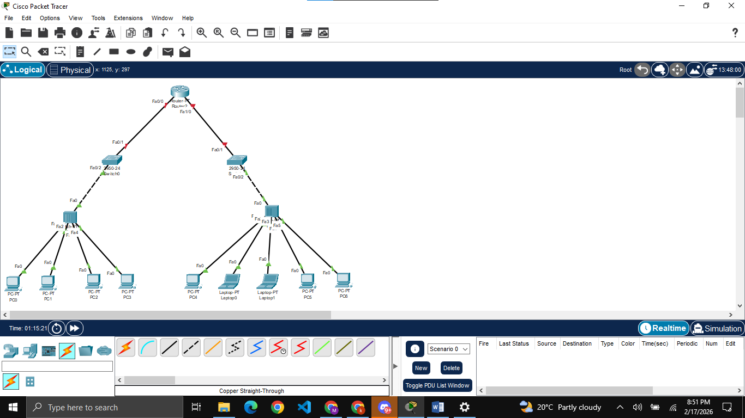

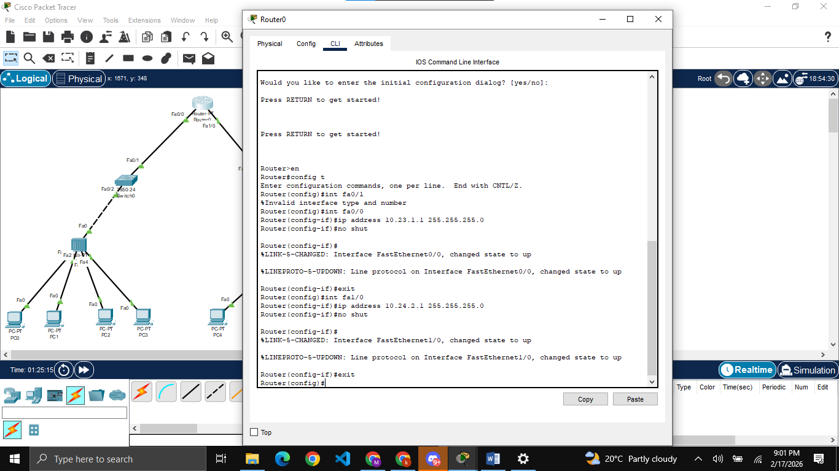
Assigning IPs to router for both networks.

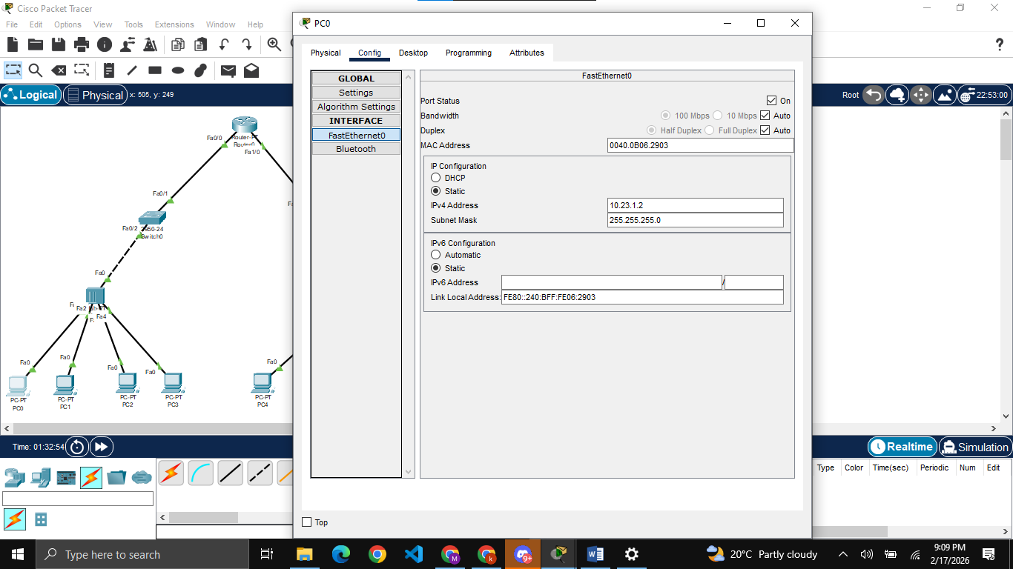
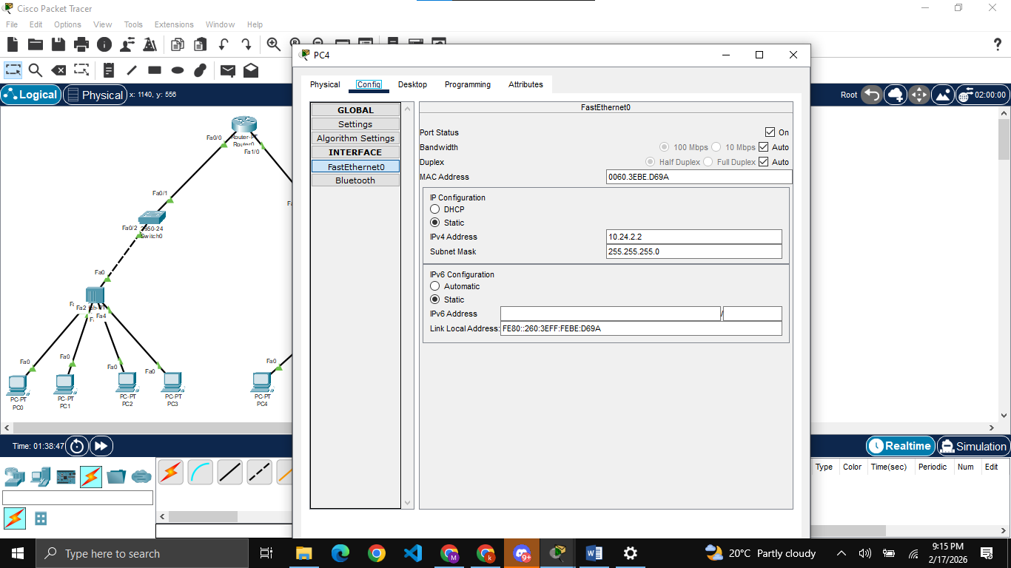
Assigning IPs to PCS and Laptops (similarly for all PCS and laptops).

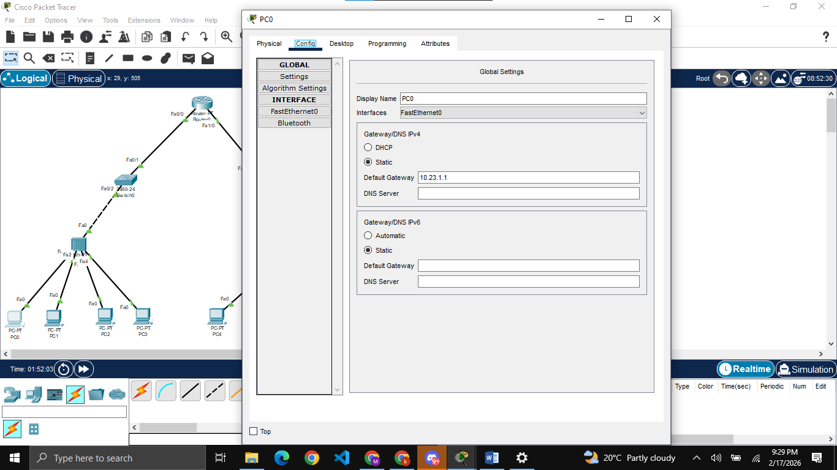
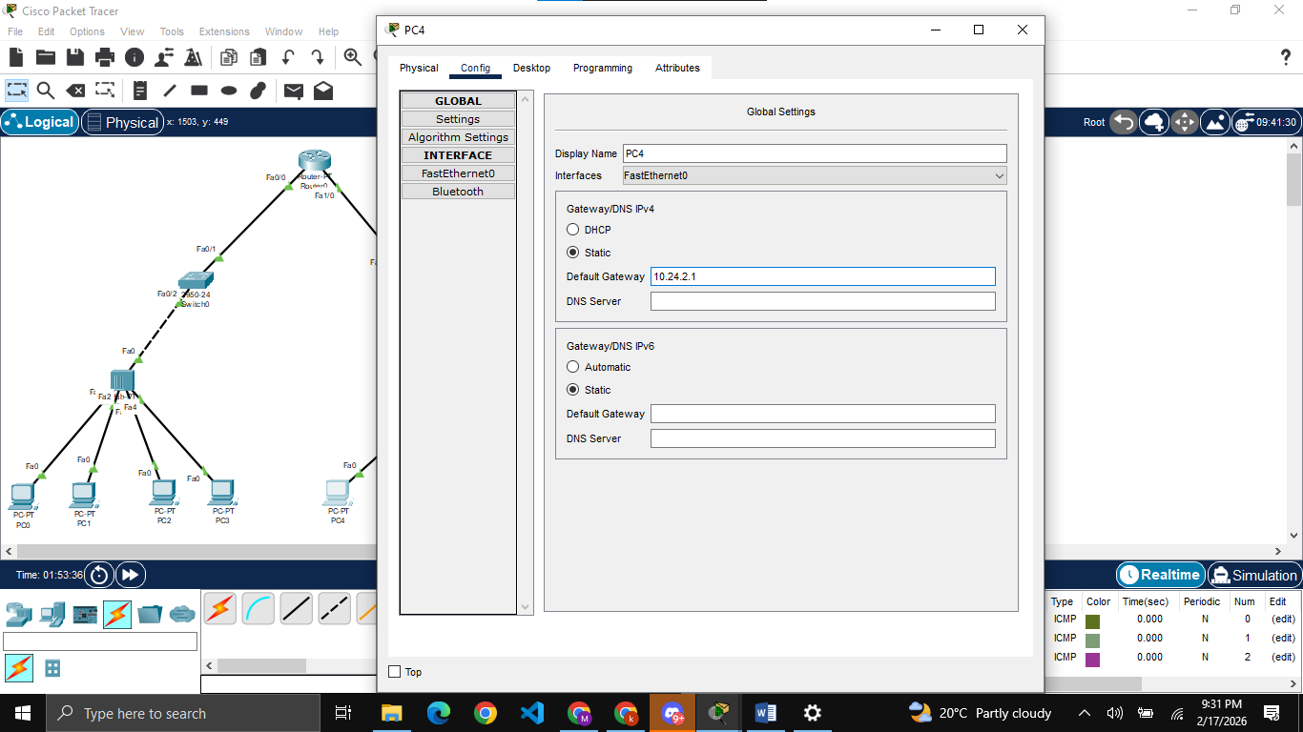
Assigning gateway to all PCS and laptops.

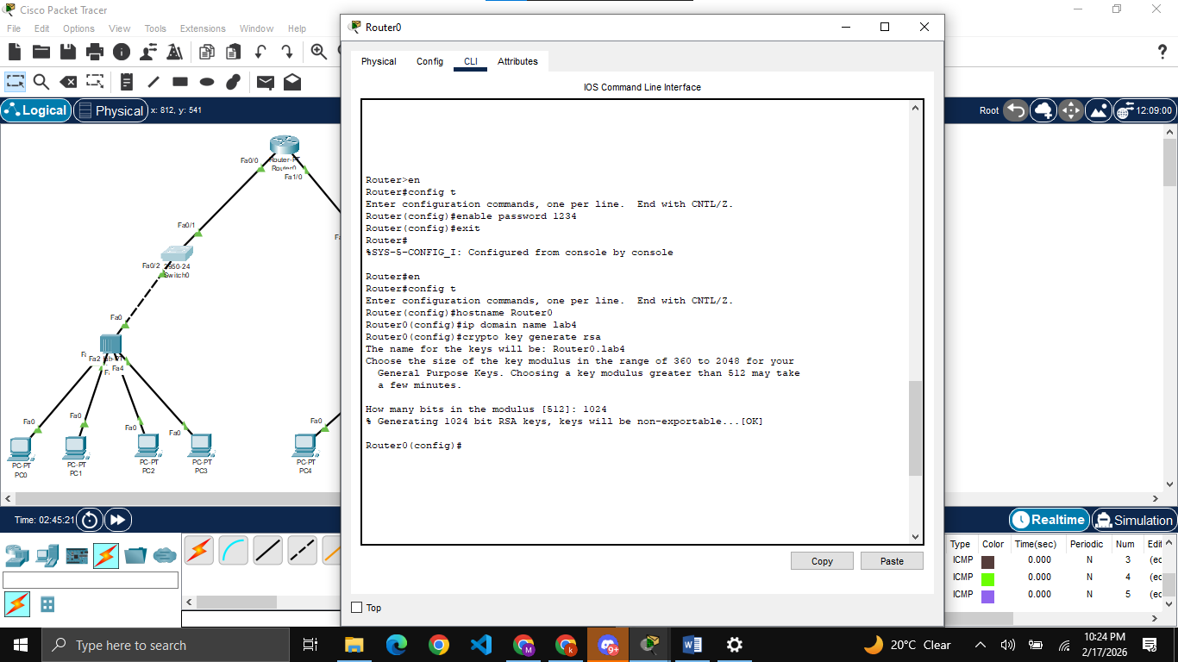
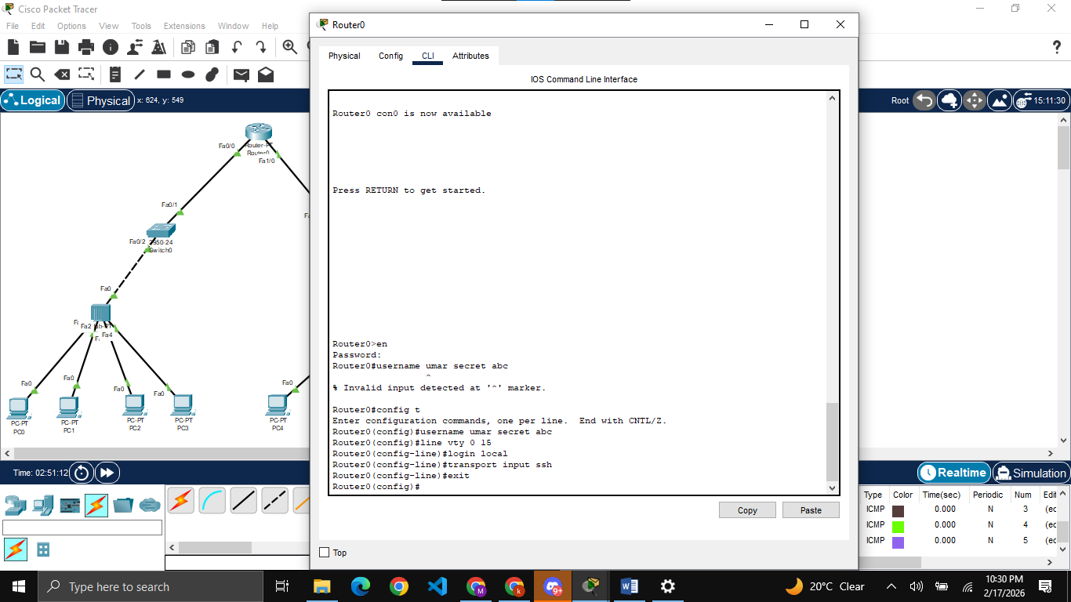
Setting host name and domain

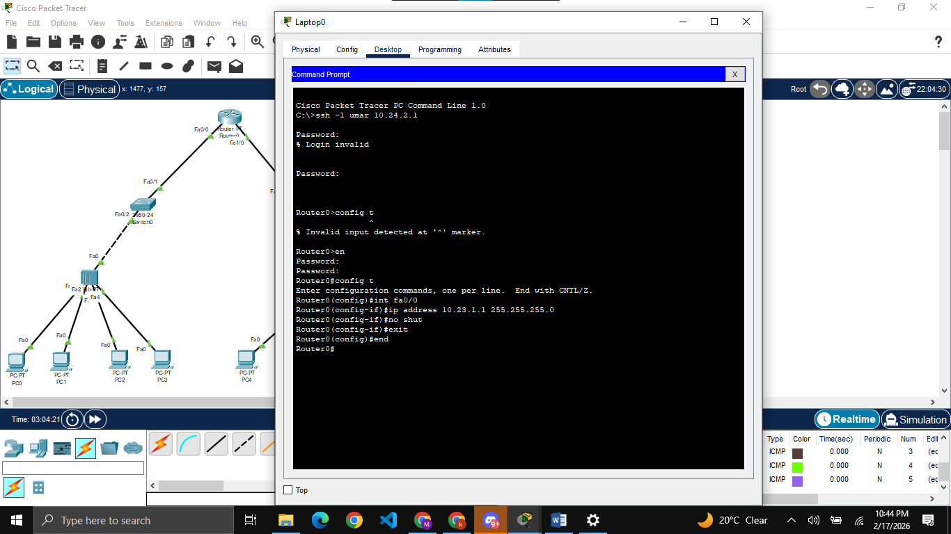
Assigning IP to other interface using Laptop 0.

