Question 1:
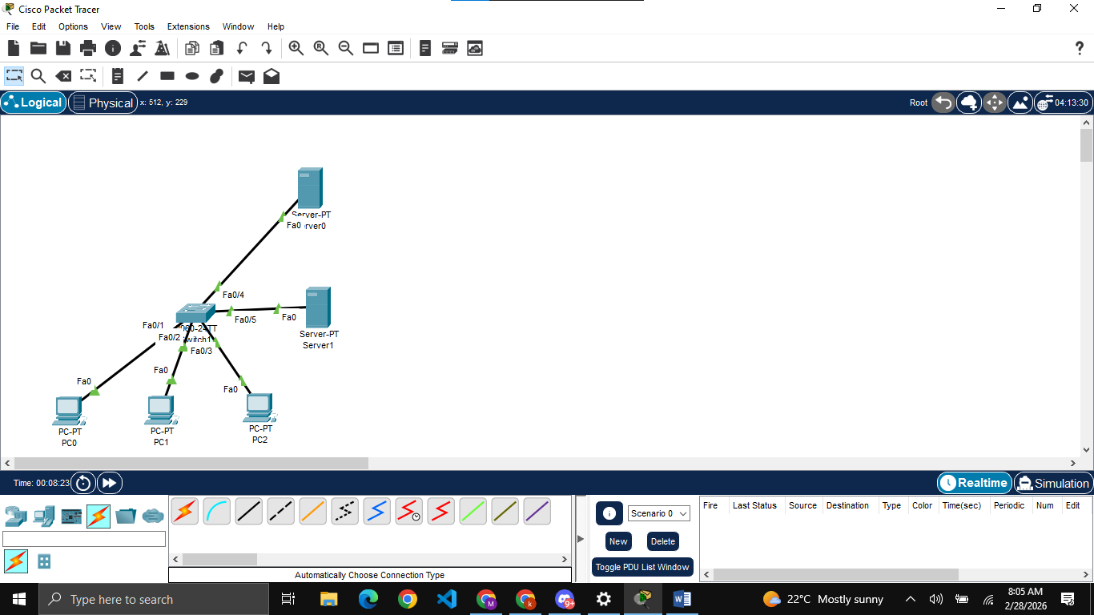
Building initial topology

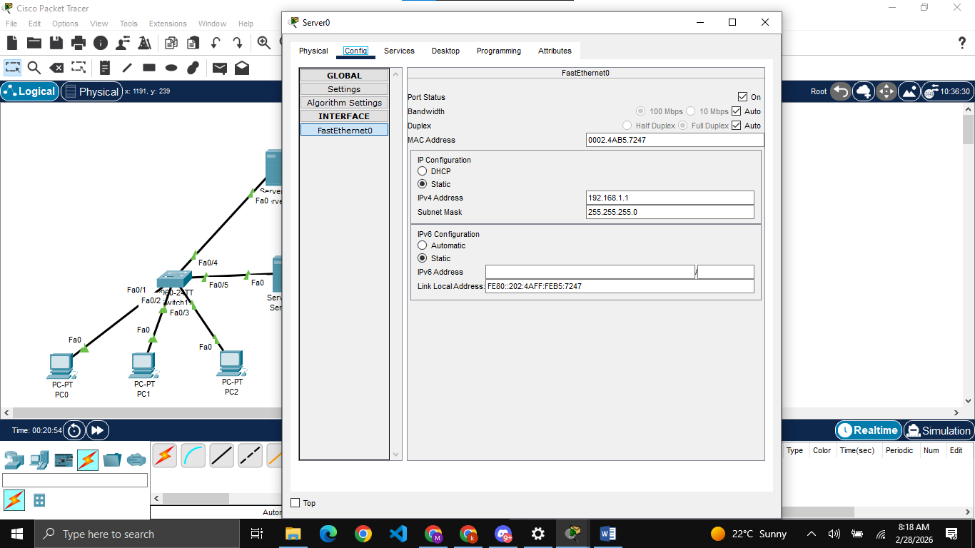
Assigning IP to both servers. Here server 0 will work as DHCP server and server 1 will work as DNS server
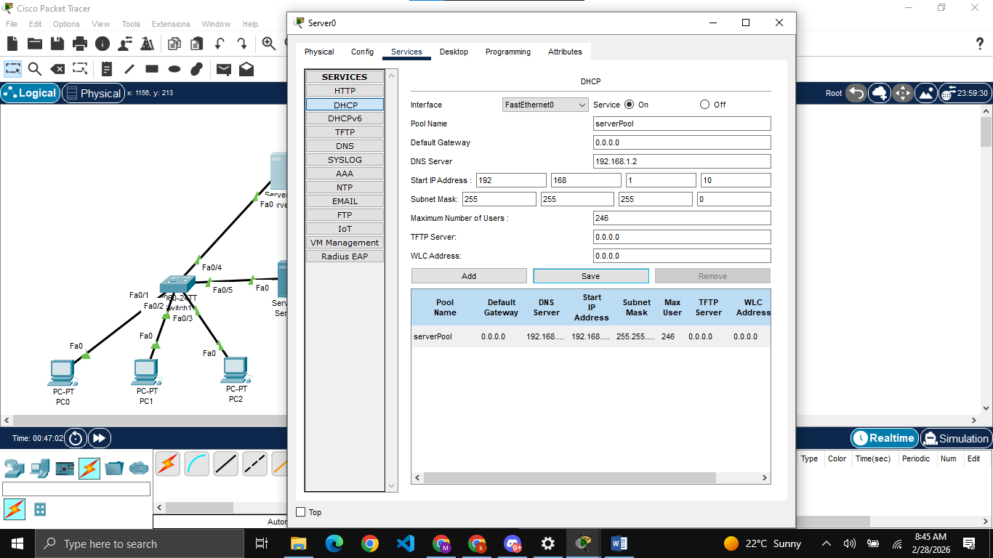
Setting up Server0 as DHCP server

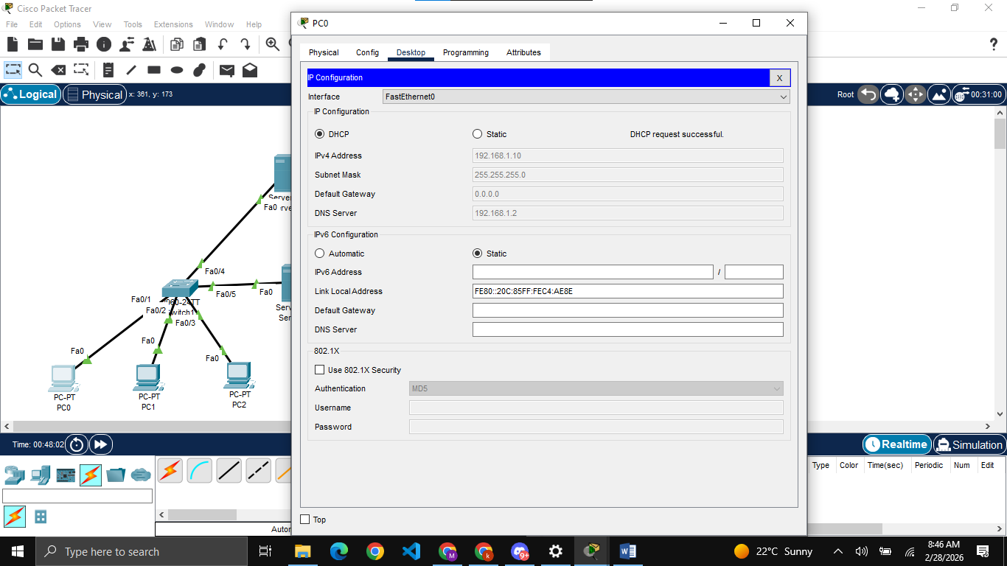
Assigning IPs and DNS server to all PCs using DHCP

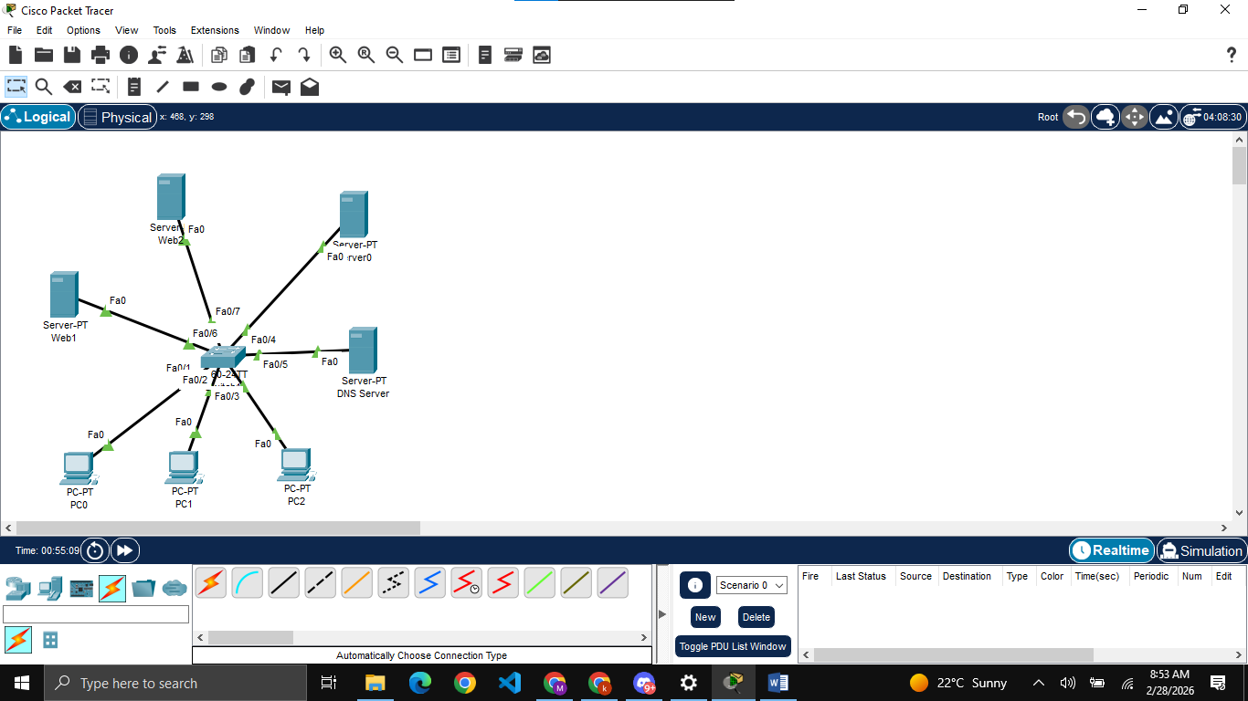
Adding 2 more servers as Web1 and Web2

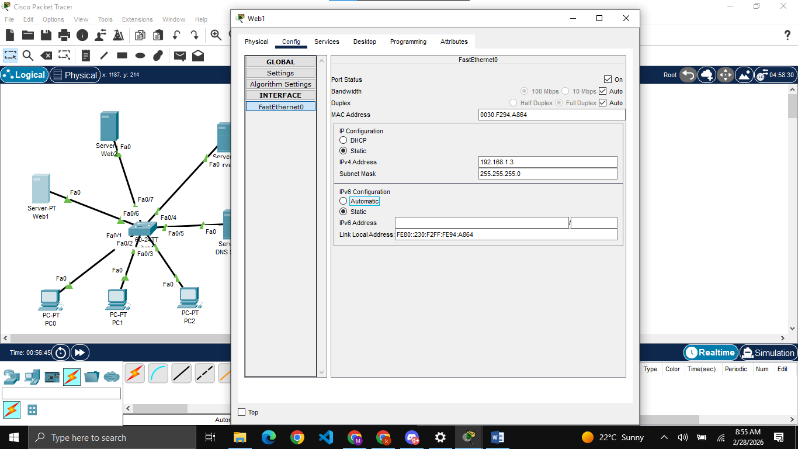
Assigning IPs to both new servers

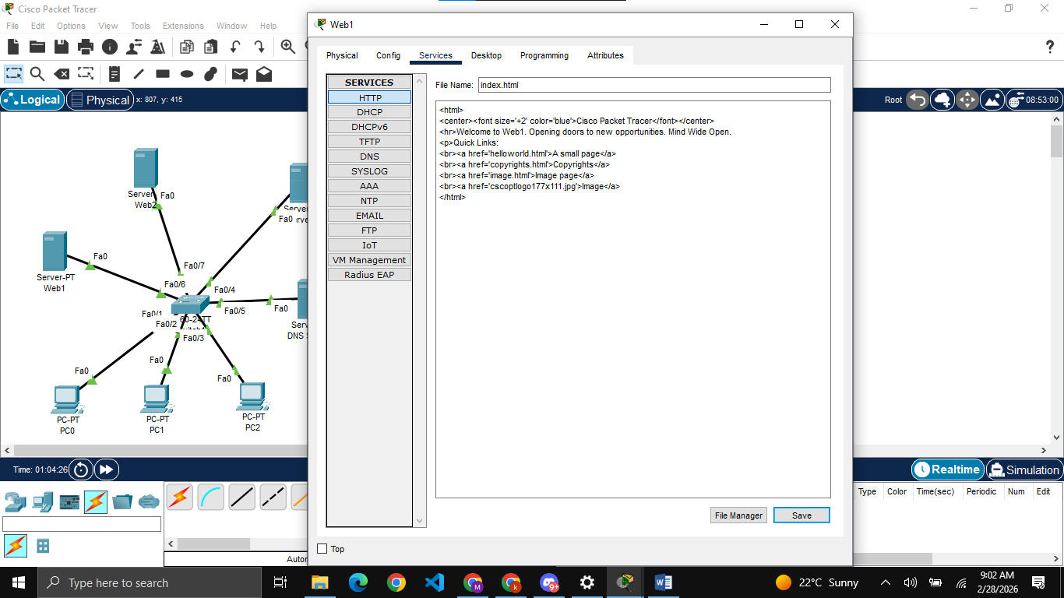
Editing index.html file for both new websites

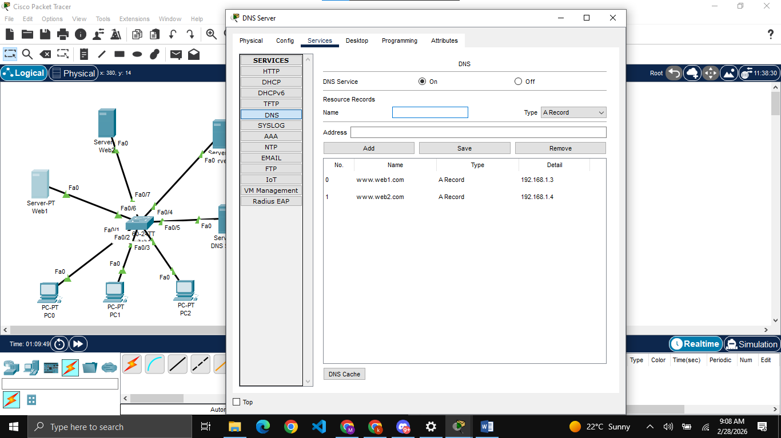
Setting up DNS server

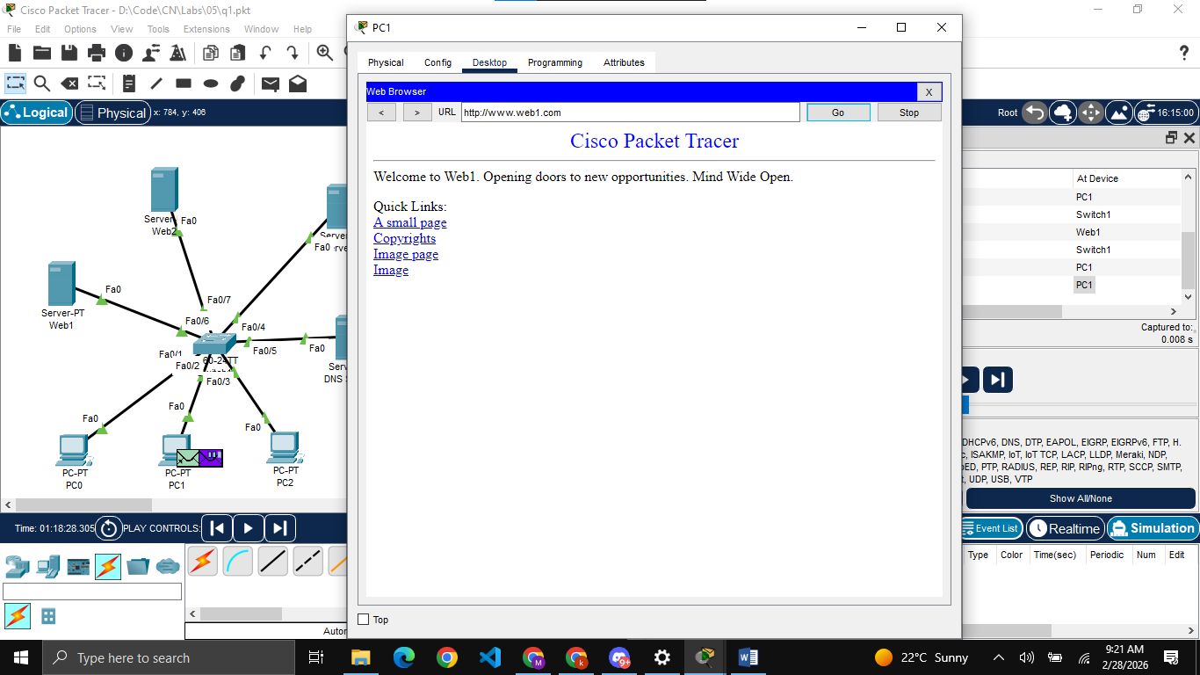
Opening PC1 and visiting Web1 from it

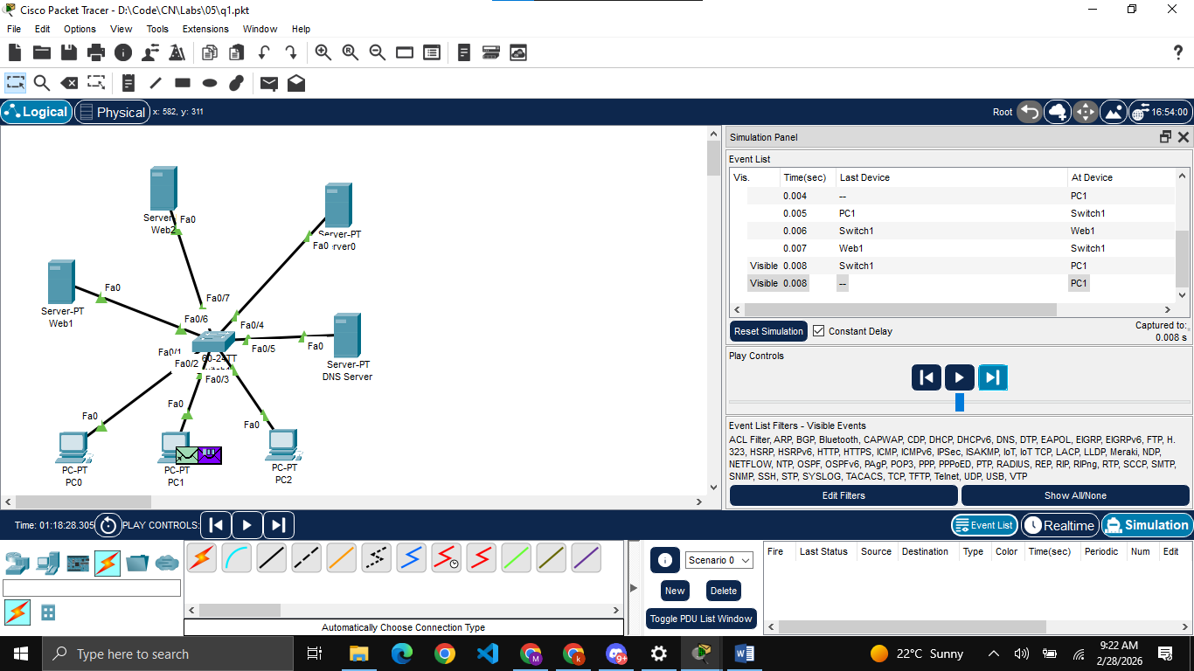
Simulating the above

Question 2:
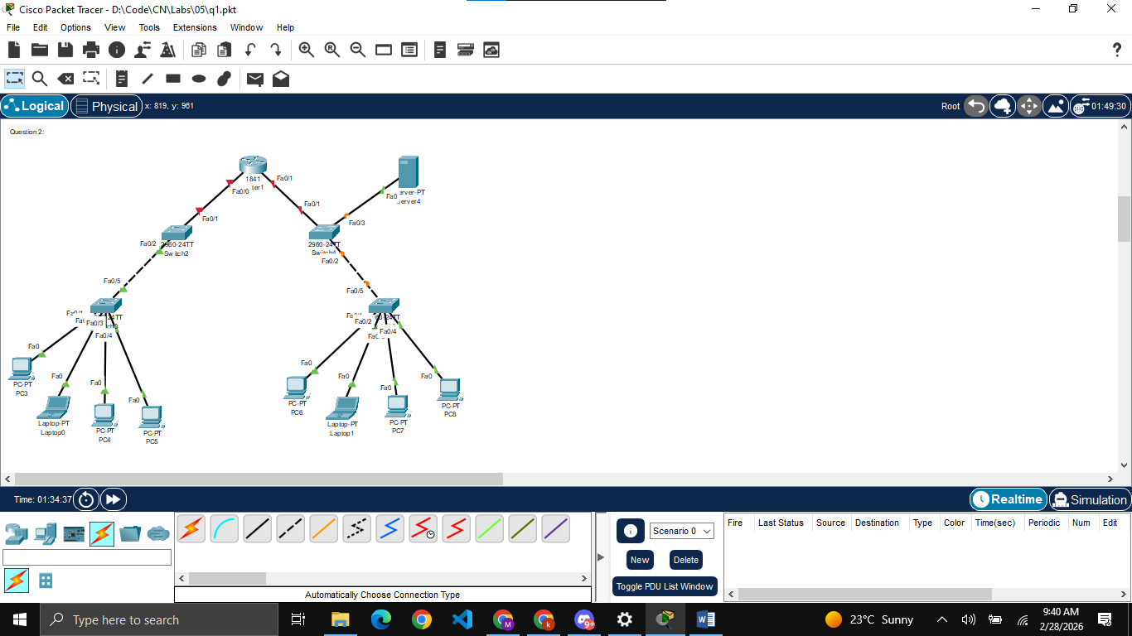
Building the topology

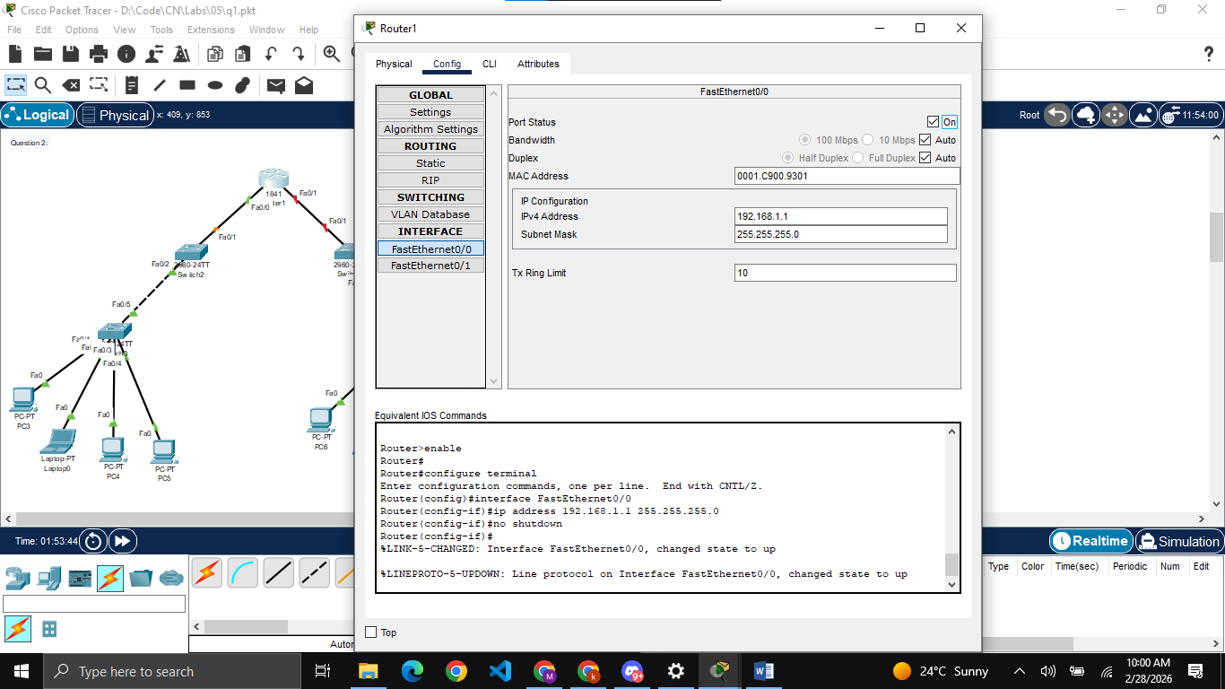
Assigning IP to left side of router using GUI
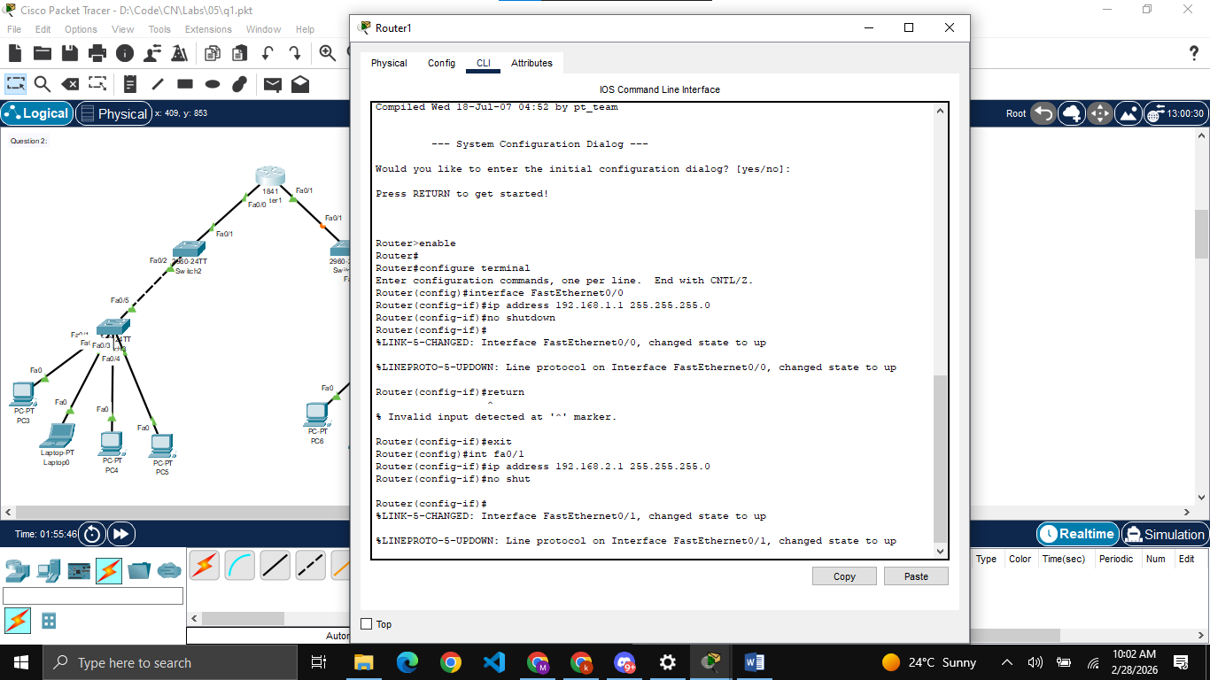
Assigning IP to right side of router using CLI

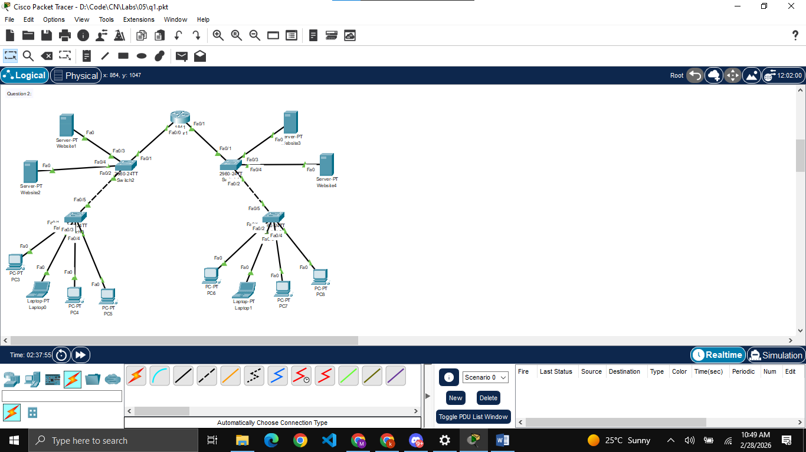
Adding few more servers, now there are two servers website1 and website2. Website1 will act as the DHCP server for left side while Website3 will act as the DHCP server for right side. Website3 will also act as the DNS server for whole topology.
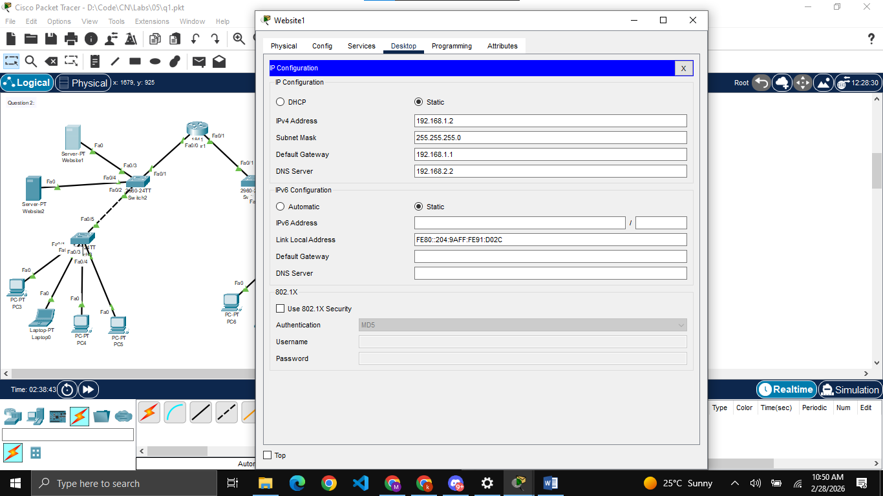
Setting up IPs, gateways and DNS server for all servers

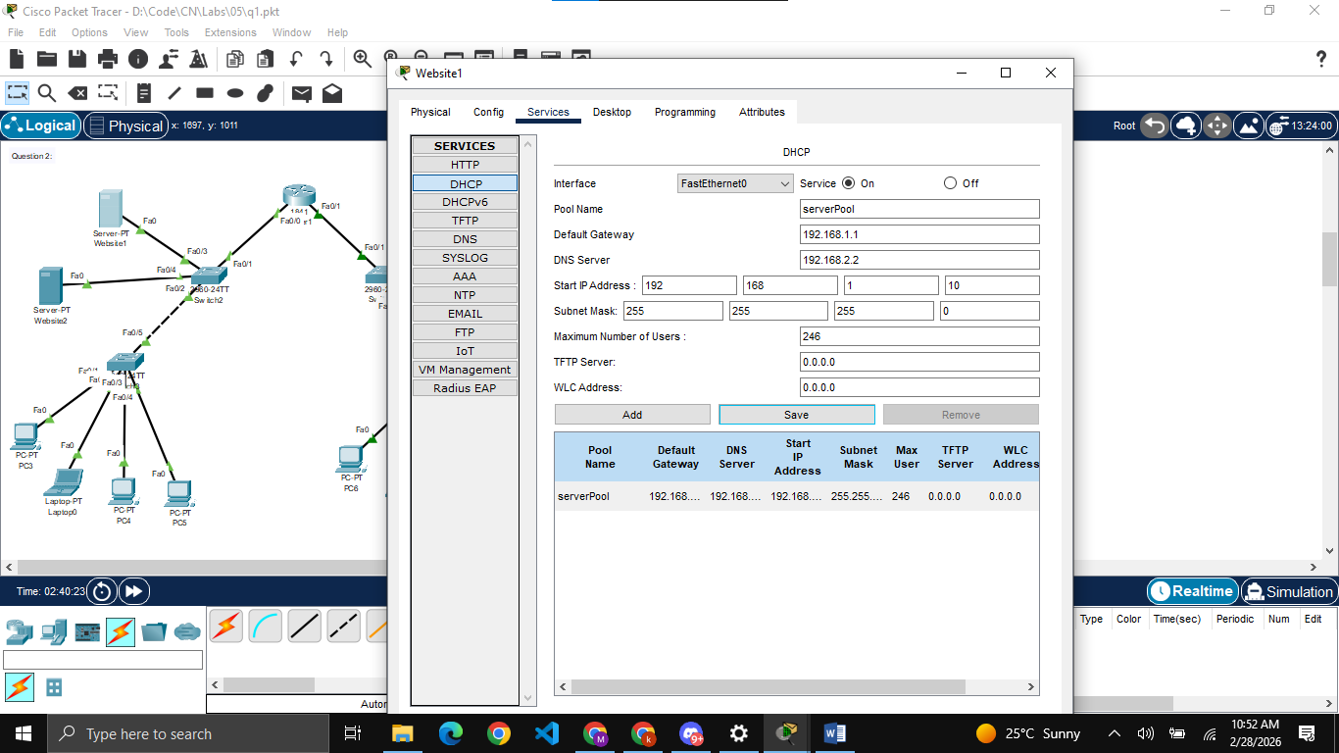
Setting up DHCP at Website1 (for left side) and Website3 (for right side)

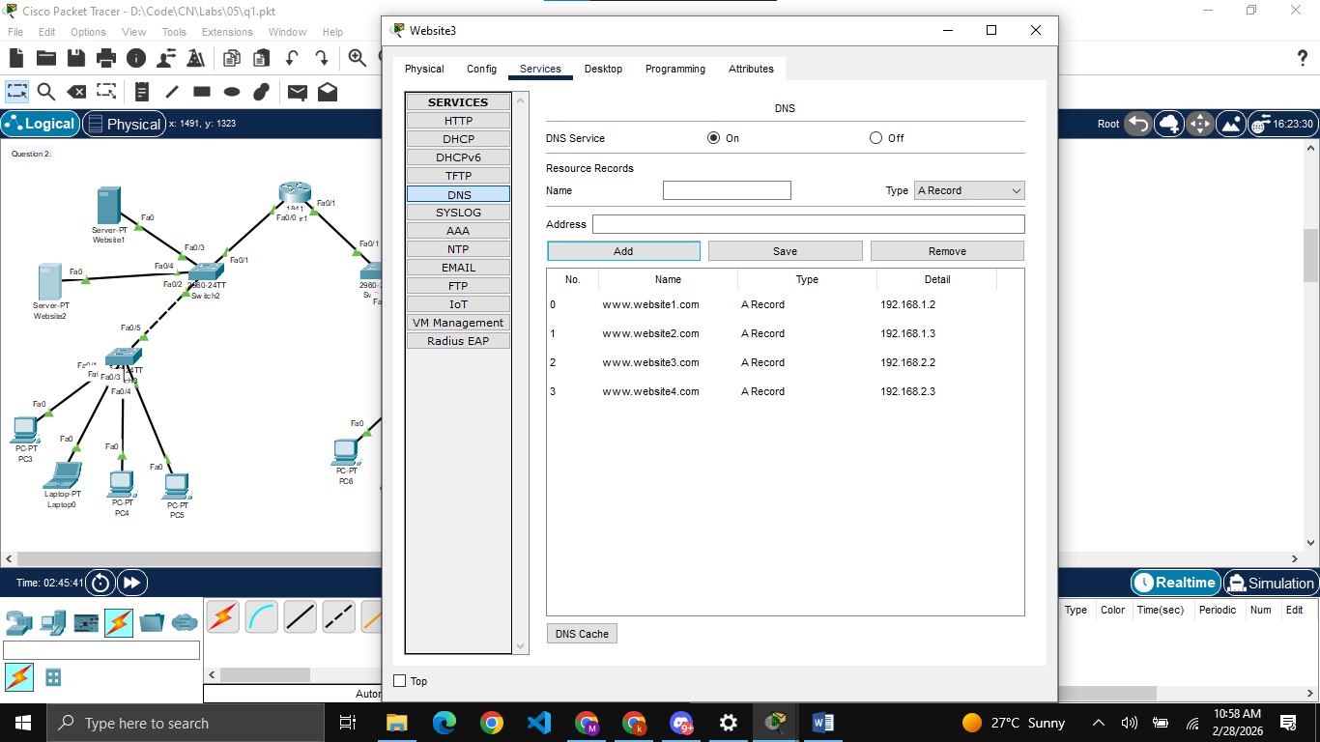
Setting up DNS at Website3 and adding records of all web servers

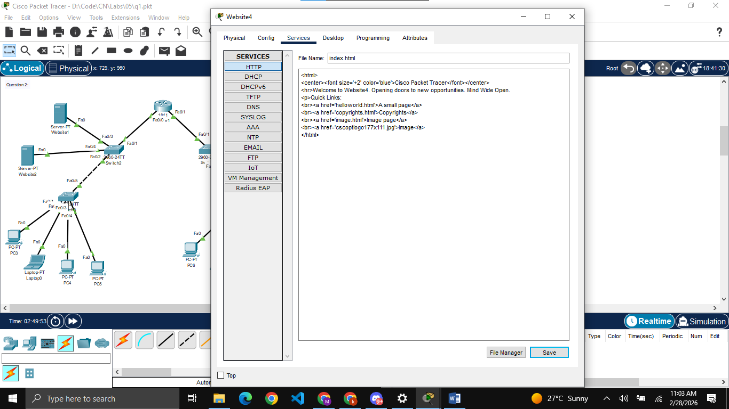
Editing index.html file for all web servers with their respective names

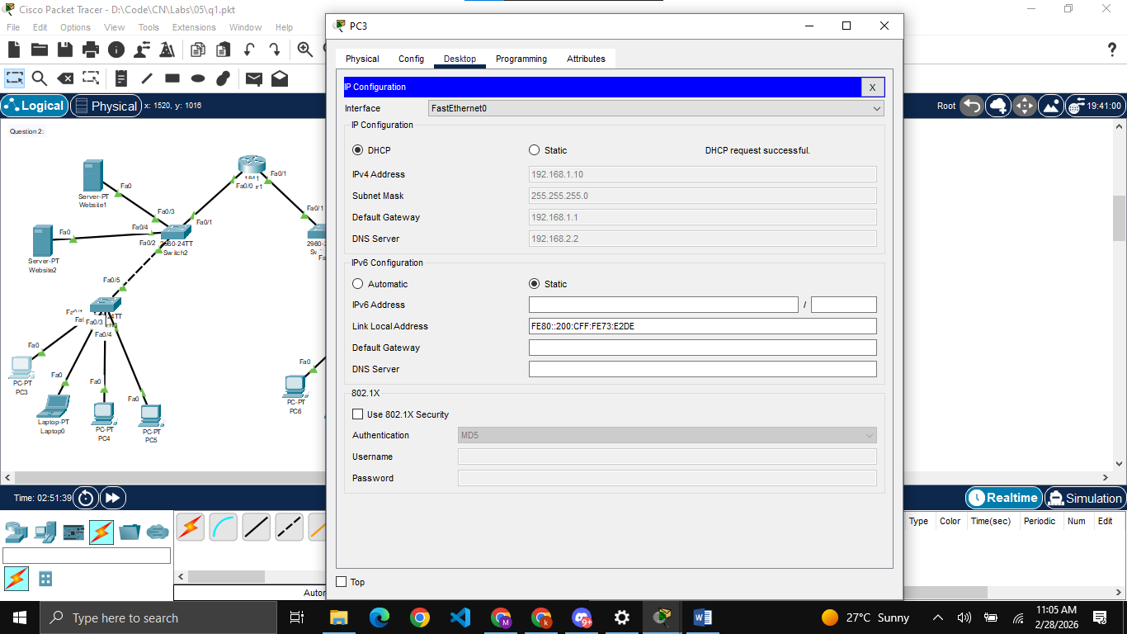
Assigning IPs, gateways and DNS server to all PCs and laptops using DHCP

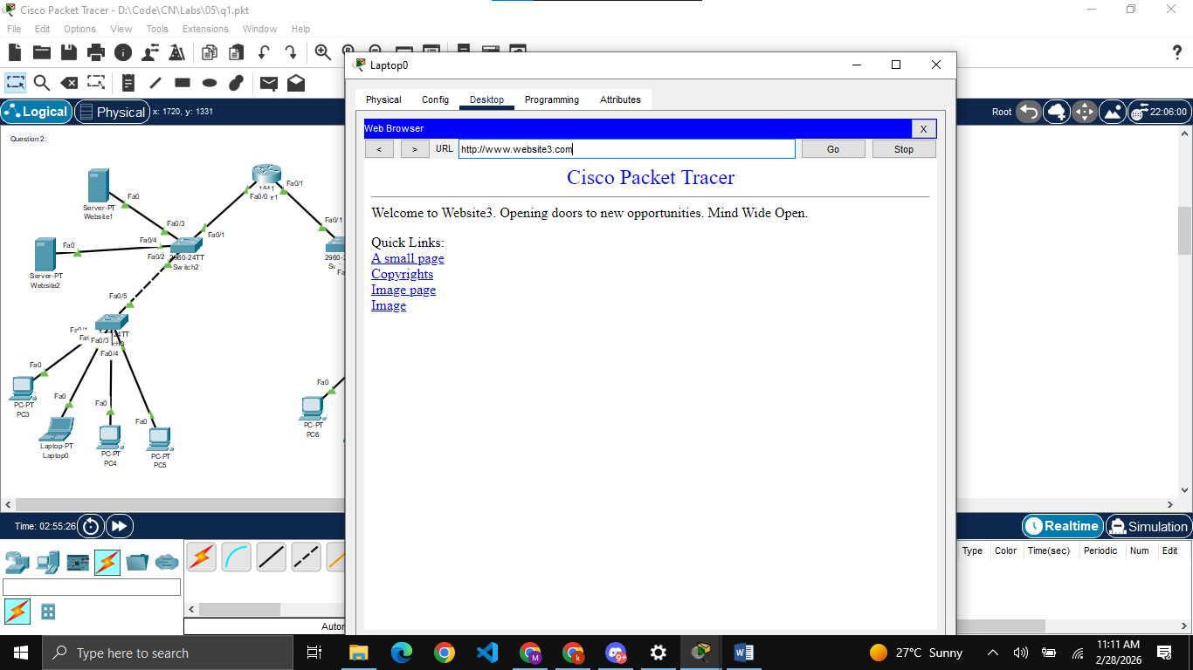
Opening Laptop0 and visiting Website3 from it

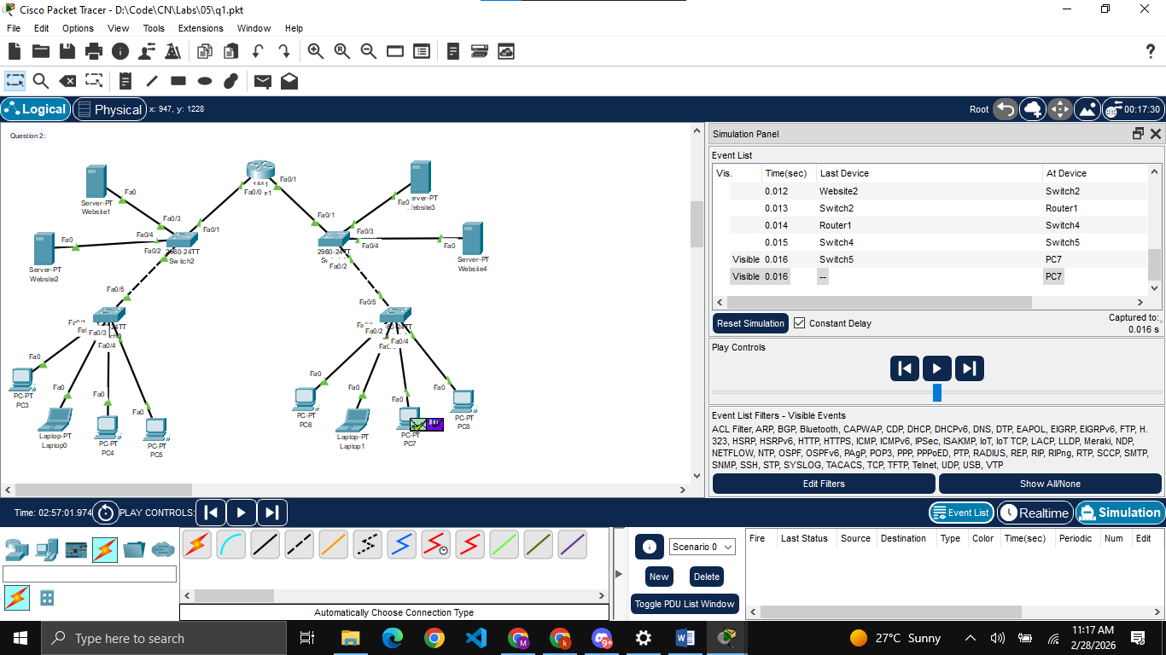
Opening PC7 and simulating the process of visiting website2 from it

I am sorry for not adding the extra servers on other switches (as mentioned by you) as I have listened your guidelines about tasks later when I had already completed my work.

Wireshark Tasks:
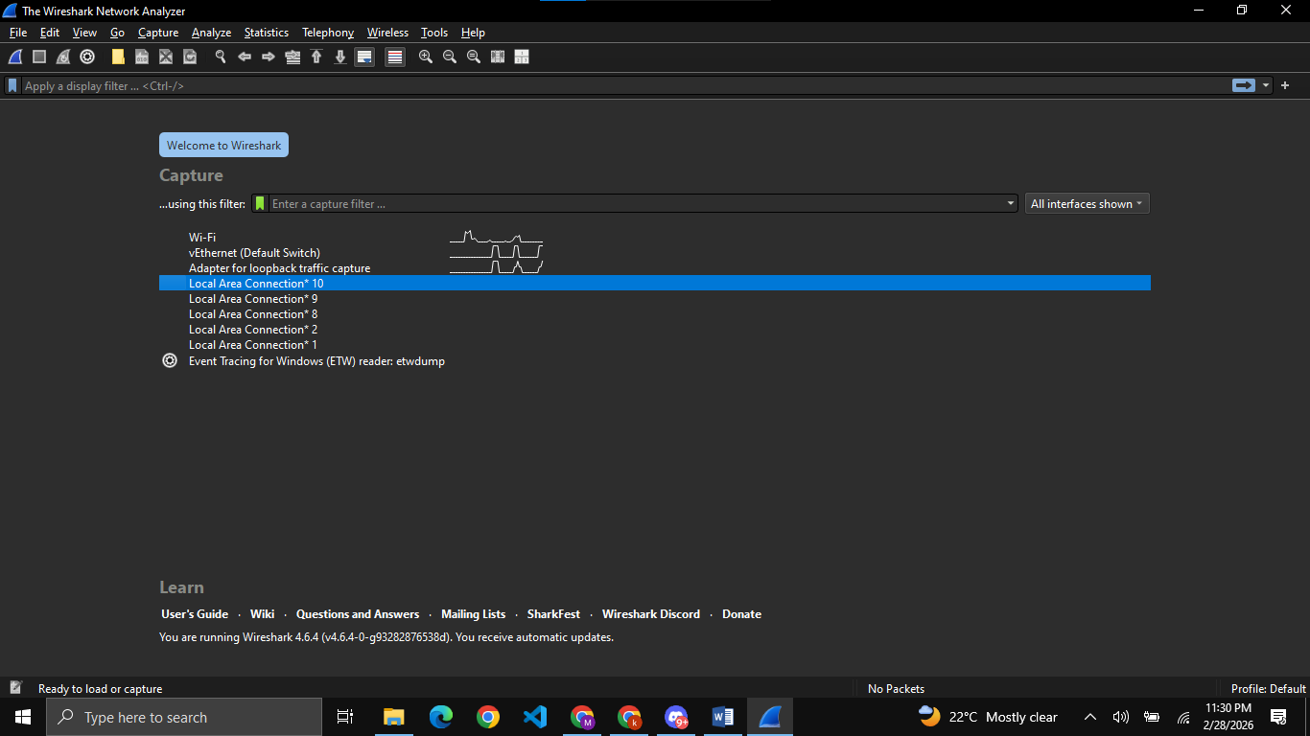
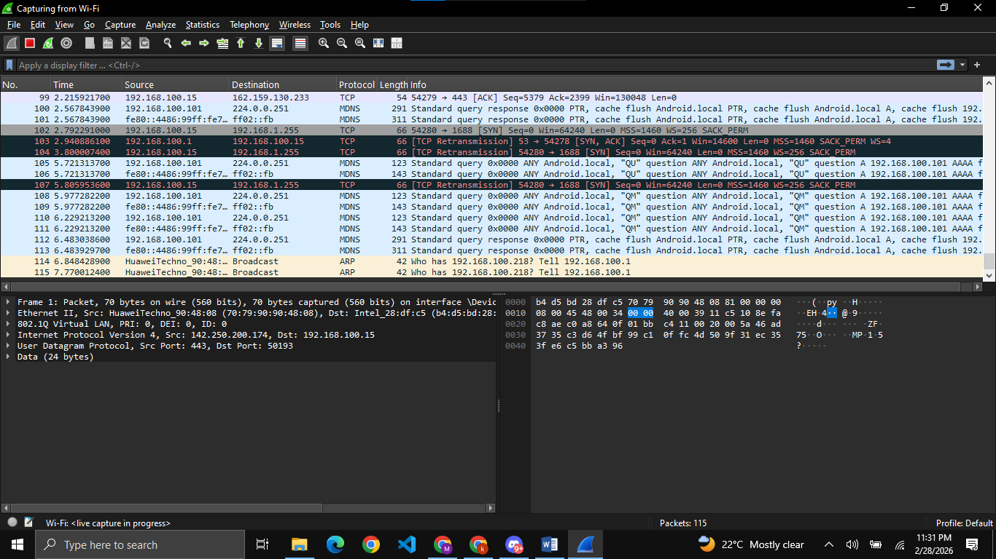

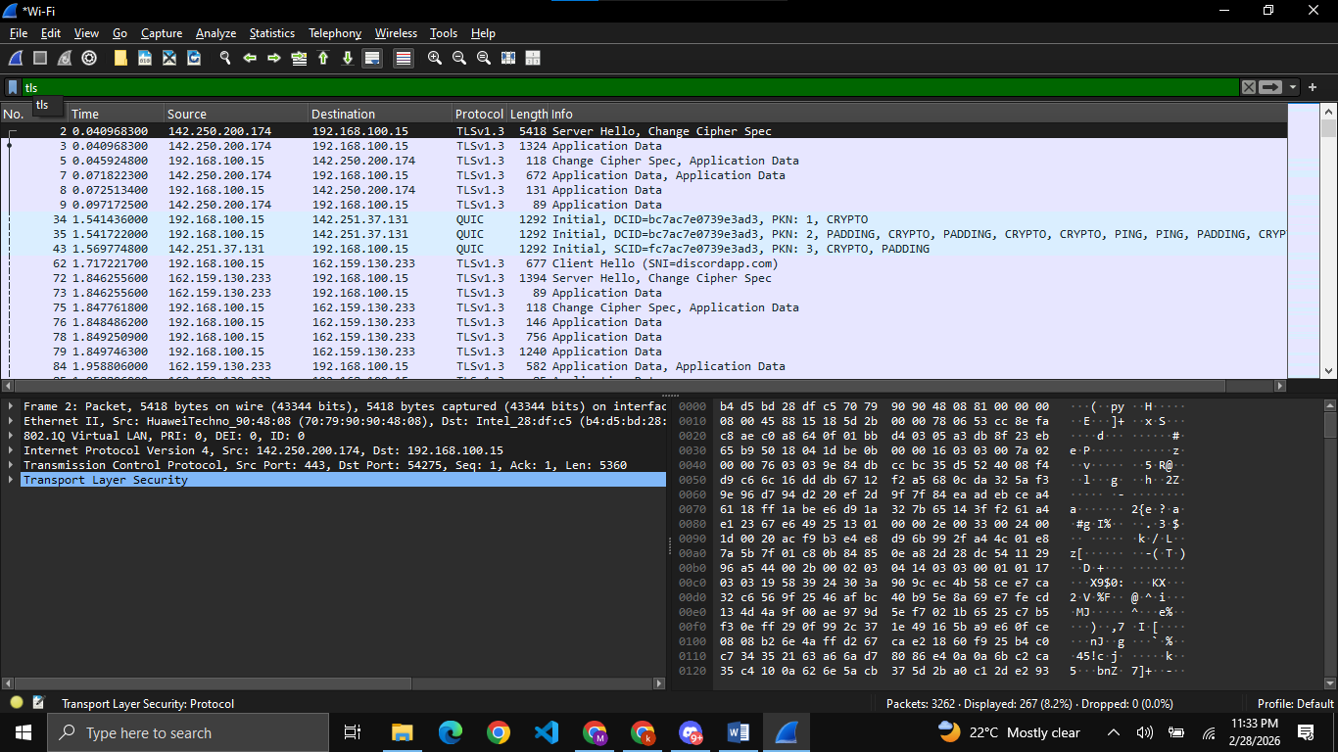
Filtering HTTPS packets using “tls”
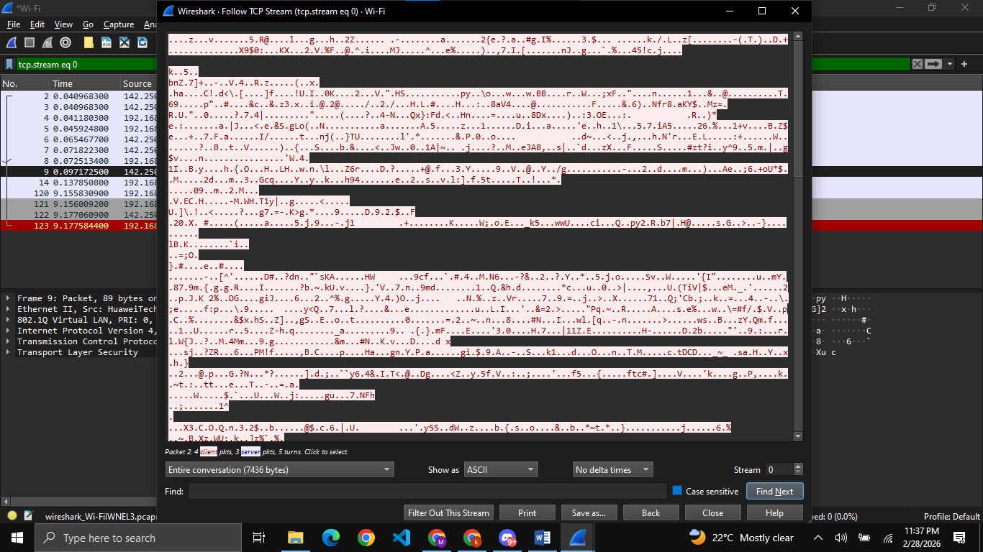
Encrypted, unreadable text as HTTPS is encrypted
I understand that when capturing HTTPS traffic, the data is encrypted using TLS/SSL protocols, making the actual contents (like passwords or web pages) completely unreadable to anyone intercepting the network.
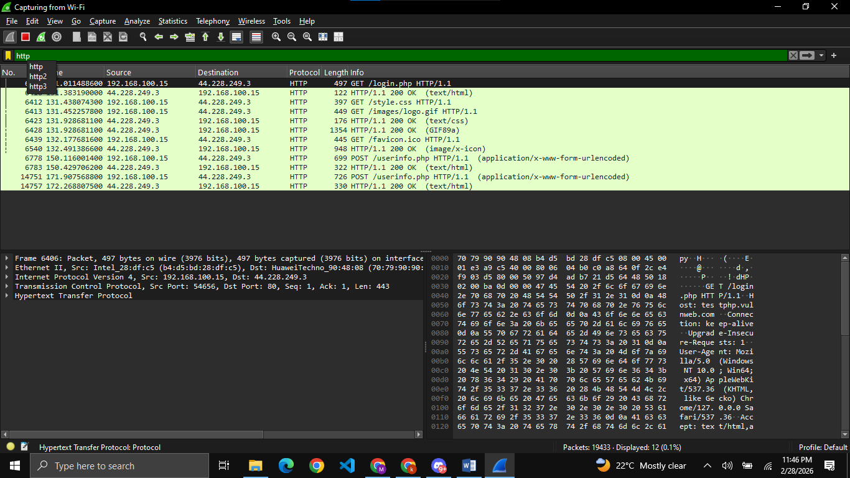
Filtering HTTP packets using “http”
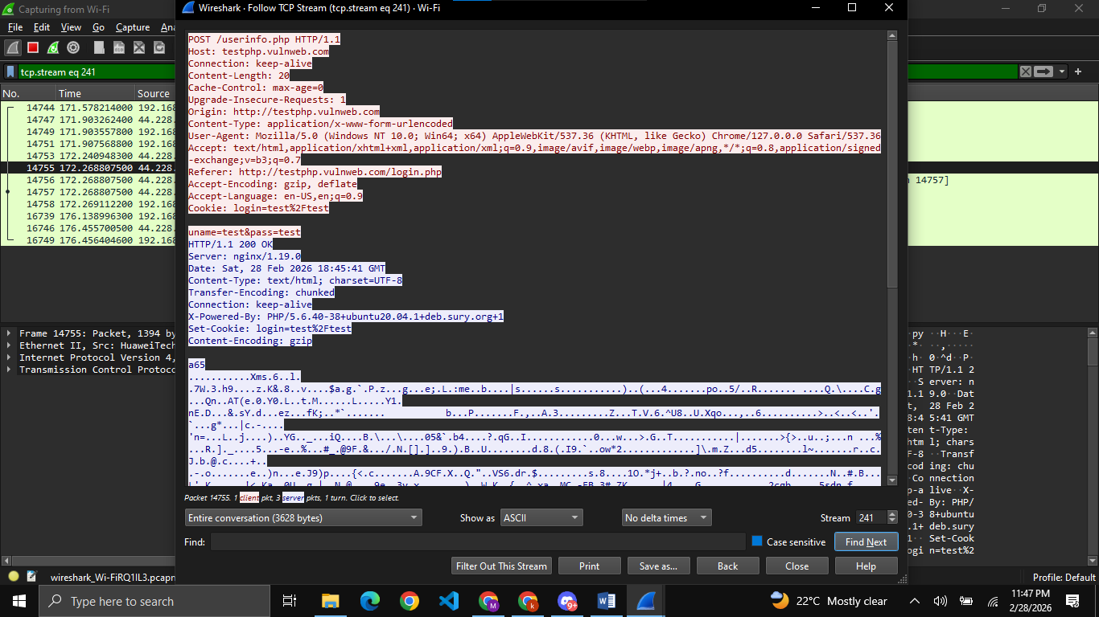
In HTTP, all the data Is unsecured and I can easily read the data of any other user on the network.
Difference between HTTPS and HTTP: The primary difference is that HTTP transmits data in plain, readable text, whereas HTTPS encrypts the data payload, providing a secure connection between the client and server.

