Cisco Packet Tracer Tasks:
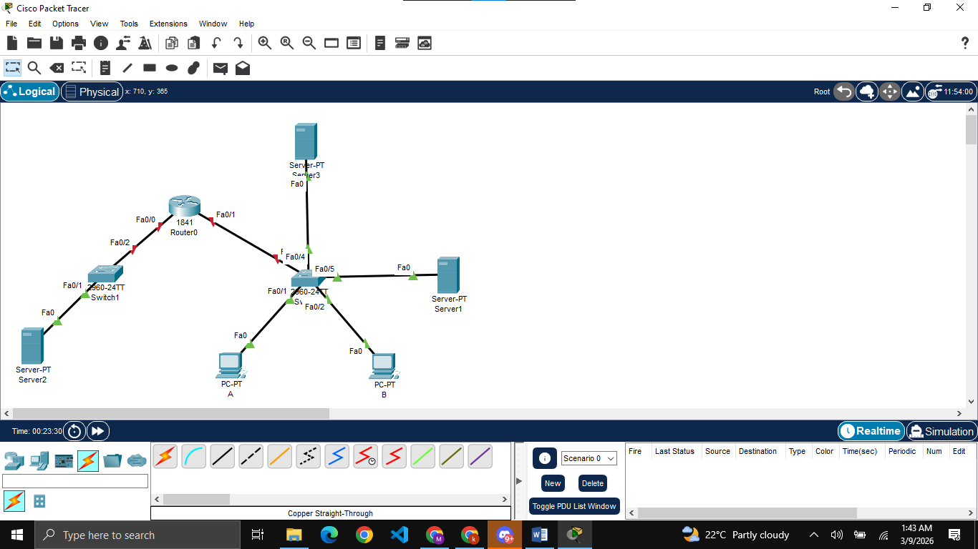
Building the topology

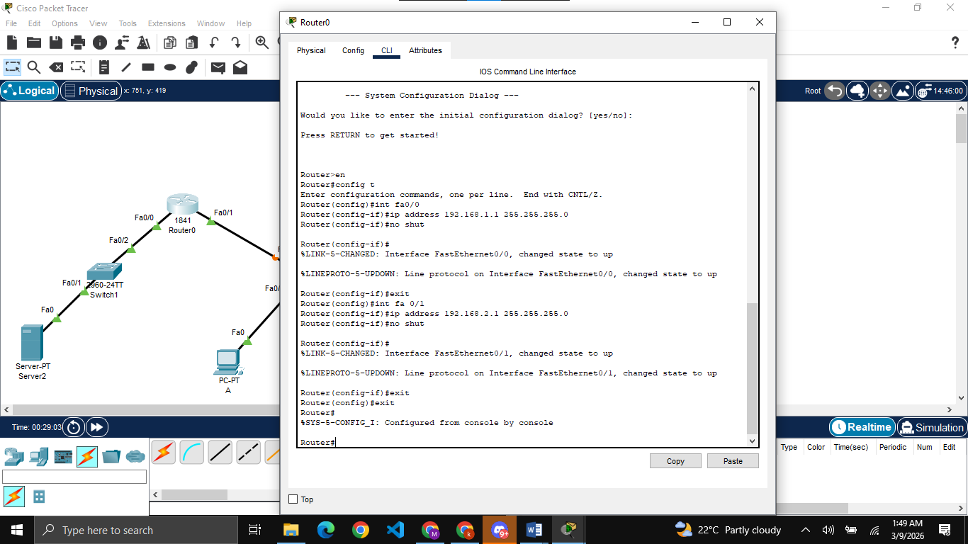
Assigning IPs to both sides of router
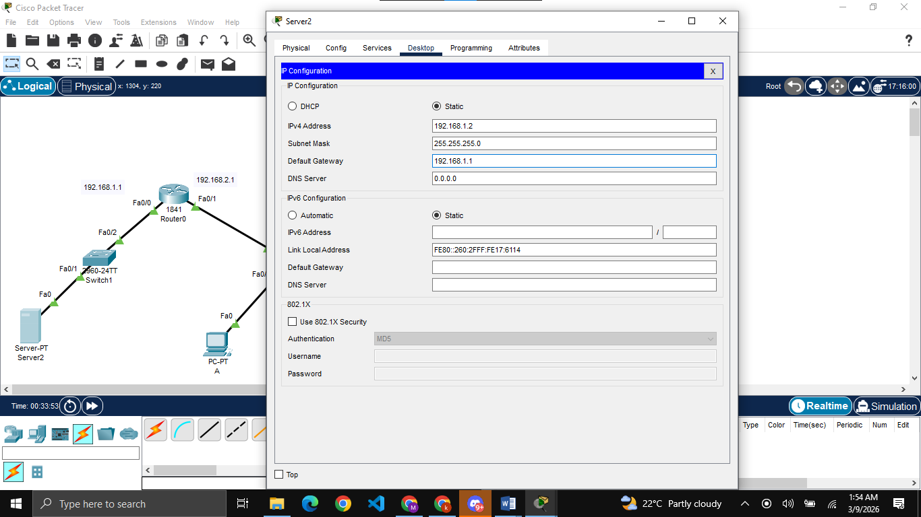
Setting up IPs and gateways for all servers and PCs

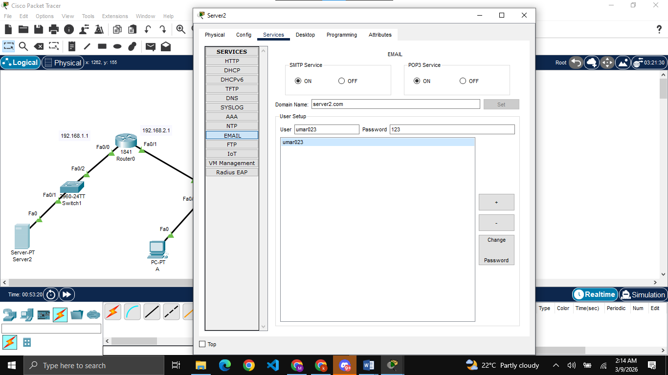
Setting Email service on server2 and adding one user (for PC-A)

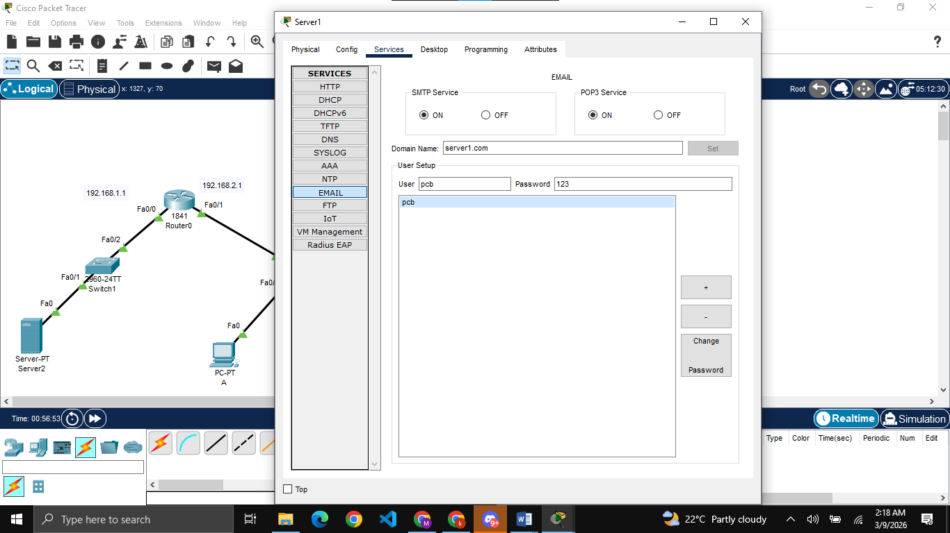
Similarly setting email service on server1 and adding one user (for PC-B)

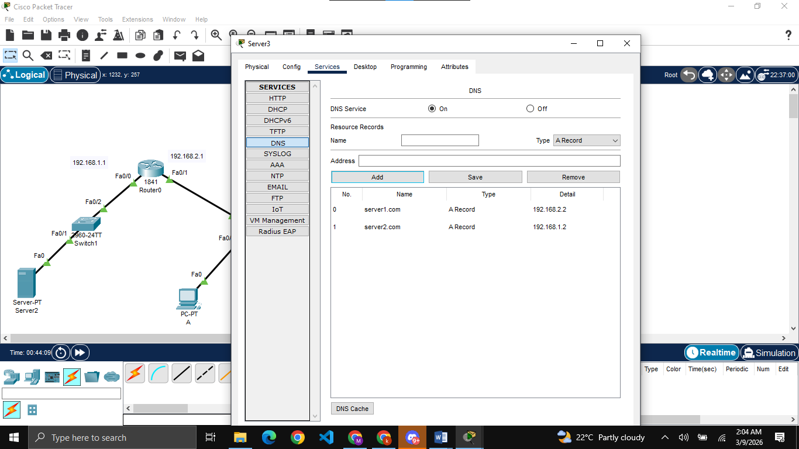
Making server3 as DNS server and adding the records of other 2 servers on it

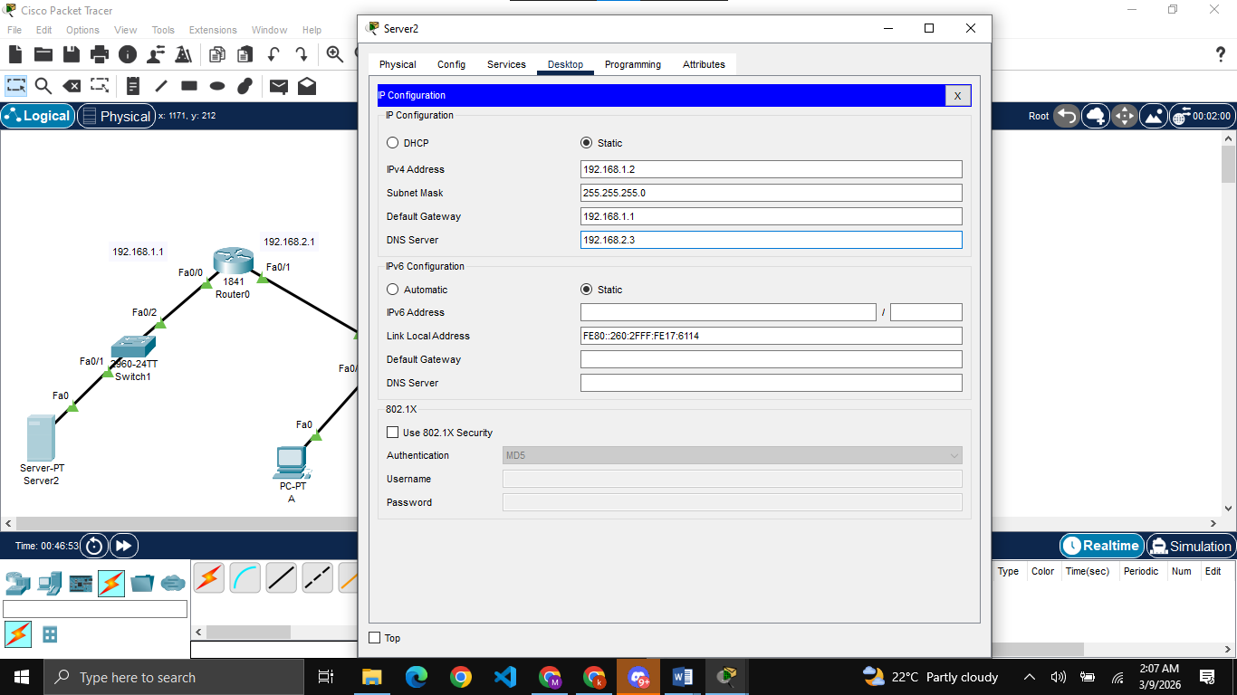
Adding the IP of server3 as DNS on all the servers and PCS (except server3)

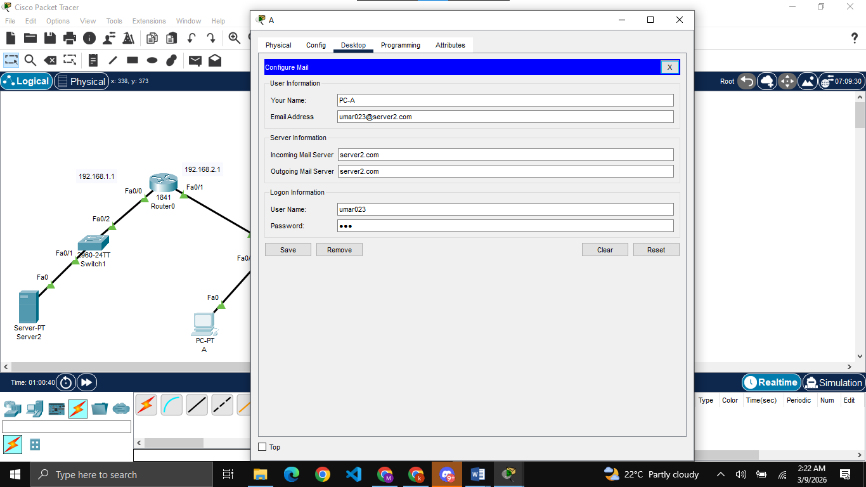
Logging in from PC-A on its id, similarly doing for PC-B

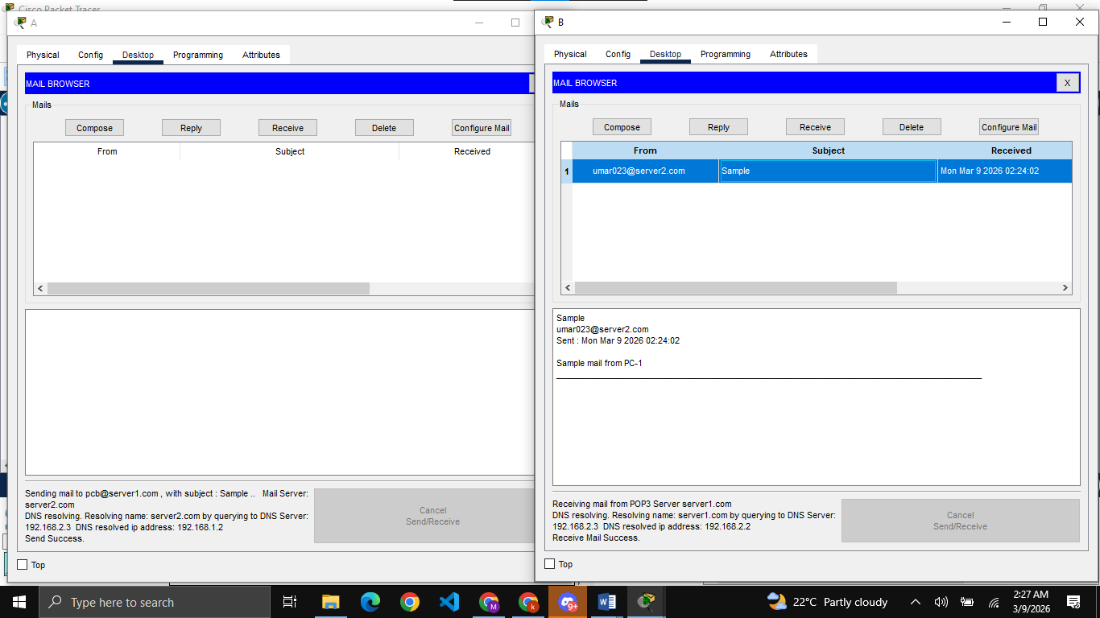
Sending mail from PC-A to PC-B

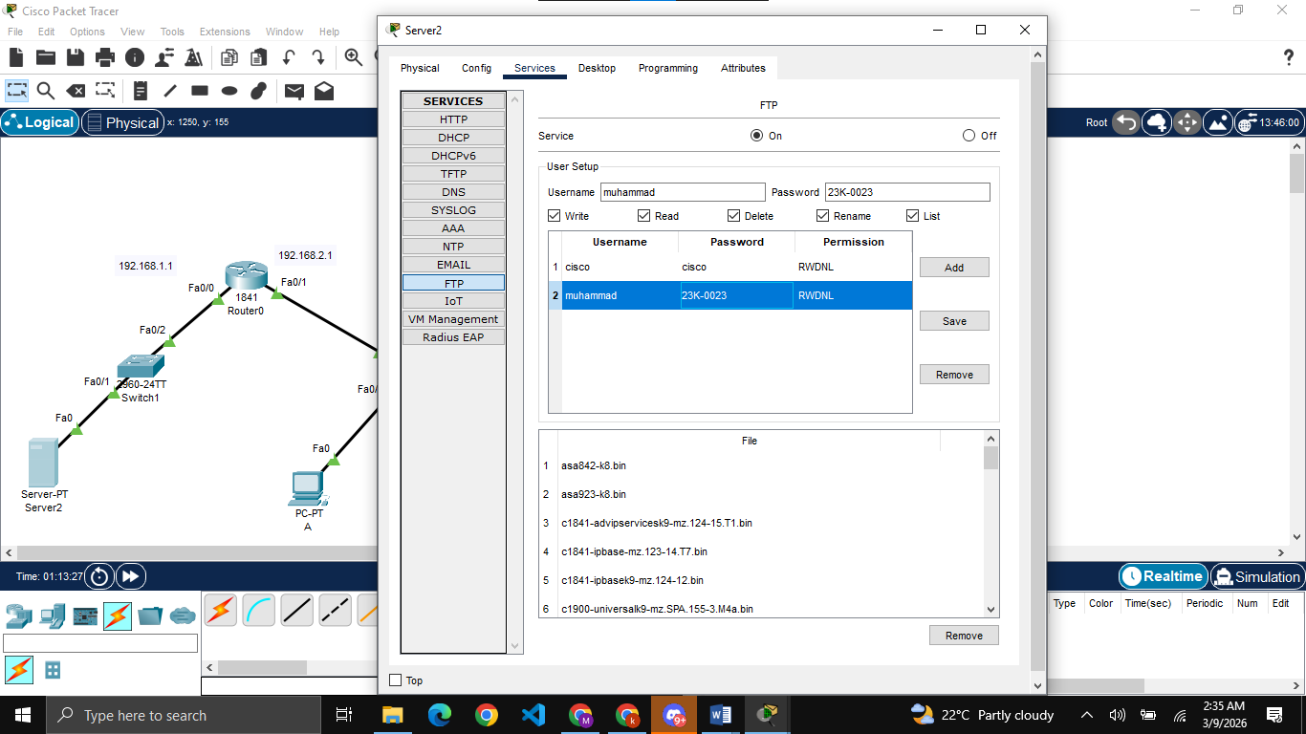
Setting up FTP and creating account on both server2 and server3

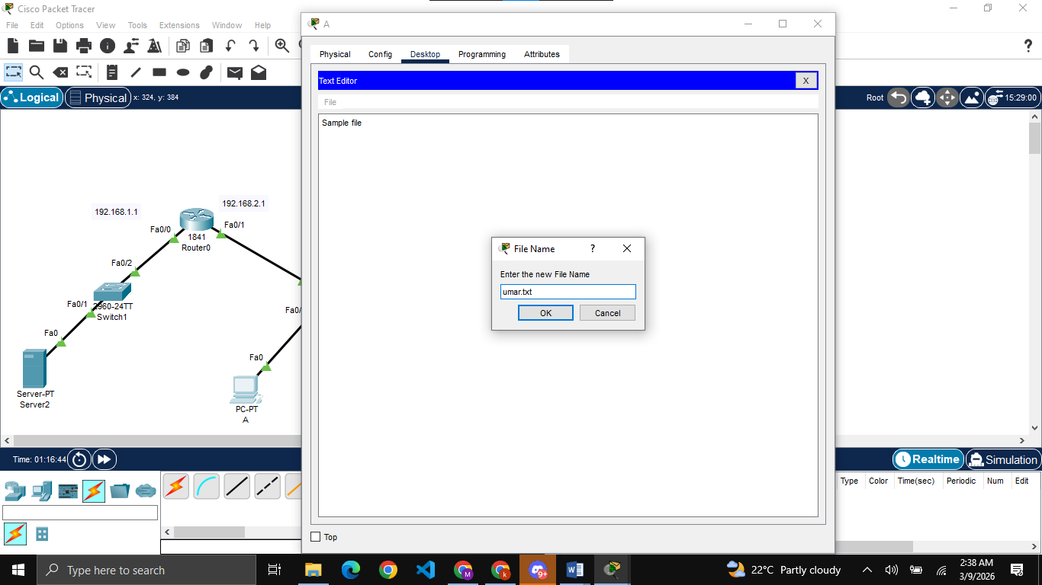
Creating a .txt file from PC-A

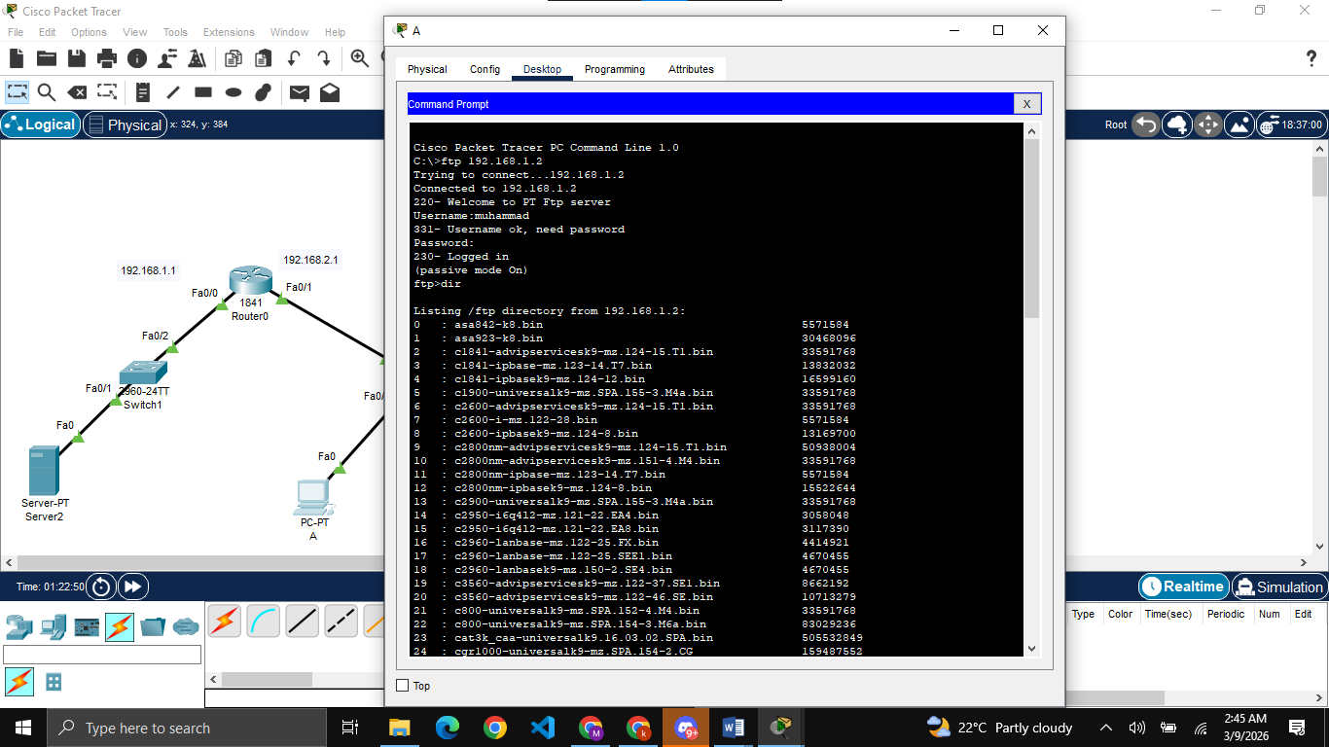
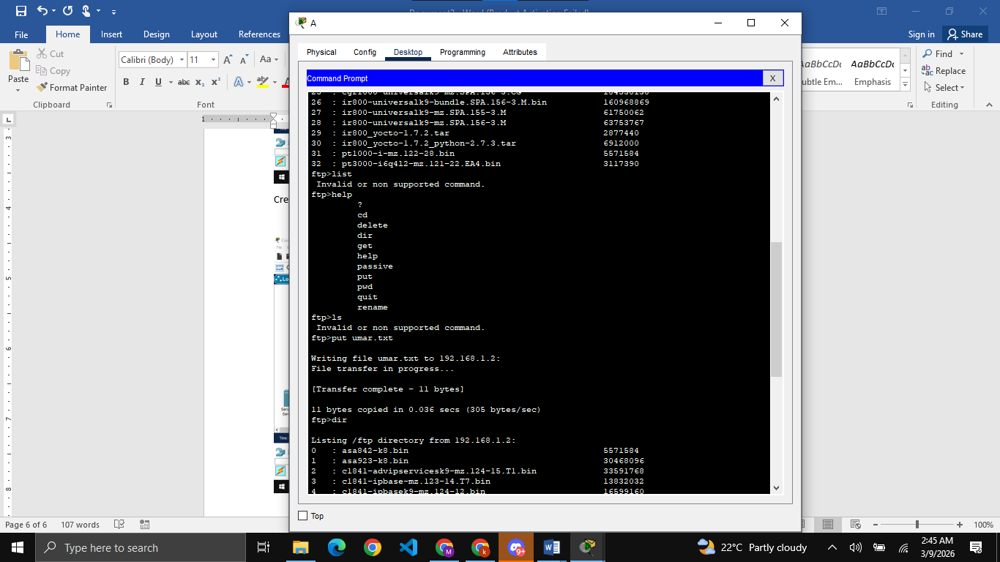
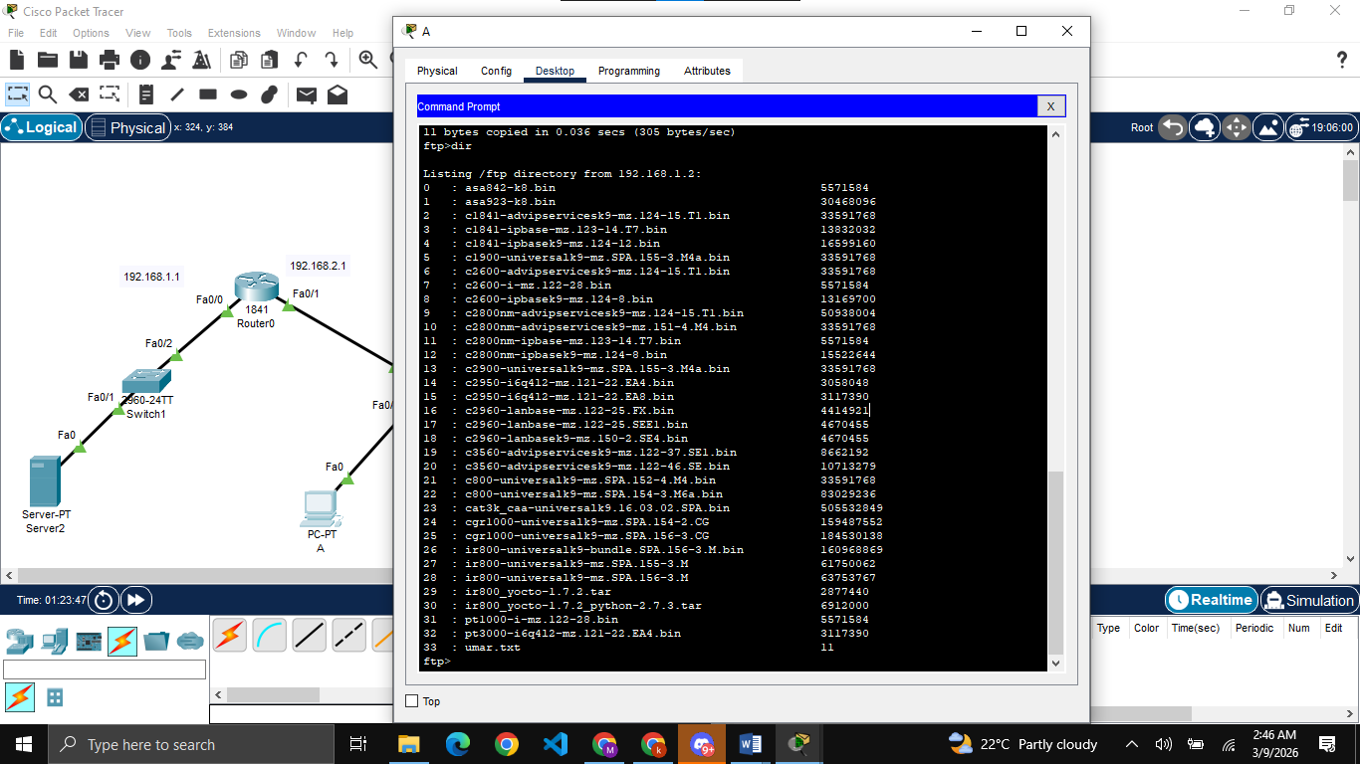
Testing the connection and then putting the file on FTP server2 from PC-A, similarly doing for server3

Wireshark Tasks:
3. Retrieving Long Documents
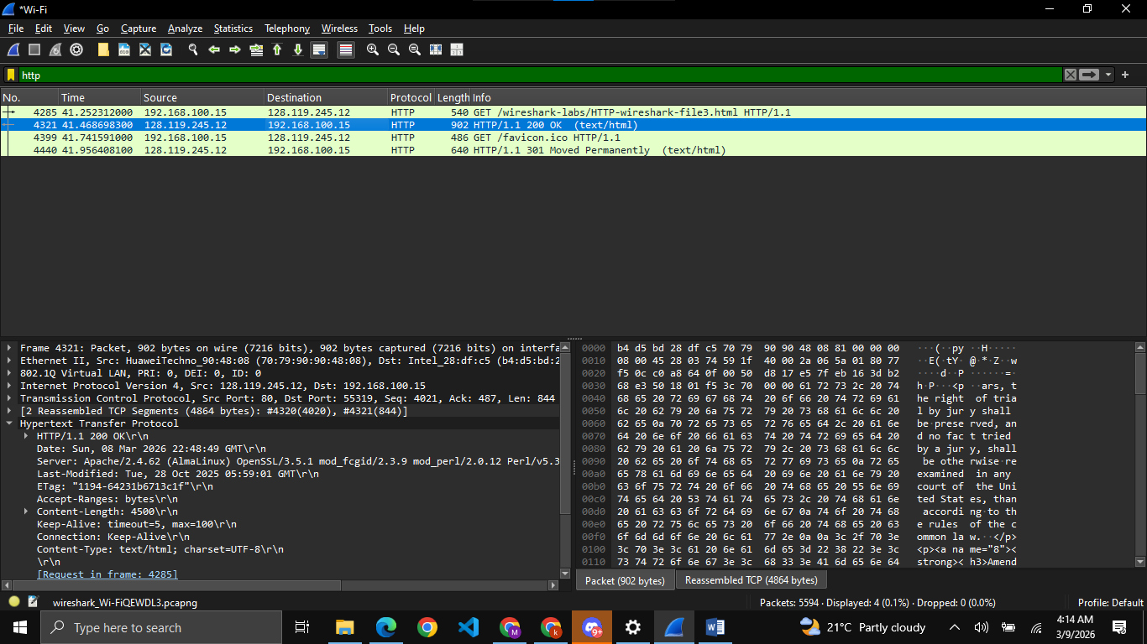
- 1 request, packet number 4285
- 4321
- Status code is 200 and phrase is OK
- 2

4. HTML Documents with Embedded Objects
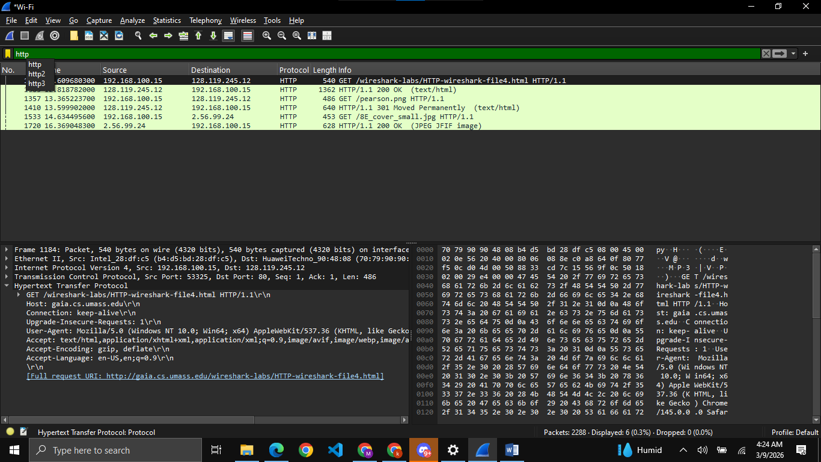
- 3 GET requests were send
- First: 128.119.245.12
- Second: 128.119.245.12
- Third: 2.56.99.24
- Browser downloads both images serially as the time for the GET request of the second image was after the response of the GET request of the first image.

- HTTP Authentication
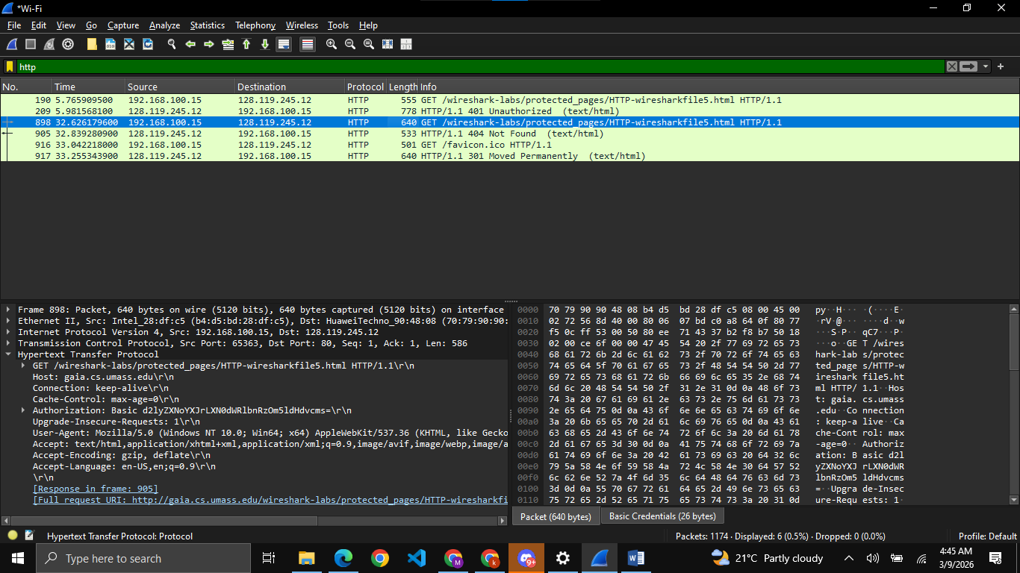
- 401 Unauthorized
- Field of Authorization is added

8. A First Look at The Captured Trace
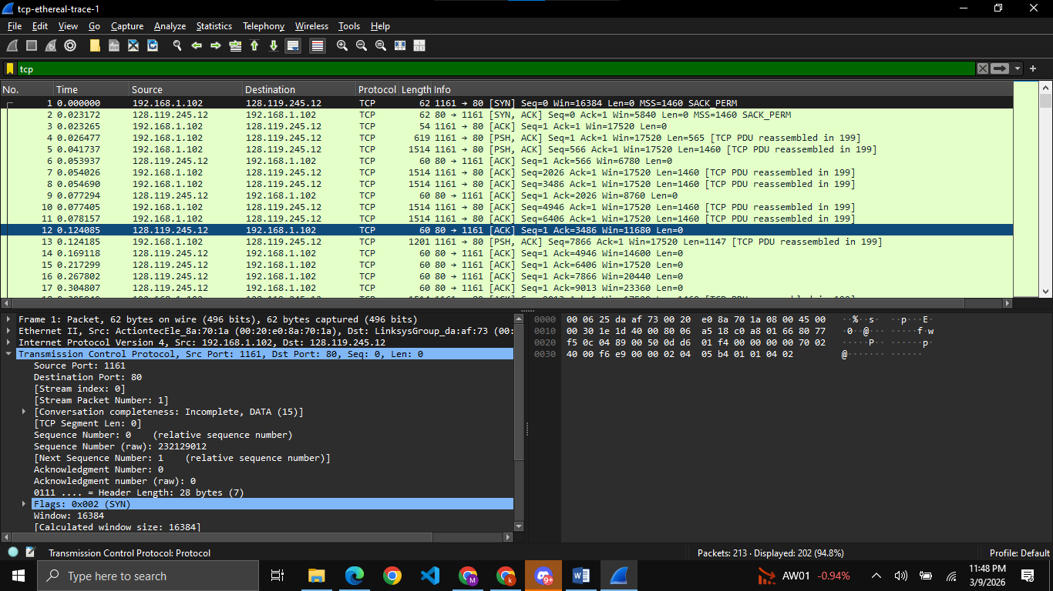
- IP address is 192.168.1.102 and TCP port no. is 1161
- IP address is 128.119.245.12 and port no. is 80
- I am using given file so cant give the ans

